**Urodynamic patterns in conus and epiconus mass lesions**

Maamoun Abo Shosha, M.D., Hamdy Mohammad Behary, M.D., Mohamed A. Ellabbad, M.D.

Department of Neurosurgery, Faculty of Medicine, Al-Azhar University, Cairo, Egypt.

[alaarashad81@yahoo.com](mailto:alaarashad81@yahoo.com)

**Abstract:** *Object:* To study the urodynamic patterns in conus and epiconus mass lesions before and after operation. *Study Design*: Analytical study. *Settings and Participants:* Twenty individuals with conus and epiconus mass admitted to the Department of Neurosurgery in Al-Hussein and Sayed Galal Hospitals. Detailed clinical, neurological evaluation and radiological assessment were done along with clinical examination of bladder and urodynamic study. *Results*: Out of 20 patients with conus and epiconus mass lesions, 12 (60%) had pre-operative affection of urodynamics and 8 (40%) had intact urodynamics. Post operative evaluation revealed improvement of urodynamics of all 12 patients (100%) and no deterioration of urodynamics of the other 8. *Conclusion:* The correlation between somatic neurologic findings, spinal imaging studies, and urodynamic findings in patients with conus and epiconus lesions is not exact. Therefore, bladder management should not completely rely only on clinical bladder evaluation or neurological examination alone, but should always include urodynamic studies.

[Maamoun Abo Shosha, Hamdy Mohammad Behary, Mohamed A. Ellabbad. **Urodynamic patterns in conus and epiconus mass lesions.** *N Y Sci J* 2017;10(5):29-33]. ISSN 1554-0200 (print); ISSN 2375-723X (online). <http://www.sciencepub.net/newyork>. 6. doi:[10.7537/marsnys100517.06](http://www.dx.doi.org/10.7537/marsnys100517.06).

**Keywords:** Urodynamic; patterns; conus; epiconus; mass; lesion

**1. Introduction**

Urologic complications continue to be an important reason for high morbidity in conus and epiconus lesion. Longitudinal studies reveal a high incidence of urinary tract infection (UTI; incidence of bacteremia at least one episode in 1 year being 66.7-100% depending on various bladder management methods) (1), renal stones (8%), bladder stones (36%), vesicoureteral reflux, hydronephrosis, and renal deterioration (2,3). These complications can lead to renal failure (4).

Classification of a neurogenic bladder depends on the location of the lesion along the central nerve pathway and includes sacral, suprasacral, and suprapontine lesions. Lesions of the peripheral nerves or the sacral micturition center cause detrusor areflexia. These lesions may affect the conus medullaris, the cauda equina, and S2-S4 peripheral nerves. Lesions of the spinal cord or brainstem below the pontine micturition center, but above the sacral micturition center, lead to uninhibited bladder contractions with uncoordinated sphincter activity. These lesions cause interruption of the spinobulbospinal reflex. Two pathological mechanisms are in play here. The first is an acute areflexia and then detrusor hyperreflexia. The second is detrusor-sphincter dyssynergia, where the external sphincter contracts at the same time the detrusor contracts. Individuals with lesions below the pontine micturition center have both detrusor hyperreflexia and detrusor-sphincter dyssynergia. Suprapontine lesions lead to uninhibited bladder contractions, which may be secondary to loss of cerebral cortex inhibition at the sacral micturition center. Suprapontine lesions are located at or between the pontine micturition center and the cerebral cortex and involve the spinobulbospinal reflex. They may or may not coincide with sacral lesions. These lesions present as uninhibited bladder contractions with retained voluntary urethral sphincter relaxation during micturition (5).

On a teleological and anatomical basis, when there is injury proximal to the sacral spinal cord, one expects a voiding pattern consistent with motor neuron injury. In contrast, injury to either the sacral cord or cauda equina segment should result in lower motor neuron injury. To our knowledge, three studies have so far noted an exact correlation between somatic neurologic findings and characteristic urodynamic findings (7-9).

Several factors merit considerations as contribution to this inexact correlation. First, degeneration and reorganization of crucial neural pathways distal to the lesion with or without neural sprouting at the level of injury may affect the neurologic and urodynamic findings. Second, conus and epiconus lesions may be incomplete, thereby partially allowing the integration and modulation of complex micturition signals at multiple levels of the nervous system. Multiple injuries coexisting at different levels can result in unpredictable mixed voiding dysfunction. In fact, the multiplicity of levels of injury is occasionally unrecognized when based solely on urologic history and evaluation in patients with new conus and epiconus lesions (10).

The history and physical examination alone cannot determine the type of bladder and sphincter function in a person with conus and epiconus lesions. It is imperative that complete urodynamic study be undertaken for specific identification. We evaluated 20 patients with conus and epiconus lesions and tried to find the underlying neurogenic bladder type in these cases.

**2. Clinical material and methods**

**Evaluation of the study subjects**

All patients underwent routine history and physical examination, including evaluation of perianal sensation, anal sphincter tone, and sacral reflexes along with urodynamic study. The patients were divided into neuroanatomical groups based on the clinical neurological levels. Patients were also categorized as complete or incomplete, in which subgroups based on the integrity of the sacral dermatomes where made. Those with abnormalities of the sacral reflex arc (absent bulbocavernosus reflex, and lax anal sphincter tone) were deemed positive for the presence of conus and epiconus lesions and those with intact sacral reflexes were deemed negative for sacral cord lesions. All the patients considered for the study underwent routine testing including blood counts, renal function tests, urine microscopy, urine culture and sensitivity, radiographs, and diagnostic ultrasound of the urinary tract.

**Urodynamic evaluation**

Urodynamic evaluation on each patient was performed using Ellipse, which is a Danish-designed German urodynamic device from Andromeda. It consisted of a filling phase and a voiding phase cystometrogram along with perineal muscle electromyography (EMG). A 9F double-lumen catheter was introduced transurethrally into the bladder. One lumen was used for bladder filling at an average flow rate of 21ml/minute and another was used to record intravesical pressure. Intra-abdominal pressure was recorded by a 12F rectal catheter. Through multichannel pressure transduction, intra-vesical and intra-abdominal pressures was simultaneously transduced on a strip chart recorder. Sphincter EMG was performed using patch electrodes (Ambu blue sensor NF) by an experienced electromyographer.

**Inclusion Criteria**

Patients with conus and epiconus lesions undergo urodynamic evaluation.

**Exclusion criteria**

All those who were diagnosed with urinary tract stones, foreign body, symptomatic UTI, or any other bladder abnormality were excluded from the study.

**Table 1**: Summary of the clinical data:

|  |  |  |  |  |  |  |
| --- | --- | --- | --- | --- | --- | --- |
| **Case No.** | **Age (years) / Sex** | **Preoperative urodynamics** | **Histopathology** | **Postoperative Urodynamics** | **Follow up (months)** | **Complications** |
| **1**  **2**  **3**  **4**  **5**  **6**  **7**  **8**  **9**  **10**  **11**  **12**  **13**  **14**  **15**  **16**  **17**  **18**  **19**  **20** | 63/F  57/M  23/M  60/M  50/F  66/F  48/F  8/F  52/F  13/F  9/F  60/M  55/F  10/F  54/M  62/F  35/F  49/M  41/F  55/F | Affected  Affected  Affected  Intact  Affected  Affected  Intact  Affected  Intact  Intact  Intact  Affected  Affected  Affected  Intact  Affected  Intact  Intact  Affected  Affected | Ependymoma  Meningioma  Ependymoma  Meningioma  Ependymoma  Ependymoma  Meningioma  Lipoma  Ependymoma  Lipoma  Lipoma  Ependymoma  Meningioma  Lipoma  Ependymoma  Meningioma  Ependymoma  Meningioma  Ependymoma  Ependymoma | Improving  Improving  Improving  Intact  Improving  Improving  Intact  Improving  Intact  Intact  Intact  Improving  Improving  Improving  Intact  Improving  Intact  Intact  Improving  Improving | 6  8  6  9  10  9  12  10  10  12  8  9  6  12  6  9  9  12  6  9 | -  -  -  -  -  -  -  CSF leak  -  CSF leak  -  CSF leak  -  -  -  CSF leak  -  -  -  - |

**Standard Definitions**

Detrusor overactivity (DO) is a urodynamic observation characterized by involuntary detrusor contractions during the filling phase which may be spontaneous or provoked (11). Detrusor-external sphincter dyssenergia was defined as the intermittent or continuous involuntary contraction of the urethral sphincter during detrusor contraction (6). Bladder compliance was defined as ratio of a change in bladder volume to the associated change in intravesical pressure and is usually obtained from a urodynamic study (12). Low compliance was defined as <20 ml/cm H2O (15). Patients who had absence of urodynamic and neurological abnormalities were further classified as normal. Detrusor leak pressure was defined as the bladder pressure at which there was leakage from urethra without increasing abdominal pressure due to either phasic or tonic muscular activity (7). Urodynamic terms used in this study conform to the International Continence Society definitions and to the above- mentioned reports (13).

**3. Results**

There was a total of 20 individuals with conus and epiconus lesions, of whom 10 (50%) conus ependymoma, 6 (30%) meningioma and 4 (20%) lipoma. Among these individuals, 12 had neurologically urodynamics abnormalities and 8 intact urodynamics at the time of examination. 12 individuals with detrusor areflexia had signs of sacral cord involvement. Only one of the 8 patients with conus and epiconus lesions had normal urodynamic findings and sacral cord lesions, whereas none of the patients had detrusor areflexia. Post-operatively, Urodynamics of the affected patients showed improvement in all cases (12/12) with no deterioration of the remaining 8 patients with intact preoperative urodynamics.

**Case Presentation**

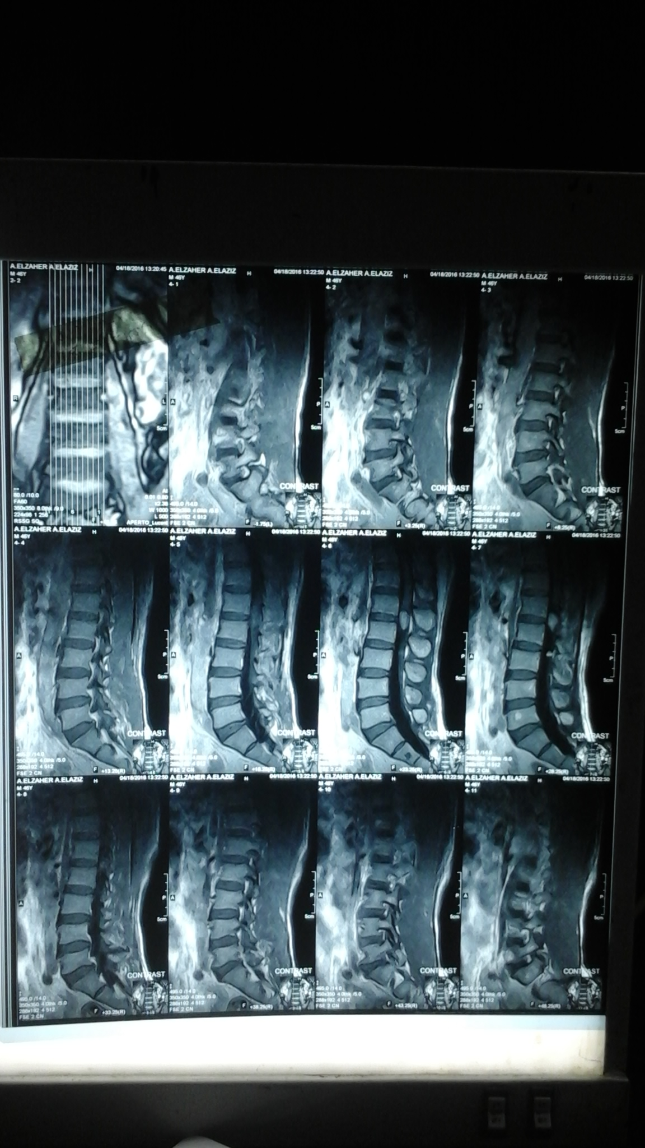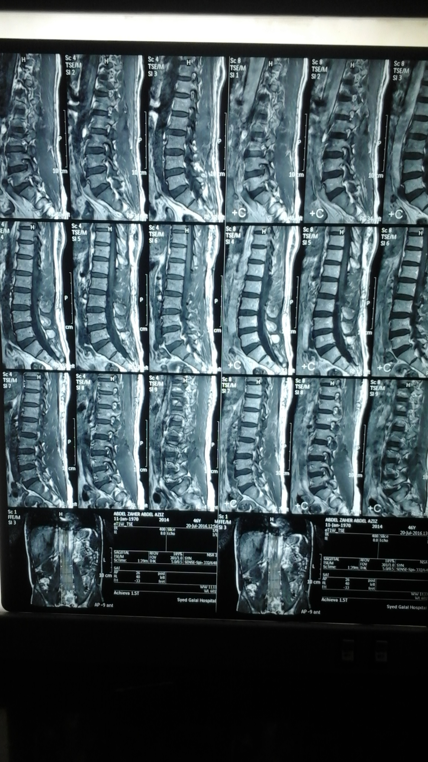

(a) (b)

**Figure (1)**: MRI lumbar and lower dorsal spine T1-weighted images with contrast showing (a) conus mass showing homogenous enhancement and (b) post operative image showing complete resection of the tumor.

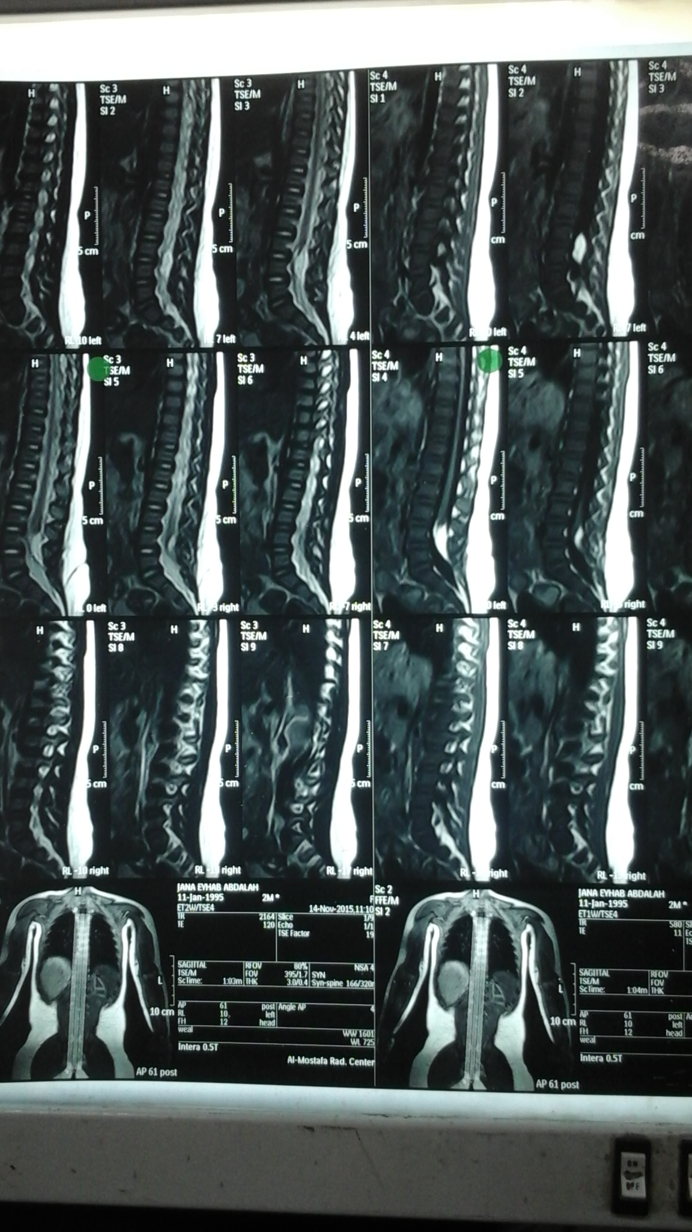

**Figure (2)**: MRI lumbar and lower dorsal spine T1-weighted images without contrast showing hyperintense space occupying lesion at L4 and L5 vertebrae with cord tethering.

**Table 2**: Symptoms of conus and epiconus mass at time of diagnosis:

|  |  |  |
| --- | --- | --- |
| **Symptoms** | **Cases** | |
| **Number** | **Percent** |
| **Lower limb pain and weakness** | 12 | 60% |
| **Sphincteric disturbance** | 12 | 60% |
| **Gait affection** | 6 | 30% |
| **Sensory affection** | 8 | 40% |

**4. Discussion**

Subramonian et al. (3), Bradley and Conway (14), Fletcher and Bradley (15) stated that normal micturition is a complex neurophysiological event that is dependent on a variety of integrated neuronal pathways connecting the cerebral cortex, brain stem nuclei in the pons, and the sacral spinal cord. They also enumerated that the centers for volitional control of voiding are located in the cerebral cortex and therefore, pathological entities that affect this area of the brain should theoretically result in an overactive bladder, that is DO with loss of voluntary control (3,14,15). Reflex detrusor activity is dependent on the integrity of the sacral micturition reflex arc.

Our understanding of the overall neural control of micturition can only be advanced if objective assessment of detrusor sphincter dysfunction is combined with accurate neurologic diagnosis maintaining a careful distinction between observed functional derangements and our concepts of the mechanisms involved.

Past classification systems and terminologies used to define neurogenic bladder dysfunction have usually been based on the site and degree of neurologic damage. As urodynamic techniques are no longer regarded as merely a research tool in the investigation of patients with neurogenic bladder dysfunction, the pendulum now appears to be swinging away from such an approach and attention is being focused on the actual detrusor and/or sphincter dysfunction, regardless of the site and degree of neurologic damage. However, the findings of urodynamic studies can be influenced by various factors like UTI, stones etc. We administered appropriate antibiotics to all the individuals suffering from UTI until the final urine was sterile. Medications known to interfere with urodynamic results were stopped for adequate time before carrying out the urodynamic evaluation. Neurological and urodynamic evaluation can help to objectively define the neurologic deficit of the bladder. Patients with severe spasticity in the lower extremities, invariably, also present with a spastic pelvic floor and external urethral sphincter along with severe detrusor sphincter dyssynergia. Understanding of the basic neurologic lesion and bladder dysfunction is vital to bladder retraining or transurethral surgery to provide adequate voiding.

A poorly compliant bladder distends with high intravesical pressure at relatively low volumes, and may lead to vesicoureteral reflux and places the upper urinary tract at even greater risk for deterioration, as has been explained by Weld et al. (16), Hackler et al. (17), and McGurie et al. (18). Samson et al. (12) said that a highly compliant bladder is associated with hyporeflexive or areflexive bladder as seen in lower motor neuron injuries, But our findings do not match with the findings of Weld and Dmochowski, who demonstrated a higher frequency of impaired compliance in the sacral injury group, which can be explained on the basis of a relatively smaller sample size in our study (7). Hackler et al. (17) and McGurie et al. (18) have correlated low bladder compliance with upper tract complications and decreased upper tract function. A poorly compliant bladder increases the ureteral workload and compromises upper tract drainage. High detrusor leak point pressures are known to correlate with low bladder compliance as noted by Ghoniem et al. (10) in their study. All complications of untreated external detrusor sphincter dyssynergia result from high intravesical pressure prior to urinary leakage. As is recommended by McGurie et al. (18) the pressure must be < 40 cmH2O in a neurogenic bladderto minimize upper tract damage.

Weld and Dmochowski (7) and Kaplan et al. (9) concluded that detrusor sphincter dyssynergia is a common occurrence in supra sacral spinal cord lesions. It is clinically characterized by high detrusor pressure, vesicoureteral reflux, and upper tract deterioration (19). Arnold et al. (20) reported that all patients with supranuclear injury developed features of detrusor-external sphincter dyssynergia. However, most individuals with lesion had higher detrusor pressures. Other authors have noted that detrusor areflexia may occur with upper motor neuron lesions, presumably due to a coexistent clinical or subclinical spinal cord lesion.

Most of the patients with conus and epiconus lesions in our study had complete lesions (60%). In fact, in our series, these patients with conus and epiconus lesions had either DO or detrusor sphincter dyssynergia and negative sacral cord signs except 8 patients who had normal bladder function. Patients with mixed cord lesions or simultaneous thoraco-lumbar injury have less predictable voiding dysfunction, as noted by Yalla and Andriole (21).

Wyndaele (8) in their study of 92 ptients with spinal cord injury concluded that clinical examination for detailed diagnosis of neurological bladder is insufficient and urodynamic tests are needed for a profound evaluation of the function of different parts of lower urinary tract. Although the majority of patients demonstrated consistent bladder and sphincter behavior based on the neurologic deficit, this is by no means absolute. In addition, the presence or absence of abnormalities on the neurourological examination was helpful but not always predictive. Thus, one should be wary of predicting urological dysfunction based solely on neurological injury. Thorough attempts to evaluate bladder and sphincter behavior should be done before appropriate therapy is instituted.

**Conclusion**

Urodynamic study is of the same clinical importance as EMG and nerve conduction studies in carpal tunnel syndrome. Bladder function improved after conus and epiconus mass lesion excision. Inferences from neurologic examination may be incorrect because of the superimposed complexity of multiple injury levels. Despite consistent data regarding classic voiding dysfunction with conus and epiconus mass lesions, therefore, urodynamic evaluation is crucial to correctly identify the type of voiding dysfunction and to optimize long-term management.

**References**

1. Lloyd LK, Kuhlemeier KV, Fine PR, Stover SL. Initial bladder management in spinal cord injury: does it make a difference? J Urol 1986;135(3):523-527.
2. De Vivo MJ, Fine PR. Predicting renal calculus occurrence in spinal cord injury patients. Arch Phys Med Rehabil 1986;67(10):722-725.
3. Subramonian K, Cartwright RA, Harnden P, Harrison SC. Bladder cancer in patients with spinal cord injuries. BJU Int 2004;93(6):739-743.
4. Price M, Kottke FJ, Olson ME. Renal function in patients with spinal cord injury: the eighth year of a ten-year continuing study. Arch Phys Med Rehabil 1975;56(2):76-79.
5. Barrett DM, Wein AJ. Voiding dysfunction. Diagnosis, Classification and Management. Gillenwater JY, et al, eds. Adult and Pediatric Urology. 2nd ed. St. Louis, Mo: Mosby Year Book, 1991:1001-1099.
6. Abrams P, Anderson KE, Brubaker L, Cardozo L, Cottenenden A, et al. Evaluation and treatment of urinary incontinence, pelvic organ collapse and fecal incontinence. 3rd International consultation on incontinence: Recommendations of International Scientific Committee; 2005 p. 1589-1630.
7. Weld KJ, Dmochowski RR. Association of level of injury and bladder behavior in patients with post traumatic spinal cord injury. Urology 2000;55(4):490-494.
8. Wyndaele JJ. Correlation between clinical neurological data and urodynamic function in spinal cord injured patients. Spinal Cord 1997;35(4):213-216.
9. Kaplan SA, Chancellor MB, Blaivas JG. Bladder and sphincter behavior in patients with spinal cord lesions. J Urol 1991;146(1):113-117.
10. Ghoniem GM, Roach MB, Lewis VH, Harmon EP. The value of leak pressure and bladder compliance in the urodynamic evaluation of myelomeningocele patients. J Urol 1990;144(6):1440-1442.
11. Abrams P, Cardozo L, Fall M, Griffiths D, Rosier P, Ulmsten U, et al. The standardization of terminology of lower urinary tract function: report from the Standardization Sub-committee of the International Continence Society. Neurol Urodyn 2002;21(2):167-178.
12. Samson G, Cardenas DD. Neurogenic bladder in spinal cord injury. Phys Med Rehabil Clin N Am 2007;18(2):255-274.
13. Griffiths D, Hofner K, van Mastrigt R, Rollema HJ, Spangberg A, Gleason D. Standardization of terminology of lower urinary tract function: pressure flow studies of voiding, urethral resistance and urethral obstruction. Neurol Urodyn 1997;16(1):1-18.
14. Bradley WE, Conway CJ. Bladder representation in the pontine-mesencephalic reticular formation. Exp Neurol 1966;16(3)237-241.
15. Fletcher TF, Bradley WE. Neuroanatomy of the bladder-urethra. J Urol 1978;119(2):153-160.
16. Weld KJ, Graney MJ, Dmochowski RR. Differences in bladder compliance with time and associations of bladder management with compliance in spinal cord injured patients. J Urol 2000;163(4):1228-1233.
17. Hackler RH, Hall MK, Zampieri TA. Bladder hypocompliance in the spinal cord injury population. J Urol 1989;141(6):1390-1393.
18. McGurie EJ, Woodside JR, Borden TA, Weiss RM. Prognostic value of urodynamic testing in myelodysplastic patients. J Urol 1981;126(2):205-209.
19. Perkash I. Detrusor-sphincter dyssynergia and detrusor hyperreflexia leading to hydronephrosis during intermittent catheterization. J Urol 1978;120(5):620-622.
20. Arnold EP, Fukui J, Anthony A, Utley WL. Bladder function following spinal cord injury: a urodynamic analysis of the outcome. Br J Urol 1984;56(2):172-177.
21. Yalla SV, Andriole GL. Vesicourethral dysfunction following pelvic visceral ablative surgery. J Urol 1984;132(3):503-509.

4/10/2017