Effect of Carvedilol, Silymarin and Combination of Both on Carbon Tetrachloride-Induced Hepatic Toxicity in Rats

Rashad Abd El-Nabi Atlam, Abd El-Rahim Mohamed Abd El-Samad, Hamdy Abdou Mansour and Reda Abd Rabou Fayyad.

Pharmacology Department, Faculty of Medicine for Male, Al-Azhar University (Cairo), Egypt
rasatlam@gmail.com

Abstract: Background: hepatotoxicity is injury to the liver that is associated with impaired liver function caused by exposure to a drug or other chemical agents, such as those used in laboratories, industries and natural chemicals. The most commonly used hepatotoxic model is carbon tetracholoride (CCL4) because it gives the same hepatic changes in animal as in human. Silymarin is an isoflavonoid in origin used in patients suffering from hepatotoxicity as it has different properties that make it hepatoprotective drug. It has antioxidant and anti-inflammatory properties. Carvedilol is one of beta blockers that are used to decrease portal hypertension in cirrhotic patients. Carvedilol has antifibrotic, anti-inflammatory and antioxidant properties. Methods: 50 male albino rats were divided into five groups: group one received normal saline, group two received CCL4, group three received carvedilol and CCL4, group four received Silymarin and CCL4 and group five treated with carvedilol, silymarin and CCL4. After 5 weeks rats were scarified and parameters were measured in serum (AST, ALT, ALP and total bilirubin) in tissue (GSH, MDA and total protein). Liver was used for histopathological examination and assay of the change in tissue parameters.Result: CCL4 treated group showed significant elevation in all liver enzymes, total bilirubin and tissue MDA and significant decrease in GSH, total protein, with significant loss of hepatic architecture. In Silymarin, carvedilol and combination groups there were decrease in liver enzymes, total bilirubin and tissue MDA and increase in GSH, total protein and improvement of necrosis and inflammation in hepatic tissues. Results were more significant in combination group than with Silymarin and with carvedilol respectively. Conclusion: Silymarin has antioxidant and anti-inflammatory properties that showed protection more significant than carvedilol, and the combination of both arvedilol and Silymarin showed more significant results.
[RashadAbd El-NabiAtlam, Abd El-Rahim Mohamed Abd El-Samad, HamdyAbdouMansour and RedaAbdRabou Fayyad.Effect of Carvedilol, Silymarin and Combination of Both on Carbon Tetrachloride-Induced Hepatic Toxicity in Rats. N Y Sci J2017;10(5):19-28]. ISSN 1554-0200 (print); ISSN 2375-723X (online).http://www.sciencepub.net/newyork.5. doi:10.7537/marsnys100517.05.

Key words: CC1₄, silymarin, carvedilol.

1. Introduction
Liver, which is the major organ responsible for biotransformation of drugs, toxic chemicals and byproducts endogenous to the body, is also the primary target for detoxification of many endogenous and exogenous toxic chemicals (Luster et al,2001).
CCL₄ is one of the most widely used hepatic toxins for experimental induction of liver fibrosis and cirrhosis following hepatocellular necrosis in laboratory animals. Besides hepatocellular regeneration and inflammatory infiltration, proliferation of hepatic stellate cells and deposition of connective tissue are major features of liver histopathology (Jiang et al., 1992).
Silymarin is used for treatment of several hepatic disorders (Hakova and Misuruva, 1993) and is mainly indicated for acute and chronic hepatitis, liver cirrhosis, fatty degeneration and toxic metabolic liver disease (feher et al., 1987). silymarin has antioxidant activity (Valenzuela and Garrido ,1994).
Carvedilol treatment alone significantly enhances the antioxidant enzyme activities and glutathione levels and inhibited lipid peroxidation as compared to the control values. These finding support the premise that carvedilol can guard against the sequences of oxidative stress. Hence, the antioxidant properties of carvedilol are involved in its hepatoprotective mechanism. The powerful antioxidant activity of carvedilol has been examined previously in different oxidative stress situations (El–Demerdash , 2006).

2. Material and Methods
Drugs:
1-Carvedilol: 25 mg tablets from MAP (multi-apex pharma; prepared as a suspension using distilled water to a final concentration of 3.6 mg/ml and given in adose of 10 mg/kg, p.o. /day (Hamdy N and El-Demerdash, 2012).
2-Silymarin: (50 mg/5ml) from medical union pharmaceuticals (Abu-Sultan, Ismailia, Egypt). Rats received 50mg/kg, p.o. /day for 5 weeks. (Pradeep K, 2007).
Chemical:
Carbon tetracholoride (CCL₄): Liquid from, Elfaroina Company 153.8 Mr.
Animals:
50 male wistar albino rats (150-200gm) were selected for this study. They were obtained from the animal house, of pharmacology department of Al Azhar University.
Methods:
a-Animal grouping and design of the work:
Animals in this study were randomly divided into five groups each contain ten rats:-
1-Group (1): control normal rats received normal saline (2.78ml/ kg, p.o. /day).
2-Group (2): (CCL₄ intoxicated model): rats received CCL₄ in a dose of 1ml/ kg, p.o., twice weekly for 4 weeks (Mortezaee K .et al 2015).CCL₄ is prepared under surface of corn oil in ratio 1: 1 V/V (Basu, 2003).
3-Group (3): rats received carvedilol (10 mg/kg/day =2.78 ml/ kg, p.o. /day) for 5 weeks (Massart P.et al.1999).Carvedilol administration started one week before CCL₄ administration.
4-Group (4): rats received Silymarin (50mg/kg,p.o./day)for 5 weeks (Pradeep K . et al.2007). Silymarin administration started one week before CCL₄ administration.
5-Group (5):rats received carvedilol (10 mg/kg/day =2.78 ml/ kg, p.o. /day) for 5 weeks and Silymarin (50mg/kg,p.o./day)for 5 weeks. Both were administrated one week before CCL₄ administration.b- Biochemical studies:
Collection of blood samples:
Blood samples will be collected from the retro-orbital venous plexus of rat eye by using heparinized capillary tubes. The collected bloodwill be then centrifugedat 3000 round/minute for 30 minutes. Then the serum will be transferred into clean vials and stored at -18°C for biochemical parameters determinationand the abdomens of the rats will be dissected and the livers will be excised to measure the following parameters:
(A) Biochemical measurements:
1- Serum parameters:liver function tests will be done by measuring Serum alanine amino transferase (ALT), Serum aspartate amino- transferase (AST), Alkaline phosphatase (ALP), totalserum bilirubin.
2- Liver homogenate parameters: Total protein in liver, malondialdehyde in liver and reduced glutathione in liver.
(B) Histopathological study:
To study theprotective effect of the tested drugs on hepatotoxicity; Fixed liver specimens will be embedded in paraffin cubes. Sections of 5–6µm in thickness will be cut and stained with Hematoxylin& Eosin (H&E) and Masson Trichrome (MT) then subjected to photomicroscopic examination.
3. Results
The effects of carvedilol (10mg/kg, p.o. / day) and Silymarin (50 mg/kg, p.o. /day) and combination of both on the levels of liver enzymes (ALT, AST and ALP) and serum total bilirubin: table (1) and figures (1), (2), (3) and (4):
- CCL₄ (group 2) significantly increased serum levels of ALT, AST, ALP and total bilirubin by about (371%, 220%, 1460% and 1790%) respectively compared to control group.
- Carvedilol (group 3) administration showed significant decrease in serum levels of ALT, AST, ALP and total bilirubin by about (45.5%, 57.5%, 88.8% and 45%) respectively compared to CCL4.
- Silymarin (group 4) showed significant decrease in serum levels of ALT, AST, ALP and total bilirubin by about (49.5%, 58.5%, 90.3% and 56.5%) respectively compared to CCL4.
- Carvediloland Silymarin(group 5) combined treatment exhibited more significant decrease in serum levels of ALT, AST, ALP and total bilirubin by about (52%, 60.5%, 90.7% and 62.5%) respectively compared to CCL4.
Table 1: Effects of carvedilol (10mg/kg, p.o. / day) and Silymarin (50 mg/kg, p.o. /day) and combination of both on the levels of liver enzymes (ALT, AST and ALP) and serum total bilirubin:
Parameter  Treatment | ALT (U/ml) | AST (U/ml) | ALP (IU/L) | Serum total bilirubin (mg/ dl)
Saline ¹ | 23.3  ±7.55 | 32.9  ±1.63 | 87.5  ±11.26 | 0.4100  ±0.06
CCL₄² | 109.8 ^{a,b}  ±1.468 | 105.31 ^{a,c,d,e}  ±8.289 | 1365.3 ^{a,c,d,e} ±194..58 | 7.75 ^{a,c,d,e}  ±0.317
CCL₄+ Carvedilol ³ | 59.7 ^{a,b}  ±4.45 | 44.65 ^{b}  ±3.014 | 152.4 ^{b}±11.53 | 4.26 ^{a,b,d,e}  ±0.303
CCL₄+ Silymarin ⁴ | 55.3 ^{a,b}  ±2.43 | 43.62 ^{b}  ±2.52 | 131.8 ^{b}  ±7.47 | 3.38 ^{a,b,c}  ±0.308
CCL₄+  carvedilol  + Silymarin ⁵ | 52.5 ^{a,b}  ±2.27 | 41.7 ^{b}  ±3.112 | 126^{b}  ±7.64 | 2.91^{a,b,c}  ±0.182
Data are presented as means ± SEM.
¹ Control animals received saline (2.78ml/kg/day orally).
²CCL₄ (1 ml/kg b.w., orally) was given twice weekly for 4 consecutive weeks.
³Carvedilol (10 mg/kg/day =2.78 ml kg /day; orally) for 5 weeks, started one week before CCL₄ administration.
⁴ Silymarin (7.5mg/kg,p.o./day)for 5 weeks, started one week before CCL₄ administration.
⁵Carvedilol &Silymarinadapting the same regimen and schedule of treatment as previously mentioned. Rats received Carvedilol &Silymarin continuously for 5 weeks. Both administrated one week before CCL₄ administration.
a: Significantly different from control .
b: Significantly different from CCL₄ treated group.
c: Significantly different from CCL4+carvedilol treated group.
d: Significantly different from CCL4+Silymarin treated group.
e: Significantly different from CCL4+carvedilol+Silymarin treated group.
- Multiple comparisons were accomplished using one way ANOVA followed by Tukey-Kramer as a post-hoc test (P≤ 0.05).

Figure 1: comparison of alanine amino transfrerase (ALT) (u/ml) in different studied groups.

Figure 2: comparison of aspartate amino transfrerase (AST) (u/ml) in different studied groups.

Figure 3: comparison of serum alkaline phosphatase (ALP) (IU/L) in different studied groups.

Figure 4: comparison of serum total bilirubin mg/dl in different studied groups.

The effects of carvedilol (10mg/kg, p.o. / day) and silymarin (50 mg/kg, p.o. /day) and combination of both on the levels of parameters detecting oxidative stress (tissue total protein, GSH and MDA): table (2) and fig (5),(6) and (7):
- CCL₄ (group 2) significantly decreased tissue total protein and tissue GSH by about (61% and 48.5%) respectively and increased tissue MDA by about 32.95% compared to control group.
- Carvedilol (group 3) administration showed significant increase in tissue total protein by about 83% and decrease in tissue MDA by about 33%, but non-significant increase in tissue GSH by about 12% compared to CCL4.

- Silymarin (group 4) showed significant increase in tissue total protein by about 94.5% and decrease in tissue MDA by about 44.5% and non-significant increase in tissue GSH by about 14.7% compared to CCL4.
- Carvediloland silymarin (group 5) combined treatment exhibited more significant increase in tissue total protein by about 79% and tissue GSH by about 16.5% and decrease in MDA by about 50.5% compared to CCL4.

Table 2: Effects of carvedilol (10mg/kg, p.o. / day) and Silymarin (50 mg/kg, p.o. /day) and combination of both on the levels of parameters detecting oxidative stress (tissue total protein, GSH and MDA):
Parameter  Treatment | Tissue total protein (gm/dl) | GSH (mmol/ gm tissue) | MDA (mmol/ gm tissue)
Control ¹ | 6.53  ±0.22 | 191.3  ±9.92 | 125  ±6.49
CCl₄² | 2.53 ^{a,c,d,e}  ±0.31 | 98.6 ^{a,e}  ±9.95 | 282.8^{a,c,d,e}  ±10.94
CCl₄+  Carvedilol ³ | 4.63^{a,b}  ±0.33 | 110.2 ª  ±4.76 | 189.6^{a,b,e}  ±21.56
CCl₄+ Silymarin ⁴ | 4.92^{a,b}  ±0.248 | 113.1 ª  ±3.08 | 157 ^{b}  ±10.42
CCl₄+  carvedilol  + Silymarin ⁵ | 4.99 ^{a,b}  ±0.27 | 114.8^{a,b}  ±2.93 | 140^{b,c}  ±9.31

Data are presented as means ± SEM.

¹ Control animals received saline (2.78ml/kg/day orally).
²CCL₄ (1 ml/kg b.w., orally) was given twice weekly for 4 consecutive weeks.
³Carvedilol (10 mg/kg/day =2.78 ml kg /day; orally) for 5 weeks, started one week before CCL₄ administration.
⁴ Silymarin (7.5mg/kg,p.o./day)for 5 weeks, started one week before CCL₄ administration.
⁵Carvedilol &Silymarinadapting the same regimen and schedule of treatment as previously mentioned. Rats received Carvedilol & Silymarin continuously for 5 weeks. Both administrated one week before CCL₄ administration.

a: Significantly different from control .
b: Significantly different from CCL₄ treated group.
c: Significantly different from CCL4+carvedilol treated group.
d: Significantly different from CCL4+Silymarin treated group.
e: Significantly different from CCL4+carvedilol+Silymarin treated group.

- Multiple comparisons were accomplished using one way ANOVA followed by Tukey-Kramer as a post-hoc test (P≤ 0.05).

Table 5: comparison of tissue total protein (g/dl) in different studied groups.

Figure 6: comparison of (GSH) in (mmol/gm tissue) different studied groups.

Figure 7: comparison of (MDA) in (nmol/gm tissue) different studied groups.
Histopathological findings:
In group 1(receivednormal saline)there was pathological study of section of this group confirmed the clinical serological parameters, showing normal hepatic architecture, normal hepatocytes, normal blood sinusoids and central vein (by H&E) and no excess fibrous tissue (by Mallory triochrome).
In group 2 (received CCL₄) showed diffuse loss of hepatic archticture, vaculated liver cells(ballooning), diffuse inflammatory cell infilteration, congested venulesand cholestasis (by H&E) and showedexcess fibrous tissue (by Mallory trichrome).
In group3 (received carvedilol and CCL₄) showing some pyknosis, little inflammatory cells and preserved hepatic architecture (H&E) andshowing no or mild fibrosis (by Mallory trichrome).
In group4 (received silymarin and CCL₄) showing normal liver architecture and congested hepatic central vein and normal hepatocytes (H&E) andno or mild fibrosis (by Mallory trichrome).
In group5 (received carvedilol, silymarin and CCL₄) showing normal hepatic architecture and hepatocytes and preserved hepatic architecture (H&E) and showing no excess fibrosis (by Mallory trichrome).

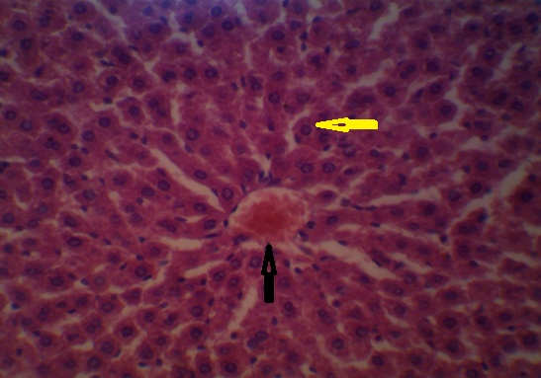
Figure 8:group 1(received normal saline) showing normal liver architecture and hepatocytes (H&E×400). Yellow arrow refers to normal hepatocyte and dark arrow refers to central vein.

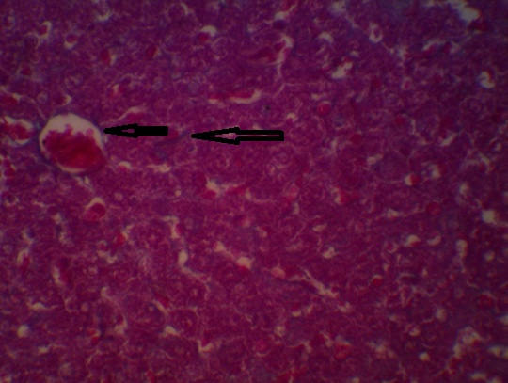
Figure 9:group 1(received normal saline) showing normal collagen fibers (Mallory trichrome x400). Black arrows are directed to fibrous tissue.
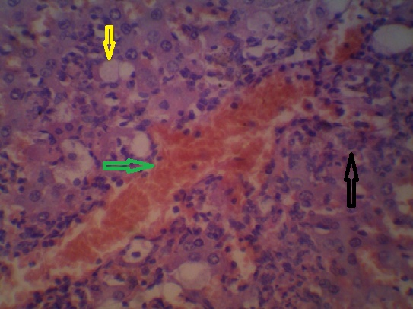
Figure 10: group2 (received CCL₄) showing loss of hepatic archticture, vaculated liver cells (ballooning) (yellow arrows), diffuse inflammatory cell infilteration (black arrows) andcongested venules (green arrows) (H&E×400).

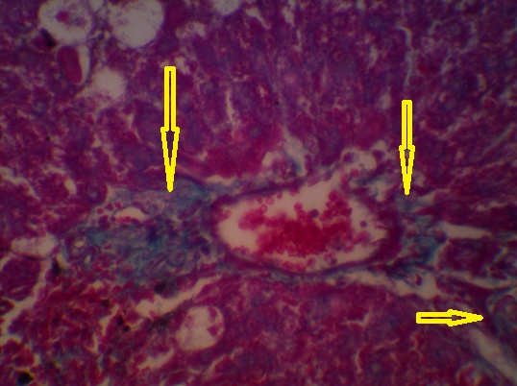
Figure 11: group2 (received CCL₄) showing excess fibrous tissue (yellow arrows(Mallory trichrome x400).

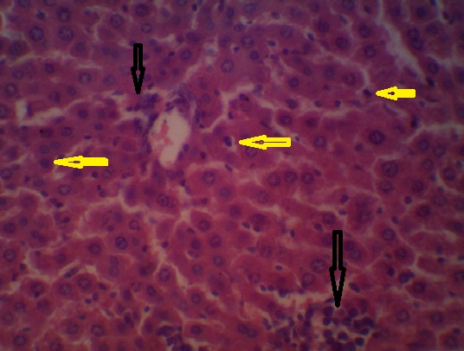
Figure 12: group3 (received carvedilol and CCL₄) showing some pyknosis (yellow arrows), little inflammatory cells (dark arrows) and preserved hepatic architecture (H&E×400).
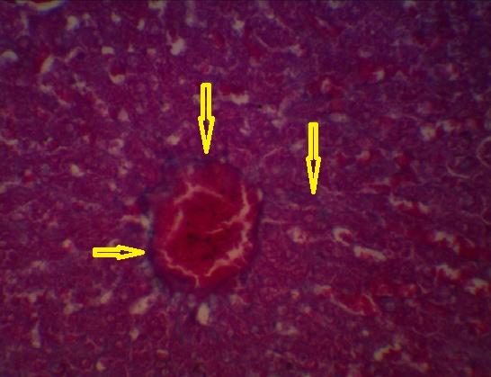
Figure 13: group3 (received carvedilol and CCL₄) showing no or mild fibrosis (yellow arrows (Mallory trichrome x400).
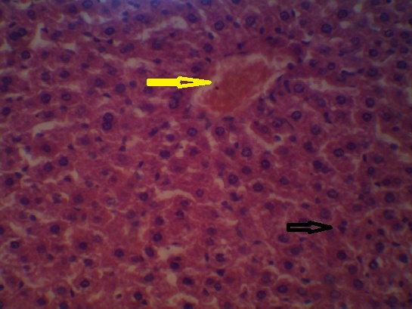
Figure 14: group4 (received Silymarin and CCL₄) showing normal liver architecture, congested hepatic central vein (yellow arrow) and little pyknotic cells (dark arrows) (H&E×400).
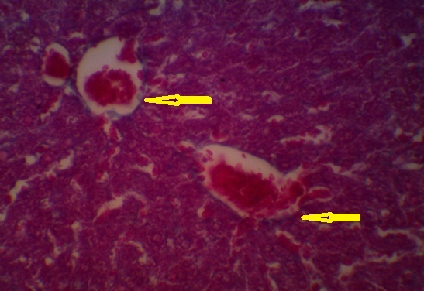
Figure 15: group4 (received Silymarin and CCL₄) showing no or mild fibrosis (yellow arrows) (Mallory trichrome x400).
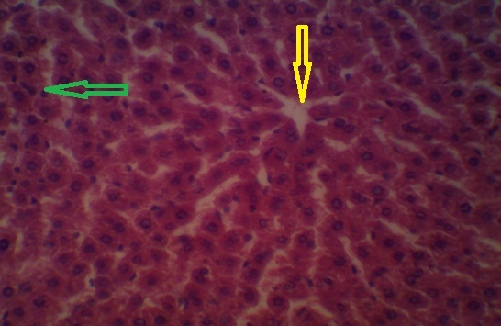
Figure 16: group5 (received carvedilol, Silymarin and CCL₄) showing normal hepatic architecture and hepatocytes, normal central vein (yellow arrow) and little pyknotic cells (green arrow) (H&E×400).
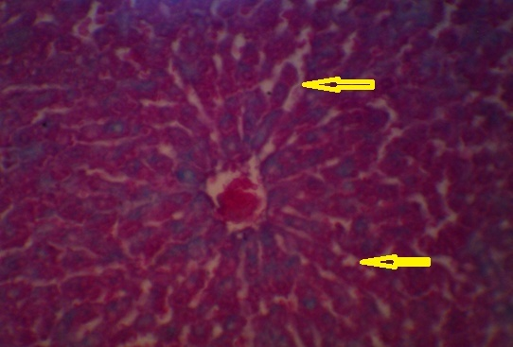
Figure 17: group5 (received carvedilol, Silymarin and CCL₄) showing no fibrosis (yellow arrows) (Mallory trichrome x400).
4. Discussion:
Liver has an important role in detoxification and is a primary target organ for many toxic chemicals and inflammatory processes that participate in a number of pathological (necrosis and fibrosis) conditions. Liver has protective and repair events following exposure to hepatotoxic chemicals and other inflammatory diseases which can affect the liver damage (Mora et al., 2010).
Carbon tetrachloride (CCl₄) is a hepatotoxin, causing liver necrosis, fibrosis and cirrhosis when administered. Lipid peroxidation occurred in carbon tetrachloride administered induced hepatotoxicity. Also covalent binding of the compound to cellular macromolecules may contribute to the damage. Kupffer cells may be involved in the hepatotoxicity of carbon tetrachloride, as a source of cytotoxic factors, such as active oxygen species leading to hepatocellular damage (Mora et al., 2010).
Many natural and artificial agents possessing anti-oxidative properties have been proposed to prevent and treat hepatopathies induced by oxidative stress. There is increasing evidence for the hepatoprotective role of flavonoids, from some herbs as (Silymarin) possess a wide range of anti-oxidant properties in vitro, such as inhibition of lipid peroxidation, Flavonoids inhibit the cytochrome P450 enzymes and are also known to reduce the hepatotoxicity of carbon tetrachloride (Kumarappan et al.,2010).
Carvedilol is beta blocker drug, possess both ROS-scavenging and ROS-suppressive effects and its use is associated with reduction in oxidative stress that is cardinal in the pathogenesis of hepatotoxicity. The anti-oxidant and anti-fibrotic effects of carvedilol were used to protect against carbon tetracholoride induced hepatotoxicity (Hamdy and El-demerdash, 2012).
In the present study, control group received normal saline for five weeks, showed no changes in parameters levels. In histopathological examination there was no change in normal liver pattern, no inflammation, any necrosis or fatty changes.
Carbon tetrachloride (CCL₄) is a common model used to induce hepatotoxicity used in the experimental study of liver diseases (Shenoy et al., 2001). This intoxication results in the stimulation of lipid peroxidation and the production of free radicals (Basu, 2003) which causes necrosis of hepatocytes, induces inflammation, and promotes the progression of hepatic fibrogenesis(Fu et al., 2008).
In the present study, CCL₄ significantly elevated levels of plasma ALT, AST, ALP and bilirubin. Decrease in the total tissue protein content was recorded following CCL₄ treatment. Increase in plasma level of ALP in CCL₄ treated rats could be due to its increased synthesis in presence of elevated biliary pressure and subsequent increase in bilirubin, and these results agree with that obtained by Moreiraet al., (2014) who tested the protective effect of bixin on carbon tetrachloride-induced hepatotoxicity in rats and CCL₄showed marked elevation in ALT, AST and reduced GSH significantly.
Liver sections of CCL₄ treated rats were characterized by significant intracellular lipid accumulation, ballooning of hepatocytes, infiltration with inflammatory cells and hepatocyte necrosis. These histopathological changes agree with previous reports on CCL₄ induced hepatotoxicity (Moreiraet al., 2014).
There is decrease in tissue reduced glutathione in CCL₄ treated rats and increase in tissue malondialdehyde. The impairment in the liver function markers was coincided with a significant increase in the liver lipid peroxidation products, as malondialdehyde (MDA) and a decrease in their reduced glutathione (GSH) and these results agree with El-Maddawy and Gad (2012), whom studied the hepato-renal protection of Silymarin against CCL₄ in comparison with vitamin E in rats. Their results showed that CCL₄ significantly increased serum ALT, AST, ALP and tissue MDA and significantly decreased tissue GSH.
The serum levels of (ALT and AST) reflect the physiological state of the liver. They are changed according to the distorsion of liver, resulting from cellular injury of the organ caused by toxic metabolites and diseases (Patrick-Iwunanyanwe et al., 2007).
Results of the present study indicated that CCL₄ caused an increase in serum levels of the diagnostic enzymes (ALT and AST) in rats that received CCL₄ as compared to the control group. Such elevation suggests that toxication was able to reach the liver and induce a detectable damage, as previously reported by Hukkeri et al., (2002)who proved the elevation in the plasma level of cytoplasmic and mitochondrial enzymes due to liver injury induced by CCL₄. This elevation could potentially be attributed to the release of these enzymes from the cytoplasm into the blood circulation after rupture of the plasma membrane and cellular damage (Shaarawy et al., 2009).
Carvedilolis a nonselective beta-blocker with potent antioxidant and free radical scavenging properties that is used in the treatment of portal hypertension.
In the present study, treatment of rats with carvedilol started one week before CCl₄ administration. It was found that carvedilol significantly counteracted the hepatotoxic effect of CCL₄ as indicated by significant decrease of serum levels of (AST, ALT, ALP and total bilirubin) compared to CCL₄intoxicated group and these results agree with that obtained by Araújo Júnior RFd., et al 2016, who found that carvedilol treatment (5 mg/kg) during the alcohol exposure protocol was associated with reduced AST, ALT, MDA, and GSH. They explained the hepato-protective effect of carvedilol by that, carvedilol can reduce the oxidative stress, inflammatory response and fibrosis in ethanol-induced liver injury in a rat model by down-regulating signaling of Kuppfer cells and hepatic stellate cells (HSCs) through suppression of inflammatory cytokines.
These results agree also with that obtained byHamdy and El-demerdash, (2012) who co-treated rats with carvedilol(10mg/kg, orally) daily for 6weeksafter CCL₄ induction of chronic hepatotoxicity fortwo weeks to toAntifibrotic effects of carvedilol in chronic carbon tetrachloride-induced liver damageand found that treatment of animals with carvedilol significantly counteracted the changes in liver function and histopathological lesions induced by CCL₄. Also, carvedilol significantly counteracted lipid peroxidation, GSH depletion, and reduction in antioxidant enzyme activities; glutathione-S-transferase and catalase that was induced by CCL₄. In addition, carvedilol ameliorated the inflammation induced by CCL₄as indicated by reducing the serum level of acute phase protein marker.
Also these results agree with Anuradha, and Krishnamoorthy,2012, who used carvedilol(5 mg/kg b.wt/ day) to detetectif carvedilol can ameliorate the hepatotoxicity induced by lead acetate and found that carvedilol decreased AST, ALT, ALP, total bilirubin and increased total protein.
These results disagree withIbrahim., et al 2010, whom studied themodulating effect of carvedilol on doxorubicin-Induced cardiomyopathy and hepatic damage using carvedilol 1mg/kg 7 times over a period of 4 weeks including a dose before doxorubicin 1st dose and found that serum ALT was significantly increased and histopathological findings showed more liver damage than control group and doxorubicin group.
There are many differences between this study and our study including the use of doxorubicin instead of CCL₄, carvedilol dose was 1mg/ kg 7 times over aperiod of 4 weeks instead of 10 mg/ kg every day for 5 weeks in our study, also they gave a single dose of carvedilol before doxorubicin and we gave seven doses of carvedilol before CCL₄ and their research was mainly to study the cardioprotective effect of carvedilol against doxorubicin.
Reactive oxygen species (ROS) are implicated in the pathogenesis of most liver diseases, including ischemia/reperfusion injury, endotoxemia, chronic hepatitis C, alcoholic and non-alcoholic fatty liver disease and cholestasis (Rost et al.,2007).
In the present study, carvedilol co-treatment with CCL₄treated group non-significantly counteracted the GSH depletion and significantly counteracted increase MDA level induced by CCL₄that agree with Hamdy and El-demerdash, (2012). And there is also significant increase in total protein study which agrees with that obtained by Anuradha and KrishnamoorthyP, (2012).
The powerful antioxidant activity of carvedilol has been examined previously in different oxidative stress situations (EI-Demeerdash, 2006; Arozal et al., 2010).
Carvedilol therapeutic actions could not be fully explained by adrenoreceptor blockade. Numerous studies have provided evidence that carvedilol has various other properties including antioxidant action, calcium channel antagonism, anti-inflammatory actions (Romeo et al., 2000; Kalinowski et al., 2003; Bellenger et al., 2004; Kostka and Tykarskia, 2009).
Histopathological study of this group confirmed these results, showing some pyknosis, little inflammatory cells and preserved hepatic architecture (H&E) andshowing no or mild fibrosis (by Mallory trichrome).
Silymarinoffers good protection in various toxic models of experimental liver diseases in laboratory animals. It acts as an antioxidative, antilipid peroxidation (Hubert et al, 2011), antifibrotic, anti-inflammatory, membrane stabilizing and immunomodulatory(Pradhan and Girish, 2006).
In the present study Silymarin treatment, started one week before CCL₄ administration showed marked protective properties. There is decrease in (AST, ALT and ALP) also decrease in total bilirubin with CCL₄ treated group than CCL₄ treated rats alone and these results agree with Freitag et al., (2015) who studied the ameliorationof carbon tetrachloride induced hepatotoxicity in rat by tanarize feronia limonia, Silymarin showed decrease in serum levels of AST, ALT and ALP and had many antioxidant properities. This hepatoprotective effect of Silymarin is due to membrane stabilizing action, free radicals scavenging properties, inhibition of lipid peroxidation and modulation of hepatocyte Ca++ (Flora et al., 1998; Farghali et al., 2000).
In the present work, Administration of Silymarin significantly reduced the activity of liver enzymes in CCL₄ induced rats, a finding which agree with those shown before by Pradeep et al., (2007)and are almost definitely suggestive of protection of the structural integrity of the hepatocytes membrane or regeneration of damaged liver cells by test samples (Patrick-Iwuanyanwu et al.,2007).
Administration of Silymarin to CCL₄ treated rats was significantly able to reduce the activities to liver enzymes, liver MDA levels and to increase their GSH levels non-significantly and total protein significantly and these results agree with that obtained by Elmaddawy and Gad, (2012), whom studied the hepato-renal protection of Silymarin against CCL₄ in comparison with vitamin E in rats. They used Silymarine 10mg/ 100 g b.w. p.oand found asignificant decrease in serum ALT, AST, ALP activities and liver GSH and significant decrease in liver MDA in Silymarin treated group.
The elevated level of GSH in liver with Silymarin protects cellular proteins against oxidation through glutathione redox cycle and also directly detoxifies reactive oxygen species and/or neutralizes reactive intermediate species generated from exposure to CCL₄ (Gupta and Singh, 2007).
In comparison between rats treated with Silymarin and CCL₄ and rats co-treated with carvedilol and CCL₄, both groups gave good results in protection of liver. There were non-significant changes in measuring (ALT, AST, ALP, tissue reduced glutathione, tissue MDA and total protein) but there was significant increase in serum total protein in Silymarin group than carvedilol group.
In the present study, Silymarin showed more significantresults in decreasing (serum AST, ALT, ALP, total bilirubinand tissue MDA) and increasing tissue GSH and total protein in comparison with carvedilol group as Silymarin is a standard drug that showed the prominent protection of liver and these results agree with Ghosh et al., (2016)who studied the protective effect Silymarin on the kidney and the liver againist thioacetamide induced toxicity and showed significant decrease in srum level of ALT, AST and ALP and elevated GSH level.
Histopathological findings of this group confirmed these results, showing normal liver architecture, congested hepatic central vein, normal hepatocytes (H&E) andno or mild fibrosis (by Mallory trichrome).
In the present study, treatment with Silymarin and carvedilol for 5 weeks started one week before CCL₄ administration significantly counteracted the hepatotoxic effect of CCL₄. There is decrease in (AST, ALT and ALP), also decrease in total bilirubin when compared with CCL₄ treated group, carvedilol treated group alone and Silymarin treated group alone.
Administration of carvedilol and Silymarin to CCL₄ treated group was significantly able to reduce the activities of liver enzymes, liver MDA levels and increased significantly GSH levels and total protein more than carvidelol treated group alone and Silymarin treated group alone.
Histopathological study of this group confirmed these results, showed normal hepatic architecture and hepatocytes and preserved hepatic architecture (H&E) and showed no excess fibrosis (by Mallory trichrome).
So, as a conclusion, Silymarin which is herbal in origin, showed more significant results than carvedilol but these results also indicated that carvedilol had good role in hepatoprotection that antagonized CCL₄ induced hepatotoxicity. The treatment using Silymarin and carvedilol gave more significant results than the treatment using only one of them.

References
- Anuradha Rand Krishnamoorthy P (2012): Impact of pongamiapinnata extract on Lead acetate mediated Toxicity in Rat Liver. InternaJ of Pharm Tech Resea 4(2): 878- 882.
- Araújo Júnior RFd,Garcia VB,Leitão RF DC, BritoGAdC and MiguelEd C (2016): Carvedilol Improves Inflammatory Response, Oxidative Stress and Fibrosis in the Alcohol-Induced Liver Injury in Rats by Regulating Kuppfer Cells and Hepatic Stellate Cells. PLOS ONE 11(2): e0148868.
- Arozal W, Watanabe K, Veeraveedu P T, Ma M, Thandavarayan R A, Sunkumaran V, Suzuki K, Kodama M and Aizawa Y (2010): Protective effect of carvedilol on daunorubicin – induced cardiotoxicity and nephrotoxicity in rats.Toxicol.247 (1-3):18–26.
- Bellwnger N G, Rajappan K, Rahman S L, Lahiri A, Raval U, Webster J, MurraryGD, Costs A j, Cleland J G and Pennell DJ(2004): Effects of carvedilol on left ventricular remodeling in chronic stable heart failure: a cardiovascular mangnetic resonance study. Heart 90: 760 -764.
- Desai SN, Patel DK, Devlar RV, Patel PV and Ramachandran AV (2012): Hepatoprotectivepo-tential of polyphenol rich extract Of Mur-rayakoenigii L.: an in vivo study. Food ChemToxicol. 50:310-314.
- EL-Demerdash E (2006): Evidences for prevention of nitroglycer in tolerance by carvedilol. Pharmacol Res. 53:380-385.
- El-MaddawyZKand GadShB(2012):Hepato-Renal Protection ofSilymarin in Comparison with Vitarmin E in Rats. Global J of Pharmacol. 6 (3): 236-244.
- Farghali H, Kamenikova L, Hynie S and Kmonickova E (2000):Silymarin effects on intracellular calcium and cytotoxicity: a study in perfused rat hepatocytes after oxidative stress injury. Pharmacol Res 41: 231-237.
- Feher J.,Csomos G.&Vereckei A(1987):Free Radical Reactionsin Medicine, Springer-Verlag, Berlin, NewYork.
- Ferreira EA, Gris FF,Felipe KB, Correia J FG,Ferreira EC and Filho DW (2010): Potent hepatoprotective effect in CC14-induced hepatic injury in mice of phloroacetophe-none from Myrciamultiflora. Libyan J Med. 5:4891.
- Firdous SM, Sravanthi K, Debnath R and Neeraja K (2012):Protective effect of ethanolic extract and its ethylacetate and n-butanol fractions of Sechiumedule fruits against carbon tetrachloride induced hepatic injury in rats. Int J Pharm Pharmaceut Sci.4:354-9.
- Flora, S, (2007): Role of free radicals and antioxidantin health and disease. Cell Mol. Biol., (53): 1-2.
- Freitag,, Gabriel et al., (2015): Hepatoprotective Effect of Silymarin (Silybum marianum) on Hepatotoxicity Induced by Acetaminophen in Spontaneously Hypertensive Rats. Evid Based Complement Alternat Med. 538317.
- Fu Y S, Zheng J, Lin J, Ryerse and Chen A (2008): Curcumin protectsthe rat liver from CC14-caused injury and fibrogenesis by attenuating oxidative stress and suppressing inflammation. MolPharmacol. 73(2): 399-409.
- Ghosh S, Sarkar A, Bhattacharyya S and Sil PC (2016): Silymarin Protects Mouse Liver and Kidney from Thioacetamide Induced Toxicity by Scavenging Reactive Oxygen Species and Activating PI3K-Akt Pathway. Front Pharmacol; 7: 481.
- Gupta RS and SinghD (2007): Hepatomodulatoryrole of Enicostemmalittoral Blume against oxidative stress induced liver injury in rats. Afric J of AgriculResea. 2(4):131-138.
- Hakova, H. and Misurova, E. (1993): The effect of silymarine and gamma radiation on nucleic acids in rat organs. J. Pharmacol., 45:910-912.
- Halim AB, EI Ahmady O, HassabAllah S, AbdelGalil F,HafezYandDarwish A (1997): Bio-chemical effect of antioxidants on lipids and liver function in experimentally – induced liver damage. Ann ClinBiochem.34: 656- 663.
- Hamdy N and EI-Demerdash E (2012): Newtherapeuticaspectforcarvedilol: Antifibrotic effects of carvedilol in chronic carbon Tetrachloride – induced liver damage. Toxicol and App pharmaco 261: 292-299.
- Hubert JD, Rodrigue TK,NgemeniPD, AngeleNT, DanielaB, Bomaventure TN, Paul FM and Fulvio M (2011): Ficuscordata thumb(maraceae )is aptential source of some hepatoprtective and antioxidant compounds. Pharmacologia.2 (5): 137 - 145.
- Hurkkeri VI, Jaiprakash B, Lavhale MS, Karadi RV and Kuppast IJ(2002): Hepatoprotective activity of Anthus Excelsa Roxb. Leaf extract on experimental liver damage in rats. J pharmacogn. 11: 120-128.
- Ibrahim SS, Maged A. BarakatandHelmyHS(2010): ModulatingEffect of Carvedilol on Doxorubicin-Induced Cardiomyopathy and Hepatic Damage. Journal of American Science.6(12): 20-26.
- Jain M,RakheeK,RavirajisinhN, MenakaC T,RanjitsinhVD,Mishar SH (2010): Amelioration of carbon tetrachloride induced hepatotoxicity in rat by tanarizeferonialimonia. linn leaf extracts. Excli J.11:250-259.
- Jiang Z, You DY, Chen XC and Wu J (1992):Monitoring of serummarkers of fibrosis during CCl₄-induced liver damage. Effects ofantifibrotic agent. J Hepatol 16: 282-289, 1992.
- Kalinowski L, DobruckiI W,Szezepanska K, Jankowski M, Martyniec L, Angielski S and Malinski T (2003): Third-generation beta-blockers stimulate nitric oxide release from endothelial cells through ATP efflux:a novel mech for antihypert action Circul. 107:2747-2752.
- Kim SH, Yang YP, Sung SH, Kim CJ, Kim JW and KimYC(2003):hepatoprtective of dibenzylbuyrolactoneligans of Torreyanucifera against CC14- induced toxicity in primary cultured rat hepatocytes. BiolPharmacol Bulletin.26 (8):1202-1205.
- Kostka J and Tykarskia (2009): Carvedilol.Thelibraryof the Arterialhypertension. Jof the Polish socie of Hyperten. 1:1-50.
- Kumarappan CT, Vhand BS, Mandal SC and SengottuvelT(2010):Hepatoprotective effect of the poly phenolic extract from ichnocarpus fruits scens leaves. Deccan J pharma.1(1).
- Luster MI, Simenova PP, Gallucci RM, BruccoleriABlazka ME andYcesoy B (2001): Roleof inflammationinchemical – inducedhepatotoxicity. Toxicol. Lett. 120, 137-321.
- MassartP, DonckierJ, KyselovicJ, GodfraindT,HeyndrickxGRandWibo M (1999): Carvedilol and lacidipine prevent carvedilol hypertrophy and endothelin-1 gene overexpression after arotic banding. Hyperten. 34:1197-1201.
- Mora J, Roy S, Kamal R and Muthyala P (2010): Protectiveeffect ofresveratrol against carbon tetracholoride induced oxidative stress in rat liver. Deccan J of pharma. 1(2).
- Moreira P R, Maioli MA, Medeiros HCD, Guelfi M, Pereira FTV and Mingatto FE (2014): Protective effect of bixin on carbon tetrachloride-induced hepatotoxicity in rats. Biological Research. 47-49.
- Patrick-Iwuanyanwu KC, Wegwu MO and AyaloguEO (2007):Prevention of CC14-induced liver damage by ginger, garlic and vitamin E. Pak JBiol Sci. 15,10 (4):617-621.
- PrabhuV, ChidambaranathanN, NaliniG, VenkataramanS,Jayaparkash S. and Nagarajan M (2010): Evaluation of anti-fibrotic effect of Lagerstroemia Speciosa (L) pers. On carbon tetrachloride induced liver fibrosis. Current pharma research Vol. 1, Issue 1.
- Pradeep K, Mohan CV, Gobianand K and Karthikeyan S(2007):Silymarin modulates the oxidantantioxidant imbalance during dirthylnitrosamine induced oxidative stress in rats, Eur J pharmacol. 10, 560 (2-3): 110-116.
- PradhanSCandGirishC(2006): Hepatoprotectiveherbal drug, silymarin from experimental pharmacology to clinical medicine. Indian J med Res. 124: 491 – 504.
- Recknagel RO, Glends EA, Dolack JA and Walter RL (1992):Mechanism of carbon tetrachloride toxicity. pharmacolTherap. 43: 139 – 154.
- Romeo F, LiD, Shimand MehtaJL (2000): Carvedilol prevent sepinephrine-induced apoptosis in human coronary artery endothelial cells: modulation of Fas/Fas ligand and caspase-3 pathway. Cardiovase Res. 45:788-794.
- Rost D, WelkerA,Welker J, MillonigG,BergerI, AutschbachF,Schuppan D and Mueller S (2007): Liver-homing of purified Glucose oxidase: A novel in model of physiological hepatic oxidative stress (H2O2). J of Hepat. 46:482-491.
- Sarkar D, Sarkar BR, Mohanty JP, Bhyan NR and Halder R (2011):Study the biochemical parameters and histopathological changes in liver of albino rats to find out the effect of methanolic extract of mimosa pudica leaves against paracetamol induced hepatic damages. Pharma research J/6(1):50-57.
- Shaarawy SM, Tohamy AA, Elgendy SM, Elmageed ZY Bahnasy A, Mohamed MS, Kandil E and Matrougui K (2009): Protective effects of garlic and silymarin on NDED-induced rats hepatotoxicity. Int J Biol Sci. 11, 5 (6): 549-557.
- Shenoy KA, SomayajiSN and BairyKL(2001): Hepatoprotectiveeffects of Ginkgo Biloba against tetrachloride induced hepatic injury in rats. IND J Pharmacol. 33: 260-266.
- ValenzuelaA. andGarrido, A(1994):Biochemical basesonthe pharmacological action on the flavonoids silymarin and of its structural isomer silibinin. Biol. Res. 27: 105-112.

4/10/2017

