**Outcome of Endovascular Treatment of Cerebral Aneurysms Using Balloon Assisted Coiling and Stent Assisted Coiling Techniques**

Sayed El Zayat1, Randall Edgell2, Hassan Gad3, Khaled Sobh3, Hossam Emam3, Ahmed Sarhan4

Professor of Neurology - Faculty of Medicine - Al-Azhar University, Egypt1

Associate professor of Neurology - Director of Interventional Neurology Program - Saint Louis University, USA 2

Assistant Professor of Neurology - Faculty of Medicine - Al-Azhar University, Egypt1 3

Assistant Lecturer of Neurology - Faculty of Medicine - Al-Azhar University, Egypt1 4

[ahmedssarhan@hotmail.com](mailto:ahmedssarhan@hotmail.com)

**Abstract**: **Background:** Balloon-Assisted Coiling (BAC) and Stent-Assisted Coiling (SAC) are well-established coiling techniques used for endovascular treatment of wide-necked cerebral aneurysms. The aim of this study is to assess the long-term clinical and angiographic outcomes of aneurysms treated with balloon-assisted coiling or stent-assisted coiling. **Introduction:** Ruptured and unruptured aneurysms should be treated preventively. Coil embolization of cerebral aneurysms is now generally accepted. BAC involves placement of a suitably sized compliant balloon across the aneurysm neck during coil deployment. SAC is also a logical solution to the problem of retaining coils in sessile wide-necked aneurysms. Complete occlusion rates were better achieved using SAC or BAC techniques with slightly higher risk when using the Balloon. **Materials and methods**: To detect the efficacy of interventional endovascular management of wide-necked cerebral aneurysms using BAC and SAC techniques, we performed a prospective study for patients with wide-necked cerebral aneurysms who were treated with BAC and SAC. Study included 24 subjects, 16 were treated with BAC while the other 8 were treated with SAC. Clinical and radiologic grading for ruptured cases were assessed by Hunt and Hess scale (HHS) and modified Fisher score (mFS) respectively, Raymond and Roy Occlusion classification (RROC) were used to assess the post-coiling occlusion rates while modified Rankin score (mRS) was used to assess long-term clinical outcomes. **Results**: Incidence of wide-necked cerebral aneurysms was higher in females. Patients included had presented with either ruptured aneurysm (37.5%), or discovered accidentally (62.5%). 2 patients had HHS-1, 3 had HHS-2, 3 had HHS-3, one had HHS-4 for those presented with SAH. Of which, 6 patients scored 3, while 3 patients scored 4 on mFS. RROC-I was achieved in 19 patients, RROC-II in 4 patients and RROC-III in 1 patient. mRS and RROC were better in SAC group than BAC group. **Conclusion:** This study demonstrates the relative safety, efficacy and long-term favorable outcomes of both BAC and SAC techniques for endovascular treatment of wide-necked with superiority of SAC in achieving long-term better clinical outcomes, occlusion rates and fewer complications, we recommend SAC technique for treatment of cerebral wide-necked aneurysms. **Recommendations**: Larger studies and Long-term follow up should be encouraged for at up to two years after initial endovascular coiling to better understand the natural history and various endovascular treatment options offered for those with wide-necked cerebral aneurysms.of the wide-necked aneurysm to better assess the residual post-coiling filling.

[Sayed El Zayat, Randall Edgell, Hassan Gad, Khaled Sobh, Hossam Emam, Ahmed Sarhan. **Outcome of Endovascular Treatment of Cerebral Aneurysms Using Balloon Assisted Coiling and Stent Assisted Coiling Techniques.** *N Y Sci J* 2017;10(5):13-18]. ISSN 1554-0200 (print); ISSN 2375-723X (online). <http://www.sciencepub.net/newyork>. 4. doi:[10.7537/marsnys100517.04](http://www.dx.doi.org/10.7537/marsnys100517.04).

**Keywords**: Aneurysm, Coiling, Subarachnoid Hemorrhage, Stent-assisted, Balloon-assisted

**1. Introduction:**

Approximately 2% of adults harbor an unruptured aneurysm, whether incidental or not, it should be treated preventively [1]. The number of patients offered some form of treatment will likely continue to increase with the availability of noninvasive vascular imaging [2]. Improved understanding of the morbidity associated with treatment may help in the counseling of patients and may provide hypotheses for clinical trials [3].Coil embolization after SAH is now generally accepted using endovascular coiling [4]**.** The 2 months’ mortality after SAH was 4.1% compared to 7% in International Subarachnoid Aneurysm Trial (ISAT) in the Hydrogel-coated coils versus bare Platinum coils for the endovascular treatment of intracranial aneurysms (HELPS trial) [5]. Coated coils were introduced to improve the anatomical results of coil embolization, but trials comparing coated and bare platinum coils have shown little or no improvements in the prevention of aneurysm recurrence [6]. Balloon-assisted coiling (BAC) which is also known as ‘remodeling technique’ involves placement of a suitably sized compliant balloon across the aneurysm neck during coil deployment. The balloon is used to retain coils within the aneurysm, compress their profile at the neck (i.e. remodeling) and to be available to arrest blood flow when rupture occurs during embolization [7]. Recent analysis of using BAC has been variously reported that it did not increase the overall procedural risk [8]**.** Controlled trials have reported improvements in the safety of coil embolization, with lower complications rate [4]. Placing a stent in the parent artery is a logical solution to the problem of retaining coils in sessile very wide-necked aneurysms. The introduction of stents sufficiently flexible for intracranial navigation in the 1990s allowed their deployment in cerebral arteries lead to the design and production of stents specifically for intracranial use [9]. Complete occlusion rates with combined stents and coils were 63% good outcomes, 14% poor outcomes and 19% dead, despite that the cohort represents a difficult treatment group. The value of a stent and coil procedure in reducing the risks of recurrence stays superior to other endovascular packing techniques [10].

**2. Materials and Methods:**

This is a prospective study was carried out in endovascular and interventional neurology unit at Saint Louis University hospital to detect the efficacy of interventional endovascular management of wide-necked cerebral aneurysms using BAC and SAC techniques. Twenty-four patients with wide-necked cerebral aneurysms were enrolled either presented by subarachnoid hemorrhage or discovered accidently. Different tools were used for diagnosis including initial CT brain and diagnostic catheter angiograms. **Inclusion criteria** included those with ruptured and un-ruptured wide-necked cerebral Aneurysms with clearly recognized aneurysmal neck separated from the surrounding vessels. **Exclusion Criteria** were Hunt and Hess grade 5 (Hunt and Hess, 1968), patients with renal failure and Patients with known bleeding profile abnormalities.

Study included 24 subjects, 16 were treated with BAC while the other 8 were treated with SAC. Clinical and radiologic grading for ruptured cases were assessed by Hunt and Hess scale (HHS) and modified Fisher score (mFS) respectively, Raymond and Roy Occlusion classification (RROC) were used to assess the post-coiling occlusion rates while modified Rankin score (mRS) was used to assess long-term clinical outcomes. All data were collected and statistically analyzed using Chi-square test using SPSS (Statistical package for social science) software.

**3. Results:**

The present study included 24 patients with wide-necked cerebral aneurysms. The number of females was 17 patients (70.8%), while the male patients were 7 **(table 1).**

**Table (1): Shows number of males and females and their average age**:

|  |  |  |
| --- | --- | --- |
|  | | **n = 24** |
| Sex | Females | 17 (70.8%) |
| Males | 7 (29.2%) |
| Age (yrs) | Mean ± SD | 57.5 ± 12.25 |
| Range | 34 – 82 |

The number of patients who had wide-necked cerebral aneurysms was 24 patients. 9 patients were presented with SAH while in the other 15 patients, wide-necked aneurysms were discovered accidentally **Table (2).**

**Table (2): Shows the numbers and percentages of different aneurysmal presentations among the studied group:**

|  |  |  |
| --- | --- | --- |
| **Groups** | **Number of patients** | **Percentage** |
| Discovered accidentally | 15 | 62.5% |
| Subarachnoid hemorrhage | 9 | 37.5% |
| Total | 24 | 100.0% |

Clinically, Patients who were presented with subarachnoid hemorrhage were classified according to Hunt and Hess score as shown in **Table (3).**

**Table (3): Shows Hunt and Hess scale of the ruptured group:**

|  |  |  |
| --- | --- | --- |
| Hunt and Hess Score | Number of patients | Percentage |
| 1 | 2 | 22.2% |
| 2 | 3 | 33.3% |
| 3 | 3 | 33.3% |
| 4 | 1 | 11.2% |

Radiologically, Patients who were presented with aneurysmal subarachnoid hemorrhage (aSAH) were classified according to modified Fisher score as shown in **Table (4)**

**Table (4): Shows modified Fisher score of the ruptured group:**

|  |  |  |
| --- | --- | --- |
| Modified Fisher Score | Number of patients | Percentage |
| 1 | 0 | 0% |
| 2 | 0 | 0% |
| 3 | 6 | 66.6% |
| 4 | 3 | 33.4% |

**Table (5) shows the need of pre-coiling External Ventricular Drain:**

|  |  |  |
| --- | --- | --- |
| External Ventricular Drain | Number of patients | Percentage |
| Yes | 3 | 33.4% |
| No | 6 | 66.6% |

The need of precoiling External Ventricular Drain was found in 3 patients of those presented with aSAH. **Table (5)**

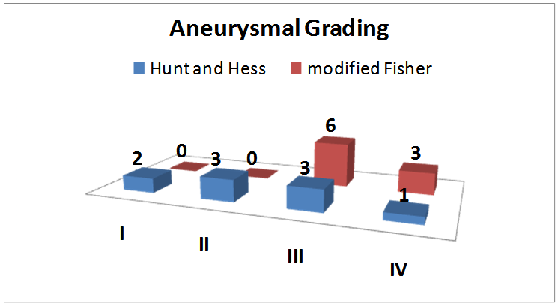

**Figure (1):** **Shows correlation between Hunt and Hess score and modified Fisher Score in patients presented with aSAH:** Showing that most patients had the combination of HH-3 and mFS-3 at the initial presentation.

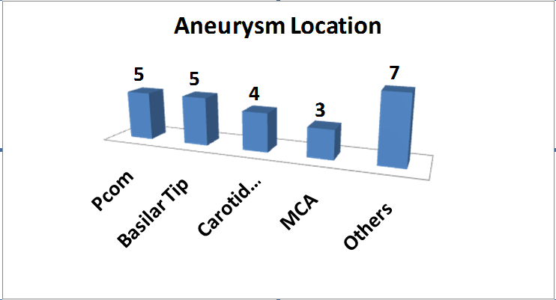

**Figure (2): shows the anatomical locations of the wide-necked cerebral aneurysms.** Wide-necked aneurysms were found in posterior communicating artery in 5 patients, basilar tip in 5 patients, carotid terminus in 5 patients, middle cerebral artery in 3 patients and other locations in 7 patients.

**Figure (3): shows the different shapes of the wide-necked cerebral aneurysms.** Wide-necked aneurysms shapes varied in the studied patients, it was spherical in 14, Complex in 4, Bilobed in 3, Elongated in 2 and Triangular in 1 patient.

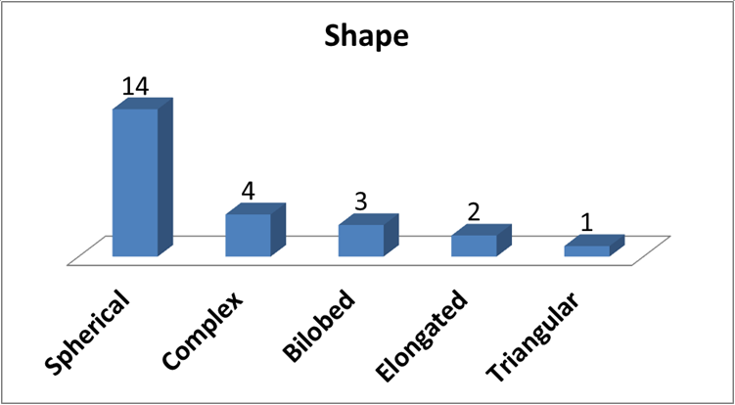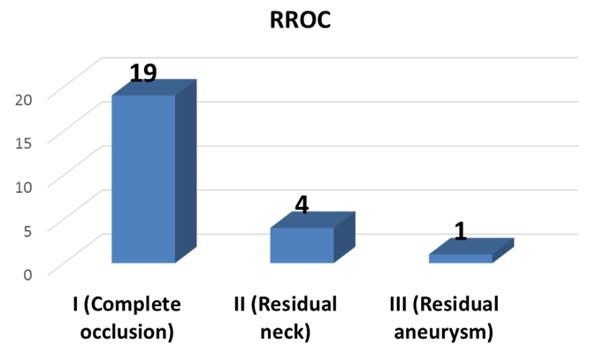

**Figure (4): shows Raymond and Roy post-coiling occlusion for the wide necked aneurysms.** 19/24 complete occlusion achieved, with 4/24 near complete occlusion (Residual neck) and only 1/24 had partial occlusion (Residual aneurysm).

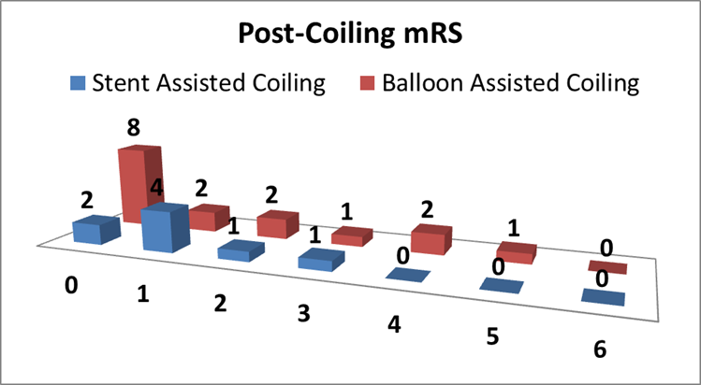

**Figure (5): shows modified Rankin Score for the wide necked aneurysms treated with either BAC or SAC.**

**4. Discussion:**

In the past, surgical clipping had been the mainstay of treatment of both ruptured and unruptured cerebral aneurysms. With the development of newer interventional materials and techniques and increasing experience of interventionists, traditional concepts of cerebral aneurysm treatment have changed. Moreover, with the emergence of new technologies and approaches for the treatment of aneurysms, the field of neurovascular intervention is only likely to expand further [11]. This study was developed for assessment of safety and efficacy of BAC and SAC in Interventional Neurology unit at Saint Louis University Hospital. Clinical, radiological, angiographical and long-term outcome assessments were obtained.In the present study 5 patients (20.8%) had posterior communicating artery aneurysms, 5 patients (20.8%) had basilar artery aneurysms, 4 patients had carotid terminus (16.7%), 3 patients had middle cerebral artery aneurysms (12.5%), 7 patient had their aneurysms in different other locations (29.1%) and this in agree with ***Gasparotti*** [12]and ***Kojra*** [13] who stated that;  the most common locations of ruptured intracranial aneurysms were the middle cerebral (32%), anterior communicating (32%), posterior communicating (14%). Increased occurrence of aneurysms in circle of Willis could be due to that at least one component of the circle is relatively hypoplastic and diminished in its capacity to provide collateral flow. Asymmetry of the circle of Willis results in significant asymmetry of flow, and this is an important factor in the development of intracranial aneurysms [14]. Searching for a relation between aneurysm size and risk of rupture revealed that; (33.3%) were small aneurysms less than 5 mm, (62.5%) were medium size aneurysms 5-15 mm and (8.2%) were large size more than 15 mm. As well as increased aneurysm size, risk of rupture was increased and this is agreeing with ***Flemming et al.,*** [15] who said one of the factors that increase risk of aneurysm rupture was aneurysm size. More recent natural history studies continue to reinforce the importance of size in evaluating risk of aneurysmal rupture. Also, a study by ***Zhang et al.,*** [16] classified aneurysms by size, small (<5 mm), medium (5–15 mm), large (15-25 mm), and giant (>25-50 mm) and super-giant (>50mm) found annual risk of rupture 0.5%, 1.7%, 4.4%, and 33.4% and 43.1%, respectively. As the aneurysm enlarges, the risk of rupture increases significantly and this was confirmed in our study as most of patients have medium to large sized aneurysms. In the present study, successful assisted-coiling was done in all aneurysms without coiling failure and complete occlusion was achieved in 79.2% of all aneurysms and this goes in agreement with ***Muto et al.,*** [17] who found procedural feasibility of occlusion with stent-assisted coiling for ruptured aneurysms was 82.5% of all aneurysms. Also, in the study of ***Dinc et al.,*** *[18]*; the overall immediate post embolization angiographic results were as follows: (63.4%) were completely occluded, (30.8%) had neck remnants, and (5.8%) were incompletely occluded and this is partially agreeing with our study as we achieved complete occlusion in (79.2%), near complete in (16.7%) and partial occlusion in (4.2%). Failure rate was zero denoting a good experience with different aneurysmal sites and ability to handle tortuous anatomy with similar occlusion rate to the above studies. When trying to find a relation between ages, sex of patients and rate of occlusion the results were no significant relation between these factors and rate of occlusion and this in agreement with [***Kawanabe***](http://link.springer.com/search?facet-author=%22Y.+Kawanabe%22) ***et al.,*** [19]and ***Pierot et al.,*** [20]who said age and sex and the rate of adequate occlusion was not significantly correlated. This support the hypothesis that the anatomical site, size and configuration of cerebral aneurysms is the most important single risk factor for rupture. In this study there were no significant relation between site and size of circle of Willis aneurysms and rate of occlusion which is incongruent with ***Turjman et al.,*** [21] who said Parameters that correlated with the unsatisfactory result of partial occlusion were large aneurysmal diameter, volume, and neck size. This can be further explained by the statistical power of his study which included higher number of as he takes large number of patients. ***Kim et al.,*** [22]who said that aneurysms with wide necks, defined by neck diameters greater than 4 mm or dome-to-neck ratios less than 2, are the most difficult to treat with the endovascular method. In wide-necked intracranial aneurysms, complete coil embolization is often technically difficult owing to the risks of distal coil migration or coil impingement on the parent ves­sel. In our study, we targeted this group of wide-necked intracerebral aneurysms and used SAC and BAC techniques which successfully achieved complete occlusion in (79.2%) which goes in agreement with what ***Zheng et al.,*** [23] and ***Cai*** ***et al.,*** and ***Wang et al.,*** [24] proposed. There is significant relation between aneurysm neck, rate of occlusion and technique used in aneurysms embolization and this is in agree with ***Cottier et al.,*** who reported that the best angiographic results (complete occlusion) are obtained when the aneurysm is small and narrow-necked but aneurysms with wide neck or increase sac/neck ration need either balloon-assisted coiling or stent-assisted coiling techniques for homogenous complete packing of aneurysms. ***Zhao******et al.,*** [25] found that Balloon-assisted coiling technique was demonstrated to be a successful tool for the treatment of wide-necked intracranial aneurysms with unfavourable neck/fundus ratio, located on an arterial bifurcation or for the so-called sidewall aneurysms. Balloon-assisted technique strongly supporting efforts to achieve as complete aneurysm exclusion as possible and this is in agree with our study to prevent coil herniation into parent vessel during coil packing. In the present study, minor thromboembolic complication due to distal embolic stroke occurred in one patient (4.2%). No other immediate or delayed complications occurred e.g. aneurysmal rupture, vessel dissection or death and this is agreement with ***Wang et al.,*** [24] who said that thromboembolic complications were ranging between 5-10% of patients who had endovascular aneurysmal coiling. Thromboembolic complications of coiling are most commonly recognized as distal emboli. In the present study, the mortality rate was zero and this can be explained by the interventionist skills, careful selection of the patients and technique. In this study, the recurrence rate was one patient (4.2%) and goes in agreement with ***Crobeddu et al.,***[26]and ***dos Santos et al.,*** [27] who found that after endovascular coiling, the aneurysmal recurrence can be expected to a range from 6.1 to 33.6% after endovascular treatment.

**Conclusion:**

This study demonstrates the relative safety, efficacy and long-term favorable outcomes of both BAC and SAC techniques for endovascular treatment of wide-necked cerebral aneurysms with superiority of SAC in achieving better long-term clinical outcomes, occlusion rates and fewer complications. Other larger studies are recommended to better understand the natural history and various endovascular treatment options offered for those with wide-necked cerebral aneurysms.

**References:**

1. Burns, J.D. and R.D. Brown, Jr., *Treatment of unruptured intracranial aneurysms: surgery, coiling, or nothing?* Curr Neurol Neurosci Rep, 2009. 9(1): p. 6-12.

2. Cowan, J.A., Jr., et al., *Use of endovascular coil embolization and surgical clip occlusion for cerebral artery aneurysms.* J Neurosurg, 2007. 107(3): p. 530-5.

3. Raymond, J., *Incidental intracranial aneurysms: rationale for treatment.* Curr Opin Neurol, 2009. 22(1): p. 96-102.

4. Cognard, C., et al., *Results of embolization used as the first treatment choice in a consecutive nonselected population of ruptured aneurysms: clinical results of the Clarity GDC study.* Neurosurgery, 2011. 69(4): p. 837-41; discussion 842.

5. White, P.M., et al., *HydroCoil Endovascular Aneurysm Occlusion and Packing Study (HELPS trial): procedural safety and operator-assessed efficacy results.* AJNR Am J Neuroradiol, 2008. 29(2): p. 217-23.

6. White, P.M., et al., *Hydrogel-coated coils versus bare platinum coils for the endovascular treatment of intracranial aneurysms (HELPS): a randomised controlled trial.* Lancet, 2011. 377(9778): p. 1655-62.

7. Sakai, N., et al., *Retrospective survey of endovascular treatment for ruptured intracranial aneurysm in Japan: Retrospective Endovascular Subarachnoid Aneurysm Treatment (RESAT) study.* Neurol Med Chir (Tokyo), 2010. 50(11): p. 961-5.

8. Pierot, L., et al., *Endovascular treatment of unruptured intracranial aneurysms: comparison of safety of remodeling technique and standard treatment with coils.* Radiology, 2009. 251(3): p. 846-55.

9. Mocco, J., et al., *Treatment of intracranial aneurysms with the Enterprise stent: a multicenter registry.* J Neurosurg, 2009. 110(1): p. 35-9.

10. Bodily, K.D., et al., *Stent-assisted coiling in acutely ruptured intracranial aneurysms: a qualitative, systematic review of the literature.* AJNR Am J Neuroradiol, 2011. 32(7): p. 1232-6.

11. Currie, S., K. Mankad, and A. Goddard, *Endovascular treatment of intracranial aneurysms: review of current practice.* Postgrad Med J, 2011. 87(1023): p. 41-50.

12. Gasparotti, R. and R. Liserre, *Intracranial aneurysms.* Eur Radiol, 2005. 15(3): p. 441-7.

13. Korja, M., et al., *Size and location of ruptured intracranial aneurysms: consecutive series of 1993 hospital-admitted patients.* J Neurosurg, 2016: p. 1-6.

14. Alastruey, J., et al., *Modelling the circle of Willis to assess the effects of anatomical variations and occlusions on cerebral flows.* J Biomech, 2007. 40(8): p. 1794-805.

15. Flemming, K.D. and G. Lanzino, *Management of Unruptured Intracranial Aneurysms and Cerebrovascular Malformations.* Continuum (Minneap Minn), 2017. 23(1, Cerebrovascular Disease): p. 181-210.

16. Zhang, Y., et al., *Endovascular Treatment of Spontaneous Intracranial Fusiform and Dissecting Aneurysms: Outcomes Related to Imaging Classification of 309 Cases.* World Neurosurg, 2017. 98: p. 444-455.

17. Muto, M., et al., *Stent-assisted coiling in ruptured cerebral aneurysms: multi-center experience in acute phase.* Radiol Med, 2017. 122(1): p. 43-52.

18. Dinc, H., et al., *Coil embolization in 481 ruptured intracranial aneurysms: angiographic and clinical results.* Diagn Interv Radiol, 2013. 19(2): p. 165-72.

19. Kawanabe, Y., et al., *Endovascular occlusion of intracranial aneurysms with Guglielmi detachable coils: correlation between coil packing density and coil compaction.* Acta Neurochir (Wien), 2001. 143(5): p. 451-5.

20. Pierot, L., et al., *Safety and efficacy of balloon remodeling technique during endovascular treatment of intracranial aneurysms: critical review of the literature.* AJNR Am J Neuroradiol, 2012. 33(1): p. 12-5.

21. Turjman, F., et al., *Predictors of aneurysmal occlusion in the period immediately after endovascular treatment with detachable coils: a multivariate analysis.* AJNR Am J Neuroradiol, 1998. 19(9): p. 1645-51.

22. Kim, J.W. and Y.S. Park, *Endovascular treatment of wide-necked intracranial aneurysms: techniques and outcomes in 15 patients.* J Korean Neurosurg Soc, 2011. 49(2): p. 97-101.

23. Zheng, Y., et al., *Stent-assisted coiling embolization of tiny, wide-necked intracranial aneurysms.* Acta Neurochir (Wien), 2017. 159(1): p. 93-100.

24. Wang, F., et al., *Stent-assisted coiling and balloon-assisted coiling in the management of intracranial aneurysms: A systematic review & meta-analysis.* J Neurol Sci, 2016. 364: p. 160-6.

25. Zhao, B., et al., *Stent-assisted coiling versus coiling alone of poor-grade ruptured intracranial aneurysms: a multicenter study.* J Neurointerv Surg, 2017. 9(2): p. 165-168.

26. Crobeddu, E., et al., *Review of 2 decades of aneurysm-recurrence literature, part 2: Managing recurrence after endovascular coiling.* AJNR Am J Neuroradiol, 2013. 34(3): p. 481-5.

27. dos Santos, M.P., et al., *Survival analysis of risk factors for major recurrence of intracranial aneurysms after coiling.* Can J Neurol Sci, 2015. 42(1): p. 40-7.

4/10/2017