**Improvement of Distribution Network Performance Using Distributed Generation (DG)**

S. Nagy

Faculty of Engineering, Al-Azhar University

[Sayed.nagy@gmail.com](mailto:Sayed.nagy@gmail.com)

**Abstract:** Recent changes in the energy industry initiated by deregulation have accelerated the introduction of distributed generation at the sub-transmission and distribution levels. As Distributed Generation (DGs) play a key role in the residential, commercial and industrial sectors of the power system, this paper introduce their impact on system voltage and losses of residential distribution feeder. Several studies have been conducted to illustrate how different levels of DG placement can impact voltage profile and losses of the network. The effect of changing DGs capacity, distance and number on the network performance are also discussed and investigated.

[S. Nagy. **Improvement of Distribution Network Performance Using Distributed Generation (DG).** *N Y Sci J* 2017;10(3):125-129]. ISSN 1554-0200 (print); ISSN 2375-723X (online). <http://www.sciencepub.net/newyork>. 14. doi:[10.7537/marsnys100317.14](http://www.dx.doi.org/10.7537/marsnys100317.14).

**Keywords:** Distributed generation, loss reduction and voltage profile.

1. **Introduction**

A Distributed Generator (DG) is a small-scale generation that provides electric power at a site closer to a customer thana central generation facility. A unit can be connected directly to a customer's facility or directly to a utility'stransmission or distribution system [1]. The DGs are becoming increasingly popular due to their low emission; low noise levels and high efficiency. DG technologies include photo voltaic, fuel cells, wind turbines, small and micro sized turbine packages and IC engine generators. Distributed generation interconnected at the substation, distribution feeder or customer load points [2]. The impacts of DG may manifest themselves either positively or negatively depending on the distribution system operating characteristics and the DG characteristics. Positive impacts are generally called “system support benefits,” and include: Improved utility system reliability, Lossreduction, Voltage support and improved power quality, Transmission and distribution capacity release and Deferments of new or upgraded TBD infrastructure [3]. Negative impacts include: voltage flicker, harmonics and short circuit interface. The fault contribution from DG unit can alter the short circuit levels enough to cause fuse-breaker miss-coordination [3, 4].

Voltage regulation practice is based on radial power flows from the substation to the loads and DG introduces “meshed” power flows that interfere with the effectiveness of standard voltage regulation practice. LTC (Load-Tap-Changing Transformers) depend on power flow and load demand. Inserting DG may cause under voltage due to confusion between LTC and control system. DG may also result in high voltage at some electric customers [5].

The DG installation can impact the overall voltage profile of the system. Inclusion of DG can improve feeder voltage of distribution networks in areas where voltage dip or blackouts are of concern for utilities [6]. Distributed generation will also impact losses on the feeder. Sitting of DG units to minimize losses is like sitting capacitor banks for loss reduction; also DGs may increase losses. The losses of the system vary as the DG output changes. The minimum losses depend on the characteristics of the feeder [6, 7].

The DG rating and locations are important factors for line loss reduction. Therefore, these factors have to be considered very carefully in order to determine the best location of DG [8].

DG units can be placed at optimal locations where they provide the best reduction in feeder losses. An algorithm to calculate the optimum size of DG at various buses and proposes a fast methodology to identify the best location corresponding to the optimum size for reducing total power losses in primary distribution network [9-11].

1. **System description and base case study**

The 10 buses test system shown below in Fig.1 comprises of a radial feeder with 10 laterals feeding certain loads in MW. The total load on the feeder is 24.5MW.

The values of load, no. of customers at lateral and length of sections are given in Table 1 below: assuming power factor is 0.9. The test system feeders are simulated on the ETAP 7 software with the line parameter and load data. Simulation results has been tabulated and discussed. The study considers the system of Fig. 1 as reference and a base case study. The voltage is measured at distributed points from the main substation along the main distribution line. The voltage drops as the distance from the substation increases depending on the concentration of loads. Running ETAP power flow and measure voltage along the main feeder the voltage drops from 100% to 77.52% at the end of the line. See Fig. 2.

Lowest voltage

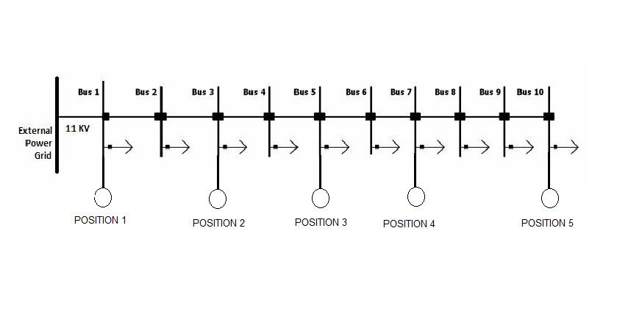

**Fig. 1: the 10 buses test system**

**Table 1 System data Feeder Data**

| **Section** | **Length**  **(KM)** | **LP** | **Load**  **(MW)** | **Customer** |
| --- | --- | --- | --- | --- |
| **1** | 1.0 | 1 | 1.5 | 50 |
| **2** | 0.85 | 2 | 2.5 | 70 |
| **3** | 0.8 | 3 | 3 | 100 |
| **4** | 0.75 | 4 | 2.5 | 80 |
| **5** | 0.65 | 5 | 1 | 30 |
| **6** | 0.65 | 6 | 2.5 | 70 |
| **7** | 0.8 | 7 | 3 | 100 |
| **8** | 1.0 | 8 | 1.5 | 50 |
| **9** | 1.0 | 9 | 2 | 70 |
| **10** | 0.75 | 10 | 4 | 100 |

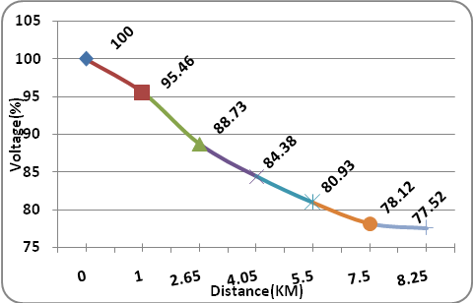

**Fig. 2: Base Case analysis**

1. **Impact of dg on voltage profile of system**

This section studies the impact of DG on voltage profile of system. DGs will be on line with substation (parallel mode). Several cases are studied to show the impact of DG on voltage profile which include; DG capacity, distance and number of distributed DG.

1. **Impact of DG Capacity on Voltage Profile**

The study investigates that impact by installing one DG with different capacities at the lowest voltage location. The lowest voltage location is determined by running the power flow in ETAP (Fig. 3). It shows the lowest voltage at LP 10 the most concentrated load. Two cases are studied, Small and large Scale Injected DG at LP10.



**Fig. 3 Distribution feeder with the proposed locations of DG**

1. **Case 1 Small Scale Injected**

Change the capacity of the installed DGat LP 10 as a percentage of LP 10 load (50% and 100%) to show voltage improvement. The voltage improvement can be seen in Fig. 4. As a small scale DG injects power at the point of DG installation, the distribution system voltage improves slightly.

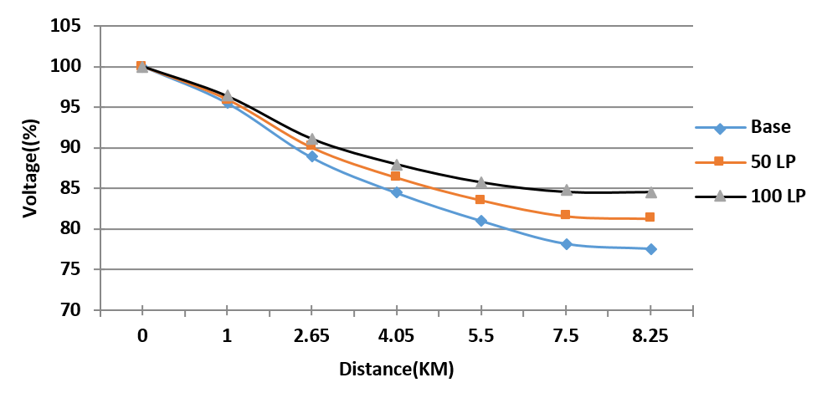

**Fig. 4: Voltage profile of inserting small DG**

1. **Case 2 Large Scale Injected**

Second, to investigate this section, the study installs DG at the lowest voltage location (LP 10) as a percentage of overall feeder load not the point load (50% and 100%). The improvement of system voltage can be seen graphically at Fig 5. As a large scale DG injects power at the point of DG installation, the distribution system voltage improves significantly. And no over voltage occurs.

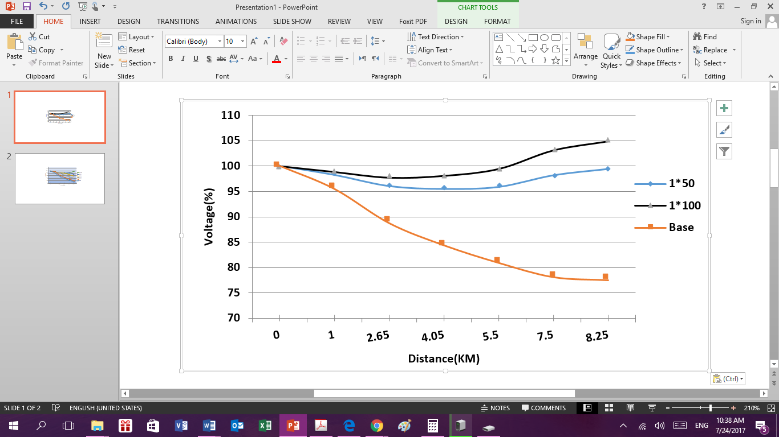

**Fig.5: Voltage profile of inserting large DG**

1. **Result Comparison: Case 1 & 2 (Size Impact**)

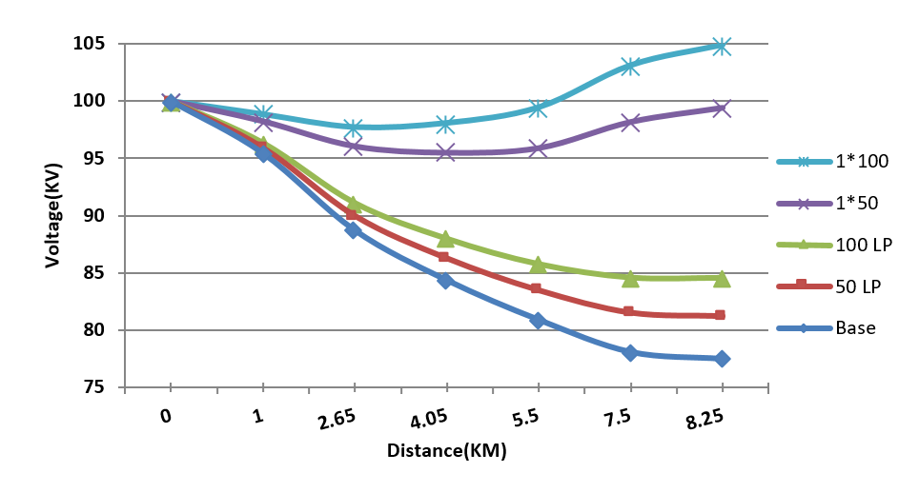

**Fig. 6: Comparison between voltagesprofiles**

As the penetration level of DG installed on the system increases the overall voltage profile is improves. Increasing the size in terms of load point at the point of DG installation does not have a considerable impact on the voltage profile and when the DG is added in terms of total system load, the overall voltage profile increases, and also no overvoltageoccurs.

1. **Impact of DG Distance on Voltage Profile**

Changing the locations of DG with the capacity of 50% of total feeder load from substation to the end of feeder, five locations are proposed for analysis as shown in Fig. 3.

Fig. 7shows that, system voltage profile improves when the DG is moved away from substation and becomes closer to the end.

1. **Impact of Distributed DGs on Voltage Profile**

In this section, DGs of size 50% and 100% of the total feeder load are distributed in 2(LP10 and LP7), 3(LP10, LP 7 and LP 5), 4( LP10, LP 7, LP 5 and LP 3) and 5 (LP10, LP 7, LP 5, LP 3 and LP 1) locations as shown in Fig 3. The voltage profiles for various DG sizes are distributed across different locations are shown in Figs. 8 and 9. Paper presents two cases studied.

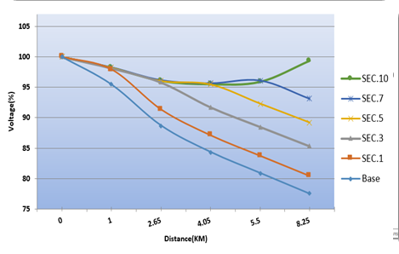

**Fig. 7: impact of DG distance on voltage profile**

1. **Case1 50% Distributed**

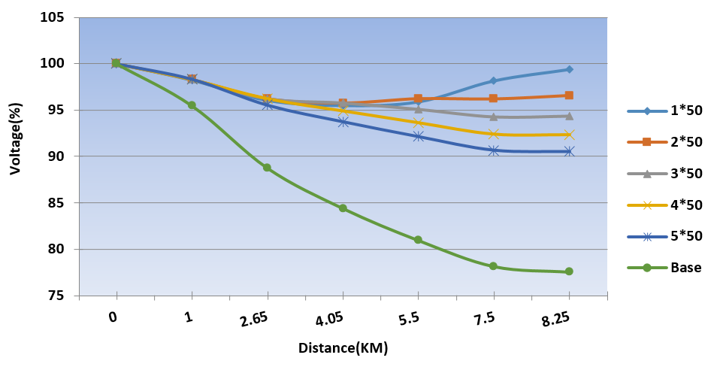

**Fig.8: Result comparisons between distributed DGs with total capacity 50%**

Distributed DGs with 50% capacity have slight positive improvement to voltage profile. At 50% of DG insertion produces the best results when distributed across 2 location.

1. **Case2 100% Distributed**

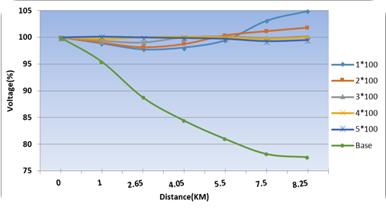

**Fig.9: Impact of distributed DGs on voltage profile**

As a result of Fig. 9, distributing the DG (especially in large scale injected) from an aggregated location (lowest voltage) to different locations make a positive difference to the voltage profile depending on the location and concentration of the loads. And reduces voltage sag (the difference among the voltage of system buses).

1. **Voltage sag of 100% Distributed**

Paper studies voltage sag (the difference between the maximum and minimum voltages) in case of Base, single and distributed DGs with total capacity of 100% of the feeder load total.

Fig. 10 shows that the distributed DGs improve voltage sag percentage. As in case of using 2 distributed DGs (100%) voltage sag improves from 18.95 to 3.58 (81%), when compared to Base case.

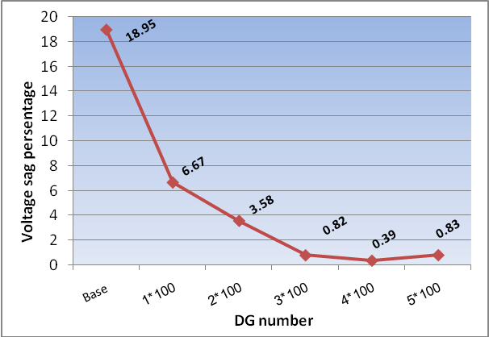

**Fig. 10: Voltage sag of case 2 (100%) distributed**

1. **Impact of dg on system losses**
2. **Impact of DG capacity on system losses**

This section studies the impact of DG capacity on system losses by inserting one DG with different capacities at the lowest voltage location (LP 10), using the same cases studied in voltage analysis.

1. **Case 1 small injected DG**

Firstly, changing the capacity of DG installed at LP 10 as a part of LP10 from 50% and 100%. As a small scale DG injects power at the point of DG installation, the distribution system losses has a considerable reduction. The losses improvement can be seen in Fig. 11.

1. **Case 2 Large injected DG**

Secondly, the large scale DG (50% to 150%) of total feeder load injects power at the lowest voltage location and the systems losses reduce significantly. The results for different DGs penetrations are graphically shown in Fig. 11.

Fig 10 shows that, the minimum losses occur when the DG output is about 50% of total load. Increasing capacity over 50% of total load, system losses will increase. It is observed also that, system losses changes according to DG size. Therefore, the minimum losses occur at different DG output based on characteristics of the system.

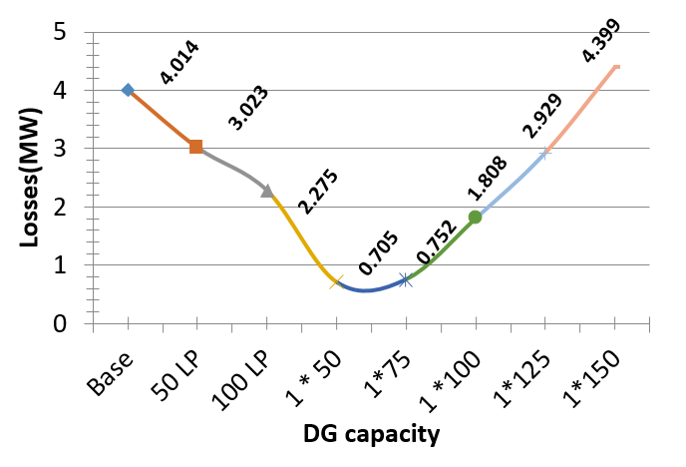

**Fig.11: Losses analysis vs. DG capacity**

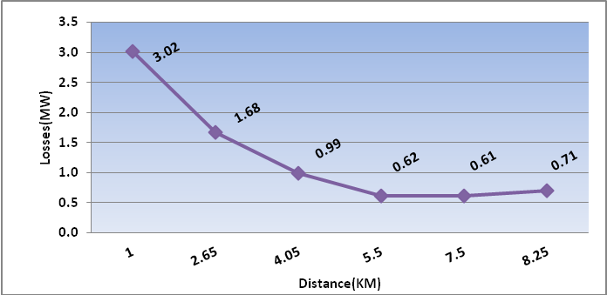

**Fig. 12: impact of DG distance on system losses**

1. **Impact of DG Distance on System Losses**

Changing the locations of DG (50%) from substation to the end of feeder, using same cases studies in voltage profile. See Fig 1. Results are graphically presented in Fig. 12.

As a result of Fig. 12, System losses are so sensitive to the distance of DG. As the DG installed away from substation more reduction in losses is presented.

1. **Impacts of Distributed DGs on System Losses**

In this section, paper distributes DGs of size 50 and 100% of the total feeder load across 2, 3, 4 and 5 locations. Distributing the aggregated DG at different locations (using same locations discussed above) can reduce the losses. Applying two cases studied**.**

1. **Case 1( 50% Distributed)**

This case study the impact of distributes DGs with total capacity 50% of total feeder load are investigated. Results are graphically presented in Fig. 13.

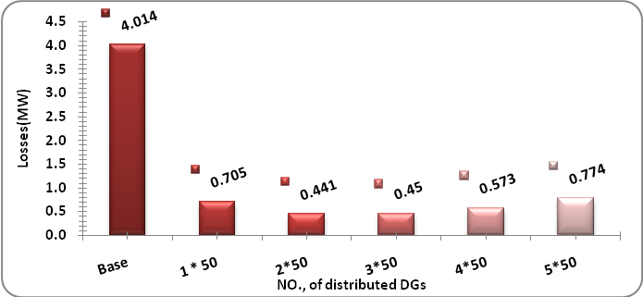

**Fig. 13: Case 1impact of distributed DGs on system losses**

1. **Case 2 (100% Distributed)**

This case study, the impact of distributes DGs with total capacity 100% of total feeder load are investigated and results are shown in Fig. 14.

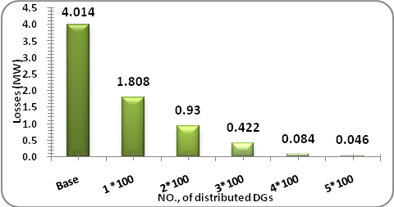

**Fig. 14: Case 2 impacts of distributed DGs on system losses**

It is observed from the graph that DGs with total capacity (100%) reduce the losses more than distributed DGs with total capacity (50%). Distributing the aggregated DG at different locations reduce the losses (especially 100% injected) instead of installing an aggregated DG at one location.

1. **Conclusion**

This paper has discussed the impact of the DG on the voltage profile and the losses in the distribution networks when the DGs are installed in parallel with the main power supply. It has demonstrated that the voltage profile improves and the losses of the network reduce when the DG is located as far as much from the substation, exactly at the end of the feeder. It also appears that the increase in the capacity of the DG improves the voltage profile. The distribution of the DGs in different places improves the voltage profile, reduces the difference in voltage among the buses, and decreases the losses according to their location and number**.**

**References**

1. S. Abeed Ali, A. Lakshmi Devi, “Multiple DG Placement For Voltage Profile Improvement And Loss Reduction Using IA And PSO Methods”, IPASJ International Journal of Electrical Engineering (IIJEE), Volume 3, Issue 10, October 2015.
2. P. A. Daly and J. Morrison, “Understanding the potential benefits of distributed Generation on power delivery systems”, in Proc. Rural Electric Power Conf., pp. A2/1–A2/13. 2001.
3. Philip. P. Barker and Robert. W de Mello, “Determining the impact of distributed generation on power systems: Part I. Radial distribution systems”, Power Engineering Society Summer Meeting 2000, IEEE, Volume: 3, 16-20, Pages: 1645 – 1656, July 2000.
4. S. Chaitusaney, and A. Yokoyama, “Reliability Analysis of Distribution System with Distributed Generation Considering Loss of Protection Coordination”, 9th International Conference on Probabilistic Methods Applied to Power Systems KTH, Stockholm, Sweden, June 2006.
5. “Voltage Ratings of 60 Hz Electric Power Systems”, Institute of Electrical and Electronic Engineers, 1995.
6. Irfan Waseem, “Impacts of Distributed Generation on the Residential Distribution Network Operation”, M.Sc. thesis, Virgilio Virginia Polytechnic Institute and State University Centeno, 2008.
7. R. L. Alvarado, “Locational aspects of Distributed Generation”, Proceeding of IEEE PES winter meeting, volume 1, pp.140, Ohio 2001.
8. Priyanka Paliwal and N.P. Patidar, “Distributed Generator Placement for Loss Reduction and Improvement in Reliability”, World Academy of Science, Engineering and Technology 69, pp. 809-813, 2010.
9. J. B. V. Subrahmanyam and C. Radhakrishna, “Distributed Generator Placement and Sizing in Unbalanced Radial Distribution System ˮ, World Academy of Science, Engineering and Technology 52, pp. 737-744, 2009.
10. Borges, C.L.T. and Falcao, D.M., “Impact of distributed generation allocation and sizing on reliability, losses and voltage profile”, IEEE Bologna Power Tech Conference, Vol.2, No., 5, Bologna, Italy, June 2003.
11. Naresh Acharya, Pukar Mahat, N. Mithulananthan, “An analytical approach for DG allocation in primary distribution network Electric Power System Management”, Electrical Power and Energy Systems 28, pp 669–678, Thailand, February 2006.

3/23/2017