Brain and Gastric AT1 Gene Expression Changes in Adult Male Albino Rats Induced by Chronic Immobilization Stress. The Possible Role of Angiotensin ІІ Type 1 Receptor (AT1) Blockers

Hamed Mohamed Osman, Abd Elrazik Abd Elhafez Yousef Khedr, Mohamed Mahmoud Khamiss, Amani M. El Amin Ali

Physiology Department, Faculty of Medicine, El-Fayoum University, Egypt.
Dr.m.khamiss@hotmail.com

Abstract: Our study was conducted upon 60 male rats, they were divided into 6 equal groups, the first 3 groups were left wandering in their cages, the last 3 groups were subjected to chronic immobilization stress for 60 minutes every day for 10 consecutive days, 2 groups of non stressed group and 2 groups of stressed groups were given candesartan in a dose of 1 mg and 2 mg / kg. On the tenth day Pyloric ligation were done to all groups for 4 hours then scarification were done with an over dose of anesthetic ether. The following parameters were measured: Measurement of AT1 gene expression in brain by polymerase chain reaction (PCR), Measurement of AT1 gene expression in pylorus by polymerase chain reaction (PCR), Measurement of the following parameters in the collected gastric juice (Titratable acidity. Pepsin activity. Mucous concentration). Ulcer index in gastric mucosa. The results showed that stress causes marked increase in AT1 gene expression in both brain and stomach. Also stress caused marked increase in titritable acidity, pepsin activity, gastric ulceration and decrease in mucous concentration, with use of candesartan, gene expression had decreased dramatically in both brain and stomach, also there was a significant decrease in titritable acidity, pepsin activity, gastric ulceration and increase in mucous concentration with use of candesartan. Stress induces acute gastric mucosa lesions by a variety of mechanisms, including psychological factors influencing individual vulnerability, stimulation of specific brain pathways regulating autonomic function, decreased blood flow to the mucosa, increase in muscular contractility, mast cell degranulation, leukocyte activation and increased free radical generation resulting in increased lipid peroxidation Maintenance of gastric blood flow is important to protect the mucosa from endogenous and exogenous damaging factors, and Ang II, through AT1 receptor stimulation, increases vascular tone in resistance arteries including those of the gastric vasculature leading to decreased blood flow and ischemia. With the use of candesartan, known as a potent ARB, it was clear in the results of this study that it has a great protective role regarding gastric ulceration and stress response. The protection of gastric blood flow after administration of AT1 receptor antagonists is probably mediated by inhibition of receptors localized to the endothelium of arteries located in the gastric mucosa Lines of evidence supporting the hypothesis of a major role of brain Ang II in stress include stress-induced increases in circulating and brain Ang II levels, high AT₁ receptor expression in all areas involved in the stimulation of the hypothalamic-pituitary-adrenal axis (HPA) activity, including the hypothalamic paraventricular nucleus (PVN), the median eminence (ME) and the subfornical organ (SFO)). Sustained inhibition of peripheral and brain AT₁ receptors by peripheral administration of the AT₁ receptor antagonist candesartan prevents not only the hormonal, but also the sympatho-adrenal response to immobilization stress ). In addition, candesartan pretreatment prevents the activation of the brain sympathetic system during immobilization and produced anti-ulcer effect on gastric mucosa.
[Hamed Mohamed Osman, Abd Elrazik Abd Elhafez Yousef Khedr, Mohamed Mahmoud Khamiss, Amani M. El Amin Ali. Brain and Gastric AT1 Gene Expression Changes in Adult Male Albino Rats Induced by Chronic Immobilization Stress. The Possible Role of Angiotensin ІІ Type 1 Receptor (AT1) Blockers. N Y Sci J 2017;10(3):96-124]. ISSN 1554-0200 (print); ISSN 2375-723X (online). http://www.sciencepub.net/newyork. 13. doi:10.7537/marsnys100317.13.

Keywords: AT1Gene, Albino, Chronic Immobilization, Angiotensin ІІ.

1. Introduction
Hundreds of studies over the last twenty five years have shown that chronic stress contributes to increased incidence of common life- threatening diseases including cardiovascular diseases, endocrine disorders, strokes and cancer (Micultkova et al., 2004).
A large body of evidence suggests existence of a relationship between renin-angiotensin system and the stress response (Aguilera et al., 1995). Angiotesin II is now classified as an important stress hormone (Saavedra and Benicky, 2011). It is suggested that blockade of angiotensin ІІ receptors may be important for prevention and treatment of diabetes mellitus and coronary vascular disease CVD that are usually associated with stress as well as other induced disorders (Uresin et al., 2004).
AT1 receptor blockers (ARBs) are commonly used in the clinical treatment of hypertension (Pavel et al., 2008). Subcutaneous or oral administration of the ARB candesartan inhibits brain as well as peripheral AT1 receptors, indicating transport across the blood brain barrier. Pretreatment with candesartan profoundly modifies the response to stress.
A large body of evidence indicates that brain and peripheral Angiotensin II (Ang II), the acting principle of the Renin-Angiotensin System (RAS) is amajor stress hormone (Saavedra, 2005). However, Ang II is not usually considered as an active participant in stress, in part because its role in the regulation of blood pressure and kidney function overshadows other potential effects of Ang II in the brain and the periphery. The first firm indication of a participation of brain Ang II in stress was the discovery of increased Ang II receptors in the paraventricular nucleus of the hypothalamus (PVN) during immobilization stress.
Aim of the work
The aim of the present work is to investigate the AT 1 gene expression in brain and gastric tissue in adult male albino rats exposed to chronic immobilization stress and the possible effects of angiotensin ІІ type 1 receptor (AT1) blocker (candesartan) as an anti-stress and antiulcer (on gastric mucosa).

2. Materials and Methods
Site of the study:
The study was done at laboratory animal house unit of Kasr Al-Ainy faculty of medicine, Cairo University.
A) Materials:
I. Drugs used:
Candesartan (Atacand 8 mg, Astra Zenica, Egypt) candesartan cilexetil.
II- Animals used:
The present study was conducted on 60 adult male albino rats obtained from Kasr Elainy animal house weighing 150-200 grams without any previous preparation, with free access to food and water, kept in light/dark cycles at room temperature.
Animals were housed under similar environmental conditions in separate cages with wide meshed flooring to prevent corporphagia and were fasted but allowed water for 24 hours perior to use according to method of Anchkov and Zovodyskoya. (1968).
III- Groups of experiments:
The rats included in this study were classified into 6 equal groups
(each of 10 rats):
Group I (Control group, given distilled water, pyloric ligation only):
Animals of this group received no medication, left wondering in their cages and given free access to food and water throughout the period of the experiment then at the tenth day, pyloric ligation was done. Rats were sacrificed by an over dose of anesthetic ether four hours after pyloric ligation. (Nagai et al., 2004).
Group II (Candesartan treated group 1 mg/kgm/day + pyloric ligation):
In this group, the effect of candesartan in non stressed rats was studied. The animals of this group received candesartan dissolved in distilled water at a dose of 1mg/kgm/day orally for 10 consecutive days (Fagan et al., 2006). At the tenth day, pyloric ligation was done. Rats were sacrificed by an over dose of anesthetic ether four hours after pyloric ligation. (Nagai et al., 2004).
Group III (Candesartan treated group 2mg/kgm/day + pyloric ligation):
In this group, the effect of candesartan in non stressed rats was studied. The animals of this group received candesartan dissolved in distilled water at a dose of 2mg/kgm/day orally for 10 consecutive days (Fagan et al., 2006). At the tenth day, pyloric ligation was done. Rats were sacrificed by an over dose of anesthetic ether four hours after pyloric ligation. (Nagai et al., 2004).
Group IV (Chronic immobilization stress + pyloric ligation group, given distilled water):
Immobilization stress was performed in supine position by tapping the four limbs of the animal to metal holders by an adhesive tape (Alexander et al., 2001) for 60 min/day for 10 consecutive days to perform chronic stress. At the tenth day, pyloric ligation was done. Rats were sacrificed by an over dose of anesthetic ether four hours after pyloric ligation.
Group V (Candesartan 1mg/kgm/day + chronic immobilization stress group + pyloric ligation):
In this group the effect of candesartan in stressed rats was studied. The animals of this group received candesartan dissolved in distilled water at a dose of 1mg/kgm/day orally for 10 consecutive days before the initiation of the daily stress regimen and pyloric ligation was done in this group by the same maneuver.
Group VI (Candesartan 2mg/kgm/day + chronic immobilization stress group + pyloric ligation):
In this group the effect of candesartan in stressed rats was studied. The animals of this group received candesartan dissolved in distilled water at a dose of 2mg/kgm/day orally for 10 consecutive days before the initiation of the daily stress regimen and pyloric ligation was done in this group by the same maneuver.
B) Methods:
Pyloric ligation: Rats were anaesthetized with the help of anesthetic ether; the abdomen was opened by a small mid line incision below the xiphoid process. Pyloric portion of the stomach was slightly lifted out and ligated according to method of Shay et al. (1945) avoiding traction to the pylorus or damage to its blood supply. The stomach was replaced carefully and the abdominal wall was closed by interrupted sutures. Rats were sacrificed by an over dose of anesthetic ether after four hours of pyloric ligation. The abdomen was opened, cardiac end of the stomach was dissected out and the contents were drained into a glass tube. The inner surface of free stomach was examined for gastric lesions.
Measurements of the following parameters:
A- Measurement of AT1 gene expression in brain by polymeras chain reaction (PCR).
Quantitative Real Time PCR Protocol according to (Pfaffl et al., 2001).
B- Measurement of AT1 gene expression in pylorus by polymeras chain reaction (PCR).
Quantitative Real Time PCR Protocol according to (Pfaffl et al., 2001).
Detection of ANGIIR(AT1) gene expression.
At the end of the experiment, rats were sacrificed by an over dose of anesthetic ether, brain and stomach were removed, weighed, and stored at −70 ◦C in lysis buffer until gene expression by polymeras chain reaction (PCR) was done.
Quantitative Real Time PCR Protocol according to (Pfaffl et al., 2001).
Procedure:
Extraction of RNA from the brain and gastric tissue:
Total RNA was extracted from the brain and stomach using SV Total RNA Isolation system (Promega, Madison, WI, USA).
Homogenization of brain and gastric tissue:
- About 30mg of brain and 30 mg of gastric tissues were homogenized individually in 175 ul previous mentioned lyses buffer for 10 min and then tissue centrifuged for 20 min at 15,000 rpm.
- 350 μl of SV RNA Dilution Buffer was added to 175 μl of tissue homogenate; it was mixed by inverting the tube 3-4 times. The mixture was placed in a water bath at 70°C for 3 minutes.
- The mixture was centrifuged at 12,000-14,000 rpm for 10 minutes at 20-25°C.
RNA purification:
- The cleared lysate solution was transferred to a fresh microcentrifuge tube by pipetting.
- 200 μl of 95% ethanol were added to the cleared lysate, and were mixed by pipetting 3-4 times. This mixture was transferred to the Spin Column Assembly and was centrifuged at 12,000-14-000 rpm for one minute.
- The Spin Basket was taken from the Spin Column Assembly, and the liquid was discarded in the collection tube. The spin basket was put back into the collection tube. 600 μl of SV RNA wash solution were added to the spin column assembly. Centrifugation at 12,000-14,000 rpm for one minute was done.
- The DNase incubation mix was prepared by combining 40 μl yellow core buffer, 5 μl 0,09M MnCl2 and 5 μl of DNase I enzyme per sample in a sterile tube.
- 50 μl of the freshly prepared DNase incubation mix were applied directly to the membrane inside the spin basket.
- The mixture was incubated for 15 minutes at 20-25°C then 200 μl of DNase stop solution were added to the spin basket, and were centrifuged at 12,000-14,000 rpm for one minute.
- 600 μl 0f SV RNA wash solution with ethanol added (100ml of 95% ethanol to a bottle containing 58, 8ml concentrated SV RNA wash solution) were added then were centrifuged at 12,000-14,000 rpm for one minute.
- The collection tube was emptied and 250 μl of SV RNA wash solution with ethanol were added and centrifuged at 14000 rpm for two minutes.
- The spin basket was transferred from the collection tube to the elution tube, and 100 μl of nuclease-free water were added to the membrane.
- Centrifugation at 12,000-14,000 rpm for one minute was done. The spin basket was discarded and the elution tube containing the purified RNA was stored at -70°C.
Determination of RNA yield and quality:
The yield of total RNA obtained was determined spectrophoto-metrically at 260 nm.
Reverse transcription into cDNA:
The extracted RNA was reverse transcribed into cDNA using RT-PCR kit. (Stratagene, USA).
Procedure:
Three μl of random primers were added to the 10 μl of RNA which was denatured for 5 minutes at 65°C in the thermal cycler.
- The RNA primer mixture was cooled to 4°C.
- The cDNA master mix was prepared according to the kit as follows and was added (for each sample):
- Total volume of the master mix was 19 μl for each sample. This was added to the 13 μl RNA-primer mixture resulting in 32 μl of cDNA.
- The last mixture was incubated in the programmed thermal cycler one hour at 37°C followed by inactivation of enzymes at 95°C for 10 minutes, and finally cooled at 4°C. Then RNA was changed into c DNA.
QPCR (quantitative real time PCR):
- The gene-specific forward and reverse primer pair was normalized. Each primer (forward and reverse) concentration in the mixture was 5 pmol/ µl.
- The experiment and the following PCR program was set up:
- 50°C 2 min., 1 cycle.
- 95°C 10 min., 1 cycle.
- 95°C 15 sec. 60°C 30 sec. 72°C 30 sec., 40 cycles.
- 72°C 10 min., 1 cycle.
- A real time- PCR reaction mixture was 50µl.
The following mixture was prepared in each optical tube:
- 25 µl SYBR Green Mix (2x).
- 0.5 µl kidney cDNA.
- 2 µl primer pair mix (5 pmol/ µl each primer).
- 22.5 µl H₂O.
- After PCR is finished, the tubes from the machine were removed.
- The real time- PCR result was analyzed with the step one applied biosystem software.
Data Analysis:
At the end of a qPCR running with SYBR Green chemistry, the relative quantification was used according to step one + applied bio system software.
Calculation of Results
Average the duplicate readings for each standard, control, and sample and subtract the average zero standard optical density (O.D.). Create a standard curve by reducing the data using computer software capable of generating a four parameter logistic (4-PL) curve-fit. As an alternative, construct a standard curve by plotting the mean absorbance for each standard on the y-axis against the concentration on the x-axis and draw a best fit curve through the points on the graph. The data may be linearized by plotting the log of the rat VEGF concentrations versus the log of the O.D. and the best fit line can be determined by regression analysis. This procedure will produce an adequate but less precise fit of the data. If samples have been diluted, the concentration read from the standard curve must be multiplied by the dilution factor.
C – Measurement of the following parameters in the collected gastric juice:
- Titratable acidity:
This was measured colorimetry by determining the number millimeters of 0.01. N NaOH required for neutralize 100 ml of gastric juice.
A given volume of gastric juice (0.2 ml) was titrated to pH 7.0 against 0.01 N NaOH using phenol red as an indicator (Grossman. 1963).
- Pepsin activity:
Enzyme Activity Assays- Pepsin: Hemoglobin (300 µL 2.5%) and 75 µL 0.3 M HCl were mixed and incubated for 10’ at 37°C, then added to 75 µL pepsin solution (0.1 mg/ml in 0.01 M HCl, pH=2.0). The samples were incubated for 0 min, 10 min and 20 min at 37°C, and the reaction was stopped by addition of 750 µL 5% Trichloroacetic acid (TCA). Samples were centrifuged for 10 min at 13400×g, and absorption was recorded at 280 nm. One unit renders TCA soluble absorption of 0.001 at 280 nm per min at 37°C from a denatured hemoglobin substrate.( Anson, M.L 1988)
- Mucous concentration:
Gastric wall mucus content was determined by the method described by (Corne, et al.1974), The dissected stomach was soaked for 2 h in 0.1% Alcian blue dye:
- Alcian blue is a histological dye which stains mucins.
- This is a method used to estimate barrier mucus indirectly using a dye binding procedure.
Steps:
- The everted stomachs were weighed and soaked for 2 hours in 0.1% alcian blue dissolved in 0.16 M sucrose buffered with 0.05 M sodium acetate adjusted to pH 5.8 with HCl.
- Uncomplexed dye was removed by two successive washes of 15 and 45 minutes in 0.25 M sucrose.
- Dye complexed with mucus was recovered by immersion in 10 ml. aliquots of 0.5 M MgCl₂ for 2 hours.
- The resulting blue solutions were shaken briefly with equal volumes of diethyl ether and the optical density of the aqueous phase measured at 580 nm by the R.A. 50 apparatus.
The mucus content was expressed in terms of μg of Alcian blue/g of glandular tissue.
D-ulcer index in gastric mucosa:
After 24 hours of starvation, the animal was scarified by an over dose of anesthetic ether, Abdominal cavity, was opened and the stomach was quickly removed. the stomach was opened along the greater curvature, the mucosa was washed with running normal saline and pinned out on a cork, and was inspected for the presence of ulceration and hemorrhage by the naked eye and with the aid of biconvex magnifying lens (2 x). The gastric mucosa was examined for the presence of mucosal ulcers; the number and severity of these ulcers were estimated. Lesions were defined as erosions in the gastric mucosa, which may be linear along the rugal folds or punched out, and their bases were red or black. The ulcers are evaluated by an independent trained observer who was unaware of the identity of the specimen. Only those visible to naked eye were counted (Anchkov and Zovodyskoya, 1968). Haemorrhage without actual erosion was considered negative (Hanson and Brodie, 1960).
Estimation of immobilization stress-induced gastric ulcer:
Examination of the stomach for ulceration was expressed in terms of "ulcer index" (UI) according to the method of. Robert et al. (1968) which is equals the sum of:
- Ulcer percentage incidence: The % of animals developed ulcers in each group divided by 10.
- The mean number of ulcer per stomach.
- Severity score per group in pluses (from a scale of 0 - 3). The following scale adopted by Guth, (1972) was used:
1+ = small petichiae or erosions.
2+ = linear erosions up to 5 mm.
3+ = linear erosions greater than 5 mm.
The severity of the lesion for a given stomach was that of the most sever ulcer for that stomach (Robert et al., 1968).
For example: Of ten male albino rats in the group, eight developed gastric ulcers. Incidence of ulceration was 8/10 r 80%. The number 80 is divided by 10 to get the figure 8. The range of ulcer per stomach for the whole group was 0 - 4 with a mean value of 2 ulcers/rat.
The severity score for the whole group was 0 - 2 with a mean of 1.5/rat. The ulcer index for this group was 8 + 2 + 1.5 = 11.5.
In the restraint method, the drug has been administrated to the animal before immobilization and the preventive effect on the ulcer producing processes was tested (Takagi and Okabe, 1968).

Statistical Analysis:
- Data were collected, coded to facilitate data manipulation and double entered into Microsoft Access and data analysis is performed using SPSS software version 18 under windows 7.
- Simple descriptive analysis in the form of numbers and percentages for qualitative data, and arithmetic means as central tendency measurement, standard deviations as measure of dispersion for quantitative parametric data, results were shown in the form of mean + or – standard deviation (SD) from the mean and inferential statistic test:
- For quantitative parametric data:
- In-depended student t-Test used to compare measures of two independent groups of quantitative data.
- One way ANOVA test in comparing more than two independent groups of quantitative data.
- For quantitative non parametric data
- kruskal wallis test used in comparing more than two independent groups.
- Mann-whitney test in comparing two independent groups.
- The level P ≤ 0.05 was considered the cut-off value for significance.

Component | Volume
First strand buffer | 5 μl
10 mM dNTPs | 2 μl
RNase inhibitor (40 U/μl) | 1 μl
MMLV-RT enzyme (50 U/μl) | 1 μl
DEPC-treated water | 10 μl

 | Sequence of the primers used for real-time PC
AT1 receptor | 5`-caagtcgcactcaagcctgtc-3`  5`-tcactccacctcagaacaagacg-3`

3. Results
The aim of the present work is to investigate the AT 1 gene expression in brain and gastric tissue in adult male albino rats exposed to chronic immobilization stress and the possible effects of angiotensin ІІ type 1 receptor (AT1) blocker (candesartan) as an anti-stress and anti-ulcer (on gastric mucosa).
The present study was conducted on 60 adult male albino rats; they were classified into 6 equal groups.
Group 1, 2, 3 had a free access to food and water with no stress throughout the period of the experiment, Group 2, 3 The animals of these groups received candesartan dissolved in distilled water at a dose of 1mg/kgm/day and 2mg/kgm/day respectively orally for 10 consecutive days then at the tenth day pyloric ligation was done. Rats were sacrificed by an over dose of anesthetic ether four hours after pyloric ligation. (Nagai et al., 2004).
Group 4,5, 6 were exposed to chronic immobilization stress that was performed in supine position by tapping the four limbs of the animal to metal holders by an adhesive tape (Alexander et al., 2001) for 60 min/day for 10 consecutive days to perform chronic stress. Group 5, 6 The animals of these groups received candesartan dissolved in distilled water at a dose of 1mg/kgm/day and 2mg/kgm/day respectively orally for 10 consecutive days then at the tenth day pyloric ligation was done. Rats were sacrificed by an over dose of anesthetic ether four hours after pyloric ligation. (Nagai et al., 2004).
The results showed that chronic immobilization stress caused significant increase in AT1 gene expression in both brain and stomach as compared to non stressed rats, with the use of candesartan, AT1 gene expression decreased significantly in both brain and stomach.
The results showed that chronic immobilization stress caused an increase in gastric HCL production as evidenced by the increase in titritable acidity; also pepsin activity had increased with stress while mucous concentration had decreased in stomach. With the use of candesartan, titritable acidity had decreased, as well as pepsin activity and mucous concentration had increased with its use.
As regard gastric ulceration, the study provoked that chronic immobilization stress produced gastric ulcers, however with use of candesartan, gastric ulceration had decreased indicating the gastric protection action of candesartan as antiulcer.
Table (1) and Figure (8) illustrate that there is no statistically significance difference with p-value > 0.05 between non-stressed groups of rats as regards to brain gene expression changes between groups 1, 2 & 3.
Also there is no statistically significance difference with p-value >0.05 between non-stressed groups of rate as regards to stomach gene expression changes.
Table (2) and figures (9), (10), (11) illustrate that there is no statistically significant difference with p-value > 0.05 between non-stressed groups of rats as regards to titratrible acidity, mucous content and pepsin activity.
Table (3) and figure (12) illustrate that there is no statistically significance difference with p-value >0.05 between non-stressed groups of rats as regards to ulcer index.
On the other hand there is no statistically significance difference with p-value > 0.05 as regards to protection ratio.
Table (4) and figure (13) showed that the administration of candesartan, dose 1 & 2 mg / kg caused significant reduction in AT1 gene expression in brain AT1 gene expression in rats exposed to immobilization stress (groups 5 & 6).
Also table (4) and figure (13) showed that the administration of candesartan, dose 1 & 2 mg / kg caused significant reduction in AT1 gene expression in stomach AT1 gene expression in rats exposed to immobilization stress (groups 5 & 6).
But no statistical significance difference between group 5 with 1mg/kgm/day Candesartan and group 6 with 2mg/kgm/day Candesartan.
Table(5) and figures (14), (15), (16) illustrate that there is statistically significance difference with p-value <0.05 between stressed groups of rats as regards to Titratrible acidity with high mean value among group 4 who did not receive any medications with significant decrease in group 5 and group 6.
But no statistical significance difference between group 5 with 1mg/kgm/day candesartan and group 6 with 2mg/kgm/day Candesartan.
Also there is statistically significance difference with p-value <0.05 between stressed groups of rats as regards to Mucous content with low mean value among group 4 who not receive any medications with significant increase in group 5 and group 6.
But no statistical significance difference between group 5 with 1mg/kgm/day Candesartan and group 6 with 2mg/kgm/day Candesartan.
Finally there is statistically significant difference with p-value <0.05 between stressed groups of rats as regards to pepsin activiy with high mean value among group 4 who did not receive any medications with significant decrease in group 5 and group 6.
But no statistical significance difference between group 5 with 1mg/kgm/day candesartan and group 6 with 2mg/kgm/day Candesartan.
Table (6) and figure (17) illustrate that there is statistically significance difference with p-value <0.05 between stressed groups of rats as regards to ulcer index with high mean value among group 4.
Also there is statistically significance difference with p-value <0.05 as regards to protection ratio with high mean among group 6.
Table (7) and figure (18) illustrate that there is statistically significance difference with p-value <0.05 between stressed and non-stressed groups of rats who did not receive any medications as regards to brain and stomach gene expression with high mean value among group 4 " stressed group". And low mean value in group 1.
Table (8) and figures (19), (20), (21): illustrate that there is statistically significance difference with p-value <0.05 between stressed and non-stressed groups of rats who did not receive any medications as regards to titratrible acidity, mucous content and pepsin acidity with higher mean of titratrible acidity, and pepsin acidity, and low mean of mucous content among group 4 "stressed group".
Table (9) and figure (22) illustrate that there is statistically significance difference with p-value <0.05 between stressed and non-stressed groups of rats who did not receive any medications as regards to ulcer index with higher mean among group 4.
Table (10) and figure (23) illustrate that there is statistically significance difference with p-value <0.05 between stressed and non-stressed groups of rats who received 1mg/kgm/day Candesartan medications as regards to brain and stomach gene change with high mean among group 5 " stressed group".
Table (11) and figures (24), (25), (26) that there is statistically significance difference with p-value <0.05 between stressed and non-stressed groups of rats who receive 1mg/kgm/day Candesartan medications as regards to titratrible acidity, mucous content and pepsin acidity with high mean of titratrible acidity, and pepsin acidity, and low mean of mucous content among group 5 " stressed group".
Table(12) and figure (27) illustrate that there is statistically significance difference with p-value <0.05 between stressed and non-stressed groups of rats who received 1mg/kgm/day Candesartan medications as regards to ulcer index with high mean among group 5.
Also there is statistically significance difference with p-value <0.05 as regards to protection ratio with high mean among group 2.
Table (13) and figure (28) illustrate that there is statistically significance difference with p-value <0.05 between stressed and non-stressed groups of rats who received 2 mg/kgm/day Candesartan medications as regards to brain and stomach gene change with high mean among group 6 " stressed group".
Table (14) and figure (29), (30), (31) illustrate that there is statistically significance difference with p-value <0.05 between stressed and non-stressed groups of rats who received 2mg/kgm/day Candesartan medications as regards to titratrible acidity, mucous content and pepsin acidity with high mean of titratrible acidity, and pepsin acidity, and low mean of mucous content among group 6 " stressed group".
Table(15) and figure (32) illustrate that there is statistically significance difference with p-value <0.05 between stressed and non-stressed groups of rats who received 2mg/kgm/day Candesartan medications as regards to ulcer index with high mean among group 6.
Also there is statistically significance difference with p-value <0.05 as regards to protection ratio with high mean among group 6.
Table (16) and figures 33, 34 & 35 illustrates that there is statistically significance positive correlation with p-value < 0.05 between ulcer index and each of titratrible acidity, and Pepsin acidity in all study groups.
Also there is statistically significance negative correlation with p-value <0.05 between Ulcer index and mucous content in all study groups.

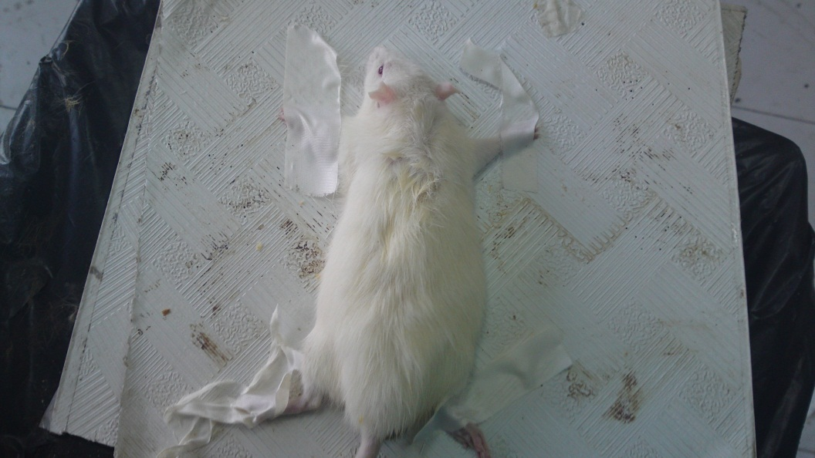

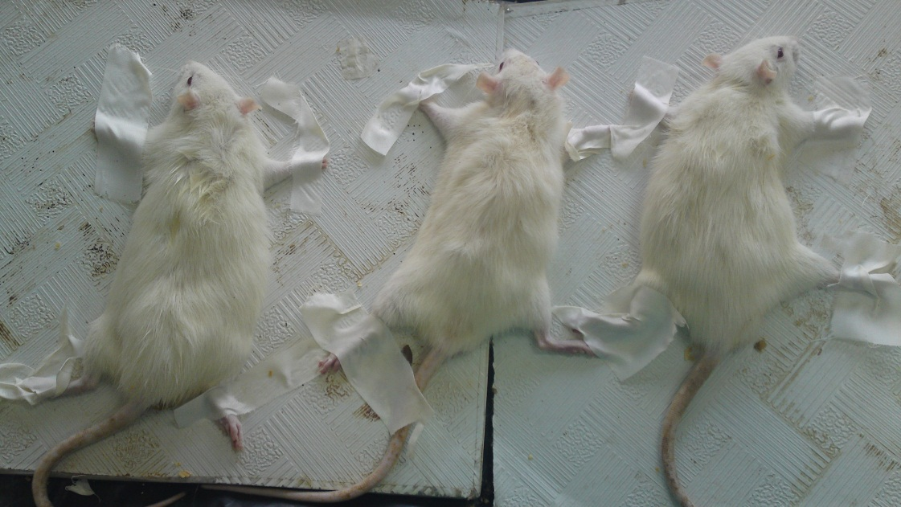
Figure (6): Immobilization stress was performed in supine position by tapping the four limbs of the animal

Table (1): Comparisons of brain and gastric AT1 gene expression change in different non-stressed study groups ( n = 10 )
Variables | Group 1 | Group 2 | Group 3 | p-value | Sig.
 | Mean ± SD | Mean ± SD | Mean ± SD
AT1 gene expression in brain | 1.02±0.02 | 1.03±0.34 | 1.029±0.19 | 0.9 | NS
AT1 gene expression in stomach | 1.04±0.02 | 1.05±0.06 | 1.039±0.40 | 0.8 | NS
n = No of rats in each group.

Figure (7): Comparisons of brain and gastric AT1 gene expression changes in different non-stressed study groups

Table (2): Comparisons of gastric juice parameters in different non-stressed study groups. ( n = 10 ).
Variables | Group 1 | Group 2 | Group 3 | p-value | Sig.
 | Mean ± SD | Mean ± SD | Mean ± SD
Titratrible acidity (gm/L) | 91.8±2.2 | 90.1±1.3 | 92.1±4.7 | 0.3 | NS
Mucous content (µg/gm) | 401.8±18.4 | 407.9±12.7 | 396.8±50.1 | 0.7 | NS
Pepsin activity (µM/ml) | 138.2±45.8 | 132.6±7.1 | 140.6±4.7 | 0.9 | NS
n = No of rats in each group.

Figure (8): Comparisons of titritable acidity in different non-stressed study groups.

Figure (9): Comparisons of mean mucous content in different non-stressed study groups.

Figure (10): Comparisons of mean pepsin activity in different non-stressed study groups.

Table (3): Comparisons of ulcer index, and protection ratio in different non-stressed study groups. (n = 10)
Variables | Group 1 | Group 2 | Group 3 | p-value | Sig.
 | Mean ±SD | Mean ±SD | Mean ±SD
Ulcer index | 3±0 | 3±0 | 3±0 | 1 | NS
Protection ratio | --- | 0 | 0 | 1 | NS
n = No of rats in each group.

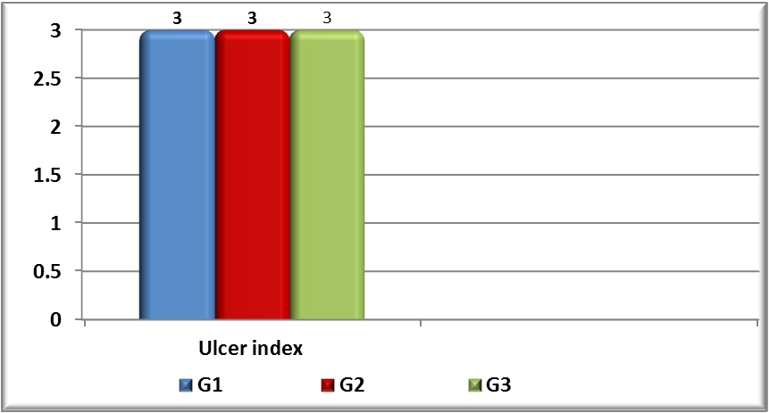
Figure (11): Comparisons of ulcer index, and protection ratio in different non-stressed study groups.

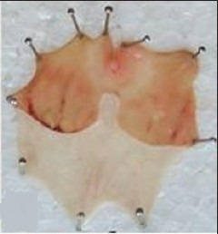

Figure (12): Gastric ulcers induced by chronic immobilization stress and pyloric ligation

Table (4): Comparisons of brain and gastric AT1 gene expression change in different stressed study groups.
Variables | Group 4 | Group 5 | Group 6 | p-value | Sig.
 | Mean ± SD | Mean ± SD | Mean ± SD
AT1 gene expression in brain | 9.59±0.82 | 5.21±0.71* | 3.64±0.78* | <0.001 | HS
AT1 gene expression in stomach | 12.02±1.3 | 2.95±1.3 | 4.38±0.65 | <0.001 | HS

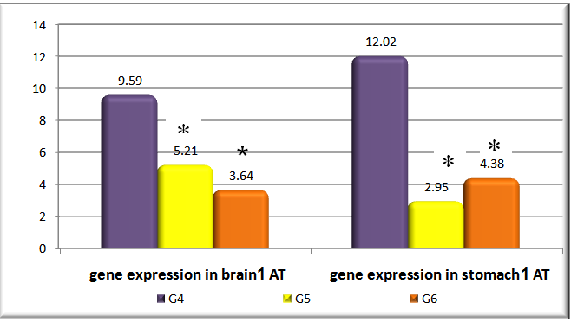
*
*
*
Figure (13): Comparisons of brain and gastric AT1 gene expression change in different stressed study groups.

Table (5): Comparisons of gastric juice parameters in different stressed study groups.
Variables | Group 4 | Group 5 | Group 6 | p-value | Sig.
 | Mean ± SD | Mean ± SD | Mean ± SD
Titratrible acidity (gm/L) | 149.1±12.1 | 102.27±2.3* | 104.52±3.9* | <0.001 | HS
Mucous content (µg/gm) | 141.62±27.1 | 189.42±14.7* | 237.48±34.7* | <0.001 | HS
Pepsin activity (µM/ml) | 404.69±21.5 | 161.38±16.6* | 165.98±5.6* | <0.001 | HS

*
*
Figure (14): Comparisons of mean titritable acidity in different stressed study groups.

*
Figure (15): Comparisons of mean mucous content in different stressed study groups.

*
*
Figure (16): Comparisons of mean pepsin activity in different stressed study groups.

Table (6): Comparisons of ulcer index, and protection ratio in different stressed and non-stressed study groups without any medication.
Variables | Group 4 | Group 5 | Group 6 | p-value | Sig.
 | Mean ±SD | Mean ±SD | Mean ±SD
Ulcer index | 19.6±0 | 11.8±0 | 9.3±0 | <0.001 | HS
Protection ratio | ---- | 39.7±0 | 52.5±0 | <0.001 | HS
*
*
*
Figure (17): Comparisons of ulcer index, and protection ratio in different stressed and non-stressed study groups without any medication.

Table (7): Comparisons of brain and gastric AT1 gene expression change in different stressed and non-stressed study groups without any medication.
Variables | Group 1  "non-stressed" |  | Group 4  "stressed" |  | p-value | Sig.
 | Mean | SD | Mean | SD
AT1 gene expression in brain | 1.02 | 0.02 | 9.59 | 0.82 | <0.001 | HS
AT1 gene expression in stomach | 1.04 | 0.02 | 12.02 | 1.3 | <0.001 | HS

*
*
Figure (18): Comparisons of brain and gastric AT1 gene expression change in different stressed and non-stressed study groups without any medication.

Table (8): Comparisons of gastric juice parameters in different stressed and non-stressed study groups without any medication.
Variables | Group 1  "non-stressed" |  | Group 4  "stressed" |  | p-value | Sig.
 | Mean | SD | Mean | SD
Titratrible acidity (gm/L) | 91.8 | 2.2 | 149.1 | 12.1 | <0.001 | HS
Mucous content (µg/gm) | 401.8 | 18.4 | 141.6 | 27.1 | <0.001 | HS
Pepsin activity (µM/ml) | 138.2 | 45.8 | 404.7 | 21.5 | <0.001 | HS

*
*
Figure (19): Comparisons of mean titritable acidity in different stressed and non-stressed study groups without any medication.
*
Figure (20): Comparisons of mean mucous content in different stressed and non-stressed study groups without any medication.

*
Figure (21): Comparisons of mean pepsin activity in different stressed and non-stressed study groups without any medication.

Table (9): Comparisons of ulcer index in different stressed and non-stressed study groups without any medication.
Variables | Group 1  "non-stressed" | Group 4  "stressed" | p-value | Sig.
 | Mean ±SD | Mean ±SD
Ulcer index | 3±0 | 19.6±0 | <0.001 | HS

*
Figure (22): Comparisons of ulcer index in different stressed and non-stressed study groups without any medication.

Table (10): Comparisons of brain and gastric AT1 gene expression hange in different stressed and non-stressed study groups treated with 1mg/kgm/day candesartan medication.
Variables | Group 2  "non-stressed" |  | Group 5  "stressed" |  | p-value | Sig.
 | Mean | SD | Mean | SD
AT1 gene expression in brain | 1.03 | 0.34 | 5.21 | 0.71 | <0.001 | HS
AT1 gene expression in stomach | 1.05 | 0.06 | 2.95 | 1.3 | <0.001 | HS

*
*
Figure (23): Comparisons of brain and gastric AT1 gene expression change in different stressed and non-stressed study groups with 1mg/kgm/day Candesartan medication.

*
Figure (24): Comparisons of mean titritable acidity in different stressed and non-stressed study groups treated with 1mg/kgm/day Candesartan medication.

Table (11): Comparisons of gastric juice parameters in different stressed and non-stressed study groups with 1mg/kgm/day Candesartan medication.
Variables | Group 2 "non-stressed" |  | Group 5 "stressed" |  | p-value | Sig.
 | Mean | SD | Mean | SD
Titratrible acidity (gm/L) | 90.1 | 1.3 | 102.3 | 2.3 | <0.001 | HS
Mucous content (µg/gm) | 407.9 | 12.7 | 189.4 | 14.7 | <0.001 | HS
Pepsin activity (µM/ml) | 132.6 | 7.1 | 161.4 | 16.6 | <0.001 | HS

*
Figure (25): Comparisons of mean mucous content in different stressed and non-stressed study groups treated with 1mg/kgm/day Candesartan medication.

*
Figure (26): Comparisons of mean pepsin activity in different stressed and non-stressed study groups treated with 1mg/kgm/day Candesartan medication.

Table (12): Comparisons of ulcer index, and protection ratio in different stressed and non-stressed study groups treated with 1mg/kgm/day Candesartan medication.
Variables | Group 2  "non-stressed" | Group 5  "stressed" | p-value | Sig.
 | Mean ±SD | Mean ±SD
Ulcer index | 3±0 | 11.8±0 | <0.001 | HS
Protection ratio | 0 | 39.7±0 | <0.001 | HS

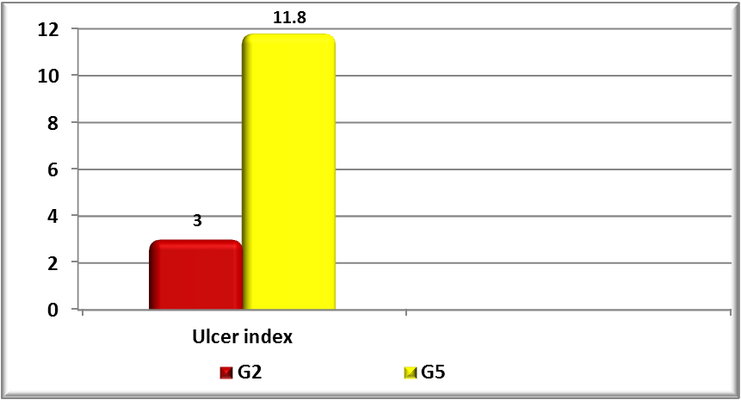
*
Figure (27): Comparisons of ulcer index in different stressed and non-stressed study groups with 1mg/kgm/day Candesartan medication.

Table (13): Comparisons of brain and gastric AT1 gene expression change in different stressed and non-stressed study groups treated with 2mg/kgm/day Candesartan medication.
Variables | Group 3  "non-stressed" |  | Group 6  "stressed" |  | p-value | Sig.
 | Mean | SD | Mean | SD
AT1 gene expression in brain | 1.029 | 0.19 | 3.6 | 0.78 | <0.001 | HS
AT1 gene expression in stomach | 1.039 | 0.40 | 4.38 | 0.65 | <0.001 | HS

Table (14): Comparisons of gastric juice parameters in different stressed and non-stressed study groups treated with 2mg/kgm/day Candesartan medication.
Variables | Group 3  "non-stressed" |  | Group 6  "stressed" |  | p-value | Sig.
 | Mean | SD | Mean | SD
Titratrible acidity (gm/L) | 92.1 | 4.7 | 104.5 | 3.9 | <0.001 | HS
Mucous content (µg/gm) | 396.8 | 50.1 | 237.5 | 34.7 | <0.001 | HS
Pepsin activity (µM/ml) | 140.65 | 4.7 | 165.9 | 5.6 | <0.001 | HS

*
*
Figure (28): Comparisons of brain and gastric AT1 gene expression change in different stressed and non-stressed study groups treated with 2mg/kgm/day Candesartan medication.

*
Figure (29): Comparisons of mean titritable acidity in different stressed and non-stressed study groups treated with 2mg/kgm/day Candesartan medication.

*
Figure (30): Comparisons of mean mucous content in different stressed and non-stressed study groups treated with 2mg/kgm/day Candesartan medication.

*
Figure (31): Comparisons of mean pepsin activity in different stressed and non-stressed study groups treated with 2mg/kgm/day Candesartan medication.

Table (15): Comparisons of ulcer index, and protection ratio in different stressed and non-stressed study groups with 2mg/kgm/day Candesartan medication.
Variables | Group 3 "non-stressed" | Group 6 "stressed" | p-value | Sig.
 | Mean ±SD | Mean ±SD
Ulcer index | 3±0 | 9.3±0 | <0.001 | HS
Protection ratio | 0 | 52.5±0 | <0.001 | HS
*

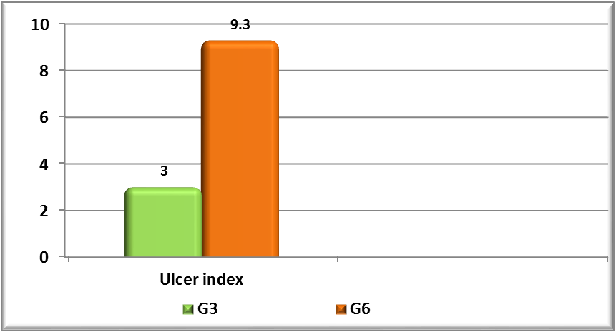
Figure (32): Comparisons of ulcer index in different stressed and non-stressed study groups treated with 2mg/kgm/day Candesartan medication.

Table (16): Correlation between Ulcer index with gastric juice parameters in all study groups.
Variables | Ulcer index
 | r | p-value | Sig.
Titratrible acidity (gm/L) | 0.91 | <0.001 | HS
Mucous content (µg/gm) | -0.93 | <0.001 | HS
Pepsin activity (µM/ml) | 0.84 | <0.001 | HS

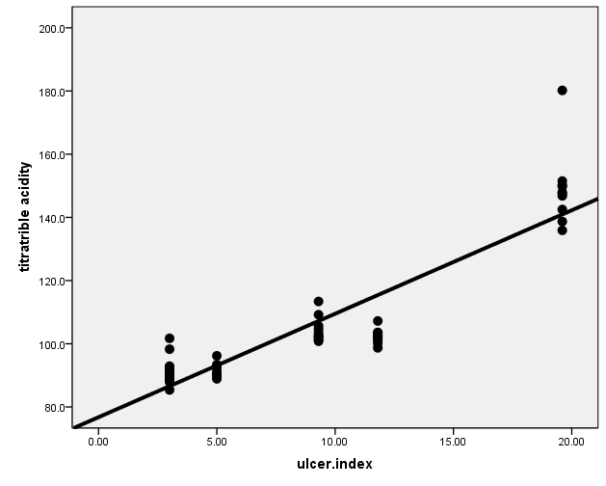
Figure (33): Correlation between ulcer index and titritable acidity.

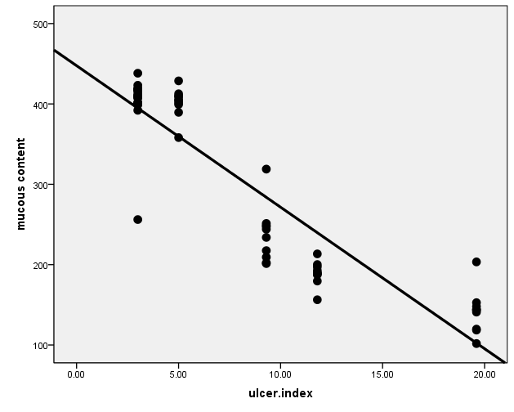

Figure (34) Correlation between ulcer index and mucous content.

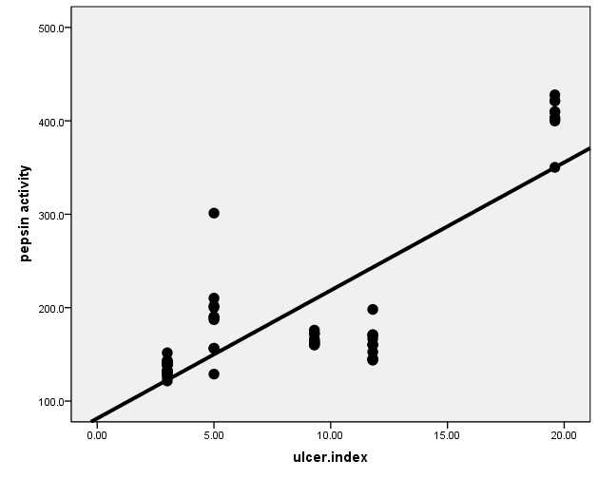

Figure (35): correlation between ulcer index and pepsin activity.

4. Discussion
Stress is a familiar aspect of the modern life (Young and Welsh, 2005). Although, the origin of the concept of stress in biology and medicine is unknown but investigations of stress rises from the recognition by Claude Bernard in 1878, that all living process exist in a state of dynamic internal physiologic equilibrium formed by organic liquid that surrounds all tissue elements (Rosmond, 2009).
The mechanism of stress ulcer is believed to be multi-factorial; a major factor in the development of stress ulcer is splanchnic hypo-perfusion, which results from a number of stress-related effects that the body produces in response to critical illness (e.g., hypotension and hypovolemia). These stress-related effects may include sympathetic nervous system activation, increased catecholamine release and vasoconstriction, hypovolemia, decreased cardiac output, and release of pro-inflammatory cytokines (Martindale, 2005). Many factors such as gastric acid and pepsin secretion, gastric microcirculation, PGE₂ content (Laine et al., 2008), and pro-inflammatory cytokines; interleukin 1 (IL-1) and tumor necrosis factor (TNF-α) (Appleyard et al., 1996) play, each in different way, important roles in the genesis of gastric mucosal damage, and its subsequent development(Wang et al., 2007; Wallace, 2008).
Angiotensin II is the primary active product of the RAAS. It is an octapeptide (1 – 8) formed from angiotensin I by the action of ACE (Brewster and perazella, 2004).
The angiotensin receptors are class of G protein-coupled receptors with angiotensins as their ligands (De Gasparo et al., 2000). At least 4 angiotensin receptor subtypes have been described (Stanton, 2013).
Ang II mediates nearly all of its physiological actions by activating two well characterized ang II receptor subtypes; Ang II -type 1 (AT₁) and Ang II- type 2 (AT₂) receptors (Brewster and perazella, 2004). Both receptors are polypeptides that contain approximately 360 amino acids. Major differences clearly separating their ultimate actions are their gene residue on different chromosomes; AT₁ on the 3rd chromosome and AT₂ on the 10th chromosome while they share a sequence homology of only 30% (Goodfriend et al., 1996).
Angiotesin II is now classified as an important stress hormone (Yang et al., 1996 and Saavedra and Benicky, 2011) and has been understood to become more important in cardiovascular regulations (Porter, 2000). Also, it is suggested that blockade of angiotensin ІІ may be important for prevention and treatment of diabetes mellitus and CVD that are usually associated with stress (Uresin et al., 2004).
The aim of this work is to investigate the effect of chronic immobilization stress, which is thought to be a mixture of physical and physchological stressors, on the AT 1 gene expression in brain and gastric tissue in adult male albino rats and the possible effects of angiotensin ІІ type 1 receptor (AT1) blocker (candesartan) as a possible anti-stress and anti-ulcer (on gastric mucosa).
In the present study, chronic immobilization stress for 60 min/day for 10 consecutive days resulted in significant increase in titraitble acidity and pepsin activity in gastric secretion in stressed rats who did not receive any medications (group 4) with values of 149.1 gm/L and 404.7 µM/ml respectively as compared to non-stressed group of rats who did not also receive any medications (group 1) with values of 91.8 gm/L and 192.2 µM/ml respectively.
The increase in titratable acidity in immobilization stress agree well with (Iwao Arai et al., 2003) who stated that gastric acid output significantly increases by water-immersion stress and immobilization stress.
Gastric acid secretion is controlled by sympathetic and parasympathetic nerves, and by certain hormones, such as gastrin. Generally, sympathetic activity inhibits, and parasympathetic activity stimulates, gastric acid secretion. Occasionally, sympathetic stimulation may also increase gastric acid secretion, because adrenalin releases gastrin; and vagal nerves may exert some sympathetic-like effect as they have adrenergic fibers (Paul et al., 2006).
Stress causes time-dependent increase in pepsin activity as reported by (Dipak et al., 1993), who also mentioned that histological examination of gastric tissue revealed stress induced extensive damage of the surface epithelial cell with lesions extending up to submucosa in some cases.
Merai et al. (2009) reported that, pepsin activity increases during different types of stress including immobilization stress, this increase in pepsin activity occurs through stimulation of vagus nerve by vago-vagal reflexes, stimulation of peptic cells by acetyl choline released from vagus nerve or from gastric enteric nervous plexus. He mentioned that stimulation of peptic cell secretion occurs also in response to acid in the stomach, HCL do not stimulate pepsin secretion directly but instead, it elicits additional enteric nervous reflexes that support the original nervous signals to peptic cells.
The results showed that mucous content has decreased significantly to a mean value of 141.6 µg/gm in stressed group, while it was 401.8 µg/gm in non stressed group. These results agree with Nosálová et al., (1991), who stated that gastric mucus originates from the goblet cells and chronic immobilization stress decreased the gastric mucus content and induced hemorrhagic erosions in the stomach.
Gastric mucus plays a critical role in the primary defense of the gastric mucosa and provides a protective barrier in the gastric epithelium.
(Kanuitz, 1999).
Nishida et al. (2014) have reported that immobilization stress induces gastric mucosal lesions with a decrease in gastric mucus content in rats. He also reported a decrease in mucus content with lesion development in the gastric mucosa of rats following immobilization stress and have indicated that impaired gastric mucus synthesis and secretion occur through a decrease in gastric eOS activity in immobilized-stressed rats.
Ichikawa et al. (2015) reported that NO generators increase the thickness of the mucus layer in the rat stomach and stimulate mucus secretion from rat gastric mucosal cells.
Suleyman et al. (2010) reported that stress induces gastric mucosal lesions by complex psychological factors including a decrease in the release of protective factors like bicarbonate, and mucus with an increase in the aggressive factors like acid.
Boveris et al. (2003) reported that both candesartan and enalapril produced a significant increase in NO and glutathione. NO has a role in the protection of gastric mucosa by the maintenance of mucosal blood flow, and stimulation of gastric mucus synthesis and secretion.( Tandon et al., 2004 ).
The results demonstrated that chronic immobilization stress produced gastric ulcer with mean ulcer index of 19.6 ± 0 in group 4 as compared to group 1 with an ulcer index of 5 ± 0.
These results agreed well with Paul et al. (2006) who stated that there is a certain relationship between gastric ulcer and stress.
Stress stimulates the RAS by enhancing ANG II formation which leads to vasoconstriction and generation of free radicals causing a gastric ulcer.
Stress reduces gastric blood flow and produces acute gastric mucosal lesions. Angiotensin II (ANG II) is a stress hormone where the levels of which dramatically increase in plasma and tissues, including stomach, during stress. It is the main effector of the RAS where it is generated from the precursor angiotensinogen by the actions of renin, ACE and various peptidases. ANG II not only regulates vascular tone in resistance arteries and in the brain but also constricts the gastric vasculature through AT1R stimulation. In addition, ANG II generates reactive oxygen species (ROS) with cellular damage and inflammation. Oxidative stress with the generation of ROS, mucosal vasoconstriction and proinflammatory effects of ANG II could contribute to the production of stress-induced gastric ulcers ( Tandon et al., 2004 ).
Stress has significant contribution in the pathophysiology of gastric ulcer and can promote damage through acid secretion, activation of hypothalamus-pituitary-adrenal axis, proliferation of pro-inflammatory cytokines and decrease in local blood flow. Such lesions can be detected after short exposure of animals to a stressful situation (Morsy et al., 2012).
Goldin and Peura (1996) reported that stress-induced lesions in the gastrointestinal tract can cause overt bleeding and hemodynamic instability in critically ill patients. Endoscopy studies have demonstrated that these lesions develop in many patients within the first few days of a critical illness; many lesions develop within 24 hours.
Many terms have been used to describe stress ulcer in critically ill patients, including stress ulcer/ulceration, stress erosions, stress gastritis, hemorrhagic gastritis, erosive gastritis, and stress-related mucosal disease (Quenot et al., 2009).
Bregonzio et al. (2003) reported that a stress-induced disorder, acute gastric ulceration as a consequence of cold-restraint stress in rats produces, through local and centrally-induced vasoconstriction and mucosal inflammation, a significant number of ulcerations of the gastric mucosa with increase in gastric acid secretion and pepsin activity.
Stress induces acute gastric mucosa lesions by a variety of mechanisms, including psychological factors influencing individual vulnerability, stimulation of specific brain pathways regulating autonomic function, decreased blood flow to the mucosa, increase in muscular contractility, mast cell degranulation, leukocyte activation and increased free radical generation resulting in increased lipid peroxidation (Andrade et al., 2001).
Maintenance of gastric blood flow is important to protect the mucosa from endogenous and exogenous damaging factors, and Ang II, through AT1 receptor stimulation, increases vascular tone in resistance arteries including those of the gastric vasculature leading to decreased blood flow and ischemia. (Paul et al., 2006).
With the use of candesartan, known as a potent ARB, it was clear in the results of this study that it has a great protective role regarding gastric ulceration and stress response.
In pylorus ligated rats, there is accumulation of gastric acid and pepsin in the stomach leading to development of ulcers (Merai et al., 2009). The probable mechanism of increased acid output in pylorus ligation method in rats with intact vagus, is that this acid response is elicited by vago-vagal reflexes activated by pressure receptors located in the pyloric gland area (Alumets et al., 1982).
The probable mechanism by which angiotensin receptor antagonists decreases titritable acidity in pylorus ligation method could be attributed to their increased stimulation of gastrointestinal HCO3- secretion by a common pathway involving NO, PGs and bradykinin. This anti-secretory activity could be because of increased NO generation by AT receptor antagonists (Szlachcic et al., 2013) in response to enhanced acid secretion induced by vagally mediated mechanism, which occurs in pylorus ligation (Alumets J et al., 1982). This NO reduces the gastric acid secretion under basal as well as stimulated conditions (Szlachcic et al., 2013).
The dose of 1 mg/kg/day (group 5) and 2 mg/kg/day candesartan (group 6) orally reduced gastric ulceration with an ulcer index 11.8 and 9.3 in group 5 and 6 respectively as compared to group 4 with a value of 19.6 which did not receive candesartan treatment with the daily immobilization stress 60 minutes per day for 10 consecutive days with a protection ratio of 39.7% and 52.5% respectively.
These results could be explained by the results of Bregonzio et al. (2003) who found that the effects of candesartan on the stress-induced disorder, acute gastric ulceration as a consequence of cold-restraint stress in rats, established that AT₁ receptor blockade has meaningful therapeutic benefits. Cold-restraint stress, through local and centrally-induced vasoconstriction, and mucosal inflammation, produces a significant number of ulcerations of the gastric mucosa. Blockade of AT₁ receptors dramatically decreased the number of gastric ulcerations in this model.
So, the protective effect of candesartan could be the result of prevention of the stress-induced reduction on gastric blood flow and ischemia, of reduction of central and peripheral sympathoadrenal stimulation and of direct anti-inflammatory effects in the gastric mucosa as was described by Bregonzio et al. (2003).
ANG II, the most active factor in RAS, is a well-known oxidative stress inducer. It increases the generation of superoxide anion, hydrogen peroxide, and hydroxyl radicals by activating the NADPH oxidase enzyme. Also, ANG II activates inflammatory cascades with increased production of the pro-inflammatory cytokine, tumor necrosis factor-α which is responsible for further gastric mucosal injury (Bregonzio et al., 2003).
The protection of gastric blood flow after administration of AT1 receptor antagonists is probably mediated by inhibition of receptors localized to the endothelium of arteries located in the gastric mucosa (Bregonzio et al., 2003).
Lines of evidence supporting the hypothesis of a major role of brain Ang II in stress include stress-induced increases in circulating and brain Ang II levels (Yang et al. , 1996), high AT₁ receptor expression in all areas involved in the stimulation of the hypothalamic-pituitary-adrenal axis (HPA) activity, including the hypothalamic paraventricular nucleus (PVN), the median eminence (ME) and the subfornical organ (SFO) (Tsutsumi and Saavedra 1991), and a stress-induced increase in AT₁receptor expression in the parvocellular PVN, where cell bodies forming the corticotropin-releasing hormone (CRH) are located (Aguilera et al., 1995).
Sustained inhibition of peripheral and brain AT₁ receptors by peripheral administration of the AT₁ receptor antagonist candesartan prevents not only the hormonal, but also the sympatho-adrenal response to immobilization stress (Armando et al., 2002). In addition, candesartan pretreatment prevents the activation of the brain sympathetic system during immobilization. (Saavedra et al., 2006).
These results suggest that the effect of AT₁ receptor antagonists may not be limited to their action in the hypothalamus. In addition to hypothalamic areas, AT₁ receptors are expressed in brain areas regulating the response of the limbic system to stress, such as the basolateral amygdaloid nucleus (Tsutsumi and Saavedra, 1991). This, and the anxiolytic and cortical effects of AT₁ receptor blockade, suggest a role for Ang II in the regulation not only of the autonomic and hormonal, but also the behavioral response to stress (Shekhar et al., 2003).
The brain also expresses another Ang II receptor type, the AT₂ receptors (Tsutsumi and Saavedra, 1991) located, in the adult rat brain, in areas related to sensory and motor function and behavior, such as the inferior olivary complex and thalamic nuclei (Tsutsumi and Saavedra, 1991). In the rat, there are high numbers of AT₂ receptors in the locus coeruleus (Tsutsumi and Saavedra, 1991), the major site for catecholamine synthesis projecting to the forebrain (Sawchenko and Swanson, 2013). A role for brain AT₂ receptors in the regulation of central catecholamine formation and stress is further supported by the decrease in AT₂ receptor mRNA in the locus coeruleus and inferior olive of rats submitted to chronic cold stress (Peng and Phillips, 2014) and by the increased stress response (Watanabe et al. 2009), HPA axis stimulation and AT₁ receptor expression (Armando et al., 2002).
Candesartan pretreatment prevented a stress-induced disorder, the development of cold-restraint induced gastric ulcers in rats. (Bregonzio et al., 2003).
In rats, stress-induced overexpression of the AT1 angiotensin receptors in brain and periphery has been known for a long time (Aguilera et al., 1995; Yang et al., 1996). Various types of stress, through peripheral sympathetic stimulation, increase renin activity and therefore production of circulating angiotensin II (Ang II) (Xang et al., 1993). Stress increases Ang II content in many brain regions including the hypothlalamus (Xang et al. 1993).
AT-II is a stress hormone (Brzozowski et al., 2012), whose levels get increased in plasma and tissues like brain, kidneys, liver, including stomach during stress. This generates reactive oxygen species (ROS) which cause cell inflammation and damage. During stress, there occurs increased expression of the proinflammatory cytokines; TNF-α and intracellular adhesion molecule-1 (ICAM-1) along with neutrophil infiltration and leukocyte migration in the gastric mucosa (Pawlik et al., 2011.
So, by virtue of its variety of effects including oxidative damage, inflammation, and impaired gastroduodenal blood flow; AT-II is involved in the pathogenesis of peptic ulcers. Therefore, AT receptor antagonists which prevent binding of AT-II to AT1 receptors; have been thought to be implicated in protection of gastric mucosa against development of ulcers (Rozza et al. 2013).
It was found that stress markedly increased the expression of the proinflammatory cytokine tumor necrosis factor α (TNF-α), the adhesion molecule intercellular adhesion molecule-1 (ICAM-1) and the number of infiltrating neutrophils in the gastric mucosa (Bregonzio et al., 2003), which play crucial roles in the progression of gastric injury (Hamaguchi et al., 2011).
Activated neutrophils release inflammatory mediators capable of damaging endothelial cells and inhibition of neutrophil infiltration prevents the stress-induced reduction of mucosal blood flow and the production of gastric lesions (Liu et al., 2009).
Ang II promotes tissue inflammation; enhancing neutrophil infiltration through AT1 receptor stimulation, increased expression of TNF-α, ICAM-1 and P-selectin (Piqueras et al., 2014). It was documented that pretreatment with the AT1 antagonist decreased the stress-induced overexpression of TNF-α and ICAM-1 overexpression and the neutrophil infiltration in the gastric mucosa indicating that the anti-inflammatory effects of AT1 blockade could be relevant for the protection of stress-induced lesions (Bregonzio et al., 2003).
It was found that inhibition of AT1 receptors, by combined local and systemic mechanisms, protects gastric blood flow, inhibits the pro inflammatory cascade preventing the gastric ischemia and inflammation characteristic of a major stress response and protecting the gastric mucosa from stress-induced ulcerations.
In the present study, gene expression in brain and stomach increased markedly in stressed group that did not receive any medications (group 4) with values of 9.59,12.02 respectively compared to1.02,1.04 in non-stressed groups of rats which did not receive any medications (group 1).
These results agree well with (Yang , et al 1996) who reported that during stress, both the peripheral and the central Ang II systems are stimulated, with increases in Ang II levels and AT 1 receptor expression. Different types of stress, through peripheral sympathetic nerve stimulation, increase renin activity and therefore the production of circulating Ang II.
The expression of AT1 and AT2 receptors in the adrenal zona glomerulosa and medulla and in the anterior pituitary is increased during isolation or restraint stress, although these changes are dependent on the type and duration of the stressor (Armando et al., 2002).
Stress increases the concentration of brain Ang II, Acute stress increases Ang II content in many brain regions including the hypothalamus and AT1 receptor expression in the parvocellular portion of the paraventricular nucleus, the subfornical organ, the median eminence and the anterior pituitary (Leong et al., 2002).
Demonstration of central AT1 receptor inhibition after systemic administration of the ARB candesartan (Nishimura et al., 2000) allowed pursuing studies to clarify the role of AT1 receptors in the brain under physiological and pathological conditions. It was also possible to determine the consequences of central AT1 receptor inhibition resulting from systemic ARB administration. A more complex and widespread functional spectrum for Angiotensin II AT1 receptors emerged, indicating participation on the central control of endocrine and autonomic functions and behavior. Studies on the role of brain Angiotensin II have been extensively summarized in a number of reviews ( Saavedra et al., 2005; Saavedra et al. 2006; Paul et al., 2006; Phillips and de Oliveira, 2008; Bader, 2010).

References
- Aguilera, G.; Kiss, A. and Sunar-Akbasak, B. (1995): Hyperreninemic hyperaldosteronism after chronic stress in the rat. J. Clin. Invest.; 96 (3): 1512 – 19.
- Alexander, K.; Dana, J.; Danila, J. and Olga, K. (2001): Changes in angiotensin AT1 receptor mRNA levels in the rat brain after immobilization stress and inhibition of central nitric oxide synthase. Endocrine Regulations; 35: 65 – 70.
- Alumets J, Ekelund L, Hakanson R, Hedenbro J, Rehfeld JF, Sundler F, Vallgren S. (1982): Gastric acid response to pylorus ligation in rats: Is gastrin or histamine involved? J. Physiol. 323: 145-56.
- Anchkov, S.V and Zovodskoya, I.S.; (1968): The experimental Basis of gastric ulcer pharmacotherapy, p.56. Pergamon press.
- Anson, M.L.,(1988): The estimation of pepsin, trypsin, papain, and cathepsin with haemoglobin. Journal of General Physiology; 22, 79-89 (1988).
- Appleyard C.B., McCafferty D.M., Tigley A.W., Swain M.G. and Wallace J.L. (1996): Tumor necrosis factor mediation of NSAID-induced gastric damage: role of leukocyte adherence. Am J Physiol 270: G42–G48.
- Armando I, Carranza A, Nishimura Y, Hoe KL, Barontini M, Terro´nJA, et al. (2002): Peripheral administration of an angiotensin II AT1 receptor antagonist decreases the hypothalamic–pituitary–adrenal response to stress. Endocrinology 2002; 142: 3880–9.
- Bader, M. (2010): Tissue Renin-Angiotensin-Aldosterone Systems: Targets for Pharmacological Therapy. Ann. Rev. Pharm. Tox. 2010; 50: 439–465.
- Boveris A, D'Amico G, Lores-Arnaiz S (2003): Enalapril increases mitochondrial nitric oxide synthase activity in heart and liver. Antioxid Redox Signal.; 5 (6): 691-7.
- Brewster, U.C. and Perazella, M.A. (2004): Cardio-renal effects of the renin- angiotensin- aldosterone system. Am J Med Sci. 2003 Jul; 326 (1): 15-24. Review. PMID: 12861121.
- Brzozowski T, Ptak-Belowska A, Kwiecien S, Krzysiek-Maczka G, Strzalka M, Drozdowicz D et al. (2012): Novel concept in the mechanism of injury and protection of gastric mucosa: role of renin-angiotensin system and active metabolites of angiotensin. Curr Med Chem. 2012; 19 (1): 55-62.
- Corne SJ, Monisey SM and Wood RJ. (1974): A method for the quantitative estimation of gastric barrier mucus. Physiol. 1974; 242 (2): 116-117.
- De Gasparo, M.; Catt, K.J.; Inagami, T.; Wright, J.W. and Unger, T. (2000): The angiotensin II receptors. International union of pharmacology. XXIII. Pharmacol. Rev.; 52 (3): 415 – 72.
- Dipak Das, Ranajit K. Banerjee Nosálová, V., Juránek, I. & Babulová, A. Agents and Actions (1993): Effect of stress on the antioxidant enzymes and gastric ulceration Molecular and Cellular Biochemistry 33:164. doi:10.1007/BF01993156 August 1993, Volume 125, Issue 2, pp 115–125.
- Fagan SC, Kozak A, Hill WD, Pollock DM, Xu L, Johnson MH, Ergul A, and Hess DC (2006): Hypertension after experimental cerebral ischemia: candesartan provides neurovascular protection. J Hypertens. 24: 535-539.
- Goldin, G. F. & Peura, D. A. (1996): Stress-related mucosal damage. What to do or not to do. Gastrointest. Endosc. Clin. N. Am. 6, 505–526.
- Goodfriend, T.L.; Elliot, M.E. and Catt, K.J. (1996): Angiotensin receptors and their antagonists. N. Engl. J. Med.; 334: 1649 – 55.
- Grossman, M.L. (1963): "Gastric secretion" in physiology for the physicians. A monthly publication of American physiological society volume 1 (7) 1-5.
- Guth, P.H. (1972): Gastric blood flow in restraint stress. Am. J. Dig. Dis. 17: 807 - 813.
- Hamaguchi M, Watanabe T, Higuchi K, Tominaga K, Fujiwara Y, Arakawa T. (2011): Mechanisms and roles of neutrophil infiltration in stress-induced gastric injury in rats. Dig Dis Sci; 46: 2708–15.
- Hanson, H.M and Brodie, D.A. (1960): Use of restraint rat technique for study of antiulcer effect of drugs. J. Appl. physiology. 15(2): 291-294.
- Ichikawa T, Ishihara K, Kusakabe T et al. (2015): Stimulant effect of nitric oxide generator and roxatidine on mucin biosynthesis of rat gastric oxyntic mucosa. Life Sci.; 65: PL41–6.
- Iwao A., Haruko H., Makoto M., and Hironaka A. (2003): Effects of restraint and water-immersion stress and insulin on gastric acid secretion in rats. Research Center, Taisho Pharmaceutical Co., Ltd. I - 403, Yoshino-cho, Ohmiya, Saitama 330, Japan.
- Kanuitz JD. (1999): Barrier function of gastric mucus. Keio Med. J. 1999 Jun;48 (2):63 – 8.
- Laine, L., Takeuchi, K. and Tarnawski, A. (2008): Gastric mucosal defense and cytoprotection: Gastroenterology 135: 41 – 60.
- Leong, DS, Terro´n, JA, Falco´n-Neri, A, Armando I, Ito, T, Jfhren, O, et al. (2002): Restraint stress modulates brain, pituitary and adrenal expression of angiotensin II AT 1A, AT1B and AT2 receptors. Neuroendocrinology 2002; 75: 227 – 40.
- Liu, W, Okajima, K, Murakami, K, Harada, N, Isobe, H, and Irie, T. (2009): Role of neutrophil elastase in stress - induced gastric mucosal injury in rats. J Lab Clin Med; 132: 432 – 9.
- Martindale R.G. (2005) Temporary strategies for the prevention of stress-related mucosal bleeding. Am J Health Syst Pharm 62 (10 Suppl 2): S11 - S17.
- Merai AH, Asad M, Prasad VS. (2009): Effect of Centrally Administered Losartan on Gastric and Duodenal Ulcers in Rats. Pharmacology; 84: 93 - 8.
- MicultKova, L.; krepsova, K.; Sabban E.; Krizanova, O. and Kvetnansky, R. (2004): Modulation of catecholamine-synthesizing enzymes in rat heart by repeated immobilization stress. Ann. N.Y. Acad. Sci.; 1018: 424 – 9.
- Morsy, MA, Heeba, GH, Abdelwahab, SA and Rofaeil, RR. (2012): Protective effects of nebivolol against cold restraint stress-induced gastric ulcer in rats: Role of NO HO-1, and COX1-2. Nitric Oxide 27 (Suppl.2): 117 - 122.
- Nagai M, Horikoshi K, Izumi T, Seki S, Taniguchi M, Taniguchi I, and Mochizuki S (2004): Cardioprotective action of perindopril versus candesartan in reno-vascular hypertensive rats. Cardiovasc Drugs Ther. Sep;18 (5): 353 - 62.
- Nishida K, Ohta Y, Ishiguro I (2014): Changes in nitric oxide production with lesion development in the gastric mucosa of rats with water immersion restraint stress. Res Commun Mol Pathol 100 (2): 201 – 212.
- Nishimura Y, Ito T, Hoe K, Saavedra JM. (2000): Chronic peripheral administration of the angiotensin II AT (1) receptor antagonist candesartan blocks brain AT (1) receptors. Brain Res.; 871: 29 –38.
- Nosálová, V., Juránek, I. & Babulová, A. (1991): Effect of pentacaine and ranitidine on gastric mucus changes induced by cold-restraint stress in rats, Agents and Actions 33: 164. doi:10.1007/BF01993156, Volume 33, Issue 1, pp 164 – 166.
- Paul, M.; Mehr, A.P. and Kreutz, R. (2006): Physiology of local renin- angiotensin system. Physiol. Rev.; 86: 747 – 803.
- Pavel J1, Benicky J, Murakami Y, Sanchez-Lemus E, Saavedra JM.(2008): Peripherally administered angiotensin II AT1 receptor antagonists are anti-stress compounds in vivo. Ann N Y Acad Sci.; 1148:360-6. doi: 10.1196 / annals. 1410.006.
- Pawlik M, Pajdo R, Kwiecien S, Ptak-Belowska A, Sliwowski Z, Mazurkiewicz-Janik M et al. (2011): Nitric oxide (NO)- releasing aspirin exhibits a potent esophagoprotection in experimental model of acute reflux esophagitis. Role of nitric oxide and proinflammatory cytokines. J Physiol Pharmacol. 2011; 62 (1): 75 - 86.
- Peng JF, Phillips MI. (2014): Opposite regulation of brain angiotensin type 1 and type 2 receptors in cold-induced hypertension. Regul Pept.; 97: 91 – 109.
- Pfaffl M.W. and Hageleit,M. (2001): Validities of mRNA quantification using recombinant RNA and recombinant DNA external calibration curves in real-time RT–PCR. Biotechnol. Lett., 23: 275 – 282.
- Piqueras L, Kubes P, Alvarez A, O’Connor E, Issekutz AC, Esplugues JV, et al. (2014): Angiotensin II induces leukocyte–endothelialcell interactions in vivo via AT1 and AT2 receptor-mediated P-selectin upregulation. Circulation 20; 102: 2118–23.
- Porter, J.P. (2000): Contribution of central ANG. ІІ to acute stress- induced changes in baroreflex function in young rats. Am. J. Physiol.; 279 (4): R1386 – R1391.
- Quenot J.P., Thiery N., Barbar S. (2009) When should stress ulcer prophylaxis be used in the ICU? Curr Opin Crit Care 15: 139–143.
- Robert, A., Nezamis, J.E. and Philips, J.p. (1968): Effect of prostaglandin E1 on gastric secretion and ulcer formation in the rat. Gastroenterology 55(4): 481 - 487.
- Rosmond, R. (2009): Metabolic effects of stress. Biol Signals.; May-Jun; 2 (3): 166 - 72.
- Rozza, A.L.; Hiruma-Lima, C.A.; Takahira, R.K.; Padovani, C.R.; Pellizzon, C.H. (2013): Effect of menthol in experimentally induced ulcers: Pathways of gastroprotection. Chem. Biol. Interact.; 206, 272 – 278.
- Saavedra, J.M. and Benicky, J. (2011): Brain and peripheral angiotensin II play a major role in stress. Stress; 10(2): 185 – 93.
- Saavedra JM. (2005): Brain Angiotensin II: New Developments, Unanswered Questions and Therapeutic Opportunities. Cell Mol Neurobiol.; 25: 485 – 512.
- Saavedra JM, Armando I, Bregonzio C, Juorio A, Macova M, Pavel J, Sanchez-Lemus E. (2006): A centrally acting, anxiolytic angiotensin II AT1 receptor antagonist prevents the isolation stress-induced decrease in cortical CRF1 receptor and benzodiazepine binding. Neuropsychopharmacology.; 31: 1123 – 1134.
- Sawchenko P, and Swanson L. (2013): Central noradrenergic pathways for the integration of hypothalamic neuroendocrine and autonomic responses. Science.; 214: 683 – 687.
- Shay, H., (1945): A simple method for the uniform production of gastric ulceration in the rat. Gastroenterology, 4: 43-61.
- Shekhar A, Sajdyk TJ, Gehlert DR, and Rainnie DG. (2003): The amygdala, panic disorder, and cardiovascular responses. Ann NY Acad Sci.; 85: 308 – 325.
- Stanton, A. (2013): Therapeutic potential of renin inhibitors in the management of cardiovascular disorders. Am. J. Cardiovasc. Drugs; 3: 389 – 94.
- Suleyman H, Albayrak A, Bilic M, Cadirci E. (2010): Different mechanisms in information and prevention of indomethacin-induced gastric ulcers. Inflammation.; 33 (4): 224 - 34.
- Szlachcic A, Krzysiek-Maczka G, Pajdo R, Targosz A, Magierowski M, Jasnos K et al. (2013): The impact of asymmetric dimethylarginine (ADMA), the endogenous nitric oxide (NO) synthase inhibitor to the pathogenesis of gastric mucosal damage. Curr Pharm Des.; 19: 90 - 97.
- Takagi, k and Okabe, S. (1968): The effect of drugs on the production and recovery process of the stress ulcer. Jap. J. pharmacol. 18: 9 -18.
- Tsutsumi K, Saavedra JM. (1991): Angiotensin-II receptor subtypes in median eminence and basal forebrain areas involved in regulation of pituitary function. Endocrinology. 1991 Dec; 129(6):3001-8.
- Uresin, A.Y.; Tonyali, H. and Karamursel, S. (2004): The effects of losartan and immobilization stress on heart rate variability and plasma corticosterone levels in rats. Int. J. Neurosci. 114 (3): 365 – 79.
- Wallace J.L. (2008): Prostaglandin, NSAIDs, and gastric mucosal protection: why doesn’t the stomach digest itself? Physiol Rev 88:1547–1565.
- Xang G, Xi ZX, Wan Y, Wang H, Bi G (1993): Changes in circulating and tissue angiotensin II during acute and chronic stress. Biol Signals. May - Jun; 2(3): 166 - 72.
- Young, C.R. and Welsh, C.J. (2005): Stress, health and disease. Introductory Review. Cell Sci. Rev.; 2 (2): 1742.
- Wang G.Z., Huang G.P., Yin G.L., Zhou G., Guo C.J., Xie C.G., Jia B.B. and Wang J.F. (2007): Aspirin can elicit the recurrence of gastric ulcer induced with acetic acid in rats. Cell Physiol. Biochem. 20: 205 – 212.
- Watanabe, T.; Fujioka, T.; Hashimoto, M. and Nakamura, S. (2009): Stress and brain angiotensin ІІ receptors. Critical Reviews in Neurobiology; 12 (4): 305 – 317.

3/15/2017

