Effect of Muscular Exercise Program with and without Antioxidant on Serum Level of S100B Protein in Male Albino Rats as a Marker of Central Exhaustion and Some Related Parameters

Saad Kamal Taha¹, Hamed Mohamed Osman¹ and Ahmed Mohamed Abd El-Monaem²

¹Medical Physiology, Faculty of Medicine, Al-Azhar University, Egypt
²Medical Physiology Department, Faculty of Medicine, Fayoum University, Egypt

Abstract: The study targeted effect of muscular exercise alone on plasma level of s100B protein level as a marker of central exhaustion which increases permeability of blood brain barrier, and some related factors as serum lactic acid, malondialdohyde (MDA) and total antioxidant capacity. Also, to investigate the effect of muscular exercise with the use of antioxidant on plasma level of s100B protein level and some related factors as serum lactic acid, malondialdohyde (MDA) and total antioxidant capacity. Twenty seven adult male albino rats were divided into 3 equal groups; Group 1: control, Group 2: exposed to muscular exercise program only and Group 3: exposed to muscular exercise program and take vitamin C. The results showed that there were statistically significant differences of measured markers between resting and after the exhaustive muscular exercise bout before the application of training program in all groups, After the application of a 12 weeks training program; During rest, There were statistically significance differences between different groups regarding S100B and TAC only, while the other markers (MDA and LAC) didn’t show any significant changes. After the exhaustive exercise bout: There were statistically significant differences between group 1 and the other two groups as regards to LAC, MDA and TAC level. There was no statistically significant difference among the 3 groups in serum level of S100B. But in groups 2 & 3 there were statistically significant differences between resting and exhaustion after application of training program regards all markers (S100B, LAC, TAC, and MDA).
[Ahmed Mohamed Abd El-Monaem, Saad Kamal Taha and Hamed Mohamed Osman. Effect of Muscular Exercise Program with and without Antioxidant on Serum Level of S100B Protein in Male Albino Rats as a Marker of Central Exhaustion and Some Related Parameters. N Y Sci J 2017;10(3):80-95]. ISSN 1554-0200 (print); ISSN 2375-723X (online). http://www.sciencepub.net/newyork. 12. doi:10.7537/marsnys100317.12.

Keywords: shanghai; Muscular Exercise; Antioxidant; Serum; Protein; Male; Rat; Exhaustion; Parameter

1. Introduction
S100B is a beta homodimeric protein within the S100 family of calcium-binding proteins, with each beta monomer approximately 10.5 kDa in size (Gonc et al., 2008). However, S100B is not speciﬁc to the brain, as it has been detected in extracerebral cell types such as adipocytes (Gonc et al., 2010), melanocytes, skeletal myoﬁbers and myoblasts (Tubaro et al., 2010). S100B can also be found in tissues of the bladder, liver, kidney, colon, lungs, pancreas, tonsil and stomach via immune histo- chemical staining with antibody detection (Pham et al., 2010). intracellular and extracellular functions of S100B, including a recent review by Michetti et al. (Michetti et al., 2012). The intracellular effect of S100Bas it regulates cytoskeleton and cell proliferation and regulates levels of cytosolic Ca2 and/ or transducing the intracellular Ca2 signal (Donato, 2003). Extracellular effect of S100B appears to have a neurotropic role in both development and repair (Sorci et al., 2010). It stimulates neurite outgrowth, glial proliferation, and the regeneration of injured nerves (Iwasaki et al., 1997). S100B also has a neuro-protective function, in enhancing neuronal cell maintenance, preventing motor neuron degeneration and enhancing the survival of neurons (Bhattacharyya et al, 1992).
However, the possibility of a cerebral origin of S100B in this study still cannot be excluded, as vitamin E may play a role in the maintenance of neurological structure and function. (Pace et al., 2003).
A possible relationship between S100B and vitamin E was suggested by Bialowas-McGoey et al., 2008, who reported that vitamin E can alter the oxidative state of S100B and affect the expression of an S100B receptor to cause increases in microglial activation. However, the signiﬁcance of this, and its relationship with S100B levels are still not well studied (Khanna et al., 2005).
The aim of this study was to examine the effect of vitamin C as an antioxidant supplementation on serum level of S100B and oxidative stress in rest and after an exhaustive exercise bout pre and after a scheduled exercise training program.

3. Materials and Methods
This study was carried out on 27 adult male albino rats which divided into 3 equal groups as follow; Group 1: Included 9 for control, Group 2: Included 9 exposed to muscular exercise program only and Group 3: Included 9 exposed to muscular exercise program and take vitamin C.
Serum were collected from all groups before and after the application of exercise program for estimating the level of S100B, Serum MDA, Serum Lactic Acid, Serum TAC.

3. Results and Discussion
The obtained results are shown in tables 1-14 and figures 1-12.
For many years, a physically active lifestyle has been promoted to decrease risks to several chronic diseases by stimulating respiratory, cardiovascular, and immune systems. However, studies regarding the effects of exercise on central nervous system have gained increased interest in applied and basic research. Regular exercise decreases the risks of cognitive impairment related to age and Alzheimer disease in humans. (Laurin et al., 2001).
Conversely, it has been postulated that exercise in humans, instead of benefit effects, can induce brain damage. To confirm this hypothesis, the measurement of blood concentration of S100B protein has been acknowledged as a promising tool. An increased number of studies have suggested that the measurement of S100B level in blood and cerebrospinal fluid could be used in clinical practice to evaluate brain injury involving reactive astro-gliosis, astro-cytic death, and/or blood-brain barrier dysfunction. (Portela et al., 2002).
However, to our knowledge, there are few studies about exercise and S100B peripheral levels. Exhaustive exercise, especially when sporadic, can produce muscle damage and initiate an acute inflammatory response, evidenced by increased cytosolic enzymes in the blood, and sarcolemma and line disruption (Gomez-Cabrera et al., 2007).
Growing body of evidence suggests that antioxidant supplementation can be a useful strategy to reduce the harmful effects of exercise induced oxidative stress (Malaguti et al., 2013).
Vitamin C is the major water-soluble antioxidant present within the cell and extracellular fluids (Close et al., 2006).
The aim of this study was to examine the effect of vitamin C as an antioxidant supplementation on serum level of S100B and oxidative stress in rest and after an exhaustive exercise bout pre and after a scheduled exercise training program.
Serum level of S100B and other oxidative stress markers (MDA, TAC, and lactic acid) was evaluated in all groups, and the relation of their level to rest state and after exhaustion before and after exercise training program with and without the use of Vit.C was assessed.
The obtained data showed a statistically significant high in the level of S100B after exhaustion in pre and post exercise program in the all groups compared to the resting state.
Despite of there was no head trauma occurs during exercise, this increase may be due to direct effect of exercise on BBB causing disruption in permeability or due to activation or exercise-induced damage of peripheral tissues containing S100B will likely lead to an increase in serum S100B (Marchi et al., 2003).
The obtained data nearly coincides with the results of Otto et al.(2000), Straume-Naesheim et al. (2008), Bailey et al.(2011), Michetti et al.(2011), Neselius et al.(2012) and Stocchero et al.(2014).
However, several studies have also failed to show this relationship as Saenz et al.( 2006), Cheuvront et al.( 2008) and Stavrinou et al.( 2011).
There is large variability in the studies conducted to investigate this relationship with regards to their hypotheses, type of exercise activity, sample collection methods. etc. Furthermore, changes in S100B have been attributed to different causes and are not limited to changes in BBB permeability alone. These causes may include:-
Firstiy:- trauma to the head (in contact sports like boxing, soccer, basketball, etc.) (Otto et al., 2000, Straume-Naesheim et al., 2008, Graham et al., 2011 and Neselius et al., 2012).
Secondly:-Chronic exposure to hypoxic conditions in breath-hold divers (Andersson et al., 2009).
Thirdly:-Decompression after scuba diving (Stavrinou et al., 2011) and,
Fourthly:-Its release from extra-cranial sources (Hasselblatt et al., 2004).
The obtained data showed also non-significant differences in the level of S100B between resting pre-exercise program state and resting post-exercise program state. In group 2, exposed to muscular exercise program only the mean level of S100B at pre exercise rest was 3.11± 0.70 respectively and after post exercise rest was 2.76±0.37 respectively. In group 3 which exposed to muscular exercise program and take vitamin C, the mean of S100B level at pre exercise rest was 3.12±0.52 and after post exercise rest was 2.59±0.36 respectively. This finding may contributes to antioxidant effect of exercise program and use of Vit.C in group 3.
This result doesn't matche with the result founded by St˚alnacke et al. (2003) and Michetti et al. (2011) who noticed high S100B baseline concentrations that exceeded the upper limit for a normal healthy adult population in professional sportsmen. This implies that the disruption in BBB as a result of exercise may be greater in professional sportsmen.
On comparing between pre and post exercise exhaustion markers in 2 groups, the obtained data showed a statistically significant low in the level of S100B after exercise program as follow: in group 2: pre exercise exhaustion was (3.56±0.54) ng/ml and post exercise exhaustion was(3.32±0.47) in group 3: pre exercise exhaustion was (3.89±0.50) ng\ml and post exercise exhaustion was (3.05±0.34) ng/ml. This decrease may be due to effect of exercise training on oxidative stress state that generally decreased following exhausting exercise and the use of antioxidant in group 3, as will be discussed later.
In comparison between group 2 and group 3 according to S100B level, the obtained data showed that degree of increase in S100B level in group 3 which received Vit.C is less than that of group 2. This result is matched with Schulpis et al. (2007) who used a-tocopherol (vitamin E) supplementation as an antioxidants there was reduction in the response of S100B to exercise. Vitamin E is known to be an antioxidant, shown to reduce the oxidative stress caused by exercise. The S100B response to exercise seems to be partially attenuated after 30 days of vitamin E supplementation, suggesting that higher levels of antioxidant may determine the levels of S100B released during exercise. While the S100B response is reduced after vitamin E supplementation, baseline S100B was unaffected. A possible relationship between S100B and vitamin E was also suggested by Bialowas-McGoey et al. (2008) who reported that vitamin E can alter the oxidative state of S100B and affect the expression of an S100B receptor. However, the signiﬁcance of this, and its relationship with S100B levels are still not well studied.
There is still much discussion revolving around the exact mechanisms of S100B release during exercise and its implications (Donato et al., 2013).
Four main causes of S100B release are under investigation (increases in BBB permeability, head injury, skeletal muscle injury and lipolysis), and it is acknowledged that each of these may contribute to S100B elevations in varying proportions and in different situations. Care must therefore be taken when interpreting S100B levels after exercise. In the absence of substantial head injury, skeletal muscle injury and lipolysis, S100B elevations might then be a good marker for the detection of increased BBB permeability. Implications of this S100B increase are also unclear, but it has been pointed out that S100B is not simply a marker for brain injury, or a compound involved in neurotoxic processes. It is recognized that S100B is also involved in several extracellular signaling pathways that may be beneﬁcial in initiating repair and regeneration processes in the brain (Schulte et al., 2013) or in injured skeletal muscle (Donato et al., 2013).
The obtained data showed that both pre-exercise and post-exercise exhaustion significantly increased serum MDA levels, thereby confirming the role of exercise in free radical production and consequent oxidative stress. Lipid peroxidation can cause decrease in cell membrane fluidity, inability to maintain ionic gradient, cellular swelling, and tissue inflammation. All these changes modulate a variety of cellular processes, eventually leading to limited muscle contraction (Thirumalai et al., 2011).
Samples of pre exercise program showed a statistically significant increase mean level of serum MDA in the 3 groups after an acute bout of exercise until exhaustion pre-exercise program. In group 1 the mean MDA level before exhaustion was (11.4±2.2) μmol/L and after exhaustion was (21.04±2.8) μmol/L, in group 2 before exhaustion was (11.3±1.1) μmol/L and after exhaustion was (21.1±3.5) μmol/L, and in group 3 before exhaustion was (12.1± 1.3) μmol/L and after exhaustion was (22.7±3.2) μmol/L. This is matched with Kostka et al.(2000) and Miyazaki et al.(2001). Similarly, Child et al. (2000) found an increase in MDA of about 40% immediately after a half marathon. Lekhi.(2007) who found a significant increase in the content of MDA and uric acid in serum after an exhaustive endurance exercise. Also, Mohammad et al.(2014) found statistically significant increase in the levels of serum MDA after the bout of intense exercise (p value <0.05). Spirlandeli et al.(2014) and Ljiljana et al.(2015) found increase of MDA after acute exercise.
However Marta et al.(2015) found that the physical exercise was unable to change MDA level. This difference might be explained by the type, time, and intensity of exercise.
Not all studies reported increases in MDA in response to exercise Viinikka et al.(1984), Niess et al. (1996) measured plasma levels of MDA in trained and untrained individuals at rest, before and after an exhaustive bout of exercise. They found no significant increases in MDA in either group following a treadmill test to exhaustion, either at 15 min post-exercise or 24 h post-exercise.
Also, Duthie et al.(1990) and Dufaux et al. (1997) found that moderately trained subjects who ran for 2.5 h on a treadmill showed no change in plasma MDA. Similarly, there were no documented changes at rest, before or after 4 weeks of high intensity rowing training plasma MDA levels as found by Dernbach et al. (1993) in athletes, and Alessio et al. ( 2000) found no change in plasma MDA after repeated isometric contractions. In addition, Dixon et al.(2006) has studied the effects of moderate-intensity whole-body resistance exercise and found that it had no effect on serum MDA concentration.
The obtained data in the present study showed a significant difference in the increase of MDA in group 2 and 3 before and after exercise training. In group 2, the level of MDA after post exercise exhaustion was (18.3±2.4) μmol/L and after pre exercise exhaustion was (21.1±3.5) μmol/L. In group 3 the level of MDA after post exercise exhaustion was (15.9±2.18) μmol/L and after pre exercise exhaustion was (22.7±3.2) μmol/L. This mean that exercise program improve of the level of MDA in group 3 with a difference of
This is in agreement with Miyazaki et al.( 2001) who reported a decrease in MDA after regular exercise program. There was a smaller increase in erythrocyte MDA in response to the exercise bout post-training compared to pre-training. Also, Aysun et al.(2013) in his study, the MDA was found to decrease after regular exercise.
Moreover, decreased levels of MDA in response to exercise have also been reported in highly trained skiers and runners immediately following exercise to exhaustion Hubner-Wozniak et al.( 1994 ) and Rokitzki et al.(1994a). So, strenuous endurance training was shown to reduce indices of oxidative stress following exhausting exercise.
In group 3, which received Vit.C, there was significant decrease in the mean level of MDA (15.9±2.18) μmol/L compared with group 2 exposed to exercise program only (18.3±2.4) μmol/L. This result was in agreement with some studies done by Babaei et al.(2009), Mandana et al.(2014), Popovic. (2015) and Leila and Mohammad. (2016). There was a significant reduction in MDA serum concentration of the training group treated with anti-oxidants supplementation compare to control group not received antioxidant supplementation.
However, Goldfarb. (2005) did not observe any significant difference between the MDA level of the exercise group receiving vitamin C supplementation and its control group.
A variety of sports activities lead to oxidative stress and oxidative damage to lipids, and subsequent production of lipid peroxidation through increased production of reactive species (Fisher-Wellman and Bloomer., 2009). Long-term exercise decreases blood cholesterol and plasma LDL. Therefore, part of the reduction in the levels of MDA may be due to reduced availability of fatty acids (Michalczyk et al., 2008).
In general, three factors may be involved in this reduction:
firstly: a decrease in the production of free radicals in the body.
secondly: an increase in the activity of antioxidant enzymes.
and thirdly: a balancing of oxidants against antioxidants in the body.
In addition, by reviving free radicals and turning them into ascorbic acid radicals, vitamin C prevents oxidative stress and MDA increase, resulting in a negative correlation between plasma ascorbic acid (PAA) and MDA (Belviranli and Gokbel., 2006).
The obtained data noticed that mean serum level of TAC statistically significantly increased after an acute exhaustive bout before training exercise in all groups. In group 1 before exhaustion was (1.11±0.13) mg/dl and after exhaustion was (2.25±0.41) mg/dl. In group 2 before exhaustion was (1.08±0.11) mg/dl and after exhaustion was (2.38±0.62) mg/dl. In group 3 before exhaustion was (1.09±0.17) mg/dl and after exhaustion was (2.35±0.64) mg/dl. This increase may contribute to uric acid, which is considered as an important component of the antioxidant system, and is responsible for one third of the TAC increase. Another possible explanation for the elevation of TAC is changes in other antioxidants, for example, GSH, melatonin, or the antioxidant enzymes (Yu, 1994).
The previous result matching with that of Sekineh et al.(2014) who observed that plasma TAC levels increased significantly after the eccentric exercise. he explain this increase probably due to cellular damage caused by eccentric exercise, release of intracellular- muscle enzymes to the blood and high concentrations of GSH.
Nuttakaan et al.(2005) found that athletes who have regular exercise showed the benefit of exercise by gaining a higher total antioxidant capacity, lower oxidation of protein and lipid and moreover, against the free radicals from exhaustive exercise better than in non-exercised people.
The increase in total antioxidant capacity of plasma after the exercise was also consistent with that of Child et al.(1998). They found that plasma total antioxidant capacity increased from 475±84 (mmol/1) to 564±11 (mmol/1) after the half-marathon in 17 male runners. The increase in plasma TAC levels is due to the increase in the levels of creatine kinase in the blood which consequently leads to high concentration of GSH as one of TAC factors. Also, Möller et al.(1996) and Liu et al.(1999) observed increased levels of plasma total antioxidant capacity after acute or exhausting exercise.
Diaz et al.(2011) stated that a short duration bout of submaximal exercise elicited a significant increase in TAC levels 60 and 120 minutes post-exercise.
However TAC has been shown to remain unchanged following submaximal bouts of aerobic exercise in some studies Tozzi-Ciancarelli et al. (2002), Waring et al. (2003) and Watson et al. (2005).
In this study, there is elevation in the level of TAC in both groups 2 and 3 exhaustion after training compared with exhaustion before training. In group 2 TAC level after pre-exercise exhaustion was 2.38±0.62 and after post exercise exhaustion was 3.17±0.61. In group 3 the mean level after pre-exercise exhaustion was 2.35±0.64 and after post exercise exhaustion was 3.41±0.27.
In matching with our result Brites et al. (1999) and Mukherjee and Chia. (2009) reported that regular sports training can increase plasma total antioxidant capacity as seen in their two independent studies with soccer athletes.
The increase in serum antioxidant capacity (TAC) after regular exercise is also confirmed by other studies as Sahlin et al. (2010), who noticed that after one week of exercise training a progressive decreasing on oxidative stress was observed, whereas the TAC remained at higher levels.
Also Czepluch et al.(2011) found that exposure of healthy sedentary subjects to strenuous physical exercise has been associated with inhibition of macrophage migration due to TGF-β activation, and this inhibitory effect on migratory activities of macrophages was associated with increased total antioxidant capacity.
Some studies show the effects of moderate physical activity on increasing TAC or activity of antioxidant enzymes as Lesgards et al.(2002), Fatouros et al.( 2004) and Nuttakaan et al.( 2005) who concluded that athletes, who have regular exercise, showed the benefits of exercise by gaining a higher total antioxidant capacity.
Cesari et al. (2004) also found a positive correlation between the concentration of antioxidants in the serum and the level of physical performance in the elderly.
Also, both single intense exertion (half-marathon run) and regular endurance training were connected with higher antioxidant capacity Child et al.(1998) and Child et al.(1999).
The results of other studies do not confirm any positive relation between physical activity and TAC, as with (Kostka et al., 1998 and Kostka et al., 2000). Also, Afzalpour et al. (2008) did not report any increase in TAC, but observed positive association between TAC and VO2max in a study with untrained subjects submitted to anaerobic training over eight weeks. Jackson et al.(2010) also found that exercise decrease level of TAC.
The obtained data showed that the increase in the level of TAC post exercise exhaustion in group 3 exposed to exercise program with receiving Vit.C was 3.41±0.27 more than that of group 2 which exposed to exercise program only was 3.17±0.61.
The obtained data is in agreement with Leila and Mohammad. (2016), who found supplementation of vitamin C in the control group, resulted in a significant increase in the content of TAC compared to the no-supplement training group.
Also, this increase agreed with the results of Babaei et al.(2009), Nour-Shahi et al. (2010) and Sari-Sarraf.(2013).
Vitamin C supplementation increases the levels of serum ascorbic acid and subsequently increased TAC (Lee et al., 2009). Taking a vitamin C supplement can lead to an increase in TAC by donating electrons to vitamin E and restoring this fat-soluble antioxidant. This antioxidant action of vitamin C occurs following oxidative stress and prevents further lipid peroxidation on the surface of the cell membrane (Evansm, 2000).
Also Bohlooli et al. (2015) studied the effect of spinach supplementation as antioxidants on exercise-induced oxidative stress. They found that TAC significantly elevated after supplementation (P<0.05) and lowering level of MDA (P<0.05).
The obtained data point to a significant increase in the lactic acid concentration after the exercise in all groups.
This result corroborating with previous studies Thomas et al.(2004), Beneke et al.(2005), Van.(2010), Machado et al.(2013) and Filipe et al.(2015). This increase represents the utilization of the glycolytic system, for the lactate presents itself as an important mediator of the anaerobic metabolism of energy resynthesizes (Robergs et al., 2004).
There was decrease in the level of lactic acid exhaustion after training compared with exhaustion before training. This decrease may be due to antioxidant effect of regular exercise on ROS production. Generally muscles always produce lactate, even at rest (0.8 – 1.5 mmol/L), but lactate increases incrementally with exercise intensity. At a certain intensity lactate increases exponentially, this is called the lactate threshold. Training-induced adaptations include a lower blood lactate concentration at any given workload (Overgaard et al., 2010).
The obtained data showed that the degree of increase of lactic acid after post exercise exhaustion in group 3 who received vit.c supplementation was less than that of group 2. Previous reports have demonstrated an increased level of ROS during high-intensity exercise (Viña et al., 2000). Another study found that ingestion of an antioxidant substance inhibited the production of ROS (Zembron-Lacny et al., 2006). Although the details of the mechanism behind the correlation between the blood lactate and ROS levels remain unclear, we hypothesize that the antioxidant function of Vit. C suppresses the increase in the blood lactate concentrations during high-intensity exercise.
The obtained data matched with Morimasa et al. ( 2013) who investigated the anti-fatigue effects of A. sieboldianus (antioxidant substances) by subjecting rats to exercise at several levels of intensity and found that A. sieboldianus intake before high-intensity exercise decreases the blood level of lactate. This finding suggests that A. sieboldianus intake could help to alleviate fatigue during high-intensity exercise. Their result demonstrates a novel activity of A. sieboldianus in addition to its previously reported antioxidant and hyperglycemia-suppressing properties (Tabuchi et al., 2004; Yamada et al., 2005). They infer that inhibiting blood lactate elevation during performing high-intensity exercise by ingesting this plant as a dietary supplement could suppress production of reactive oxygen species (ROS), improve metabolic capability, and prevent an excessive stress response.
Exercise is one of the internally generated sources of free radicals. Endurance exercise can increase oxygen utilization from 10 to 20 times over the resting state. This greatly increases the generation of free radicals. Prompting concern about enhanced damage to muscles and other tissues, for that athletes need to take extra antioxidants to defend against the increased free radicals resulting from exercise.

Table (2): Comparisons of the differences in the measured markers during rest before the application of the exercise training program between the different groups. (n = 9).
Variables | resting, pre training program |  |  | p-value | Sig.
 | G1  (Control) | G2  ( ms.train.) | G3  (ms.train. +vit C)
 | Mean ± SD | Mean ± SD | Mean ± SD
S100B (ng/mL) | 2.9±0.49 | 3.11±0.70 | 3.12±0.523 | 0.8 | NS
LAC(mmol/L) | 1.26±0.20 | 1.14±0.12 | 1.09±0.22 | 0.2 | NS
MDA(μmol/L) | 11.4±2.2 | 11.3±1.1 | 12.1±1.3 | 0.5 | NS
TAC(mg/dl) | 1.11±0.13 | 1.08±0.11 | 1.09±0.17 | 0.9 | NS
N= number of rats in each group NS = non-significant
Table 2: Illustrates that there were no statistically significance differences (p-value > 0.05) between different groups in all markers (S100B, LAC, MDA, and TAC level) in rest before the application of the exercise training program.

Table (3): Comparisons of the differences in the measured markers after the exhaustive muscular exercise bout before the application of the exercise training program between the different groups. (n=9).
Variables | Exhaustive exercise, pre training program |  |  | p-value | Sig.
 | G1  (Control) | G2  ( ms.train.) | G3  (ms.train.+vitC)
 | Mean ± SD | Mean ± SD | Mean ± SD
S100B (ng/mL) | 3.57±0.24 | 3.56±0.54 | 3.89±0.50 | 0.2 | NS
LAC(mmol/L) | 4.23±0.38 | 4.34±0.88 | 4.53±0.44 | 0.6 | NS
MDA(μmol/L) | 21.04±2.8 | 21.1±3.5 | 22.7±3.2 | 0.4 | NS
TAC(mg/dl) | 2.25±0.41 | 2.38±0.62 | 2.35±0.64 | 0.9 | NS
N= number of rats in each group. NS = non-significant
Table 3: Illustrates that there were no statistically significance differences (p-value > 0.05) between different study groups in all markers (S100B, LAC, MDA, and TAC level) after the exhaustive muscular exercise bout.

Table (4): Comparisons of differences in the measured markers in resting and exhaustive conditions before the application of the training program in group 1. (n=9)
Group 1  Variables | Resting | Exhaustive exercise | % change | p-value | Sig.
 | Mean ±SD | Mean±SD
S100B(ng/dl) | 2.9±0.49 | 3.57±0.24 | 23.1 | 0.03 | S
LAC(mmol/L) | 1.26±0.20 | 4.23±0.38 | 235 | <0.001 | S
MDA(μmol/L) | 11.4±2.2 | 21.04±2.8 | 84.56 | <0.001 | S
TAC(mg/dl) | 1.11±0.13 | 2.25±0.41 | 102.7 | <0.001 | S
N= number of rats in each group S = significant
Table 4: Illustrates that there was statistically significant increase (p-value <0.05) in serum level of different markers (S100B, LAC, MDA, and TAC level) after the exhaustive exercise bout when compared to resting condition in group 1 (control) before the application of training program.

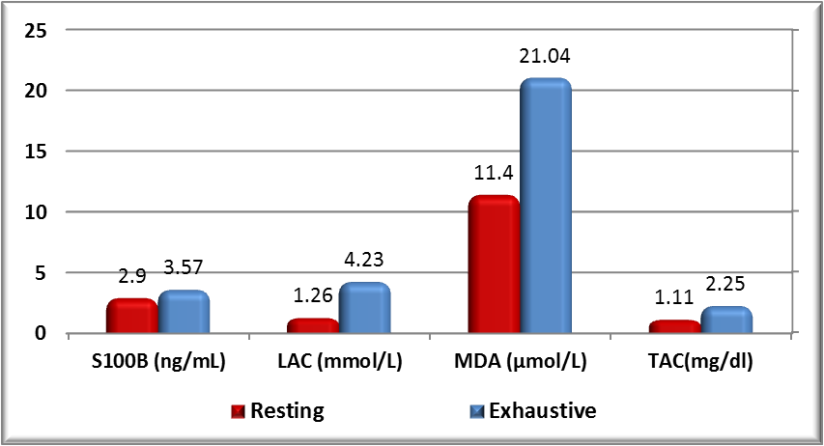
Figure (3): Comparison of different markers under resting and exhaustive conditions in group 1 before the application of training program.

Table (5): Comparisons of differences in the measured markers in resting and exhaustive conditions before the application of the training program in group 2. (n=9)
Group 2 Variables | Resting | Exhaustive exercise | % change | p-value | Sig.
 | Mean ±SD | Mean ±SD
S100B (ng/mL) | 3.11 ± 0.70 | 3.56 ± 0.54 | 14.47 | 0.02 | S
LAC(mmol/L) | 1.14 ± 0.12 | 4.34 ± 0.88 | 280.7 | <0.001 | S
MDA(μmol/L) | 11.3 ±1.1 | 21.1 ± 3.5 | 86.73 | <0.001 | S
TAC(mg/dl) | 1.08 ± 0.11 | 2.38 ± 0.62 | 120 | <0.001 | S
N= number of rats in each group S = significant
Table 5: Illustrates that there was statistically significant increase (p-value <0.05) in serum level of different markers (S100B, LAC, MDA, and TAC level) after the exhaustive exercise bout when compared to resting condition in group 2 before the application of training program.

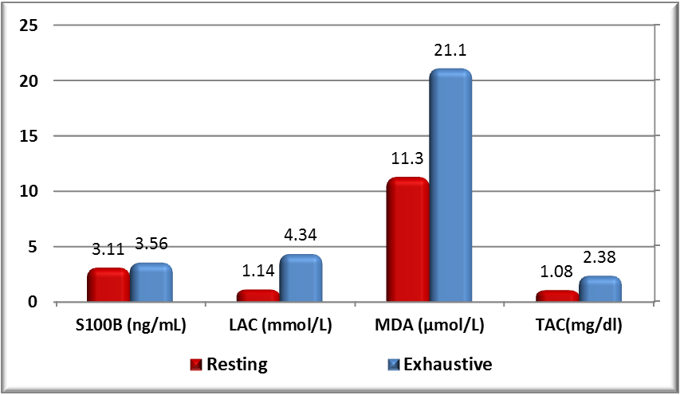
Figure (4): Comparison of different markers under resting and exhaustive conditions in group 2 before the application of training program.

Table (6): Comparison of differences in the measured markers in resting and exhaustive conditions before the application of the training program in group 3. (n=9)
Group 3  Variables | Resting | Exhaustive exercise | % change | p-value | Sig.
 | Mean ±SD | Mean ±SD
S100B(ng/dl) | 3.12±0.52 | 3.89±0.50 | 24.68 | 0.02 | S
LAC(mmol/L) | 1.09±0.22 | 4.53±0.44 | 315.6 | <0.001 | S
MDA(μmol/L) | 12.1±1.3 | 22.7±3.2 | 87.6 | <0.001 | S
TAC(mg/dl) | 1.09±0.17 | 2.35±0.64 | 115.6 | <0.001 | S
N= number of rats in each group S = significant
Table 6: Illustrates that there was statistically significant increase (p-value <0.05) in serum level of different markers (S100B, LAC, MDA, and TAC level) after the exhaustive exercise bout when compared to resting condition in group 3 before the application of training program.

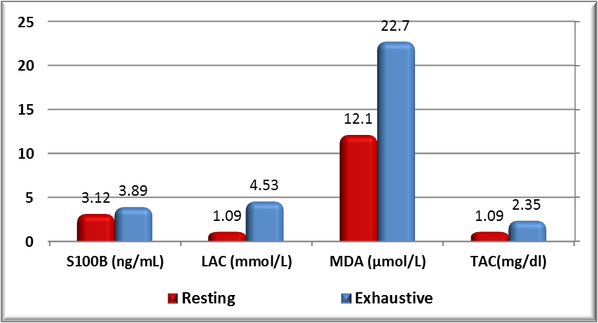
Figure (5): Comparison of different markers under resting and exhaustive conditions in group 3 before the application of training program.

Table (7): Comparison of the changes in the measured markers during rest after the application of the exercise training program between the different groups. (n = 9).
Variables | Resting, post training program |  |  | p-value | Sig.
 | G1  (Control) | G2  (ms training) | G3  (ms.train+vitC)
 | Mean ± SD | Mean ± SD | Mean ± SD
S100B ng/Ml | 2.9±0.49 | 2.76±0.37 | 2.46±0.36 | 0.05 | S
LAC(mmol/L) | 1.26±0.20 | 1.34±0.31 | 1.12±0.19 | 0.1 | NS
MDA(μmol/L) | 11.4±2.2 | 11.1±1.4 | 11.2±2.04 | 0.9 | NS
TAC(mg/dl) | 1.11±0.13 | 1.36±0.24 | 1.36±0.27 | 0.02 | S
N= number of rats in each group NS = non-significant S = significant
Table (7): Illustrates that there were statistically significance differences (p-value <0.05) between groups 2 and 3 in S100B and TAC levels during rest after application of the training program. There were no statistically significant differences (p-value >0.05) between different study groups in LAC, and MDA levels during rest after application of the training program.

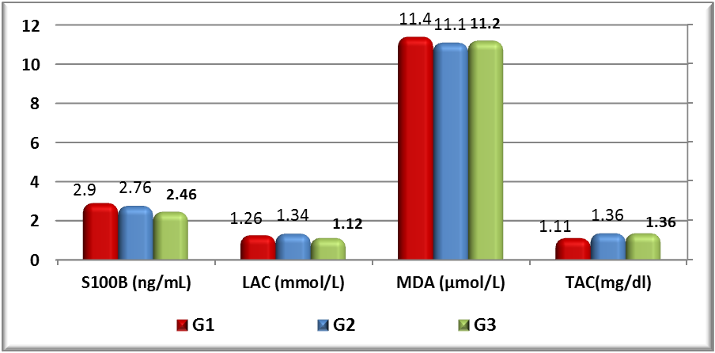
Figure (6): Comparison of the changes in the measured markers during rest after the application of the exercise training program between the different groups.

Table (8): Comparison of the changes in the measured markers following the exhaustive exercise bout after the application of the exercise training program in the different groups. (n = 9).
Variables | Exhaustive exercise, post training program |  |  | p-value | Sig.
 | G1  (Control) | G2  ( ms.train) | G3  (ms.train+vitC)
 | Mean ± SD | Mean ± SD | Mean ± SD
S100B (ng/mL) | 3.45±0.17 | 3.32±0.47 | 3.05±0.34 | 0.06 | NS
LAC(mmol/L) | 4.25±0.33 | 3.68±0.46 | 3.48±0.52 | 0.003 ^{a,b} | S
MDA(μmol/L) | 21.5±2.6 | 18.3±2.4 | 15.9±2.18 | < 0.001 ^{a,b} | S
TAC(mg/dl) | 2.24±0.34 | 3.17±0.61 | 3.41±0.27 | < 0.001 ^{a,b} | S
N= number of rats in each group NS = non-significant S = significant
a: significance between G2, and G1 b: significance between G3, and G1
Table (8): Illustrates that there were statistically significant differences (p-value <0.05) in different groups (after exhaustive exercise bout after application of training program) for measured markers (p-value <0.05) between group 1 and each of groups 2, and 3 as regards to LAC, MDA and TAC level.

On the other hand there were no statistically significance differences (p-value >0.05) as regards SB100 level.

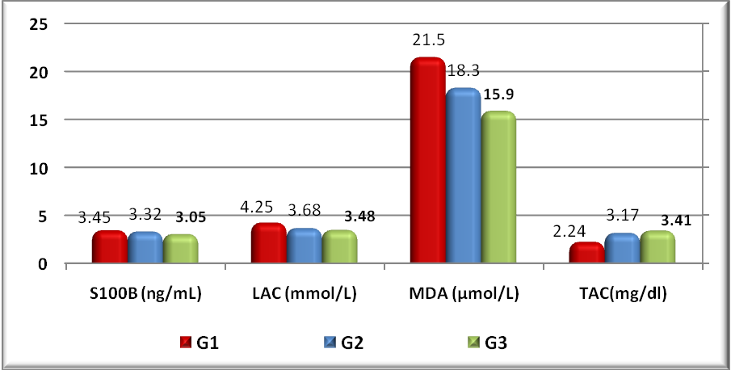
Figure (7): Comparisons between exhaustive after application of training program markers in different groups.

Table (9): Comparison of differences in the measured markers in resting and exhaustive conditions after the application of the training program in group 2. (n=9)
Variables | Resting | Exhaustive exercise | % change | p-value | Sig.
 | Mean±SD | Mean±SD
S100B (ng/mL) | 2.76±0.37 | 3.32±0.47 | 20.3 | 0.003 | S
LAC(mmol/L) | 1.34±0.31 | 3.68±0.46 | 174.62 | <0.001 | S
MDA(μmol/L) | 11.1±1.4 | 18.3±2.4 | 64.86 | <0.001 | S
TAC(mg/dl) | 1.36±0.24 | 3.17±0.61 | 133.1 | <0.001 | S
N= number of rats in each group S = significant

Table 9: Illustrates that there was statistically significant increase (p-value <0.05) in serum level of different markers (S100B, LAC, MDA, and TAC level) after the exhaustive exercise bout when compared to resting condition in group 2 after the application of training program.

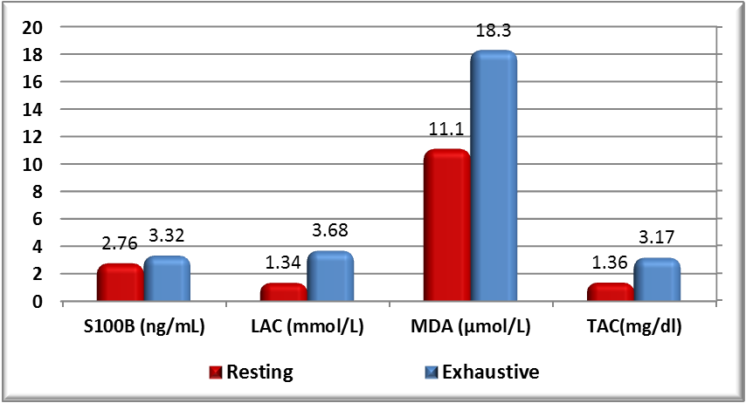
Figure (8): Comparison of different markers under resting and exhaustive conditions in group 2 after the application of training program.

Table (10): Comparison of differences in the measured markers in resting and exhaustive conditions after the application of the training program in group 3. (n=9)
Variables | Resting | Exhaustive exercise | % change | p-value | Sig.
 | Mean ±SD | Mean ±SD
S100B (ng/mL) | 2.59±0.36 | 3.05±0.34 | 17.76 | 0.001 | S
LAC(mmol/L) | 1.12±0.19 | 3.48±0.52 | 210.71 | <0.001 | S
MDA(μmol/L) | 11.2±2.04 | 15.9±2.18 | 41.96 | 0.001 | S
TAC(mg/dl) | 1.36±0.27 | 3.41±0.27 | 150.7 | <0.001 | S
N= number of rats in each group S = significant

Table 10: Illustrates that there was statistically significant increase (p-value <0.05) in serum level of different markers (S100B, LAC, MDA, and TAC level) after the exhaustive exercise bout when compared to resting condition in group 3 after the application of training program.

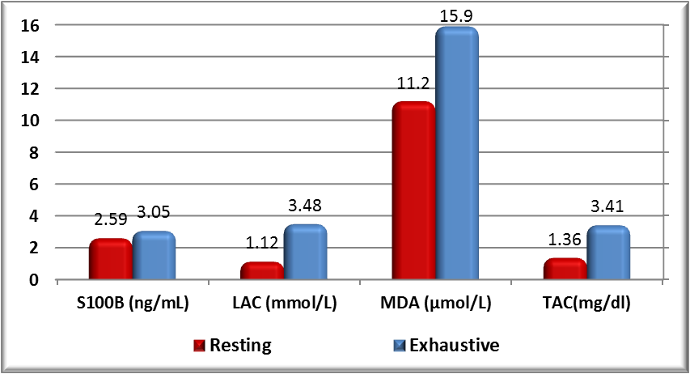
Figure (9): Comparison of different markers under resting and exhaustive conditions in group 3 after the application of training program.

Table (11): Follow up of the changes in different markers before and after application of the training program in group 2. (n=9)
Variables | Resting pre training program | Exh. exc. pre training program | Resting post training program | Exh. exc. post training program | p-value | Sig.
 | Mean± SD | Mean± SD | Mean± SD | Mean± SD
S100B (ng/mL) | 3.11±0.70 | 3.56±0.54 | 2.76±0.37 | 3.32±0.47 | <0.001 | S
LAC (mmol/L) | 1.14±0.12 | 4.34±0.88 | 1.34±0.31 | 3.68±0.46 | <0.001 | S
MDA (μmol/L) | 11.3±1.1 | 21.1±3.5 | 11.1±1.4 | 18.3±2.4 | <0.001 | S
TAC (mg/dl) | 1.08±0.11 | 2.38±0.62 | 1.36±0.24 | 3.17±0.61 | <0.001 | S
N= number of rats in each group S = significant
Table 11: Illustrates that there were statistically significant differences (p-value <0.05) in different markers (S100B, LAC, MDA, and TAC level) follow up at resting and after exhaustion before training program with increase levels after exhaustion. Then decrease in the level at resting after training program then increase again exhaustion after training program with decrease in the level of (S100B, LAC and MDA) and increase in the level of TAC in group 2.

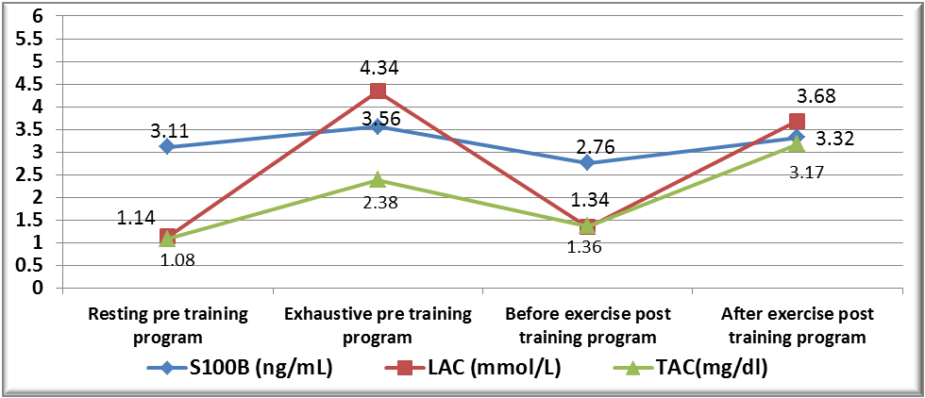
Figure (10): Different markers before and after application of the training program follow up in group 2.

Table (12): Follow up of the changes in different markers before and after application of the training program in group 3. (n=9)
Variables | Resting pre training program | Exhaustive pre training program | Resting post training program | Exhaustive post training program | p-value | Sig.
 | Mean± SD | Mean± SD | Mean± SD | Mean± SD
S100B (ng/mL) | 3.12±0.52 | 3.89±0.50 | 2.59±0.36 | 3.05±0.34 | <0.001 | S
LAC (mmol/L) | 1.09±0.22 | 4.53±0.44 | 1.12±0.19 | 3.48±0.52 | <0.001 | S
MDA (μmol/L) | 12.1±1.3 | 22.7±3.2 | 11.2±2.04 | 15.9±2.18 | <0.001 | S
TAC (mg/dl) | 1.09±0.17 | 2.35±0.64 | 1.36±0.27 | 3.41±0.27 | <0.001 | S
N= number of rats in each group S = significant

Table 12: illustrates that there was statistically significance decrease with p-value <0.05 in different markers (S100B, LAC, MDA) between resting and exhaustive pre training program and resting and exhaustion post training program with use of vit c. there was also statistically significance increase in level of TAC level between resting and exhaustive pre training program and resting and exhaustion post training program with use of vit.c.

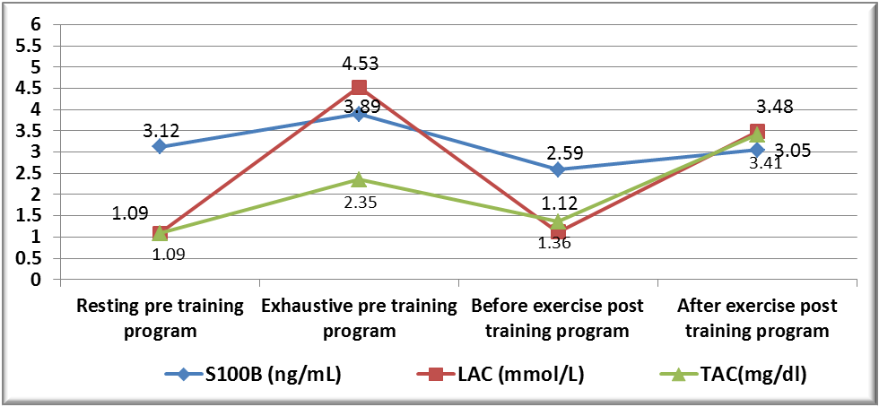
Figure (11): Different markers follow up among group 3 (taking vitamin C).

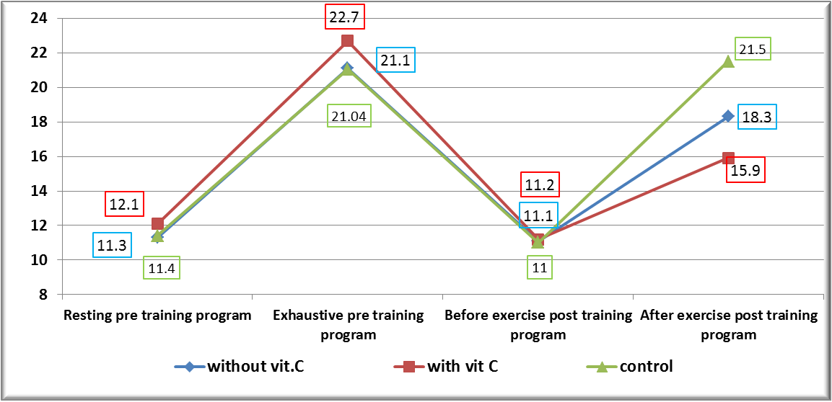
Figure (12): MDA marker follows up in different study groups.

Table (13): Comparisons of different change between resting and exhaustive pre and post training program markers in group 2. (n=9)
Variables | Difference in pre training program | Difference in post training program | p-value | Sig.
 | Mean ±SD | Mean ±SD
S100B (ng/mL) | 0.36±0.11 | 0.25±0.1 | 0.04 | S
LAC (mmol/L) | 2.84±0.82 | 1.88±0.75 | 0.02 | S
MDA (μmol/L) | 0.89±0.26 | 0.66±0.20 | 0.05 | S
TAC (mg/dl) | 1.1±0.40 | 1.52±0.45 | 0.05 | S
N= number of rats in each group S = significant

Table 13: Illustrates there were statistically significance differences (p-value <0.05) in markers (LAC, S100B,Lactic acid and MDA level) as regards to percent change exhaustive and post training program with low mean difference post training.

Table (14): Comparisons of different change different markers resting and exhaustive before and after application of training program in group 3. (n=9)
Variables | Difference in exhaustion | Difference in exercise | p-value | Sig.
 | Mean ±SD | Mean ±SD
S100B (ng/mL) | 0.40±0.32 | 0.17±0.08 | 0.05 | S
LAC (mmol/L) | 3.31±1.1 | 2.2±0.81 | 0.03 | S
MDA (μmol/L) | 0.86±0.19 | 0.54±0.31 | 0.02 | S
TAC (mg/dl) | 1±0.59 | 1.60±0.52 | 0.04 | S
N= number of rats in each group S = significant

Table 14: Illustrates there were statistically significance differences with p-value <0.05 in (MDA, S100B, TAC and Lactic acid) as regards to percent change between resting and exhaustive before and after application of training program.

Conclusion and Recommendation
The present work showed that endurance exercise promoted an increase in serum S100B levels independent of CNS injury. Several mechanisms related to central and/or peripheral S100B sources may be involved. However, more studies are needed to clarify the influence of serum S100B protein in exercise physiology, as well as the mechanism involved in its secretion during physical activity.
Vitamin C is an essential component of the diet and may reduce the adverse effects of exercise–induced reactive oxygen species, including muscle damage, immune dysfunction, and fatigue. However, reactive oxygen species may mediate beneficial training adaptation that vit.C attenuates and provide other health benefits without impairing training adaptation. In addition, the positive health benefits of using vitamins E and C may suggest an additive or synergistic effect when combined with regular exercise. New research initiatives should examine the following:
• The effects of vitamin E and C together on the adaptive response to strength training.
• The combined effects of exercise and vitamin C on diabetes risk factors.
• The combined effects of exercise and vitamin C on lipoprotein status and risk factors for cardiovascular disease.

References
- Alessio H.M.(2000) In: Hanninen, O., Packer, L., Sen, C.K. (Eds.), Handbook of Oxidants and Antioxidants in Exercise. Elsevier, Amsterdam, pp. 115/128.
- Andersson JP, Liner MH, Jonsson H. (2009):-Increased serum levels of the brain damage marker S100B after apnea in trained breath-hold divers: a study including respiratory and cardiovascular observations. J Appl Physiol (1985).107(3):809–815.
- Aysun Bay Karabulut, M. Emin Kafkas, Armagan Sahin Kafkas, Yunus Önal and Tugba Rabia Kiran(2013):- The effect of regular exercise and massage on oxidant and antioxidant parameters. Indian J Physiol Pharmacol.57(4):378-383.
- Babaei P, Rahmani-NIA F, Nakhostin B, Bohlooli SH. (2009):- The Effect of VC on Immuno-endocrine and oxidative stress responses to exercise. J Clin Diagnostic Res.3: 1627-32.
- Bailey DM, Evans KA, McEneny J, et al. (2011):- Exercise-induced oxidative-nitrosative stress is associated with impaired dynamic cerebral auto-regulation and blood-brain barrier leakage. Exp Physiol.96:1196–207.
- Belviranli M, Gokbel H. (2006):-Acute Exercise induced oxidative and antioxidant changes. Eur J Gen Med. 3:126–31.
- Beneke R., Hutler M., Jung M. and Leithauser R. M.(2005):- Modeling the blood lactate kinetics at maximal short-term exercise conditions in children, adolescents, and adults. Journal of Applied Physiology.99(2):499-504.
- Bialowas-McGoey LA, Lesicka A, Whitaker-Azmitia PM.(2008):- Vitamin E increases S100B-mediated microglial activation in an S100B-overexpressing mouse model of pathological aging. Glia. 56:1780–90.
- Bije N, Tavakol-Afshari J, Nejat-Shokoohi A, et al. (2003):-The effect of eccentric and concentric exercises on special index in athletic womens immune system. J Res Phys Educ.3: 27-40.
- Bohlooli S, Barmaki S, Khoshkhahesh F, NakhostinRoohi B (2015):- The effect of spinach supplementation on exercise induced oxidative stress. J Sports Med Phys Fitness.55(6):609-14.
- Brites FD, Evelson PA, Christiansen MG, Nicol MF, BasílicoMJ, Wikinski RW, Llesuy SF. (1999):- Soccer players underregular training show oxidative stress but an improved plasmaantioxidant status. Clin Sci. 96:381–385.
- Carro E, Trejo JL, Busiguina S, et al (2001):-Circulating insulin-like growth factor I mediates the protective effects of physical exercise against brain insults of different etiology and anatomy. J Neurosci. 21:5678–5684.
- Cesari M, Pahor M, Bartali B, et al (2004):-Antioxidants and physical performance in elderly persons: the Invecchiare in Chianti (InCHIANTI) study. Am J Clin Nutr. 79:289–94.
- Cheuvront SN, Chinevere TD, Ely BR, et al. (2008):- Serum S-100beta response to exercise-heat strain before and after acclimation. Med Sci Sports Exerc. 40(8):1477–1482. 47.
- Child RB, Wilkinson DM, Fallowfield JOL, Donnelly AE (1998):-Elevated serum antioxidant capacity and plasma malondialdehyde concentration in response to a simulated half-marathon run. Medicine and Science in Sports and Exercise. 30(11):1603–1607.
- Child RB, Wilkinson DM, Fallowfield JL. (1999):-Resting serum antioxidant status is positively correlated with peak oxygen uptake in endurance trained runners. J Sports Med Phys Fitness.39: 282–4.
- Child RB, Wilkinson DM, Fallowﬁeld JL (2000):- Effects of a training taper on tissue damage indices, serum antioxidant capacity and half-marathon running performance. Int. J. Sports Med. 21:325-331.
- Close GL, Ashton T, Cable T, et al. (2006):-Ascorbic acid supplementation does not attenuate post-exercise muscle soreness following muscle-damaging exercise but may delay the recovery process. British Journal of Nutrition. 95(5):976–981.
- Cotman CW, Berchtold NC(2002):- Exercise: a behavioral intervention to enhance brain health and plasticity. Trends Neurosci. 25:295–301.
- Czepluch FS, Barrès R, Caidahl K, Olieslagers S, Krook A, Rickenlund A, Zierath JR, Waltenberger J (2011):- Strenousphysical exercise adversely affects monocyte chemotaxis. Thromb Haemost. 105:122–130.
- Dernbach A.R., ShermanW.M., Simonsen J.C., Flowers K.M., Lamb D.R.(1993):- No evidence of oxidant stress during high intensity rowing training. J. Appl. Physiol. 74 (5):2140-2145.
- DIAZ K.M, FEAIRHELLER D.L,STURGEON K.M, WILLIAMSON S.T, and BROWN M.D(2011):-Oxidative Stress Response to Short Duration Bout of Submaximal Aerobic Exercise in Healthy Young Adults. Int J Exerc Sci.4 (4): 247–256.
- Dietrich MO, Tort AB, Schaf DV, et al. (2003):-Increase in serum S100B protein level after a swimming race. Can J Appl Physiol.28(5):710–716.
- Dixon CB, Robertson RJ, Goss FL, Timmer JM, Nagle EF, Evans RW (2006):-The effect of acute resistance exercise on serum malondialdehyde in resistance-trained and untrained collegiate men. J Strength Cond Res 20: 693–698.
- Donato R, Riuzzi F, Sorci G. (2013):-Causes of elevated serum levels of S100B protein in athletes. Eur J Appl Physiol. 113:819–20.
- Dufaux B, Heine O, Kothe A, Prinz U, Rost R (1997):- Blood glutathione status following distance running. Int. J. Sports. 18:89-93.
- Duthie GG, Robertson JD, Maughan RJ, Morrice PC ( 1990):- Blood antioxidant status and erythrocyte lipid peroxidation following distance running. Arch. Biochem. Biophys. 282 (1):78-83.
- Elias Dantas, Márcio Rabelo Mota(2015):- Glycemic and Blood Lactate Response to Maximal Incremental Treadmill Test. International Journal of Sports Science.5(2): 59-64.
- Evansm WJ. (2000):-Vitamin E, vitamin C, and exercise. Am J ClinNutr.72:647-52.
- Fatouros IG, Jamurtas AZ, Villiotou V, Poulipoulou S, Foti-nakis P, Taxildaris K, Deliconstantinos G (2004):- Oxidativestress responses in older men during endurance training anddetraining. Med Sci Sport Exerc. 36:2065–2072.
- Fisher-Wellman K, Bloomer RJ. (2009):-Acute exercise and oxidative stress a 30 year history. Dyn Med. 8:1-25.
- Fowkes, S.W.(1996):-Antioxidant Intervention in Down’s Syndrome. Smart Drug News 4 (10):1-12.
- Gomez-Cabrera M-C, Domenech E, Viña J (2008):- Moderate exercise is an antioxidant: upregulation of antioxidant genes by training. Free Radical Biology and Medicine. 44(2):126–131.
- Goldfarb AH, Patrick SW, Bryer S, You T. (2005):- Vitamin C supplementation affects oxidative-stress blood markers in response to a 30-minute run at 75% VO2max. Int J Sport Nutr Exerc Metab.15(3):279–90.
- Graham MR, Myers T, Evans P, et al. (2011):- Direct hits to the head during amateur boxing is associated with a rise in serum biomarkers for brain injury. Int J Immunopathol Pharmacol. 224:119–25.
- Hasselblatt M, Mooren FC, von Ahsen N, et al. (2004):-Serum S100beta increases in marathon runners reﬂect extracranial release rather than glial damage. Neurology. 62(9):1634–1636.
- Hubner-Wozniak E, Panczenko-Kresowka B, Lerczak K, Posnik, J (1994):- Effects of graded treadmill exercise on the activity of blood antioxidant enzymes, lipid peroxides and non-enzymatic anti-oxidants in long-distance skiers. Biol. Sport 11 (4), 217-226.
- Filipe Dinato de Lima1, Ricardo Jacó de Oliveira1, Ana Luiza Matias Correia1, Eduardo Silva Trindade, Renata Aparecida
- Jackson R1, Ramos C, Gupta C, Gomez-Marin O (2010):- Exercise decreases plasma antioxidant capacity and increases urinary isoprostanes of IPF patients. Respir Med.104(12):1919-28.
- Kostka T, Drai J, Berthouze SE, Lacour JR, Bonnefoy M. (1998):- Physical activity, fitness and integrated antioxidant system in healthy active elderly women. Int J Sports Med. 19:462–7.
- Kostka T, Drai J, Berthouze SE, Lacour JR, Bonnefoy M. (2000):- Physical activity, aerobic capacity and selected markers of oxidative stress and the anti-oxidant defence system in healthy active elderly men. Clin Physiol.20:185–90.
- Laurin D, Verreault R, Lindsay J, et al. (2001):- Physical activity and risk of cognitive impairment and dementia in elderly persons. Arch Neurol. 58:498–504.
- Lee J, Clarkson P. (2003):-Plasma creatin kinas activity and glutathione after eccentric exercise. Med Sci Sports Exerc.35(6): 930-936.
- Lee S, Mar G, Ng L (2009):- Effects of tocotrienol-rich fraction on exercise endurance capacity and oxidative stress in forced swimming rats. Eur J ApplPHysiol.107(5):587-95.
- Leila Vesali-Akbarpour and Mohammad Ali Samavati-Sharif (2016):-The Effect of Endurance Swimming Plus Vitamin C Supplement on Oxidative Stress and Muscles Damage Indices in Male Wistar Rats. Avicenna J Med Biochem. In Press (In Press): e34241.
- Lekhi C, Gupta PH, Singh B (2007):- Inﬂuence of exercise on oxidant stress productsinelite Indiancyclists. Br J SportsMed. 41(10):691–3.
- Lesgards J-F, Durand P, Lassarre M, Stocker P, Lesgards G, Lanteaume A, Prost M, Lehucher-Michel M-P (2002):- Assess-ment of lifestyle effects on the overall antioxidant capacity ofhealthy subjects. Environm Health Perspect. 110:479–486.
- Liu M-L, Bergholm R, Mäkimattila S, Lahdenperä S, Valkonen M, Hilden H, Yki-Järvinen H and Taskinen M-R( 1999):- A marathon run increases the susceptibility of LDL to oxidation in vitro and modifies plasma antioxidants. Am J Physiol., 276: E1083–E1091.
- Ljiljana M, Popovic Nebojsa R, Mitic Dijana Miric, Boban Bisevac, Mirjana Miric, Brankica Popovic (2015):- Influence of Vitamin C Supplementation on Oxidative Stress and Neutrophil Inflammatory Response in Acute and Regular Exercise. Hindawi Publishing Corporation Oxidative Medicine and Cellular Longevity Volume Article ID 295497, 7 pages.
- Machado F. A., Kravchychyn A. C., Peserico C. S., da Silva D. F., and Mezzaroba P. V.(2013):- Effect of stage duration on maximal heart rate and post-exercise blood lactate concentration during incrementl teradmill tests. Journal of Science and Medicine in Sports.16(3): 276-280.
- Malaguti M, Angeloni C, Hrelia S (2013):-Polyphenols in exercise performance and prevention of exercise-induced muscle damage. Oxidative Medicine and Cellular Longevity.2013:9.
- Mandana Gholami PhD1, Masoud Mabani MS1, Mehdi Hedayati PhD2, Mina Mabani(2014):- Effects of four weeks supplementation of vitamin C on total antioxidant capacity and malondialdehyde among inactive men after an eccentric exercise MHSR 12:173-178.
- Ma J., Z. Liu, W. Ling (2003):- Physical activity, diet and cardiovascular disease risks in Chinese women. Public Health Nutr. 6:139-146.
- Marchi N, Fazio V, Cucullo L, et al. (2003):-Serum transthyretin monomer as a possible marker of blood-to-CSF barrier disruption. J Neurosci. 23(5):1949–1955.
- Marcelo O. Dietrich, Adriano B. Tort, Débora V. Schaf, Marcelo Farina, Carlos A. Gonçalves, Diogo O. Souza, and Luis V. Portela (2003):- Increase in Serum S100B Protein Level After a Swimming Race. Can. J. Appl. Physiol. 28(5): 710-716.
- Marta Esgalhado, Milena Barcza Stockler-Pinto, Ludmila Ferreira Medeiros de França Cardozo, Cinthia Costa, Jorge Eduardo Barboza, Denise Mafra(2015):- Effect of acute intradialytic strength physical exercise on oxidative stress and inflammatory responses in hemodialysis patients. Kidney Res Clin Pract.34(1): 35–40.
- Michalczyk M, Kłapcinska B, Sadowska-Kre pa E, Jagsz S, Pilis W, Szołtysek-Bołdys I, et al.(2008):- Evaluation of the Blood Antioxidant Capacity in Two Selected Phases of the Training Cycle in Professional Soccer Players. J Hum Kinet. 19(1).
- Michetti F, Bruschettini M, Frigiola A, et al. (2011):-Saliva S100B in professional sportsmen: high levels at resting conditions and increased after vigorous physical activity. Clin Biochem. 44(2–3):245–247.
- Miyazaki H, Oh-ishi S, Ookawara T, Kizaki T, Toshinai K, Ha S, Haga S, Ji LL, Ohno H (2001):- Strenuous endurance training in humans reduces oxidative stress following exhausting exercise. Eur. J. Appl. Physiol. 84 (1/2), 1/6.
- Mohammad Shadab, Najmul Islam, Zamirullah Khan, Fauzia Khan, Mohammad Mobarak Hossain (2014):- Oxidative Stress in Sports Persons after a bout of Intense Exercise: A Cross Sectional Study. Biomedical Research.25 (3): 387-390.
- Morimasa Kato, Shizue Kurakane, Atsuyoshi Nishina, Jaeyoung Park and Hyukki Chang.(2013):-The Blood Lactate Increase in High Intensity Exercise Is Depressed by Acanthopanax sieboldianus. Nutrients, 5:4134-4144.
- Möller P, Wallin, and Knudsen L E (1996):- Oxidative stress associated with exercise, psychological stress and life-style factors. Chem-Biol Inter., 102: 17–36.
- Mukherjee S, Chia M. (2009):- Urinary total antioxidant capacityin soccer players. Acta Kinesiologica. 3(1):26–33.
- Neselius S, Brisby H, Theodorsson A, et al. (2012):-CSF-biomarkers in Olympic boxing: diagnosis and effects of repetitive head trauma. PLoS One.7: e33606.
- Niess AM, Hartmann A, Fuchs-Grunert M, Poch B, Speit G (1996):- DNA damage after exhaustive treadmill running in trained and untrained men. Int. J. Sports Med. 17:397-403.
- Nikolaidis MG, Jamurtas AZ (2009):- Blood as a reactive species generator and redox status regulator during exercise. Archives of Biochemistry and Biophysics.490(2):77–84.
- Nour-Shahi M, Khosro E, Taheri-chadorneshin H (2010):- Effected of vitamin E supplementation on anjiojenetic factor response in endurance activity (Persian). Res Sports Sci.
- Nuttakaan Leelarugrayub, Tharaporn Sutabhaha, Prapas Pothongsunun and Nantaya Chanarat(2005):-Exhaustive Exercise Test and Oxidative Stress Response in Athletic and Sedentary Subjects. CMU. JournalVol. 4(2) 183.
- Otto M, Holthusen S, Bahn E, et al. (2000):-Boxing and running lead to a rise in serum levels of S-100B protein. Int J Sports Med. 21(8):551–555.
- Overgaard K, Højfeldt GW, Nielsen OB (2010):- Effects of acidification and increased extracellular potassium on dynamic muscle contractions in isolated rat muscles. J Physiol.588: 5065-76.
- Portela LV, Brenol JC, Walz R, et al.(2002):- Serum S100B levels in patients with lupus erythema-tosus: preliminary observation. Clin Diagn Lab Immunol. 9:164–166.
- Popovic LM, Mitic NR, Miric D, Bisevac B, Miric M, Popovic B. (2015):-Influence of vitamin C supplementation on oxidative stress and neutrophil inflammatory response in acute and regular exercise. Oxid Med Cell Longev. 2015:295497.
- Powers SK, Jackson MJ (2008):- Exercise-induced oxidative stress: cellular mechanisms and impact on muscle force production. Physiological Reviews.88 (4):1243–1276.
- Robergs R. A., Ghiasvand F., Parker D. (2004):-Biochemistry of exercise-induced metabolic acidosis. American Journal of Physiology Regulatory, Integrative and Comparative Physiology.287(3): R502-R516.
- Rokitzki L., Logemann E., Sagredos A.N., Murphy M., Wetzel-Roth W., Keul J. (1994a):- Lipid peroxidation andantioxidative vitamins under extreme endurance stress. ActaPhysiol. Scand. 151:149 -158.
- Saenz AJ, Lee-Lewandrowski E, Wood MJ, et al. (2006):-Measurement of a plasma stroke biomarker panel and cardiac troponin T in marathon runners before and after the 2005 Boston Marathon. Am J Clin Pathol.126(2):185–189.
- Sahlin K, Shabalina IG, Mattson CM, Bakkman L, FernströmM, Rozhdestvenskaya Z, Enqvist JK, Nedergaard J, EkblomB, Tonkonogi M (2010):- Ultraendurance exercise increasesthe production of reactive oxygen species in isolated mito-chondria from human skeletal muscle. J Appl Physiol.108(4):780–787.
- Sari-Sarraf V, Asri-Rezaei S, Amirsaman R, Zolfeghar-didani H.(2013):- The Effects of Vitamin C and E Supplementation and Anaerobic Activity on Oxidative Indices in Male Teenager Speed Skaters. J Olympic.21:7-17.
- Schulte S, Schiffer T, Sperlich B, et al. (2013):- Response to the Letter to the Editor of Sorci et al. ‘‘Causes of elevated serum levels of S100B protein in athletes’’. Eur J Appl Physiol. 113: 821–2.
- Sekineh Norouziyan, Afsaneh Shemshaki, Parichehr Hanachi(2014):-The Effect of Eccentric Exercise on Total Anti-Oxidant Capacity, Reduced Glutathione and Malondialdehyde Levels in Active Women. Zahedan J Res Med Sci 2014 June; 16(6): 47-52.
- Spirlandeli AL, Deminice R, Jordao AA (2014):- Plasma malondialdehyde as biomarker of lipid peroxidation: effects of acute exercise. Int J Sports Med.35 (1):14-8.
- Stavrinou LC, Kalamatianos T, Stavrinou P, et al. (2011):- Serum levels of S-100B after recreational scuba diving. Int J Sports Med.32(12):912–915.
- St˚alnacke BM, Tegner Y, Sojka P. (2003):-Playing ice hockey and basketball increases serum levels of S-100B in elite players: a pilot study. Clin J Sport Med. 13(5):292–302.
- Stanković S, Majkić-Singh N(2011):- Myeloperoxidase: new roles for an old molecule. Journal of Medical Biochemistry. 30(3):230–236.
- Stocchero CM1, Oses JP, Cunha GS, Martins JB, Brum LM, Zimmer ER, Souza DO, Portela LV, Reischak-Oliveira (2014):-A Serum S100B level increases after running but not cycling exercise. Appl Physiol Nutr Metab. 39(3):340-4
- Straume-Naesheim TM, Andersen TE, Jochum M, Dvorak J, Bahr R.(2008):- Minor head trauma in soccer and serum levels of S100B. Neurosurgery. 62(6):1297–1305.
- Subudhi AW, Davis SL, Kipp RW and Askew EW (2001):- Antioxidant status and oxidative stress in elite alpine ski racers. Int J Sport Nutr Exerc Metab.11(1): 32-41.
- Tabuchi M., Tamura A., Matsuba S., Onodera J., Yamada N. (2004):- Inhibitory effects of ukogi (Acanthopanax sieboldianus) leaves on postprandial blood glucose elevation in rats. J. Jpn. Soc. Nutr. Food Sci. 57: 271–275.
- Thirumalai T S V, Therasa E K, Elumalai E et al.(2011):- “Intense and exhaustive exercise induce oxidative stress in skeletal muscle,” Asian Pacific Journal of Tropical Disease, vol. 1, no.1, pp.63–66.
- Thompson D, Bailey DM, Hill J, Hurst T, Powell JR, Williams C(2004):-Prolonged vitamin C supplementation and recovery from eccentric exercise. European Journal of Applied Physiology.92 (1-2):133–138.
- Thomas C., Sirvent P., Perrey S., Raynaud E., and Mercier J. (2004):- Relationships between maximal muscle oxidative capacity and blood lactate removal after supramaximal exercise and fatigue indexes in humans. Journal of Applied Physiology, 97(6), 2132-2138. -508.
- Tidball JG(2005):- Inflammatory processes in muscle injury and repair. The American Journal of Physiology—Regulatory Integrative and Comparative Physiology. 288(2): R345–R353.
- Tozzi-Ciancarelli MG, Penco M, Di MC. (2002):-Influence of acute exercise on human platelet responsiveness: possible involvement of exercise-induced oxidative stress. Eur J ApplPhysiol. 86(3):266–272.
- Van Hall G. (2010):- Lactate kinetics in human tissues at rest and during exercise. Acta Physiologica (Oxford, England), 199(4), 499.
- Viinikka L., Vuorz J., Ylikorkala O.(1984):- Lipid peroxides, prostacyclin, and thromboxane A2 in runners during acute exercise. Med. Sci. Sports Exerc. 16 (3), 275/277.
- Viña J, Gimeno A, Sastre J, Desco C, Asensi M, Pallardó FV, Cuesta A, Ferrero JA, Terada LS, Repine JE(2000):- Mechanism of free radical production in exhaustive exercise in humans and rats; role of xanthine oxidase and protection by allopurinol. IUBMB Life 2000, 49, 539–544.
- Vollaard NBJ, Shearman J P, Cooper CE (2005):- Exercise-induced oxidative stress: myths, realities and physiological relevance. Sports Medicine. 35(12):1045–1062.
- Waring WS, Convery A, Mishra V, Shenkin A, Webb DJ, Maxwell SR. (2003):-Uric acid reduces exercise-induced oxidative stress in healthy adults. Clin Sci (Lond); 105(4):425–430.
- Watson TA, Callister R, Taylor RD, Sibbritt DW, Donald-Wicks LK, Garg ML.(2005):- Antioxidant restriction and oxidative stress in short-duration exhaustive exercise. Med Sci Sports Exerc. 37(1):63–71.
- Watson P, Black KE, Clark SC, Maughan RJ. (2006):-Exercise in the heat: effect of ﬂuid ingestion on blood-brain barrier permeability. Med Sci Sports Exerc.38(12):2118–2124.
- Yamada N, Tamura A, Tabuchi M (2003):- Composition characteristics and antioxidative activity of ukogi (Acanthopanax siebldianum). Bull. Yamagata Prefect. Yonezawa Women’s Jr. Coll. 38:1–6 (in Japanese).
- Yu BP (1994):- Cellular defenses against damage from reactive oxygen species. Physiological Reviews. 74(1):139–162.
- Zembron-Lacny A, Szyszka K, Sobanska B, Pakula R (2006):- Prooxidant-antioxidant equilibrium in rowers: Effect of a single dose of vitamin E. J. Sports Med. Phys. Fitness. 46:257–264.

3/15/2017

