Comparative study of color flow Doppler velocimetry of ovarian artery in cases of polycystic ovaries before and after metformin therapy

Mohamed S. M. Fouad¹, Kamel N. E. Abdelgelel¹,Khaled F. Helal²,Amr E. M. Gouda³.

¹Department of Obstetrics & Gynecology, Faculty of Medicine, Al-Azhar University, Egypt.
²Department of Obstetrics & Gynecology, Faculty of Medicine, Zagazig University, Egypt.
³Resident of Obstetrics and Gynecology, Zagazig General Hospital, Egypt.
dr_amr_gouda@yahoo.com

Abstract: Background: Polycystic Ovarian Syndrome is a chronic condition with manifestations that start most commonly in adolescence with irregular menstruation and hyperandrogenic manifestations. It is a buildup of small cystic follicles and of associated infertility, hair growth, abnormal hormones and missed periods. may be started by stress, obesity, family genetics or other reasons, but once this starts, the cysts can create hormonal problems within the ovary and increase the problem. Objective: The aim of the work is to show effect of metformin therapy on Doppler indices of ovarian artery in cases of polycystic ovary syndrome, and whether this affects the hormonal profile of the patient and clinical features of PCOs or not. Subject and Methods: A prospective observational study was conducted at infertility clinic of Zagazig General Hospital, during the period from (June 2015 to May 2016), included 85 women aged between 18 and 35 years old with mean ± SD (23.64 ± 4.24). They were diagnosed as having polycystic ovarian disease treated by metformin therapy and suffering of anovulation and oligomenorrhea or amenorrhea for at least one year and none of them had any medical disorder and there was no recent history of any drug intake. Result: The mean age of the patients participating in our study was 23.64±4.24 years. There was a statistical significant difference as regard BMI before and after adding the metformin therapy. The hormonal profile before and after the metformin therapy, showed a change in FSH with no significant difference and a change in LH values with a significant difference. There was significant difference before and after metformin therapy regarding difference of ultrasonographic picture of patients’ and endometrial thickness. There was a significant difference regarding ovarian volume, vascularization index, flow index and Vascularization flow index. There were positive significant correlation between LH and both Ovarian Volume and Vascularization index and negative significant correlation between LH and flow index and in Vascularization flow index Conclusion: we concluded that The use of metformin therapy have been associated with: Improvement of clinical features of PCOs patients, ovulation Return of menses, occurrence of pregnancy in some patients and Improvement in Hirsutism. There is a positive correlation between the Doppler and LH level. Significant reduction in VI as well as significant increase in FI and VFI in cases treated with metformin therapy and these finding is associated with Decreased of LH hormone after the use of the metformin therapy.
[Mohamed S. M. Fouad, Kamel N. E.Abdelgelel, Khaled F. Helal and Amr E. M. Gouda. Comparative study of color flow Doppler velocimetry of ovarian artery in cases of polycystic ovaries before and after metformin therapy. N Y Sci J 2017;10(3):63-68]. ISSN 1554-0200 (print); ISSN 2375-723X (online). http://www.sciencepub.net/newyork. 9. doi:10.7537/marsnys100317.09.

Keywords: Antenatal; Booked; Unbooked; Maternal; Perinatal

1. Introduction
Polycystic ovary syndrome (PCOS) is heterogeneous endocrine disorder characterized by irregular menses, hyperandrogenism, and polycystic ovaries (Sirmans and Pate, 2014). It is the most common endocrine disorder in women (Badawy and Elnashar, 2011) affecting 6%-7% of reproductive-aged women (Ndefo, et al.. 2013).
Polycystic ovary syndrome (PCOS) was first reported in modern medical literature by Stein and Leventhal who, in 1935, described seven women suffering from amenorrhea, hirsutism, and enlarged ovaries with multiple cysts (Stein and Leventhal, 1935).
The etiology of PCOS remains unclear but it can be described as an oligogenic disorder in which the interaction of a number of genetic and environmental factors determine the heterogeneous, clinical, and biochemical phenotype. Environmental factors implicated in PCOS (e.g., obesity) can be exacerbated by poor dietary choices and physical inactivity; infectious agents and toxins may also play a role (Ndefo, et al. 2013).
The clinical presentation of PCOS varies widely. Women with PCOS often seek care for menstrual disturbances, clinical manifestations of hyperandrogenism, and infertility. Menstrual disturbances commonly observed in PCOS include oligomenorrhea, amenorrhea, and prolonged erratic menstrual bleeding. However, 30% of women with PCOS will have normal menses. Approximately 85%–90% of women with oligomenorrhea have PCOS while 30%–40% of women with amenorrhea will have PCOS (Sirmans and Pate, 2014).
Infertility affects 40% of women with PCOS.14 PCOS is the most common cause of anovulatory infertility. Approximately 90%–95% of anovulatory women presenting to infertility clinics have PCOS. Women with PCOS have a normal number of primordial follicles and primary and secondary follicles are significantly increased. However, due to derangements in factors involved in normal follicular development, follicular growth becomes arrested as follicles reach a diameter of 4–8 mm. Because a dominant follicle does not develop, ovulation does not ensue. (Fetouh, et al. 2015).
Because the primary cause of PCOS is unknown, treatment is directed at the symptoms. Few treatment approaches improve all aspects of the syndrome, Treatment goals should include correcting anovulation, inhibiting the action of androgens on target tissues, and reducing insulin resistance. Weight reduction for obese patients with PCOS is beneficial in many ways. Weight loss helps to decrease androgen, luteinizing hormone (LH), and insulin levels. It also helps to regulate ovulation, thereby improving the potential for pregnancy (Ndefo, et al.. 2013).

2. Subjects and Methods
This is a hospital based prospective observational study conducted in 12 months at Outpatient Clinic of Obstetrics and Gynecology of Zagazig General hospital- Egyptian Ministry of Health in coordination with the Obstetrics & Gynecology Departments, Faculty of Medicine, Al-Azharand Zagazig University, during the period from June 2015 to May 2016.
Before the start of the study, permission was obtained from Ethical Committee in the faculty of medicine, Al-AzharUniversity. Also Informed written consents from patients included in the study was obtained.
- Subjects: A total number of85 women aged between 18 - 35 years old with mean values ± SD 23.64 ± 4.24, 5 patients were excluded for different reasons (discontinue metformin or irregular use or side effect of metformin. The selected cases were suffering of anovulation and oligomenorrhea or amenorrhea at least one year and none of them had any medical disorder and there was no recent history of any drug intake.
- Inclusion Criteria:
- Documented anovulation as the cause of infertility by day 21 serum progesterone.
- Criteria Absence of galactorrhea.
- Absence of other causes of infertility as evidenced by normal hysterosalpingography, laparoscopy and/or hysteroscopy.
- Normal liver and kidney function tests, normal thyroid function tests, and normal glucose tolerance test.
- Normal semen analysis of women`s husbands.
- Normal postcoital tests.
- Husbands are available with timed intercourse at proposed ovulation period.
- Exclusion Criteria:
- Presence of other factors of infertility including peritoneal adhesions or moderate or severe endometriosis or male factors.
- History of intake of hormonal therapy for induction of ovulation.
- Hysterosalpingographic abnormalities in the form of tubal block, uterine synechiae malformations (e.g. bicornuate uterus) and leiomyoma.
- Laparoscopic abnormalities as negative tubal patency test, moderate to severe endometriosis or peritoneal adhesions.
- Hysteroscopic abnormalities in the form of intrauterine synechiae, septate uterus, fibroids, or proximal tubal obstruction.
- Abnormal semen analysis.
- Abnormal thyroid functions.
- Patients who proved to have diabetes mellitus according to oral glucose tolerance test were also excluded.
- Also patients with any other medical problem like impaired renal or hepatic function for fear of metabolic acidosis with metformin.
- Methods: All cases were diagnosed to have PCOS by the following criteria:
- Clinical criteria: anovulation, oligomenorrhea and hirsutism.
- Ultrasonic criteria: detected by transvaginal ultrasonic assessment.
For all cases, the following were done:
- Full history: including Personal, Menstrual, Past & Present Obstetric, Medical and Family.
- Thorough clinical examination: including General, Abdominal and Local examination.
- Hormonal profile (LH, FSH, E1 and androgen) before and after treatment by metformin therapy.
- Ultrasound scan and Doppler On ovarian artery and uterine artery before and after metformin therapy. We used Volusol 730 Por V apparatus for ultrasound and Doppler.
- Statistical Analysis:-
Data were revised for completeness and consistency. Accordingly, some questionnaires were excluded from the study and replaced by an equal number of other patients. Pre-coded data were entered and analyzed with the aid of Statistical Package of Social Science Software program (SPSS) version 22.
Mean, standard deviation, range, frequency and percentages were used as descriptive statistics. Chi square test and t-test were used according to type of variables analyzed.
The results were represented in tabular and diagrammatic forms then interpreted.

3. Results
The mean age of the patients participating in our study was 23.64±4.24 years (range: 18-35).
There was a statistical significant difference between weight and body mass index “BMI” measurements of all cases before (wt: 78.23±5.56 & BMI: 36.4±2.46) and after (wt: 71.65±4.98 & BMI: 32.56±1.17) the addition of metformin with p-value: <0.01 &<0.05 respectively.
As regards the relative incidence of clinical signs of PCOS such as Hirsutism and android obesity, there was no statistically significant difference in their results in studied patients before (52.6% & 47.6%) respectively and after metformin therapy (45% & 40%) respectively; however, oligohydromenorrhoea showed significant improvement (75% before Vs 25% after).

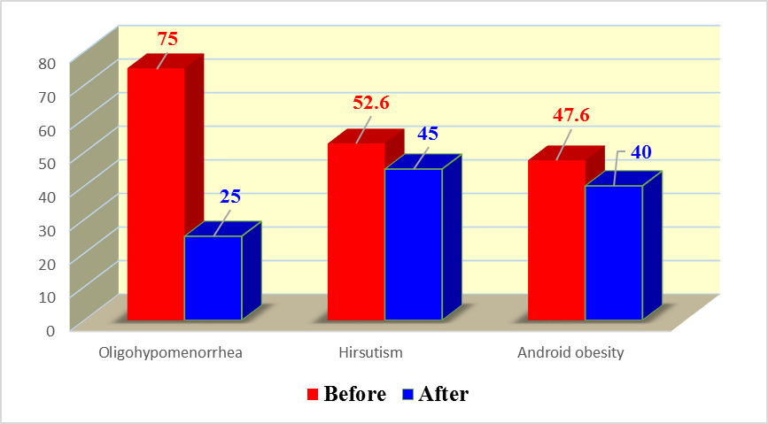
Figure (1): Clinical signs of PCOS among the studied groups before and after therapy.

As regards the hormonal profile before the start and after the end of metformin therapy, there was a change in both FSH (6.2±1.3 before vs 6.4±1.89 after) and LH values (16.89±5.12before vs7.12±2.1 after) after the addition of metformin; however, only LH levels showed statistically significant reduction after the metformin therapy with p-value <0.001.
There were no significant change of fasting glucose concentrations, but fasting insulin levels and calculated glucose/insulin ratio showed highly significant decrease and increase respectively after metformin treatment.

Table 1.
Variable | Before  (n=80) | After  (n=80) | P#
FSH: (mIU/ml):  Mean ± SD | 6.2 ±1.3 | 6.4±1.89 | >0.05
LH: (mIU/ml):  Mean ± SD | 16.89± 5.12 | 7.12 ± 2.1 | <0.001
Fasting serum insulin: (μU/ml)  Mean ± SD | 25.12±5.6 | 18.76±3.5 | <0.001
Fasting serum glucose:(mg/dl)  Mean ± SD | 86.23±12.89 | 85.1±12.2 | >0.05
G/I ratio:  Mean ± SD | 3.2 ± 0.11 | 4.62±0.32 | <0.01

Difference of ultrasonographic picture of patients’ ovaries before and after metformin as regards as presence of positive ultrasonographic criteria of PCOS. There was significant difference before and after metformin therapy. In addition, thick endometrium was more significantly detected after the use of metformin.

Table (2):
Variable | Before(n=80) | After(n=80) | P
Endometrial thickness: (mm) Mean ± SD | 5.67±1.32 | 8.21±2.2 | <0.01

The mean ovarian volume as measured by color flow Doppler was higher among cases of PCOS compared between before and after metformin with a high statistical significant difference in between them.
The mean vascularization index as measured by Doppler ultrasonography was high among cases of PCOS when compared between before and after metformin with a statistical significnat difference in between them.
Also there was a high statistical significant difference between before and after metformin therapy as regard flow index and Vascularization flow index.

Table 3.
Variable | Before  (n=80) | After  (n=80) | P#
Ovarian Volume: (mm)  Mean ± SD | 13.65 ± 3.48 | 9.86 ± 2.8 | <0.001
Vascularization index:  Mean ± SD | 0.67 ± 0.22 | 0.61 ± 0.09 | <0.05
Flow index:  Mean ± SD | 31.23 ± 10.1 | 43.5 ± 14.1 | <0.01
Vascularization flow index:  Mean ± SD | 0.45 ± 0.15 | 0.63 ± 0.20 | <0.001

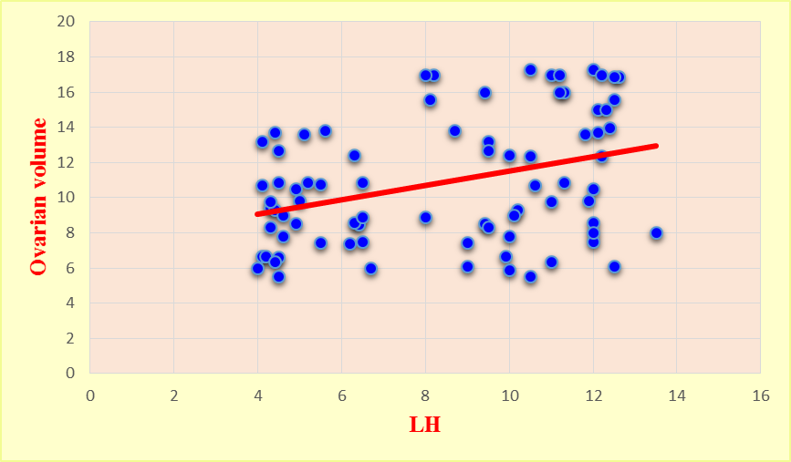
Figure (2): Correlation between serum LH level and ovarian volume after therapy in the studied group.

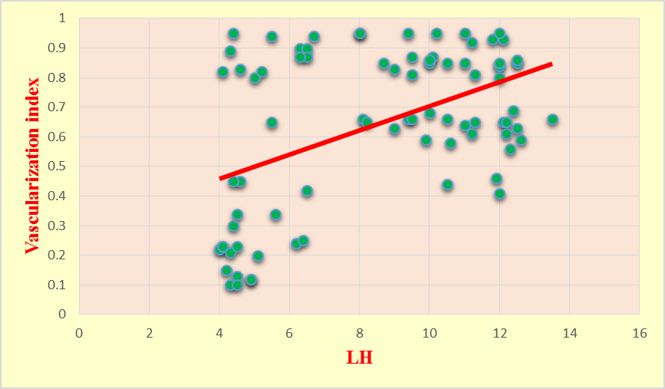
Figure (3): Correlation between serum LH level and Vascularization index after therapy in the studied group.

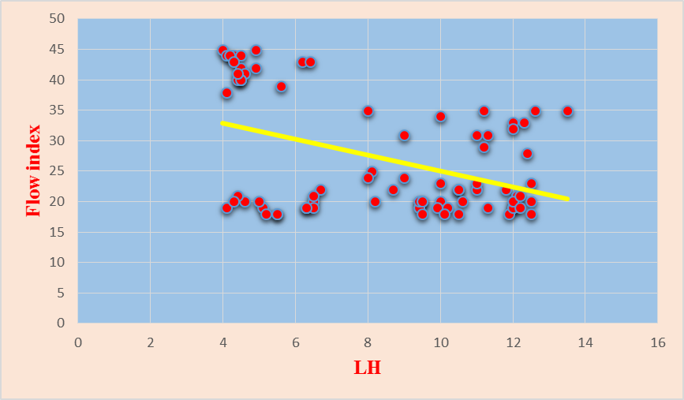
Figure (2): Correlation between serum LH level and Flow after therapy in the studied group.

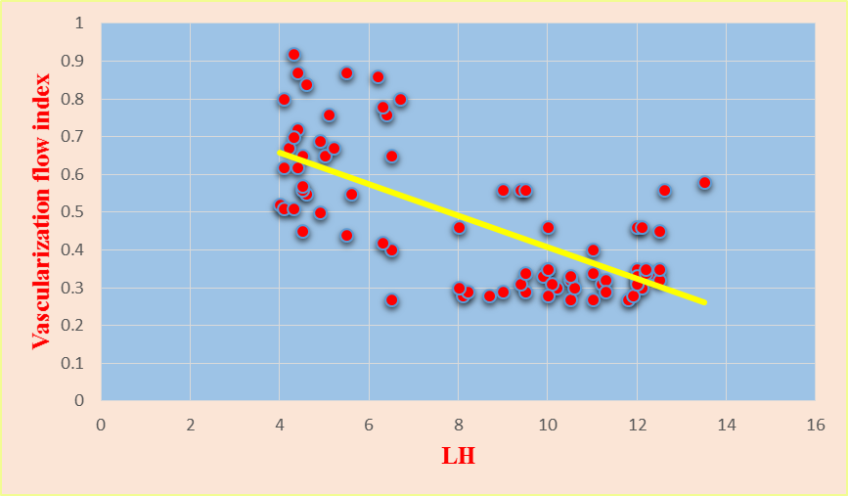
Figure (2): Correlation between serum LH level and vascularization Flow after therapy in the studied group.

There were positive significant correlation between LH and both Ovarian Volume and Vascularization index and negative significant correlation between LH and flow index and in Vascularization flow index.

4. Discussion
Polycystic Ovary Syndrome “PCOS” is a complex heterogeneous endocrine disorder. It is a syndrome and, therefore, no single diagnostic criterion is sufficient for clinical diagnosis. During the first international conference on PCOS at the National Institutes of Health (NIH) in the USA in 1990, three key features of PCOS were generally agreed on: chornic anovulation, hyperandrogenism (clinical or laboratory evidence) and the absence of other endocrine disorders (e.g. congenital adrenal hyperplasia, hyperprolactinemia or thyroid abnormalities). Polycystic Ovarian Syndrome (PCOS) is a common diagnosis among infertility patients, accounting for a significant proportion of women seeking infertility treatment (Chang and Cook-Andersen, 2013).
Management of women with PCOS depends on the symptoms. These could be ovulatory dysfunction-related infertility, menstrual disorders, or androgen-related symptoms (Badawy and Elnashar, 2011).
Insulin-sensitizing agents have been proposed as a therapy for the treatment of PCOS. These agents improve insulin action by increasing insulin sensitivity, thereby decreasing hyperinsulinemia. Since almost all obese PCOS women and more than half of those with normal weight are insulin resistant and present with some degree of fasting or stimulated hyperinsulinemia (Pasquali and Gambineri, 2006).
The initial use of metformin in the treatment of PCOS by Nestler et al. (1998) was initially received with some skepticism but is now accepted to be a valuable and inexpensive therapeutic modality, as Lord et al. (2003) have indicated that metformin is highly effective in inducing ovulation and increasing pregnancy rates.
Following-up Body Mass Index “BMI” of the studied patients before and after metformin therapy revealed significant reduction in the mean BMI of all patients from 36.4 ± 2.46 to 32.56 ± 1.17. Also, despite following-up fasting blood glucose levels in studied patients before and after metformin therapy revealed no statistically significant reduction in their plasma levels, there were highly significant reduction in fasting insulin levels after metformin therapy as well as highly significant increase of glucose/insulin ratio before and after metformin.
This is in agreement with Tan et al. (2007) who proved the fundamental rule of adding metformin therapy in reducing insulin levels and improving hyperinsulinaemia by improving peripheral insulin sensitivity through increasing its receptors on target cells or promoting glucose uptake by tissues.
In contrast to this, many other studies; Legro et al. (2007) and Palomba et al. (2005) found that both glucose and insulin responses to an oral glucose challenge and the profound insulin resistance of obese women with PCOS were not improved by metformin.
As regard the hormonal profile of studied patients as FSH level was not reduced with significant reduction in LH levels after metformin therapy. This coincide with the result (Morin-Papunen et al. 2003) proved that metformin therapy was followed by a significant reduction in basal levels of LH, this was explained on the base of the possibility that spontaneous or induced ovulation or a reduction in androgens may lead to a secondary reduction in LH.
The mean ovarian volume was significantly reduced in PCO patients treated with metformin in comparison with their results before metformin therapy. These finding agree with the results reported by Pam et al. (2002) who investigated 25 PCO patients in their study. The results of ovarian volume and LH in PCO patients revealed correlation (r = 0.31, P>0.04).
This goes in contrast to results of Nardo et al. (2008) who found positive correlation of ovarian volume and LH levels.
The mean LH before metformin was larger than after metformin which was statistically highly significant (p < 0.001). Similar results were obtained by Jarvela et al. (2002) and Ng et al. (2005). Also the results of fasting insulin, fasting blood sugar reported in this study are agree with these reported by Ng et al. (2005).
The mean flow index in PCO patients treated with metformin was which is statistically significant higher (p<0.01) when compared with the results of the same patients at start of the study before metformin therapy.
These findings agree with the results reported by Pam et al. (2002) and those reported by Lam and RaineFemming (2006) who demonstrated similar results of high flow index in PCO patients treated with metformin (36.8±16) when compared to the results of control group (31.01±14.1).
On the controversy of the above results, Jarvela et al.(2002) have conducted different results, as there were no differences in the ovarian blood flow index as measured 3D Doppler vascular index between PCO patients treated with metformin and control group (26.3±12.1 VS 25.11±10.8 consequently ).

Conclusion
The study showed a positive correlation between unbooked mothers and increased risks of maternal and fetal adverse outcomes. Educating the communities at the grass roots level about the benefits of receiving antenatal care and supervised delivery by skilled attendants will have a significant impact on improving pregnancy outcomes in our locale. Our primary healthcare facilities should be staffed with trained staff supervised by obstetricians and the secondary care hospitals should have obstetricians and facilities for providing emergency services.

References
- Badawy A and Elnashar A. (2011): Treatment options for polycystic ovary syndrome. Int J Womens Health. 2011; 3: 25–35.
- Sirmans SM and Pate KA. (2014): Epidemiology, diagnosis, and management of polycystic ovary syndrome. ClinEpidemiol. 2014; 6: 1–13.
- Ndefo UA, Angie Eaton A, Green MR. (2013): Polycystic Ovary Syndrome: A Review of Treatment Options With a Focus on Pharmacological Approaches. P T. 2013 Jun; 38(6): 336-338, 348, 355.
- Stein IF and Leventhal ML. (1935): Amenorrhea associated with bilateral polycystic ovaries. Am J Obstet Gynecol. 1935;29:181–191.
- Fetouh AA and Mohamed RS (2015): Ovarian Doppler Study In Polycystic Ovary Syndrome In Relation To Body Weight. Al-Azhar Assiut Medical Journal. Aamj, Vol 13, No 3, July 2015.
- Chang RJ and Cook-Andersen H. (2013): Disordered follicle development. Mol Cell Endocrinol 2013 July 5; 373(0): 51–60.
- Pasquali R and Gambineri A (2006): Insulin-sensitizing agents in polycystic ovary syndrome. European Journal of Endocrinology; 154(6): 763-75.
- Nestler JE, Jakubowicz DJ, Evans WS, Pasquali R. (1998): Effects of metformin on spontaneous and clomiphene-induced ovulation in the polycystic ovary syndrome. N Engl J Med. 1998;338(26):1876–1880.
- Lord JM, Flight IHK and Norman RJ (2003): Metformin in polycystic ovary syndrome: systematic review and meta-analysis. BMJ; 327 (7421): 951–3.
- Tan S, Hahn S and Benson S (2007): Metformin improves polycystic ovary syndrome symptoms irrespective of pre-treatment insulin resistance. Eur J Endocrinol; 157:669-76.
- Palomba S, Binger J and Carlson MS (2005): metformin for infertility treatment in PCOS. Human reproduction; 18(3):631-637.
- Morin-Papunen LC, Vauhkonen I and Koivunen R (2003): Metformin versus ethinyl estradiol- cyproterone acetate in the treatment of nonobese women with polycystic ovary syndrome: a randomized study. Journal of Clinical Endocrinology and Metabolism; 88: 148–156.
- Pam L, Clark C and Morrison S (2002): Assesement of Doppler indeces of ovarian vessels in PCO patients, Hum repord. Reproduction; 16(2:171).
- Nardo LG, Patchava S and Laing I (2008): Polycystic ovary syndrome: Pathophysiology, molecular aspects and clinical implications. Panminerva Med; 50(4): 267-78.
- Jarvela R, Bingger B and Norman M, (2002): 3D Doppler indeces study in PCOs patients treated with insulin sensitizer. Obstet, Gynecol J, 48 (3): 507.
- Ng EH, Chan CC, Young WS and Hopc (2005): Comparison between ovarian stromal blood flow between fertile woman and infertile woman with PCO and difference in ultrasound parameters; 60:803.
- Lam PM and Raine-Femming NJ (2006): Doppler indeces in PCO patients treated with metformin therapy. Hum repord; 20 (8):221-26.

3/7/2017

