Sugar Cane Crop Evapotranspiration under Different Irrigation Systems, (El Minia, Egypt)

Abdel Raheem H.A

Water Mangement Research Insititute, National Water Research Center, Egypt

dr.hassanahmed_999@yahoo.com

Abstract: Two field experiments were carried out at El Minia requirements research station, El Minia Governorate, Egypt-Water Management Research Institute – National Water Research center during 2015 and 2016 seasons. The aim of this investigation was to study the effect and relationship between different irrigation system and different planting methods on crop coefficient of sugar cane crop. This study also aims to evaluate and compare the potential evapotranspiration (ET_{p}) using different equations with actual water requirement under El-Minia Governorate conditions – Egypt. The results indicated that the first irrigation treatment where plants irrigated with surface irrigation system had the highest value of actual consumptive use (daily, monthly and seasonal). While, the second irrigation treatments for plants irrigated development irrigation system by gated pipes had the lowest value of actual consumptive use (daily, monthly and seasonal). The planting method in beds caused decrease in daily, monthly and seasonal actual evapotranspiration (ETa), in both seasons. Modified Penman and modified Blaney & Criddle gave high average values for potential evapotranspiration ETp (2289.83 and 2171.26 mm /season) for the two studied seasons, respectively. While Raditaion method and Pan method gave less average values (2128.16 and 1840.57 mm/season) for the two studied seasons respectively. The actual values of evapotranspiration were less than those computed by climatological equations. This due to the estimated factors in these equations. The average values of potential evapotranspiration (ETp) for the two studied seasons, by Radation method and modified Blany & Criddle were the nearest (ETp) values to general average (+0.98 and + 3.03 % respectively) while, the farthest (ETp) values to general average were obtained by Pan method and modified Penman (-12.66 and +8.65 % respectively) Average Kc for surface irragtion (A₁) were 0.75 and 0.65 under sub-treatments furrows and beds, respectively. While average Kc for delovpment irragtion system by gatedpipes (A₂) were 0.59 and 0.53 for the same sub treatments respctively. The nearest values to the average Kc were those of Raditaion method and Modified Blany & Criddle. While, the farthest values to the average Kc were those of Pan method and modified Penman. Raditaion method, modified Blany & Criddle followed by modified Penman were the nearest to actual consumptive use therefore it could be recommend Raditaion method, modified Blany & Criddle followed by modified Penman equation for calculating the potential evapotranspiration for sugar cane crop which grown El–Minia region (Middle Egypt) and areas with similar climatic conditions.
[Abdel Raheem H.A. Sugar Cane Crop Evapotranspiration under Different Irrigation Systems, (El Minia, Egypt). N Y Sci J 2017;10(3):1-10]. ISSN 1554-0200 (print); ISSN 2375-723X (online). http://www.sciencepub.net/newyork. 1. doi:10.7537/marsnys100317.01.

Keywords: Surface irrigation – Development irrigation by gated pipes –Aactual water consumptive use (ET_{a}) - Potential evapotranspiration (ET_{P}) - Crop coefficient (Kc)

1. Introduction
Water is fast becoming an economically scarce resource in many areas of the world, especially in arid and semi arid regions. In Egypt, there are many plans for increasing cultivable land and agricultural production to overcome problems of the food security. However, water is an affecting factor in any agricultural expansion. Accordingly, it is advised to evaluate new possible approaches to control the cop water requirements through modern irrigation systems and management techniques.
So the use of improve irrigation systems becomes very important to save water the best system should give favorable crop yield, optimum use of water and minimum labors requirement.

On the other hand sugar cane crop (Saccharum officinarum L.) is considered to be one of the most important sugar crops all over the world. But in Egypt, sugar cane production faces some problems which developed by time. The main problems nowadays are the limited freshwater supply and water requirements which increased Accompanying the increase in temperature degrees and wind speed as well as the reduction in the relative humidity. In addition, soils with low productivity have high water needs. So, it was found that crops grown in the same soil and the same season almost have equal water needs (Moursi, et al., 1977, El-Shafai, 1996, Chapman and Egan, 1997, CCSC, 2003, and ESST, 2006).

Sugar cane is repeatedly accused with having the highest water requirements among field crops. Therefore, some voices have lately risen up demands of the replacement of surface irragation with surface irragation devlopment system by gated pipes which has relatively lower water needs.
Measuring or calculating evapotranspiration rate could be achieved by many ways such as soil moisture depletion method and using the meterological data throughout the growth seasons. The later method leads to evaluate an imperial constant, for specific vegetation grown in particular location, which can be used afterwards as an index for direct calculation of evapotranspiration. For many years, certain types of climatological data, such as temperature, precipitation, solar radiation, wind speed. etc. have been correlated.
The determination of crop coefficient (Kc) can be used to relate reference crop evapotranspiration (ET_{p}) to maxium crop evaportranspiration when water supply fully meets water requirements of the crop. Israelsen and Hansen (1962) stated that when the soil is wet, most of moisture will be consumed from the surface. The reason is that roots normally grow near the surface. However, when the moisture of soil surface decrease more moisture is extracted from lower depths. He also indicated that soil moisture begins to be a limiting factor as the plant began to with and that thereafter, the rate of transpiration is linear function of the soil moisture and added the evapotranspirtion rate increase to a peak and then diminishes as the crop matures. This peak of consumption of water comes at beginning of flowering and at end of the vegetative stage of growth. Rijtema (1966) stated that there are many methods to calculate the potential evapotranspiration. Some of these methods or formulas give reasonable accuracy under certain climatological conditions. Other methods agree only with observed values if corrections for time log and wind speed are applied. Doorenhbos and Pruitt (1975)stated that
Blaney – Criddle method may be used when temperature data are the only available measured weather data. They reported that the radiation method is more reliable than the presented Blaney –Criddle approach. In equatorial zones, on small island or at high altitudes, the radiation method may be more reliable even if measured sunshine or cloudness data are not available. Solar radiation maps were prepared for most locations in the world and they provide the necessary solar radiation data. They also pointed out that crop water requirements are normally expressed by the rate of evapotanspiration (ET) in mm/ day or mm/ period. The level of ET has been shown to be related to evaporative demand of air which could be expressed as refernce evapotranspiration and added calculated the crop evapotranspiration by ET_{o} using the following formula
ETc = Kc x ET_{o}
Where:
ETc= Crop evapotranspiration
Kc= Crop coefficient.
ETo = Reference crop evapotranspiration
They added that the determination of crop coefficient (Kc) could be used as reference crop evapotranspiration(ETo) to maximum crop evapotranspiration when water supply full met water requirements of the crop. Jen Hu Chang (1971)and Van der Molen (1976) defined consumptive use of plant as a sum of water loss by both evaporation and transpiration. Van der Molen (1976) stated that crop evapotranspiration (ETc) was less than potential evapotranspiration (ETp) for short grass due to:
a. moisture shortage.
b. inadequate covering of the crop (e.g young beets).
c. end of growth period (e.g. ripening cerals).
Thus, the evapotransiration of arable land was often less than that of grass land. On the other hand, ETp of short grass was less than ETp of tall crops when they were provided with irrigation water. Dorrenbos and Pruitt (1977) defined reference crop evapotranspiration as the rate of evapotranspiration from an extensive surface of 8-15 cm tall green grass cover of uniform height, activly growing, completely shading the ground and not suffer short of water. Wright (1981) defined reference crop ET, as being equal to daily alfalfa ET when the crop occupies an extensive surface, is actively growing standing erect and at least 20 cm tall and well watered soil water availability. Vermiren and jobling (1986) reported that the accuracy of determined ET crop depend on type of climatic data available, and the accuracy of method chosen to estimate ETo. They also concluded that Penman and radiations methods are best for near estimates over short periods of about 10 days. The Pan evaporatin method is often the second choice, but can be superior with excellent sitting and light winds. Also, they reported that Blaney & Criddle method is the best for period of one month. Semaika and Rady (1987) recommended any of modifield Blaney & Criddly or the radiation formulas for estimating evapotranspiration of wheat, field beans and clover for Giza area, Egypt, with the everage crop coefficient due highest accuracy. Stansell et al. (1990) found that crop coefficient initially increased then decreased with the plant age, when Pan evaportation method, under three soil moisture tension, was used. Omar and Eid (1999) compred 6 ET formula with the measured ET values in Bahtim (South Delta), they found that Doorenbos – Pruitt method had the best estimation followed by the evaporation Pan and then the Penman – Monteith method. The fourth one, in order was modified Penman. They found also that, the values of Penman – Montieth method and the modified Penman, introduced a new method which gives estimates of ETo near to those of the best method of Doorenbos- Pruitt.
Tarantino and Spano (2001). Values of K_{c} for most agricultural crops increase from a minimum value at planting until maximum K_{c} is reached at about full canopy cover. The K_{c} tends to decline at a point after a full cover is reached in the crop season. The declination extent primarily depends on the particular crop growth characteristics.
Vicente de da Silva et al. (2012) This study evaluates the applicability of the dual crop coefficient method for sugarcane in a tropical region, Brazil, and compares the estimated ET by the single and dual crop coefficients with the ET measured by the field water balance. In a tropical area with sub humid climate, evapotranspiration ranges over a large interval depending on water amount. Crop coefficient and evapotranspira- tion for sugarcane are found to be linearly related to the leaf area index. The greatest coefficient of determination value (0.88) of the relationship with the LAI is that for Kc compared to r² value of 0.67 for ET and LAI. How- ever, the r² value for the relationship between ET and Kc from initial to mid-season stages (0.84) is greater than that for the whole season. The maximum ET rates occurred in the mid-season stage, ranging from 6 to 9 mm·day⁻¹. The daily ET calculated using Kc dual are comparable to ET calculated by soil water balance. The recommended crop coefficient values derived from field soil water balance during the initial, mid-season and late stages for sugarcane growth in tropical region are 0.56, 1.43 and 1.32, respectively. These values are consistently higher than those suggested by FAO-56 for sugarcane. The most commonly used methods for estimating ET demand considerable instrumentation, namely, the soil water balance and micrometeorological methods. Indeed, some methods are more suitable than others in terms of convenience, accuracy or cost for the measurement of ET at a particular spatial and/or a particular time scale. The dual crop coefficient method can provide accurate esti- mates of sugarcane ET at both daily and seasonal time scales in the tropical regions when appropriate instru- mentation is not available. Statistical tests show that the observed differences between values from the estimated ET by Kc dual and ET calculated by field water balance are not significant. However, the ET values calculated from Kc single underestimates those obtained from soil water balance measurements with RQMDM by 36% and EMD by −0.16 mm·day−1.
Gabriel Greco de Guimarães Cardoso et al. (2015) Found that the crop coefficients of sugar cane for edaphoclimatic conditions of the savannah region were similar to the coefficients suggested by FAO-33. The crop coefficients of sugar cane from distinct phases were 0.31 (initial), 1.15 (crop development), 1.25 (mid-season) and 0.90 (late season).
The use of crop coefficients for each region is basic for precise water supplementation in each development phase of the crop. The determined values of Kc can be recommended to be used in future works of hydric supplementation for sugar cane in the Brazilian savannah.
This study aims to evaluate and compare the potential evapotranspiration (ET_{p}) by different equations with actual water requirement under El-Minia Governorate conditions – Egypt.

Material and Methods
Two field experiment were carried out for two seasons 2015 and 2016 seasons, at Mallawy, Water Requirements Research Station –El Minia Governorate, Middle Egypt - Water Management Research Institute- National Water Research Center. The farm situated at 27º 9⁻ latitude and 30º 5⁻ longitude. Its altitude is about 44 m above mean sea level.
The present research was carried out to study the effect of irrigation system and planting methods on water consumptive use, water applied and crop coefficient.
The experiments were included two irrigation systems (A) (surface irrigation & improving surface by gated pipes) and two planting methods
(furrow & beds with four replications so that experiment was arranged in split plot design. The treatments of irrigation systems were randomly distributed in the main plots and planting methods treatments were randomly distributed in the sub-plots.
Soil analyses showed that the experimental soil was clay containing (37.0 % of total N), (7.32 ppm available P), and (267.99 ppm available K) with pH 8.31, in both studied seasons. All the agronomic practice except the irrigation treatment and planting methods were applied as commonly use in growing.
Recorded data:
Water consumptive use (CU)
Actual evapotranspiration of potato plants was estimated by soil moisture depletion method (Gravimetric method). The amount of (CU) is assumed to be equal to the difference between both soil moisture contents after irrigation and before the next one. In fact the amount was consumed by the plants as transpiration in addition to the quantity lost from the soil surface by evaporation.
The quantities of water consumptive use were calculated for the 60 cm soil depth which was assumed to be the depth of the roots zone as reported by many investigators.
Monthly and seasonal water consumptive use were calculated by the summation of water consumed for the different successive irrigation through the whole growth season.
Water consumptive use per feddan (4200 m²) can be obtained by the following equation
CU = Israelsen and Hansen (1962)
Where:
CU = Amount of water consumptive use.
θ₂ = Soil moisture content % after irrigation.
θ₁ = Soil moisture content befor the next irrigation.
b.d = Bulk density (g / cm³).
Calculation of CU was repeated for all irrigations until the harvesting date.
Climatic Conditions
Some meteorological data during the two growing seasons are presented in Table 3. Metrological data obtained from metrological Mallawy Station located at the 27º.9⁻ latitude and ْ30.5⁻ longitude and its altitude is about 44 m above sea level. These data are used to get potential evapotranspination mm/ day by many empirical formula
Potential Evapotranspiration (ETP)
Modified Pemman equation
ETP = c [(W.Rn + 1-w). f(u). (ea-ed)] mm/ day.
Where:
ETP = Reference crop evapotranspiration mm / day.
W = Temperature – related weighting factor.
Rn = Net radiation in equivalent evaporation in mm/day.
F (u) = Wind - related function.
ea = Saturation vapour pressure of the air in (mm bar).
ed = Mean actual vapour pressure of the air in (m bar)
= ea x RH mean / 100, in which, RH = relative humidity.
(ea – ed) = Difference between the saturation vapour pressure at mean air temperature and the mean atcual vapour pressure of the air, both in mbar.
c = Adjustment factor to compensate for the effect of day and night weather conditions.
Modified Blaney & Criddle equation:
Blaney and Criddle (1955) observed that the amount of water consumptive used by crop during the growing seasons was closely correlated with means monthly temperature and day light hours.
ETp= C [ P (0.64 T + 8.13) ] mm / day
Where:
ETp = Potential evapotranspiration in mm /day.
T = Mean daily temperature in Cْ.
P = Mean daily percentage of total annual day time hours for given month and latitude.
C = Adjustment factor which depends on minimun relative humidity, sunshine hours and day time wind estimate.
Radiation method
ETp = C x W.Rs.
Where:

ETP = Reference crop evapotranspiraion in mm/ day.
Rs = The solar radiation expressed in equivalent evaporation in m/day.
W = Weighting factor which depends on temperature and altitude.
C = Adjustment factor which depends on mean humidity and day time wind conditions.
Pan evaporation method
Reference crop evapotranspiration (ETP) can be obtained from the following equation:
ETP=Kp. EPan (mm / day)
Where:
KP = Pan coefficient depends on type of Pan, condition of Humidity, wind speed and Pan environmental conditions (=0.75).
EPan = Pan evaporation in mm / day and represents the mean daily value of the period considered.
Crop Coefficient(Kc)
Crop coefficient defined as the ratio between actual crop evapotranspiration (ETa) and potential evapotranspirtaion (ETP) when both are in a large fields, under optimum growing conditions (FAO, 1977). In the experiment the following equation was applied to compute the Kc values.
Kc = ETa / ETp
Where:
Kc = Crop coefficient
ETa = Actual evapotranspirtation.
ETp = Potential evapotranspiration calculated by the four equations
Statistical analysis:
The proper statistical analysis of all data was carried out according to program SPSS version 20

3. Results and Discussion
4-Daily, monthly and seasonal actual water consumptive use: (ET_{a})
Daily monthly and seasonal water consumptive use values for each region were presented in Table (2). The data obtained indicated that the highest values of seasonal of water consumptive use was 172.24 cm/season obtained from surface irrigation in furrow (A₁b₁), while the lowest values of seasonal of water consumptive use was 122.24 cm/season obtained from development irrigation by gated pipes in beds (A₂b₂). Generally it clear that the surface irrigation in furrow have high values of actual water consumptive use cm/seasons. while, the irrigation system by gated pipes in beds gave lowest values of actual water consumptive use for each region. It could be noticed from the data that water consumptive use starts with small amount because the needs small amount of water plants at initial growth stage, therefore, soil moisture are mainly affect by evaporation from soil surface at this time, with the advance with plant age, evapotranspiration increase and consequently the monthly consumptive use increased as plant foliage develops. The monthly water consumptive use reaches its peak value in the middle off growing (May-August) season which is considered the critical period in water demands of sugar cane crop. These results were similar to thoe obtained by Isrealen and Hansen (1962).

Table (1): The average of temperature, relative humidity %, wind speed (km / day), sun shin (hours /day) and evaporation (mm/day) during the two seasons studies for sugar cane crop.
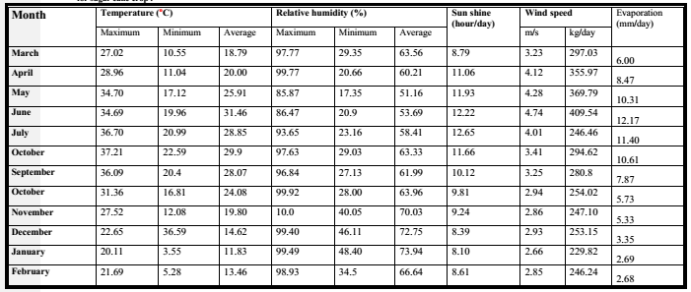

Table (2): Average values of actual water consumptive use (daily, monthly and seasonal) for sugar cane plants as affected by irrigation systems and planting methods in the two studied seasons.
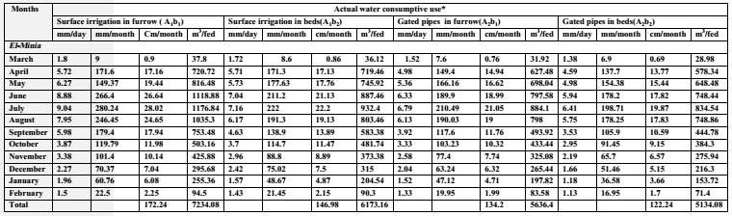
Actual consumptive use was calculated from 27/3 untill 15/2
Where; A₁= surface irrigation b₁= irrigation the furrow A₂=Improving surface irrigation by gated pipes b₂= irrigation in beds.

Potential evapotranspiration (ET_{P})
Data in Table (3) show that the computed values daily, monthly and seasonal potential evapotranspiration (mm/day, mm/month and mm / season) according to modified Penman, modified Blaney & Criddle, Radation methods and Pan method for two studied seasons. It can be observed that the average lowest ETp (1840.57, 2128.16 mm /season) were obtained from Pan method and readation methods during the two studied seasons. While the average highest ET_{p} (2289.83 and 2171.26 mm / season) obtained from modified Penman and modified Blaney & Criddle respectively during the two studied seasons.
It could be noticed from data in Tables 5 that the nearest ET_{p} values to the average are those which are obtained form Radation methods and, modified Blaney & Criddle (+0.98% &+3.03 %) while, the fareast were those of Pan method and modified Penman (-12.66 % & +8.65). These results are in agreement with those of Doorenhboos and Pruitt (1975).
Crop coefficient (Kc)
Effect of crop characteristics on crop water requirements is indicated by the crop coefficient (Kc) which represents the relationship between reference potential (ET_{P})and actual crop evapotranspiration (ETa).
Data of crop coefficient of sugar cane crop every irrigation treatment calculated using the actual consumptive use (from Table 2) and potential evapotranspiration (ETp), where (Kc= ET_{a} / ETp), using the modified Penman, modified Blaney and Criddle, Radiation method and Pan method.
The values of Kc for irrigation treatments are shown in Tables (4-5). It is cleared that the values of Kc showed slight increase with time after planting till they reach their peak in months (May – August)and then they decrease again at the end of growth season. The highest Kc values obtained from first irrigation treatment (surface irrgtion system) while the lowest Kc values obtained from secound irrigation treatment (devlpoment irragtion system by gated pipes). The values of crop coefficient average (Kc average) by many empirical formula for irrigation treatment A ₁ were 0.75 and 0.65 for b₁, b₂ respectively while were 0.59 and 0.53 for irrigation treatment A₂ under b₁, b₂ respectively It could be noticed that the nearest values to average Kc those Radation methods and mofidied Blany & Criddle while the farthest were those of Pan method.

The calculated evapotranspiration (ET_{cal}.)
The calculated evapotranspiration (ET_{cal}.) (mm /month, mm / season and cm / season) are shown in Tables 6 & 7 for irrigation treatments using the relation ET_{cal}. = K c average X ET_{p} and its comparison with actual consumptive use (ET_{a}) for different irrigation treatments. Where calculated evapotranspiration by many different climatic equtions modified Penman, mofidied Blany & Criddle, Radation methods and Pan method and compared with acutal comptive use in Table (8).
Data in Table (8) and Figures (1, 2) indicate that calculated evapotranspiration (ET_{cal}) by Radtion methods and modifierd Blany & Criddle easily clarify the degree of the calculated evapotranspiration where it nearest to actual water consumptive use than other equations. So it could be recommend the Radation method and modified Blany & Criddle for estimating ET_{p} in Minia region with the average crop coefficient due to the highest accruing for suger can crop. These results are in agreement with those reported by Semika and Rady (1987) and EI – Tantawy (1997).

Table (3): Computed daily monthly, seasonal evapotranspiration (mm) ETp and deviation percentage in the two studies seasons
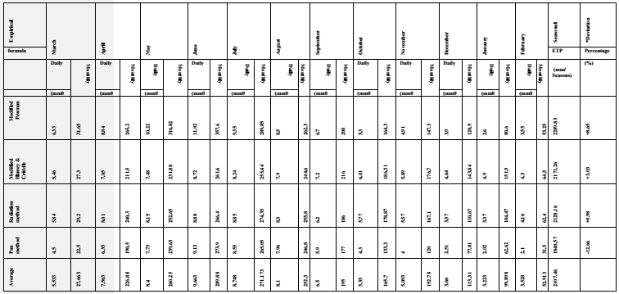
ET_{p} was calculated from 27/3 untill 15/2
*Deviation from the averages

Table (4): The crop coefficient (Kc=ETa / ETp) for surface irrigation treatment under (b₁ and b₂) for sugarcane crop in two studied seasons.
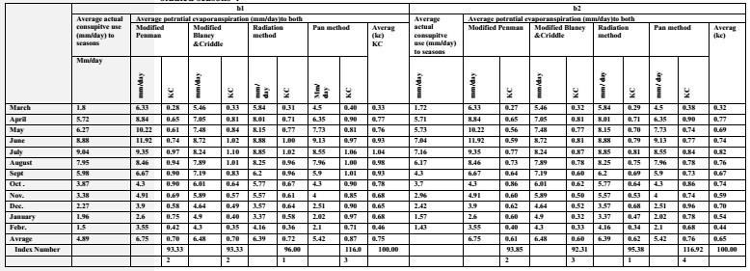

Table (5): The crop coefficient (Kc=ETa / ETp) for delovpment irrigation by gated pipes under(b₁ and b₂) for sugarcane
crop in two studied seasons.
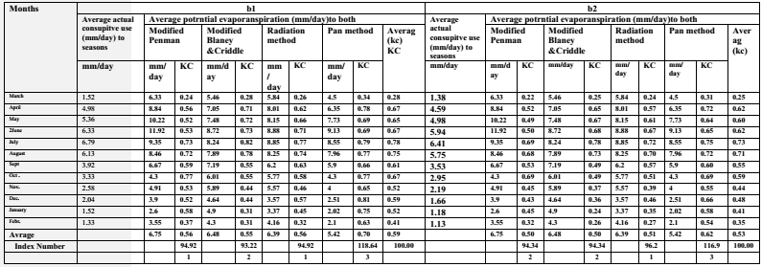

Table (6): The Avreage calculated monthly, evapotranspiration (K_{c} avreage × ETp) mm / month for surface irrigation (A₁) under (b₁ & b₂) for sugar cane crop in the two studied seasons.
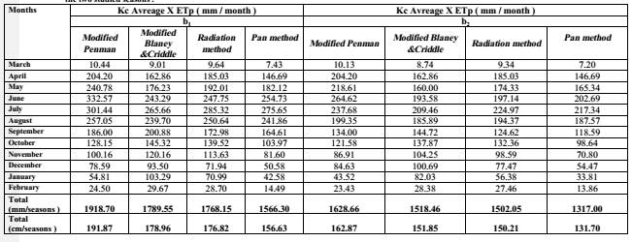

Table (7): The Avreage calculated monthly, evapotranspiration (K_{c} avreage × ETp) mm / month for irragtion system by gated pipes (A₂) under (b₁ & b₂) for sugar cane crop in the two studied seasons.
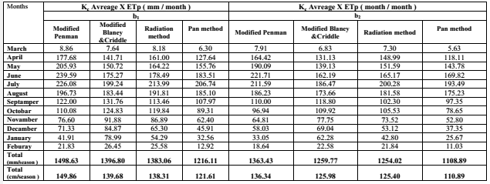

Table (8): Comparison between the actual consumptive use (cm/season for two seasons) and calculated evapotranspiration (cm/season for two season) for different irrigation treatments for sugar cane crop.
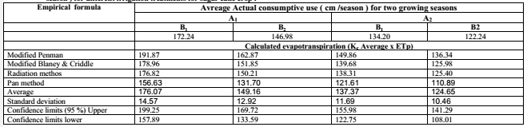

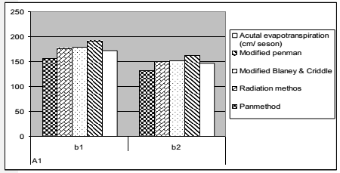
Fig (1): Comparison between actual consumptive use (cm/season) and calculated evapotrous piration (cm / season) under surface irragtion for sugar cane crop in the two sutdied seasons.

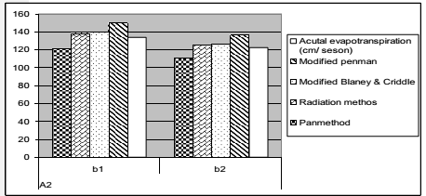
Fig (2): Comparison between actual consumptive use (cm/season) and calculated evapotrous piration (cm / season) under delvelopment irrgation system by gated pipes for sugar cane crop in the two sutdied seasons.

Conclusions and Recommendations
The values of crop coefficient average (Kc average) by many empirical formula for surface irrigation treatment(A₁) were 0.75 and 0.65 for b₁, b₂ respectively while were 0.59 and 0.53 for surface irrigation by gatedpipes (A₂) under b₁, b₂ respectively. Raditaion method, modified Blany & Criddle followed by modified Penman were the nearest to actual consumptive use therefore it could be recommend Raditaion method, modified Blany & Criddle followed by modified Penman equation for calculating the potential evapotranspiration for sugar cane crop which grown El–Minia region (Middle Egypt) and areas with sumilor conditions with the average crop coefficient due highest accuracy.

Acknowledgements
The authors would like to thank the Science and Technology Development Fund (STDF), Egypt, for the financial support granted for this work also thanks for water management institute for scienitific support.

References
- Blaney, H.F. and W. D. Criddle (1955). Deetermining water in irrigated areas from climatological and irrigation data, SCS –TP- 46, Soit conservation service, U.S. Department of Agziculture, Washington.
- CCSC, (2003). Central Council for Sugar Crops. Annual Report, Ministry of Agriculture, Egypt.
- Chapman, L.S. and B.T. Egan (1997). Sugarcane yield responses from furrow irrigation at Mackay. BSES, Mackay, Qld. 4740, Australia. Proc. Conf. Australian Soc. Sugar Cane Technol., Cairi, Queensland, 29th April to 2nd May. p. 285-292.
- Doorrenbos, J. and W.D. Pruitt (1977). Guidelines for predicting crop water requirements.
- Doorrenbos, j. and W.O Pruitt (1975). Crop water requirements. Irrigation and Drainage paper 24, F.A.O Rome.
- El – Tantawy, Manal M.M. (1997). Plant response to climatic factors as an indication to estimating evapotranspiration for some vegetable crops. Ph. D. Thesis, Fac. Agric., Ain Shams Univ.
- El-Shafai, A.M.A.(1996). Water requirements of sugarcane under different levels of nitrogen fertilization. Ph.D. Thesis, Agron. Dept. Fac. Agric. Moshtohor, Zagazing Univ., Egypt.
- ESST, (2006). Thity –two Annal Conference,Egyptian Society of Sugar Technlogists,Giza, Egypt year book.
- F.A.O. (1977). Crop water requirements. Irrigation and drainage paper 24. Food and Agriculture Organization for the united Nations, Romw revised, 1977.
- Gabriel Greco de Guimarães Cardoso, Renaro Campos de Oliveira, Marconi Batista Teixeira, Mlton Sergio Dorneles, Romenig Marcos Oliveira Domingos and Clarice Aparecisa Megguer (2015). Sugar cane coefficient by the soil water balance method. African Journal of Agricultural Research. vol.10 (24), pp.2407-2414.
- Israelsen, O.W.and V.E.Hasen (1962). Irrigation principles and practices, 3 rd Edit. John willey & Sons. Inc., New York.
- Jen –Hu-Chang (1971). Climate and Agriculture An ecological survey. Aldiene publishing Cam Pany, Chicago.
- Moursi, M.A. and Nemat A. Nour El-Din (1977). Irrigation of field crops. El-Anglo Library. 165Mohamed Fardid St., Cairo. Pp.332 (Arabic Eddition).
- Omar, M.H. and H.M.. Eid (1999). Comparative study on ETo estimated with different ET formulae in South Delta. Third Conference of On - Farm Irrigation and Agrocilmatology (under publication).
- Penman, H.L., (1961). Weather, plant and soil factors in hydrology Weather, 16, 207.
- Rijtema, P.E. (1966). Transpiration and production of crops in relation to climate and irrigation. Institute Land and Water Mangement Research Holland (C.f A.F.M. Mohamed (1981) Ph.P Thesis Fac. Agric. Alex.).
- Semaika, M. and A. Rady. (1987). On the calculation of crop coefficient when estimatiny crop water requirement.. Water science 3 rd Issue, 2nd year, November 1987 –Egypt.
- Stansell, J.R.; M.R. Hall and D.A. Smittle (1990). Effects of irrigation regimes on yield and water use by sweet potato. Journal of American Socicty for Horticultural Seience, Goshbs. 115 (5): 712-714.
- Tarantino E., and D. Spano (2001), La valutazione dei fabbisogni irrigui, Rivista di Irrigazione e Drenaggio. 48(4), 21-35 (in Italian).
- Van der Molen (1976). Agrohydrology. M.Sc. Course in soil science and water management, Agric Univ. Wagenin gon– Holland (C.f M 1981) Ph.D. Thesis, Fac. Agric., Alexandria.
- Vermiren, L; and G.A. Jobling (1986). Localized irrigation: design installation, Operation and evaluation.Irrigation and Drainage Paper No. 36, FAO, Rome, Italy.
- Vicente de P. R. da Silva, Cicera J.R. Borges, Carlos H.A.Farias, Vijay P.Singh, Walker G.Albuquerque and Bernardo Barbosa da Silva. (2012). Water requirements and single and dual crop coefficients of sugarcane grown in a tropical region, Brazil vol.3, No.2, 2744-286 (2012) Agricultural Sciences http://dx.doi.org/10.4236/as,201232032.
- Wright, J.L (1981). Crop coefficients for estimates of daily evapotranspiration. Proc. American Society of Agricultural Engineers. Irrigation Scheduling Conference, St. Joseph, MI. pp18-26.

2/8/2017

