The Significance of Tumor Markers in Sinonasal Inverted Papilloma Assigned for endoscopic surgery

Mostafa M. Elsayed¹, Ibrahim I. El-Dsoky¹, Mohammed F. Ramadan¹, Mohammed S. Abdelwahed², Nabil F.Esmael³, Abdelgawad M.Hadeya¹

Otorhinolaryngology¹, Histopathology², Clinical Pathology³ Departments; Faculty of Medicine, Al-Azhar University, Egypt. dr.guda@yahoo.com

Abstract: Background: Inverted papilloma (IP) is a primarily benign lesion that occurs in the nasal cavity and paranasal sinuses. Clinical problems include a tendency towards local destruction, recurrence and malignant transformation into squamous cell carcinoma. Tumor markers can be helpful in clinical practice to monitor the response to treatment and to indicate recurrent disease mainly in malignant neoplasms. Aim: Measuring squamous cell carcinoma antigen (SCCA1) and epidermal growth factor receptor (EGFR) as tumor markers in sinonasal IP and detection of their significance for early detection of malignant transformation. Methods: Blood samples were collected pre and post-operatively from 30 IP patients for the analysis of serum SCCA1. In addition, nasal biopsies were collected and immunohistochemical studies were performed for measuring EGFR. Results: There was statistically significant decrease of SCCA1 levels at 2 days and at 3-5 months postoperatively when compared to preoperative values .In addition, there was statistically significant decrease of SCCA1 at 3-5 months postoperatively when compared to values at 2 days postoperatively. These data indicated significant decrease of SCCA1 over time. EGFR intensity by immunohistochemical staining revealed statistically significant difference between study and control group. Conclusion: SCC antigen is a reliable tumor marker in the management and monitoring of sinonasal IPs. Expression of EGFR can be used for differentiation between benign IP and IP with malignant transformation even in early phases of dysplasia.
[Mostafa M. Elsayed, Ibrahim I. El-Dsoky, Mohammed F. Ramadan, Mohammed S. Abdelwahed, Nabil F. Esmael and Abdelgawad M. Hadeya. The Significance of Tumor Markers in Sinonasal Inverted Papilloma Assigned for endoscopic surgery. N Y Sci J 2017;10(2):78-82]. ISSN 1554-0200 (print); ISSN 2375-723X (online). http://www.sciencepub.net/newyork. 13. doi:10.7537/marsnys100217.13.

Keywords: squamous cell carcinoma antigen; inverted papilloma; epidermal growth factor receptor; tumor marker.

1. Introduction
Inverted papilloma is arelatively uncommon sinonasal lesion constituting 0.5–4% of all nasal tumors (Oikawa et al., 2007). They are composed of well-differentiated columnar or ciliated respiratory epithelium with variable squamous differentiation. IP has an incidence of 0.74–1.5 cases per 100,000inhabitants per year and accounts for approximately70% of all sinonasal papillomata. Males are4–5 times more frequently affected than females, IP is prevalent in the fifth and sixth decades of life, although isolated observations in the pediatric age group have been reported (Busquets and Hwang, 2006; Oikawa et al., 2007).
The incidence of associated malignancy has been estimated to be approximately 10% to 15%.Lawson and Allen in 2003 reported that 7% of patients have associated malignancy with synchronous carcinoma and 4% with metachronous carcinoma. These develop 3 to 8 years after initial diagnosis (Toi et al., 1996). IP arises from the outlining Schneiderian ectodermal respiratory membrane. The behavior of the invasion into the underlying stroma was attributed to its origin from the Schneiderian membrane, as there may be some difference in the underlying stroma, which permits inversion of the papilloma. In the English-speaking area, it is also called “inverted Schneiderian papilloma,”(Figuerola et al., 1990).
The four characteristic attributes of IP are, its tendency to recur, its destructive capacity, the associated nasal polyps, and its liability for malignancy. Initially, the nasal columnar (respiratory) epithelium changes into transitional (cuboidal) epithelium followed by squamous metaplasia. Once epithelial dysplasia is established, carcinoma in situ and invasive squamous cell carcinoma (SCC) could follow (Oikawa et al., 2007). Therefore, postoperative long-term follow-up is recommended. In general, patients are examined postoperatively with nasal endoscopy. CT or MRI is restricted to those cases where nasal endoscopy does not afford adequate visualization. However, it is sometimes difficult to diagnose recurrent disease. Therefore, the establishment of a biologic marker reflecting the extent of disease can be of great help in follow up management. Serum tumor markers have been shown to be helpful in clinical practice to monitor the response to treatment and to indicate recurrent disease mainly with malignant neoplasms. (Liu et al., 2011; Tabata et al., 2000).
This study was done to evaluate the clinical usefulness of serum SCCA1 in the follow-up of patients with sinonasal IPs. We investigated whether serum SCCA1 level correlates with disease status and is useful in the early detection of recurrent disease.
Also we attempted to measure EGFR using quantitative immunohistochemical studies. The expression of EGFR is thought to play a crucial role in the progression of tumour. It has been suggested that increased expression of EGFR may give clues to malignant transformation in IP.

2. Patients and methods
This current prospective 2 years study was conducted at Otorhinolaryngology departments, Al Azhar University Hospitals, The study included 30 inverted papilloma patients. Blood samples from 15 healthy volunteers’ blood donors were taken as control for SCCA1. Fifteen nasal mucosa specimen were obtained from patients undergoing partial turbinectomies as control. After obtaining fully informed patients’ consent, all patients underwent full history taking, general and local examination and CT imaging.
Thirty venous blood samples were obtained from IP patients prior to surgical resection and 2 days and 3-5 months postoperatively. Blood samples were allowed to clot then, serum was separated by centrifugation at 3000 rpm for 10 min. Serum was removed and stored at -70°C until Enzyme-linked Immunosorbent Assay (ELISA) done for estimation of serum SCCA1.
Method of estimation of SCCA1
The kit is for the quantitative level of SCCA1,obtained from bio _science company, adopt purified Human SCCA1 to coat microtiter plate, make solid-phase antibody, then add SCCA1 to wells, Combine SCCA1 antibody with labeled horseradish peroxidase (HRP) to form antibody-antigen -enzyme-antibody complex, after washing completely, add Tetramethylbenzidine (TMB) substrate solution, TMB substrate becomes blue color at HRP enzyme-catalyzed, reaction is terminated by the addition of a stop solution and the color change is measured at a wavelength of 450 nm. The concentration of SCCA1 in the samples is then determined by comparing the optical density (O.D.) of the samples to the standard curve.

EGFR evaluation.
Histopathological examination
Paraffin sections (5-μm-thick) were prepared from IP specimens and inferior turbenectomy control biopsies stained with hematoxylin and eosin were examined.

Immunohistochemistry
The immunohistochemical analysis was performed on formalin-fixed, paraffin-embedded tissue sections using standard streptavidin–biotin–peroxidase complex methods. Briefly, 5-μm-thick sections mounted on positively charged adhesive slides (Biogenex Co.) Pretreatment of tissue with proteolytic enzymes (pepsin) was performed. Then treated with 0.3% hydrogen peroxide in methanol for 30 min to block endogenous peroxidase activity. Sections were then washed in PBS (pH=7.4) and Tris-buffer solution (pH=7.6). Thereafter, the slides were microwaved for 20 min for antigen retrieval and incubated overnight at 4°C with optimal dilutions of primary antibody (Monoclonal Mouse Anti-Human Epidermal Growth Factor Receptor (EGFR) Clone H11 , Code M3563, Dako, Denmark), Sections were then treated with avidin–biotin–peroxidase reagent for 30 min ( Dako, Japan Ltd, Kyoto, Japan). Finally, they were incubated with diaminobenzidine, counterstained with hematoxylin, and then cleared and mounted. Cells of the eccrine gland and sebaceous gland of the skin were used as positive control.

Assessment of EGFR immunoreactivity
Membranous EGFR expression was analyzed according to the methods described by (Giant et. al., 2013), EGFR immunoreactivity scored on a scale of 1 to 4. Grade 1 for less than 5% staining, grade 2 for 5 to 20%, grade 3 for 21 to 50%, and grade 4 for greater than 50%. Intensity was scored as 1 for no staining, 2 for low intensity, 3 for moderate intensity, and 4 for high intensity.

3. Results:
There was no statistically significant difference between study and control groups as regard to age and sex distribution (table 1).

Table (1): Comparison between study and control groups a regard to patient age and sex
Variable |  | Study group | Control group | Test | P value
Age |  | 62.06±10.35 | 60.73±9.72 | 0.51 | 0.61(ns)
Sex | Male | 22(73.3%) | 25(83.3%) | 0.88 | 0.34(ns)
 | Female | 8(26.7%) | 5(16.7%)

As regard to preoperative SCCA1 level it ranged from 0.70 to 7.0 ng/ml and there was statistically significant increase in study group when compared to control group (3.78±1.42 vs 1.23±0.30 respectively) (table 2).

Table (2): Comparison between study and control groups a regard to preoperative SCCA1 level
 | Mean | S. D | Minimum | Maximum | T | P
Study group | 3.78 | 1.42 | 1.60 | 7.00 | 9.57 | <0.001*
Control group | 1.23 | 0.30 | 0.70 | 2.00
Total | 2.50 | 1.64 | 0.70 | 7.00

When comparing postoperative to preoperative values of SCCA1: we found that, there was statistically significant decrease of SCCA1 levels at 2 days postoperatively when compared to preoperative values and similarly, there was statistically significant decrease of SCCA1 at 3-5 months postoperatively when compared to preoperative values. Finally, there was statistically significant decrease of SCCA1 at 3-5 months postoperatively when compared to values at 2 days postoperatively. These data indicated significant decrease of SCCA1 overtime (table3).

Table (3): Comparison between preoperative and postoperative levels of SCCA in study group
 |  | Mean | SD | Paired (t) | P
Pair 1 | Preoperative | 3.78 | 1.42 | 7.26 | <0.001*
 | Two days PO | 1.85 | 0.42
Pair 2 | Preoperative | 3.78 | 1.42 | 8.01 | <0.001*
 | Three- five months PO | 1.67 | 0.39
Pair 3 | Two days PO | 1.85 | 0.42 | 2.78 | 0.009*
 | Three- five months PO | 1.67 | 0.39

As regard GEFR intensity by immunohistochemical staining, all control specimens had no staining; while in study group six subjects (20.0%) showed no staining; 11 subjects (36.7%) had low staining; nine subjects (30.0%) had moderate stating and four subjects (13.3%) had high staining; and there was statistically significant difference between study and control group (table 4).

Table (4): Comparison between study and control groups as regard to EGFR intensity
 |  | Study group |  | Control group |  | Statistics
 |  | N | % | N | % | X² | P
EGFR  Intensity | No staining | 6 | 20.0% | 15 | 100.0% | 40.0 | <0.001*
 | Low | 11 | 36.7% | 0 | 0.0%
 | Moderate | 9 | 30.0% | 0 | 0.0%
 | High | 4 | 13.3% | 0 | 0.0%

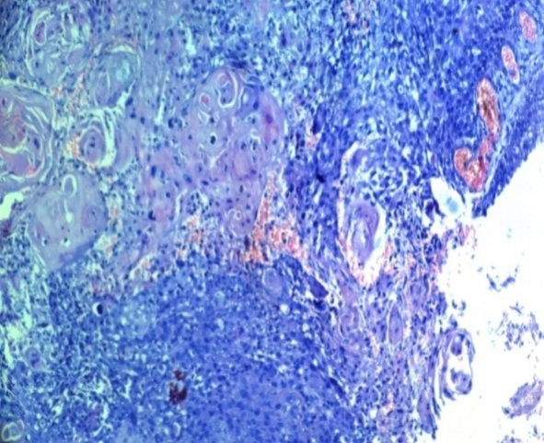 | 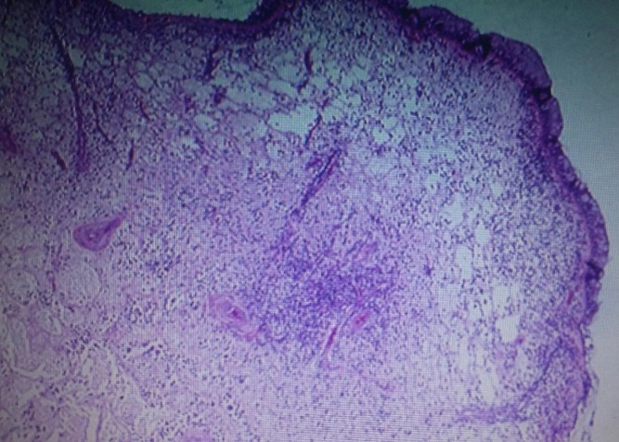
Fig (1): showing focal area of nasal squamous cell carcinoma (H&E 200X). | Fig (2): showing nasal mucosa of a control case with immuonohistochemical negativity (DAB 200X).

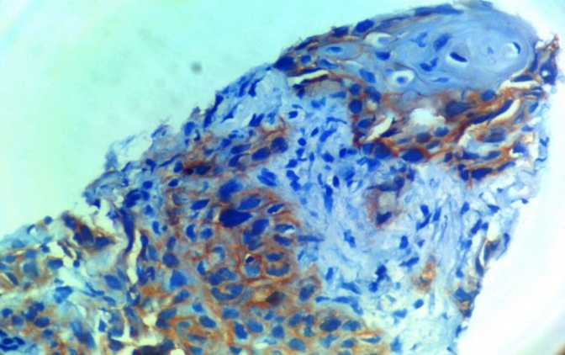 | 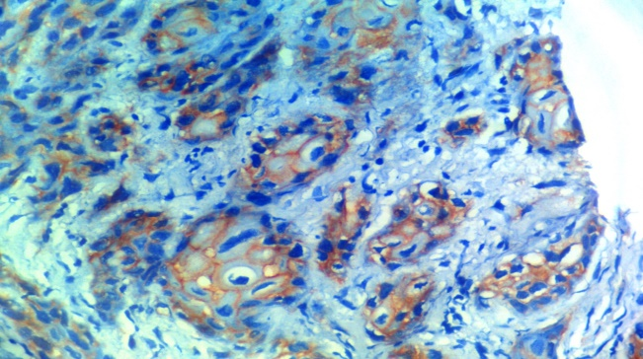
Fig (3): showing focal area of nasal squamous cell carcinoma showing strong membranous EGFR immunohistochemical positivity (DAB 200X). | Fig (4): showing focal area of nasal squamous cell carcinoma showing strong membranous EGFR immunohistochemical positivity (DAB 400X).

4. Discussion
Tumor markers are useful for clinicians in the diagnosis and management of tumors. To date, many tumor markers have been reported to be clinically helpful in various malignant neoplasms (Toi et al., 1996; Lin et al. 2011).
In this study, we investigated the significance of SCCA1 serum level and EGFR as a tumor markers in IP and their usefulness for the early detection of recurrence and malignant transformation of IP. Postoperative serum SCCA1 levels were significantly lower in all IP cases compared to their respective preoperative measures. Also post-operative measures showed non-significantly higher levels compared to control levels. These data indicated a fact that the source of SCCA1 estimated in serum was the papillomatous growth and the more the change the higher the serum level. When comparing postoperative to preoperative values of SCCA; it was found that, there was statistically significant decrease of SCCA levels at 2 days postoperatively when compared to preoperative values (1.85±0.42 vs 3.78±1.42 respectively) and similarly, there was statistically significant decrease of SCCA at 3-5 months postoperatively when compared to preoperative values (1.67±0.39 vs 3.78±1.42 respectively). Finally, there was statistically significant decrease of SCCA at 3-5 months postoperatively when compared to values at 2 days postoperatively. These data indicated significant decrease of SCCA overtime table3.
The study showed that EGFR where significantly elevated in IP with SCC compared to benign IP and in recurrent IP compared to de novo IP, a finding indicating increased local expression of growth factors in tissues of IP and illustrated the role played by growth factors in pathogenesis and progression of IP. In line with these data multiple studies detected a relation between both tissue expression of EGFR and/or serum levels of SCCA and papillomatous lesions anywhere in the body and with their progression or changed behavior. Huang et al. (2006) indicated that SCCA may be of great potential as the biomarker of tongue cancer and as the potential therapeutic target for gene therapy. Iwata et al. (2007) reported a case of IP causing high serum levels of SCCA and Carcinoembryonic Antigen (CEA), postoperatively, the serum levels of CEA and SCCA significantly decreased within 3 months.
Lin et al. (2011) demonstrated that preoperative SCCA is a good marker of pathologic lymph node metastasis, an advanced tumor stage and a higher rate of distant metastasis in patients had oral carcinoma.
In support of the pathogenic role of EGFR in development and progression of IP, expression of different variants of EGFR was documented in airway papillomatous and/or malignant lesions (Yang et al., 2009).Kourelis et al. (2009) documented that EGFR was up regulated significantly along the epithelial deterioration toward neoplasia. Also, Wu et al. (2010) reported that respiratory papillomas overexpress the EGFR.
The obtained results and review of literature allowed concluding that EGFR tissue expression could be used for differentiation between benign and malignant IP even in early phases of dysplasia. Serum SCCA1 could be used as a marker for complete operative excision of IP irrespective of its pathological diagnosis and allow for suspicion of hidden malignancy. However, further studies with larger series are needed to support these results and to clarify rationales.

References
Busquets, J.M. and Hwang, P.H., 2006. Endoscopic resection of sinonasal inverted papilloma: a meta-analysis. Otolaryngology-Head and Neck Surgery, 134(3), pp.476-482.
Figuerola E, Liern M, Palomero JM, et al. 1990. Nasosinusal inverted papilloma. Acta otorrinolaringologica espanola; 41(1):35–38
Huang, X., Y. Wei, L. Li, Y. Wen and J. Yang et al., 2006. Serum proteomics study of the squamous cell carcinoma antigen 1 in tongue cancer. Oral Oncol, 42: 25-30.
Iwata, T., K. Inoue, N. Nishiyama, N. Izumi and S. Mizuguchi et al., 2007. Pulmonary inverted schneiderian papilloma causing high serum levels of carcinoembryonic antigen and squamous cell carcinoma-associated antigen: Report of a case. Surg. Today, 37: 790-793.
Katori, H., Nozawa, A. and Tsukuda, M., 2005. Markers of malignant transformation of sinonasal inverted papilloma. European Journal of Surgical Oncology (EJSO), 31(8), pp.905-911.
Kourelis, K., G. Vandoros, T. Kourelis, P. Goumas and G. Sotiropoulou-Bonikou, 2009. Retinoid X receptor overexpression desensitizes laryngeal epithelium to carcinogenic effects associated with epidermal growth factor receptor upregulation. J. Otolaryngol. Head Neck Surg., 38: 233-239.
Lin, W.H., I.H. Chen, F.C. Wei, J.J. Huang and C.J. Kang et al., 2011. Clinical significance of preoperative squamous cell carcinoma antigen in oral-cavity squamous cell carcinoma. Laryngoscope, 121: 971-977.
Liu, W., Z. Li, Q. Luo, Y. Lai and J. Zhang et al., 2011.The elevated expression of osteopontin and vascular endothelial growth factor in sin onasal inverted papilloma and its relationship with clinical severity. Am. J. Rhinol. Allergy, 25:313-317.
Lawson, W. and Patel, Z.M., 2009. The evolution of management for inverted papilloma: an analysis of 200 cases. Otolaryngology--Head and Neck Surgery, 140(3), pp.330-335.
Oikawa, K., Furuta, Y., Oridate, N. and Fukuda, S., 2007. Clinical and pathological analysis of recurrent inverted papilloma. Annals of Otology, Rhinology & Laryngology, 116(4), pp.297-303.
Tabata T, Takeshima N, Tanaka N, Hirai Y, Hasumi K., 2000. Clinical value of tumor markers for early detection of recurrence in patients with cervical adenocarcinoma and adenosquamous carcinoma. Tumour Biol; 21:375 – 380
Toi, M., Taniguchi, T., Yamamoto, Y., Kurisaki, T., Suzuki, H. and Tominaga, T., 1996. Clinical significance of the determination of angiogenic factors. European Journal of Cancer, 32(14), pp.2513-2519.
Wang, X., Shi, G., Liu, Y., Ji, H., Li, J. and Wang, H., 2011. [Analysis of the clinical and pathological characteristics of sinonasal neoplasms]. Lin chuang er bi yan hou tou jing wai ke za zhi= Journal of clinical otorhinolaryngology, head, and neck surgery, 25(23), pp.1071-1075.
Wu, R., A.L. Abramson, M.H. Symons and B.M. Steinberg, 2010.Pak1 and Pak2 are activated in recurrent respiratory papillomas, contributing to one pathway of Rac1-mediated COX-2 expression. Int. J. Cancer, 127: 2230-2237
Yang, B., J. Chen, X. Zhang and J. Cao, 2009.Expression of Epidermal Growth Factor Receptor variant III in laryngeal carcinoma tissues. Auris Nasus Larynx, 36:682-687.

2/5/2017

