Financial Risk and Foreign Direct Investment: Evidence from China

Anwar Kamal Khan, Zong Yongjian

School of Economics & Management, Nanjing University of Science & Technology, Nanjing 210094, China
Anwarkamal572@gmail.com, zongyounjin@sina.com

Abstract: China has reported an unprecedented rise in foreign direct investment (FDI) flow since the country has opened its door to the foreign investors. This FDI inflow has brought a positive and dramatic change in China’s economy. The present study examines whether increased FDI inflow impacts a country’s economic growth and development and whether higher financial risks reduces the FDI inflow. A quantitative data analysis technique, especially SPSS, has been used to obtain data for the analysis of the correlation between the dependent and independent variables. The dataset employed in these study spans from 1970 to 2011. The study results indicate that increased FDI inflow positively impacts the economic growth and development of China. Moreover, the study indicates that financial risks, such as inflation, negatively affect the FDI inflow. The study implication clearly states that China should continue with the economic reforms to attract more FDI because of its perceived role in boosting economic growth and development.
[Anwar Kamal Khan, Zong Yongjian. Financial Risk and Foreign Direct Investment: Evidence from China. N Y Sci J 2017;10(2):72-77]. ISSN 1554-0200 (print); ISSN 2375-723X (online). http://www.sciencepub.net/newyork. 12. doi:10.7537/marsnys100217.12.

Keywords: Foreign Direct Investment (FDI), Economic, Development, Financial Risks.

1. Introduction
The last three decades have seen a remarkable rise in the inflow of FDI in China; this translates to robust economic growth and development in the country (Zhang, 2011). This rise in foreign investment has propelled China to acquire the second position, in terms of the largest FDI recipient globally (Zhang, 2011). Additionally, the rise in the volume of foreign direct investment in China has significantly contributed towards the dramatic positive change in the society as well as the economy. Accordingly, the planned economy of China has transformed into a market-oriented economy. Notably, FDI has played a central role both in funding local investments and driving productivity growth through the introduction of modern production techniques and management skills. The success of the FDI commitment requires proper functioning of the local financial systems, institutions, and instruments (Kitanov, 2010; Solomon, 2011). FDI is sensitive to financial changes, especially the short-run credits and asset investment. The increased investments have been considered crucial in the development and formation of the multinational corporations (MNCs) that play a major role in the economic and political growth. Studies have established different factors, such as political stability, government policies, and economic activities, affecting the location for MNCs (Coy & Cormican, 2014). Eicher, Helfman and Lenkoski (2011) argued that the productivity of a company is critical while making an investment decision. This is because the most productive companies are capable of making reasonable profits to recover from the relatively high sunk costs of investing in a particular country. Hornberger, Battat and Kusek (2011) further contributed to this knowledge through a theoretical proposition that countries with stable financial systems present favorable investment destinations for reputable MNCs. Using data from selected Chinese firms, Zhang (2011) affirmed that countries with lower credit defaults, stable interest rates, and efficient fina cial markets attract many potential investors in the modern business world. Undoubtedly, the effectiveness and stability of a country's financial systems, and thus, volatility of the financial market are pivotal for attracting FDI (He, Dong & Wenlang Zhang, 2010). The present study explores the effects of financial risk on FDI in China. The topic therein is extremely interesting and important as there is a worldwide competition for FDI. However, the flow of FDI is skewed due to differences in each country's commitment towards strengthening her financial systems (OECD, 2012). Considering the significance of the FDI, it is imperative to explore the impact of the financial risks on the FDI flow. This will compel the Chinese economic policy makers to reform their economic policy so as to escalate their ability to attract more FDI.

2. Research Background
The last decade has witnessed remarkable changes in the global economy as capital movement across the countries continues to play a central role in determining the economic growth. Undoubtedly, attracting FDI is growingly gaining prominence for many countries, particularly those willing to boost their economic growth and development. FDI is considered to be critical in the establishment, acquisition, and development of a stable and long-term relation between different world economies (Piteli, 2010; Chen, Ying, & Huiwen, 2011). This section reviews literature related to ascertaining the relationship between the FDI flow, financial risks and the economic growth and development.
2.1 Foreign Direct Investment and the Economic Development
Many studies: Brenkeviciute (2010) and Kitanov (2010) have extensively explored the role of FDI in the economic growth and development of a country. Their findings indicated that positive FDI inflow is a pre-requisite to economic growth and development. Such sentiments have also been emphasized by The Economist (2011) that asserted FDI inflow to be one of the country’s critical economic performance indicators. Barauskaite (2012) opined that investments through FDI have an enormous impact on production rate, gross domestic product, and the country’s unemployment level. Zhang (2011) argued that the inflow of FDI in China positively influenced the country’s economic growth. He further highlighted that since the “opening up policy” in 1978, China has recorded an inspiring growth of approximately 9.5% annually. He also contended that the FDI inflow in China provides essential equipments, capital, and technologies required to spearhead the economic growth. In the 1980s, China’s foreign reserve was extremely low and therefore, could not support any substantial economic growth and development (Mah, 2010). This situation persisted until the middle of the 1990s when the FDI flow in the country grew rapidly. The growth in the FDI witnessed a sharp rise in the gross domestic product (GDP) from about RMB 696 million, i.e., approximately USD365 million, in the year 1983 to more than RMB 300 billion, i.e., an estimated USD 44 billion, in the year 2009. In 2006, China’s foreign reserves surpassed that of Japan and later became the largest reserves globally. Such statistics clearly show that Chinese’s FDI flow has grown significantly since 1983 (Zhang, 2011). Figure 1 displays the rise in the country’s GDP and the FDI from 1983 to 2008.

3. Data Collection Methodologies
The two commonly used methodologies for collecting the FDI data includes the secondary and the primary data collection methodologies. The secondary data, in this case, include the data used by the researcher, which have been acquired from a variety of external and internal sources. The major advantage of primary data is that it is “first hand” collected for a specific objective. In addition, the data are usually pre-collected, and hence, no resources have been devoted by the researcher. The major disadvantage of this type of data is that it is time consuming, costly and is less precise and reliable as compared to the secondary data. In this study, the secondary data were used for empirical as well as statistical analysis to test the research hypotheses.
3.1 Data Source
The study utilized secondary data, specifically the FDI, GDP, the inflation rate, and the openness of the economy among other critical secondary information used for the analysis. The data were collected within the year range of 1970-2011, which is exactly 42 years. The data used in this study have been acquired from two major sources, including the Chinese economic databases and the Urban Statistical Yearbook. The Chinese Urban Statistical Yearbook is a renowned statistical yearbook published annually by the Chinese National Bureau of Statistics (NBS). It is known for providing pertinent Chinese Economic data that have been used in this study to test the stated hypotheses.

4. Result And Discussion
A close look at the correlation output in Table 2 indicates the presence of a positive relationship between the dependent variables–GDP, exports, import and the ratio of the sum of both import and export over the GDP and the FDI (independent variable). However, there tends to be a negative correlation between the variable inflation and the latter. This means that an increase in the inflation rate signifies that more foreign investors are edging out of the country, translating to low FDI flow. Therefore, based on the above correlation analysis, greater GDP improves FDI flow while increased inflation leads to reduced FDI flow.
The multiple regression output data shows R value to be 0.519, which establishes a positive relationship between the dependent and independent variables in the model. The R-square value, 0.269, shows that the independent variables in the model predict 26.9% of the dependent variable (standard error: 95373374448.433).

Table 2: indicates the presence of a positive relationship between the dependent variables–GDP, exports, import and the ratio of the sum of both import and export over the GDP and the FDI
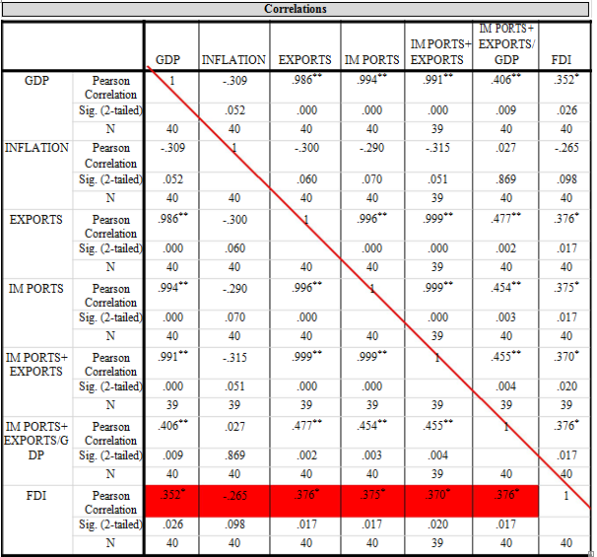

Table 3: The F (5, 33) value, 2.430 is statistically insignificant with Sig. value 0.56 being greater than the alpha value of 0.05. This means that the above independent variables are unreliable predictors of the dependent variable – FDI.
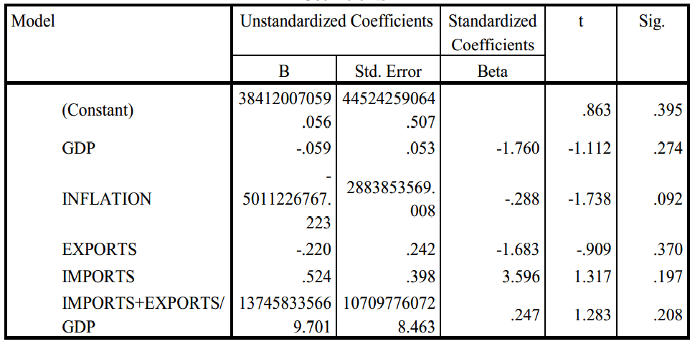

Table 4 shows that none of these variables seem to have a significant impact in predicting the variable FDI as all the Sig.
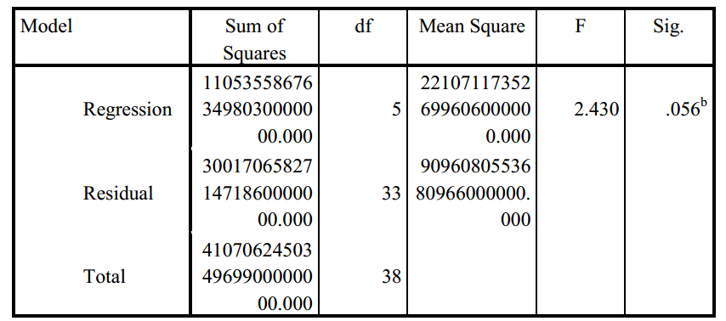

Table 4 shows that none of these variables seem to have a significant impact in predicting the variable FDI as all the Sig. values for the variables under discussion turned out to be above the cut-off point of 0.05. Further interrogation on the impact of the reliable variables was done by carrying a stepwise multiple linear regressions. The obtained R value 0.37 indicates a positive correlation between FDI and the predictor variable. R square value 0.137 shows that 13.7% of the variance in FDI score can be predicted by the sum of imports and exports (standard error: 978855247.140).

Table 5: From the model, it is apparent that the sum of exports and imports could predict 2.6% of the FDI.
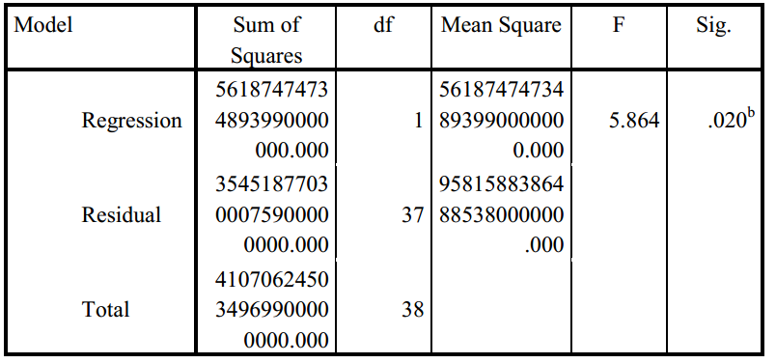
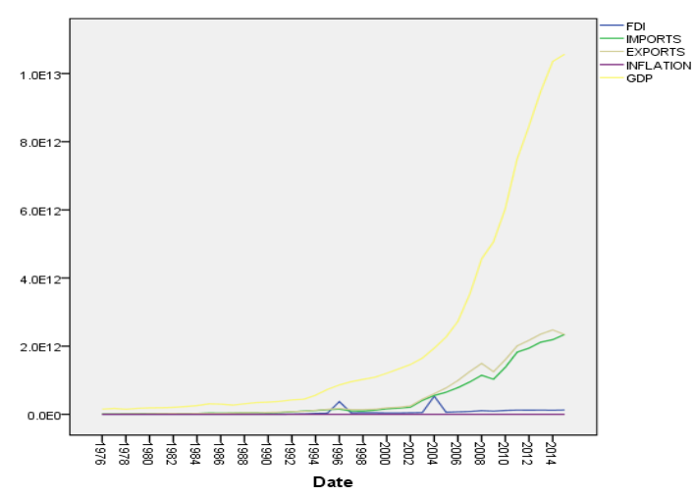
Figure 3: ARIMA Model for foreign direct investment

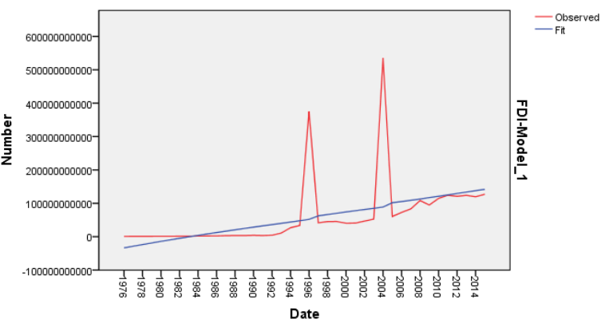
Figure 4: shows that China has been experiencing a steady growth in FDI inflow over the period between 1976 and 2014 on looking at the fit values rather than the observed values.

The sequence chart below shows that China’s GDP has experienced an enormous growth during the years 1994 to 2014. This could be attributed to a stagnant inflation rate, which was further enhanced by the fact that China’s export had always been ahead of the imports all over the years. FDI rose in the year 1995 and was at its peak within the year 1996 before experiencing a slump. The same trend is evident from the year 2003 to 2005.
The ARIMA model in Figure 4 shows that China has been experiencing a steady growth in FDI inflow over the period between 1976 and 2014 on looking at the fit values rather than the observed values. It is worth noting that this may be due to the influence of GDP and imports and exports with an exclusion of inflation rate, which seems to predict the growth of FDI as confirmed by the stepwise regression analysis. Based on this output, one can clearly conclude that the rate of FDI will increase as much as the inflation rate is kept at a constant (low), consequently attracting more investors into China.

5. Conclusions
The first hypothesis was geared towards determining whether the increased FDI flow impacts the economic growth and development of China. With respect to this research question, the study findings demonstrated that an unprecedented rise in the economic growth and development following the implementation of the opening up economic policy has significantly contributed to the economic growth and development of China (Zhang, 2011). This was further confirmed by the statistical analysis, which demonstrated the positive significant relationship between FDI inflow and economic growth and development. The second question examined the impact of the financial risks on the FDI flow. The study revealed that higher financial risks significantly discouraged the FDI inflow. Coy and Cormican (2014) concluded that higher financial risks such as the cost of production discouraged the flow of FDI. The increased cost of production that leads to low FDI inflow has been confirmed by the statistical analysis results, which showed a negative relationship between FDI and inflation. The findings of this study imply that countries willing to attract a considerable FDI inflow should open up their economies, as well as put in place the economic measures to ensure financial stability (controlling inflation). The results also imply that countries willing to boost their economic growth and development must put in place strategies to boost FDI inflow because high FDI inflow is linked to robust economic growth and development.

References:
- Ali, M. A., Asfand, A. Y. K., Bakhtiyar, B. K., & Hammad, R. H. A. (2014). Financial Risk and Foreign Direct Investment: Evidence from Pakistan Economy.
- Barauskaite, L. (2012). An Analysis of Foreign Direct Investments: In flows and Determinants. Retrieved from https://brage.bibsys.no/xmlui/bitstream/handle/11250/135808/Oppgave%20Laura%20Barauskaite.pdf?sequence=1.
- Brenkevičiūtė R. (2010), “ Tiesioginių užsienio investicijų poveikio šalies ekonomikai analizė”.
- Mokslas Lietuvos ateitis [Science – Fiture of Li thuania], 2(2), 11 – 17.
- Chen, Z., Ying Ge, & Huiwen, L. (2011). "Foreign Direct Investment and Wage Inequality: Evidence from China." World Development 39.8, 1322-32.
- Coy, R., & Cormican, K. (2014). Determinants of foreign direct investment: Analysis of Japanese investment in Ireland using the Ka.
- Eicher T., Helfman L., Lenkoski A. (2011). Robust FDI Determinants: Bayesian Model Averaging in the Presence of Selection Bias, University of Washington, Washington.
- He, Dong and Wenlang Zhang (2010) “How Dependence is the Chinese Economy on Exports and in What Sense has it s Growth been Export - led?” Journal of Asian Economics, 21, 87–104.
- Hornberger, K., Battat, J. and Kusek, P. (2011). Attracting FDI: How much does Investment Climate Matter, New York: The World Bank Group.
- Khrawish, H. A. (2014). The Effect of Economic and Financial Risks on Foreign Direct Investment in Jordan: Multivariate Analysis. International Business Research, 7(5), 124.
- Kitanov B. (2010), “Does Foreign Direct Investment Have an Effect on Economic Development? The Case of Bulgaria”. Scholarly Research Paper, 3 p. no model, Investment Management and Financial Innovations, 11(1), 8-17.
- Mah, J ai S. (2010) “Foreign direct investment inflows and economic growth of China,” Journal of Policy Modeling, 32, 155 - 158.
- OECD (2012). FDI in Figures, OECD Investment Division.
- Piteli E. (2010). Determinants of foreign direct investment in developed economies: A comparison between European and non-European countries, Contributions to Political Economy, Vol. 29, No. 1, and pp. 111-128.
- Solomon E. (2011). Foreign Direct Investment, Host Country Factors and Economic Growth, Ensayos Revista de Economía, 30(1), 4-70.
- The Economist (2011), “World Investment Prospect 2011”. Available at: http://www.vcc.columbia.edu/pubs/documents/WorldInvestmentProspectsto2011.pdf.
- Wyk, J. V., & Anil, K. L. (2008). Risk and FDI Flows to developing countries. SAJEMS.
- Zhang, N. (2011). Foreign Direct Investment in China: Determinants and Impacts. Retrieved from https://ore.exeter.ac.uk/repository/bitstream/handle/10036/3320/ZhangN.pdf?sequence=2 &isAllowed=y.
- Shaw, E., 1973, “Financial Deepening in Economic Development”, Oxford University Press, NY.
- Shirzour, Z., 2010, “Studying the Information Efficiency of Stock Exchange by Variance Test Method”, PhD. Thesis, Mashhad University.
- Stiglitz, J.E., 1994, “The Role of the State in Financial Market”, Supplement to World Bank Economic Review and World Bank Research Observer, pp. 19-27.
- Taghavi, M., S. Bagheri, and P. Mohajeri, 2011, “Surveying of Structural Break in Nexus of Financial Development and Economic Growth and Optimal Size of Lending of Bank Credit to Private Sector”, Quarterly Journal of Economic Growth and Development, 1(4), pp. 37-54.
- Zicchino, L., 2002, “Financial Structure and Economic Activity under Asymmetric Information”, Colombia University.

2/3/2017

