Effect of royal jelly and ginger on the histological changes of the testes of cyclophosphamide-treated adult male albino rats

Ebada M.A.¹, Yossef Y.GA¹, Al-Sayed A. Abd-Elrhman², Fathy M.A²

¹Department of Anatomy and Embryology, Faculty of Medicine, Al-Azhar University, Cairo, Egypt
²Department Anatomy and Embryology, Faculty of Medicine, Al-Azhar University, Assuit, Egypt

Abstract: Background: Cyclophosphamide is a widely used cytotoxic alkylating agent with antitumor and immunosuppressant properties. In spite of its therapeutic importance, a wide range of adverse effects including reproductive toxicity had been demonstrated following cyclophosphamide administration. Objective: Evaluating the possible protective effects of royal jelly and ginger on cyclophosphamide-induced testicular damage in adult male albino rats. Material and Methods: Twenty adult male albino rats of an average body weight (250-300 g.) were randomly divided into two groups. One group (five rats) was served as the control group (group1) and other group 2 (fifteen rats) was served as treated group, which was subdivided into 3 equal subgroups (a, b and c). Subgroup (a): consisted of five rats that were treated with cyclophosphamide. Subgroup (b): consisted of five rats that were given royal jelly orally and cyclophosphamide. Subgroup (c): consisted of five rats that were given ginger and cyclophosphamide. The testes were excised and histologicaly prepared for a light and an electron microscopic examination. Results: Light microscopic examination of cyclophosphamide treated adult male albino rat showed that the seminiferous tubules were markedly distorted. Most of the tubules showed many vacuoles. The lumina of the seminiferous tubules were devoid of spermatozoa. There was an increase in the amount of interstitial areas that contained some thick walled congested blood vessels. By electron microscopic examination there were marked affection of the cytoplasm of the germinal epithelial cells in the form of degenerated mitochondria, multiple lipid droplets and many empty spaces. Sertoli cells were rested on an irregular thickened basement membrane and its nucleus had an irregular nuclear membrane without nucleolus. Royal jelly had a potent protective effect against the testicular toxicity of the cyclophosphamide and showed a notable effect compared to the effect of ginger. Conclusion: It could be concluded that cyclophosphamide produced testicular histological alterations. Royal jelly has a potent protective effect against the testicular toxicity of this agent and might be clinically useful. The study suggests that ginger has got some recovery role in cyclophosphamide induced testicular damage of rat.
[Ebada M.A., Yossef Y.GA, Al-Sayed A. Abd-Elrhman, Fathy M.A. Effect of royal jelly and ginger on the histological changes of the testes of cyclophosphamide-treated adult male albino rats. N Y Sci J 2017;10(2):61-71]. ISSN 1554-0200 (print); ISSN 2375-723X (online). http://www.sciencepub.net/newyork. 11. doi:10.7537/marsnys100217.11.

Keywords: Testis - Cyclophosphamide - Royal jelly - Ginger - Albino rat.

1. Introduction
Cancer is the most serious disease that causes death all over the world (Grandis and Sok, 2004).
Drugs used for cancer chemotherapy are often limited by their severe acute toxic and undesirable side effects in multiple organ systems (Sahin et al., 2010).
Most of the chemotherapeutic drugs used in the treatment of neoplastic cells cause various sorts of damage to normal living cells. One of these drugs is cyclophosphamide which is a widely used cytotoxic alkylating agent with antitumor and immunosuppressant properties. It is used for treating chronic and acute leukemia, multiple myeloma, lymphomas, rheumatic arthritis, and systemic lupus erythematosus, as well as in preparation for bone marrow transplantation (Dollery, 1999).
In spite of its therapeutic importance, a wide range of adverse effects including reproductive toxicity has been demonstrated following cyclophosphamide treatment in humans and experimental animals (Anderson et al., 1995).
Human studies showed a long term male gonadal damage after cyclophosphamide chemotherapy, including reduced hormone production and infertility due to spermatogonial depletion (Nurmio et al., 2009).
It has been reported that oxidative stress-induced biochemical and physiological damage is responsible for cyclophosphamide toxicity in testis (Ahmadi et al., 2008).
Medicinal plants play an important role in pharmacology and medicine for many years (Ogbera et al., 2010).
Royal jelly, produced by the bees, had a stimulated cell survival, cell growth and cell differentiation. It also had a cytotoxic effect on the carcinoma cells (Salazar-Olivo and Paz-Gonzalez, 2005).
Proteins and peptides of royal jelly have many effects including antioxidation (Guo et al., 2005).
Ginger extracts showed different pharmacological effects such as an anti platelet, anti-oxidant, anti-tumour, anti-rhinoviral, anti-hepatotoxicity and anti-arthritic effects (Kamtchouing et al., 2002).
The use of antioxidant agents seemed partially to protect the male reproductive organs from cyclophosphamide toxic effects in animal models (Turk et al., 2010).
The aim of this study is to investigate the effects of cylophosphamide on testis of adult male albino rats and the possible protective effects of either royal jelly or ginger on its histological and electron microscopic structure.

2. Material and methods:
In the present study, twenty adult male albino rats of an average body weight (250-300 g.) were used. Rats were apparently normal, healthy and were kept in animal houses under ordinary suitable conditions during the whole period of the experiment. Animals were fed on a standard rodent pellet diet and freely supplied with water. These animals were divided into two groups. One group consisted of five rats that were served as the control group (group1) and other group 2 consisted of fifteen rats that were served as treated group, which was subdivided into 3 equal subgroups (a, b and c).
Subgroup (a): consisted of five rats that were intra-peritoneally injected with cyclophosphamide solution at a dose of 50 mg/kg body weight in every alternative day for 14 days.
Subgroup (b): consisted of five rats that were given royal jelly orally at dose of 1000 μg/kg body weight for 1 week before and continued with the use of cyclophosphamide at a same dose with subgroup (a).
Subgroup (c): consisted of five rats that were given ginger orally at daily dose of 200 mg/kg body weight for 1 week before and continued with the use of cyclophosphamide at a same dose with subgroup (a) and (b).
At the end of the experiments the animals of each group were anethesized with ether and were sacrificed by decapitation and the testes were excised and histologicaly prepared for a light and an electron microscopic examination.

3. Results
Light microscopic examination
Examination of sections of the testis of an adult control male albino rat showed that the testis was covered by a fibrous tunica albuginea (Fig. 1). The testicular tissue was formed of regular rounded or oval shaped sections of the seminiferous tubules. Each tubule was surrounded by a regular thin basement membrane (Fig. 3). The seminiferous tubules lined by a germinal epithelium which was formed of spermatogenic cells at different stages of maturation that arranged from the base to the lumen of the tubules in which the spermatozoa were seen (Fig. 2). In the space between the seminiferous tubules, there is an interstitial tissue stroma, contained thin walled blood vessels and interstitial cells of Leydig that were arranged into small clumps (Figs. 2 & 3).

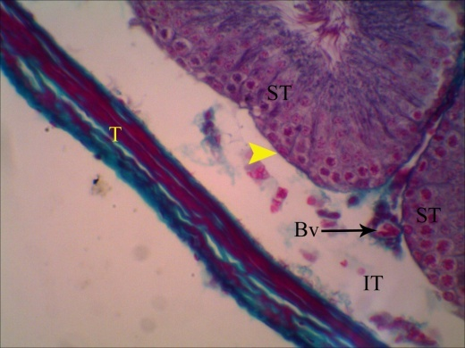

Fig. 1: A photomicrograph of transverse section of the testis of an adult control male albino rat showing: seminiferous tubules (ST). Testis is covered by a fibrous tunica albuginea (T). Each seminiferous tubule is surrounded by a thin basement membrane (arrow head) with intervening interstitial tissue (IT) containing normal blood vessel (Bv). (Massonʼs Trichrome Stain, X400).

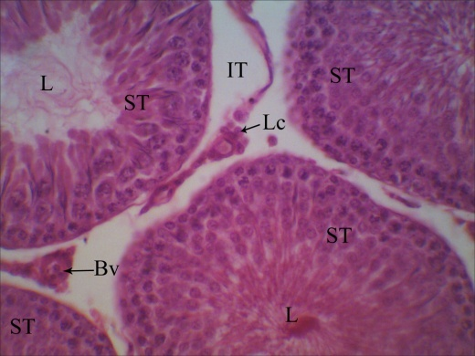

Fig. 2: A photomicrograph of transverse section of the testis of an adult control male albino rat showing: group of seminiferous tubules (ST) lined by well arranged seminiferous epithelium and have lumen (L) containing sperms with an intervening interstitial tissue (IT) showing Leydig cells (Lc) and normal blood vessel (Bv).

(Hx&E, X 400).

Examination of sections of the testis of cyclophosphamide treated adult male albino rat showed that it was covered by a thick tunica albuginea in comparison with the control group and each seminiferous tubule surrounded by a thick basement membrane (Fig. 6). The seminiferous tubules were markedly distorted with many vacuoles and constituent cells were less dense. The diameter of the seminiferous tubules appeared less than that of the control. The lumina of the seminiferous tubules were devoid of spermatozoa (Fig. 4). In between the seminiferous tubules, there was an increase in the amount of interstitial areas that contains some thick walled and congested blood vessels (Fig. 5).

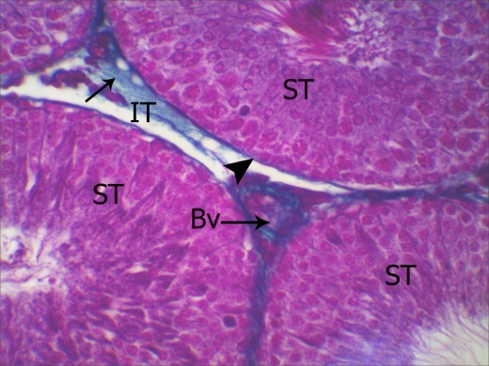

Fig. 3: A photomicrograph of transverse section of the testis of an adult control male albino rat showing: seminiferous tubules (ST) surrounded by thin and regular basement membrane (arrow head) with intervening interstitial tissue (IT) which showing normal amount of collagen fibers (arrow) and normal blood vessel (Bv). (Massonʼs Trichrome Stain, X400).

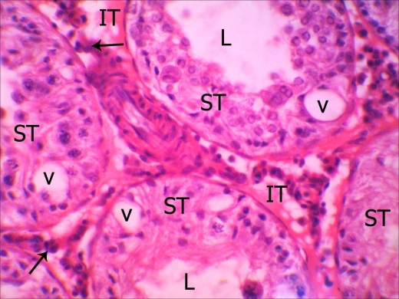

Fig. 4: A photomicrograph of transverse section of the testis of cyclohposphamide treated an adult male albino rat showing: group of seminiferous tubules (ST) lined by unarranged seminiferrous epithelium containing vacuoles (V), lumen (L) devoid of sperms and intervening interstitial tissue (IT) which showing Leydig cells (arrow). (Hx&E, X 400).

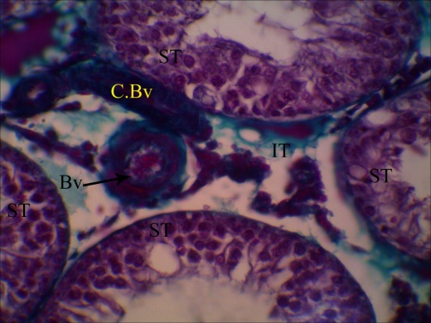

Fig. 5: A photomicrograph of transverse section of the testis of cyclohposphamide treated an adult male albino rat showing: group of seminiferous tubules (ST). The intervening interstitial tissue (IT) showing two blood vessels one of them thick walled (Bv) and the other is congested (C. Bv). (Massonʼs Trichrome Stain, X400).

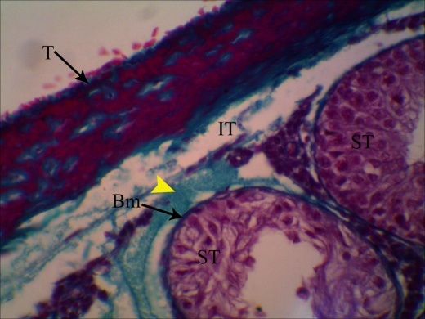
Fig. 6: A photomicrograph of transverse section of the testis of cyclohposphamide treated an adult male albino rat showing: group of seminiferous tubules (ST) covered by thick tunica albuginea (T), each seminiferous tubule is surrounded by thick basement membrane (Bm). The interstitial tissue (IT) showing great amount of collagen fibers (arrow head). (Massonʼs Trichrome Stain, X400).

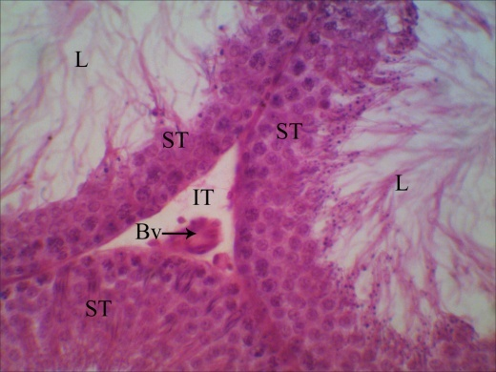

Fig. 7: A photomicrograph of transverse section of the testis of an adult male albino rat treated with cyclohposphamide & royal jelly showing: group of seminiferous tubules (ST) lined by well differentiated seminiferous epithelium and have lumen (L) which containing sperms with intervening interstitial tissue (IT) which showing normal blood vessel (Bv). (Hx&E, X 400).

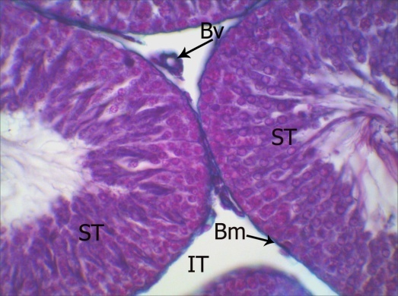

Fig. 8: A photomicrograph of transverse section of the testis of an adult male albino rat treated with cyclohposphamide & royal jelly showing: group of seminiferous tubules (ST), each of which surrounded by thin and regular basement membrane (Bm) with intervening interstitial tissue (IT) with a thin walled blood vessel (Bv). (Massonʼs Trichrome Stain, X400).

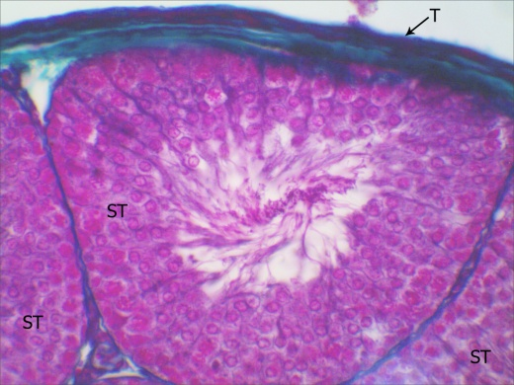
Fig. 9: A photomicrograph of transverse section of the testis of an adult male albino rat treated with cyclohposphamide & royal jelly showing: group of seminiferous tubules (ST) covered by a thin fibrous tunica albuginea (T). (Massonʼs Trichrome Stain, X400).

Examination of sections of the testis of rats treated with cyclophosphamide and royal jelly showed that the testis was covered by a thin fibrous tunica albuginea (Fig. 9). The majority of the seminiferous tubules appeared regular in their outline, they showed nearly normal architecture with the appearance of the germinal cell population including different types of germ cell and the lumina of the tubules contained spermatozoa (Fig. 7). Regarding the interstitial tissue, it appeared nearly similar to the control group in which it contained thin walled blood vessels and interstitial cells of Leydig that were arranged into small clumps (Fig. 8).
Examination of sections of the testis of rats treated with cyclophosphamide and ginger showed that the testis was covered by a thick tunica albuginea in comparison with the control group (Fig. 12). The majority of seminiferous tubules appeared regular in their outline, they showed nearly normal architecture with the appearance of the germinal cell population including different types of germ cell. But the lumina of the tubules were devoid of spermatozoa (Fig. 10). Regarding the interstitial tissue, it appeared nearly similar to the control group, with the presence of thick walled blood vessels that were seen in some sections (Fig. 11).

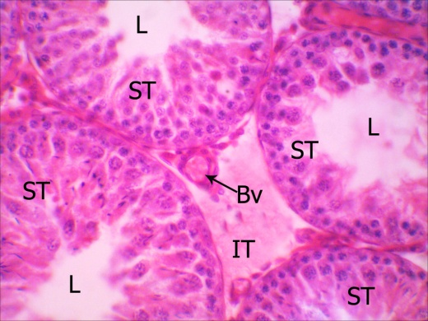

Fig. 10: A photomicrograph of transverse section of the testis of an adult male albino rat treated with cyclohposphamide & ginger showing: group of seminiferous tubules (ST) that were lined by well differentiated germinal epithelium and had lumen (L) which devoid of spermatozoa. The intervening interstitial tissue (IT) showed normal blood vessel (Bv). (Hx&E, X 400).

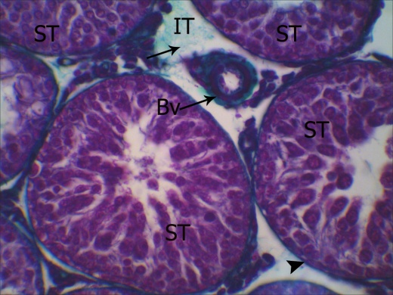

Fig. 11: A photomicrograph of transverse section of the testis of an adult male albino rat treated with cyclohposphamide & ginger showing: Seminiferous tubules (ST) surrounded by thin and regular basement membrane (arrow head). The intervening interstitial tissue (IT) showing a little amount of collagen fibers (arrow) and thick walled blood vessel (Bv). (Massonʼs Trichrome Stain, X400).

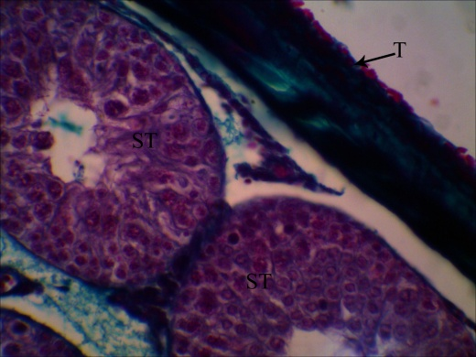
Fig. 12: A photomicrograph of transverse section of the testis of an adult male albino rat treated with cyclohposphamide & ginger showing: group of seminiferous tubules (ST) covered by thick tunica albuginea (T). (Massonʼs Trichrome Stain, X400).

Electron microscopic examination
Examination of ultrathin sections of the control testis of adult male albino rats showed normal structure of seminefrous tubules and interstisial tissue (Figs. 13, 14 & 15).
Examination of ultrathin sections of the testis of a cyclophosphamide treated male albino rat showed marked affection of the cytoplasm of the germinal epithelial cells in the form of degenerated mitochondria, multiple lipid droplets and many empty spaces. The nuclei revealed very slight irregularity in their outline with very light indentations. Sertoli cells were rested on an irregular thickened basement membrane and their nuclei which had irregular nuclear membrane and contained an electron dispersed chromatin material without nucleoli (Figs. 16 & 17).
Examination of ultrathin sections of the testis of rats treated with cyclophosphamide and royal jelly showed nearly normal mitochondria of the germinal epithelial cells. The nuclei revealed regular outline with chromatin patches of some of them. The lumen contained many spermatozoa. Sertoli cells were rested on regular thin basement membrane and their cytoplasm contained normal organelles with few lipid droplets. The nucleus had a regular nuclear membrane and contained normal chromatin material with a nucleolus (Figs. 18, 19 & 20).
Examination of ultrathin sections of the testis of rats treated with cyclophosphamide and ginger showed normal mitochondria of the cytoplasm of the germinal epithelial cells with few small lipid droplets and empty spaces. The lumina of seminiferous tubules were devoid of spermatozoa. The nuclei revealed regular outline. Sertoli cells were rested on an irregular thick basement membrane and their nuclei had a regular nuclear membrane and contained normal chromatin material with a nucleolus (Fig.21).
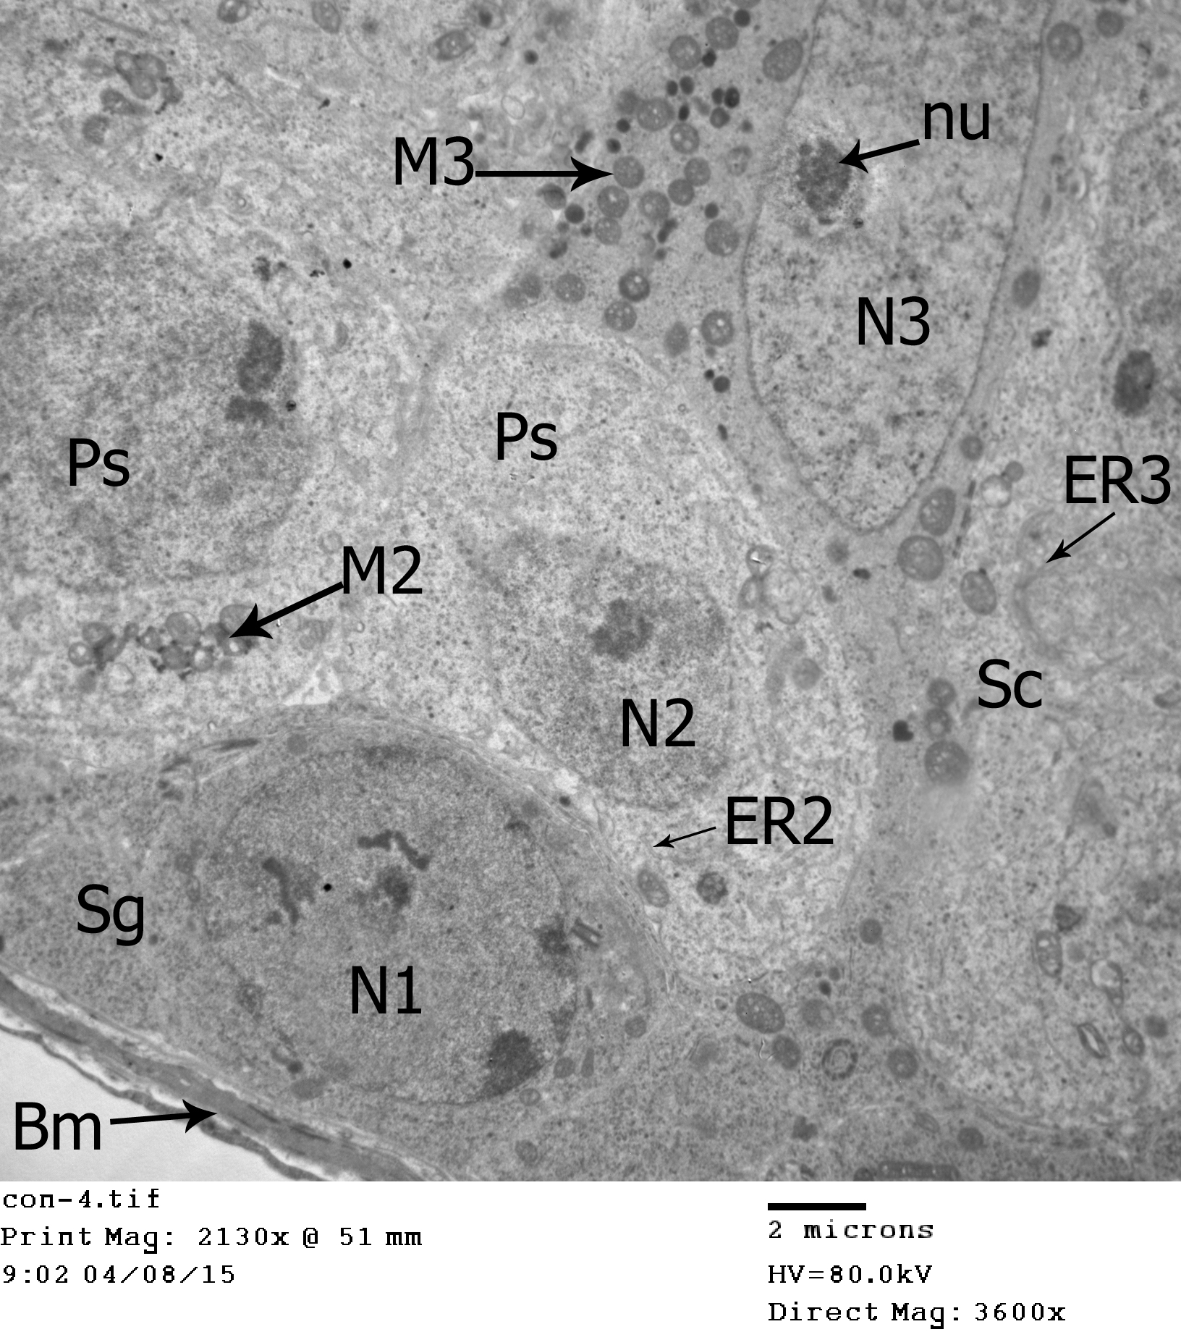
Fig. 13: An Electron micrograph of seminiferous tubule of the testis of adult control male albino rat showing: type A spermatogonia (Sg) which appeared in contact with the basement membrane (Bm) and had an oval nucleus (N1) with regular nuclear membrane. This section also showing Sertoli cell (Sc) which appeared as large branching cell which had large more or less oval nucleus (N3) with prominent nucleolus (nu) and had cytoplasm showed endoplasmic reticulum (ER3) and numerous mitoconderia (M3). This section also showing two primary spermatocytes (Ps) which has rounded nucleus (N2) and its cytoplasm containing mitochonderia (M2) appears in groups and endoplasmic reticulum (ER2). (X 3600).
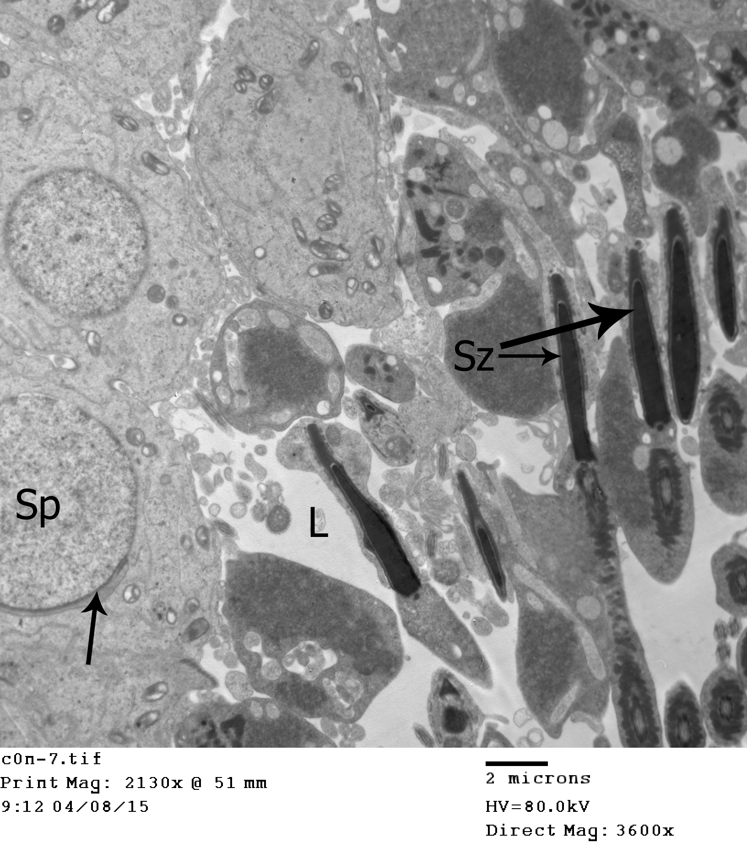
Fig. 14: An Electron micrograph of seminiferous tubule of the testis of adult control male albino rat showing: round spermatid (Sp) characterized by presence of acrosomal cap (arrow) which spreads over one pole of the nucleus. This section also showing the lumen (L) which containing large number of spermatozoa (Sz). (X 3600).

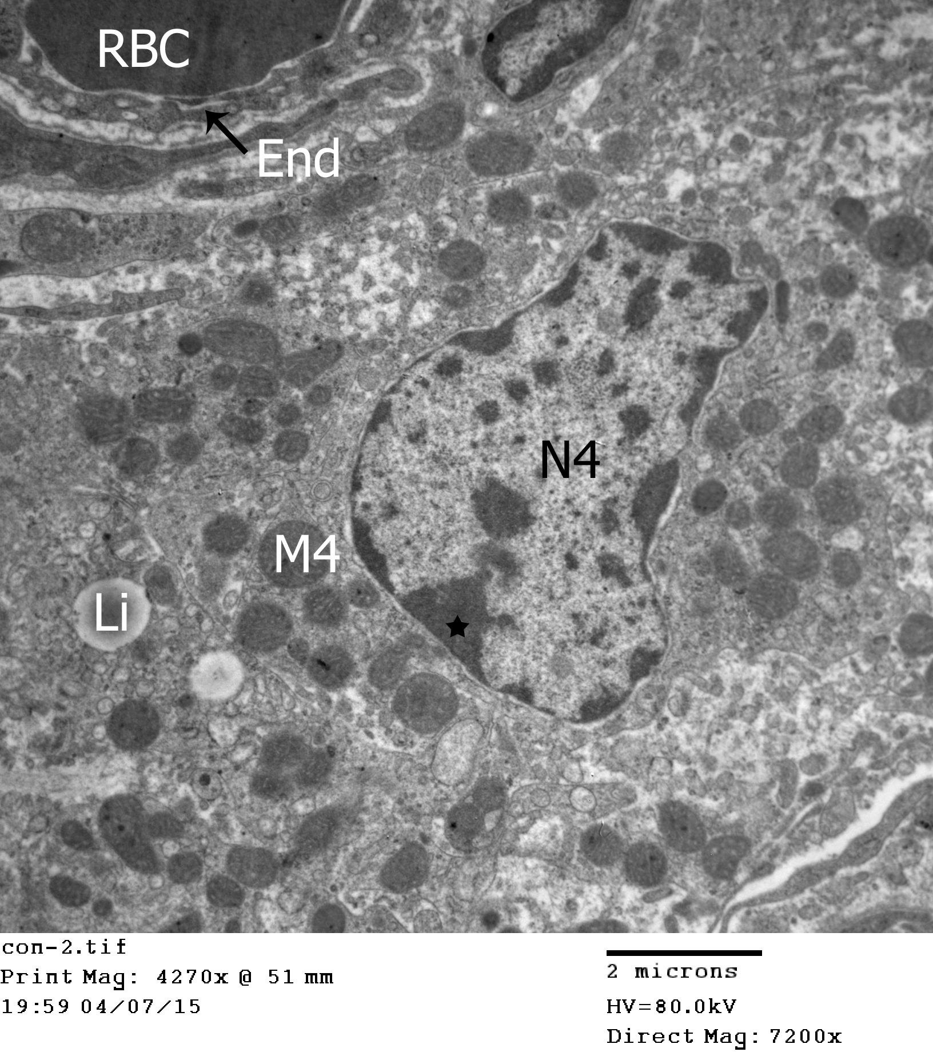
Fig. 15: An Electron micrograph of seminiferous tubule of the testis of an adult control male albino rat showing: Leydig cell that has a nucleus (N4) with fine indentation and peripheral rim of chromatin (*) and its cytoplasm containing multiple mitochonderia (M4), lipid droplets (Li) and red blood cell (RBC) showing normal endothelial lining (End). (X 7200).

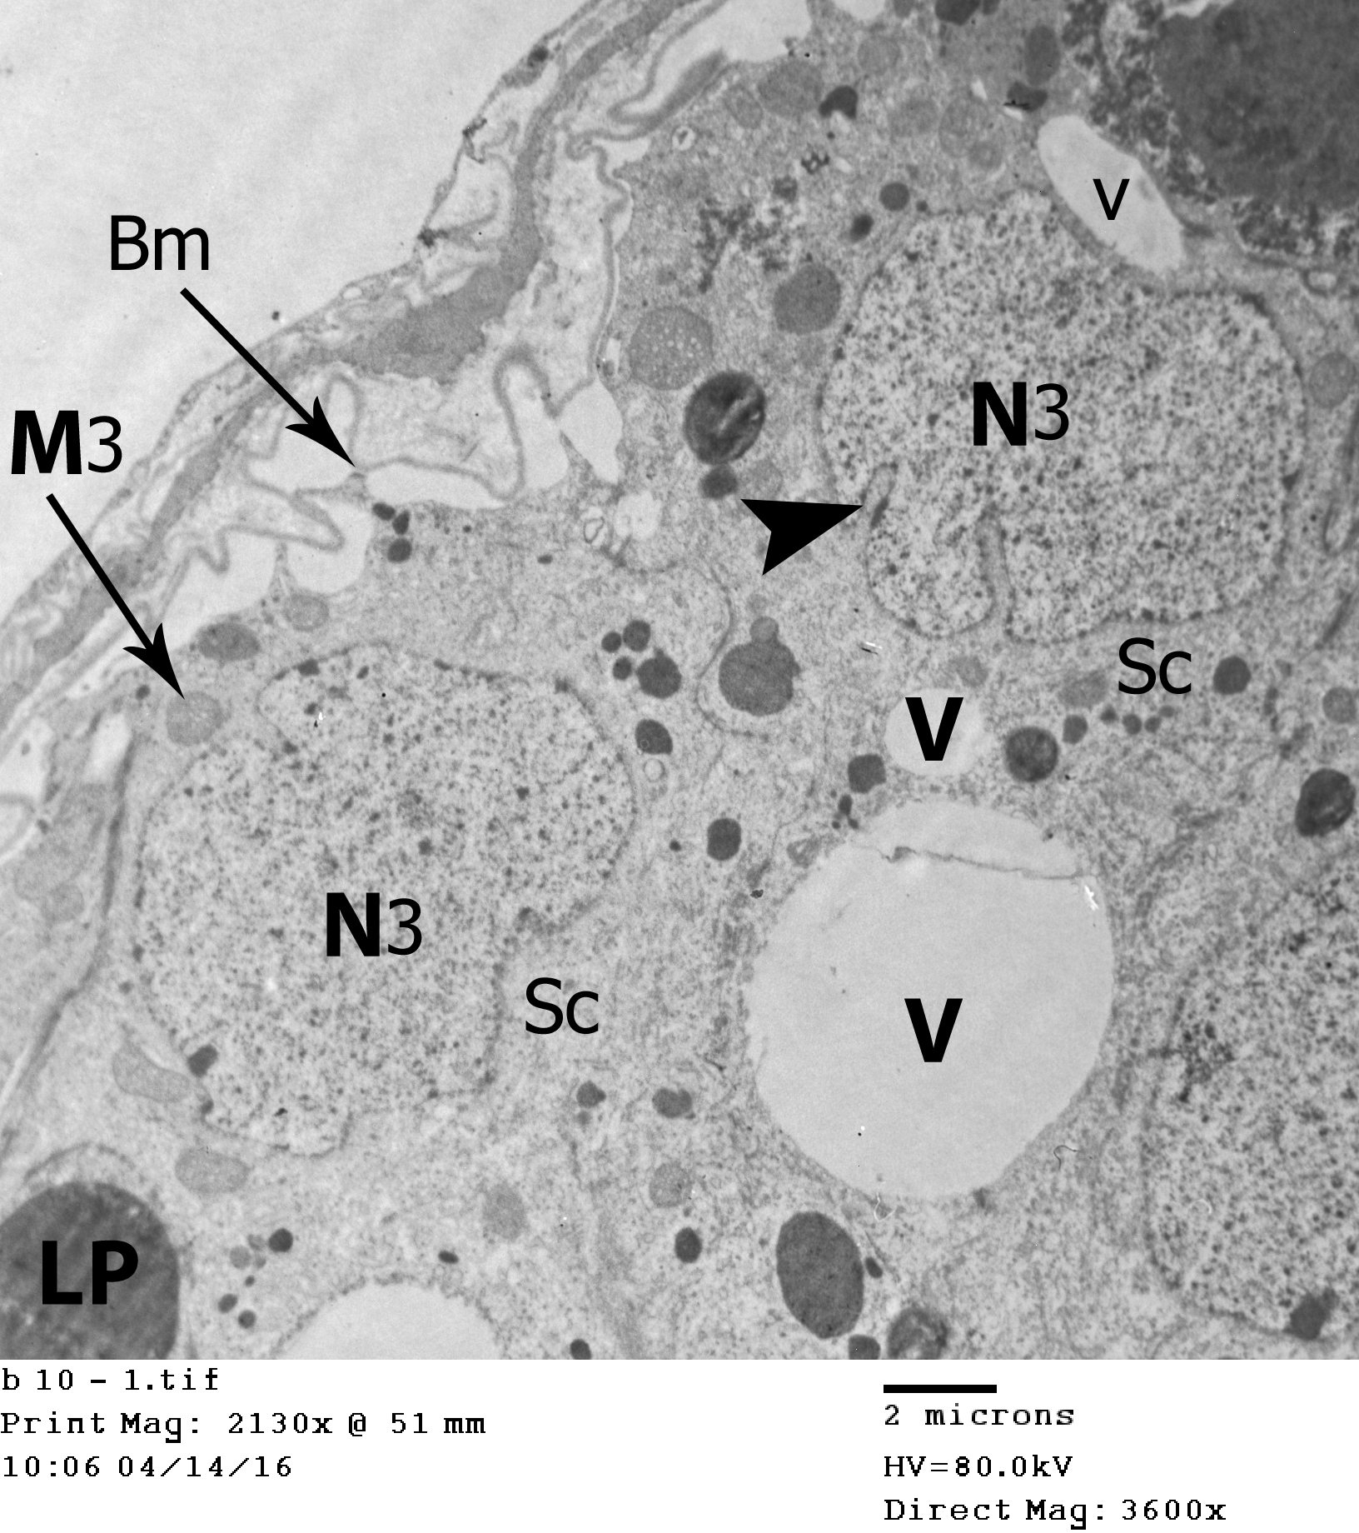
Fig. 16: An Electron micrograph of seminiferous tubule of the testis of cyclohposphamide treated adult male albino rat showing: Sertoli cell (Sc) which appear resting on irregular thick basement membrane (Bm) and having oval nucleus (N3) without nucleolus and has irregular nuclear membrane (arrow head). The surrounding cytoplasm contains vacuoles (v) and scanty degenerated mitochondria (M3) and multiple lipid droplets (LP). (X 3600).

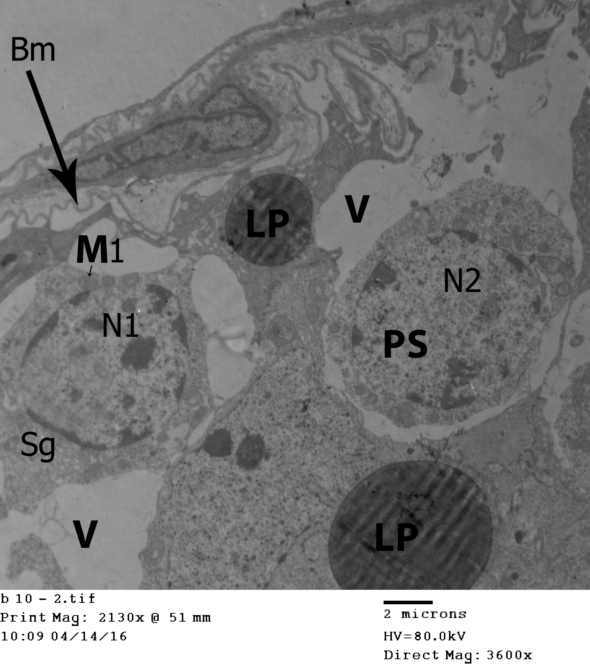
Fig. 17: An Electron micrograph of seminiferous tubule of the testis of cyclohposphamide treated adult male albino rat showing: type A spermatogonia (Sg) which is markedly irregular and has mitochondria (M1), large vacuoles (V) and oval nucleus (N1). This section also show Primary spermatocyte (Ps) which have oval nucleus (N2), large lipid droplets (LP) and large vacuoles (V). The basement membrane (Bm) of this seminiferous tubule appears thick and irregular. (X 36000).
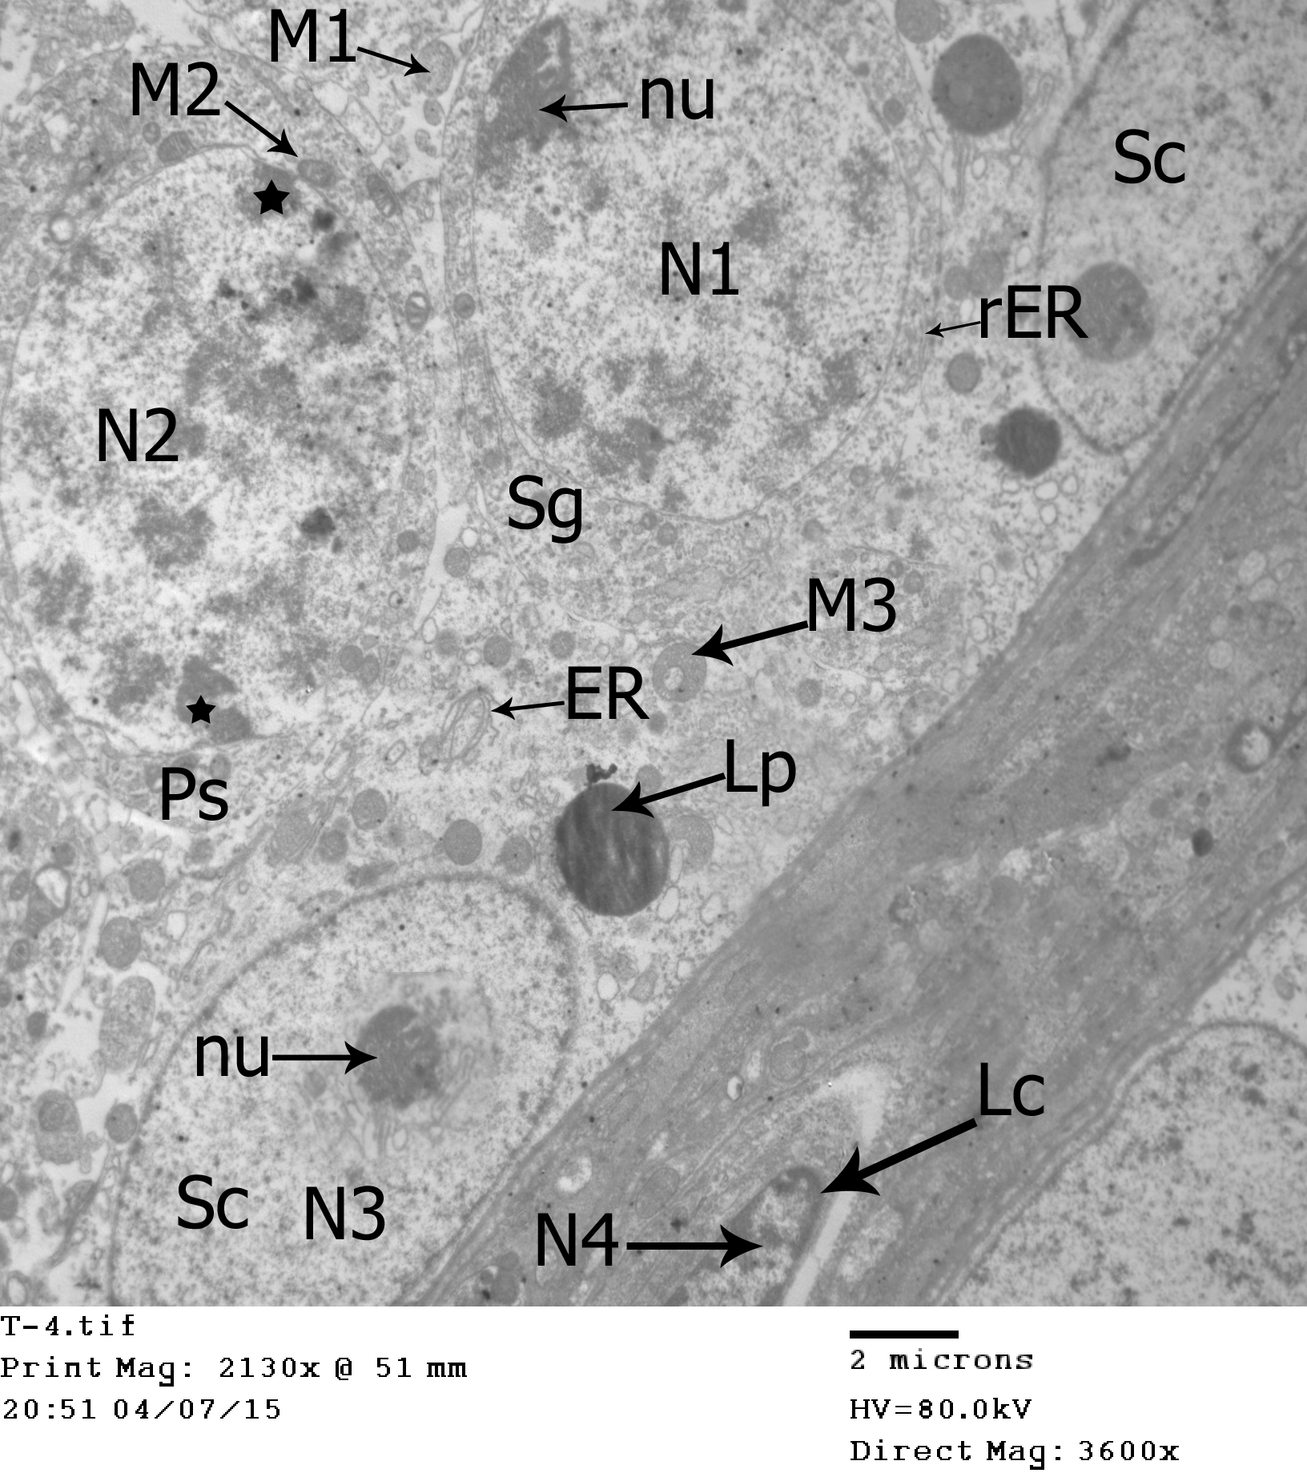
Fig. 18: An Electron micrograph of seminiferous tubule of the testis of cyclohposphamide and royal jelly treated adult male albino rat showing: Sertoli cell (Sc) which appear resting on thin regular basement membrane and having oval nucleus (N3) with prominent nucleolus (nu) and regular nuclear membrane, its cytoplasm showing normal mitochondria (M3), endoplasmic reticulum (ER) and small lipid droplets (LP). This section also shows spermatogonia (Sg) showing large rounded nucleus (N1) contains a nucleolus (nu) at one pole of the nucleus and its cytoplasm showing normal mitochondria (M1) and endoplasmic reticulum (ER). This section also shows primary spermatocyte (Ps) showing large rounded nucleus (N2) contains patches of chromatin material (*). The interstitial tissue shows Leydig cell that has a nucleus (N4). (X 3600).

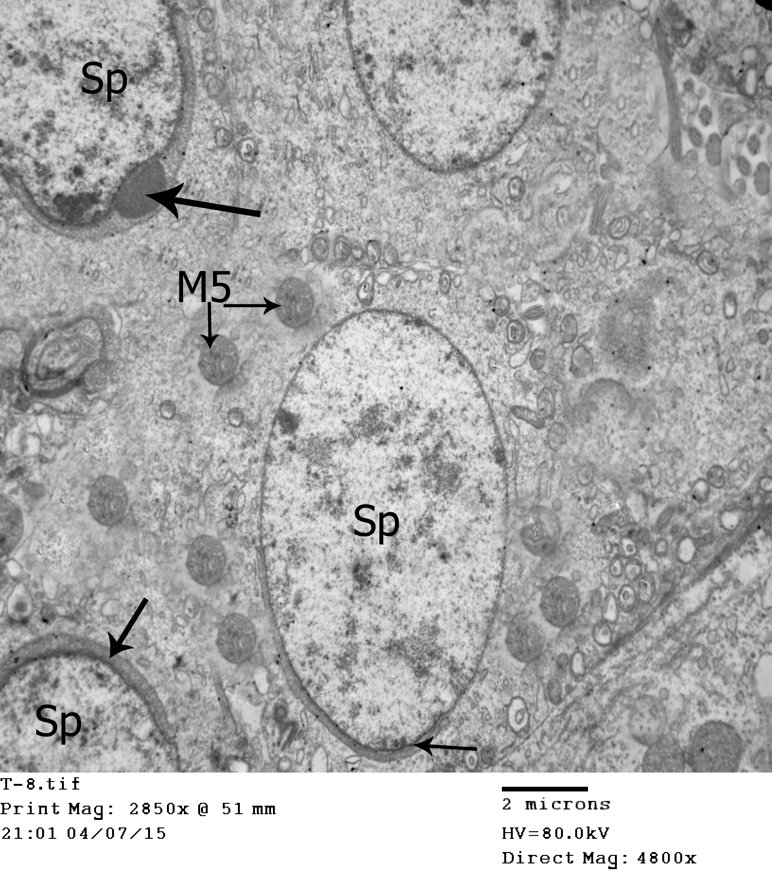
Fig. 19: An Electron micrograph of seminiferous tubule of the testis of cyclohposphamide and royal jelly treated adult male albino rat showing: rounded spermatids (Sp) characterized by presence of acrosomal cap (arrow) which spreads over one pole of the nucleus and its cytoplasm containing normal mitochondria (M5). (X 4800).

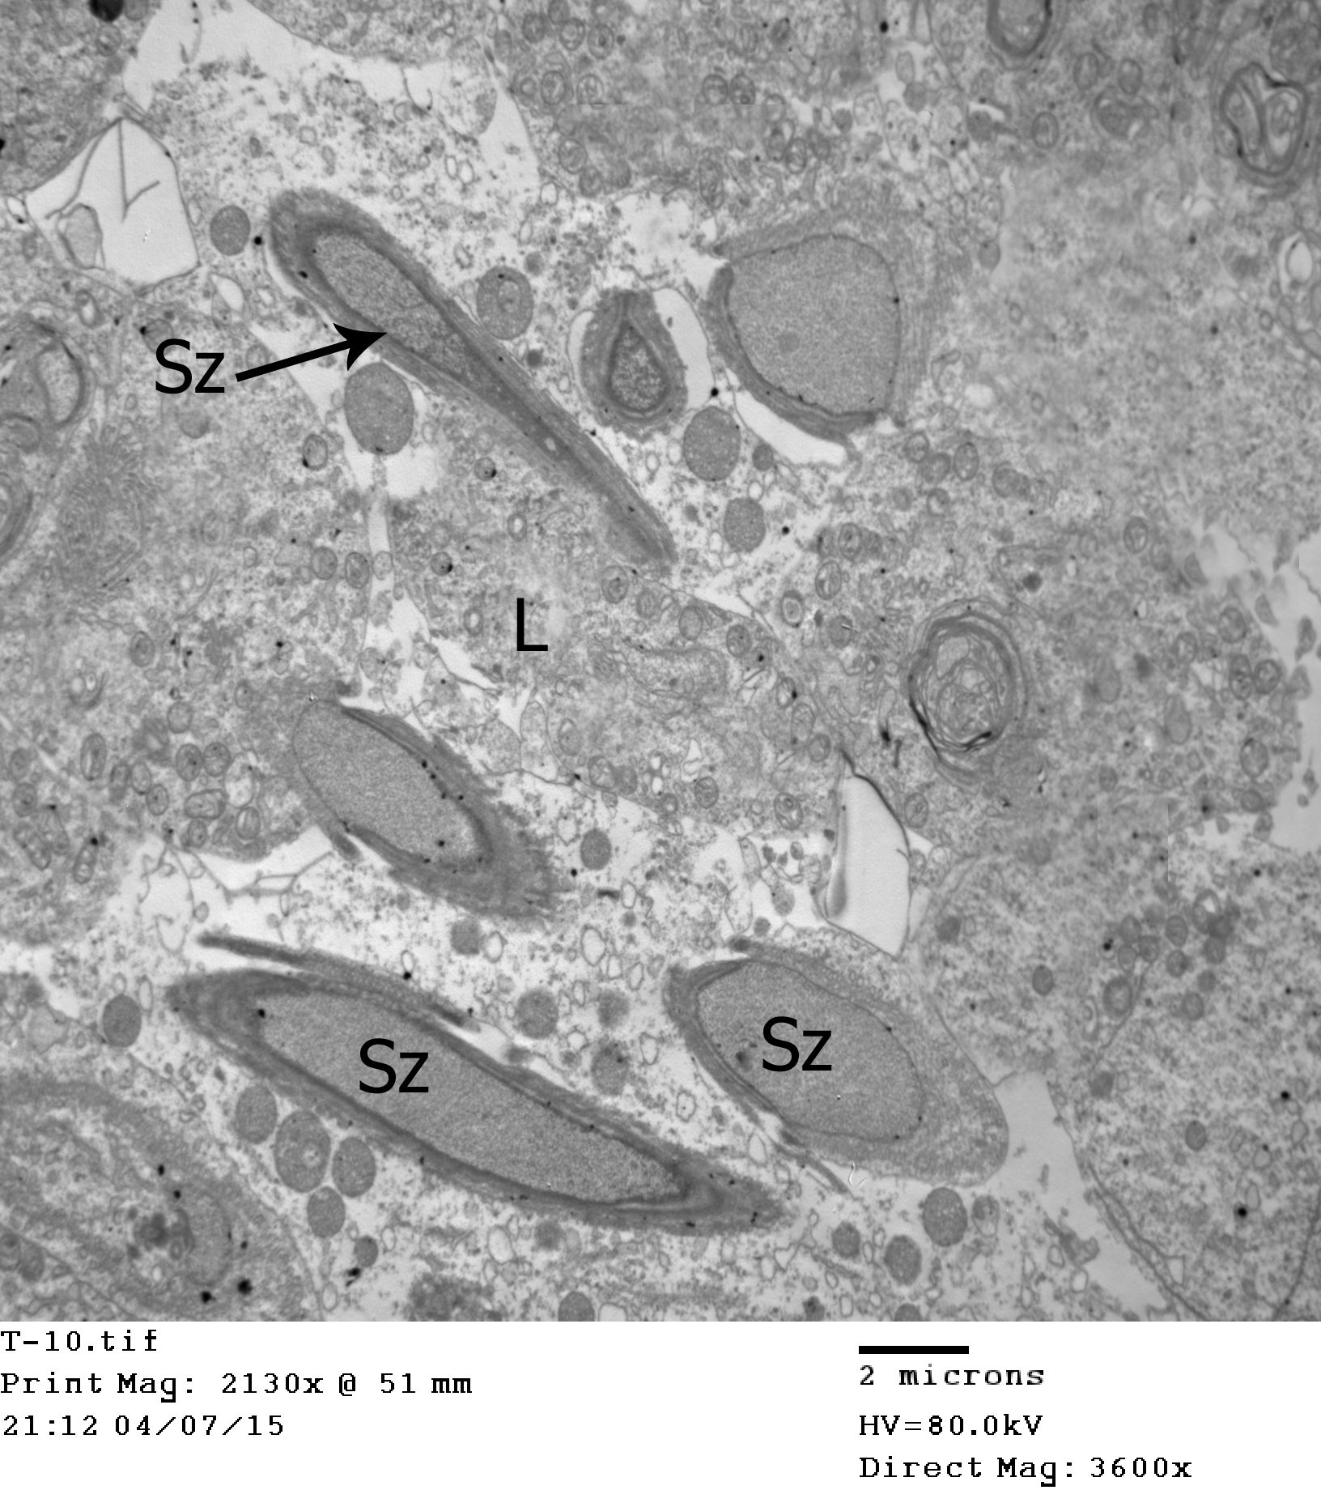
Fig. 20: An Electron micrograph of seminiferous tubule of the testis of cyclohposphamide and royal jelly treated an adult male albino rat showing: the lumen (L) which containing large number of spermatozoa (Sz). (X 3600).

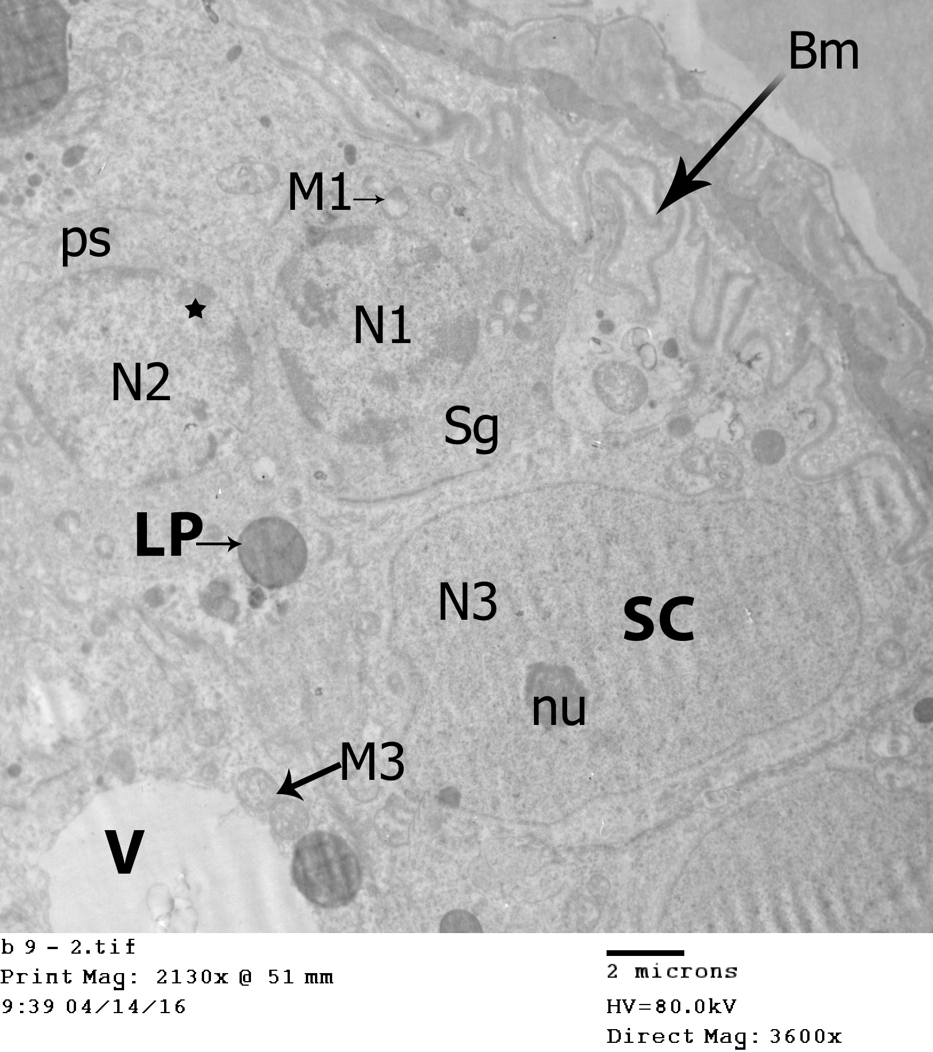
Fig. 21: An Electron micrograph of seminiferous tubule of the testis of cyclohposphamide and ginger treated adult male albino rat showing: Sertoli cell (Sc) which appear resting on thick irregular basement membrane (Bm) and having oval nucleus (N3) with prominent nucleolus (nu) and regular nuclear membrane, its cytoplasm showing large vacule (v), scanty mitochondria (M3) and small lipid droplets (LP). This section also show spermatogonia (Sg) which contact with thick irregular basement membrane (Bm) and has small rounded nucleus (N1), its cytoplasm showing vacuolated mitochondria (M1) which appear in groups. This section also shows primary spermatocyte (PS) showing large rounded nucleus (N2) contains patches of chromatin material (*). (X 3600).

4. Discussion
Spermatogenesis is one of the processes that involves a large number of different types of cells and is regulated through certain hormones (Fawcett, 2002). In spite of such complexity, it was not surprising that spermatogenesis demonstrated a marked sensitivity to many toxic substances (Crisp et al., 1998). Of all the toxicities associated with cyclophosphamide therapy, the most disturbing one was its gonadal toxicity (Katsifis and Tzioufas, 2004).
In this study, cylophosphamide was administered in a dose of 50 mg/kg/day intraperitoneally in an every other day for 14 days (Afsan et al., 2011). The intraperitoneal route was chosen since it is more reliable in animals and it is equal to the intravenous route which is the common route of administration of cylophosphamide in human (Huitema et al., 2000).
In the present study, the administration of cylophosphamide to the rats produced marked distortion of the seminiferous tubules. Most of seminiferous tubules showed many vacuoles and the cells were less dense. The diameters of the seminiferous tubules appeared lesser than that of the control. The lumina of the seminefrous tubules were devoid of spermatozoa.
Similarly, Forouzan et al. (2014) reported that cyclophosphamide treatment caused a reduced thickness of the epithelium of tubules as well as a reduction in the size and the number of different types of cells in the seminiferous tubules. Degeneration, vacuolation and exfoliation of germ cells into the lumen of seminiferous epithelium were other features. In addition, El–Alfy et al. (2013) stated that most of the spermatogonia had pyknotic nuclei and lost their reticular pattern and were darkly stained. Most tubules showed germ cell hypoplasia, in which the spermatogenic cells are reduced to few discrete layers. Several large vacuoles in the germinal epithelium in the majority of the seminiferous tubules were observed. Moreover Kamarzaman et al. (2013) reported that testis of animals administered cyclophosphamide for 5 days showed large numbers of irregular seminiferous tubules with degeneration of the spermatogenic layers. Vacuolization of the spermatogonia was observed. Furthermore, Kanth et al. (2014) concluded that male Rattus rattus treated up to 15 days with low dose (40mg/kg body weight) of cyclophosphamide showed relatively less number of spermatozoa in lumen (reduction the number of spermatozoa). There was also disorganization of spermatogenic cells with reduction of number of spermatids. Zhu et al. (2015) found that the testes of cyclophosphamide group showed moderate degeneration of spermatogenic cells, diffuse edema of interstitial cells, and significantly fewer spermatozoa in tubules.
Jalali et al. (2012) concluded that the treatment of rats with cyclophosphamide at a dose of 5 mg/kg/day for 28 days caused atrophy of the seminiferous tubules, a severe shortage of sperm cells, and the formation of intraepithelial vacuolization with the emergence of rupture and congestion of blood vessels.
In the present study, the interstitial tissue between seminefrous tubules, was increased and contained some thick walled congested blood vessels. The testis was covered by a thick tunica albuginea. These findings were in accordance with El–Alfy et al. (2013) who stated that the blood vessels in the interstitial tissue and under the tunica albuginea exhibited marked congestion as indicated by their dilatation and their engorgement. In addition, Jalali et al. (2012) noticed the emergence of rupture and congestion of blood vessels in testis of cyclophosphamide treated animals.
In the present study, ultrathin sections of the testis of an adult cyclophosphamide treated male albino rat showed marked affection of the cytoplasm of the germinal epithelial cells in the form of degenerated mitochondria, multiple lipid droplets and many empty spaces. The nuclei revealed very slight irregularity in their outline with very light indentations. Sertoli cells were rested on irregular thickened basement membrane. Their nuclei had an irregular nuclear membrane and contained an electron dispersed chromatin material without nucleoli.
Sakr et al., (2011) stated that seminiferous tubules obtained from animals treated with cyclophosphamide for 8 weeks were severely affected. These effects included degenerated basal lamina, abnormal sertoli cell and type A spermatogonium with irregular cell membranes and degenerated nuclei. The spermatocytes appeared containing degenerated cytoplasmic organelles. The germinal epithelium showed many spaces between the spermatogenic cells. Abnormal round spermatid was detected. El-Seedy et al. (2005) indicated that marked increase in sperm abnormality induced by CPA in mice proved the ability of this drug to interfere with different processes of spermatogenic cells.
The particular sensitivity of the reproductive tissue to cyclophosphamide was due to its high proliferating activity (Jarrelle et al., 1991).
It was believed that acrolein and phosphormide that were produced by cyclophosphamide drug metabolism within the body were responsible for its reproductive toxicity, due to their ability to the alkylation of the DNA molecule (Tripathi and Jena, 2008).
Lipid peroxidation was one of the principal causes of cyclophosphamide toxicity and was mediated by the production of acrolein, a metabolite for much of its toxicity (Selvakumar et al., 2005)
In the present work, the rats treated with cyclophosphamide and royal jelly showed that the testis was covered by a thin fibrous tunica albuginea. The majority of the seminiferous tubules appeared regular in their outline, with nearly normal appearance of the germinal cell population. The lumina of the tubules contained spermatozoa. The interstitial tissue appeared nearly similar to that of the control group. It contained a thin walled blood vessels and interstitial cells of Leydig that were arranged into small clamps. Similar results were obtained by El–Alfy et al. (2013). Raafat and Hamam (2012) found that royal jelly improves the histological effect of cisplatin on testis of adult male albino rat. They mentioned that most seminiferous tubules were nearly similar to those of the control group. Interstitial spaces were apparently narrow with few areas of acidophilic exudates.
Examination of ultrathin sections of the testis of rats treated with cyclophosphamide and royal jelly showed nearly normal mitochondria of the germinal epithelial cells. The nuclei revealed regular outline with chromatin patches of some of them. The lumen contained many spermatozoa. Sertoli cells were rested on regular thin basement membrane and their cytoplasm contained normal organelles with few lipid droplets. The nuclei had a regular nuclear membrane and contained normal chromatin material with a nucleoli.
The royal jelly contains amino acids such as aspartic acid, cysteine, cystine, tyrosine, glycine, lysine, leucine, valine, and isoleucine that were biologically active. The antioxidant effect of royal jelly might be related to its free amino acids content (Tamura et al., 2009). The protective effect of royal jelly might be due to its component vitamins, antioxidant vitamins A, E, C, vitamin D and vitamin B complex (Leigh, 1999). Royal jelly had an immunomodulatory effect (Sver et al., 1996). Hence, royal jelly with antioxidant and immunomodulatory activities might be useful in the prevention of side effects of cyclophosphamide induced sperm toxicity.
Examination of the testis of rats treated with cyclophosphamide and ginger showed that the majority of seminiferous tubules appeared regular in their outline, they showed nearly normal architecture. But the lumina of the tubules were devoid of spermatozoa. The testis was covered by a thick tunica albuginea. Regarding the interstitial tissue, it appeared nearly similar to the control group, with the presence of thick walled blood vessels in some sections.
Similar results were obtained by Forouzan et al. (2014), who reported that the administration of combined extract of ginger and pumpkin seed to cyclophosphamide treated could significantly increase germ cells count in seminiferous tubules (spermatogonia, spermatocytes, sperm) compared to cyclophosphamide group. However, epithelium thickness and tube diameter were decreased in combined groups with or without cyclophosphamide in comparison to control group.
Examination of ultrathin sections of the testis rats treated with cyclophosphamide and ginger showed normal mitochondria of the cytoplasm of the germinal epithelial cells with few small lipid droplets and empty spaces. The nuclei revealed regular outlines. Sertoli cells were rested on irregular thick basement membrane and thier nuclei had a regular nuclear membrane and contained normal chromatin material with a nucleoli.
Administration of 50mg/kg/rat and 100mg/kg/rat ginger for twenty consecutive days significantly increased sperm motility and viability in both experimental groups as compared with the control group (Khaki et al., 2009).
Ahmed et al. (2000) found that ginger significantly lowered lipid per oxidation by maintaining the activities of the antioxidant enzymes –super oxide dismutase, catalase and glutathione peroxides in rats.
The most reported effects of ginger are immuno-modulatory, anti-tumorigenic, anti-inflammatory, anti-apoptotic, anti-hyperglycemic, anti-lipidemic and anti-emetic activity. Ginger is a powerful antioxidant and may either mitigate or prevent generation of free radicals. It is considered as a safe herbal medicine with only few and insignificant adverse side effects (Dawson et al., 1992) Ginger oil has a protective effect on DNA damage against Hydrogen Peroxide (H2O2) and might decrease oxygen radical and could be used as an antioxidant (Grzanna et al.,2005).

Conclusion:
It could be concluded that cyclophosphamide produced testicular histological alterations. Royal jelly has a potent protective effect against the testicular toxicity of this agent and might be clinically useful. The study suggests that ginger has got some recovery role in cyclophosphamide induced testicular damage of rat.

Recommendation
- The present study demonstrates that antioxidants such as royal jelly and ginger could be an effective strategy for prophylaxis of cyclophosphamide induced testicular damage.
- Further studies are required on royal jelly before its clinical application can be recommended.
- Further study in human regarding ginger dose and its duration of treatment should be carried out.

References
- Afsan M, Ahmed AHH, Khaleque MA, Nessa J and Shaheed S (2011): Testicular Recovery Effects of Folinic Acid on Cyclophosphamide Induced Damage in Rat. Med Coll;3(2): 31-34.
- Ahmadi A, Hosseinimehr SJ, Naghshvar F, Hajir E, Ghahremani M (2008): Chemoprotective effects of hesperidin against genotoxicity induced by cyclophosphamide in mice bone marrow cells. Arch Pharm Res; 31: 794–7.
- Ahmed RS, Seth V, Banerjee BD(2000): Influence of dietary ginger (Zingiber officinales Rosc) on antioxidant defense system in rat: comparison with ascorbic acid. Indian J Exp Biol; 38:604-606.
- Anderson D, Bishop JB and Garner RC (1995): Cyclophosphamide: review of its mutagenicity for an assessment of potential germ cell risks. Mutat Res; 330: 115–181.
- Crisp MT, Clegg ED, Copper RL and Pater YM (1998): Environmental endocrine disruption: An effects assessment and analysis. Environ. Health Perspect.106: (suppl 1): 11 – 56.
- Dawson EB, Harris WA, Teter MC, Powell LC (1992): Effect of ascorbic acid supplementation on the sperm quality of smokers. Fertil Steril;58: 1034-9.
- Dollery C. (1999): Therapeutic Drugs. Edinburgh: Churchill Livingstone;: 349–354.
- El–Alfy NZ, Isa M, Mahmoud M and Emam A (2013): The Protective Role of the Royal Jelly against Histological Effects of Endoxan Drug on the Testis of the Male Albino Mice. N Y Sci J;6(1):96-101.
- El-Seedy AS, Taha TA, El-Seehy MA, and Maklouf AA (2005): Ultrastructure sperm defects in male mice during carcinogenicity of urethane and indoxan. Arab Journal Of Biotechnology 9(1), 27–40.
- Fawcett DW (2002): Concise histology. Bloom and Fawcett, second edition, Chapman and Hall, Deprt. B.C. New York, London, Male Reproductive System. Chapter 20, 270 – 277.
- Forouzan M., Hossein N., Aliakbar T., Mohsen T., Abolfazl A., Homayon N., Mohammad A. (2014): Combined Effect of Ginger and Pumpkin Seed Extracts on Rat Testis and Serum Biochemical Parameters after Cyclophosphamide Treatment, anatomical science, February 2014, Volume 11, Number 1 33-39.
- Grandis, J.R. and Sok J.C. (2004): Signaling through the epidermal growth factor receptor during the development of malignancy. Pharmacol. Ther., 102: 37-46.
- Grzanna R, Lindmark L, Frondoza CG (2005): Ginger-an herbal medicinal product with broad anti-inflammatory actions. Journal of medicinal food. 8(2): 125-132.
- Guo, H, Kouzuma Y and Yonekura M (2005): Isolation and properties of antioxidative peptides from watersoluble royal jelly protein hydrolysate. Food Science and Technology Research,11: 222- 230.
- Huitema AD, Smits KD, Mathot RA, Schellens JH, Rodenhuis S and Beijnen JH (2000): The clinical pharmacology of alkylating agents in high dose chemotherapy. Anticancer Drugs. 11(7): 515 – 33.
- Jalali AS, Hasanzadeh S and MalekinejadH (2012): Crataegus monogyna aqueous extract ameliorates cyclophosphamide-induced toxicity in rat testis: stereological evidences. Acta Media Iranica, 2012; 50:1-8.
- Jarrelle J, Bodo L, Young L, Barr R, and O’Connell G (1991): The short-term reproductive toxicity of cyclophosphamide in the female rat. Reproductive Toxicology 5: 481–485.
- Kamarzaman S, Sha’ban M and Abdul Rahman S (2013): effects on mouse spermatogenesis and DNA fragmentation following exposure to cyclophosphamide and thymoquinone, European International Journal of Science and Technology Vol. 2 No. 7,119-136.
- Kamtchouing P, Mbongue Fndio GY, Dimo T and Jatsa HB (2002): Evaluation of androgenic activity of Zingiber officinale and Pentadiplandra brazzeana in male rats. Asian J. Androl.; 4(4): 299- 301.
- Kanth MA, Kaur P, Ahmad B and Sharma S (2014): Histological Effect of Anticancer Drug Cyclophosphamide (CPA) on Testis of Rattus Rattus. Indo American Journal of Pharmaceutical Research. 4(5); 2645-2649.
- Katsifis GE, Tzioufas AG (2004): Ovarian failure in systemic lupus erythematosus patients treated wiyh pulse intravenous cyclophosphamide. Lupus; 13: 673-678.
- Khaki A, Fathiazad F, Nouri M, Khaki A, Ozanci C, Ghafari-Novi M, Hamadeh M. (2009): The effects of Ginger on spermatogenesis and sperm parameters of rat Iranian Journal of Reproductive Medicine Vol.7. No.1. pp: 7-12.
- Leigh, B.C. (1999): Review of bee products: Honey, pollen, propolis and royal jelly. Nutr. Sci. News, 4: 366-368.
- Nurmio M, Keros V, Lahteenmaki P, Salmi T, Kallajoki M, Jahnukainen K, ( 2009): Effect of childhood acute lymphoblastic leukemia therapy on spermatogonia populations and future fertility. Journal of Clinical Endocrinology and Metabolism, v. 94, n. 6, p. 2119-2122.
- Ogbera AO, Dada O, Adeyeye F and Jewo PI (2010): Complementary and alternative medicine use in diabetes mellitus. West Afr. J. Med.; 29(3): 158-162.
- Raafat MH and Hamam GG (2012): The possible protective role of royal jelly against cisplatininduced testicular lesions in adult albino rats: a histological and Immunohistochemical study, The Egyptian Journal of Histology, 35:353-365.
- Sahin K, Sahin N, Kucuk O (2010): Lycopene and chemotherapy toxicity. Nutr Cancer; 62(7): 988-995.
- Sakr S A, Mahran HA and Abo –El-Yazid S M (2011): Effect of fenugreek seeds extract on cyclophosphamide-induced histomorphometrical, ultra-structural and biochemical changes in testes ofalbino mice, Toxicology and Industrial Health, 28 (3) 276–288.
- Salazar-Olivo LA and Paz-Gonzalez V (2005): Screening of biological activities present in honeybee (Apis mellifera) royal jelly. Toxicol. In Vitro, 19: 645-651.
- Selvakumar E, Prahalathan C, Mythili Y, Varalakshmi P. (2005): Beneficial effects of DL-alpha-lipoic acid on cyclophosphamide induced oxidative stress in mitochondrial fractions of rat testis. Chem Biol Interact; 152(1): 59-66.
- Sver L, Oršolić N, Tadić Z, Njari B, Valpotić I, Bašić I.(1996): A royal jelly as a new potential immunomodulator in rats and mice. Comp Immunol Microbiol Infect Dis 1996; 19:31–38.
- Tamura S, Kono T, Harada C, Yamaguchi K, Moriyama T (2009): Estimation and characterisation of major royal jelly proteins obtained from the honeybee Apismerifera. Food Chem. 114:1491–1497.
- Tripathi DN and Jena GB.( 2008) Astaxanthin inhibits cytotoxic and genotoxic effects of cyclophosphamide in mice germ cells. Toxicology,; 248:96-103.
- Turk G, Ceribasi AO, Sakin F, Sonmez M and Atessahin A(2010): Antiperoxidative and anti-apoptotic effects of lycopene and ellagic acid on cyclophosphamideinduced testicular lipid peroxidation and apoptosis, Reproduction, Fertility and Development, v. 22, n. 4, p. 587-596.
- Zhu B, Zheng Y, Zhang Y, Cao Y, Zhang L, Li X, Liu T, Jiao Z, Wang Q, Zhao Z (2015): Protective effect of L-carnitine in cyclophosphamide-induced germ cell apoptosis, J Zhejiang Univ-Sci B (Biomed & Biotechnol) 2015 16(9):780-787.

1/27/2017

