Minimally Invasive Plate Osteosynthesis (MIPO) in Treatment of Tibial Plateau Fractures

El-Mohamady El-Gharib¹, Mahmoud Seddik¹and Aymen Eweis²

¹Department of Orthopaedic Surgery, Al-azhar University, Cairo, Egypt.
²Resident of orthopaedic surgery, Kafr Elsheikh General Hospital, Egypt.
aymn872010@yahoo.com

Abstract: Tibial plateau fractures involve the proximal tibia in its articular and metaphyseal segments. A series of 20 patients of closed tibial plateau fractures treated with minimally invasive plate osteosynthesis using buttress plating have been reviewed after surgery. All the operations were performed using image intensification to aid reduction of the fracture and to guide screw placement. Ten patients had unicondylar fracture, eight of them had isolated fracture lateral condyle, and two patients had isolated fracture medial condyle. Ten patients had bicondylar fractures. Out of 20 patients, 4 had excellent results, 8 had good results,5 patient had a fair result and 3 had bad results. This minimally invasive technique avoids many of the complications of both conservative and operative treatment and will have an expanding role to play in the management of these fractures.
[El-Mohamady El-Gharib, Mahmoud Seddik and Aymen Eweis. Minimally Invasive Plate Osteosynthesis (MIPO) in Treatment of Tibial Plateau Fractures. N Y Sci J 2017;10(2):27-30]. ISSN 1554-0200 (print); ISSN 2375-723X (online). http://www.sciencepub.net/newyork. 6. doi:10.7537/marsnys100217.06.

Keywords: Minimally invasive plate osteosynthesis, tibial plateau, buttress plating.

1. Introduction:
Minimally invasive plate osteosynthesis is a method of treatment of tibial plateau fractures by a less invasive technique.⁽¹⁾ This type of fractures is challenging, as it is an intra-articular fracture involving the knee, one of the main weight-bearing joints whose serious injury results in movement and ability dysfunctions.⁽²⁾ Tibial plateau fractures occur when the proximal tibia is exposed to an excessive axial load. The mechanism of injury and the energy required to cause these fractures are mainly age dependent. Younger patients tend to sustain fractures secondary to high energy trauma such as a fall from a height or a motor vehicle accident. Older patients tend to sustain such fractures secondary to low energy trauma such as from a low-level fall or a stumble.⁽³⁾ The fracture management is challenging especially if there is severe displacement of bony fragments, the concomitant depression and impaction of the cancellous subchondral bone, and the inevitable associated cartilage injury. Often the associated complications as compartment syndrome, soft tissue envelop damage, post-operative infection and post-traumatic arthritis are devastating.⁽⁴⁾ The main goal of treatment of these fractures is to restore joint congruity, maintain normal function of the knee joint, improve joint stability, prevent lower limb malalignment and minimize knee osteoarthritis.⁽⁵⁾ Functional outcome depends mainly on range of knee motion and strength of the Quadriceps muscle.⁽⁶⁾ Open reduction and internal fixation (ORIF) is the usual treatment modality used in treatment of such intra-articular fracture. The standard ORIF technique is frequently complicated by wound dehiscence, postoperative infection, and delayed healing of the fracture.⁽⁷⁾ Minimally invasive plate osteosynthesis (MIPO) seems to be more advantageous for soft tissue and bone biology, as it minimizes soft tissue dissection and damage of blood supply.⁽⁸⁾ Limited open reduction and internal fixation refers to the technique of utilizing small incisions, indirect reduction via reduction aids, and intraoperative fluoroscopic guidance.⁽⁸⁾

2. Materials and Methods:
This work is both prospective and retrospective randomized clinical study on patients with fracture tibial plateau received in emergency department in in Al-azhar University Hospital, and Kafr El-sheikh general hospital at Kafr El- sheikh. Twenty patients have been enrolled in this study from April 2016 to November 2016. The inclusion criteria are patients with closed displaced tibial plateau fractures, patients aged 20 years, or older and treated within one week of the injury. The exclusion criteria are patients aged less than 20 years old, open fractures, fractures associated with neurovascular injuries, other ipsilateral limb fractures, or aprevious knee fracture, patients presented after one week of injury and any associated skin lesion of the knee and the proximal tibia such as burn, cellulitis, psoriasis, contractures, boils, carbuncles or other local skin lesions. Patients were treated by minimally invasive plate for either lateral plateau, medial plateau or bicondylar tibial plateau fractures. The follow up period ranged from sixteen weeks to twenty four weeks, with an average of twenty weeks. The age of the patients ranged from 28 to 65 years (average 43.2 years). Plain radiography: anteroposterior, lateral, and oblique radiographs of the knee and proximal tibia were taken. Fractures were classified according to Schatzker classification. CT scan of the knee and proximal tibia was done for all cases. Internal fixation was done within two days from admission for all patients. The timing of surgery was affected by the degree of oedema and skin condition. Patients were placed in supine position with the knee semiflexed on radiolucent table. The minimal anterolateral approach was used for 18 cases fixed by lateral plating (90%), thirteen of them fixed by conventional plates (72.2%), and five cases fixed by locked plates (27.8%). Locked plates were used in osteoporotic patients. Minimal anteromedial approach was used for 2 cases fixed by medial conventional plates (10%). Postoperatively, the limb was protected in above knee splint for 2 weeks until subsidence of swelling and removal of stitches. Assessment of wound condition, muscle power, range of motion and stability of the knee joint was done. Plain X-ray films were done postoperatively in anteroposterior, lateral and oblique views for assessment of progress of bone healing or possible complications using Anatomical grading of Rasmussen knee score and Assessment of alignment of the proximal tibia.

3. Results:
Twenty cases enrolled in this research were assessed clinically, radiologically, and functionally. The results were variable according to the age, sex, patient’s activity, type of the fracture, timing of surgery, stability of fixation, quality of reduction, associated injuries, and associated complications.

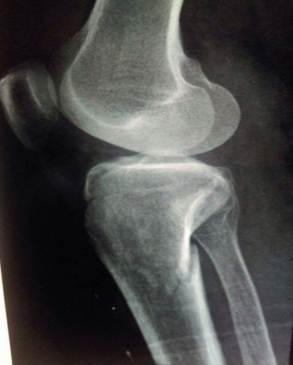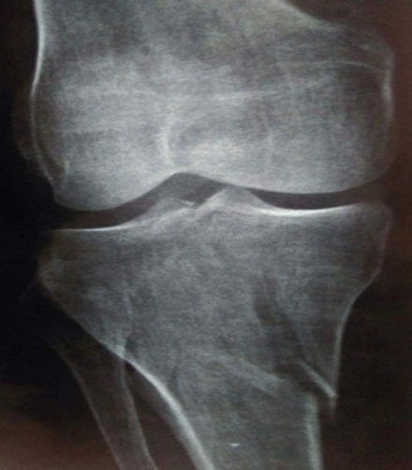
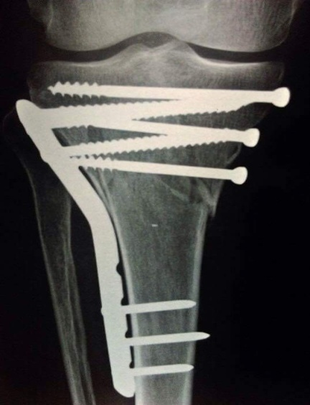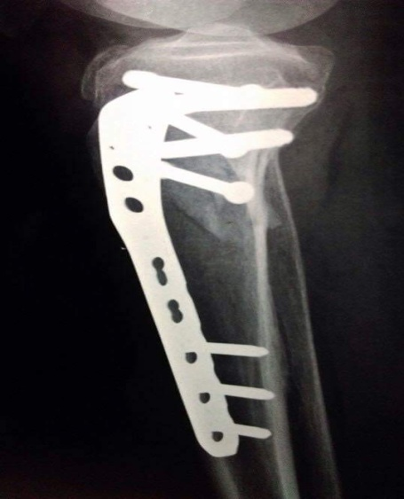
Figure 1: Plain X ray A-P and lateral views show bicondylar tibial plateau fracture (schatzker type V) and postoperative fixation by lateral locked plate and medial cancellous screws.

Table 1: Overall end results
Satisfactory |  |  |  | Unsatisfactory
Excellent |  | Good |  | Fair |  | Poor
No. | % | No. | % | No. | % | No. | %
4 | 20% | 8 | 40% | 5 | 25% | 3 | 15%

Table 2: Range of knee motion compared to the other side
ROM compared to the uninjured other side | patients | percentage
Excellent | 3 | 15%
Good | 8 | 40%
Fair | 6 | 30%
Poor | 3 | 15%
Total | 20 | 100%

All patients were assessed by Oxford knee score with a maximum score of 60 points. At the end of follow up period, Oxford knee score for all patients ranged from 33 to 51 with a mean of 42 points. Fourteen patients (70%) had satisfactory knee function with a score above 40 points. Six patients (30%) had a score below 40 point. Statistical analysis of the end results of the sum of the functional outcome of Oxford knee score and radiological results of the anatomic grading of Rasmussen knee score was insignificant as the P-value was > 0.05 (0.539). The mean time for starting partial weight bearing was 10.65 weeks (range, 9-13). Partial weight bearing was decided according to the radiological union and as tolerated by the patients.
The mean time for starting full weight bearing was 18.2 weeks (range, 16-21).

4. Discussion:
The present study was carried out for evaluation and analysis of the role of MIPO technique in treating selected cases of tibial plateau fractures. 20 cases included in the study were evaluated according to the clinical results, radiological results, and rate of associated complications. Knee joint injuries, as regard the bony and ligamentous structures may result in many complications as infection, wound dehiscence, joint stiffness, joint instability, mal-union, non-union, and posttraumatic arthrosis. These complications depend mainly on the age of the patient, quality of the bone, mechanism of injury, associated ligamentous injuries, method of the treatment and postoperative rehabilitation.⁽¹ ⁾ The concept of minimally invasive osteosynthesis refers basically to the conservation of vascularity of the bone during surgical intervention to ensure the continued vitality of the individual fragments, and to achieve improved fracture healing.⁽⁴⁾ The soft tissues overlying the proximal tibia are relatively thin and do not accommodate significant amount of hardware well. Swelling, as well as associated contusions and abrasions, may jeopardize the soft tissue flaps typically necessary for adequate exposure.⁽⁴⁾ Various fixation techniques have been described for complex tibial plateau fractures. ORIF has been frequently associated with complications as bone and skin devascularisation, wound dehiscence, delayed weight bearing, superficial and deep infection because of extensive dissection through injured soft tissues.⁽⁵ ⁾ The treatment principle in this study was to try to obtain reduction as near as possible to the patient’s anatomy with the least possible damage to the soft tissues. Effective stabilization allows early weight bearing and activity resumption. The age of the patients ranged from 28 to 65 years (average 42.75 years). Male predominance (70% of cases) was seen in the present study, (as the mode of trauma was a high velocity injury), since males are more susceptible due to their activities. All patients were classified according to plain X-rays done preoperatively. CT scan was done for all patients for better assessment of the fracture, and better visualisation of the articular surface. MRI was done for patients suspected to have associated ligamentousinjury. Internal fixation was done within two days from admission for better and easier reduction of the fracture. Spinal anaesthesia was done for all patients as there was no indication for general anaesthesia. Minimal anterolateral and anteromedial approaches were used according to the side of fracture. Reduction of the condylar fractures was done under fluoroscopic assistance by manual traction and using large pointed reduction clamp to compress the fracture percutaneously or through the proximal incision. This technique does not allow direct visualization and reduction of the articular surface. However, it preserves much blood supply to the surrounding soft tissues, and most of fracture hematoma. Associated joint depression fragments were reduced with an elevator placed through a cortical window. Bone graft (for indicating cases) was inserted through the cortical window to replace the compressed bone fragments and prevent re-depression of the articular surface. Radiological evaluation included using anatomical grading of Rasmussen knee score and proximal tibial alignment. Radiological evaluation is a good prognostic method for expecting possible future complications. Patients who still have non-satisfactory splitting or depression postoperatively, but functionally not suffering from pain, giving away, or arthritis have high risk of suffering from secondary osteoarthritis later on. Rasmussen evaluation is a non-invasive, objective, and available method of assessment. Functional evaluation using Oxford knee score included assessment of pain, giving away of the knee, and the effect of the daily activities on the injured knee. It is the most important method of assessment as it evaluates directly the function of the knee during different usual activities. All patients underwent regular clinical evaluation during follow up visits. Assessment of possible still pain, knee swelling, stability, ROM, ability to bear weight, and possible associated complications. None of the patients had postsurgical deep infection, wound dehiscence, DVT, or compartmental syndrome. Compared to the other side, the knee ROM was near normal in 55% of patients, most of them were less than 40 years old, or patients who had simple non comminuted fractures. ROM is worse in elder patients, patients with bicondylar fractures, fractures with metaphyseal comminution, or depressed articular surface. The functional outcome is better in patients with Schatzker type I and type II even if anatomical reduction is not obtained. Younger patients had mainly good functional outcome, earlier rate of healing, better ROM, and rapid weight bearing. Patients with Schatzker type V and type VI achieved mainly the least functional out come. Stability of the knee joint was satisfactory in all the patients by the end of follow up period, except for those who had associated ligamentous injury.

References:
- Barrow BA, Fajman WA, Parker LM, et al. Tibial plateau fractures: evaluation with MR imaging. Radiographics 1994; 15:553-560.
- Bennett WF, Browner B. Tibial plateau fractures: a study of associated softtissue injuries. J Orthop Trauma 1994; 8:183-188.
- DeCoster TA, Nepola JV, El-Khoury GY. Cast brace treatment of proximal tibia fractures. A 10-year follow-up study. Clin Orthop. 1988; 231:196-204.
- Biggi F, Di Fabio S, D'Antimo C, Trevisani S: Tibial plateau fractures: Internal fixation with locking plates and the MIPO technique. Injury, Int. J. Care Injured 2010; 41: 1178-1182.
- Barei DP, Nork SE, Mills WJ, Coles CP, Henley MB, Benirschke SK. Functional outcomes of severe bicondylar tibial plateau fractures treated with dual incisions and medial and lateral plates. J Bone Joint Surg Am 2006; 88:1713–21.
- Canadian Orthopedic Trauma Society. Open reduction and internal fixation compared with circular fixator application for bicondylar tibial plateau fractures. Results of a multicenter, prospective, randomized clinical trial. J Bone Joint Surg Am 2006; 88:2613–23.19. Cole PA, Zlowodzki.
- Lachiewicz PF, Funcik T. Factors influencing the results of open reduction and internal fixation of tibial plateau fractures. Clin Orthop Relat Res 1990; 259:210–5.
- Stevens DG, Beharry R, McKee MD, Waddell JP, Schemitsch EH. The long-term functional outcome of operatively treated tibial plateau fractures. J Orthop Trauma 2001; 15:312–20.

1/25/2017

