Prognostic Significance of Neutrophil Lymphocyte Ratio in Diffuse Large B Cell Lymphoma

Fathy Ghamry Abdelrazek¹,Ezzat Abd-Elrahman El-Etraby¹, Essam Abd-El-Wahed Hassan¹, Mohammed Saeid Alshorbagy² and Ali Hosni Ali¹

¹Department of Internal Medicine, Faculty of Medicine, Al-Azhar University, Cairo, Egypt
²Department of Clinical Pathology, Faculty of Medicine, Al-Azhar University, Cairo, Egypt
mohammadhosny8@gmail.com

Abstract: Background: The systemic inflammatory response has been postulated as having prognostic significance in a wide range of different cancer types. Recently the neutrophilia has been proposed as an easily determinable prognostic factor in cancer patients. Aim: In the present study we are aiming to evaluate the prognostic significance of baseline neutrophilia in diffuse large B cell lymphoma (DLBCL). Methods: eighty eight consecutive DLBCL patients will be evaluated prospectively. The prognostic influence of neutrophil lymphocyte ratio (NLR) on 2 years overall and disease free survival will study. Results: Prediction of easily, inexpensive, available (NLR) is associated with poor prognosis of DLBCL. Conclusion: in the present study, we showed that a high (NLR) at diagnosis of DLBCL represents a poor prognostic factor for clinical outcome.
[Fathy Ghamry Abdelrazek, Ezzat Abd-Elrahman El-Etraby, Essam Abd-El-Wahed Hassan, Mohammed Saeid Alshorbagy and Ali Hosni Ali. Prognostic Significance of Neutrophil Lymphocyte Ratio in Diffuse Large B Cell Lymphoma. N Y Sci J 2017;10(2):6-10]. ISSN 1554-0200 (print); ISSN 2375-723X (online). http://www.sciencepub.net/newyork. 2. doi:10.7537/marsnys100217.02.

Keywords: DLBCL – NLR – prognosis

1. Introduction
Lymphomas are the fifth most common systemic cancer, with the most common subtype being diffuse large B-cell lymphoma followed by follicular lymphoma and Hodgkin lymphoma. Diffuse large B-cell lymphoma represents approximately 30% of all lymphomas and is the most common subtype throughout the world. This is in contrast to many other types of lymphoma, which have striking geographic variation in frequency of occurrence (Anderson et al., 1998).
Current prognostic models, including the International Prognostic Index (IPI), incorporate patient and tumor characteristics. However, with improved outcomes, the identification of a high-risk subset of patients remains a challenge with the use of these models alone. Over the past 2 decades, many studies have been conducted to identify novel biomarkers characterizing patients with a poor prognosis (Alizadeh et al., 2000).
Gene expression profiling (GEP), mutational analyses, immunohistochemistry (IHC)-based detection, and early interim analysis with positron emission tomography (PET), have provided crucial information about several new prognostic parameters for the response to therapy in DLBCL (Mikhaeel., 2009 ).
Although they are promising, many of these methods are costly, difficult to obtain, not easily interpreted, and require further validation. Therefore, the evaluation of a patient's prognosis using simple, inexpensive, and easily interpreted clinical parameters warrants investigation.
Blood neutrophil to lymphocyte (N/L) ratio is a simple marker of subclinical inflammation that can be easily obtained from the differential white blood cell count. The N/L ratio has been used to predict outcomes in patients with cancer and coronary artery disease (Halazun et al.,2009).
This ratio has been used to predict outcomes in patients with cancer and coronary artery disease. The rationale for using the N/L ratio in cancer patients is to compare the inflammatory response produced by the tumour as assessed by the neutrophil count with the host immunity as assessed by the lymphocyte count (Walsh et al.,2005).
Systemic inflammation, a risk factor for cardiovascular disease and the N/L ratio, which integrates the detrimental effects of neutrophilia (reflecting inflammation) and lymphopenia (reflecting physiological stress), has emerged as a useful prognostic marker (Gibson et al.,2010).

2. Patients and Methods:
Eighty consecutive DLBCL patients diagnosed according to the 2008 World health organization criteria, at the Department of Hematology, Ain Shams University, will be studied prospectively. Human immune deficiency virus (HIV) sero-positive patients and those with central nervous system lymphoma will be excluded.

Base line data:
Before therapeutic intervention, all the following base line data will collect; histopathological confirmation of DLBCL, gender, age, Ann Arbor stage and cell of origin categories according to the Han algorithm (Han et al, 2004). In addition total leucocytic, neutrophilic, lymphocutic and platelet counts as well as lactate dehydrogenase will assess prior to treatment.
Therapeutic intervention:
All patients indicated for treatment will receive treatment according to Department of Hematology, Ain Shams University current protocol.
Post-treatment follow up:
Follow up will carry on for a total of two years from the time of pathological diagnosis. It will conduct monthly in the first three months, and every three months later on. Post-treatment follow up data will include; routine clinical and laboratory data, imaging results (CT/MRI), date of death, OS and DFS. Overall survival is defined as the time (in months) from date of diagnosis until death due to any cause within the follow up period. Disease free survival is defined as the time (in months) from the date of diagnosis to the date of demonstration of recurrent disease confirmed radiologically or histologically.
Approval and patient consent:
The study will approve from local ethics committee of Al-Azhar School of Medicine, and patient consent will obtain from all patients.

Statistical analysis:
The primary end point of the study will be OS, while the secondary end point will be DFS. The optimal cutoff value for the NLR, will determine by receiver operating curve (ROC) analysis (Absenger et al, 2013). The cutoff value to discriminate best (in mean of sensitivity and specificity) between survival and death will use for OS. The cutoff value to discriminate best between disease-recurrence and no recurrence will use for DFS. The association between the NLR, with OS and DFS will analyze using Kaplan–Meier curves and compared by the log-rank test. Backward stepwise multivariate Cox proportional analysis will perform to determine the influence of clinicopathological variables, significantly associated with clinical outcome in univariate analysis of OS and DFS. Hazard ratios (HRs) and the corresponding 95% CIs will estimate from the Cox regression analysis. A P value < 0.05 will consider statistically significant.

3. Results:
The results are shown in the following Tables and Figures.

Table (1): Demographic data distribution of the study group
 | No. | %
Sex
Male | 46 | 52.27
Female | 42 | 47.73
Age (years)
<60 years | 72 | 81.82
≥60 years | 16 | 18.18
Range [Mean±SD] | 22-67 [42.43±13.56]

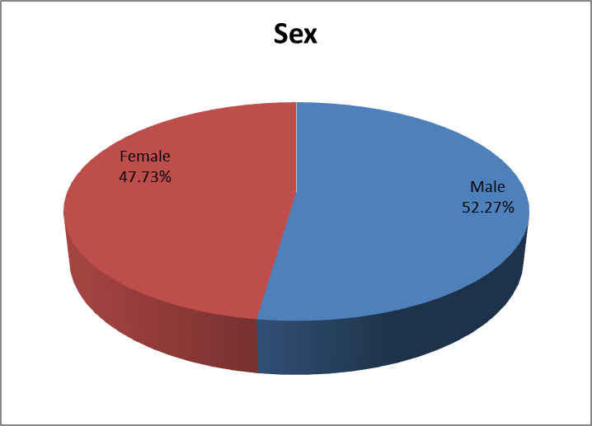
Fig (1):- sex distribution of the study group

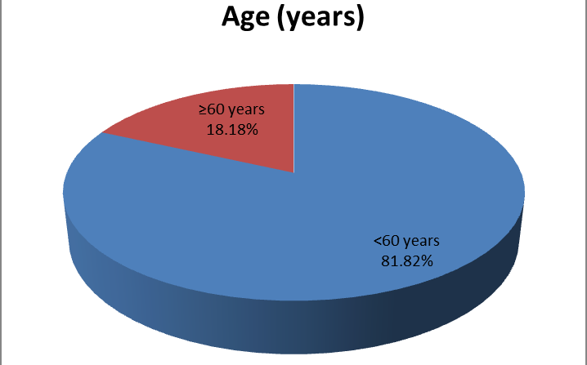
Fig (2):- Age distribution of the study group

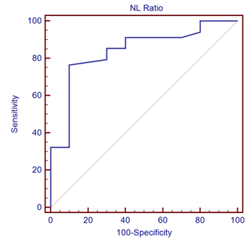
Fig (3):- Diagnostic Performance of OS (months) in Discrimination of NL ratio:

Table (2): Descriptive data of the studied group.
 | Min. | Max. | Mean | ±SD
BMI | 18 | 31 | 23.16 | 3.65
Hb | 7.9 | 12.7 | 10.38 | 1.13
RBCs | 3.1 | 5.1 | 4.07 | 0.51
WBCs | 1.9 | 15.3 | 6.98 | 2.65
PLT | 157 | 728 | 354.20 | 136.97
NEUT. | 0.8 | 10.9 | 4.74 | 2.30
LYMPH | 0.5 | 3.6 | 1.59 | 0.77
N.L ratio | 0.8 | 15.8 | 3.53 | 2.72
P.L ratio | 81.9 | 636.6 | 263.23 | 145.50
LDH | 190 | 711 | 381.91 | 174.10
dNLR | 0.7 | 7.3 | 2.30 | 1.48
OS (months) | 3 | 24 | 20.52 | 7.29
DFS (months) | 0 | 24 | 18.48 | 9.26

Table (3): Diagnostic Performance of OS (months) in Discrimination of NL ratio.
Cut-off | Sen. | Spe. | +PV | -PV | Accuracy
2.2 | 76.47% | 90% | 96.3% | 52.9% | 84%
Receiver operating characteristics (ROC) curve was used to define the best cut off value of NL ratio which was 2.2, with sensitivity of 76.47% specificity of 90% positive predictive value of 96.3%, negative predictive value of 52.9% with diagnostic accuracy of 84%.

Table (4): Kaplan–Meier curves for 24-months OS regarding (NL ratio < 2.2 vs. ≥2.2 ).
NLratio |  | OS (Months)
 |  | Median | SE | 95% C.I.
 |  |  |  | Lower | Upper
< 2.2 |  | 23.73 | 0.20 | 23.33 | 24.12
≥ 2.2 |  | 10.91 | 2.84 | 5.34 | 16.48
Overall |  | 20.52 | 1.10 | 18.37 | 22.68
Log Rank  (Mantel-Cox) | x²  p | 27.725  (<0.001)

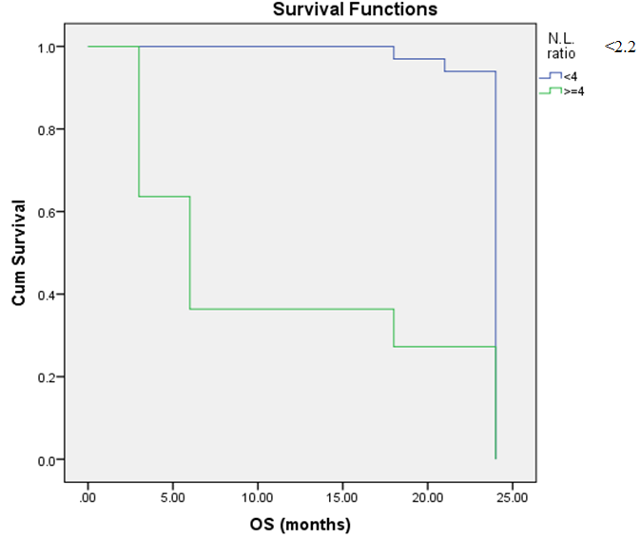
Fig. ( 4): Kaplan–Meier curves for 24-months OS regarding (NL ratio <2.2 vs. ≥2.2 ). (P<0.001 HS).

Table (5): Correlation between NLR and other parameters, using Pearson correlation Coefficient of the study group.
Parameters | NLR
 | r | p-value
Age (years) | .408** | 0.006
BMI | 0.063 | 0.686
Hb | 0.023 | 0.880
RBCs | 0.048 | 0.755
WBCs | .499** | 0.001
PLT | 0.033 | 0.833
NEUT. | .727** | <0.001
LYMPH | -.417** | 0.005
dN.L ratio | .930** | <0.001
P.L ratio | .426** | 0.004
B symptoms | .439** | 0.049
R-IPI | .627** | <0.001
Ann Arbor Stage | .539** | 0.048
LDH | .575** | <0.001
Performance status | .530** | <0.001
OS (months) | -.477** | <0.001
DFS (months) | -.588** | <0.001
Positive correlation and significant between NLR and age, WBCs, Neut., dN.L ratio, P.L ratio, LDH, B symptoms, R-IPI, Ann Arbor stage, performance status, while NLR and LYMPH, OS and DFS negative and significant.

Table ( 6 ): Correlation between Neut, Lymph and OS & DFS, using Pearson correlation Coefficient of the study group.
 | NEUT. |  | LYMPH
 | r | p | r | p
OS (months) | -0.413 | <0.001 | 0.327 | 0.002
DFS (months) | -0.449 | <0.001 | 0.391 | <0.001

4. Discussion
Diffuse large B-cell lymphoma (DLBCL) is the most commonly occurring form of lymphoma, accounting for 30–40% of newly diagnosed non-Hodgkin’s lymphomas (NHL). With standard immunochemotherapy, DLBCL, even when in advanced stage, is considered a curable disease. Nevertheless, despite the improvements in therapy, approximately one-third of patients with advanced-stage DLBCL will still be refractory to therapy or will relapse (Friedberg, 2011).
Historically, clinicians and investigators have relied on prognostic schemes that imply clinical risk factors to predict the risk for disease progression, relapse and death of patients with aggressive NHL.
One of the most commonly used schemes of rating, the International Prognostic Index (IPI) for lymphomas, developed in the 1990s, remains a robust clinical prognostic index for aggressive lymphomas.
Inflammation has been identified to be a critical component of tumour progression, highlighting the role of the microenvironment, which is largely orchestrated by inflammatory cells as an indispensable participant in the neoplastic process, fostering proliferation, survival and migration (Coussens and Werb, 2002).
For different solid tumours, as well as lymphomas, inflammation parameters, including leukocytes, neutrophils, lymphocytes and C-reactive protein, have been associated with higher mortality rates (Mohri et al, 2010; Cao et al, 2012).
In addition to absolute counts of inflammation parameters, also the neutrophil to lymphocyte ratio (NLR) has been identified as an prognostic factor for OS and progression free survival (PFS) in various types of cancer, including renal cell carcinoma, colorectal cancer, sarcoma and pancreatic cancer ( Pichler et al, 2013).
Recently, the NLR has been suggested to be a simple, inexpensive, standardized prognostic factor to assess clinical outcomes in DLBCL patients treated with R-CHOP (Porrata et al, 2010).
In our study Patients with N/L ratio >2.2 at diagnosis were associated with prognostic factors related to inflammation (i.e., neutrophilia and B-symptoms) and tumor burden (i.e., LDH). Thus, in an attempt to understand how N/L ratio affects survival in DLBCL, we studied the relationships between N/L ratio and prognostic factors associated with inflammation/tumor burden. We identified a higher N/L ratio with higher R- IPI scores (p<0.001). Higher N/L ratio was also associated with B-symptoms (P = 0.049), higher Ann Arbor Stage (Stage III/IV) (P = 0.048), Neutrophilia (p<0.001) and with higher LDH (p<0.001). our results is in agree with porrata et al 2010 who found that there is positive correlation and significance between higher levels of NLR and higher (R- IPI scores, Ann Arbor Stage, LDH, neutrophil count and B-symptoms ).
In our study the mean of lymphocyte = 1.59 ± 0.77 and the mean of OS = 20.52 ± 7.29 and the mean of DFS = 18.48 ± 9.26 by using Pearson correlation and scatter plot test There is positive correlation and significants between lymphocyte and OS (p = 0.002) also There is positive correlation and significans between lymphocyte and DFS ( p < 0.001).
And this was consistent with Talaulikar et al who determine the incidence of lymphocytopenia at diagnosis in patients with DLBCL, and confirm its significance as a prognostic factor. stated that Lymphocytopenia is correlated adversely with overall survival and DFS in patients with DLBCL (Talaulikar et al 2008).
In our study the mean of neutrophil = 4.74 ± 2.30 and the mean of OS = 20.52 ± 7.29 and the mean of DFS = 18.48 ± 9.26 by using Pearson correlation and scatter plot test There is negative correlation and significants between neutrophil and OS ( p < 0.001) also There is negative correlation and significans between neutrophil and DFS ( p < 0.001).
And this was consistent with Dannenberg and Subbaramaiah, 2003 ).
First, we evaluated the previously published cutoff value (NLR=2) as the potentially optimal cutoff value for the continuous NLR by the Kaplan–Meier curve analysis (Proctor et al, 2012). However, we could not find a survival difference between patients with low (<2) and high (≥2) NLR (P>0.05 NS). Therefore, applying the criteria mentioned above in our study, we determined by ROC analysis a cutoff value of (2.2) for the NLR to be best to discriminate between patients’ survival and death so the level of the NLR correlated with the poor prognosis in patients with DLBCL according to our results.
This cutoff value prompted us to reevaluate the NLR as a universally useful prognostic biomarker. in our study the Kaplan–Meier curve for 2-year OS and DFS reveals that a high NLR ≥2.2 is a consistent factor for poor prognosis in DLBCL patients (P<0.001 HS).

References:
- Absenger G, Szkandera J, Pichler M, et al.,(2013) A derived neutrophil to lymphocyte ratio predicts clinical outcome in stage II and IIIcolon cancer patients. Br J Cancer;109(2): 395–400.
- Alizadeh AA, Eisen MB, Davis RE, et al.,(2000) Distinct types of diffuse largeB-cell lymphoma identified by gene expression profiling. Nature; 403:503–511.
- Cao Y, Shi YX, Chen JO, et al., (2012) Serum C- reactive protein as an important prognostic variable in patients with diffuse large B cell lymphoma. Tumour Biol; 33(4): 1039–1044.
- Coussens LM and Werb Z (2002) Inflammation and cancer. Nature 420(6917):860–867.
- Dannenberg AJ, Subbaramaiah K (2003) Targeting cyclooxygenase-2 in human neoplasia: Rationale and promise. Cancer Cell; 4(6): 431–436.
- Friedberg JW (2011) New strategies in diffuse large B-cell lymphoma: translating findings from gene expression analyses into clinical practice Clin Cancer Res 17(19): 6112–6117.
- Gibson PH, Cuthbertson BH, Croal BL, et al., (2010) Usefulness of neutrophil/lymphocyte ratio as predictor of new-onset atrial fibrillation after coronary artery bypass grafting. Am J Cardiol; 105: 186–91.
- Halazun KJ, Hardy MA, Rana AA, et al., (2009) Negative impact of neutrophil-lymphocyte ratio on outcome after liver transplantation for hepatocellular carcinoma. Ann Surg; 250:141–51.
- Mikhaeel NG (2009). Interim fluorodeoxyglucose positron emission tomography for early response assessment in diffuse large B cell lymphoma: where are we now? Leuk Lymphoma; 50:1931–1936.
- Mohri Y, Tanaka K, Ohi M, et al., (2010) Prognostic significance of host- and tumor-related factors in patients with gastric cancer. World J Surg; 34(2): 285–290.
- Pichler M, Hutterer GC, Stoeckigt C, et al., (2013) Validation of the pre-treatment neutrophil-lymphocyte ratio as a prognostic factor in a large European cohort of renal cell carcinoma patients. Br J Cancer; 108:901–907.
- Porrata LF, Ristow K, Habermann T, et al., (2010) Predicting survival for diffuse large B-cell lymphoma patients using baseline neutrophil/lymphocyte ratio. Am J Hematol; 85(11): 896–899.
- Proctor MJ, McMillan DC, Morrison DS, et al., (2012) A derived neutrophil to lymphocyte ratio predicts survival in patients with cancer. Br J Cancer; 107(4): 695–699.
- Talaulikar D, Choudhury A, Shadbolt B, et al., (2008) Lymphocytopenia as a prognostic marker for diffuse large B-cell lymphomas. Leuk Lymphoma; 49:959–964.
- Walsh SR, Cook EJ, Goulder F, et al., (2005) Neutrophil-lymphocyte ratio as a prognostic factor in colorectal cancer. J Surg Oncol; 91: 181–4.

1/15/2017

