Evaluation of the Smear Layer Removal Ability of MTAD and Propolis Irrigations

Rasha Farouk Sharaf¹, Sherine Ezz El Din Taha², Mohamed Abou El Yazeed¹, Amr Ezzat Abd El Latif², and Norha nAbd El Wahab El Dokky²

¹Orthodontics and Pediatric Dentistry Department, National Research Center –Egypt
²Pediatric Dentistry and Dental public health, Faculty of Oral and Dental Medicine, Cairo University –Egypt
Rasha_sharaf@hotmail.com

Abstract: Objective: This study was carried out to assess the ability of MTAD and propolis extract irrigation to remove the smear layer formed on the walls of the root canals of primary teeth during the procedures of pulpectomy. Materials and Methods: A sample of 30 freshly extracted primary anterior teeth were divided into 2 equal groups according to the irrigant used: Group I: Included 15 teeth irrigated with MTAD, Group II: Included 15 teeth irrigated with Propolis extract. Samples were scanned using the scanning electron microscope (SEM). Results showed that, MTAD showed better results in removal of the smear layer at the coronal, middle and apical thirds of the root canal than propolis. Conclusion: MTAD is an efficient irrigant in removal of smear layer formed during pulpectomy in primary teeth.
[Rasha Farouk Sharaf, Sherine Ezz El Din Taha, Mohamed Abou El Yazeed, Amr Ezzat Abd El Latif, and Norhan Abd El Wahab El Dokky. Evaluation of the Smear Layer Removal Ability of MTAD and Propolis Irrigations. N Y Sci J 2017;10(1):125-129]. ISSN 1554-0200 (print); ISSN 2375-723X (online). http://www.sciencepub.net/newyork. 21. doi:10.7537/marsnys100117.21.

Keywords: Smear Layer, MTAD, Propolis

1. Introduction
Root canal irrigation is an integral part of nonvital pulp therapy for primary teeth. Several irrigation materials and devices have been introduced to aid in root canal debridement. They aid by killing microorganisms, flushing debris, dissolve remnants of organic tissues without damaging the periradicular tissues if extruded into the periodontium and remove the smear layer from the root canal system.⁽¹⁾
A large number of substances have been used as root canal irrigants. MTAD is an irrigating solution that is famous for its strong antibacterial effect and it is often used to remove the smear layer formed on the walls of the root canals.⁽²⁾
Propolis is a resinous substance collected by worker bees, it has been used in dentistry for several purposes and has a promising role in future medicine as well as in dentistry. ⁽³⁾
Thus, the aim of this study was to evaluate their efficacy of MTAD versus Propolison smear layer removal formed the walls of the root canals of primary teeth after pulpectomy using Scanning Electron Microscope.

2. Materials and Methods
A sample of 30 freshly extracted primary anterior teeth were obtained from patients attending the outpatient clinic of Pediatric Dentistry Department, Faculty of Oral and Dental medicine, Cairo University. These teeth were extracted due to trauma or extensive coronal decay, after extraction they were stored in saline.
These teeth were used to assess the ability of MTAD and propolis extract to remove the smear layer from the root canal of primary teeth after root canal treatment.
Samples were divided into 2 equal groups according to the irrigant used:
Group I: Included 15 teeth irrigated with MTAD.
Group II: Included 15 teeth irrigated with Propolis extract.
- Decoronation was performed for all teeth, then filing of the root canals was performed using K- files sizes 20, 25 and 30 respectively (not greater than size 30) as recommended by UK Clinical Guidelines in Paediatric Dentistry ⁽⁴⁾.
Each root canal was irrigated with 5ml of the irrigating solution(either MTAD or propolis), after irrigation with one of the previously mentioned irrigants, then the canals were dried using sterile paper point.
Preparation of the samples for scanning Electron Microscopic Examination
All roots were grooved longitudinally on the external surface with a diamond disc, avoiding penetration into the root canals. The teeth were then carefully splitted with a mallet and chisel, fig (1 ) and then scanned with the electron microscope at a magnification of 4000X.
Scanning Electron Microscopic Evaluation:
After sectioning of the samples longitudinally, they were scanned using the scanning electron microscope (SEM), and eachphotomicrograph was given a score, according to the amount of smearlayer present and opened dentinal tubules, using the following smear score.
Smear Scoring system:
1. No smear layer. No smear layer on the surface of the root canals; all tubules were clean and open.
2. Moderate smear layer; the tubules contained debris.
3. Heavy smear layer. Smear layer covered the root canal surface.^{(5, 6)}
The score of each photomicrograph was used to evaluate the ability of different irrigants to remove the smear layer and opening the dentinal tubules. Mann-Whitney U test was used to compare between smear layer scores in the two groups.
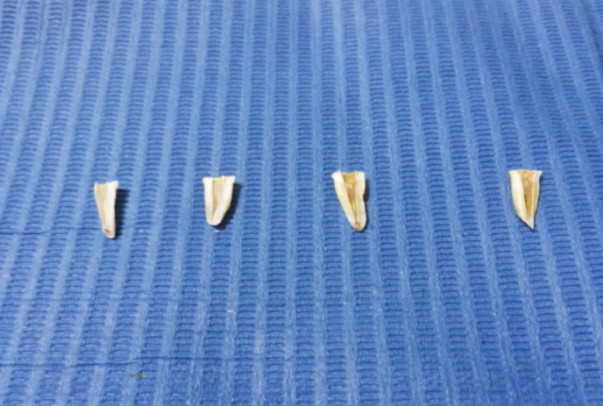
Fig (1): showing roots of primary teeth after decoronation and vertical sectioning.

3. Results
- Comparison between the two groups
By comparing between the 2 groups it was found that either at the coronal, middle as well as apical root levels, MTAD showed statistically significantly lower mean smear layer score than Propolis group, as shown in table ( 1 ) and fig ( 2 ).
Comparison between root levels in each group In MTAD group.
There was no statistically significant difference between coronal and middle levels; both showed the statistically significantly lowest mean scores. While the apical level showed the statistically significantly highest mean smear layer score, as shown in table (2) and fig (3).
While in Propolis group, Coronal level showed the statistically significantly lowest mean score. Middle level showed statistically significantly lower mean score. While the apical level showed the statistically significantly highest mean smear layer score.
In the coronal third of the root canals irrigated with MTAD, no smear layer was seen and most of the dentinal tubules were clean and opened as shown in fig (4), while in the middle third of the root canals, little smear layer was seen and at the apical third, moderate smear layer was seen.

Table (1): Mean, standard deviation (SD) values and results of Mann-Whitney U test for the comparison between smear layer scores in the two groups
 | MTAD |  | Propolis |  | P-value
 | Mean | ±SD | Mean | ±SD
Coronal | 1.00 | 0.00 | 1.73 | 0.46 | <0.001*
Middle | 1.33 | 0.49 | 2.33 | 0.49 | <0.001*
Apical | 1.80 | 0.56 | 2.73 | 0.46 | <0.001*
*: Significant at P ≤ 0.05

Figure ( 2 ): Bar chart representing mean smear layer scores in the two groups

Table (2): Mean, standard deviation (SD) values and results of Friedman’s and Wilcoxon signed-rank tests for comparison between smear layer scores at different root levels in each group
 | Coronal |  | Middle |  | Apical |  | P-value
 | Mean | ±SD | Mean | ±SD | Mean | ±SD
MTAD | 1.00 ^{b} | 0.00 | 1.33 ^{b} | 0.49 | 1.80 ª | 0.56 | <0.001*
Propolis | 1.73 ^{c} | 0.46 | 2.33 ^{b} | 0.49 | 2.73 ª | 0.46 | <0.001*
*: Significant at P ≤ 0.05, Different superscripts in the same row are statistically significantly different

Figure (3): Bar chart representing mean smear layer scores at different root levels

.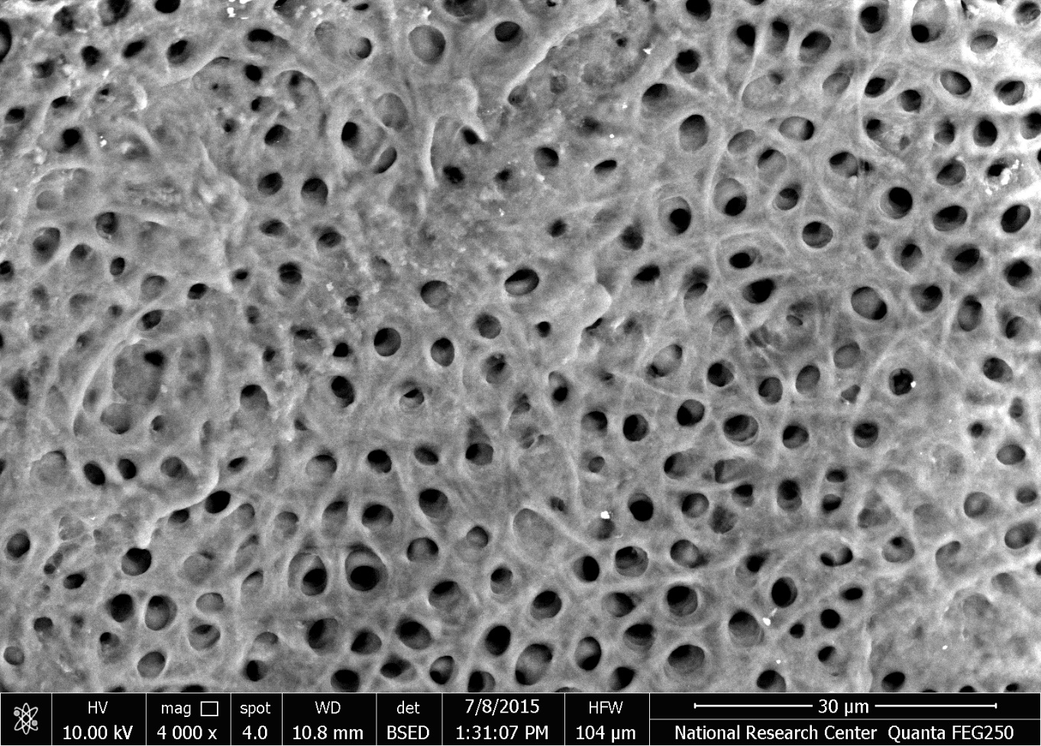
Fig (4)

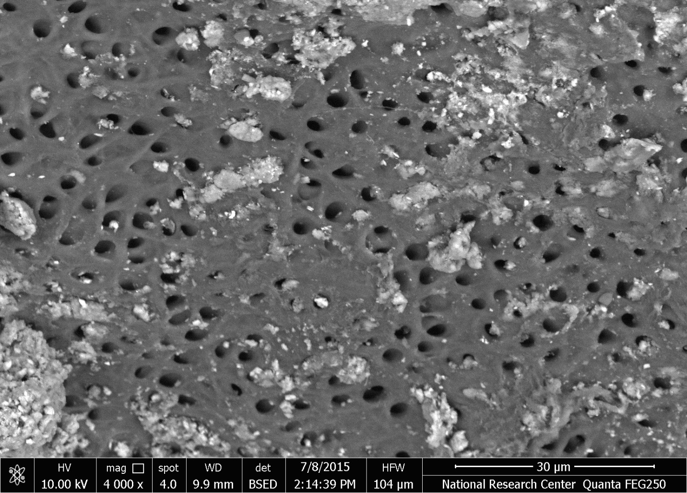
Fig (5)

4. Discussion:
Root canal irrigation is an integral part of nonvital pulp therapy for primary teeth. The choice of irrigating solution used in root canals of primary teeth is complicated by the complex morphology, irregularity and curved shape of the root canals. The irritation of periapical tissues is an important factor to be considered in selection of root canal irrigant in primary teeth. ⁽⁷⁾
All the irrigating solutions at our disposal have their share of limitations and the search for an ideal root canal irrigant continues with the development of newer materials and methods. ⁽⁸⁾
In the current study, MTAD and Propolis extract were used for irrigation, to evaluate the efficacy of each irrigant in removal of smear layer formed during the pulpectomy procedures on the walls of the root canal.
The smear layer formed on the walls of the root canals whenever dentin is.
Cut, it contains organic and inorganic materials from the pulp and dentin chips, and also microorganisms. This smear layer become infected and protect the bacteria already present in the dentinal tubules, because of these concerns, removal of the smear layer in infected root canals is advisable, this is in accordance with. ^{(5,9)}
It was found that smear layer removal improves the primary teeth pulpectomy outcome, therefore using suitable irrigating solution that is efficient in removal of smear layer, increase the success rate of pulpectomy. ⁽¹⁰⁾
The current study aimed to evaluate the ability of MTAD and propolis extract to remove the smear layer formed on the walls of the root canals of primary teeth.
Results showed that at the coronal, middle as well as apical root levels, MTAD showed statistically significantly lower mean smear layer score and more opened dentinal tubules than propolis group. Root canal irrigation MTAD increased the cleaning effect in the coronal third of the root canal as it completely removed the smear layer with opened dentinal tubules.
Based on the results of the current study, MTAD was an effective irrigating solution in removal of most of the smear layer at the coronal, middle, and apical thirds of the root canals of primary teeth. This may be attributed to the effect of the detergent which decrease the surface tension of the solution and increase its ability in wetting the surface of the root canal, leading to better contact between the solution and the root canal surface, resulting in better removal of smear layer, this was in accordance with. ^{(5, 11,12)}
These results agree with ^{(6, 13, 14)} who found that MTAD has the ability to remove the smear layer from wall of the root canals, but disagree with⁽¹⁵⁾ who found that after MTAD irrigation, moderate smear layer covered the root canal surface and the tubules, this may be attributed to the use of rotary files in preparation of the root canal which has higher cutting efficiency than manual files and resulted in heavy smear layer.
While in propolis group, smear layer and deposits were seen on the walls of the root canals, this can be attributed to the high viscosity of the propolis due to presence of essential oils and wax in its composition which result in higher surface tension, and decrease in the wet ability of the root canal surface according to. ^{(7, 16)}

Conclusion
From the results of the current study, it can be concluded that, MTAD irrigation can remove the smear layer formed on the walls of the root canals during pulpectomy at the coronal, middle and apical thirds more efficiently than propolis.

References
- Gotze Gda R, Cunha CB, Primo LS and Maia LC. Effect of the sodium hypochlorite and citric acid association on smear layer removal of primary molars. Braz Oral Res, 19(4), 261-266, (2005).
- Tong Z, Zhou L, Li J, Jiang W, Ma L and Ni L. In vitro evaluation of the antibacterial activities of MTAD in combination with nisinagainst Enterococcus faecalis. J Endod, 37(8), 1116-1120, (2011).
- Shingare P and Chaugule V. Comparative evaluation of antimicrobialactivity of miswak, propolis, sodium hypochlorite and saline as rootcanal irrigants by microbial culturing and quantification inchronically exposed primary teeth. Germs, 1(1), 12-21, (2011).
- Rodd HD, Waterhouse PJ, Fuks AB, Fayle SA and Moffat MA. Pulptherapy for primary molars. Int J Paediatr Dent, 16 Suppl 1, 15-23,(2006).
- Torabinejad M, Khademi AA, Babagoli J, Cho Y, Johnson WB, Bozhilov K, Kim J and Shabahang S. A new solution for the removal of the smear layer. J Endod, 29(3), 170-175,(2003).
- Balto H, Salama F, Al-Mofareh S and Al-Yahya F. Evaluation of different irrigating solutions on smear layer removal of primary rootdentin. J Contemp Dent Pract, 16(3), 187-191, (2015).
- Verma MK, Pandey RK, Khanna R and Agarwal J. The antimicrobial effectiveness of 25% propolis extract in root canal irrigation of primary teeth. J Indian Soc Pedod Prev Dent, 32(2), 120-124, (2014).
- Omar O, El-Dokky N, and Nada M. Evaluation of the antimicrobial efficacy of Propolis extract as a root canal medicament on primary molars with infected pulps. Poster in The Second International Conference of The Egyptian Society for Pediatric Dentistry &Children with Special Needs, (2012).
- Gupta PK, Mahajan UP, Gupta K and Sheela NV. Comparative evaluation of a new endodontic irrigant - mixture of a tetracycline isomer, an Acid, and a detergent to remove the intracanal smear layer: a scanning electron microscopic study. J Int Oral Health,7(4), 111-116, (2015).
- Barcelos R, Tannure PN, Gleiser R, Luiz, RR and Primo LG. The influence of smear layer removal on primary tooth pulpectomy outcome: a 24-month, double-blind, randomized, and controlled clinical trial evaluation. Int J Paediatr Dent, 22(5), 369 - 381,(2012).
- Mozayeni MA, Javaheri GH, Poorroosta P, Ashari MA and Javaheri HH. Effect of 17% EDTA and MTAD on intracanalsmear layer removal: a scanning electron microscopic study. Aust Endod J, 35(1), 13-17, (2009).
- Lopes HP, De Faria AR, Alves FRF and Elias CN. Wettability of Irrigants used in Root Canal Treatment. Dentistry 5(3), 283-288(2015).
- Mancini M, Armellin E, Casaglia A, Cerron L and Cianconi L.A comparative study of smear layer removal and erosion in apicalintraradicular dentine with three irrigating solutions: a scanning electron microscopy evaluation. J Endod, 35(6), 900-903, (2009).
- Darrag AM. Effectiveness of different final irrigation solutions onsmear layer removal in intraradicular dentin. Tanta Dental Journal, 11(2), 93-99, (2014).
- Lotfi M, Vosoughhosseini S, Saghiri M A, Zand V, Ranjkesh B and Ghasemi N. 'Effect of MTAD as a final rinse on removal of smear layer in ten-minute preparation time', J Endod, 38(10), 191- 194,(2012).
- Park YK, Alencar SM and Aguiar CL. Botanical origin and chemicalcomposition of Brazilian propolis. J Agric Food Chem, 50(9),252-256, (2002).

1/25/2017

