Avian diversity of Anchar lake, Kashmir, India

Mustahson F. Fazili¹, Bilal A. Bhat¹ Fayaz A. Ahangar²

¹Department of Zoology University of Kashmir, Srinagar- 190006
² State Education Department J & K, HSC Gander bal -India
bilalwildlife@yahoo.co.in

Abstract: Present study documents avian diversity of the Anchar lake, located at a distance of 14kms north-west of Srinagar in the Indian state of Jammu and Kashmir. Sixty eight (68) bird species comprising of 21 species of resident birds, 27 summer visitors, 11 winter visitors and 9 local altitudinal migrants were recorded during two year study period from July 2013 to June 2015. Population estimation of bird species was carried out using visual census; block count and line transect method. The birds were identified following standard reference keys. The data regarding species composition, periodicity of their occurrence and relative abundance of each species is presented.
[Mustahson F. Fazili, Bilal A. Bhat Fayaz A. Ahangar. Avian diversity of Anchar lake, Kashmir, India. N Y Sci J 2017;10(1):92-97]. ISSN 1554-0200 (print); ISSN 2375-723X (online). http://www.sciencepub.net/newyork. 15. doi:10.7537/marsnys100117.15.

Key words: Avian diversity, Anchar lake, altitudinal migrants, visual census

1.Introduction
The aquatic habitats of Kashmir like lakes and wetlands are important for their ecological importance as they provide habitat to aquatic flora and fauna including different bird species. They attract large congregations of migratory waterfowl like mallard, pintail, gadwall, shoveller besides, a good number of summer migrants of which Indian great reed warbler, pheasant tailed jacana, Indian whiskered tern etc. are noteworin thy. The species diversity is an important component of health of any ecosystem including lakes and wetlands wherein, bird species occupy an important place serving as useful indicators for assessing ecological status of such habitats. The Anchar lake (34º 20’ to 34º 36’N and 74º 82’ to 74º 85’E, Figure 1) is located near Soura at a distance of 14kms north-west of Srinagar at an altitude of 1583m above sea level with an area of about 4.26 Km² and a maximum depth of 2.6 meter (Sushil et al 2014).
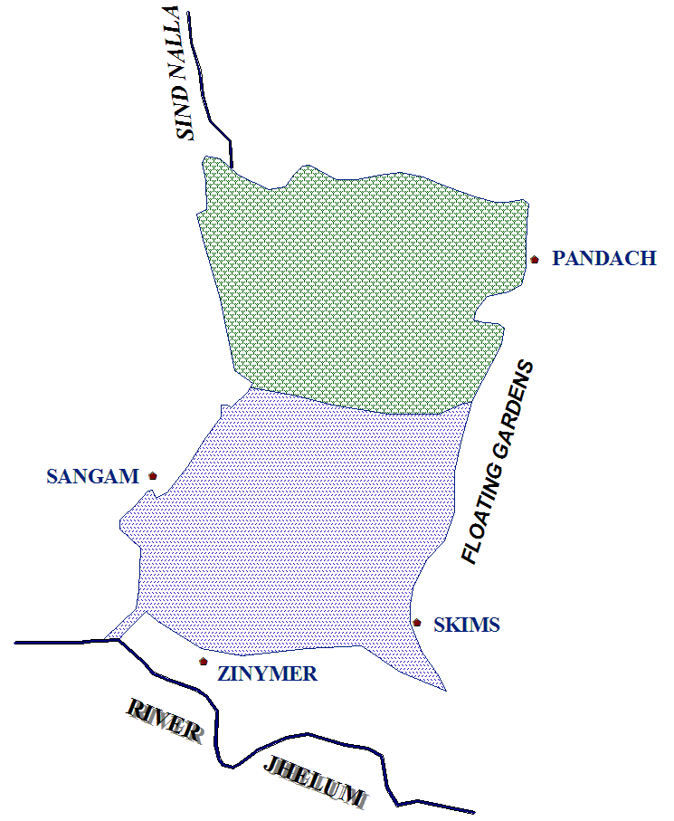
Figure 1. Map of Anchar lake Kashmir

The lake is facing a number of anthropogenic threats like waste disposal, encroachment, macrophyte harvesting, water bird poaching etc. resulting in loss of habitat as well as its biodiversity. Although a complete checklist of birds of various wetlands and lakes of Kashmir is available (Shah, 1984; Dar, 1998; Ahangar, 2008) but no work has been carried out to explore the avifauna of Anchar lake. The present work was, therefore, undertaken to explore bird species composition with relative abundance which can be used in future for evaluating the condition of this lake.

2. Methods
The lake was divided into four study sites viz., (i) peripheral wooded areas with dense growth of willow trees (ii) open water area (iii) area with submerged and floating aquatic vegetation and (iv) marshy areas with tall and dense macrophytic vegetation. All study sites were visited for bird watching once in a fortnight for a period of two years from July 2013 to June 2015. Birds were observed with naked eye and through 10 X 50 field binoculars from camouflaged study posts and identified with the help of identification keys and coloured plates of Ali (2002), Bates and Lowther (1952) and Robin et al. (1983). The birds have been named after Manakadan and Pittie (2001). Population estimation of bird species was carried out using, visual census, block count, line transect method (Watson, 1965; Gaston, 1975), and 4. Counting nests in colonies (Thompson and Rothery, 1991). Terms used in defining abundance of each species are those used by Bull (1964) and Mc Caskie (1970) as:
Very abundant (VA): over 1000 individuals seen per day; Abundant (A): 201-1000 individuals seen per day; Very common (VC): 51-200 individuals seen per day; Common (C): 21-50 individuals seen per day; Fairly common (FC): 7-20 individuals seen per day; Uncommon (UC): 1-6 individuals seen per day; Rare (Re): 1-6 individuals seen per season; Very rare (R): infrequent occurrence.
3. Results and discussion
A total of 68 species of birds belonging to 13 orders and 29 families were recorded in Anchar lake (Table 1). Passerines represented by 26 species contribute about 38.23% of bird diversity. Of the total diversity 39.7% (27 species) were summer migrants (SM), followed by 30.88% (21 species) of residents (R), 16.18% (11 species) of winter migrants and 13.23% (9 species) of local altitudinal migrants (LAM). Among these some like mallard, northern pintail, teals, northern shoveller, Eurasian wigeon, gadwall, poachards, common moorhen and grebes are typical marsh dwelling species while as some terrestrial upland birds like pond heron, black-crowned night heron, grey heron, little bittern, Eurasian collared dove, rollers etc. spend a great deal of their time in the lake. A total of 300 resident and non-resident bird species have been reported from Jammu and Kashmir (Ali and Ripley 983). More than 90 species have been recorded from wetlands of Kashmir (Holmes and Parr 1988, Ahangar, 2008). Lesser number of species recorded during present study may be due to severe anthropogenic interference in the form of boating, macrophyte harvesting and water bird poaching in the lake as it does not come under jurisdiction of J&K Wildlife Protection Department. These activities disturb the water birds and may force them to shift to protected premises of Shallabugh wetland, which is in close proximity of Anchar Lake. Ducks and geese are forced to shift to safer habitats to avoid human interferences (Ma Zhijun et al. 1998, Terge and Arild 1998).
The areas with floating vegetation like Trapa natans, Nymphoides sp., and Potomogeton sp. were used for nesting by the birds like little grebe, whiskered tern and pheasant-tailed jacana. The emergent macrophytic vegetation, Phragmites communis, Typha angustata, Scirpus palustis, Sparganium ramosum, Butomus umbullatus etc. were used for nesting by birds like mallard, little bittern, great reed- warbler, common moorhen and wagtails while as the peripheral trees served as the nesting sites for a number of upland species like herons, doves, rollers, golden oriole, rufous-backed shrike, paradise flycatcher etc. These findings are in consistency with Bates and Lowther (1952) and Ali (2002).

Table 1: List of birds recorded in Anchar lake
S. No. | Common name | Scientific name | Status* | Abundance
Order: Podicipediformes
Family: Podicipedidae
1 | Little grebe | Tachybaptus ruficollis | R | VC
Order: Ciconiformes
Family: Ardeidae
2 | Little egret | Egretta garzetta | R | C
3 | Cattle egret | Bubulcus ibis | R | FC-C
4 | Indian Pond heron | Ardeola grayii | R | C-VC
5 | Black-crowned Night-Heron | Nycticorax nycticorax | R | C-VC
6 | Grey heron | Ardea cinerea | R | C
7 | Little bittern | Ixobrychus minutes | SM | C-VC
Order: Anseriformes
Family: Anatidae
8 | Greylag goose | Anser anser | WM | FC-C
9 | Mallard | Anas platyrhynchos | WM | VA
10 | Northern Pintail | Anas acuta | WM | A-VA
11 | Common teal | Anas crecca | WM | A-VA
12 | Northern Shoveller | Anas clypeata | WM | VA
13 | Eurasian Wigeon | Anas Penelope | WM | A-VA
14 | Gadwall | Anas strepera | WM | A-VA
15 | Tufted Pochard | Aythya fuligula | WM | C-VC
16 | Common pochard | Aythya ferina | WM | VC
17 | Red-crested pochard | Rhodonessa rufina | WM | C-VC
Order: Falconiformes
Family: Accipitridae
18 | Black kite | Milvus migrans | R | C-VC
Order: Gruiformes
Family: Rallidae
19 | Baillon’s crake | Porzana pusilla | SM | Re
20 | Ruddy-breasted Crake | Porzana fusca | SM | UC-Re
21 | Common moorhen | Gallinula chloropus | SM | VC
22 | Common coot | Fulica atra | WM | A-VA
Order: Charadriformes
Family: Jacanidae
23 | Pheasant tailed Jacana | Hydrophasianus chirurgus | SM | FC-C
 | Family: Scolopacidae
24 | Common snipe | Gallinago gallinago | R | UC-FC
25 | Common sandpiper | Actitis hypoleucos | R | C-VC
 | Family: Laridae
26 | Whiskered tern | Chlidonias hybridus | SM | VC-A
Order: Columbiformes
Family: Columbidae
27 | Blue rock pigeon | Columba livia | R | C
28 | Eurasian Collared-Dove | Streptopelia decaocto | SM | C
29 | Oriental turtle-dove | Streptopelia orientalis | SM | C-VC
Order: Psittaciformes
Family: Psittacidae
30 | Slaty-headed parakeet | Psittacula himalayana himalayana | SM | FC
31 | Rose-ringed parakeet | Psittacula krameri | LAM
Order: Cuculiformes
Family: Cuculidae
32 | Common cuckoo | Cuculus canorus | SM | FC-C
Order: Strigiformes
Family: Strigidae
33 | Barn owl | Tyto alba | LAM | Re
Order: Coraciiformes
Family: Alcedinidae
34 | Small blue kingfisher | Alcedo atthis | R, | C-VC
35 | White-breasted kingfisher | Halcyon smyrnensis | R | FC-C
36 | Lesser pied kingfisher | Ceryle rudis | R | C
 | Family: Coraciidae
37 | European Roller | Coracias garrulous | SM | UC-C
 | Family: Upupidae
38 | Common hoopoe | Upupa epops | SM | FC-C
Order: Piciformes
Family: Picidae
39 | Himalayan pied woodpecker | Dendrocopos himalayensis | LAM | , UC
40 | Brown-fronted Pied Woodpecker | Dendrocopos auriceps | LAM | UC
41 | Large Scaly-bellied Green Woodpecker | Picus squamatus | R | FC
42 | Eurasian wryneck | Jynx torquilla | SM | FC
Order: Passeriformes
Family: Hirundinidae
43 | Common swallow | Hirundo rustica | SM | VC-A
 | Family: Dicruridae
44 | Ashy drongo | Dicrurus leucophaeus | SM | C
 | Family: Oriolidae
45 | Eurasian golden oriole | Oriolus oriolus | SM | C
 | Family: Laniidae
46 | Rufous-backed shrike | Lanius schach | SM | C
 | Family: Sturnidae
47 | Common myna | Acridotheres tristis | R | C-VC
48 | Common starling | Sturnus vulgaris | SM | C-VC
 | Family: Corvidae
49 | House crow | Corvus splendens | R | VC-A
50 | Jungle crow | Corvus macrorhynchos | R | FC-C
51 | Eurasian jackdaw | Corvus monedula | R | VC-A
52 | Short-billed minivet | Pericrocotus brevirostris | SM | UC-FC
 | Family: Pycnonotidae
53 | Himalayan bulbul | Pycnonotus leucogenys | R | C
 | Family: Muscicapidae
54 | White-capped redstart | Chaimarrornis leucocephalus | SM | UC
55 | Tickell’s thrush | Turdus unicolor | SM | C
56 | Blue Whistling-Thrush | Myiophonus caeruleus | LAM | C
57 | Streaked laughing thrush | Garrulax lineatus | LAM | C
58 | Asian-paradise flycatcher | Terpsiphone paradisi leucogaster | SM | FC-C
59 | Indian Great Reed-Warbler | Acrocephalus stentoreus | SM | VC
60 | Spotted forktail | Enicurus maculates | SM | FC
61 | Little forktail | Enicurus scouleri | LAM | Re
 | Family: Troglodytidae
62 | Winter wren | Troglodytes troglodytes | LAM | UC
 | Family: Paridae
63 | Great tit | Parus major | R | C
 | Family: Certhidae
64 | Eurasian Tree-creeper | Certhia himalayana | LAM | C
 | Family: Motacillidae
65 | White wagtail | Motacilla alba | SM | VC
66 | Grey wagtail | Motacilla cinerea | SM | C-VC
67 | Citrine wagtail | Motacilla citreola | SM | VC
 | Family: Passerinae
68 | House sparrow | Passer domesticus | R | VC
Status: R=Resident; SM= Summer migrant;
WM= Winter migrant, LAM =Local altitudinal migrant

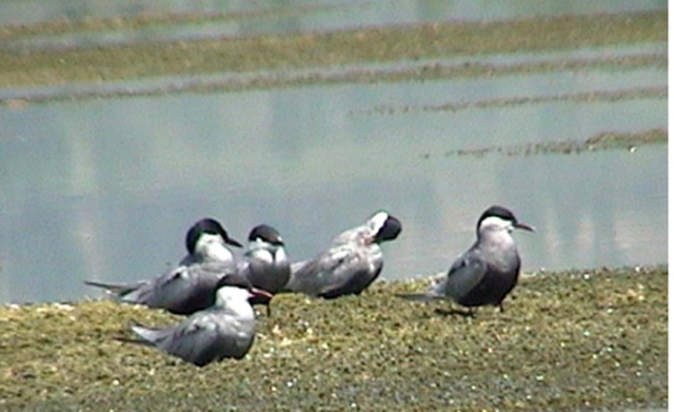

a. Indian whiskered tern

b. Graylag goose

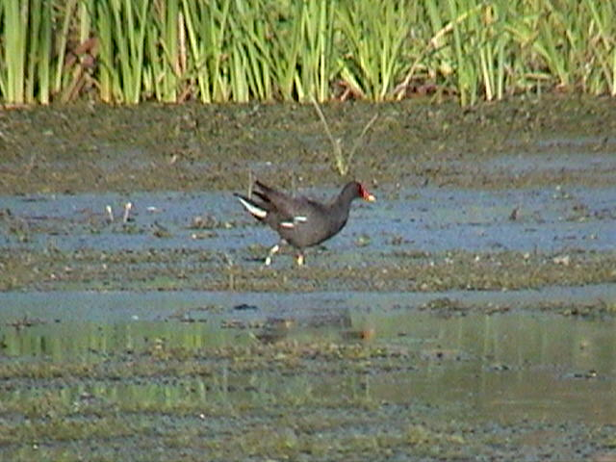

c. King fisher

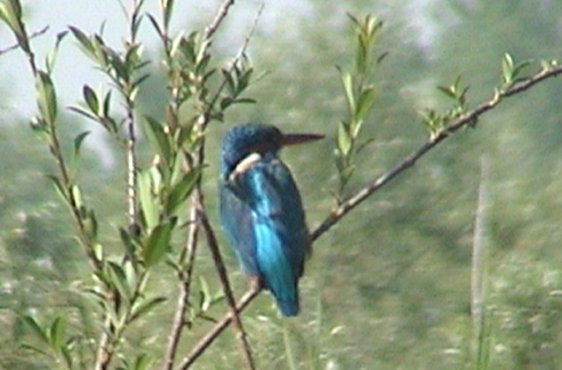

d. Moorhen

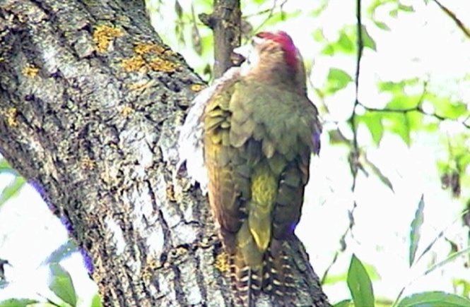

e. Large scaly bellied green woodpecker

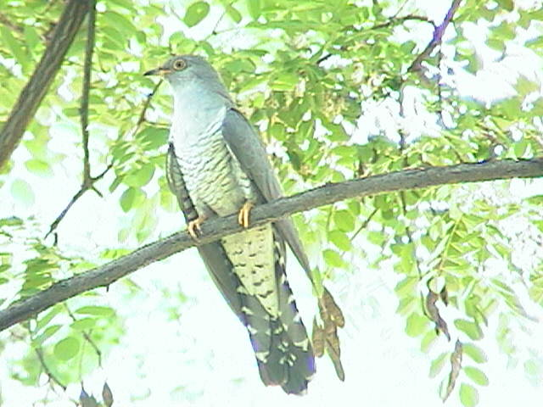

f. Common cuckoo

Conclusion
Avifauna of Anchar lake shows a rich diversity comprising of 21 species of resident birds, 27 summer visitors, 11 winter visitors and 9 local altitudinal migrants. But in comparison to the bird diversity of protected wetlands it is far less because of high anthropogenic activities going on inside the wetland. It is suggested that the said lake be included in the list of wetlands protected under Wildlife Protection Department of Jammu and Kashmir in order to safeguard its diversity.

Acknowledgement
We are highly thankful to Mr. Mohd. Altaf for providing boat facilities. Our thanks go to all the officials that are at the helm of affairs in the department of Zoology, KU for providing necessary equipments to carry out the study.

Corresponding Author
Bilal Ahmad Bhat
Postgraduate Department of Zoology, University of Kashmir, Hazratbal Srinagar-190006, Kashmir.
bilalwildlife@yahoo.co.in

References
  - Ahangar, F.A. Studies on avian diversity and breeding biology of mallard Anas platyrhynchos in the wetlands of Kashmir. (2008). Ph.D. thesis, Department of zoology University of Kashmir Srinagar.
  - Ali, S and Ripley, S.D. (1983). Handbook of the birds of India and Pakistan. Compact edition. Oxford Univ Press. Delhi.
  - Ali, S. (2002). The Book of Indian Birds. Oxford Univ. Press, Bombay.
  - Bates, R.S.P and Lowther, E.H.N. (1952). Breeding birds of Kashmir. Oxford Univ. Press, London.367pp.
  - Bull, J. (1964). Birds of New York area. Harper and Row, NewYork. 540pp.
  - Gaston, A.J. (1973). Methods for estimating bird populations. J. Bom. Nat. Hist. Soc.72 (2): 271-27.
  - Holmes, P.R and Parr, A.J. (1988). A checklist of the birds of Haigam Rukh, Kashmir. J. Bom. Nat. Hist. Soc. 85:465-473.
  - Ma Zhijun; Wenjun, Li; Zijian, W and Hong, X. (1998). Habit at changes and protection of Red-crowned crane (Grusjaponensis) in Yeng Cheng Biosphere reserve- China. Ambio. 27(6): 46-64.
  - Manakadan, R and Pittie, A. (2001). Standardised common and scientific names of the birds of the Indian subcontinent. Buceros 6(1): i-ix, 1-38.
  - Mc Caskie, G. (1970). Shorebirds and water birds use of Salton sea. California fish and game. 66(2): 87-95.
  - Shah, G. Mustafa. (1984). Birds of Hokersar: food, feeding and breeding biology of resident and non-resident birds. PhD thesis, P. G. Department of Zoology, University of Kashmir.
  - Shushil, M. Reshi, J.M and Krishna, M. (2014). To evaluate the water quality status and responsible factors for variation in Anchar lake Kashmir. IOSR- JESTFT 8(2):55-62.
  - Terge, Morten, E and Arild, L. (1998). Action plan for goose management in Norway. Skrifter 0(200): 19-28.
  - Thompson, K.R and Rothery, P. (1991). A census of Black-browd Albatross Diomeda melanophrys population on Steeple Jason Island, Falkland Islands. Biologicalconservation.56:39-48.

1/7/2017

