Studying Efficacy of Bilateral Transversus Abdominus Plain Block Guided Sonography as a Post analgesic Procedurein Cesarean Section.

Taher Salh-Eldein¹, Mohsen El Gioshey², Mostafa Abo El Enin², Mohamed I. Al mohandes¹ and Yehia A. Wafa³

¹Department of Gynecology and Obstetrics, Al Glaa' Teaching Hospital, Ministry of Health, Cairo, Egypt
²Department of anesthesiology and Pain relief, Faculty of Medicine, Al Azhar University, Cairo, Egypt
³Department of Gynecology and Obstetrics, Faculty of Medicine, Al Azhar University Cairo, Egypt.
tahersalah5050@gmail.com

Abstract: Background and Aim: Muscular nerve block usually used as an effective and safe adjunct to multimodal postoperative analgesia for variable abdominal surgeries. However multiple studies have demonstrated its superiority over standard medical therapy for postoperative pain control regarding Cesarean Sections. Nevertheless the use of ultrasound for the placement of nerve blocks has proved its efficacy post cesarean operations, accordingly we aimed to study the efficacy of TAB in cesarean section. Patients and Methods: 20 pregnant women have experienced cesarean section were achieved TAP, however another 20 pregnant women were received normal saline (Placebo) as a control group, both groups were followed for several hours post CS, performing a comparative analysis to estimate such efficacy of pain relief. Results: Post-operative pain scores were significant during first 6 hours P =0.001, however such scores were better post 12 and 24 hours, was not statistically significant P=0.3 and 0.4 respectively. Conclusion: TAP guided sonography, was easy, safe to perform and provided applicable and effective analgesia in Cesarean Sections.
[Taher Salh-Eldein, Mohsen El Gioshey, Mostafa Abo El Enin, Mohamed I. Al mohandes, Yehia A. Wafa. Studying Efficacy of Bilateral Transversus Abdominus Plain Block Guided Sonography as a Post analgesic Procedurein Cesarean Section. N Y Sci J 2017;10(1):33-39]. ISSN 1554-0200 (print); ISSN 2375-723X (online). http://www.sciencepub.net/newyork. 6. doi:10.7537/marsnys100117.06.

Key words; TAP; Cesarean section; Pain relief; Post –operative.

Abbreviations: NSAIDs; Non-Steroidal Anti-inflammatory drugs, PGE 2; prostaglandin E2, TAPB; Transverse abdominal plane block

1. Introduction
Post-operative pain is a major concern related- abdominal surgeries may affect the overall operation success, affecting patient´ s psychology. Traditionally, analgesia for abdominal surgery is provided either by systemic drugs such as opioids, ketamine, nonsteroidal anti inflammatories (NSAIDs), Alpha agonists and paracetamolor by epidural anaesthesia[ 1-3 ]. However Peripheral nerve blockade is an alternative means of providing analgesia, by anaesthetising the sensory nerves conveying pain impulses from the incision site to the spinal cord and brain [4]. There are varieties of peripheral nerve blocks can be performed to provide anesthesia and/or analgesia for Cesarean sections. Usually such procedures are performed by injection of local anesthetic (LA) into interfascial planes through which peripheral nerves run. One of the most common procedures is Transversus Abdominus Block [5]. Here we will present the efficacy of such TAB in cesarean sections.

2. Patients and Methods
20 Pregnant women in the current study were included; Group (A), however another 20 pregnant women were included as placebo; Control; Group (B).
Group A: Members of this group received general anesthesia at the end of the caesarean section, TAP block was performed guided- sonographyusing 20ml bupivacaine (0.25%) as a postoperative analgesia.
Group B: This group served as the control group, Members of this group received 20ml normal saline as placebo.
Inclusion Criteria:
• Sex: females.
• Age: Adults ≥ 18.
• Pain and analgesia Scores were identified to American Society of Anesthesiologists (ASA) class I-II.
• Body mass index [BMI]: Less than forty was accepted in the study and more than twenty.
• Type of surgeries: Elective caesarean sections.
B. Exclusion Criteria:
• Age: less than 18 or more than 40 years old.
• Known sensitivity to local anesthetics or ultrasound conduction gel.
• History of psychological disorders and/or chronic pain.
• Body mass index [BMI]: more than forty and less than twenty.
• Emergencies.
• Patients further refusal to participate in the study.
• Local cause e.g. infection.
II- Parameters used to evaluate the study:
• Hemodynamic monitoring postoperative in the form of blood pressure recording (systolic blood pressure [SBP], diastolic blood pressure [DBP] and mean blood pressure [MBP]) and heart rate [HR].
• Respiratory monitoring in the form of respiratory pattern and arterial blood gases (PO2 & PCO2).
• Block quality in the form of visual analog scale [VAS] for pain.
• Monitoring of other side effects of opioids and local anesthetics.
• Frequency of administration and the first rescue of analgesia, together with total consumption of opioids (see detailed analgesic plan below).
III- Methods:
This study was carried out at AL Galaa' teaching hospital – Cairo. The study protocol was approved by the Obstetric & gynecology department scientific and ethical committees. All patients were informed about the study design and objectives as well as tools and techniques. Informed written consent had been signed by every patient prior to the study.
IV- Randomization:
Patients were randomly allocated to one of two groups using simple randomization method utilizing closed envelops technique.
A. Preoperative day:
Routine preoperative assessment was done to all patients including history, clinical examination, laboratory investigations (complete blood picture, kidney function tests, liver function tests, prothrombin time, partial thromboplastin time), chest X-ray, electrocardiogram [ECG] was done for patients with any cardiac problem. The study protocol was explained to the patients and their consents were taken.
B. Operative day:
1. General Anesthesia Technique:
Just arrival to the operative room after establishing a peripheral intravenous access, patients were given ranitidine (50 mg, IV), and metocloropramide (10 mg, IV). Vital signs; were continuously monitored till anesthesia induction.
After Standard monitoring including ECG, noninvasive blood pressure and pulse oximetry were connected to patient pre-oxygenation for 5 minutes, general anesthesia was induced to every patient with fentanyl (1-2 μg/kg, IV), thiopental sodium (3-6 mg/kg, IV), and atracurium (0.5 mg/kg, IV) to facilitate tracheal intubation and then (0.1 mg/kg, IV) every 30 minutes to maintain muscle relaxation. Volume controlled ventilation mode was utilized to maintain O2 saturation > 98% and ETCO2 around 35-38 mmHg. Maintenance of anesthesia was obtained with inhalation of isoflurane (1-1.5 volume %).
2. Transversus Abdominis Plane Block Technique:
The TAP block was performed at the end of the surgery in the supine position, using ultrasound machine (LOGIQ 500 pro series) model, using the scanning probe; linear multi-frequency 13-16 MHz transducer.
The control group was given normal saline; 0.9% in the same fashion given to the study group.
Statistical Analysis
The data were collected, coded, tabulated then analyzed using SPSS® (Statistical Package for Social Science) computer software version-21.0. Numerical variables were presented as mean ± standard deviation (SD), while categorical values were presented as numbers. Comparison of numerical variables were performed by repeated measures ANOVA with chi-square test was used for testing proportion independence.

3. Result
In this study, forty women undergoing cesarean section were recruited, 20 cases received (TAP) block and the other 20 controls received placebo in the form of TAP saline.
Both groups were observed post-operatively evaluate the pain scores related-analgesia and normal saline in both studied pregnant women and controls respectively, the pain scores during rest and movement at 6, 12 and 24 hours and also to observe for any side effects or complications.

Table (1): Comparison of patients’ characteristics in the two study groups
Variable | Control group  (n=20) | TAP group  (n=20) | P value
Maternal age | 29.9 ±5.9 | 29.2±5.1 | 0.496
BMI | 28.82±1.53 | 28.80±1.54 | 0.943
Data are presented as mean ± SD.

The average maternal age, as described in the table, was29 years. Only small percentage of women aged below twenty years or above thirty five years –old. However Body mass index (BMI) didn’t show significant marked variation, and exclusion of women with BMI > 35 was intended to avoid discrepancies in the outcome due to extremedifference in weight of the patients (as the dose of local anesthetic used is fixed).

Table (2): Comparison of parity in the two study groups.
Parity | Control group  (n=20) | TAP group  (n=20) | P value
PG,P0 | 5(25.0%) | 6 (30.0%) | 0.753
P1.P2 | 12(60.0%) | 9 (45.0%) | 0.527
P3 | 3(15.0%) | 5 (25.0%) | 0.693

Data are presented as number (%). PG, primigravida; P0, previous pregnancy or pregnancies < 24 weeks; P1, previous one pregnancy ≥ 24 weeks; P2, previous two pregnancies ≥ 24 weeks, etc.
As shown in the table above, large percentage of patients had either previous one or two previous deliveries, while primiparous or patients with more than three previousdeliveries comprises lesser percentage.

Table (3): Comparison of the number of previous cesarean deliveries in the two study group.
Previous deliveries | Control group  (n=20) | TAP group  (n=200 | P value
NIL | 9(45.0%) | 9(45.0%)
One CS | 7(35.0%) | 5(25.0%) | 0.821
Two CS | 3(15.0%) | 5(25.0%) | 0.693
Three CS | 1(5.0%) | 1(5.0%) | 1.000
Data are presented as number (%).

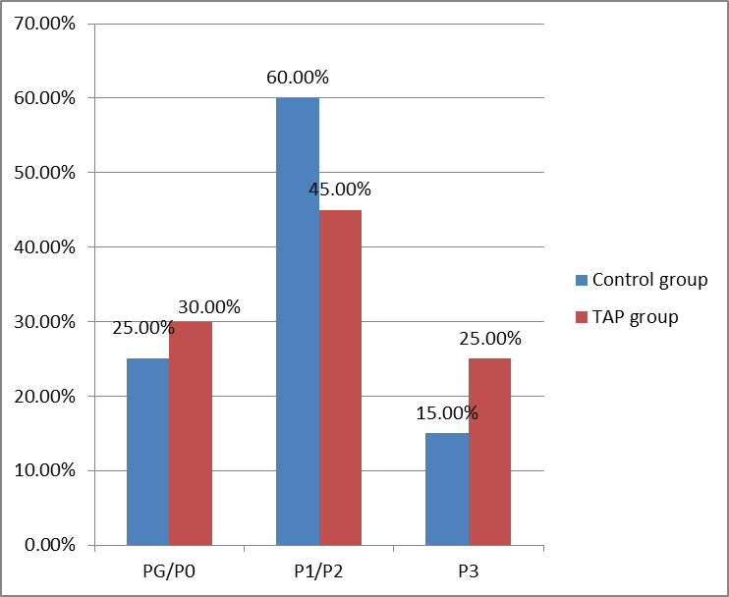
Fig (1): Parity in the two study groups.

According to table (3) 9 women in the control group and 9 women in the TAP group had no previous cesarean sections, whereas, the total number of women with previous cesarean sections in the control group and TAP group were 11 women. The above criteria were good for successful randomization of patients to decrease any difference between the two groups regarding operative time.

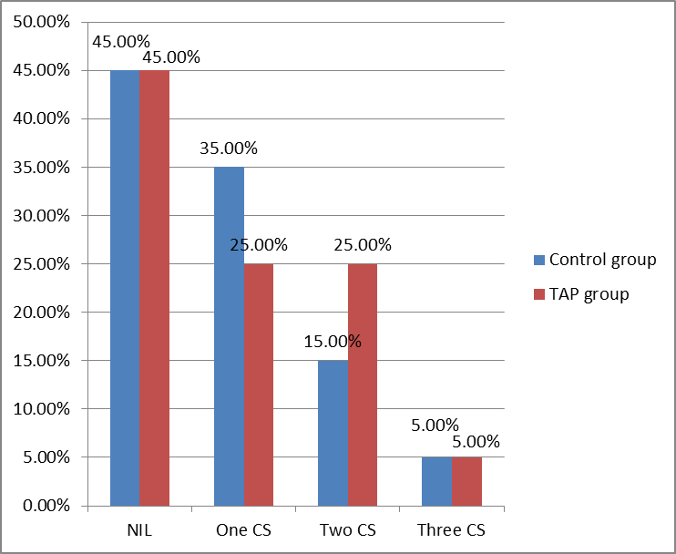
Fig (2): Previous cesarean section (CS)in the two study groups

Table (4): Comparison of operative time in the two studygroups
Variable | Control group  (n=20) | TAP group  (n=20) | P value
Operative time(min) | 47.6(7.4) | 49.4(8.0) | 0.317
Data are presented as mean (SD).

Table (5): Comparison of post-operative pain scores at rest in the two study groups.
Pain score at rest | Control group  (n=20) | TAP group  (n=20) | P value
at6 h | 54(49-57) | 46(40-54) | <0.001
At 12 h | 22(21-24) | 23(21-29) | 0.395
At24 h | 12(11-15) | 12(10-14) | 0.455

Table (6): Comparison of postoperative opioid doses consumption in the two study groups.
Post operativeopiod consumption | Control grop  (n=20) | TAP group  (n=20) | P value
NIL | 11(55.0%) | 14(70.0%) | 0.137
1dose | 8(40.0%) | 4(20.0%) | 0.301
2dose | 1(5.0%) | 2(10.0%) | 0.598
Data are presented as number (%).

Data are presented as median (interquartile range). As described in the table (5), the pain scores at 6 hours during rest in the surgical TAP group ranged between 40-54 mm, while in the control group, the pain scores ranged between 49-57 mm, with p-value <0.001. The difference in the pain scores was statistically significant. However, observing pain scores at 12 and 24 hours during rest showed no clinical or statistical difference.

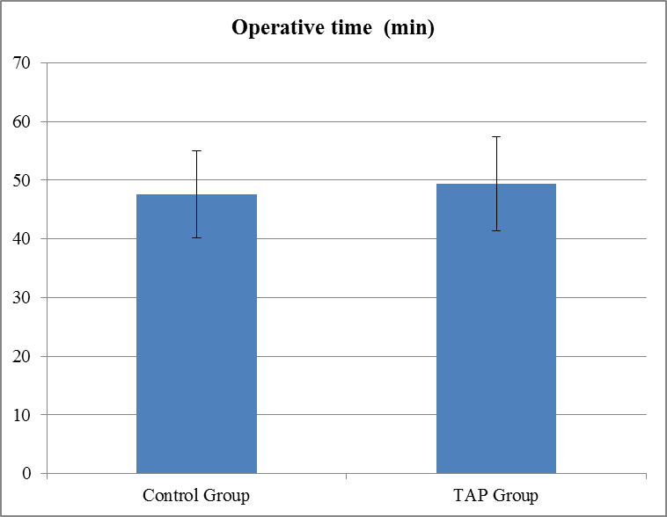
Fig (3): Mean operative time in both study groups. Line across box represents median. Error bars represent SD.

As regard opioid consumption post-operatively, 4 women from the TAP group requested 1 dose (100 mg) of intramuscular pethidine, compared to 8 women from the control group. Furthermore, 3 cases requested 2 doses (200 mg) of pethidine, 1 case in the control group and 2 cases in the TAP group. 2 women out of the 3 requiring additional dose of pethidine had relatively longer operative time compared to other patients due to some operative difficulties, this maybe the cause for higher pain scores.

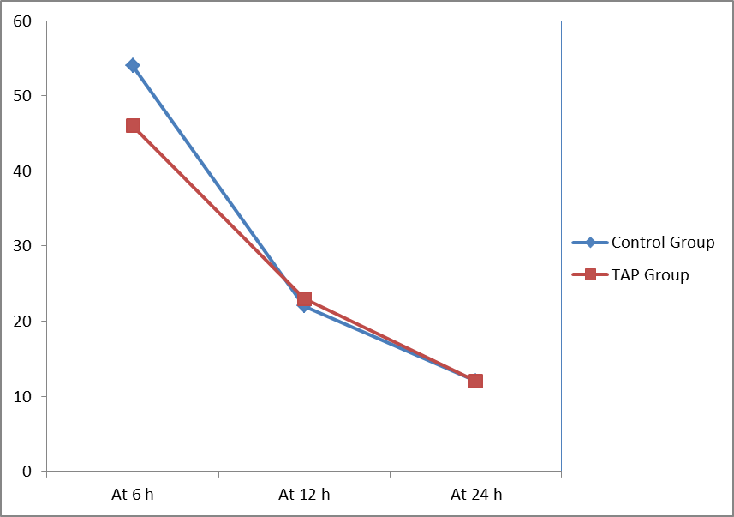
Fig (4): Box plot showing postoperative pain scores at rest in the two study groups. Box represents interquartile range. Line across box represents median. Error bars represent minimum and maximum values excluding outliers (rounded markers) and extreme values (asterisks).

Additionally, low pain threshold for some women might contribute to exaggerated response and consequently higher analgesic demands.

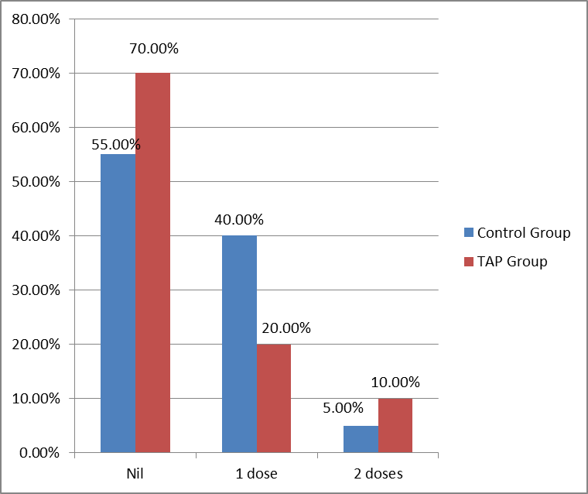
Fig (5): Postoperative opioid consumption in the two study groups.

Table (7): Comparison of the incidence of post-operative nausea and vomiting (PONV) and other side effects (pruritus, hypotension or arrhythmia, hematoma formation) in the two study groups.
variable | Control group(n=20) | TAP group(n=20) | P value
Incidence of PONV | 3(15.0%) | 2(10.0%) | .0291
Incidence of other side effects | NIL | NIL
Data are presented as number (%).

Post-operative nausea and vomiting occurred in 2 women from the TAP group, compared to 3 women in the control group. No other side effects related to the injection of local anesthetic including pruritus, hypotension, arrhythmia or hematoma formation were noticed in both groups.

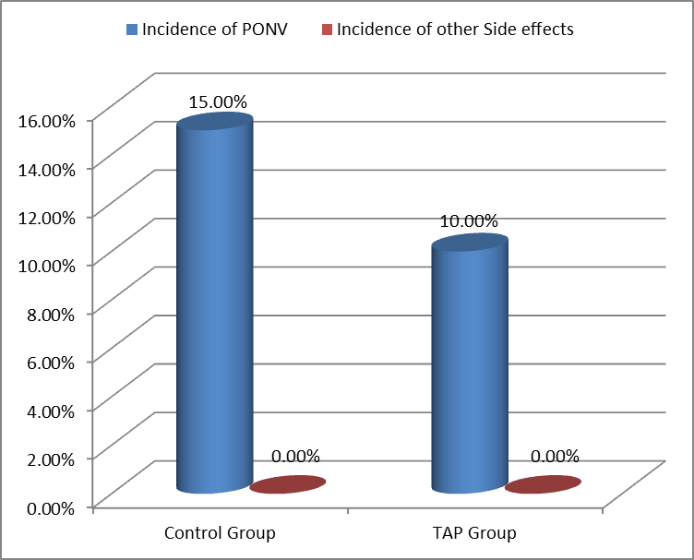
Fig (6): Incidence of postoperative nausea and vomiting in the two study groups.

4. Discussion
Pregnant women undergoing Cesarean section (CS) require a multimodal post-operative pain treatment regimen that provides high quality analgesia with minimal side effects. Many studies have been carried out trying to find a solution for these dilemma thus different analgesic modalities as local infiltration of the surgical field, systemic analgesia, neuro-axial blocks, and nerve blocks. However; each has shown its side effects which limit its use to specific cases [6].
A substantial component of pain experienced by patients after abdominal surgery is derived from abdominal wall incision, hence our discussion will obscure all related abdominal surgery including those undergoing Cesarean section (CS), because the abdominal wall is innervated by nerve afferents that course through the transversus abdominis neuro-fascial plane.84 Recently, there has been renewed interest in abdominal field blocks and the quest for a single injection providing widespread analgesia has led to the rapid popularity of the TAP block [7].
Our study demonstrates that real time ultrasound TAP block is an effective and safe adjunct to multi modal post -operative analgesia.
The result of the present study shows that pain score in TAP group lower than the control group. Pvalue<0.001.
The result of the present study show that TAP group reduced morphine consumption than control group. P<0.05 and this in accordance to different international studies, compared the effect of spinal morphine and TAP block for post cesarean section pain relief by recruiting 4 groups (1st group was given spinal morphine, 2nd was given spinal saline, 3rd was given TAP block and 4th group was given TAP saline) and found that spinal morphine but not TAP block improved analgesia after cesarean section. Additionallyin current study, ultrasound guided TAP block provided better analgesic effect over the 1st 6 hours‟ post-operative and the difference was statistically significant. Patients who received Ultrasound guided TAP block in our study had pain scores at rest average of 46 mm, while those who received TAP saline had pain scores average of 54 mm at 6 hours post-operative (P value <0.001).
Some studies compared the TAP block to other analgesic modalities compared TAP block with subarachnoid morphine, they concluded that subarachnoid morphine is superior to TAP block for post-operative pain relief (1st time to request post- operative analgesic was average of 8 hours in subarachnoid morphine group compared to 4 hours in the TAP group, P value< 0.01) [8-14].
Owen et al. 2011[15], had studied the surgical TAP block effect on 16 patients who received conventional analgesics and compared it with 18 patients who only received conventional analgesics, they found that surgical TAP block provided better pain relief hours: 1 in TAP group compared to 2 in the conventional analgesic group, P value< 0.01) and less morphine consumption. The results of Owen et al. are similar to the results in this study, however, in this study there was obvious difference in the pain scores between patients who received ultrasound guided TAP block and who received TAP saline at 6 hours during rest and during movement only (p value < 0.001), yet, this difference in the pain scores was not observed at 12 and 24 hours‟ post- operative. Owen et al., did not asses the pain scores at 12, 24 hours but they assessed the mean 24 hours‟ morphine consumption which proved to be less in the ultrasound guided TAP group. In the present study, the pain scores were assessed at 12, 24 hours in both groups at rest which revealed no advantage of the ultrasound TAP block group over TAP saline group.
Patients who received regional anesthesia were excluded from this study to eliminate the post-operative anesthetic effect in the anterior abdominal wall during the 1st few hours‟ post- operative, this will unmask any pain relieved due to use of regional anesthesia which may affect the assessment of pain scores as described in some studies.
Most of the studies performed to assess the efficacy of the TAP block were done transcutaneous either blindly using anatomical landmarks or under ultrasound guidance, while here, TAP block was performed under ultrasound guidance when the abdomen closed, the bottom line here is that the same procedure has been done using two different methods, but the final result was blocking the intercostal nerves in the neurovascular plane. Additionally it was reported that there is some evidence that the TAP block offered some additional analgesia in the first 6 hours postoperatively (fewer patients required opioid, P = 0.02, non- significant); however, this benefit was not found in the ensuing time points examined in the study (12, 24, and 48 hours), this data is also comparable to the results in this study, where the analgesic effect of the TAP block have faded away by time, and there was no difference in the pain scores at 12 and 24 hours post-operative [ 16-20].
In the present study, the suboptimal pain relief compared to other studies performed on the efficacy of the TAP block for post-operative pain maybe related to some reasons, first there is no universal or standard dose of local anesthesia used in all of the studies which may cause discrepancy in the analgesic effect, as described before. Additionally we described in the present study, that 20 ml of bupivacaine (0.25%) was enough in each side, which is the same dose used in the surgical TAP block done by Owen et al., 2011. However their results showed that TAP block was more effective for pain relief [15]. Another reason for the inconsistent results might relate to the usage of ultrasound to ensure the proper diffusion of the local anesthetic in the right plane which was not performed in our study or in similar studies like Owen et al. 2011 Moreover, the different techniques for the TAP block either transcutaneous or surgical from inside the abdominal cavity may have different outcomes and this should be compared separately in further studies.

Conclusion
Ultrasound guided TAP block is an easy, fast and relatively safe method that can be used as a part of multimodal analgesia post-cesarean section. However, when other methods like intrathecal opioids are available the TAP block would provide inferior results. Furthermore, the post- operative analgesic effect of ultrasound TAP block in this study was not highly effective in the late post-operative period, this may be related to either the dose used or the different technique. Hence, further research is needed concerning the use of ultra sound approach for TAP block using larger sample size trials. The upcoming studies should focus on comparing different techniques of the TAP block either transcutaneous or trans-peritoneal, the optimal dose of local anesthetic used for the block and finally the success and distribution of the block after the procedure.

Corresponding to:
Prof. Dr. Yeia Abd El-Salam Wafa,
Professor and Head of Gynecology and Obstetrics Departments, Faculty of Medicine, Al Azhar university, Cairo, Egypt.
Email: tahersalah5050@gmail.com

References
- Ng A, swami A, smith G, Davidson AC, Emembolu J. The analgesic effects of and incisional bubivacaine with epinephrine after total abdominal hysterectomy. Anesth Analg 2002; 95:158-62.
- Brennan F, Carr DB, Cousins M. Pain management: a fundamental human right. Anesthesia and Analgesia 2007; 106:205.
- Wall PD, Melzack R. Pain measurements in persons in pain. IN: Wall PD, Melzack R editor(s). Textbook of Pain. 4th Edition. Edinburgh: Churchill Livingstone 1999:409-26.
- Kehlet H, Dahl JB. The value of "multimodal" or "balanced analgesia" in postoperative pain treatment. Anesth Analg 1993; 77:1048.
- FH Back and Spinal Cord. In: Netter FH, ed. Atlas of Human Anatomy Summit. New Jersey, USA: The Ciba-Geigy Corporation 1989:145-55.
- Rafi AN. abdominal field block: a new approach via the lumber tiangle. Anaesthesia 2001;56:1024.
- Mcdonnell J G, O’donnell B D, Farrell T, Gough N, Tuite D, Power C, Laffey J G. Transversus abdominis abdominis plane block: A cadaveric and radiological evaluation, RegAnesth Pain 2007, Med, 32, 5, 399–404.
- P Hebbard, Y Fujiwara, Y Shibata, C Royse. Ultrasound Guided Transversus Abdominis Plane Block. Anaesthesia & Intensive Care 2007; 35(4): 616-617.
- Park WY, Thompson JS, Lee KK. Effect of epidural anesthesia andanalgesia on perioperative outcome: a randomized, controlled Veterans Affairs cooperative study, Annals of Surgery 2001; 234, 4, 560-9.
- Kelly DJ, Ahmad M, Brull SJ. Preemptive analgesia I: physiological pathways and pharmacological modalities. Can J Anaesth 2001; 48:1000.
- Woolf CJ, Bennett GJ, Doherty M, et al. Towards a mechanism-based classification of pain? Pain 1998; 77:227.
- Bear MF, Connors BW, Paradiso MA. Neuroscience: Exploring the brain, Philadelphia: Williams & Wilkins, 1996.
- Hollmann, M. and Durieux, M. Local Anesthetics and the Inflammatory Response, Anesthesiology 2000; 93, 3, 858-75.
- Ni Choileain N, Redmond HP. Cell response to surgery, Arch Surg 2006; 141, 11, 1132–40.
- Owen DJ, Harrod I, Ford J, Luckas M, Gudimetla V. The surgical transversus abdominis plane block—a novel approach for performing an established technique. British Journal of Obstetrics and Gynaecology 2011;118(1):24–27.

1/3/2017

