Comparison between mitral valve area measured by two-dimensional planimetry and three-dimensional transoesophageal echocardiography in patients with mitral stenosis

Mohammed Osama Kayed, Mostafa Ismael Saleh, Abdel Mohsen Moustafa Aboualia, and Abdallah Magdy

Cardiology Department - Faculty of Medicine – Al-Azhar University, Egypt
a_radwan100@yahoo.com

Abstract: Objective: To compare mitral valve area (MVA) measurements obtained by 2D transthoracic planimetry and 3D transoesophageal echocardiography (TOE) in patients with mitral stenosis (MS). Patients and methods: Thirty patients with MS.: MVA was determined by transthoracic 2D planimetry and 3D TOE in mid esophageal 4 chamber view. Clinical and echocardiographic variables were evaluated. Results: Although MVA measurements using 2Dplanimetry and 3D TOE showed fair agreement (kappa test =257; p<0.001), 2D planimetry overestimated MVA by 0.02±0.17 cm²compared with 3D TOE (p<0.001). Left atrial (LA) dimension obtained from the parasternal long-axis view at end-systole (p=0.012) and left ventricular ejection fraction (p=0.022) were independent determinants of the MVA difference (MVA by 2D—MVAby 3D TOE; MVA2D–3D). Conclusion: Because 2D planimetry tends to overestimate MVA, 3D TOE should be considered for accurate MVA assessment, especially in patients with alarge LA (>49mm).
[Mohammed Osama Kayed, Mostafa Ismael Saleh, Abdel Mohsen Moustafa Aboualia, and Abdallah Magdy. Comparison between mitral valve area measured by two-dimensional planimetry and three-dimensional transoesophageal echocardiography in patients with mitral stenosis. N Y Sci J 2017;10(1):24-28]. ISSN 1554-0200 (print); ISSN 2375-723X (online). http://www.sciencepub.net/newyork. 4. doi:10.7537/marsnys100117.04.

Keywords: Comparison; mitral valve area; two-dimensional planimetry; three-dimensional transoesophageal echocardiography; patient; mitral stenosis

- Introduction:
Measurement of the mitral valve area (MVA) using two-dimensional (2D) planimetry is widely used to assess the severity of rheumatic mitral stenosis (MS)¹. However, the 2D measurement of MVA requires technical expertise, particularly in the presence of a poor echo window or a distorted mitral valve (MV) tip¹. If the short-axis image of 2D TTE does not cross the MV tips, then MVA is overestimated^{2, 3}. Acquiring an optimal short-axis image of the MV tips using 2D echocardiography is a critical step for assessing MS severity, and error here is a major cause of inaccurate MVA measurement. In recent years, the technology of real-time three dimensional (3D) echocardiography has evolved rapidly. This technique is useful for the diagnosis and geometric analysis of valvular heart disease^{4–8}. In particular, real-time 3D TOE can provide an excellent image with a high resolution. It also identifies the ideal plane crossing the MV tips for planimetric measurement of MVA in MS patients, which may help overcome the technical limitations of 2D TTE^{9–12}. It was recently reported that MVA measurements obtained by 3D TOE agree with that obtained invasively³. Therefore, the purpose of this study was to compare MVA measurements obtained by 2D transthoracic planimetry and 3D TOE, and to determine the causes of discrepancies between the two techniques.

2. Patients and Methods
Study population:
The study was done in Cardiology department Al-Azhar University Hospital (Bab AL She’reya University Hospitals) from January 2016 to September 2016. It included thirty consecutive patients (mean age: 29.8 ± 6.8 years; (7 men), all of them had rheumatic mitral valve stenosis, some of them are candidates for valvuloplasty as proved by investigations.

Table 1 Baseline characteristics of the patients.
Demographic data | No. | %
Gender
Female | 23 | 76.7
Male | 7 | 23.3
Total | 22 | 50
Age (years)
Range [Mean±SD] | 22-50 [29.87±6.86]

The baseline characteristics of all patients are summarized in table 1. All patients underwent 2D TTE and TOE on the same day for evaluation of MV.
3D TOE measurements:
A 2–7 MHz, real-time 3D TOE Xmatrixarray transducer (X7-2t probe, iE33 system; Philips Medical Systems, Andover, Massachusetts, (USA) was used to obtain a 3D image. A full-volume image (figure 1) was acquired from each patient in regular sinus rhythm, after optimizing the gain, compression controls, and time gain compensation. Over four consecutive heart beats while the patient held his or her breath. This process resulted in wide-angled acquisition (65°×56° up to 102°×105°).
This imaging model allows real-time 3D imaging without the need for ECG gating, and displays a pyramidal volume of approximately 30°×60°.
The TOE plane angle was adjusted to locate the long commissural diameter along the wider direction of the image set. By using dedicated QLAB software (Philips Medical Systems), multiplanar reconstruction was used to locate the precise crosssectional plane to cross the tips of all parts of the MV during early diastolic opening, when MVA is greatest The planimetric MVA measurement was obtained on the magnified cross-sectional plane of the MV tips.1 MVA measurement using 3D images were conducted independently without knowing 2D echocardiography data.

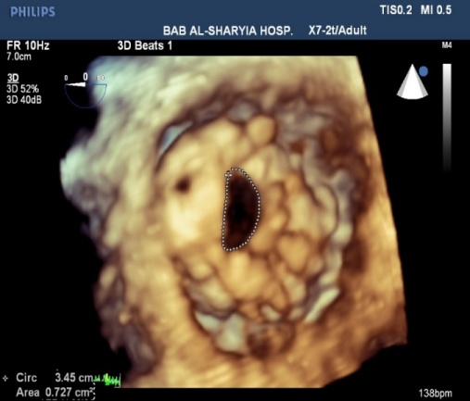
Figure1: Full volume image of a mitral valve from the left atrial perspective.

2D measurements
Transthoracic 2D echocardiographic images were obtained using acommercially available ultrasound system (S3-1 Probe and iE33; Philips Medical Systems). The MVA was measured by 2Dplanimetry during the early diastolic phase, when the diastolic opening is maximal, using a parasternal short-axis view, (Figure 2) with optimized gain, compression controls, and time gain compensation1.
Left ventricular (LV) and-systolic and end-diastolic dimensions, LV diastolic septal thickness, and ejection fraction were also measured. Right ventricular (RV) basal dimension was measured from the RV-focused view at end-diastole.13 The peak mitral velocity, trans mitral mean pressure gradient, pressure half time, and pulmonary artery systolic pressure were evaluated using continuous-wave Doppler. Because the parasternal short-axis image is usually acquired by rotating probe around 90° from the parasternal long-axis image at the location where parasternal longaxis image can be acquired the best. The difference between the MVAs measured by transthoracic 2D planimetry and 3D TOE (MVA2D–3D) was defined as: (MVA from 2D planimetry-MVA from 3D TOE planimetry). A significant overestimation of MVA by 2D compared with MVA by 3D TOE was defined as MVA2D–3D>0.17 cm².

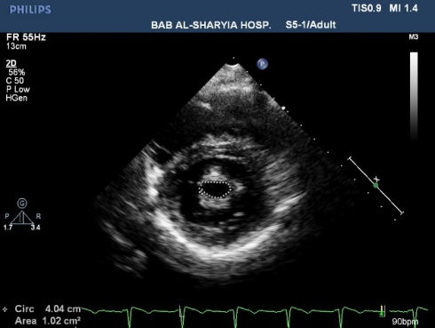
Figure 2: MVA planimetric measurement in parasternal short axis view.

Figure(3) Representative example of multiplanar reconstruction-guided measurement of mitral valve (MV) area using 3D TEE image. (A) Left and right upper panels show antero–posterior (A–P) and commissure–commissure (C–C) planes, respectively. Left lower panel shows across-sectional plane crossing mitralvalve tips. (B) Planimetric measurement of MV area on the magnified cross-sectional image.

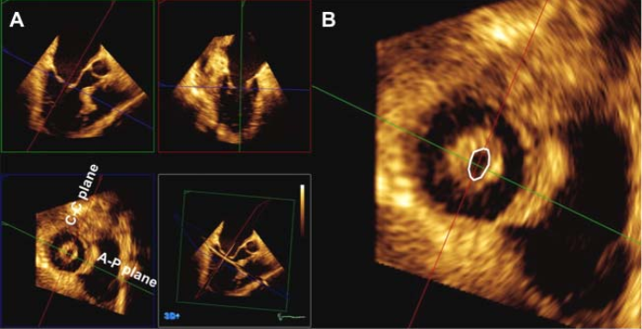
(Figure 3): Representative example of multiplanar reconstruction-guided measurement of mitral valve (MV) area using 3D TEE image. (A) Left and right upper panels show antero–posterior (A–P) and commissure–commissure (C–C) planes, respectively. Left lower panel shows a cross-sectional plane crossing mitral valve tips. (B) Planimetric measurement of MV area on the magnified cross-sectional image.

Statistical analysis:
Statistical analysis was performed using Statistical Program for Social Science (SPSS) version 20.0. Continuous variables were expressed as the mean SD. Categorical variables were expressed as a percentage. A p-value <0.05 was considered significant. the agreement between two measurements was performed by using scott´s kappa test.

3. Results:
MVA measurements using 2D planimetry and 3D TOE
Data obtained from 2D echocardiography are shown in table 2. In all 30 patients, MVA was successfully measured by both 2D planimetry and 3D TOE.

Table (2): Data obtained from echocardiography
 | Mean±SD | Min. | Max.
LAD | 4.79±0.34 | 4.1 | 5.4
ARD | 3.02±0.41 | 2.2 | 3.7
LVEDD | 4.85±0.57 | 3.4 | 5.4
LVESD | 3.47±0.59 | 2.8 | 5.3
EF% | 63.49±12.76 | 0.7 | 72

As assessed by 2D planimetry: patients with severe (MVA<1.0 cm2), moderate (1.0 cm2≤MVA ≤1.5 cm2) was 40% and 60% (table 3). The agreement between MVA measurements using 2D planimetry and 3D TOE was fair (Kappa test = 0.257, p<0.002); however, 2D planimetry overestimated MVA by 0.02±0.17 cm2 compared with 3D TOE respectively (p<0.002), The association of MVA measured by 2D planimetry and 3D TOE was evaluated by: 1-Chi-square (X²) test of significance was used in order to compare proportions between two qualitative parameters.

Table (3): Data obtained from echocardiography.
Associated valve lesions | No. | %
AR
Mild | 5 | 16.7
Trivial | 11 | 36.7
No | 14 | 46.7
MR
Mild | 21 | 70.0
Trivial | 4 | 13.3
No | 5 | 16.7
MS (Degree)
Moderate | 12 | 40.0
Severe | 18 | 60.0

Figure 4 showed the association of MVA measured by 2D planimetry or 3D TOE.
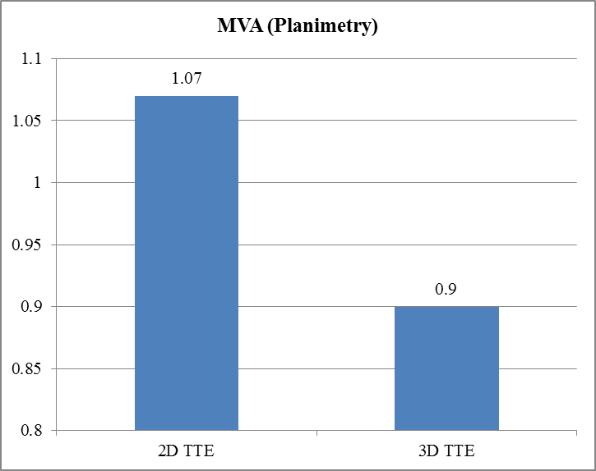
Fig. (4): Bar chart between 2D TTE and 3D TTE according MVA (planimetry).

3. Discussion:
This study demonstrated the relationship between MVA measured by 2D planimetry and 3D TOE, and identified factors associated with overestimation of MVA by 2D planimetry. The agreement between MVA measurements by 2D planimetry and 3D TOE was fair, but the former significantly overestimated MVA. Because Doppler-derived MVA can be easily affected by hemodynamic factors, such as heart rate and intravascular volume, direct MVA measurements play a major role in the assessment of severity and management of rheumatic MS¹. With 2D echocardiography, this can be a challenging task when the valve orifice is asymmetrically narrowed. In such cases, deviations from the ideal image plane positioning will lead to very significant overestimations of the MVA¹⁴. Previous studies show that MVA measured by 3D TTE is accurate, 15 even in calcific MS¹⁶, and shows superior accuracy when compared with MVA measured by transthoracic 2D planimetry when the Gorlin formula is used as the gold standard^{2,17}. However, 3D TTE frequently shows suboptimal image quality for measurement of MVA, due to the low spatial resolution of 3D images and poor echocardiographic chest window of patients^{4,18}. The recently-developed 3D TOE technique consistently provides excellent volume-rendered images of MV components with high spatial resolution^{5,9,11}. A commercially available 3D transducer offers 2D, Doppler, and 3D imaging via a single probe with excellent spatial resolution, ease of use, and time efficiency⁵. Accordingly, 3D TOE improves the accuracy of planimetry measurements, even when performed by less-experienced practitioners^{1,19}. Multiplanar reconstruction of 3D TOE images is useful for localizing the exact MV tip by steering the axes^{3, 20}. Recently, Schlosshan et al compared MVA measurements acquired by 3D TOE and 2D planimetry, and showed that MVA was significantly smaller when measured by 3D TOE rather than 2D planimetry³. This result is consistent with our current results. Difficulty in acquiring the ideal 2D short-axis plane crossing the tips of the mitral leaflets using 2D planimetry may lead to inaccurate measurements and overestimation of MVA^{2,3}. To measure MVA accurately by using planimetry on the 2D shortaxis image, the imaging plane must cross the tips of both leaflets. The short-axis plane is usually generated by rotating the probe by 90° at the same position where the parasternal longaxis image is acquired. Consequently, the short-axis image of the MV is placed on the line of the echo probe-to-MV tip on the long-axis image. However, in some patients, the line of the echo probe-to-MV tip may not run though both MV tips, but through the exact tip of only one leaflet and the base portion of the other leaflet. This might cause MVA overestimation. The corrected MVA which was compatible with MVA measured by 3D TOE, may help to estimate MVA more accurately with only use of 2D TTE. Despite the promising benefits of 3D TOE, this technique is semi-invasive and requires additional off-line measurement.11Thus, 3D TOE is not normally considered as the primary method for measuring MVA, nor is it used routinely for all MS patients^{3,11}. Defining a significant MVA overestimation by 2D planimetry as MVA2D–3D>1.7 cm², we found that, when measured by 2D planimetry, MVA was significantly overestimated in 43.3% of patients.

Study Limitations:
Because we did not use the Gorlin formula or a surgical specimen as a reference, our measurements could not be compared with the gold standard value for MVA. However, we assume that the MVA measured from 3D TOE is a gold standard, because we could confirm that the cross-sectional plane was correctly positioned at the tips of the MV using multiplanar reconstruction, and the image quality of 3D TOE appeared to be superior to that obtained using transthoracic 2D. Furthermore, the Gorlin method is invasive and has several pitfalls and technical limitations.23 24 Direct measurement of the MVA during surgery is not always successful either, especially in cases of severely distorted valves.25.

Conclusions:
Two-dimensional planimetry tends to overestimate MVA compared with 3D TOE planimetry.

Acknowledgement:
We greatly appreciate the Contributors of Drs. Moustafa El Deep, Hani Khalaf, Islam Abdel Monem for their efforts in case selection& study.

Funding: internal.
Conflicts of interest: non declared.

References:
  - Baumgartner H, Hung J, Bermejo J, et al. Echocardiographic assessment of valve stenosis: EAE/ASE recommendations for clinical practice. J Am Soc Echocardiogr 2009; 22:1–23.
  - Zamorano J, Cordeiro P, Sugeng L, et al. Real-time three-dimensional echocardiography for rheumatic mitral valve stenosis evaluation: An accurate and novel approach. J Am Coll Cardiol 2004;43:2091–6.
  - Schlosshan D, Aggarwal G, Mathur G, et al. Real-time three-dimensional transesophageal echocardiography for the evaluation of rheumatic mitral stenosis: an accurate and novel approach. JACC Cardiovasc Imaging 2011;4:580–8.
  - Yang HS, Bansal RC, Mookadam F, et al. Practical guide for three-dimensional transthoracic echocardiography using a fully sampled matrix array transducer. J Am Soc Echocardiogr 2008;21:979–89.
  - Kirkpatrick JN, Lang RM. Surgical echocardiography of heart valves: a primer for the cardiovascular surgeon. Semin Thorac Cardiovasc Surg 2010;22:200.e1–e22.
  - Zamorano J, Perez de Isla L, Sugeng L, et al. Non-invasive assessment of mitral valve area during percutaneous balloon mitral valvuloplasty: role of real-time 3D echocardiography. Eur Heart J 2004;25:2086–91.
  - Delabays A, Jeanrenaud X, Chassot PG, et al. Localization and quantification of mitral valve prolapse using three-dimensional echocardiography. Eur J Echocardiography. 2004;5:422–9.
  - Goland S, Trento A, Iida K, et al. Assessment of aortic stenosis by three-dimensional echocardiography: an accurate and novel approach. Heart 2007;93:801–7.
  - Sugeng L, Shernan SK, Salgo IS, et al. Live 3-dimensional transesophageal echocardiography initial experience using the fully-sampled matrix array probe. J Am Coll Cardiol 2008;52:446–9.
  - Vegas A, Meineri M. Core review: three-dimensional transesophageal echocardiography is a major advance for intraoperative clinical management of patients undergoing cardiac surgery: a core review. AnesthAnalg 2010;110:1548–73.
  - Flachskampf FA, Badano L, Daniel WG, Recommendations for transoesophageal echocardiography: update 2010. Eur J Echocardiogr 2010;11:557–76.
  - Kupferwasser I, Mohr-KahalySQuantification of mitral valve stenosis by three-dimensional transesophageal echocardiography. Int J Card Imaging 1996;12:241–7.
  - Lang RM, Bierig M, Devereux RB, et al. Recommendations for chamber quantification: a report from the American Society of Echocardiography’s Guidelines and Standards Committee and the Chamber Quantification Writing Group, developed in conjunction with the European Association of Echocardiography, a branch of the European Society of Cardiology. J Am Soc Echocardiogr 2005;18:1440–63.
  - Johri AM, Passeri JJ, Picard MH. Three dimensional echocardiography: approaches and clinical utility. Heart 2010;96:390–7.
  - Xie MX, Wang XF, Cheng TO, et al. Comparison of accuracy of mitral valve area in mitral stenosis by real-time, three-dimensional echocardiography verustwo-dimensional echocardiography versus Doppler pressure half-time. Am J Cardiol 2005;95:1496–9.
  - Chu JW, Levine RA, Chua S, et al. Assessing mitral valve area and orifice geometry in calcific mitral stenosis: a new solution by real-time three-dimensional echocardiography. J Am Soc Echocardiogr 2008;21:1006–9.
  - Perez de Isla L, Casanova C, Almeria C, et al. Which method should be the reference method to evaluate the severity of rheumatic mitral stenosis? Gorlin’s method versus 3D-echo. Eur J Echocardiogr 2007;8:470–3.
  - Sugeng L, Coon P, Weinert L, et al. Use of real time 3-dimensional transthoracic echocardiography in the evaluation of mitral valve before disease. J Am Soc Echocardiogr 2006;19:413–2.
  - Messika-Zeitoun D, Brochet E, Holmin C, et al. Three-dimensional evaluation of the mitral valve area and commissural opening and after percutaneous mitral commissurotomy in patients with mitral stenosis. Eur Heart J 2007;28:72–9.
  - Langerveld J, Valocik G, Plokker HW, et al. Additional value of three-dimensional transesophageal echocardiography for patients with mitral valve stenosis undergoing balloon valvuloplasty. J Am Soc Echocardiogr 2003;16:841–9.
  - Park K, Kim HK, Park YB. A giant left atrium in rheumatic mitral stenosis. Korean, Circ J 2010;40:609–10.
  - Binder TM, Rosenhek R, Porenta G, et al. Improved assessment of mitral valve stenosis by volumetric real-time three-dimensional echocardiography. J Am Coll Cardiol 2000;36:1355–61.
  - Hammermeister KE, Murray JA, Blackmon JR. Revision of Gorlin constant for calculation of mitral valve area from left heart pressures. Br Heart J 1973;35:392–6.
  - Klarich KW, Rihal CS, Nishimura RA. Variability between methods of calculating mitral valve area: simultaneous Doppler echocardiographic and cardiac catheterization studies conducted before and after percutaneous mitral valvuloplasty. J Am Soc Echocardiogr 1996;9:684–90.
  - Faletra F, Pezzano A, Fusco R, et al. Measurement of mitral valve area in mitral stenosis: four echocardiographic methods compared with direct measurement of anatomic orifices. J Am Coll Cardiol 1996;28:1190–7.

12/26/2016

