Correlation between the Degree of Diastolic Function and Severity of Coronary Artery Disease As Defined By Syntax Score

Ihab El-Sayed, Mustafa Attia, Mohamed Mosaad, Ibrahim Yassin, Ashraf Al-Amir, Islam Abdel-Fatah

Cardiology department - Faculty of Medicine - Al-Azhar University, Cairo, Egypt
drislamaboelenin@gmail.com

Abstract: Background: Early identiﬁcation of high-grade ischemia based on echocardiographic diastolic abnormalities may be clinically useful in the acute coronary syndrome (ACS) setting. This could provide the clinician with an awareness of the burden of coronary artery disease (CAD) before angiography is performed to allow for early intervention of suspected ischemic lesions. Aim of the work: To assess the relation between the degree of diastolic function and severity of coronary artery disease by cardiac catheterization-derived syntax score. Material and methods: a prospective study done over a period of eight months that included cases of acute coronary syndrome and chronic stable angina during the study period from (1/12/2015 to 1/8/2016).90 patients were evaluated for degree of diastolic function by echocardiography and severity of coronary artery disease by cardiac catheterization-derived syntax score. The data was analysed using Chi-square test using SPSS (Statistical package for social science) software. Results: The study population included a total of 90 patients (mean age 49 ± 7 years) with 76% presenting with an ACS. The mean SYNTAX score was (18.37±10.48). The E/A ratio was higher, and deceleration time (DT) was lower in the high SYNTAX group in comparison with the low SYNTAX group (P = 0.016 and P = 0.046, respectively). The grade of diastolic dysfunction was higher in the high SYNTAX group in comparison with the low SYNTAX group (P = 0.042). Conclusion: Early identiﬁcation of high-grade ischemia based on echocardiographic diastolic abnormalities may be of important clinical signiﬁcance for predicting CAD burden prior to invasive angiography.
[Ihab El-Sayed, Mustafa Attia, Mohamed Mosaad, Ibrahim Yassin, Ashraf Al-Amir, Islam Abdel-Fatah. Correlation between the Degree of Diastolic Function and Severity of Coronary Artery Disease As Defined By Syntax Score. N Y Sci J 2017;10(1):13-23]. ISSN 1554-0200 (print); ISSN 2375-723X (online). http://www.sciencepub.net/newyork. 3. doi:10.7537/marsnys100117.03.

Keywords: echocardiography, coronary angiography, diastolic function, SYNTAX Score

1. Introduction:
Coronary artery disease (CAD) is the leading cause of death worldwide. The World Health Organization estimates that approximately 17 million people die from CAD every year.¹An estimated 84 million American adults are afflicted with cardiovascular disease, accounting for 1 in 3 individuals.² This number is expected to rise given the increasing rates of obesity and diabetes leading to greater economic strain on our overall health care system.²
Coronary angiography is considered the gold standard for the invasive assessment of obstructive CAD.³ While generally considered a safe procedure, coronary angiography is associated with complications. Major complications including death, myocardial infarction (MI), and/or major embolization have been estimated to occur in less than 2% of cases,⁴ with higher rates approaching 4% when percutaneous coronary intervention (PCI) is performed.⁵ Additionally, renal dysfunction is a well-established complication of angiography that is estimated to occur in up to 5% of patients.⁶ The SYNTAX (Synergy between PCI with TAXUS and Cardiac Surgery) score is frequently used to comprehensively assess the complexity and burden of CAD.⁷ It was initially developed to assess outcomes in patients with left main or three-vessel disease.⁸ The SYNTAX score is an anatomically based risk calculation that was developed as an aid in determining the optimal technique of revascularization. It has been proven to predict prognosis and response to revascularization strategies.^{8–10} In the setting of ischemic heart disease (IHD), diastolic dysfunction occurs before systolic dysfunction in the ischemic cascade.¹¹ Although diastology can be assessed invasively using cardiac catheterization, echocardiography remains the most commonly used imaging modality for the noninvasive determination of diastolic dysfunction in clinical practice.¹² In combination with conventional diastolic parameters including E velocity, A velocity, E/A ratio, deceleration time (DT), and isovolumic relaxation time (IVRT), tissue Doppler imaging (TDI) provides a comprehensive evaluation of diastolic function using transthoracic echocardiography (TTE).¹² A number of previous studies have examined the relationship of diastolic echocardiographic parameters and CAD in the setting of an acute coronary syndrome (ACS).^{13–21} However, the use of color TDI-derived parameters in relation to the SYNTAX score as a marker of CAD burden has not been previously evaluated. Early identification of high-grade ischemia or early myocardial dysfunction based on echocardiographic diastolic abnormalities rather than overt systolic dysfunction would be advantageous. This could provide the clinician with an awareness of the burden of CAD before angiography is performed to allow for early intervention on suspected ischemic lesions. The objective of this hypothesis-generating study is to assess whether 2D TTE-derived TDI parameters can predict the severity of CAD with the SYNTAX score in patients presenting with stable angina or ACS.
Methods:
A prospective study done over a period of eight months that included 90 cases from (1/12/2015 to 30/7/2016). Patients presented with either stable angina or ACS were included in the study. Exclusion criteria included previous coronary artery bypass surgery (CABG) as the SYNTAX score cannot be applied in this patient population. Individuals who presented with symptoms other than angina or angina- equivalent and those with severe valvular heart disease were excluded. Elderly over 60 years, diabetic patients, hypertensive patients or patients had atrial fibrillation were also excluded. The study protocol was approved by Al-Azharuniversity, Faculty of Medicine. A chart review was performed, and data were collected including patient demographics, medical history, examination, ECG, echocardiography and coronary angiography.
Echocardiography:
A Philips IE 33 X Matrix phased array system equipped with TDI using a multi frequency (1 - 5 MHz) S5-1 matrix array probe was used. All patients will be subjected to the following:
Two dimensional measurement:
The apical two chamber and four chamber views will be used to obtain LV end-systolic volume (LVESV) and LV end-diastolic volume (LVEDV) by manually tracing the endocardial borders. These measurements allowed for calculation of the LV ejection fraction (LVEF) using the biplane modified Simpson’s method. Left atrial (LA) was obtained by tracing of the blood-tissue interface on apical four- and two-chamber views.
Assessment of diastolic function:
I-Pulsed wave Doppler:
Diastolic function will be evaluated using pulsed-wave Doppler obtained at the level of the mitral valve inflow, assessing peak early (E) and late (A) mitral inflow velocities, and deceleration time (DT). The E/A ratio will be calculated as a marker of diastolic function.
II-Tissue Doppler:
TDI parameters including early (E'), and late (A') tissue velocities will be obtained at the medial and lateral mitral annuli of the LV cavity. Finally, the dimensionless index of E/E' will be calculated.
SYNTAX Score:
Blinded to the echocardiographic reviewed the coronary angiograms for each patient, and an online calculator was used to with the SYNTAX score in patients presenting determine the SYNTAX score (www.syntaxscore.com).²² Left and right coronary artery dominance was determined as this impacted the weighing factor of the lesion. Each coronary lesion in a vessel with a diameter greater than 1.5 mm was scored if there was greater than 50% luminal obstruction. Each lesion was assigned a composite value based on: location, total occlusion, bifurcation, trifurcation, tortuosity, length, heavy calciﬁcation, and thrombus. Additional points were provided for the presence of diffuse disease. Patients were categorized as having a low SYNTAX score (<22), intermediate score (23–32), or high score (≥33).²³

Results:

Table (1): Demographic data distribution of the study group:
Demographic Data | No. | %
Sex
Male | 65 | 72.2
Female | 25 | 27.8
 | Range | Mean±SD
Age (years) | 29-60 | [49.29±7.04]
BSA | 1.83-2.3 | [2.0±0.12
Weight (kg) | 70-110 | [86.93±12.09]
Height (cm) | 147-191 | [170.13±10.02]
BMI [wt/(ht)2] | 22.86-46.49 | [30.65±7.36]
This table shows that the male (72.2%) and female (27.8%) of sex.

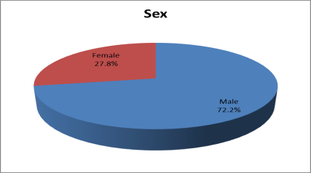
Fig. (1): Bar chart gender distribution of the study group.

The study was done at at Bab EL-She'riya University Hospitals – Al-Azhar University – Cairo – Egypt between December 2015 and August 2016. It included ninety patients. The patients were classified in to three groups:
Group (1) patients: 56 patients with low syntax score
Group (2) patients: 23 patients with intermediate syntax score
Group (3) patients: 11 patients with high syntax score
Descriptive data of the study group:

A) Demographic data of the study group.
B) Risk Factors data of the study group:

Table (2): Risk factors distribution of the study group:
Risk factors | No. | %
Smoking
Yes | 71 | 78.9
No | 19 | 21.1
Family history of premature CAD
Yes | 26 | 28.9
No | 64 | 71.1

This table shows that the smoking (78.9%) and family history (28.9%) of risk factors.

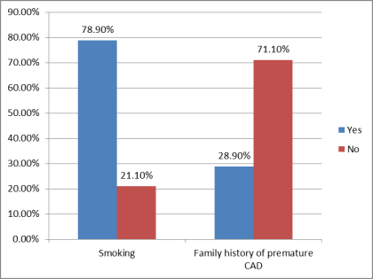
Fig. (2): Bar chart Risk factors distribution of the study group.

C) Presentation data of the study group:

Table (3): Presentation distribution of the study group:
Presentation | No. | %
UA | 27 | 30.0
CSA | 22 | 24.4
NSTEMI | 34 | 37.8
STEMI | 7 | 7.8
Total | 90 | 100.0

This table shows that the UA (30.0%), CSA (24.4%), NSTEMI (37.8%) and STEMI (7.8%) of presentation.

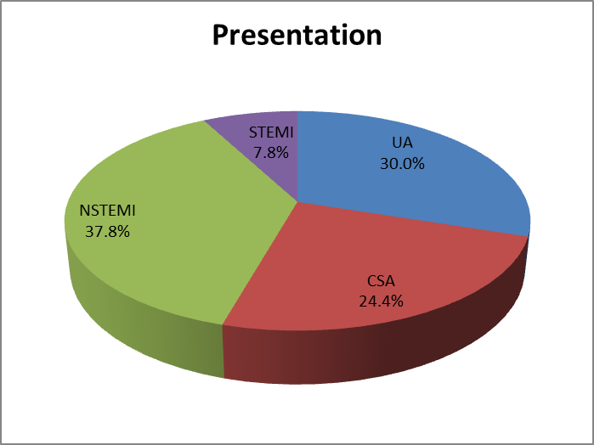
Fig. (3): Pie chart presentation distribution of the study group.

D) Diastolic dysfunction groups of the study patients:

Table (4): Diastolic dysfunction grade distribution of the study group:
Diastolic Dysfunction Grade | No. | %
Grade I | 48 | 53.3
Grade II | 27 | 30.0
Grade III | 15 | 16.7
Total | 90 | 100.0

This table shows that the Grade I (53.3%), Grade II (30%) and Grade III (16.7%) of diastolic dysfunction grade.

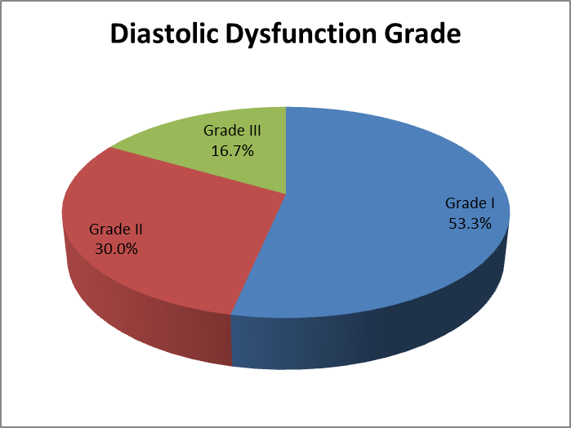
Fig. (4): Pie chart dysfunction grade distribution of the study group.

E) Echocardiography descriptive data of the study group:

Table (5): Echocardiography descriptive data of the study group:
Echocardiography | Range | Mean±SD
LVEDD | 4.3-49 | 5.57±4.64
LVESD | 2.4-4.1 | 3.32±0.33
IVSD | 0.8-1.2 | 0.94±0.10
EF | 41-67 | 54.98±6.76
Aortic root | 2.3-4 | 2.96±0.34
LAD | 2.8-4.7 | 3.77±0.60
LAV | 23-53 | 36.64±8.34
E | 30-120 | 72.73±19.21
A | 46-120 | 79.68±21.13
E/A | 0.28-2.27 | 1.02±0.52
EDT | 130-282 | 197.17±41.33
E | 3.9-10.1 | 6.54±1.55
A | 4.3-12.4 | 8.27±2.24
E/e | 4.54-26.8 | 11.72±5.42

F) SYNTAX Score groups data of the study patients:

Table (6): SYNTAX score distribution of the study group.
Syntax Score | No. | %
Low | 56 | 62.2
Intermediate | 23 | 25.6
High | 11 | 12.2
Total | 90 | 100.0
Syntax Score [Range (Mean±SD)] | 3-44 [18.37±10.48]

This table shows that the low (62.2%), intermediate (25.6%) and high (12.2%) of syntax score.

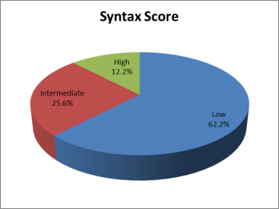
Fig. (5): Pie chart syntax score distribution of the study group.

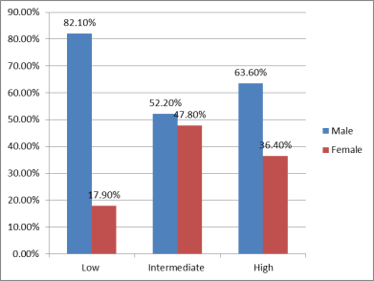
Fig. (6): Bar chart between SYNTAX score and sex.

Comparison between the three groups:
A) Comparison between the three groups regarding to demographic data:

Table (7): Comparison between SYNTAX score groups and demographic data.
Demographic Data | SYNTAX score |  |  | LSD†*
 | Low (group1) | Intermediate (group2) | High (group3) | 1 vs. 2 | 1 vs. 3 | 2 vs. 3
Sex‡
Male | 46 (82.1%) | 12 (52.2%) | 7 (63.6%) | 0.014 | 0.329 | 0.794
Female | 10 (17.9%) | 11 (47.8%) | 4 (36.4%)
Age (years) | 49.20±7.00 | 48.26±7.62 | 51.91±5.79 | 0.593 | 0.246 | 0.161
BSA | 1.99±0.10 | 2.02±0.15 | 2.00±0.11 | 0.362 | 0.910 | 0.607
Weight (kg) | 85.34±10.65 | 89.04±15.41 | 90.64±10.74 | 0.217 | 0.186 | 0.719
Height (cm) | 171.61±8.68 | 167.87±12.84 | 167.36±9.18 | 0.133 | 0.199 | 0.890
BMI [wt/(ht)2] | 29.43±6.32 | 32.58±9.48 | 32.85±6.51 | 0.084 | 0.157 | 0.918
† ANOVA test; ‡ Chi-square test
* LSD: Least significant difference
1: Low; 2: Intermediate; 3: High
p-value<0.05 S; p-value >0.05 NS

This table shows statistically significant difference between low in intermediate according to sex.
B) Comparison between the three groups regarding to sex factors:

Table (8): Comparison between SYNTAX score and risk factors.
Risk factors | SYNTAX score |  |  | LSD*
 | Low | Intermediate | High | 1 vs. 2 | 1 vs. 3 | 2 vs. 3
Smoking
Yes | 46 (82.1%) | 17 (73.9%) | 8 (72.7%) | 0.609 | 0.760 | 0.732
No | 10 (17.9%) | 6 (26.1%) | 3 (27.3%)
Family history
Yes | 14 (25.0%) | 8 (34.8%) | 4 (36.4%) | 0.545 | 0.685 | 0.769
No | 42 (75.0%) | 15 (65.2%) | 7 (63.6%)
Chi-square test; * LSD: Least significant difference
1: Low; 2: Intermediate; 3: High
p-value>0.05 NS

This table shows no statistically significant difference between SYNTAX score according to risk factors.

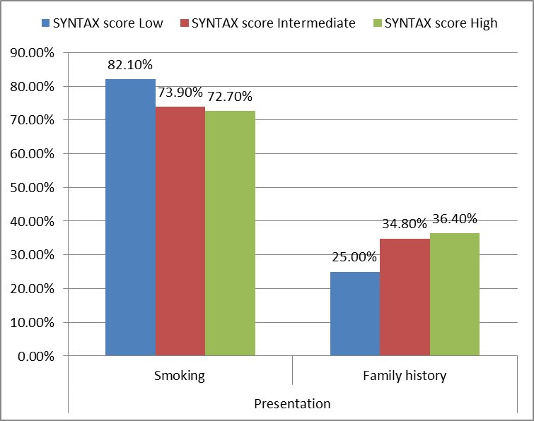
Fig. (7): Bar chart between SYNTAX score and risk factors.

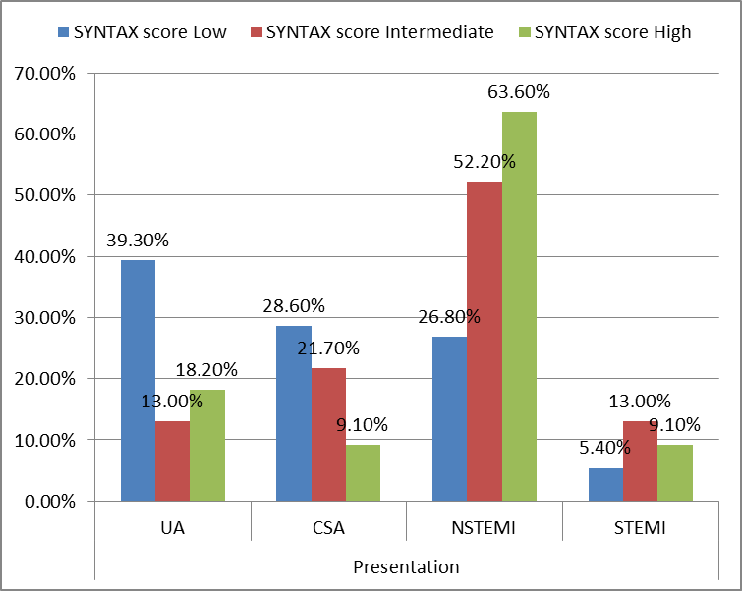
Fig. (8): Pie chart between SYNTAX score and presentation.

C) Comparison between the three groups regarding to presentation:

Table (9): Comparison between SYNTAX score groups and presentation.
Presentation | SYNTAX score |  |  | LSD*
 | Low | Intermediate | High | 1 vs. 2 | 1 vs. 3 | 2 vs. 3
UA | 22 (39.3%) | 3 (13.0%) | 2 (18.2%) | 0.043 | 0.088 | 0.781
CSA | 16 (28.6%) | 5 (21.7%) | 1 (9.1%)
NSTEMI | 15 (26.8%) | 12 (52.2%) | 7 (63.6%)
STEMI | 3 (5.4%) | 3 (13.0%) | 1 (9.1%)
Total | 56 (100%) | 23 (100%) | 11 (100%)
Chi-square test; * LSD: Least significant difference 1: Low; 2: Intermediate; 3: High
p-value<0.05 S; p-value >0.05 NS

This table shows statistically significant difference between low in intermediate according to presentation.

D) Comparison between the three groups regarding to grades of diastolic dysfunction:

Table (10): Relation between SYNTAX score and diastolic dysfunction grade.
Diastolic Dysfunction Grade | SYNTAX score |  |  | LSD*
 | Low | Intermediate | High | 1 vs. 2 | 1 vs. 3 | 2 vs. 3
Grade I | 35 (62.5%) | 10 (43.5%) | 3 (27.3%) | 0.244 | 0.042 | 0.572
Grade II | 15 (26.8%) | 8 (34.8%) | 4 (36.4%)
Grade III | 6 (10.7%) | 5 (21.7%) | 4 (36.4%)
Total | 56 (100%) | 23 (100%) | 11 (100%)
Chi-square test; * LSD: Least significant difference
1: Low; 2: Intermediate; 3: High p-value<0.05 S; p-value >0.05 NS

This table shows statistically significant difference between low syntax group and high syntax group according to diastolic dysfunction grade.

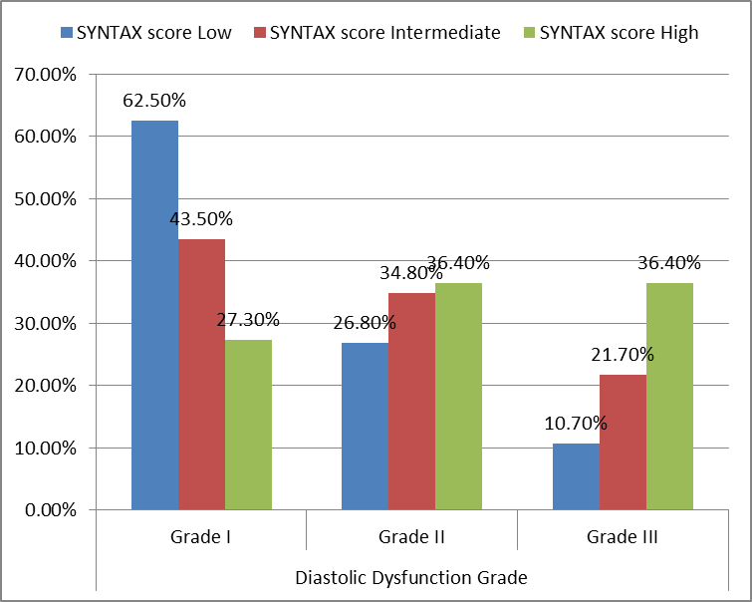
Fig. (9): Bar chart between SYNTAX score and diastolic dysfunction grade.

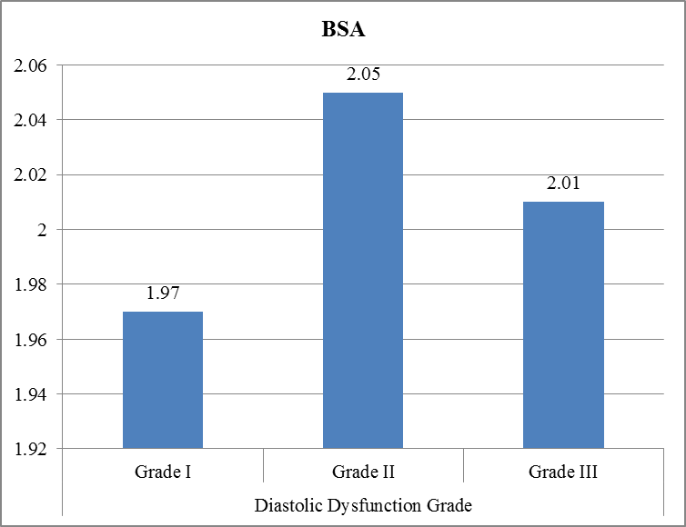
Fig. (10): Bar chart between grades of diastolic dysfuction and BSA.

E)Comparison between the three groups regarding to echocardiographic parameters:

Table (11): Comparison between SYNTAX score and echocardiographic parameters.
Echocardiographic parameters | SYNTAX score |  |  | LSD†*
 | Low | Intermediate | High | 1 vs. 2 | 1 vs. 3 | 2 vs. 3
LVEDD | 5.85±5.88 | 5.06±0.29 | 5.18±0.19 | 0.493 | 0.662 | 0.944
LVESD | 3.27±0.33 | 3.39±0.28 | 3.39±0.35 | 0.164 | 0.293 | 0.998
IVSD | 0.95±0.11 | 0.92±0.11 | 0.95±0.07 | 0.325 | 0.914 | 0.569
EF | 56.75±6.01 | 52.83±7.25 | 50.45±6.47 | 0.015 | 0.004 | 0.315
Aortic root | 3.01±0.35 | 2.87±0.33 | 2.95±0.29 | 0.112 | 0.596 | 0.546
LAD | 3.71±0.61 | 3.77±0.56 | 4.06±0.66 | 0.671 | 0.038 | 0.191
LAV | 36.05±8.75 | 36.65±7.35 | 39.64±8.23 | 0.773 | 0.197 | 0.333
E | 68.93±16.93 | 77.39±23.70 | 82.36±15.49 | 0.072 | 0.032 | 0.471
A | 81.63±21.13 | 79.74±20.46 | 69.64±21.60 | 0.718 | 0.087 | 0.193
E/A | 0.92±0.45 | 1.09±0.59 | 1.34±0.62 | 0.195 | 0.016 | 0.187
DT | 201.73±42.32 | 192.74±38.33 | 183.18±41.71 | 0.381 | 0.046 | 0.529
E | 6.80±1.60 | 6.14±1.44 | 6.03±1.29 | 0.082 | 0.126 | 0.842
A | 8.47±2.17 | 7.94±2.37 | 7.93±2.39 | 0.346 | 0.465 | 0.984
E/e | 10.59±4.91 | 13.38±6.44 | 14.04±4.27 | 0.036 | 0.050 | 0.734
† ANOVA test; * LSD: Least significant difference
1: Low; 2: Intermediate; 3: High
p-value<0.05 S; p-value >0.05Ns

This table shows statistically significant difference between SYNTAX score and EF, LAD, E, E/A, DT and E/e.

F) Comparison between the grades of diastolic dysfuction regarding to demographic data:

Table (12): Comparison between diastolic dysfunction and demographic data.
Demographic data | Diastolic Dysfunction Grade |  |  | LSD†*
 | Grade I | Grade II | Grade III | I vs. II | I vs. III | II vs. III
Sex‡
Male | 37(77.1%) | 20(74.1%) | 8(53.3%) | 0.991 | 0.147 | 0.554
Female | 11(22.9%) | 7(25.9%) | 7(46.7%)
Age (years) | 49.67±7.36 | 47.74±7.41 | 50.87±4.81 | 0.258 | 0.565 | 0.171
BSA | 1.97±0.11 | 2.05±0.12 | 2.01±0.12 | 0.003 | 0.249 | 0.241
Weight (kg) | 82.19±11.10 | 90.59±13.13 | 95.53±3.60 | 0.002 | <0.001 | 0.165
Height (cm) | 172.02±10.05 | 169.33±7.47 | 165.53±12.64 | 0.260 | 0.029 | 0.234
BMI [wt/(ht)2] | 28.35±7.03 | 32.09±7.33 | 35.44±5.62 | 0.027 | <0.001 | 0.136
† ANOVA test; ‡ Chi-square test * LSD: Least significant difference p-value<0.05 S; p-value <0.001 HS; p-value >0.05 NS

This table shows statistically significant difference between Grade I and Grade II according BSA.
Also, significant between Grade I and other grade II according to BMI [wt/(ht)2].

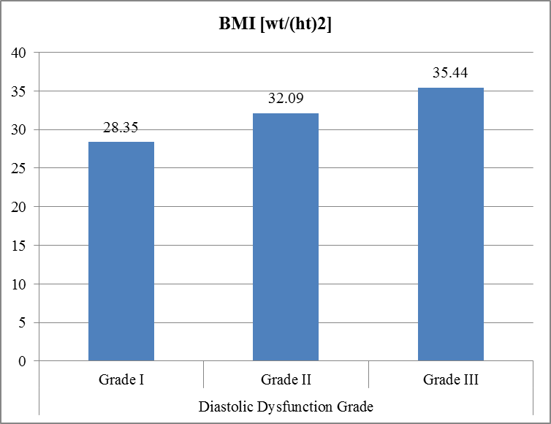
Fig. (11): Bar chart between diastolic dysfuction and BMI.
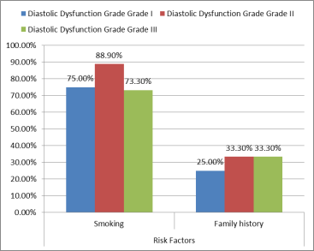
Fig. (12): comparison between diastolic dysfunction grade and risk factors.

F) Comparison between the grades of diastolic dysfuction regarding to risk factors:

Table (13): comparison between diastolic dysfunction grade and risk factors.
Risk Factors | Diastolic Dysfunction Grade |  |  | LSD*
 | Grade I | Grade II | Grade III | I vs. II | I vs. III | II vs. III
Smoking
Yes | 36(75.0%) | 24(88.9%) | 11(73.3%) | 0.253 | 0.833 | 0.388
No | 12(25.0%) | 3(11.1%) | 4(26.7%)
Family history
Yes | 12(25.0%) | 9(33.3%) | 5(33.3%) | 0.615 | 0.763 | 0.732
No | 36(75.0%) | 18(66.7%) | 10(66.7%)
Chi-square test; * LSD: Least significant difference
p-value>0.05 NS

This table shows no statistically significant difference between diastolic dysfunction grades according risk factors.

F) Comparison between the grades of diastolic dysfuction regarding to presentation:

Table (14): comparison between diastolic dysfunction grade and presentation.
Presentation | Diastolic Dysfunction Grade |  |  | LSD*
 | Grade I | Grade II | Grade III | I vs. II | I vs. III | II vs. III
UA | 22(45.8%) | 5(18.5%) | 0(0.0%) | <0.001 | <0.001 | 0.055
CSA | 17(35.4%) | 4(14.8%) | 1(6.7%)
NSTEMI | 7(14.6%) | 17(63.0%) | 10(66.7%)
STEMI | 2(4.2%) | 1(3.7%) | 4(26.7%)
Total | 48(100.0%) | 27(100.0%) | 15(100.0%)
Chi-square test; * LSD: Least significant difference
p-value<0.001 HS; p-value >0.05 NS

This table shows statistically significant difference between grade I and other grade according presentations.

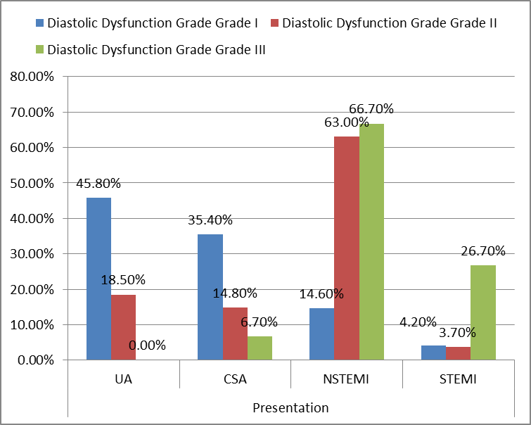
Fig. (13): Bar chart between diastolic dysfunction grade and presentation

Correlation between SYNTAX score and other parameters:

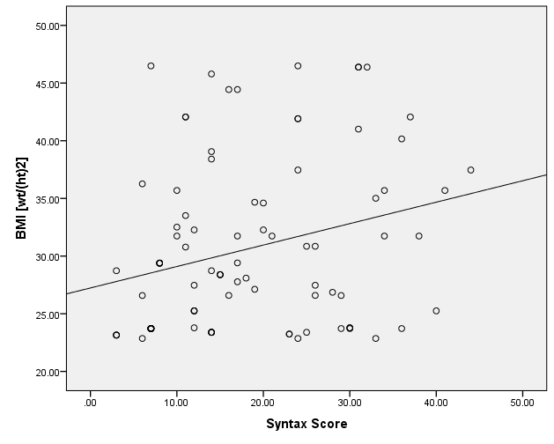
Fig. (14): Positive correlation and significant between SYNTAX score and BMI.

Table (15): Correlation between SYNTAX score and other parameters, using Pearson Correlation Coefficient of the study group.
Parameters | Syntax Score
 | R | p-value
Age (years) | 0.054 | 0.616
Weight (kg) | 0.251 | 0.017
Height (cm) | -0.221 | 0.036
BMI [wt/(ht)2] | 0.265 | 0.012
BSA | 0.116 | 0.277
LVEDD | -0.039 | 0.719
LVESD | 0.274 | 0.009
IVSD | -0.053 | 0.617
EF | -0.449 | <0.001
Aortic root | -0.176 | 0.097
LAD | 0.221 | 0.036
LAV | 0.259 | 0.014
E | 0.312 | 0.003
A | -0.121 | 0.254
E/A | 0.283 | 0.007
DT | -0.234 | 0.027
E | -0.291 | 0.005
A | -0.099 | 0.355
E/e | 0.347 | <0.001
Diastolic Dysfunction Grade | 0.352 | <0.001
r- Pearson Correlation Coefficient
p-value<0.05 S; p-value <0.001 HS; p-value >0.05 NS

Positive correlation and significant between SYNTAX score with BMI, LVISD, EF, LAD, LAV, E, E/A, DT, e, E/e and diastolic dysfunction grade.

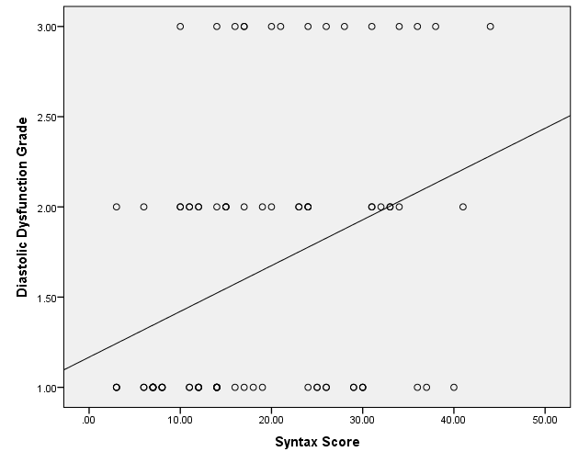
Fig. (15): Positive correlation and significant between SYNTAX score and diastolic dysfunction grade.

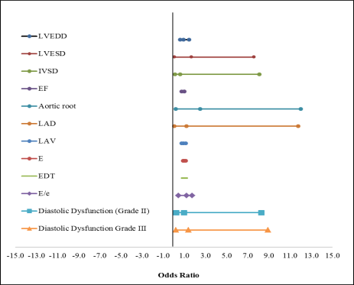
Fig. (16): Odds ratio diastolic dysfunction grade and its impact on the SYNTAX score.

Table (16): Logistic regression of factors affecting Syntax score.
 | B | Exp(B) | 95% C.I.for EXP(B) |  | Sig.
 |  |  | Lower | Upper
LVEDD | -0.065 | 0.937 | 0.611 | 1.438 | 0.767
LVESD | 0.512 | 1.668 | 0.041 | 7.570 | 0.786
IVSD | -0.509 | 0.601 | 0.128 | 8.082 | 0.921
EF | -0.140 | 0.994 | 0.748 | 1.010 | 0.037
Aortic root | 0.912 | 2.489 | 0.193 | 12.020 | 0.484
LAD | -0.199 | 1.196 | 0.031 | 11.759 | 0.037
LAV | -0.089 | 0.914 | 0.743 | 1.125 | 0.397
E | 0.008 | 1.008 | 0.902 | 1.127 | 0.886
EDT | 0.005 | 1.005 | 0.972 | 1.040 | 0.765
E/e | -0.323 | 1.724 | 0.437 | 1.199 | 0.021
Diastolic Dysfunction Grade |  | 1
Grade II | -1.979 | 0.953 | 0.232 | 8.270 | 0.048
Grade III | -3.021 | 1.381 | 0.198 | 8.887 | 0.013

This tables shows that EF, LAD, E/e and diastolic dysfunction grade have a significant effect on the SYNTAX score.

4. Discussion:
The prevalence of coronary artery disease (CAD) continues to rise worldwide associated with increasing patient morbidity and mortality.
In the early phase of ischemic heart disease (IHD), diastolic dysfunction can be detected non-invasively by TTE prior to the development of overt systolic dysfunction.
In a patient population with stable angina and ACS, these unique echocardiographic parameters may provide prognostic information regarding CAD burden prior to the performance of an invasive cardiac catheterization.
Our study demonstrated that patients with high CAD burden based on SYNTAX Score have lower EF as compared with patients with low syntax score(p-value = 0.004) & patients with intermediate SYNTAX Score have lower EF as compared with patients with low syntax score (p-value = 0.015). Also there was significant negative correlation between SYNTAX score and EF (p-value = 0.001) and positive correlation between SYNTAX score and LVESD (p-value = 0.009).
Similarly, a study by Liu et al. examined systolic and diastolic echocardiographic parameters in patients with stable angina and ACS. The study demonstrated that patients with higher SYNTX score have lower EF as compared to low/intermediate Syntax score (Liu et al., 2015).
The E/A ratio is a traditional marker of diastolic function obtained using pulsed-wave Doppler across the mitral valve in the apical four chamber view on TTE.¹²
In healthy, young, disease-free individuals, the mitral E-wave velocity exceeds the A-wave resulting in an E/A ratio of greater than one. However, as the LV wall becomes stiffer, this results in impaired relaxation, with an E/A ratio closer to 0.5 reﬂecting mild diastolic dysfunction. Finally, with progressive diastolic dysfunction in a pathologically stiff ventricle and increased volume overload, a pseudonormal and restrictive pattern develop.
Previous studies evaluating diastolic abnormalities in ambulatory patients with known stable CAD have found conﬂicting results with respect to the E/A ratio. In a population with stable angina, Mishra et al. found that although patients with a restrictive ﬁlling pattern had an increased risk of hospitalization for heart failure (HR 2.54, 95% CI 1.52–4.24, P < 0.001), other major adverse cardiovascular events including cardiovascular death, nonfatal myocardial infarction, and/or cerebrovascular disease remained unchanged (Mishra et al., 2011).
Bruch et al. examined the E/A ratio in a patient population with single vessel CAD in the setting of preserved LVEF. They demonstrated that the E/A ratio was signiﬁcantly lower in patients with CAD, mainly due to lower E-wave velocities.¹⁴
Hoffmann et al. evaluated diastolic function including TDI prior to coronary angiography in patients with suspected angina pectoris without any cardiac history and preserved LVEF. They found that the E/A ratio was not signiﬁcantly different in patients with CAD as compared to age-matched controls.¹⁸
Liu et al. had shown that in a mixed patient population of ACS and stable CAD, a higher E/A ratio was predictive of higher CAD burden based on the SYNTAX score after multivariate analysis. The inclusion of a higher proportion of patients with ACS, including nearly 75% patients with a NSTEMI, may account for our notable ﬁnding of the prognostic use of the E/A ratio as a noninvasive marker of high-risk CAD burden.²⁴
In our study, we have shown that patients with high SYNTAX score have significant increase in E/A ratio compared to patients with low SYNTAX score(P = 0.016). Also there was positive correlation between CAD burden based on SYNTAX score and E/A ratio (P = 0.007).
In addition to the E/A ratio, DT serves as another conventional measurement of diastolic dysfunction. DT is an age-dependent variable with normal values ranging from 142 ± 19 milli-seconds (ms) for 16- to 20-year-olds to 200 ± 29 ms for individuals > 60 years of age.¹²
Although the DT increases to greater than 200 ms in the setting of mild diastolic dysfunction, it normalizes and then decreases with increasing severity of diastolic dysfunction.
In the study described above, Hoffmann et al. demonstrated that in 82 patients (mean age 66 ± 8 years) with suspected angina pectoris and preserved LVEF, DT was not signiﬁcantly different as compared to the control population (mean age 65 ± 9 years).¹⁸
Although the study examined a mixed population with one, two and three vessel disease patients, they did not differentiate whether DT changed with increased burden of CAD.
On the contrary, a study by Sakata et al. examined diastolic functional parameters in the setting of an acute ACS. The study demonstrated that the DT was shorter in non-survivors after acute MI (111 ± 48 ms) compared to survivors with congestive heart failure (CHF) after an acute MI (119 ± 38 ms) as well as survivors without CHF (149 ± 44 ms).¹⁶
Similar to the study by Sakata et al., Liu et al. study of both stable CAD and patients with ACS, they found that DT decreased in patients with higher burden of CAD. After multivariate analysis, DT was predictive of a higher SYNTAX score (P = 0.001).²⁴
In our study, we found there was negative correlation between CAD burden based on SYNTAX score and DT (P = 0.027). Also there was significant difference between patient with low SYNTAX and patients with high SYNTAX score compared to DT (P = 0.046).
Conventional diastolic functional parameters including the E/A ratio and DT may serve as important non-invasive echocardiographic markers of high CAD.

Conclusion:
Early identiﬁcation of high-grade ischemia based on echocardiographic diastolic abnormalities may be of important clinical signiﬁcance for pre- dicting CAD burden prior to invasive angiography.

References:
  - World Health Organization: The Atlas of Heart Disease and Stroke. 2014. Available at http://www.who.int/cardiovascular_diseases/resources/atlas/en/. (accessed June 10, 2016).
  - Go AS, Mozaffarian D, Roger VL, et al: Heart disease and stroke statistics – 2014 update: a Report From the American Heart Association. Circulation 2014;129: e28–e292.
  - Scanlon PJ, Faxon DP, Audet AM, et al: ACC/AHA guidelines for coronary angiography: executive summary and recommendations: a report of the American College of Cardiology/American Heart Association task force on practice guidelines (committee on coronary angiography) developed in collaboration with the Society for Cardiac Angiography and Interventions. Circulation 1999;99:2345–2357.
  - Noto TJ Jr, Johnson LW, Krone R, et al: Cardiac catheterization 1990: a report of the Registry of the Society for Cardiac Angiography and Interventions (SCA&I). Cathet Cardiovasc Diagn 1991;24:75–83.
  - Anderson HV, Shaw RE, Brindis RG, et al: A contemporary overview of percutaneous coronary interventions. The American college of cardiology – National cardiovascular data registry (ACC-NCDR). J Am CollCardiol 2002;39:1096–1103.
  - Tommaso CL: Contrast-induced nephrotoxicity in patients undergoing cardiac catheterization. Cathet Cardiovasc Diagn 1994;31:316–321.
  - Sianos G, Morel MA, Kappetein AP, et al: The SYNTAX Score: an angiographic tool grading the complexity of coronary artery disease. Euro Intervention 2005;1:219– 227.
  - Serruys PW, Onuma Y, Garg S, et al: Assessment of the SYNTAX score in the Syntax study. Euro Intervention 2009;5:50–56.
  - Brito J, Teles R, Almeida M, et al: Predictive value of SYNTAX score in risk stratification of patients undergoing unprotected left main coronary artery angioplasty. J Invasive Cardiol 2011;23:494–499.
  - He JQ, Gao YC, Yu XP, et al: Syntax score predicts clinical outcome in patients with three-vessel coronary artery disease undergoing percutaneous coronary intervention. Chin Med J (Engl) 2011; 124:704–709.
  - Nesto RW, Kowalchuk GJ: The ischemic cascade: temporal sequence of hemodynamic, electrographic and symptomatic expressions of ischemia. Am J Cardiol 1987; 59:23C–30C.
  - Nagueh SF, Appleton CP, Gillebert TC, et al: Recommendations for the evaluation of left ventricular diastolic function by echocardiography. J Am SocEchocardiogr 2009;22:107–133.
  - Mishra RK, Devereux RB, Cohen BE, et al: Prediction of heart failure and adverse cardiovascular events in outpatients with coronary artery disease using mitral E/A ratio in conjunction with E-wave deceleration time: the heart and soul study. J Am Soc Echocardiogr 2011;24:1134– 1140.
  - Bruch C, Schmermund A, Bartel T, et al: Tissue Doppler imaging (TDI) for on-line detection of regional early diastolic ventricular asynchrony in patients with coronary artery disease. Int J Card Imaging 1999;15:379–390.
  - Hoffmann S, Møgelvang R, Olsen NT, et al: Tissue Doppler echocardiography reveals distinct patterns of impaired myocardial velocities in different degrees of coronary artery disease. Eur J of Echocardiogr 2010;11:544–549.
  - Sakata K, Kashiro S, Hirata S, et al: Prognostic value of Doppler transmitral flow velocity patterns in acute myocardial infarction. Am J Cardiol 1997;79:1165–1169.
  - Bolognesi R, Tsialtas D, Barilli AL, et al: Detection of early abnormalities of left ventricular function by hemodynamic, echo-Tissue Doppler imaging, and mitral Doppler flow techniques in patients with coronary artery disease and normal EF. J Am Soc Echocardiogr 2001;14:764–772.
  - Hoffmann S, Jensen JS, Iversen AZ, et al: Tissue Doppler echocardiography improves the diagnosis of coartery stenosis in stable angina pectoris. Eur Heart J Cardiovasc Imaging 2012;13:724–729.
  - Biering-Sørensen T, Jensen JS, Pedersen S, et al: Doppler Tissue Imaging is an independent predictor of outcome in patients with ST-segment elevation myocardial infarction treated with primary percutaneous coronary intervention. J Am Soc Echocardiogr 2014; 27:258–267.
  - Andersson C, Gislason GH, Møgelvang R, et al: Importance and inter-relationship of tissue Doppler variables for predicting adverse outcomes in high-risk patients: an analysis of 388 diabetic patients referred for coronary angiography. Eur Heart J Cardiovasc Imaging 2012;13:643–649.
  - Snopek G, Drewniak W, Borys M, et al: Prognostic value of tissue Doppler echocardiographic imaging in elderly patients with acute myocardial infarction. Echocardiography 2011;28:298–302.
  - SYNTAX Score Working Group. Syntax Score Online Calculator, http://www.syntaxscore.com/calc/syntaxscore/ frameset.htm. Accessed November 14, 2016.
  - Serruys PW, Morice MC, Kappetein AP, et al: Percutaneous coronary intervention versus coronary-artery bypass grafting for severe coronary artery disease. N Engl J Med 2009;360:961–967. ronary.
  - Shuangbo Liu, Motaz Moussa, Anthony W. Wassef, Brett M. Hiebert, Farrukh Hussain, and Davinder S. Jassal, The Utility of Systolic and Diastolic Echocardiographic Parameters for Predicting Coronary Artery Disease Burden as Deﬁned by the SYNTAX Score. (Echocardiography 2015; 00:1–9).

12/26/2016

