Development of a Digester for producing Biogas from Domestic Wastes

Osunade. J. A.; Ogunjimi, L. A. O.; and *Olanrewaju, B. A.,

Department of Agricultural and Environmental Engineering, Faculty of Technology, Obafemi Awolowo University, Ile-Ife, Osun State, Nigeria
t_olanrewaju@yahoo.com

Abstract: Human activities generates waste both at subsistence, commercial and industrial level; some of these wastes poses threat to the air, land and water bodies necessary for normal life. The main objective of this study was to develop a floating drum biodigester for biogas generation from organic wastes. The biodigester was constructed using locally available materials like plastic Keg and drum, gas hose, Gas valve, Gas pressure gauge, Tee gas connector, Gas needle nut, PVC tube pipe, PVC elbow pipe, back nut, nipple and reducer, PVC gum, Flexi tape. Ruler, funnel, oven dryer, digital vernier caliper, digital K type thermometer, digital weighing balance, hygrometer and pan were used for evaluating the digester. Wastes used for evaluation include spinach sticks (S), plantain peel (P) and poultry manure (PM); they were also mixed in equal proportion; parameters evaluated for include moisture content, carbon and nitrogen content. Data collected was subjected to analysis of variance (ANOVA) test to determine the effects of the digester temperature, ambient temperature and pH on biogas generated of the various levels of treatments. Duncan’s multiple range tests was used to establish the differences among treatments using Statistical Analysis System software. The quantity of gas produced from S, P and PM vary tremendously in volume. The mix of S+ P + PM had the highest gas production of 613.2cm³ as against those from S + P and P + PM with 437.71cm³ and 292.14cm³ respectively at early digestion of 14 days; while P+PM had the highest gas production of 254.76cm³ as against those of S + P and S +P+PM with 58.33cm³ and 40.37cm³ respectively at 28 days. The gas production on the 56th day stands at 150.39cm³ and 96.96cm³ for S +P+PM and S+P, respectively, with P+PM having the least production after the 28th day. The biodigester is safe to operate, versatile in operation and can operate as batch or continuos flow process. About 80-90% of the gas was produced within 30-35 days.
[Osunade. J. A.; Ogunjimi, L. A. O. and Olanrewaju, B. A. Development of a Digester for producing Biogas from Domestic Wastes. N Y Sci J 2016;9(12):56-61]. ISSN 1554-0200 (print); ISSN 2375-723X (online). http://www.sciencepub.net/newyork. 9. doi:10.7537/marsnys091216.09.

Keywords: Biodigester, spinach sticks, plantain peel, poultry manure, biogas

1. Introduction
Energy plays a vital role in our day-to-day activities either in domestic or industrial applications. The current use of fossil fuels is rapidly depleting the natural reserves. The natural formation of coal and oil however is a very slow process which takes ages. The dependence on oil has necessitated a search for alternative and renewable sources of energy, such as hydro-power, wind and solar energy and biogas. Biogas unit is the use of biological process, in the absence of oxygen, for the breakdown of organic matter into biogas and high quality fertilizer. Biogas as an alternative source of energy is renewable and considered one of the cheapest renewable energies in rural areas in developing countries. It is a combustible mixture of methane, carbondioxide and traces of water, hydrogen sulfide and halogens. And the process eliminates disease-causing organisms that cause disease in humans and animals. Any organic matter with the exception of mineral oil can be used as feedstock for anaerobic digestion to produce biogas (Ilori et al., 2007). In many countries various cellulosic biomass (animals dung and crop residues) are available in large quantity which have a very good potential to cater to the energy demand and fertilizer, especially in the domestic applications. But, the high installation and maintenance costs (Moutik and Srinivasta 1975; Sathianathan 1975; Moutik, 1982), lack of technical base for maintenance and repair (Roy, 1981) and organizational difficulties (Fulford, 1988) has hindered its wide spread. However, in recent years a low-cost digester, made from polyethylene tubular film, has been promoted and used in many developing countries aimed at reducing the cost of making a digester by using local materials, simplifying installation, operation and maintenance (Preston 1995; Chater 1986; Botero and Preston 1987; Hieu et al 1994; Sarwatt 1995; Soeurn 1994; Solarte 1995; Khan 1996).
Since ancient times, biogas is produced by the decay of vegetable and animal waste, and was early identified as a combustible “swamp gas” (Ronald et al., 1982, Bailey and Ollis, 1977). The highly desirable fuel was obtained by fermentation of sewage as early as 1934 and was used for heating and initial combustion engine for pumping according to White et al., 1981. Attention is currently focused on biogas generation from organic waste i.e. animal manure and plant residues. Several large demonstration plants are functioning well and many small units are in daily use (Malcolm and Chris, 1979). Presently, countries like China, India, Germany, Sweden, UK, Nepal, Pakistan, Switzerland etc have actualized this idea and doing well. As at 2005, more than 17 million family-sized low-technology digesters were used in China (Persson et al., 2006) to provide biogas for cooking and lighting and well over 15 millions in India. Germany at as 2006 had about 3 500 biogas plants. The use of biogas as vehicle fuel in Sweden started way back in the 1990s and has since led the world in biogas use for buses and other vehicles by 1996. More than 2000 high-rate anaerobic digesters are operated world-wide to treat organic polluted process waste water from beverage, food, meat, pulp and paper and milk industries (Persson et al., 2006). In Africa, there are hundreds of biogas digesters installed already in countries like South Africa, Kenya, Tanzania, Rwandan, and Nigeria among others. Nigeria produces about 227,500 tons of fresh animal waste daily and since 1 kg of fresh animal waste produces about 0.03 m³ biogas, a potential of about 6.8 million m³ of biogas everyday from animal waste only is possible (Anthony and Wilson, 2009). Also other raw materials available in Nigeria have been critically assessed for their possible use in biogas production by Odeyemi, 1983. Vegetables and plantain constitute a major food crops in Nigeria and as a result, large amount of wastes are generated from the uneaten parts (sticks and peels). Biogas plants have huge potential to manage, produce a clean fuel and manure from these wastes.
Human activities results in waste, either at subsistence level (household) or commercial level such as industries, agriculture, hotels, institutions, this has become a global problem that requires urgent solution. Wastes are now seen as a means of solving social and economic problems. This work was aimed at reducing and eliminating the menace and nuisance of these wastes by producing an alternative energy source (cooking gas) which will help in reducing environmental pollution produce high grade fertilizer for crop production. Thus, the main objective of this study was to develop a floating drum biodigester for biogas generation from organic wastes.

2. Material and Methods
Materials: Materials used for this study were locally acquired, they include: spinach sticks and plantain waste peels; poultry manure; 10 and 4 liters plastic Kegs, 100 and 70 liters plastic drum, 5mm gas hose, Gas valve, Gas pressure gauge, Tee gas connector, Gas needle nut, PVC tube pipe, PVC elbow pipe, back nut, nipple and reducer, PVC gum, Flexi tape, Ruler, Funnel, oven dryer, Digital vernier caliper, Digital K type thermometer, Digital weighing balance, Hygrometer, Pan
Inoculum: The poultry manure acts as the inoculums seed because of its bacteria content which is needed in anaerobic digestion process. This was analyzed, mixed with each crop residue and diluted with calculated clean water to turn it to pastry and make it easy to mix faster with the substrate.
Preparation of the substrate: Substrates used included: Plantain peel waste, Spinach stick waste and a mix ratio of 50-50 of both wastes. Each waste was weighed accordingly and divided into 3 parts making a triplicate sample of each substrate at 3 levels making it 27 samples (3 x 3 x 3). These substrates were then cut into 2-3cm to increase its surface area and mixed with clean water.
Moisture Content Determination: The moisture content of the wastes was determined using oven drying method. The samples collected were weighed and dried in oven at 105⁰C for 24 hours. Dried samples were allowed to cool in desiccators and weighed using digital weighing balance. Difference in weight to the intial weight was recorded as the moisture content of the samples.
Carbon and Nitrogen Content Determination: initial carbon concentration of the samples were determined using ash method for determining for crop residues (Eqn 1 and 2) and chronic acid method for the poultry manure while initial nitrogen content was determined using the Kjeldahl laboratory method (Sosulki et al., 1976).
The carbon content was estimated using the equation.
$Carbon \left(\%\right)\frac{100-ash\left(\%\right)}{1.8}$ (1)
$Ash \left(\%\right)\frac{Wr}{Wb}$ (2)
Where: Wr is the weight of residue (g) and Wb is the weight before burning.
Anaerobic Digestion Process: batch digestion process was used, known quantities of the crop residues and poultry manure were measured into a mixing tank and the known quantity of the water was added. Mixture was thoroughly mixed using a stirrer (stick) and substrates were fed into the biogas digester and agitated manually at interval every day. The gas produced by the substrate inside the digester was channeled to the gas collector chamber which was filled with water. And the weight of channeled gas produced was equivalent to the amount water displaced in the gas collector chamber. The displaced water was collected in the water collector chamber. The volume of water displaced equal the volume of gas produced. The water displaced was weighed and recorded daily. The digesters were incorporated with thermometers to monitor the daily temperature of the system. The pH of samples was monitored weekly for 60 days duration. The external temperature and humidity of the digesters were monitored and recorded daily using a hygrometer. The data were analyzed using descriptive and inferential statistics to determine the rate of production and the substrate that produced most.
Construction of a Mini Biodigester: factors considered include: economics, simplicity, optimum usage of waste and water, utilization of local materials, ease of maintenance, maintenance of temperature, operational cleanliness, durability and safety, user friendliness and versatility. The major components parts of the digester include: digester unit/fermentation unit and the gas holder.
Anaerobic digestion takes place in the digester unit is where the anaerobic digestion process takes place. 100 litres cylindrical plastic drum was cut open at the top of one side of the drum while inlet and outlet pipes were properly fixed (Plate 1).

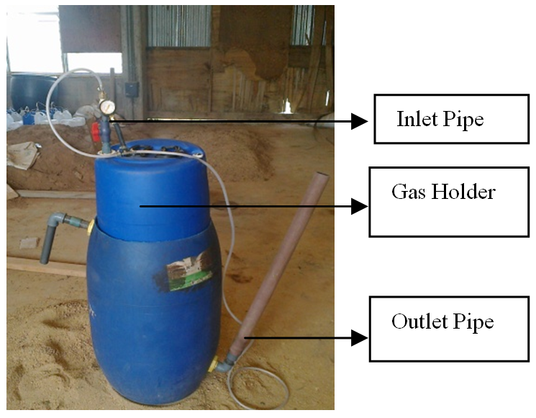
Plate 1: Constructed Bio-digester

Statistical Analysis: The data collected was subjected to a one – way analysis of variance (ANOVA) to determine the effects of the digester temperature, ambient temperature and pH on biogas generated of the various levels of treatments. Where significance was indicated, Duncan’s multiple range tests was used to establish the differences among treatments. The statistical analysis was performed using the Statistical Analysis System (SAS, 2002) software.

3. Results and Discussion
Effect of waste materials and total solid on gas production: quantity of gas produced from spinach stalk (S), plantain peel (P) and poultry manure (PM) vary tremendously in volume. The mix of spinach stalk + plantain peel + poultry manure (S+P+PM) had the highest gas production of 613.2cm³ as against those from spinach stalk + poultry (S+P) and plantain peel + poultry manure (P+PM) with 437.71cm³ and 292.14cm³, respectively at early digestion of 14th day; while P+PM had the highest gas production of 254.76cm³ as against those of S+P and S+P+PM with 58.33cm³ and 40.37cm³ respectively at 28th day. The gas production on the 56th day stands at 150.39cm³ and 96.96cm³ for S+P+PM and S+P, respectively, with P+PM having the least production after the 28th day. The effect of total solid on the quantity of gas produced from each waste combination is presented in Figures 1-3.

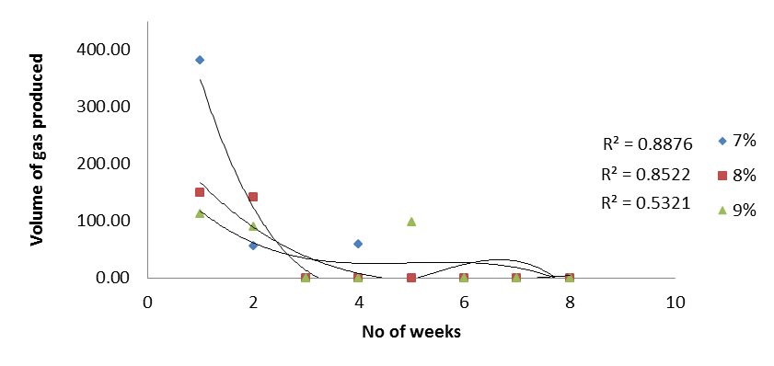
Figure 1: Volume of gas produced from Spinach Peel (S)

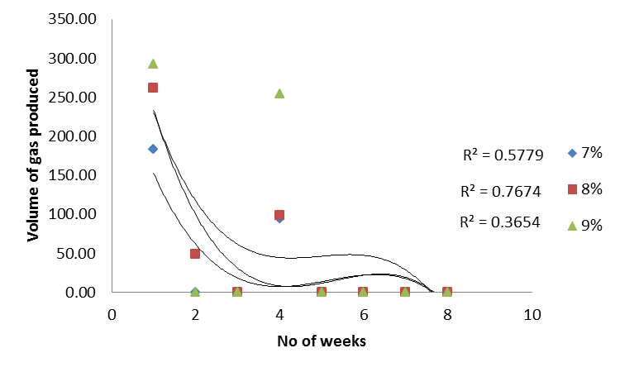
Figure 2: Volume of gas produced from Plantain Peel (P)

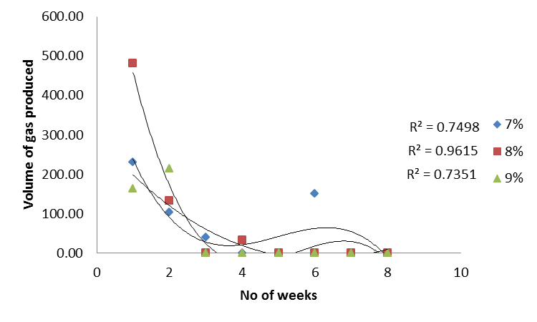
Figure 3: Volume of gas produced from Spinach + Plantain Peel (S+P)

Table 1: Mean effect of material types on Gas production
Week | Materials | Gas production (cm³)
2 | SPP | 225.67ª
 | SP | 154.80^{b}
 | PP | 130.83^{c}
4 | PP | 74.70ª
 | SPP | 12.17^{b*}
 | SP | 9.72^{b}
8 | SPP | 12.53ª
 | SP | 8.08^{b}
 | PP | 0.00^{c}
* Value with similar letter is not significantly different

Effect of waste materials on temperature of the bio-digester: temperature of the waste materials in the bio-digester increases from the second week and reaches the highest at the fourth week before fluctuations at the eight week; the temperature profile of spinach peel, plantain peel and the combination of both wastes at different solid ratio is presented in Figures 4 - 6.

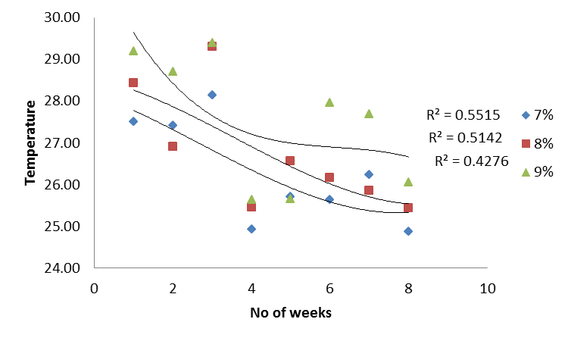
Figure 4: Temperature Profile of Spinach Waste in the Bio-digester

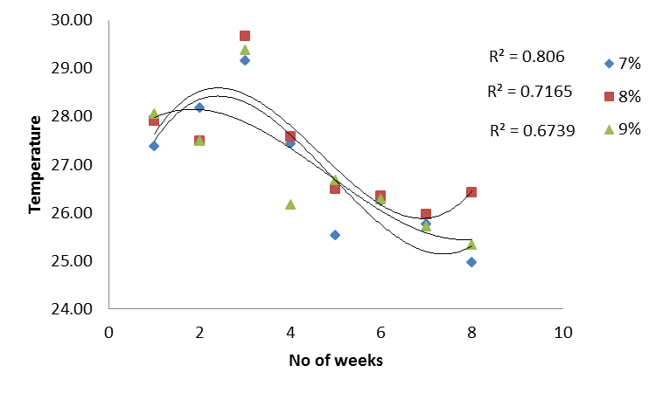
Figure 5: Temperature Profile of Plantain Peel in the Bio-digester

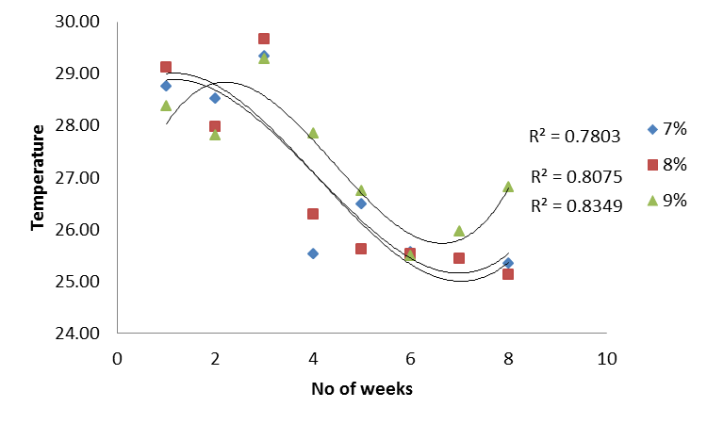
Figure 6: Temperature Profile of Spinach + Plantain Peel in the Bio-digester

Table 2: Mean effect of waste material on temperature
 | Materials | Temperature (ºC)
WK2 | S+P+PM | 28.43ª
 | S+PM | 28.03^{b}
 | P+PM | 27.75^{c}
WK4 | P+PM | 28.23ª
 | S+P+PM | 27.99^{b}
 | S+PM | 27.15^{c}
WK8 | S+PM | 26.22^{a*}
 | P+PM | 25.96^{ab}
 | S+P+PM | 25.73^{b}
* Value with similar letter is not significantly different

S+P had the highest temperature value of 29.20ºC at 14th day, then S+P+PM, P+PM with 29.12 and 28.19ºC, respectively. However, at 28th day, P+PM recorded the highest of 29.37 ºC as against those of SPP and SP with 29.33 and 29.31ºC, while the lowest temperature at 56th was S+P with 24.88ºC, P+PM and S+P+PM which has 24.97 and 25.14ºC. Gas production was however increased within the first 4 weeks of digestion as the temperature inside the biodigester increase caused by the material decomposition process, as reported by Kosobucki et al. 2007 on the influence of temperature on the process of dynamic methane fermentation of sewage sludge. The Duncan grouping, Table 2 showed that the effect of S+P, P+PM and S+P+PM materials at 14th, 28th and 56th day are significantly different. The mean values of temperature are; 28.03, 27.75, 28.43, 27.15, 28.23, 27.99 and 26.22, 25.96 and 25.73 ºC respectively. The difference between the mean temperatures at 28th day was the highest with a value of 1.08ºc compared with the difference mean temperature at 14th and 56th day which was 0.68ºc 0.49ºc. The implication of this is that the temperature of the materials increase by the day as digestion takes place before reducing at the level of methane forming stage, as reported by David, 2010.
pH of the Waste Materials as affected by Storage period in the bio-digester: initial pH of all the samples was in the range of 6.1 to 7.3. The result of the ANOVA showed that pH was dependent (P < 0.05) on the waste material type (Figures 7 – 9).

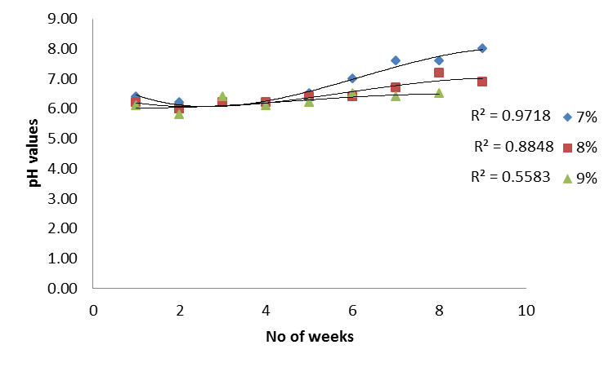
Figure 7: pH Profile of Spinach Peel in the Digester

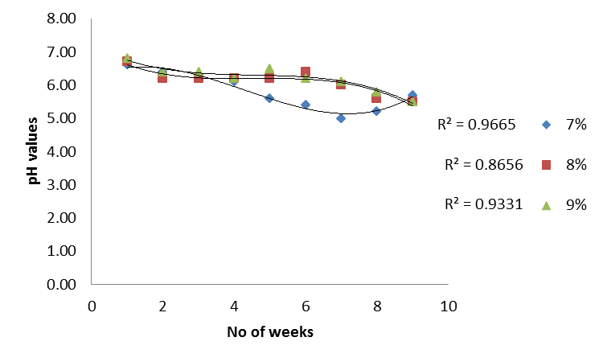
Figure 8: pH Profile of Plantain Peel in the Digester

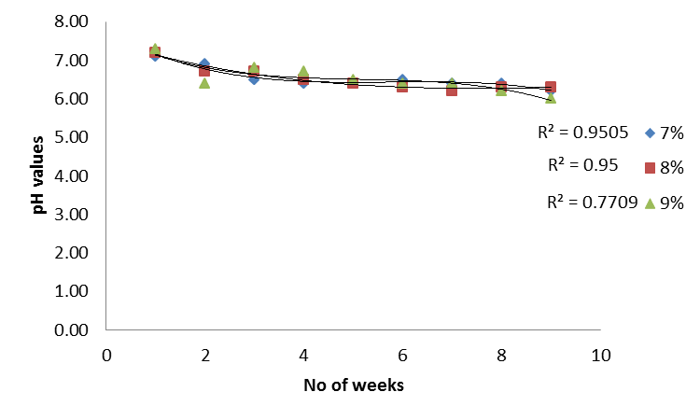
Figure 9: pH Profile of Spinach + Plantain Peel in the Digester

At the second week, the rise in the pH recorded explains the first- second stages of anaerobic digestion; hydrolysis and acidification (FAO/CMS, 1996). Acidification involves the conversion of volatile fatty acids present in the substrate into simpler organic acids including acetic acid, propionic acid, butyric acid and ethanol. This acidic intermediates naturally causes a drop in the hydrogen ion concentration of the slurry in the biodigester which was observed to fall as low as 5.0 after the first two weeks of digestion. The pH slowly began to rise as the acetic acid was converted into biogas.

Table 3: Mean effect of material types on pH
 | Materials | Temperature (ºC)
WK2 | S+P+PM | 6.93ª
 | P+PM | 6.52^{b}
 | S+P | 6.12^{c}
WK4 | S+P+PM | 6.6ª
 | P+PM | 6.22^{b}
 | S+P | 6.20^{b}
WK8 | S+P | 6.84ª
 | S+P+PM | 6.33^{b}
 | P+PM | 5.78^{c}
* Value with similar letter is not significantly different

It was observed that SPP had the highest pH with a mean value of 6.93 while SP had the value of 6.12. The difference in the mean effect of SPP and SP on pH was 0.81; this value is greater than the between SPP and PP, which is 0.41 and that of PP and SP with value of 0.4 at the 14th day. While at 56th day, the SP and SPP had the highest mean pH values of 6.84 and 6.33. The PP had a mean value of 5.78, meaning the material is more acidic than the rest materials. However, the Duncan grouping showed that the degree of significant effect of PP and SP on pH is not different on the 28th day (Table 3). The mean value of pH for SPP, PP and SP are 6.60, 6.22 and 6.20, respectively. The difference between the effect of SPP and SP is the smallest (0.40) compare with PP and SP and PP and SPP which are 0.02 and 0.38, respectively.

4. Conclusion
Experiments were conducted to know the biogas potential from domestic wastes (plantain and spinach peels) and the effect of its effluent on growth and yield of tomato. The highest number of substrate mixtures recorded the highest gas production and methane content. The biodigester is safe to operate, versatile in operation and can operate as batch or continuos flow process. About 80-90% of the gas was produced within 30-35 days.

Acknowledgements:
Authors are grateful to the Department of Agricultural and Environmental Engineering, Faculty of Technology, Obafemi Awolowo University.

Corresponding Author:
Dr. Olanrewaju, B. A
Department of Agricultural and Environmental Engineering,
Obafemi Awolowo University,
Ile Ife, Osun State, Nigeria.
Telephone: +2348178245426
E-mail: t_olanrewaju@yahoo.com

References
- Alvarez, R. and Liden, G. 2008. The effect of temperature variation on biomethanation at high altitude. Biores. Technol., 99: 7278-7284. DOI: 10.1016/j.biortech.2007.12.055.
- Bailey, J.E. and Ollis, D. F. 1977. Biochemical Engineering Fundamentals, McGraw-Hill Kogakushe Ltd., Tokyo, p. 847, 943-946.
- Botero, R. and Preston, T.R. 1987. Biodigester de bajo costo para la production de combustible y fertilizante a partir de excretas. Manuscrito ineditado CIPAV, Cali, Colombia.
- David, H. 2010. The complete biogas handbook, page 26 & 32.
- FAO/CMS. 1996. Biogas technology: “a training manual for extension"
- Fulford, D. 1988. Running a biogas program- A handbook. Intermediate Technology Publications, London.
- Hieu, L.T., Viet, Ly. Le., Ogle, B. and Preston, T. R. 1994. Intensifying livestock and fuel production in Vietnam. Proceedings National Seminar-workshop in sustainable Livestock Production on local feed resources. Agric. Pub. House: Ho Chi Minh, pp 9-16.
- Igoni, A. H., Abowei, M. F. N., Ayotamuno, J. M. and Eze, C. 2007. Effect of total solids concentration of municipal solid waste in anaerobic bath digestion on the biogas produced.
- Ilori, M. O., Sunday, A.A., Lawal, A.K. and Awotiwon, O.A. 2007. Production of biogas from banana and plantain peels, Am.-Eurasian J. Sustain. Agric., 1(1): 33-38.
- Kosobucki, P., Buszewski, B. and Górski, L. 2007. The Influence of Temperature on the Process of Dynamic Methane Fermentation of Sewage Sludge.
- Kossmann, W. and Ponitz, U. 1992. Biogas Digest Volume 1: Biogas Basic Information and Advisory Service on Appropriate Technology (ISAT) pg11-12.
- Malcolm, S. and Chris, L. 1979. Biological resources, London and F.N Span Limited, a Helsted Press Book, John Wiley and Sons, N.Y., p. 20-22, 40-41 and 50-53.
- Moutik, T.k and Srinivasta, U.K. 1975. Biogas plants at village level. Problems and prospects in Gujurat, CMA, IIM, Ahmedabad, India.
- Moutik, T.K. 1982. Biogas energy in India, Academic book center, Ahmedabad, India.
- Odeyemi, O. 1983. Resource assessment for biogas production in Nigeria. Nigerian J. Microbiol. 3: 59-64.
- Preston, T. R. and Rodríguez, L. 1997. Low-cost biodigesters as the epicenter of ecological farming systems. University of Tropical Agriculture Foundation, Cambodia.
- Ronald, F., Drobstein, R. and Edwin, H. 1982. Synthetics fuels, McGraw-Hill, p210-218 and 381-382.
- Roy, R. 1981. Family and community biogas plants in rural India. Appropriate technology, itt publications, London w.8.
- San, T., Preston. T.R. and Ly, J. 2003. Effect of retention time on gas production and fertilizer value of biodigester effluent.
- Sarwatt, S.V., Lekule, F.P. and Preston, T.R., 1995. Biodigesters as means for introducing appropriate technologies to poor farmers in Tanzania. Electronic Proc. 2nd Intl. Conference on Increasing Animal Production with Local Resources, Zhanjiang, China, p.6.
- Sasse, L., Kellner, C. and Kimaro, A. 1991. Improved biogas unit for developing countries. GATE publication, Eschborn.
- Sathianathan, M.A. 1975. Biogas achievements and challenges. Association voluntary agencies for rural development. New Delhi, India.
- Soeurn, T. 1994. Low cost biodigesters in Cambodia. Proc. National Seminar-workshop in sustainable Livestock Prod. on local feed resources. Agric. Pub. House Ho Chi Minh, pp.109-112.
- Solarte, A. 1995. Sustainable livestock systems based on local resources: Electronic Proc. 2nd Intl. Conference on Increasing Animal Production with Local Resources, Zhanjiang, China, p.2.
- UNDP/ESCAP/FAO/CHINA. 1983. Biogas Technology. The Asian-Pacific Regional Biogas Research and Training Centre, Chengdu, China. White, L.P. and Plaskette, L.G. 1981. Biomass as a fuel, Academic Press Inc. London Ltd., London, NW.

12/12/2016

