**Assessment of Prosthetic Mitral Valve by Real-Time 3D Echocardiography**

Mokhtar Gomaa, Mostafa Ismail, Mohammad Al-Deftar, Mohammed Abdelwahab

Department of Cardiology - Faculty of Medicine - Al-Azhar University

[m.abushahba87@gmail.com](mailto:m.abushahba87@gmail.com)

**Abstract**: **Introduction:** A reliable method for the assessment of the mitral valve (MV) area is essential for the management of patients with a prosthetic MV. In this study, we assess the feasibility of 3-dimensional (3D) echocardiography to directly measure the mechanical MV orifice area in a clinical imaging protocol. The 3D anatomic diastolic area (ADA) and 3D color Doppler diastolic area were compared with a manufacturer-defined geometric orifice area (GOA) and Doppler-derived effective orifice area (EOA) for normal mechanical MVs. **Aim of the work:** Assess the feasibility and reproducibility of 3DE to directly measure the orifice area of the prosthetic mechanical MV, to compare The 3D measured orifice area with a manufacturer-defined geometric orifice area (GOA) and Doppler-derived effective orifice area (EOA) for normal mechanical MVs. **Material and methods:** The study comprise thirty five patients (29females and 6 males) with mechanical prosthetic valve of different types in mitral position(7 patients of them have prosthetic valve in both mitral and aortic position), the mean age of them 38.37±8.2 years. All cases were recruited from the Cardiothoracic surgery Clinic and Cardiology department in Al-Hussein University Hospital from September 2015 to October 2016. Transthoracic and Transesophageal (2D&3D) echocardiography were done for all patient to measure EOA, 3D ADA and 3Dcolor Doppler diastolic area. **Results**: The EOA was 2.19±0.33 cm2, 3D ADA was 2.76±0.42 cm2, 3D color Doppler area was 2.47±0.39 cm2 and all correlated well with the manufacturer defined GOA which was 4.13±0.53cm2. Repeated measurements of 3D ADA and 3D color Doppler area showed no significant variability. **Conclusion:** Direct measurement of mechanical prosthetic mitral valve orifice area by 3D echocardiography is feasible, reproducible and correlated well with manufacturer defined area of different types of prosthetic mitral valves. **Recommendations:** Transesophageal 3D echocardiography should be considered for better evaluation and measurement of prosthetic mitral valve area and function.

[Mokhtar Gomaa, Mostafa Ismail, Mohammad Al-Deftar, Mohammed Abdelwahab. **Assessment of Prosthetic Mitral Valve by Real-Time 3D Echocardiography.** *N Y Sci J* 2016;9(12):40-45]. ISSN 1554-0200 (print); ISSN 2375-723X (online). <http://www.sciencepub.net/newyork>. 7. doi:[10.7537/marsnys091216.07](http://www.dx.doi.org/10.7537/marsnys091216.07).

**Keywords:** 3D echocardiography -3D Anatomic Diastolic Area - 3D color Doppler area - Effective Orifice Area - Transesophageal echocardiography.

**1. Introduction:**

Over the past 40 years, a large variety of prosthetic valves have been developed with the aim of improving hemodynamic function, increasing durability, and reducing complications. Nevertheless, there is no ideal valve, and all prosthetic valves are prone to dysfunction. The valve types now implanted include bileaflet and tilting disc mechanical valves, stented porcine and pericardial xenografts, stentless porcine xenografts, cadaveric homografts, and autografts (Ross procedure). **(Blauwet et al., 2011).**

Echocardiography is the key noninvasive modality for evaluation of prosthetic valve structure and function. Transthoracic echocardiography (TTE) is the mainstay for monitoring prosthetic valves and can generally identify normal function. Transesophageal echocardiography (TEE) is helpful particularly for assessment of valve structure, especially involving mechanical mitral valves. **(Nishimura et al., 2014).**

Echocardiography of prosthetic heart valves is more demanding, both to perform and to interpret, compared with the assessment of native valves. By their design, almost all replacement valves are obstructive compared with normal native valves. The degree of obstruction varies with the type and size of the valve. **(Ozkan et al., 2010).**

The evaluation of prosthetic mitral valve pathology is one of the most challenging clinical applications of real-time 3D echocardiography and particularly of real-time 3D transesophageal echocardiography. **(Kronzon et al., 2009).**

The evolution of echocardiography from 2-Dimensional Transthoracic Echo through to real time 3-Dimensional Transoesophageal Echo has enabled more accurate visualisation and quantification of valvular disorders especially prosthetic mitral valve*.* **(Moss et al., 2008).**

The aim of this study was assessment of feasibility and reproducibility of 3DE to directly measure the orifice area of the mechanical MV, to compare The 3D measured orifice area with a manufacturer-defined geometric orifice area (GOA) and Doppler-derived effective orifice area (EOA) for normal mechanical MVs.

**2. Material and methods:**

Thirty five patients with normal prosthetic mitral valve function by prior TTE and without clinical signs of prosthetic dysfunction were asked to participate in a 2-dimensional/3D TEE procedure in accordance with guidelines and prior informed consent. Prosthetic valve types and sizes were obtained from patient’s valve information card. All patients had a prosthetic valve in mitral position (16 Saint Jude, 12 Carbo Medics, 5 Sorin, 1 CardiaMed,1 on-X) and seven patients of them had a prosthetic valve in both mitral and aortic position. The size of the prosthetic mitral valve range 25 to 31. The study population consists of 29 women (82.9%) and 6 men (17.1%) (mean age 38.37±8.20 years, range 27 to 56 years). The mean time between mitral valve replacement and 3D TEE was 3.7±0.33 years (range 1-8 years). Twenty three patients were in sinus rhythm while 12 had atrial fibrillation.

**Transthoracic 2-dimensional echocardiography:**

2-D and Doppler Transthoracic echocardiography was performed using a 3.5-MHz probe and a commercially available ultrasound system (iE, Philips Medical System). Ejection fraction (EF) was calculated from estimation EDV and ESV using the following formula: EF = (EDV – ESV) / EDV (Modified Simpson’s method). It was obtained from apical 4 (single plane) if no RWMA, combined with apical 2 (biplane method) if RWMA were present. EF in the range of 53% to 73% classified as normal. Individuals below this range we considered them in HF **(Lang et al., 2015)**. The stroke volume was derived as the product of the cross-sectional area of the left ventricular outflow and time-velocity integral of flow. Mitral inflow velocity was recorded with continuous wave Doppler from the apical window. The Doppler derived EOA was calculated using the continuity equation. (EOA = stroke volume / time-velocity integral) through the mitral prosthesis by continuous wave Doppler **(Zoghbi et al., 2009).**

**Transesophageal 2D/3D echocardiography:**

TEE was performed usingan X7-2t transducer (iE33, Philips Medical Systems). Peak and mean mitral gradients were measured from continuous wave mitral inflow Doppler **(Hahn et al., 2013).** Live 3D (zoom mode), 3D full-volume (4-beat stitch), and 3D color Doppler (6-beat stitch) image data were acquired from the midesophageal view. Gain settings were optimized to minimize dropout of visible prosthetic leaflet and annular surfaces. Color Doppler velocity baseline and write priority settings were not adjusted. Data were transferred to an off-line analysis system (QLAB version 9, Philips Medical Systems) and stored. 3D image data were subsequently analyzed by 2 independent observers blinded to the 2-dimensional (2D) Doppler data, prosthetic valve size, and the manufacturer-defined GOA **(Krim et al., 2012).**

**3-D data analysis:**

The mitral orifice area was measured from 3 consecutive mid-diastolic frames and then averaged. The following protocol was used to define the diastolic valve area. First, 2 orthogonal long-axis imaging planes were defined through the prosthetic valve. Then the short axis of the open prosthetic valve was identified by adjustment of the “slider” data cropping feature within the short-axis image tile (Fig. 1). A true short-axis slice through the mid portion of the prosthesis was confirmed by any-plane rotation of the volume-rendered image tile **(Fig. 1)**. The inner circumference of the visible short-axis area was then manually traced at the mid-level of the open prosthesis. As shown in Figure 1, the bileaflet disk area was not excluded from the area measured. In addition, the internal valve diameter was measured from the short-axis view. The same image cropping and measurement methods were also applied to 3D color Doppler datasets used for the imaging studies **(Krim et al., 2012).**

**Reproducibility analysis**:

Intraobserver variability was assessed using repeated measurements performed by the same observer 2 weeks later, whereas interobserver variability was evaluated in all patients by repeated analysis by a second observer, blinded to the results of all previous measurements. The percentage of variability was defined from the absolute difference between repeated measurements divided by the average of the 2 measurements.

**3. Results:**

The clinical characteristics and baseline echocardiographic measures of the 35 patients with normal mechanical MV function are shown in **(Table 1)**. Atrial fibrillation was present in 12 patients. Mechanical valve sizes ranged from 23 to 31 mm. All patients demonstrated normal transprosthetic gradients (mean 5.23±1.17 mm Hg; range 3 to 8 mm Hg). Mild aortic regurge was noted in 13 patients (37.1%). six patients had tricuspid repair. The prosthetic MV was adequately visualized, and 3D image quality was diagnostic with live 3D and 3D color Doppler images obtained in all patients. The mean GOA was 4.13 ± 0.53(range 3.09-5) cm2 and the mean 3D ADA was 2.76 ± 0.42 cm2(range 2.03-3.44 cm2). The 3D color Doppler diastolic area was smaller at 2.49 ± 0.39 cm2 (range 1.86-3.35 cm2), whereas Doppler-derived EOA was the smallest and averaged 2.19 ± 0.33 cm2 (range 1.86-3.35 cm2). The mean 3D ADA was smaller, but correlated well with the GOA (2.76 ± 0.42 cm2 vs. 4.13 ± 0.53cm2; r = 0.76, p < 0.001) **(Fig. 2)**. The 3D color Doppler area showed modest correlation with the GOA (2.49 ± 0.39 cm2; r = 0.69, p < 0.001) **(Fig. 3)**. For all patients, the Doppler-derived EOA was the smallest area measure and demonstrated statistically significant correlation with the GOA (2.19 ± 0.33 cm2; r = 0.73, p < 0.001) **(Fig. 4)**.



**Figure 1. Measurement of 3D Anatomic Diastolic Area** Two orthogonal long-axis imaging planes were defined (A, B) through theprosthetic valve, and the true short axis through the mid-portion of theopen prosthetic valve was identified (C), and confirmed by any-plane rotationof the volume-rendered tile (D).**(Krim et al 2012)**

**Statistical analysis:** Hemodynamic characteristics and summary echocardiographic data were summarized as mean±SD (range). The Pearson correlation coefficient was used to assess the relationship between the mean 3D ADA, 3D color Doppler area, Doppler-derived EOA, and manufacturer-defined GOA. Pairwise multiple-comparison method (t-test) was used to assess for analysis of variance. A p value <0.05 was considered statistically significant.

**Comparison of the repeated measurements:**

For comparison of the paired samples; t-test was used. For repeated measurement of the ADA by the same observer, there was no statistically significant difference between the measurements of the same observer (t= -0.559, p-value= 0.580). For comparison of the first measurement of the first observer with the measurement of the second observer of the ADA also there was no statistically significant difference between the measurements (t= -1.340, p-value=0.189) as shown in **(table 2)**. For repeated measurement of the color Doppler area by the same observer, there was very small statistically significant difference between the measurements of the same observer (t= -2.641, p-value= **0.012**). For comparison of the first measurement of the first observer with the measurement of the second observer of the color Doppler area also there was no statistically significant difference between the measurements (t= -0.557, p-value=0.581) as shown in **(table 3)**.

**Reproducibility**:

For repeated measures of 3D anatomic diastolic area, the interobserver and intraobserver variability was 7.35 % and 7.73 %, respectively. For repeated measures of the 3D color Doppler diastolic area, the interobserver and intraobserver variability was 8.79 % and 4.47 %, respectively.

Table (1) Patient Characteristics and Echocardiographic Data

|  |  |  |
| --- | --- | --- |
| Parameter | Mean ± SD | Range |
| Age, years | 38.37±8.2 | 27-56 |
| Female, n(%) | 29(82.86%) | ------- |
| Heart rate, beats/min | 72.69±7.86 | 58-91 |
| Systolic Blood Pressure, mmHg | 117.57±13.25 | 95-150 |
| BSA, m2 | 1.71±0.1 | 1.52-1.9 |
| INR | 2.21±0.47 | 1.4-3.5 |
| EF % | 54.4±6.77 | 43-66 |
| SVLVOT, ml | 69.31±5.15 | 60-79 |
| VTI (mitral), cm | 31.94±3.57 | 25-38 |
| Mean gradient (mitral), mmHg | 5.23±1.17 | 3-8 |
| EOA by continuity equation, cm2 | 2.19±0.33 | 1.61-3.05 |

BSA = body surface area; EOA = effective orifice area; INR= international normalaisation ratio; LVOT = left ventricular outflow tract; SV = stroke volume; TVI = time-velocity integral.

**Table (2):** Difference between anatomic diastolic area measures of the study group

|  |  |  |  |  |  |
| --- | --- | --- | --- | --- | --- |
|  | **Mean±SD** | **Paired Diff.** | | **t-test** | |
| **Mean** | **±SD** | **t** | **p-value** |
| **Anatomic diastolic area** | **2.76±0.42** |  |  |  |  |
| **Anatomic diastolic area (1)** | **2.77±0.40** | **-0.014**  **(0.36%)** | **0.148** | **-0.559** | **0.580** |
| **Anatomic diastolic area (2)** | **2.80±0.44** | **-0.042**  **(1.45%)** | **0.185** | **-1.340** | **0.189** |

Anatomic diastolic area, Anatomic diastolic area (1) are the two measurements of the first observer while Anatomic diastolic area (2) is the measurement of the second observer.

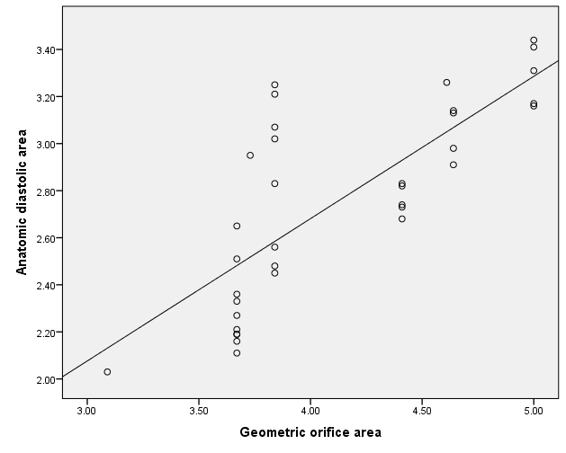

**Fig. (2):** correlation between geometric orifice area and anatomic diastolic area.

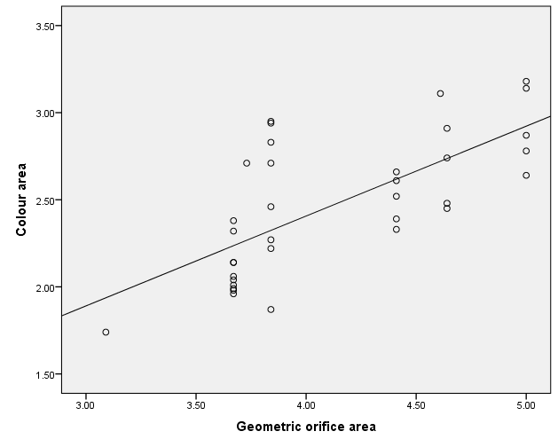

**Fig. (3):** correlation between geometric orifice area and colour area

**Table (3):** Difference between anatomic color area measures of the study group

|  |  |  |  |  |  |
| --- | --- | --- | --- | --- | --- |
|  | **Mean ± SD** | **Paired Diff.** | | **t-test** | |
| **Mean** | **±SD** | **t** | **p-value** |
| Color Doppler area | 2.47±0.39  0.39 |  |  |  |  |
| Color Doppler area (1) | 2.53±0.39  0.39 | -0.058  (2.43%) | 0.131 | -2.641 | **0.012** |
| Color Doppler area (2) | 2.49±0.39  0.39 | -0.019  (0.81%) | 0.203 | -0.557 | 0.581 |

Color Doppler area, Color Doppler area (1) are the two measurements of the first observer while Color Doppler area (2) is the measurement of the second observer.

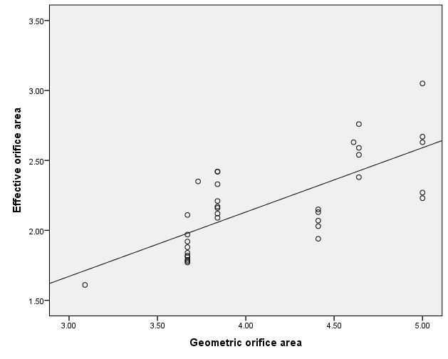

**Fig. (4):** correlation between geometric orifice area and effective orifice area.

**4. Discussion:**

The evaluation of prosthetic heart valve function has long been a clinical challenge. This study is to examine the feasibility and reproducibility of direct measurement of the orifice area by 3D TEE. All measurements correlated well with the manufacturer-defined GOA but with consistent underestimation bias. The GOA is derived from the internal valve diameter of the prosthesis and is measured in vitro by the valve manufacturer. In this study the 3D measured ADA is smaller than the reported GOA for all valves. This discrepancy is likely due to limitation in the spatial resolution of the 3D imaging methods and this result is concordant with the result of **(Krim et al., 2012)**.

Also in agreement with the result of **(Mannaerts et al., 2001)** in which the 3D ADA is smaller than the manufacturer-defined GOA.

Compared with 3D ADA, the 3D color Doppler–derived area was consistently smaller and this is concordant with the result of **(Krim et al., 2012)**.

Compared with 3D ADA and the 3D color Doppler–derived, the Doppler-derived EOA is smaller and this is concordant with the result of **(Mannaerts et al., 2001).**

Also in agreement with the results of **(Baumgartner et al., 1992)** who studied Doppler assessment of prosthetic valve orifice area.

Also in concordant with the results of **(Dumesnil et al., 1990)** who studied validation and applications of mitral prosthetic valvular areas calculated by Doppler echocardiography.

The simplicity of the directly measured 3D area assessment is reflected in the observer variability. The variability of 3D ADA was 7.3 % for interobserver variability and 7.7 % for intraobserver variability, this is concordant with the results of **(Krim et al., 2012)** in which interobserver and intraobserver variability to 3D ADA were 8 % and 5%, respectively.

This result is discordant to the result of **(Mannaerts et al., 2001)** in which interobserver and intraobserver variability to 3D ADA were 13 % and 21%, respectively. This is probably the result of technical problems related to 3D TEE acquisition and processing (motion artifacts, ultrasound scattering, and reverberation) which is solved in the newer Ultrasound Medical Systems.

The variability of 3D color-Doppler area was 8.7 % for interobserver variability and 4.4 % for intraobserver variability, this is concordant with the results of **(Krim et al., 2012)** in which interobserver and intraobserver variability to 3D color-Doppler area were 8 % and 7 %, respectively.

**Conclusion:**

Direct measurement of the mechanical MV orifice area by 3D echocardiography is feasible and simple and correlates well with manufacturer-defined area. 3D color Doppler can be used to rapidly assess prosthetic valve function and to provide a direct measurement of the EOA, and may therefore be an important adjunct to the clinical evaluation of prosthetic valve function. 3D measured orifice area is worth the effort because it is the only ultrasonographic technique that allows detailed morphologic in vivo assessment of mechanical valve prostheses, with more structural morphologic detail about the valve itself and its sewing ring, and allows functional assessment of valve kinetics, especially if the en face view with dynamic volume and surface rendered images is generated.

**References:**

1. Baumgartner H, Khan SS, DeRobertis M, et al., (1992): Doppler assessment of prosthetic valve orifice area. An in vitro study. Circulation;85: 2275–83.
2. Blauwet LA, Burkhart HM, Dearani JA, et al., (2011): Comprehensive echocardiographic assessment of mechanical tricuspid valve prostheses based on early post-implantation echocardiographic studies. J Am Soc Echocardiogr; 24:414.
3. Dumesnil JG, Honos GN, Lemieux M, et al., (1990): Validation and applications of mitral prosthetic valvular areas calculated by Doppler echocardiography. Am J Cardiol;65:1433-8.
4. Hahn R, Abraham T, Adam M, et al., (2013): Guiedlines for performing a comprehensive transesophageal echocardiographic examination: recommendation from American Society of Echocardiography and the Society of Cardiovascular Anesthesiologists. *Journal of the American Society of Echocardiography, 26*(9), 921-964.
5. Krim R., Vivo p., Patel A. et al., (2012): 3D Echo Assessment of Prosthetic Mitral Valve Area, JACC: CARDIOVASCULAR IMAGING 5(5); 478–83.
6. [Kronzon I, Sugeng L, Perk G, et al., (2009): Real-time 3-dimensional transesophageal echocardiography in the evaluation of post-operative mitral annuloplasty ring and prosthetic valve dehiscence. J Am Coll Cardiol; 53:1543.](http://www.uptodate.com/contents/echocardiographic-evaluation-of-prosthetic-heart-valves/abstract/25)
7. Lang RM, Badano LP, Mor-Avi V, et al., (2015): Recommendations for cardiac chamber quantification by echocardiography in adults: an update from the American society of Echocardiography and the European Association of Cardiovascular Imaging. *Journal of the American Society of Echocardiography, 28*(1), 1-33.
8. Mannaerts H, Li Y, Kamp O, et al (2001): Quantitative assessment of mechanical prosthetic valve area by 3-dimensional transesophageal echocardiography. J Am Soc Echocardiogr;14:723–31.
9. Moss R, Ivens E, Pasupati S, et al (2008): Role of echocardiography in percutaneous aortic valve implantation. J Am Coll Cardiol Cardiovasc Imaging 2008;1:15-24.
10. [Nishimura RA, Otto CM, Bonow RO, et al., (2014): AHA/ACC guideline for the management of patients with valvular heart disease: a report of the American College of Cardiology/American Heart Association Task Force on Practice Guidelines. J Am Coll Cardiol; 63: e57.](http://www.uptodate.com/contents/echocardiographic-evaluation-of-prosthetic-heart-valves/abstract/2)
11. [Ozkan M, Gündüz S, Yildiz M, et al.,(2010): Diagnosis of the prosthetic heart valve pannus formation with real-time three-dimensional transoesophageal echocardiography. Eur J Echocardiogr; 11: E17](http://www.uptodate.com/contents/echocardiographic-evaluation-of-prosthetic-heart-valves/abstract/8).
12. Zoghbi WA, Chambers JB, Dumesnil JG, et al.,(2009): Recommendations for evaluation of prosthetic valves with echocardiography and Doppler ultrasound. J Am Soc Echocardiogr; 22:975–1014.

12/2/2016