Assesment of Left Ventricular Function in Preeclamptic Women with Preserved Left Ventricular Ejection Fraction Using Two Dimensional Speckle Tracking Imaging

Abdel Halim Abu Al Magd, Samy Nouh, Mohammad Al-Deftar, Hany Maged, Mohamed Al Sisi

Department of Cardiology - Faculty of Medicine - Al-Azhar University, Cairo, Egypt. dr_sisi11@yahoo.com

Abstract: Introduction: Preeclampsia is a common hypertensive disorder of pregnancy. It is associated with both immediate, as well as long-term postpartum morbidity and mortality due to cardiac-related issues. Even in clinically asymptomatic patients, subtle echocardiographic changes in left ventricular function have been observed in preeclampsia. Of the conventional echocardiographic indices, ejection fraction remains relatively preserved until later in the course of the disease process, making it less useful as a screening tool to follow patients over time. Speckle tracking echocardiography (STE) is a new echocardiographic technique that allows a precise evaluation of myocardial function. This method is accurate, reproducible, and angle independent, and it enables a complete assessment of regional and global function in three directions. Aim of the work: assessment of LV systolic function in preeclamptic women using two-dimensional (2 D) speckle tracking Echocardiography (STE). Material and methods: We evaluated the feasibility of strain imaging using speckle-tracking echocardiography in women with preeclampsia. Fifty-five women were enrolled in this study and 50 were analyzed: 30 with preeclampsia, 10 with nonproteinuric hypertension and 10 without a hypertensive disorder. Echocardiographic ejection fraction and global peak longitudinal and circumferential strain were measured. All cases were collected from the Gynecology and Obstetrics department in El-Hussein University Hospital from December 2015 to September 2016. Results: in preeclamptic pregnant women, longitudinal strain and circumferential strain are reduced compared to non-proteinuric hypertensive pregnant women and non-hypertensive pregnant women. Conclusion: Myocardial strain imaging using speckle tracking is more sensitive than left ventricular ejection fraction to detect differences in left ventricular systolic function in pregnant women with and without hypertensive disorders of pregnancy. Recommendations: The STE technique should be combined with conventional echocardiography for assessment and follow up of ventricular function in preeclamptic pregnant women.
[Abdel Halim Abu Al Magd, Samy Nouh, Mohammad Al-Deftar, Hany Maged, Mohamed Al Sisi. Assesment of Left Ventricular Function in Preeclamptic Women with Preserved Left Ventricular Ejection Fraction Using Two Dimensional Speckle Tracking Imaging. N Y Sci J 2016;9(12):32-39]. ISSN 1554-0200 (print); ISSN 2375-723X (online). http://www.sciencepub.net/newyork. 6. doi:10.7537/marsnys091216.06.

Keywords: preeclampsia – echocardiography - ventricular function - speckle tracking echocardiography

1. Introduction:
Preeclampsia is a common hypertensive disorder of pregnancy. It is associated with both immediate, as well as long-term postpartum morbidity and mortality due to cardiac-related issues (Mongraw et al., 2010). Even in clinically asymptomatic patients, subtle echocardiographic changes in left ventricular function have been observed in preeclampsia. Of the conventional echocardiographic indices, ejection fraction remains relatively preserved until later in the course of the disease process, making it less useful as a screening tool to follow patients over time (Melchiorre et al., 2011). For this reason, the current assessment of pregnancy-related changes in myocardial function is based on either two-dimensional linear and volumetric chamber quantifications or Doppler indices of diastolic function. The availability of more sensitive and sophisticated non-invasive techniques may enhance our understanding of global ventricular function in the women with preeclampsia (Tyldum et al., 2012).
Speckle tracking is a recently developed echocardiographic technique that analyzes the degree of myocardial deformation, known as strain, throughout the cardiac cycle. Speckle tracking, is obtained, by an automated measurement of the distance between speckles, in a specific ventricular segment in a two-dimensional echocardiographic image. Speckles are created by the irregular reflection of ultrasound that can be tracked throughout the cardiac cycle. Because, it is based on tracking the course of a speckle of the image over time in relation to its original location it is angle-independent and is less prone to operator-related measurement errors. Speckle tracking allows for the measurement of longitudinal, radial and circumferential strain and these have been used to prognosticate changes in left ventricular function and geometry (Geyer et al., 2010).
Strain is a parameter representing deformation of an object, relative to its original shape, and is expressed as a percentage change from the original dimension. Strain using speckle tracking is calculated by assessing the differences in distance and velocity of the speckle during the cardiac cycle. Positive values reflect lengthening, negative values reflect contraction. Cardiac Myofibrils can be oriented in the radial, circumferential and longitudinal plane, giving them a helical nature. In contrast with left ventricular ejection fraction, which is a measure of global function, strain with speckle tracking measures both regional and global function and also identifies the myocyte group that is affected. Moreover, the calculation for left ventricular ejection fraction includes geometric assumptions while speckle tracking does not.
In this study, we examined changes in myocardial strain as measured by speckle-tracking echocardiography in women with preeclampsia, women with nonproteinuric hypertension and women without a hypertensive disorder. We hypothesized that global left systolic strain measures would prove more sensitive than conventional left ventricular ejection fraction in detecting early changes in systolic left ventricular function manifesting as subclinical disease prior to overt progression.

2. Material and methods:
A prospective study was done on a sample of (50) Pregnant women at least 18 years of age recruited from gynecology and obstetrics departments of Al-Hussein University Hospital with a singleton pregnancy of at least 24 weeks and less than 41 weeks and with a diagnosis of preeclampsia (30 cases), nonproteinuric hypertension (10cases) or without any hypertensive disorder of pregnancy (10cases) from December 2015 to September 2016. The diagnoses of preeclampsia, and nonproteinuric hypertension were based on the National High Blood Pressure Education Program Working Group definition, also endorsed by the American Congress of Obstetricians and Gynecologists (ACOG). Mild preeclampsia was defined as ≥140 mm Hg systolic or ≥90 mm Hg diastolic with proteinuria (plus I by dipstick method) in a previously normotensive woman after 20 weeks of gestation. Severe preeclampsia was defined by severe hypertension (≥160 mm Hg systolic and ≥110 mm Hg diastolic on 2 occasions 6 hours apart) and proteinuria (plus II or more) with or without evidence of end organ damage (such as HELLP (hemolysis, elevated liver enzymes and low platelets) syndrome, oliguria (<500 ml in 24 hours), pulmonary edema, seizures and fetal growth restriction). Exclusion criteria included chronic hypertension, history or symptoms of CAD or regional wall motion abnormality (RWMA) suggestive of CAD by two-dimensional Echocardiography, valvular heart disease, atrial fibrillation, congestive heart failure, cardiomyopathy, congenital heart disease, endocrine disease, renal failure& Poor Echo window(excluded from analysis). All of them were subjected to full history taking, general and local clinical examination and 12 lead resting surface ECG. Echocardiographic examination was done to all the study population which included the following:1) Two-dimensional echocardiography: The following measures were taken: LVESD, LVEDD from parasternal long axis view and EF was calculated automatically by machine software. (Lang et al., 2015). 2) two-D Speckle tracking echocardiography study: The following measures were taken: apical 4 chamber view, apical 2 chamber view, and apical long axis view short axis viws (basal, mid and apical levels) were taken for later analysis of the left ventricle, Automated delineation of endocardial borders was obtained (Lang et al., 2015). All data were collected and statistically analyzed using Chi-square test using SPSS (Statistical package for social science) software.

2. Results:
The present study included 50 pregnant women allocated to 3 groups according to BP and protein in urine. Group I included preeclamptic pregnant women (30cases) group II included non-proteinuric hypertensive pregnant women (10cases). group III included non-hypertensive pregnant women (10cases).

Table 1: Comparison between groups according characteristic data.
Parameters | Groups |  |  | ANOVA |  | LSD
 | Group I | Group II | Group III | F | p-value | I vs. II | I vs. III | II vs. III
Age (years)
Mean±SD | 28.93±4.61 | 30±3.37 | 29.60±5.93 | 0.223 | 0.801 | 0.536 | 0.699 | 0.850
Range | 21-38 | 25-36 | 20-36
Parity
Mean±SD | 1 | 2 | 1 | - | - | - | - | -
Range | 0-3 | 0-3 | 0-2
Gravidity
Mean±SD | 2 | 3 | 2 | - | - | - | - | -
Range | 1-4 | 1-4 | 1-3
GA (wks)
Mean±SD | 32.43±2.80 | 32.10±3.07 | 30±3.06 | 2.669 | 0.080 | 0.755 | 0.046 | 0.113
Range | 27-37 | 27-37 | 26-34
This table shows statistically significant difference between group I and group III according GA, the rest have insignificant.

Table 2: Comparison between groups according HOPIH.
HOPIH | Group I | Group II | Group III | Chi-square | p-value
Yes | 7 (23.3%) | 1 (10%) | 1 (10%) | 1.445 | 0.485
No | 23 (76.7%) | 9 (90%) | 9 (90%)
Total | 30 (100%) | 10 (100%) | 10 (100%)

This table shows no statistically significant difference between groups according HOPIH.

Table 3: Comparison between groups according HR.
HR | Groups |  |  | ANOVA |  | LSD
 | Group I | Group II | Group III | F | p-value | I vs. II | I vs. III | II vs. III
Mean±SD | 80.30±4.93 | 80.50±5.08 | 80.60±5.62 | 0.015 | 0.985 | 0.915 | 0.873 | 0.965
Range | 72-88 | 73-88 | 73-89

This table shows no statistically significant difference between groups according HR.

Table 4: Comparison between groups according blood pressure.
Blood Pressure | Groups |  |  | ANOVA |  | LSD
 | Group I | Group II | Group III | F | p-value | I vs. II | I vs. III | II vs. III
SBP
Mean±SD | 138±9.61 | 140±8.50 | 116.50±11.07 | 20.687 | <0.001 | 0.575 | <0.001 | <0.001
Range | 110-155 | 120-150 | 95-130
DBP
Mean±SD | 89.33±8.17 | 89±5.16 | 71±8.10 | 22.639 | <0.001 | 0.906 | <0.001 | <0.001
Range | 70-105 | 80-100 | 60-85

This table shows highly statistically significant difference between groups according blood pressure.

Table 5: Grades of proteinuria among group I.
PIU | Group I
I | 18 (60%)
II | 9 (30%)
III | 3 (10%)
Total | 30 (100%)

Table 6: Comparison between groups according LVEDd and LVESd.
 | Groups |  |  | ANOVA |  | LSD
 | Group I | Group II | Group III | F | p-value | I vs. II | I vs. III | II vs. III
LVEDd
Mean±SD | 47.97±2.27 | 47.80±1.87 | 47.10±2.18 | 0.595 | 0.556 | 0.835 | 0.282 | 0.476
Range | 43-52 | 45-50 | 44-51
LVESd
Mean±SD | 31.90±1.83 | 32±1.33 | 31.70±1.64 | 0.082 | 0.921 | 0.873 | 0.750 | 0.696
Range | 28-35 | 30-34 | 29-34

This table shows no statistically significant difference between groups according LVEDd and LVESd.
Table 7: Comparison between groups according EF%.
EF% | Groups |  |  | ANOVA |  | LSD
 | Group I | Group II | Group III | F | p-value | I vs. II | I vs. III | II vs. III
Mean±SD | 66.67±2.64 | 66.50±1.08 | 65.40±1.71 | 1.198 | 0.311 | 0.841 | 0.131 | 0.282
Range | 62-72 | 65-68 | 63-69

This table shows no statistically significant difference between groups according EF%.
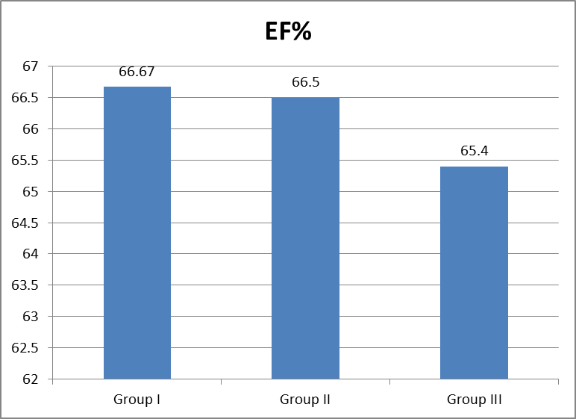
Figure(1) This figure shows no statistically significant difference between groups according EF%.

Table 8: Comparison between groups according LS.
LS | Groups |  |  | ANOVA |  | LSD
 | Group I | Group II | Group III | F | p-value | I vs. II | I vs. III | II vs. III
Mean±SD | -13.43±2.33 | -15.90±0.99 | -20.10±1.66 | 41.606 | <0.001 | 0.002 | <0.001 | <0.001
Range | -17_-10 | -17_-14 | -23_-18

This table shows highly statistically significant difference between groups according LS.

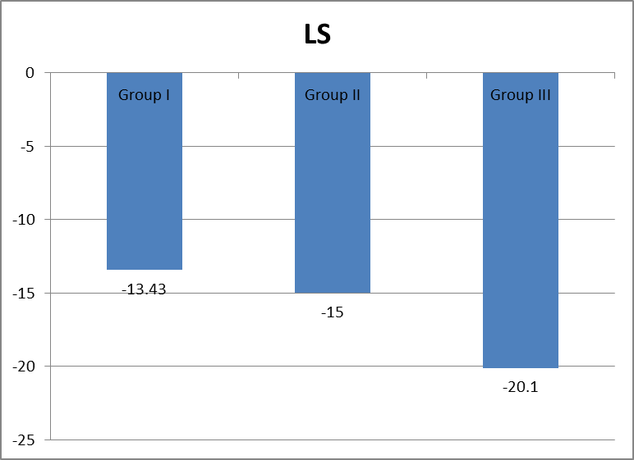
Figure(2) This figure shows highly statistically significant difference between groups according LS.

Table 9: Comparison between groups according CS.
CS | Groups |  |  | ANOVA |  | LSD
 | Group I | Group II | Group III | F | p-value | I vs. II | I vs. III | II vs. III
Mean±SD | -19.63±2.74 | -24.50±1.90 | -20.70±1.89 | 14.841 | <0.001 | <0.001 | 0.239 | <0.001
Range | -29_-16 | -28_-22 | -24_-18

This table shows statistically significant difference between groups according CS.

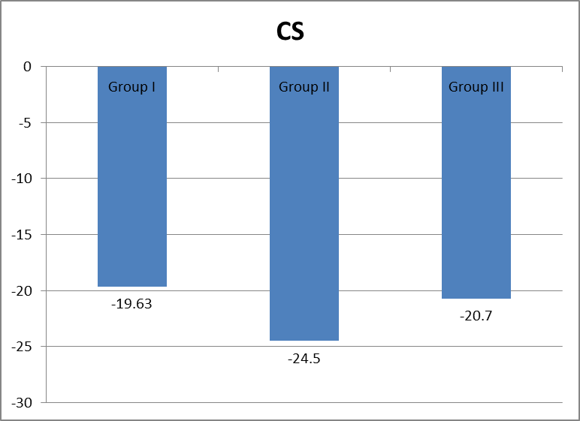
Figure (3) This figure shows statistically significant difference between groups according CS.

Table 10: Comparison between groups according PE.
PE | Group I | Group II | Group III | Chi-square | p-value
Yes | 9 (30%) | 0 (0%) | 0 (0%) | 10.526 | 0.005
No | 21 (70%) | 10 (100%) | 10 (100%)
Total | 30 (100%) | 10 (100%) | 10 (100%)

This table shows statistically significant difference between groups according PE.

Table 11: Relation between PIU and LS, CS and PE in group I.
Group I | PIU |  |  | F/x2* | p-value
 | I | II | III
LS | -15.06±1.35 | -11.33±0.71 | -10±0 | 47.295 | <0.001
CS | -21.2±2.3 | -17.7±0.87 | -16±0 | 16.662 | <0.001
PE
Yes | 2(11.1%) | 4(44.4%) | 3(100%) | 10.952 | 0.004
No | 16(88.9%) | 5(55.6%) | 0 (0%)

This table shows highly statistically significant between PIU according LS, CS and PE.

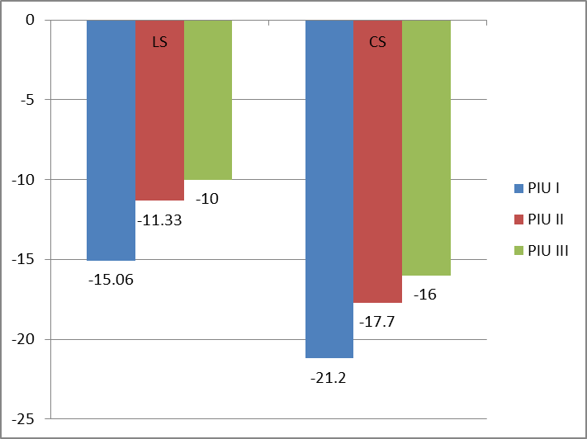
Figure(5) This figure shows highly statistically significant between PIU according LS, CS and PE.

Table 12: Relation between HOPIH and LS, CS and PE in group I.
Group I | HOPIH |  | t/x2* | p-value
 | Yes | No
LS | -13.00±2.16 | -13.57±2.41 | 0.310 | 0.580
CS | -19.14±2.04 | -19.78±2.94 | 0.290 | 0.600
PE
Yes | 2 (28.6%) | 10 (43.5%) | 0.497* | 0.481
No | 5 (71.3%) | 13 (56.5%)

This table shows no statistically significant between HOPIH according LS, CS and PE.

Table 13: Relation between HOPIH and LS, CS and in group II.
Group II | HOPIH |  | t/x2* | p-value
 | Yes | No
LS | -17.00±0.00 | -15.78±0.97 | 1.42 | 0.27
CS | -26.00±0.00 | -24.33±1.94 | 0.67 | 0.44
No | 1 (100%) | 9 (100%) | 0.000* | 1.000

This table shows no statistically significant between HOPIH according LS, CS and PE.

Table 14: Correlation between gravidity and LS, CS and PE in group I & II.
Gravidity | Group I |  | Group II
 | R | p-value | R | p-value
LS | 0.093 | 0.623 | -0.303 | 0.395
CS | 0.011 | 0.952 | 0.510 | 0.132
PE | -0.125 | 0.511 | - | -

This table shows no statistically correlation between gravidity and LS, CS and PE.

Table 15: Correlation between parity and LS, CS and PE in group I & II.
Parity | Group I |  | Group II
 | R | p-value | R | p-value
LS | 0.132 | 0.485 | -0.172 | 0.634
CS | 0.016 | 0.933 | 0.331 | 0.350
PE | -0.152 | 0.424 | - | -

This table shows no statistically correlation between parity and LS, CS and PE.

Table 16: Correlation between age (years) and LS, CS and PE in group I & II.
Age (years) | Group I |  | Group II
 | R | p-value | R | p-value
LS | -0.054 | 0.776 | -0.232 | 0.518
CS | -0.086 | 0.653 | 0.191 | 0.597
PE | -0.177 | 0.349 | - | -

This table shows no statistically correlation between age and LS, CS and PE.

4. Discussion:
Preeclampsia is associated with subclinical LV systolic dysfunction, which can be identiﬁed as a reduction of global LS and circumferential strain compared to non-hypertensive pregnant females and pregnant females with nonproteinuric hypertension.
This finding is concordant to the result of (shahul et al., 2012) in their study subclinical LV systolic dysfunction in preeclamptic pregnant women with preserved LV ejection fraction.
This can be explained by the presence of angiogenic imbalance with high circulating levels of antiangiogenic proteins such as soluble fms-like tyrosine kinase-1 (sFlt1) and soluble endoglin and low levels of proangiogenic proteins such as vascular endothelial growth factor and placenta growth factor (Levine et al., 2004).
We have recently shown that high levels of sFlt1 in women with preeclampsia can cause cardiac dysfunction characterized by an abnormal myocardial performance index, a sensitive marker of diastolic dysfunction and that sFlt1 be pathogenic in women with peripartum cardiomyopathy (Patten et al.,2012).
The decrease in longitudinal strain may represent attenuation of early longitudinal muscle relaxation leading to elevation in filling pressures and diastolic dysfunction, while changes that we observed in radial and circumferential strain in the setting of a normal ejection fraction likely represent transmural subclinical dysfunction. The observed subclinical LV dysfunction likely develops from biochemical perturbations, combined with an increased end systolic wall stress from an increased afterload, leading to subendocardial microvascular ischemia and fibrosis.
A key effector of biochemical perturbations is likely sFlt1, which causes both systemic vasoconstriction and intense small vessel myocardial vasoconstriction. This would explain why the longitudinal strain is most affected given that it is a functional measurement of subendocardial longitudinally oriented myocardium.
sFlt1 is not elevated in women with nonproteinuric gestational hypertension, consistent with our findings of different strain patterns among these women.(Verlohren et al., 2012).
Our study showed that Longitudinal and circumferential strain is not affected in nonhypertensive pregnant women.
This is concordant with (Biaggi et al., 2011) in his study Comparison of two different speckle tracking software systems: does the method matter? Echocardiography.
This is also concordant with (Shahul et al., 2012) in his study subclinical LV dysfunction in preeclamptic pregnant women with preserved ejection fraction.
Our study also showed that longitudinal strain in nonproteinuric hypertension is mid way between normal pregnant women and preeclamptic women.
This is concordant with (Shahul et al., 2012) in his study subclinical Lv dysfunction in preeclamptic women with preserve Lv ejection fraction.
This is also concordant with (Cho et al., 2011) in his study impact of gestational hypertension on Lv systolic function and geometry.
Circumferential strain in nonproteinuric hypertension is increased compared with women without a hypertensive disorder.
This is likely explained by compensatory increase in circumferential fiber function in the setting of decreased longitudinal fiber function to preserve normal LV systolic function (Mizuguchi et al., 2010).
Our study showed positive correlation between the degree of proteinuria and LV systolic dysfunction as the degree of proteinuria can express the severity of preeclampsia.
Our study also showed positive correlation between the severity of proteinuria and the presence of mild pericardial effusion. this may be explained by increased hypoalbuminemia which leads to decreased oncotic pressure of plasma.
There is no correlation between HOPIH and LS; CS or the presence of pericardial effusion.
There is no correlation between gravidity, parity, or age and LS, CS or the presence of pericardial effusion.

Conclusion:
Preeclampsia is associated with subclinical LV systolic dysfunction. compared with control subjects which can be detected with 2 D STE.

References:
- Mongraw-Chaffin ML, Cirillo PM, Cohn BA. Preeclampsia and cardiovascular disease death: Prospective evidence from the child health and development studies cohort. Hypertension. 2010;56:166–171.
- Melchiorre K, Sutherland GR, Baltabaeva A, Liberati M, Thilaganathan B. Maternal cardiac dysfunction and remodeling in women with preeclampsia at term. Hypertension. 2011;57:85–93..
- Tyldum EV, Backe B, Stoylen A, Slordahl SA. Maternal left ventricular and endothelial functions in preeclampsia. Acta Obstet Gynecol Scand. 2012;91:566–573.
- Geyer H, Caracciolo G, Abe H, Wilansky S, Carerj S, Gentile F, Nesser HJ, Khandheria B, Narula J, Sengupta PP. Assessment of myocardial mechanics using speckle tracking echocardiography: Fundamentals and clinical applications. J Am Soc Echocardiogr. 2010;23:351–369. quiz 453-355.
- Mizuguchi Y, Oishi Y, Miyoshi H, Iuchi A, Nagase N, Ara N, Oki T. Possible mechanisms of left ventricular torsion evaluated by cardioreparative effects of telmisartan in patients with hypertension. Eur J Echocardiogr. 2010;11:690–697.
- Cho KI, Kim SM, Shin MS, Kim EJ, Cho EJ, Seo HS, Shin SH, Yoon SJ, Choi JH. Impact of gestational hypertension on left ventricular function and geometric pattern. Circ J. 2011;75:1170–1176.
- Levine RJ, Maynard SE, Qian C, Lim KH, England LJ, Yu KF, Schisterman EF, Thadhani R, Sachs BP, Epstein FH, Sibai BM, Sukhatme VP, Karumanchi SA. Circulating angiogenic factors and the risk of preeclampsia. N Engl J Med. 2004;350:672–683.
- Shahul S, Rhee J, Hacker MR, Gulati G, Mitchell JD, Hess P, Mahmood F, Arany Z, Rana S, Talmor D Subclinical left ventricular dysfunction in preeclamptic women with preserved left ventricular ejection fraction: a 2D speckle-tracking imaging study. Circ Cardiovasc Imaging. 2012;5:734.
- Lang RM, Badano LP, Mor-Avi V, Aﬁlalo J, Armstrong A, Ernande L et al., in adults: an update from the American society of echocardiography and the European association of cardiovascular imaging. Eur Heart J Cardiovasc Imaging.
- Biaggi P, Carasso S, Garceau P, Greutmann M, Gruner C, Tsang W, Rakowski H, Agmon Y, Woo A. Comparison of two different speckle tracking software systems: Does the method matter? Echocardiography. 2011;28:539–547.
- Verlohren S, Herraiz I, Lapaire O, Schlembach D, Moertl M, Zeisler H, Calda P, Holzgreve W, Galindo A, Engels T, Denk B, Stepan H. The sflt-1/plgf ratio in different types of hypertensive pregnancy disorders and its prognostic potential in preeclamptic patients. Am J Obstetric Gynecol. 2012;206:58, e51–e58.
- Patten IS, Rana S, Shahul S, Rowe GC, Jang C, Liu L, Hacker MR, Rhee JS, Mitchell J, Mahmood F, Hess P, Farrell C, Koulisis N, Khankin EV, Burke SD, Tudorache I, Bauersachs J, del Monte F, Hilfiker-Kleiner D, Karumanchi SA, Arany Z. Cardiac angiogenic imbalance leads to peripartum cardiomyopathy. Nature. 2012;485:333–338.
- Geyer H, Caracciolo G, Abe H, Wilansky S, Carerj S, Gentile F, Nesser HJ, Khandheria B, Narula J, Sengupta PP. Assessment of myocardial mechanics using speckle tracking echocardiography: Fundamentals and clinical applications. J Am Soc Echocardiogr. 2010;23:351–369. quiz 453-355. (2015): Recommendations for cardiac chamber quantiﬁcation by echocardiography.
- Lang RM, Bierig M, Devereux RB, et al., (2005) Chamber QuantificationWriting Group; American Society of Echocardiography’s Guidelines and Standards Committee; European Association of Echocardiogra-phy. Recommendations for chamber quantification: a report from theAmerican Society of Echocardiography’s Guidelines and Standards Committee and the Chamber Quantification Writing Group, devel-oped in conjunction with the European Association of Echocardio-graphy, a branch of the European Society of Cardiology. J Am Soc Echocardiogr; 18:1440–1463. 16:233–71.

12/3/2016

