**Correlation between Different Trichoscopic Criteria and Aetiological Agents of Tinea Capitis**

Emad Eldin A EL-Gama1; Hoda A Moneib2; Mohammed D EL-Hariri3; Ahmed M.I. Atya1

1Dermatology Department, Faculty of Medicine, Al-Azhar University (Damietta), Egypt

2 Dermatology Department, Faculty of Medicine, Ain Shams, University, Egypt

3 Dermatology Department, Faculty of Medicine, Al-Azhar University (Cairo). Egypt

[ahmedatya1988@yahoo.com](mailto:ahmedatya1988@yahoo.com)

**Abstract**: **Background:** Tineacapitis is a scalp infection caused by fungi. In Egypt, the main causative agents are Microsporumcanis and the Trichophytonviolacum. Etiological diagnosis is based on suggestive clinical findings and conﬁrmation depends on the fungus growth in culture. However, it is not always possible to perform this test due to lack of availability. We reveal the dermoscopic ﬁndings that enable distinction between the main causative agents of Tineacapitis, M. canis and T. violacum. The association of clinical and dermatoscopic ﬁndings in suspected Tineacapitis cases may help with the differential diagnosis of the etiological agent, making feasible the precocious, speciﬁc treatment. **Objective:** tostudy thecorrelation*between different trichoscopic criteria and aetiological agents in tineacapitis.* **Patients and methods:** 30 child were included in this study. Each child was subjected to: 1) Careful history taking, 2) Clinical examination, 3)*. Dermoscopicexamination***,** and 4) Fungal culture on sabouraud agar. **Results:** There was statistically significantcorrelation between different trichoscopic criteria and aetiological agents in tineacapitis. Corkscrew hairs, comma-shaped hairs, zigzag shaped hair and morse code like hairs were seen by dermoscopic examination of tineacapitis caused by T violavum, Mcanis, T mentagrophytes and M auduinii respectively.

[EmadEldin A EL-Gama; Hoda A Moneib; Mohammed D EL-Hariri; Ahmed M.I. Atya. **Correlation Between Different Trichoscopic Criteria And Aetiological Agents Of Tinea Capitis.** *N Y Sci J* 2016;9(11):102-108]. ISSN 1554-0200 (print); ISSN 2375-723X (online). <http://www.sciencepub.net/newyork>. 15. doi:[10.7537/marsnys091116.15](http://www.dx.doi.org/10.7537/marsnys091116.15).

**Keywords:** Trichoscopy; Tineacapitis；Etiological diagnosis

**1. Introduction**

Tineacapitis is a superficial fungal infection of hair and scalp; with a propensityfor attacking hair shafts and follicles; that typically occurs in childhood with the highest incidence in children aged 3–7 years old and equally in both sexes. It is typically caused by Trichophyton and Microsporum species **(Sombatmaithai et al., 2015).**

Clinical presentation of tineacapitis varies from a scaly non inflamed dermatosis resembling seborrhoeic dermatitis to an inflammatory disease with scaly erythematous lesions and hair loss or alopecia that may progress to severely-inflamed deep abscesses termed kerion, with the potential for scarring and permanent alopecia. The type of disease elicited depends on interaction between the host and the etiologic agents **(El-Taweel et al., 2014).**

Clinical diagnosis of tineacapitis is confirmed by fungus visualization through direct mycological examinations or growth of the specific fungus in a suitable culture environment. In the direct mycological examination by 10-20 % potassium hydroxide (KOH), hyphae and spores are displayed. However, they cannot be reliably used for identifying the species that causes tineacapitis.

Definitive identification of the pathogen species is carried out by fungal culture and growth occurs after 3-4 weeks in most cases, representing an important delay in diagnosis **(Schechtman et al., 2015).**

Scalp dermoscopy or `trichoscopy' represents a valuable, noninvasive technique for the evaluation of patients with hair loss that allows for magnified visualization of the hair and scalp skin. In particular, trichoscopy enhances the diagnosis of androgenetic alopecia, alopecia areata, telogen effluvium, trichotillomania, congenital triangular alopecia, scarring alopecia, tineacapitis and hair shaft disorders. This method is simple, quick and easy to perform, reduces the need for scalp biopsy, is well accepted by patients and is useful for monitoring treatment and follow-up **(Lacarrubba et al., 2015).**

Dermoscopy of tineacapitis shows two typical features; comma hairs (curved fractured hair shafts) and corkscrew hairs. Broken and dystrophic hairs also are seen. Scales, peripilar casts and alopecia are also found. It would be desirable to establish this diagnostic tool, particularly when an optical microscope or mycology reference laboratories are not available **(Guerrero et al., 2014).**

**Aim of the work**

The aim of this work is to study correlation between different trichoscopic criteria and aetiological agents in tineacapitis.

**2. Materials and methods**

This study will include thirty patients diagnosed as tineacapitis.

**All patients will be subjected to the following**:

1. History taking, clinical examination.
2. Trichoscopic examination.
3. Fungal culture on sabouraud agar.

**Exclusion criteria:**

History of using any topical (1 month) or systemic treatment (3 month) for tineacapitis.

**Statistical analysis**

Data were analyzed with **SPSS** version 21. The normality of data was first tested with Shapiro- test.

Qualitative data were described using number and percent. Association between categorical variables was tested using Chi-square test.

Continuous variables were presented as mean ± SD (standard deviation).

1. **Result**

The present study included thirty patients with tineacapitis collected from the Outpatient Clinic of Dermatology and Venereology of Al-azhar University Hospital (Damietta).

**The results were shown into the following tables and diagrams:**

Table (1): Demographic data of studied group

|  |  |  |
| --- | --- | --- |
| Items | Study group (n=30) | |
| No | % |
| Sex | | |
| Male | 17 | 56.7 |
| Female | 13 | 43.3 |
| Age | | |
| Mean ± SD | 6.90±2.24 | |
| Min-Max | 3.00-12.00 | |
| <6y | 11 | 36.7 |
| >6y | 19 | 63.3 |

*Data expressed asMean ± SD or No (%)*

As regard sex distribution, there was non-significant difference between studied group [in study group, there was 17 males [56.7%] and 13 females [43.3%].

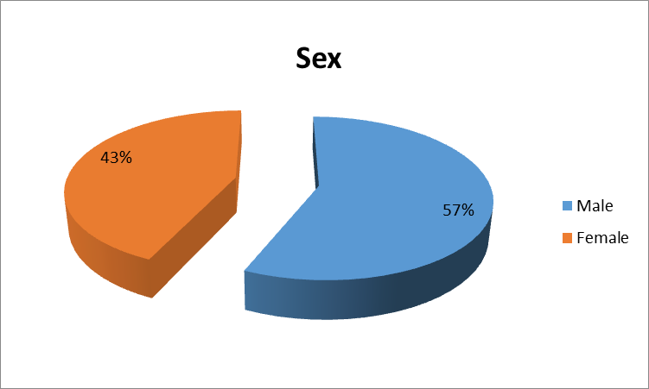

Fig. (1): sex distribution inpatients with tineacapitis

As regard to age, it ranged from 3 to 12 years with a mean of 6.90±2.24years.

The most age group affected in tineacapitis>6y [63.3%].

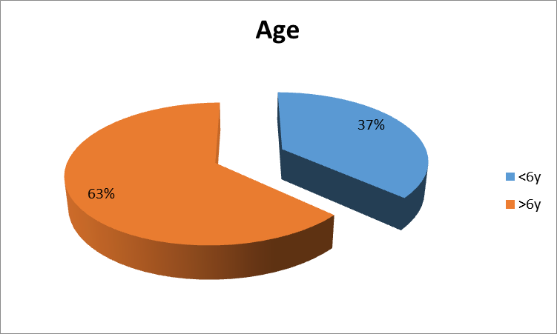

Fig. (2): Age distribution inpatients with tineacapitis.

As regard clinical type of studied group there was 15 black dot (50%), 11 scaly tineacapitis (36.4%) and 4 kerion (13.3%).

Table (2): Clinical type of studied group

|  |  |  |
| --- | --- | --- |
| Clinical type | Study group (n=30) | |
| No | % |
| Black dot | 15 | 50.0 |
| Scaly tineacapitis | 11 | 36.7 |
| Kerion | 4 | 13.3 |

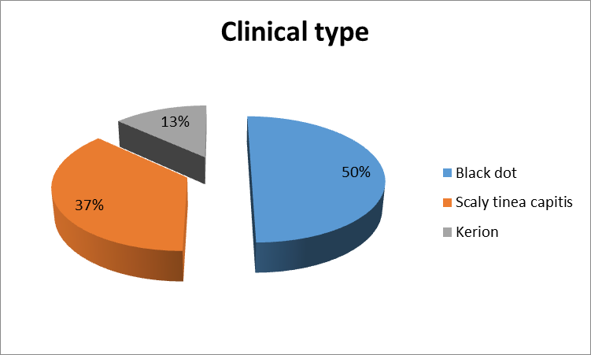

Fig (3) Clinical type of studied group

As regard dermoscopic finding of studied group there was 15 corck screw hair (50%), 9 comma shaped hair (30%), 4 zigzag shaped hair (13.3%) and 2 morse code like hair (6.7%).

Table (3): Dermoscopic finding of studied group

|  |  |  |
| --- | --- | --- |
| Dermoscopic finding | Study group (n=30) | |
| No | % |
| Corck screw hair | 15 | 50.0 |
| Comma shaped hair | 9 | 30.0 |
| Zigzag shaped hairs | 4 | 13.3 |
| Morse code like hair | 2 | 6.7 |

*Data expressed as No (%)*

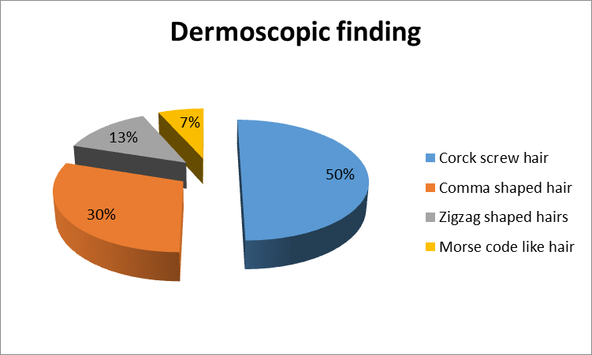

Fig (4) Dermoscopic finding of studied group

As regard Causative Organism of studied group there was 15 T. violaceum (50%), 9 M. canis (30%), 4 T. mentagrophytes (13.3%) and 2M. audouinii (6.7%).

Table (4): Causative Organism of studied group

|  |  |  |
| --- | --- | --- |
| Causative Organism | Study group (n=30) | |
| No | % |
| T.violaceum | 15 | 50.0 |
| M.canis | 9 | 30.0 |
| T.mentagrophytes | 4 | 13.3 |
| M.audouinii | 2 | 6.7 |

*Data expressed as No (%)*

Table (5): Relation between Dermoscopic finding and Clinical type

|  |  |  |  |  |  |
| --- | --- | --- | --- | --- | --- |
| Clinical type | Dermoscopic finding | | | | Test of significance |
| Corck screw hair | Comma shaped hair | Zigzag shaped hairs | Morse code like hair |
| Black dot | 14 (93.3%) | 1 (11.1%) | 0  (0%) | 0  (0%) | X2=51.38 p=≤.001** |
| Scaly tineacapitis | 1 (6.7%) | 8 (88.9%) | 0 (0%) | 2 (100%) |
| Kerion | 0  (0%) | 0  (0%) | 4 (100%) | 0  (0%) |
| Total | 15 | 9 | 4 | 2 |

χ2: Chi square test; **: Highly Statistically significant p ≤ 0.001

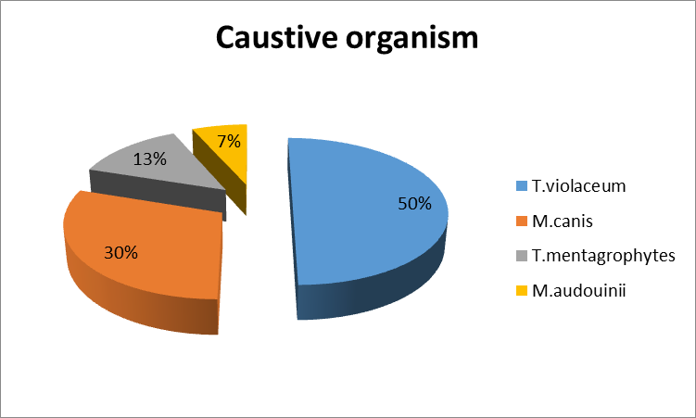

Fig (5) Causative Organism of studied group

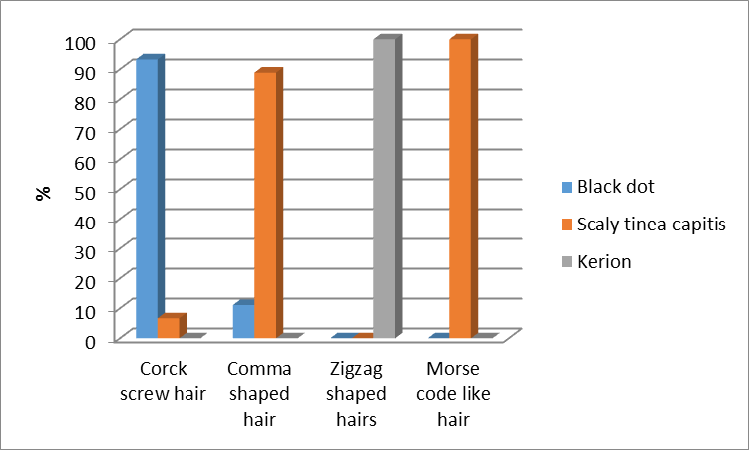

Fig (6) Relation between Dermoscopic finding and Clinical type

Table (6): Relation between Dermoscopic finding and Causitive Organism

|  |  |  |  |  |  |
| --- | --- | --- | --- | --- | --- |
| Causitive Organism | Dermoscopic finding | | | | Test of significance |
| Corck screw hair | Comma shaped hair | Zigzag shaped hairs | Morse code like hair |
| T.violaceum | 14 (93.3%) | 1 (11.1%) | 0 (0%) | 0 (0%) | X2=80.28 p=≤.001** |
| M.canis | 1 (6.7%) | 8 (88.9%) | 0 (0%) | 0 (0%) |
| T.mentagrophytes | 0 (0%) | 0 (0%) | 4 (100%) | 0 (0%) |
| M.audouinii | 0 (0%) | 0 (0%) | 0 (0%) | 2 (100%) |
| Total | 15 | 9 | 4 | 2 |

χ2: Chi square test; **: Highly Statistically significant p ≤ 0.001

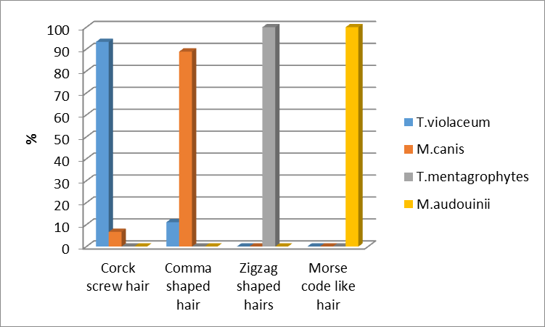

Fig (7) Relation between Dermoscopic finding and Clinical type

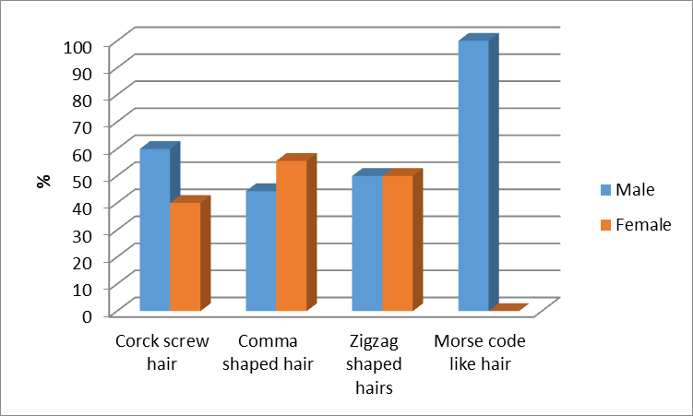

Fig (8) Relation between Dermoscopic finding and sex

Table (7): Relation between Dermoscopic finding and sex

|  |  |  |  |  |  |
| --- | --- | --- | --- | --- | --- |
| Sex | Dermoscopic finding | | | | Test of significance |
| Corck screw hair | Comma shaped hair | Zigzag shaped hairs | Morse code like hair |
| Male | 9 (60%) | 4 (44.4%) | 2 (50%) | 2 ( 100%) | X2=2.21 p=0.529 |
| Female | 6 (40 %) | 5 (55.6%) | 2 (50%) | 0 (0%) |
| Total | 15 | 9 | 4 | 2 |

Table (8 ): Relation between Dermoscopic finding and age

|  |  |  |  |  |  |
| --- | --- | --- | --- | --- | --- |
| Age | Dermoscopic finding | | | | Test of significance |
| Corck screw hair | Comma shaped hair | Zigzag shaped hairs | Morse code like hair |
| <6y | 7 (46.7%) | 3 (33.3%) | 1 (25.0%) | 0 (0%) | X2=2.08 p=0.556 |
| >6y | 8 (53.3%) | 6 (66.7%) | 3 (75.0%) | 2 (100%) |
| Total | 15 | 9 | 4 | 2 |

χ2: Chi square test Not significant (P >0.05)

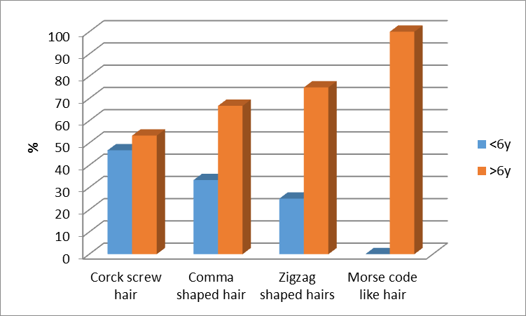

Fig (9) Relation between Dermoscopic finding and age

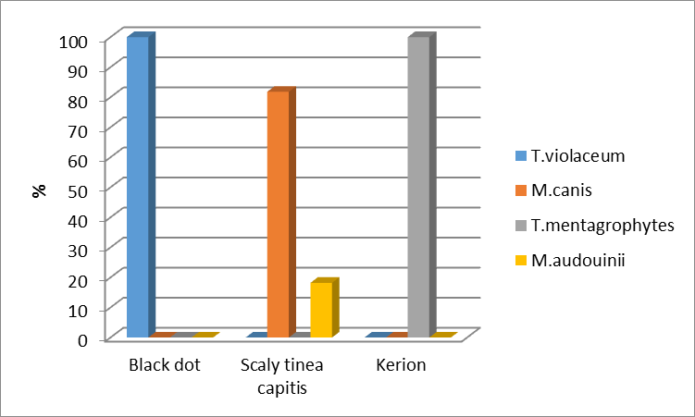

Fig (10) Relation between Clinical type and Causitive Organism

Table (9): Relation between Clinical type and Causitive Organism

|  |  |  |  |  |
| --- | --- | --- | --- | --- |
| Causitive Organism | Clinical type | | | Test of significance |
| Black dot | Scaly tineacapitis | Kerion |
| T.violaceum | 15(100.0%) | 0 (0%) | 0 (0%) | X2=60.00 p=≤.001** |
| M.canis | 0 (0%) | 9 (81.8 %) | 0 (0%) |
| T.mentagrophytes | 0 (0%) | 0 (0%) | 4 (100.0%) |
| M.audouinii | 0 (0%) | 2(18.2%) | 0 (0%) |
| Total | 15 | 11 | 4 |

χ2: Chi square test **: Highly Statistically significant p ≤ 0.001

Table (10): Relation between Clinical type and sex

|  |  |  |  |  |
| --- | --- | --- | --- | --- |
| Sex | Clinical type | | | Test of significance |
| Black dot | Scaly tineacapitis | Kerion |
| Male | 8 (53.3%) | 7 (63.6%) | 2 (50.0%) | X2=0.358 p=0.836 |
| Female | 7 (46.7%) | 4 (36.4%) | 2 (50.0%) |
| Total | 15 | 11 | 4 |

χ2: Chi square test Not significant (P >0.05)

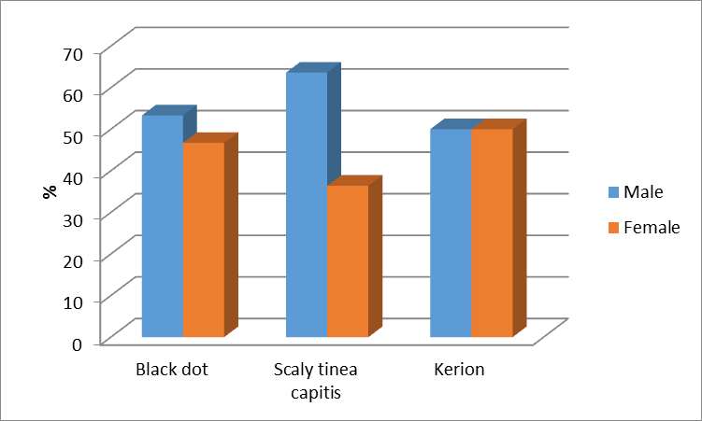

Fig(11)Relation between Clinical type and sex

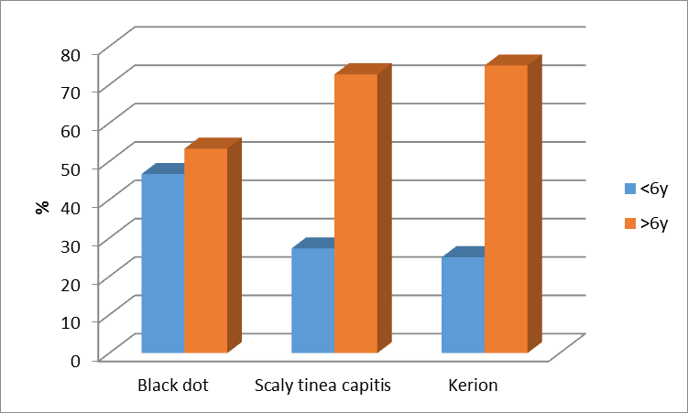

Fig(12)Relation between Clinical type and age

Table (11): Relation between Clinical type and age

|  |  |  |  |  |
| --- | --- | --- | --- | --- |
| Age | Clinical type | | | Test of significance |
| Black dot | Scaly tineacapitis | Kerion |
| <6y | 7 (46.7%) | 3 (27.3%) | 1 (25.0%) | X2=1.29 p=0.522 |
| >6y | 8 (53.3%) | 8 (72.7%) | 3 (75.0%) |
| Total | 15 | 11 | 4 |

χ2: Chi square test Not significant (P >0.05)

Table ( 12): Relation between Causative Organism and sex

|  |  |  |  |  |  |
| --- | --- | --- | --- | --- | --- |
| Sex | Causative Organism | | | | Test of significance |
| T.violaceum | M.canis | T.mentagrophytes | M.audouinii |
| Male | 8 (53.3%) | 5 (55.6%) | 2 (50.0%) | 2 (100%) | X2=1.67 p=0.643 |
| Female | 7 (46.7%) | 4 (44.4%) | 2 (50.0%) | 0 (0%) |
| Total | 15 | 9 | 4 | 2 |

χ2: Chi square test Not significant (P >0.05)

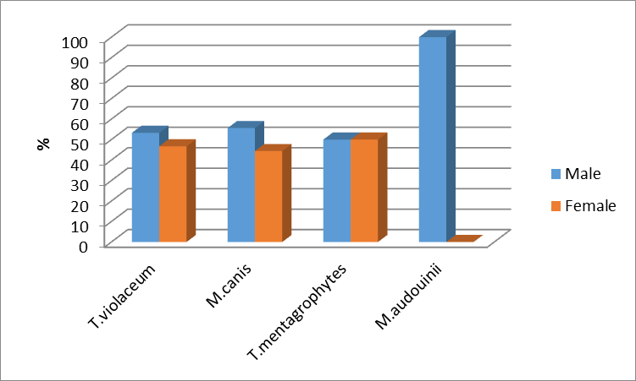

Fig (13) Relation between Causative Organism and sex

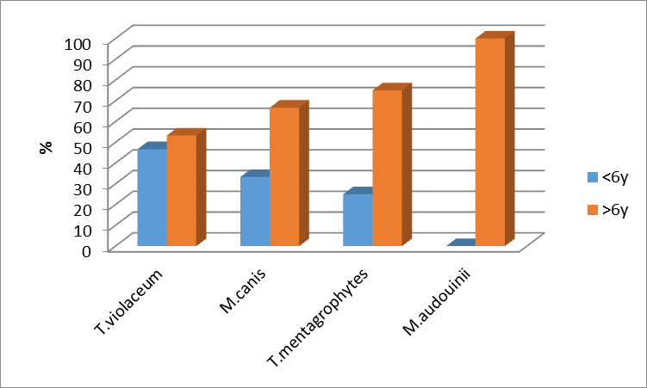

Fig (14) Relation between Causative Organism and age

Table (13): Relation between Causative Organism and age

|  |  |  |  |  |  |
| --- | --- | --- | --- | --- | --- |
| Age | Causitive Organism | | | | Test of significance |
| T.violaceum | M.canis | T.mentagrophytes | M.audouinii |
| <6y | 7 (46.7%) | 3 (33.3%) | 1 (25.0%) | 0 (0%) | X2=2.08 p=0.556 |
| >6y | 8 (53.3%) | 6 (66.7%) | 3 (75.0%) | 2 (100%) |
| Total | 15 | 9 | 4 | 2 |

χ2: Chi square test Not significant (P >0.05)

**4. Discussion**

Tineacapitis is a superficial fungal infection of hair and scalp; with a propensity for attacking hair shafts and follicles; that typically occurs in childhood with the highest incidence in children aged 3–7 years old and equally in both sexes. It is typically caused by Trichophyton and Microsporum species **(Sombatmaithai et al., 2015).**

Tineacapitis is primarily a disease of preadolescent children **(Drew et al., 2016).**

Clinical presentation of tineacapitis varies from a scaly non inflamed dermatosis resembling seborrhoeic dermatitis to an inflammatory disease with scaly erythematous lesions and hair loss or alopecia that may progress to severely-inflamed deep abscesses termed kerion, with the potential for scarring and permanent alopecia. The type of disease elicited depends on interaction between the host and the etiologic agents **(El-Taweel et al., 2014).**

Dermoscopy (dermatoscopy, surface microscopy) is a technique that uses a hand-held magnification device following the application of a liquid at the skin device interface or uses cross- polarized instruments. This technique allows the visualization of diagnostic sub-macroscopic, morphologic key structures of pigmented and non-pigmented skin lesions located in the epidermis down to the upper dermis not seen with the naked eye **(Menzies, 2013).**

The increasing use of dermoscopy in general dermatology can be partially explained by commercially available new generations of handheld dermoscopes, which are small enough to be easily placed in every dermatologist’s pocket. Moreover, some devices do not require direct contact between the patient’s skin and the optical glass plate, thus enabling a rapid and safe examination without the risk of possible transfection **(Zalaudek et al., 2013).**

Although Tcapitis is common superficial fungal infection of hair and scalp and may data reported about its different trichosopic criteria but there is few data about correlation between dermoscopic finding and causative organism.

So, the aim of this study was to study the correlation between different trichoscopic criteria and aetiological agents in tineacapitis.

It was carried out in Outpatient Clinic of Dermatology and Venereology of Al-azhar University Hospital (Damietta). The present study included 30 patients with tiniacapitis.

There was 17 males [56.7%] and 13 females [43.3%], with age ranged from 3 to 12 years with a mean of 6.90±2.24 years. The most age group affected in tineacapitis>6y [63.3%].

The results of this study showed Corkscrew hairs, comma-shaped hairs, zigzag shaped hair and morse code like hairs by dermoscopic examination of tineacapitis caused by T violavum, Mcanis, T mentagrophytes and M auduinii respectively.

The results of this study showed that 15 patient out of 30 with tineacapitis caused by T violacum and by dermoscopy showed corck screw hairs (50%).

This result agreed with the result of **Lu et al, 2016** who revealed cork screw hair were associated with tineacapitis caused by T violacuem.

This result agreed with the result of **Haliasos et al., 2013** who revealed.

Corkscrew-shaped hairs have been observed in dark-skinned patients with tineacapitis caused by trichophytonviolaceum.

This result disagreed with the result of **Hughes R et al, 2011** who revealed corkscrew hairs may be a characteristic dermoscopic pattern of T. soudanense TC.

The results of this study showed that 9 patient out of 30 with tineacapitis caused by M canisand by dermoscopy showed comma shaped hairs(30%).

This result agreed with the result of **Dong et al 2016** who revealed comma shaped hair were associated with tineacapitis caused by M canis.

This result agreed with the result of **Sandoval et al, 2010** who revealed comma shaped hair were associated with tineacapitis caused by M canis.

The results of this study showed that 2 patient out of 30 with tineacapitis caused by M audouiniiand by dermoscopy showed Morse code like hair (6.7%).

This result agreed with the result of **wang et al, 2010** who revealed Morse code like hair were associated with tineacapitis caused by M audouinii.

The results of this study showed that 4 patient out of 30 with tineacapitis caused by T mentagrophytes and by dermoscopy showed zigzag shaped hairs (13.3%) and no more data reported about correlation between T mentagrophytes and and its dermoscopic finding in literatures.

**References**

1. Arrazola-Guerrero J, Isa-Isa R, Torres-Guerrero E, Arenas R (2015): *Tineacapitis. Dermoscopic findings in 37 patients. Rev Iberoam Micol Oct-Dec;32(4):242-6.*
2. Charli Dong, John Angus, Fabia Scarampella and Moni Neradilek (2016): Evaluation of dermoscopy in the diagnosis of naturally occurring dermatophytosis in cats. Vet Dermatol; 27: 275–e6.
3. El-Taweel A, El-Esawy F, and Abdel-Salam O (2014): *Different Trichoscopic Features of Tinea Capitis and Alopecia Areata in Pediatric Patient. Dermatol Res Pract.*
4. Haliasos E., Kerner M., Jaimes N., Rudnicka L., Zalaudek I., et al. (2013): Dermoscopy for the Pediatric Dermatologist Part I: Dermoscopy of Pediatric Infectious and Inflammatory Skin Lesions and Hair Disorders. Pediatric Dermatol; 30(2): 163-171.
5. Hsaio-Han wang and Yu-Ting Lin (2015): bar code like hair dermoscopic marker of tineacapitis.
6. Hughes R, Chiaverini C, Bahadoran P et al. Corkscrew hair (2011): *anewder moscopic sign for diagnosis of tineacapitis in black children. Archives;147:355–356.*
7. Lacarrubba F, Micali G, Tosti A (2015): *Scalp Dermoscopy or Trichoscopy Curr Probl Dermatol Feb;47:21-32.*
8. Mao Lu, Yuping Ran, Yaling Dai, Song Lei, Chaoliang Zhang, Kaiwen Zhuang, And Wenying Hu (2016): An Ultrastructural Study on Corkscrew Hairs and Cigarette-Ash-Shaped Hairs Observed by Dermoscopy of Tinea Capitis 38, 128–132.
9. Menzies S. (2013): Evidence-Based Dermoscopy. Dermatol Clin; 31(4): 521-524.
10. Schechtman R C, Silva N D, Quaresma M V, Filho FB, Buçard A M, and Sodré C T(2015): *Dermatoscopic findings as a complementary tool in the differential diagnosis of the etiological agent of tineacapitis. An Bras Dermatol May-Jun;90(3):13–1.*
11. Sombatmaithai A, Pattanaprichakul P, Tuchinda P, and Muanprasart TC (2015): *Tineacapitis caused by Trichophytontonsurans presenting as an obscure patchy hair loss due to daily antifungal shampoo use. Dermatol Pract Concept 5(2): 133–5.*
12. Zalaudek I., Lallas A., Moscarella E., Longo C., Soyer HP., et al. (2013): The dermatologist’s stethoscope—traditional and new applications of dermoscopy. Dermatol Pract Concept; 3(2): 67-71.

11/25/2016