Solid Waste Management in Dev Sanskriti University, Shantikunj, Haridwar, India

Sushil Bhadula, Sudhanshu Kaushik and Pragya Sahu

Department of Environmental Science, Dev Sanskriti University, Haridwar
sushil.bhadula@dsvv.ac.in, sushil86.ntl@gmail.com

Abstract: This study is focused on Solid waste management in Dev Sanskriti University, Haridwar during the year April, 2014 to March 2015. During the present study four residential bhawans (buildings) namely: Kanva Bhawan, Shaunak Bhawan, Sandeepani Bhawan and Agastya Bhawan of Dev Sanskriti University were selected to know the present status of solid waste generation and management in University campus. Biodegradable and non-biodegradable waste was weighed and their composition was recorded. It was observed that highest mean value of biodegradable waste was recorded 690 Kg during the month of August at site-IV i.e. Agastya Bhawan and lowest mean value of biodegradable was found 310 Kg during the month of December at site-I i.e. Kanva Bhawan. Highest mean value of non- biodegradable waste was recorded 136 Kg during the month of August at site-IV i.e. Agastya Bhawan and lowest mean value of non-biodegradable was found 86 Kg during the month of December at site-I i.e. Kanva Bhawan. It was observed that solid waste management in Dev Sanskriti University is in proper manner and this University may as a training center for solid waste management. During our observation, it was found that most of the Solid waste reused, reduced and recycled in proper manner. Solid waste is also used for formation of biofertilizers, vermicompost, green manure, papers, folders, envelops etc. therefore solid waste is also great source of employment and income. It was observed that attitude and mindset of people and system of university play very important role in management of solid waste.
[Sushil Bhadula, Sudhanshu Kaushik and Pragya Sahu. Solid Waste Management in Dev Sanskriti University, Shantikunj, Haridwar, India. N Y Sci J 2016;9(11):56-61]. ISSN 1554-0200 (print); ISSN 2375-723X (online). http://www.sciencepub.net/newyork. 8. doi:10.7537/marsnys091116.08.

Key words: Solid waste Management, Awareness, Social organization

1.Introduction:
Solid waste is one of the biggest threats to environment. It is generally heterogeneous in nature and contains various types of matters such as paper, plastic, glasses, remaining of food items etc. In addition to that dead animals, chemicals, paints, hazardous medical waste, agricultural waste etc. are also regarded as Solid waste. In last two to three decades, population of India grown at tremendous rate which certainly leads in to urbanization and industrialization, which directly proportional to generation of solid waste. Improper management of solid waste may leads in to several types of pollution such as air water and soil pollution and cause different types of air and water borne diseases in human beings. India is second populous country of world and solid waste managementis important tool to manage the environmental conditions of any country. Different types of problems such as diseases transmission, air, water and soil pollution, economic losses, eutrophication in aquatic bodies occurs due to improper management of solid waste. Therefore, Hon’ble Prime Minister of India Sh. Narendra Modiji launched Swacch Bharat Mission (Abhiyan) on 2nd October, 2014 which covering 4041 statutory cities and towns to clean the streets, roads and Infrastructure of India.
Haridwar is one the holiest cities of India located at the bank of holy Ganga River and millions of devotees and tourists visit this place round the year. Population of Haridwar grown at tremendous rate but infrastructural activities relatively remains unchanged. Every year Haridwar city faces lot of problems due to improper management of solid waste. It is estimated that 70,000 visitors visit this holy city per day and these number can increase up to 200000-500000 during festive days. Researchers pointed out that number of patients related to water borne disease were increased after the famous Kanwar fair due to generation of solid waste (Saini, et. al. 2009). Dev Sanskriti University is an Indian university located 1km away from Shantikunj and Established in 2002 by act of the Uttarakhand legislative assembly is a fully residential university and running by Shri Vedmata Gayatri Trust, Shantikunj (Headquarter of All World Gayatri Pariwar). University provides various degrees, Diploma and certificate courses in the field of Yogic Science, Alternative Therapy, Indian Culture& History, Languages, Scientific Spirituality, Computer Sciences, Rural development, Environmental Sciences etc. This University is not only known for value based education but also for social welfare. Academics and volunteers of Dev Sanskriti University routinely participate in environmental related activities such as Ganga Clean Mission, removal of Solid waste from Ganga river canal, Plantation, Disaster Management etc. This university is fully residential and approximately 3000 persons including students residing within University campus. Education play very important role in development of any Nation and this unique University providing value based education to students. It is experienced that general awareness and education play important role in environmental management too. Therefore, this study conducted in Dev Sanskriti University to know the present status of Solid Waste Management and to know that how Dev Sanskriti University as model for Solid waste management for other cities of India in general and Uttarakhand in particular.

- Material And Methods
Study Area
Dev Sanskriti University: This University lies at 29.99° N, 78.19° E. The university is recognized by University Grant Commission, India under the 1956 act section 2(F), has also certified by ISO 9001: 2008 and accredited by National Assessment and Accreditation Council (NAAC).

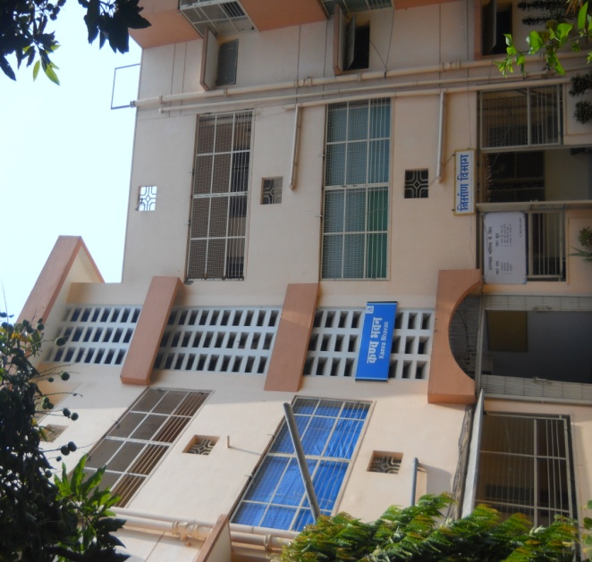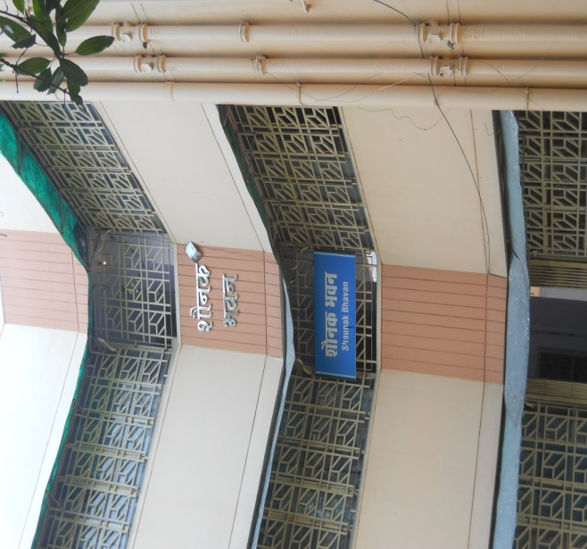
A
B
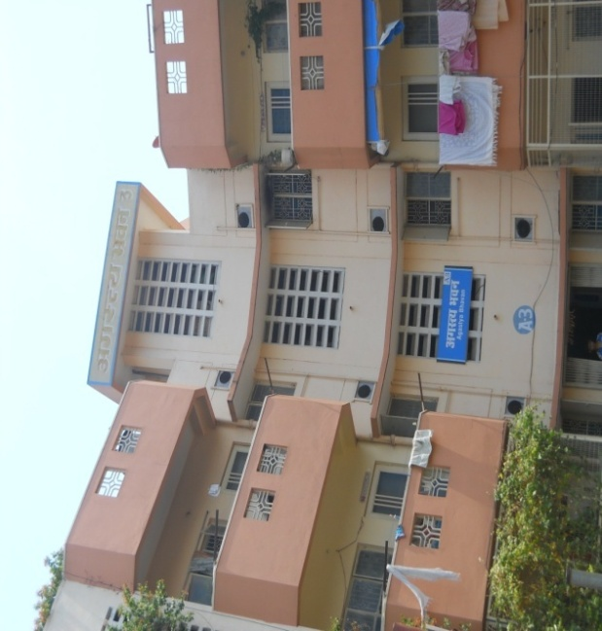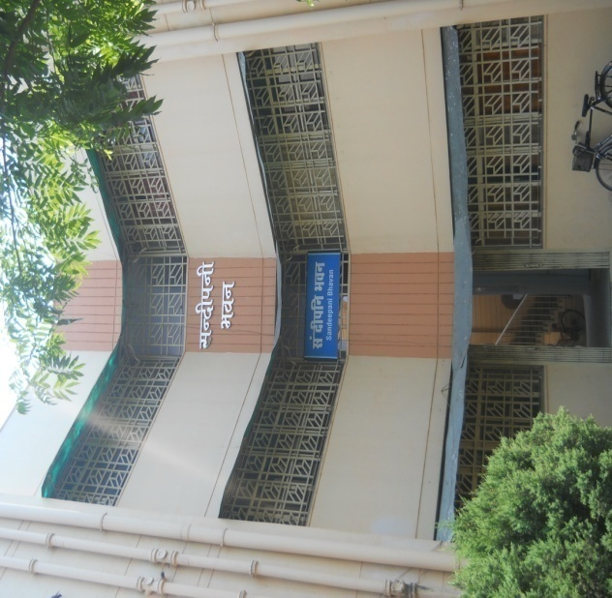
D
C
Photograph (A-D) Showing study sites i.e. residential buildings of University
- Kanva Bhawan
- Shaunak Bhawan
- Agastya Bhawan
- Sandeepani Bhawan

Four residential bhawans (buildings) namely Kanva Bhawan, Shaunak bhawan, Sandeepani Bhawan and Agastya Bhawan were selected for solid waste analysis. During the study period (April, 2014 to March, 2015) solid wastes were categorized into two categories, based on its gross composition biodegradable and non biodegradable at each sampling sites. Sampling was done round the year, solid waste were weighed separately for biodegradable and non-biodegradable with the help of standard book (Vinod Soni and Vinay Sharma, 2013).

2.Results and Discussion
The results of biodegradable and non-biodegradable waste are describe below and also presented in Table-2.
Biodegradable Waste: During the study period highest mean value of biodegradable waste was recorded 690 Kg during the month of August at site-IVi.e. Agastya Bhawan and lowest mean value of biodegradable was found 310 Kg during the month of December at site-I i.e. Kanva Bhawan.
Non- Biodegradable Waste: During the study period highest mean value of non- biodegradable waste was recorded 136 Kg during the month of August at site-IVi.e. Agastya Bhawan and lowest mean value of non-biodegradable was found 86 Kg during the month of December at site-I i.e. Kanva Bhawan.
There are very few systematic studies on role of educational institute in solid waste management; therefore we have very few amount of literature to compare our data with other studies. Shantikunj is autonomous body and situated 6 km from Haridwar railway station at Dehradun-Delhi highway. Shantikunj which literally means “Garden of harmony”, is a headquarter of All world Gayatri Pariwar and a Spiritual and Social organization established in 1971 by Pt. Shri Ram Sharma Acharyaji, who was one of the renowned scholars of India, social reformer and visionary of new golden era. Shantikunjis not only a spiritual and religious spot but also works for various socio-environmental issues such as National mission of clean Ganga, Plantation at the peripheral zone of Himalayan rivers, disaster management, solid waste management, vermi-composting, production of natural products, conservation of biodiversity etc. Every year volunteers of All World GayatriPariwar, Shantikunj removes huge of amount of solid waste from the riverine ecosystem of Ganga River. Bhadula and Joshi (2014) also studied on improvement in Environmental Conditions of Haridwar by cleanliness and Mass Awareness Programme Conducted by Shantikunj, Gayatrikunj, Haridwar and describe that most of the water quality parameters were better after removing huge amount of solid waste from Ganga canal. Kaushik and Joshi (2012) Solid waste management at Mansa Devi and Chandi Devi temple in the Siwalik foothills and pointed out that solid waste is improperly manage due to unawareness of visitors and lack of infrastructural facilities.
Solid waste has various negative impacts such as diseases, air, and water and land pollution to the concern area. During our observation, it was found that system of Dev Sanskriti University plays a very important role in the solid waste management. Mindset of the people is very clear they separate the solid waste right from their houses and then disposed in to two separate dust bins for biodegradable and non-biodegradable waste. Similarly, Gangwar and Joshi (2008) studied the quantity of solid waste during the ArdhKumbh period of 2004. They reported that 62.20% biodegradable, 17.14% Non-Biodegradable and 13.61% miscellaneous during the different festivals and it is because of unawareness and attitude of visitors. Education is an essential tool for achieving sustainability. People now recognize that current economic development trends are not sustainable and that public awareness, education, and training are the key to moving society towards sustainability (McKeown, 2002). Bhadula, et. al. (2013) studied on environmental condition of Sahastradhara stream and described that water quality parameters were degraded due to unawareness of touristic activities.
Bhadula and Joshi (2014) described that generation of solid waste certainly leads in to water pollution and it cause high BOD, turbidity, TDs and low dissolved oxygen, transparency in aquatic ecosystem. During our study period, it was revealed that most of the solid waste segregated at houses and building and remaining solid waste segregated at dumping sites for different uses such as biofertilizers, vermin-compositing etc. After one year of study it was also found that solid waste is also great source of income. Due to proper management and appropriate use of solid waste of University campus and Shantikunj, approximately Rs. 1455660.00 earned annually.
This biodegradable solid waste mostly used for formation of vermicompost, green manure, formation of papers/folders and non-biodegradable waste recycled and reused by different purposes. Solid waste certainly harmful environmentally, socially and economically. Therefore, it is necessary to manage solid waste at local, national and global level. On the basis of above account, it can be stated that if social organization, awareness of ethical people, infrastructural facilities and management of system can function together then we can change the negative impacts of solid waste in to positive impacts. But before change the negative impacts of solid waste in to positive impacts we must change the mindset of people about the earth and environment then we can achieve the objective of Swacch Bharat Mission.

Table:-1: Table showing vehicles and workers in Dev Sanskriti University for Solid Waste management.
S. N. | Type of Vehicle | Use
1. | Trolley (04) | For Transportation of Solid waste of University Campus
2. | Truck (01) | For Transportation of Solid waste of Shantikunj
3. | Workers (10) | For Collection, Separation and Disposal of Solid Waste

Table:-2: Table showing Solid waste generation from three selected buildings of Dev Sanskriti University. (All values are in mean and in Kilogram)
Name of Bhawan (Building) | Kanva Bhawan |  | Shaunak Bhawan |  | Sandeepani Bhawan |  | Agastya Bhawan |  | Total
 | Bio. Waste | Non-Bio. Waste | Bio. Waste | Non-Bio. Waste | Bio. Waste | Non-Bio. Waste | Bio. Waste | Non-Bio. Waste
April | 410.0 | 110.0 | 525.0 | 122.0 | 580.0 | 121.0 | 625.0 | 127.0 | 2620.0
May | 421.0 | 108.0 | 532.0 | 128.0 | 578.0 | 126.0 | 631.0 | 126.0 | 2650.0
June | 315.0 | 98.0 | 340.0 | 124.0 | 502.0 | 110.0 | 540.0 | 101.0 | 2130.0
July | 510.0 | 105.0 | 451.0 | 130.0 | 516.0 | 116.0 | 587.0 | 110.0 | 2525.0
August | 485.0 | 115.0 | 460.0 | 134.0 | 548.0 | 124.0 | 690.0 | 136.0 | 2572.0
September | 466.0 | 107.0 | 510.0 | 126.0 | 568.0 | 121.0 | 620.0 | 119.0 | 2637.0
October | 431.0 | 102.0 | 503.0 | 129.0 | 570.0 | 130.0 | 654.0 | 125.0 | 2644.0
November | 425.0 | 108.0 | 508.0 | 121.0 | 582.0 | 127.0 | 651.0 | 121.0 | 2643.0
December | 310.0 | 86.0 | 322.0 | 109.0 | 403.0 | 105.0 | 410.0 | 104.0 | 1849.0
January | 422.0 | 102.0 | 425.0 | 127.0 | 510.0 | 132.0 | 438.0 | 115.0 | 2271.0
February | 400.0 | 108.0 | 407.0 | 123.0 | 507.0 | 120.0 | 552.0 | 112.0 | 2329.0
March | 428.0 | 110.0 | 448.0 | 132.0 | 570.0 | 122.0 | 580.0 | 126.0 | 2516.0
Total | 5023.0 | 1259.0 | 5431.0 | 1505.0 | 6434.0 | 1454.0 | 6878.0 | 1402.0 | 29386.0

Table-3: Annual Income (In Rupees) by the Solid waste management
Biofertilizers/Manure | Vermicomposting | Recycle of Papers | By Non-Bio. Waste | Total
495090/- | 320570/- | 400000/- | 240000/- | 1455660/-

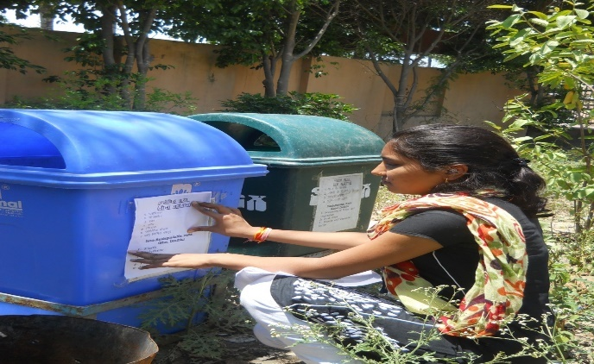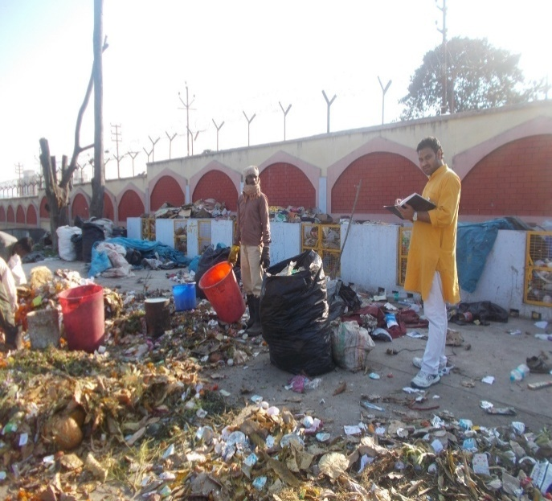

Researcher affixing the prepared Performa Performa for using biodegradable and non- Biodegradable
Picture showing chambers for segregation of Solid waste in University Campus.

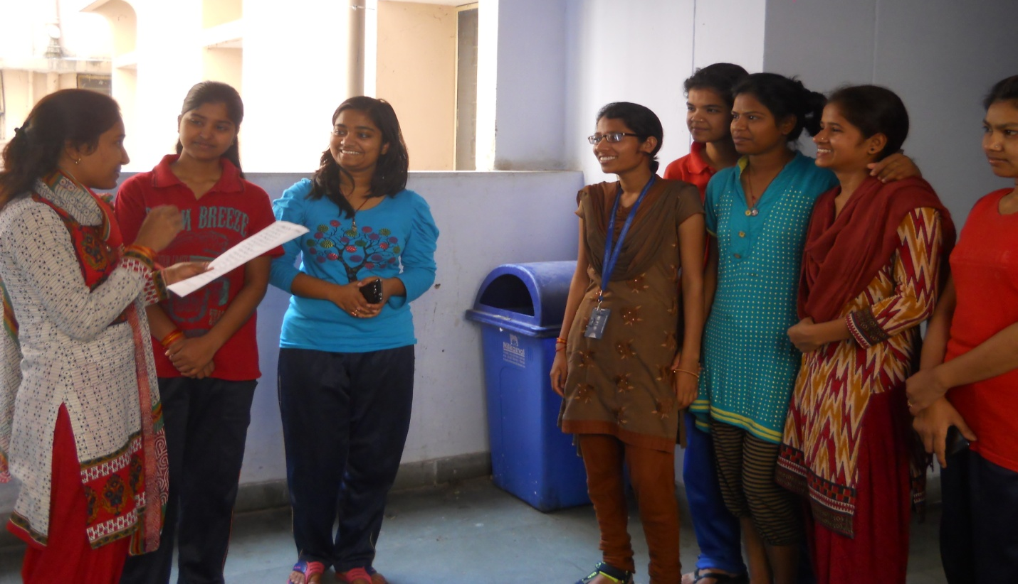
Researcher aware the students about the impacts of solid waste and its management

Conclusion:
In the present study, it is concluded that Dev Sanskriti University, Haridwar properly managing the solid waste of University campus as well as of Shantikunj. Dev Sanskriti University may be as a model for other cities such as Haridwar which certainly facing lot of problems due to improper management of Solid waste.

Acknowledgement
The authors are thankful to Dr. Chinmay Pandya, Pro-Vice Chancellor of Dev Sanskriti University for valuable guidance and encouragements. The authors extend thanks to Administration and Management of Dev Sanskriti University for providing necessary equipment during study period. Authors are also acknowledged Shree D.P. Singh, Sh. Rajkumar, Shri. Sudhir Shripad, Shri Shailendra Patel for their valuable cooperation during the present work.

Corresponding author:
Dr. Sushil Bhadula
Assistant Professor
Dev SanskritiUniversity
Gayatrikunj, Shantikunj
Haridwar
Phone: +91-9027571658
Email: sushil.bhadula@dsvv.ac.in

References
- Bhadula S, Joshi B.D. Impact of Religio-Touristic Activities on the Water Quality of Ganga River and Solid Waste Generation within Haridwar City, India. International Journal of Plant, Animal and Environmental Sciences. 2014; 44 (4):309-315.
- Bhadula, S and Joshi, B.D. Improvement in Environmental Conditions of Haridwar City by Cleanliness and Mass Awareness Programme Conducted by Shantikunj, Gayatrikunj, Haridwar with Special Reference to Ganga Water Quality: A Case Study. Proceeding of National Seminar on Ancient and Spiritual Sciences. ISBN. 978-93-81212-22-6. Published by Bharti Publication. New Delhi. Pp. 2014; 459-464.
- Bhadula, S. and Joshi, B.D. An Assessment of Solid waste generation during the Religious occasions at Haridwar city. International Journal of Nature and Research. 2014; 3, 1-7.
- Bhadula, S., Sharma, V. and Joshi, B.D. Impact of Touristic Activities on Water Quality of Sahashtradhara Stream, Dehradun. Int. Journal of Chem & Tech. 2013; Vol. 6 (1). 213-221.
- Gangwar, K. K, Joshi B.D. A preliminary study on solid waste generation at Har- Ki- Pauri, Hardwar, during the ardh-Kumbha period of sacred bathing, in the river Ganga in 2004.The Environmentalist. 2008; 28 (3): 297-300.
- Kaushik, S. and Joshi, B.D. (2012): Solid waste management at Mansa Devi and Chandi Devi temple in the Siwalik foothills, during Kumbh Mela at Haridwar (Uttarakhand). New York science Journal 4(8): 39-42. ISSN: 1554-0200.
- McKeown, R. Education for Sustainable Development Toolkit, vol.2, University of Tennessee, USA. 2002; <http://www.esdtoolkit.org> (September, 2004).
- Saini P, Sharma V, Joshi B.D. A random survey report about rise in water borne diseases in Haridwar city during Kanwar mela-2008. Journal of Environment and Biosciences. 2009; 23: 215-220.
- Zade, J.G.M, Noori, R. Prediction of solid waste generation by use of artificial neural network: A case study of Mashhad. International Journal of Environment Research. 2008; 2(1): 13-22.

11/9/2016

