People perception and coping strategies on climate in Dhauladhar area of western Himalaya

Attri, P. K., Poonam Thakur & V.K. Santvan

IIHS, Himachal Pradesh University, Summerhill, Shimla-5(H.P.) INDIA
Corresponding author: dr_pk@rediffmail.com

Abstract: Climate is the major determinant responsible for fluctuation in agricultural productivity and largely determined the suitability of vegetation in particular area. It alter distribution quality of natural resources and adversely affect the livelihood of people of any region. It is generally agreed by the world’s scientific community that future changes in climate are likely to have a profound impact on world’s forests. A warmer climate in the Himalayas will accelerate the hydrological cycle; enhancing rainfall and snowfall events, setting a stage for potential for floods, extent and timing of runoff. Climate change is also likely to affect change in moisture regimes, ground water recharge and droughts. The present work is to understand the impacts of climate change in the four villages of Palampur tehsil present at the base of Dhauladhar range by taking into account people's perception, and to know how and to what extent they are adjusting and/or not adjusting to these changes. This study reveals that it will take a long time for climate change impacts to become evident in this area but definitely people’s perceptions are very much useful to establish the fact that the villages are facing indirect problems in agricultural production and in other livelihood options of shepherds and herdsmen.
[Attri, P. K., Poonam Thakur & V.K. Santvan. People perception and coping strategies on climate in Dhauladhar area of western Himalaya. N Y Sci J 2016;9(10):89-95]. ISSN 1554-0200 (print); ISSN 2375-723X (online). http://www.sciencepub.net/newyork. 15. doi:10.7537/marsnys091016.15.

Keywords: People; perception; strategy; climate; western Himalaya

Introduction
Climate change is now recognized as phenomenon that will be seen and experienced by people all over the world. It poses new challenge resource management and livelihood. The poor people are most vulnerable to climate change, which will increase their vulnerability and make pro-poor growth more difficult. The impacts of climate change are evenly distributed in intensity within the region and among communities. India is most populous country in the world with a population of 100 crore people, keeping pace with growing population rapid industrialization and urbanisation in India. Climate change could put additional pressure on its overall ecology and socio-economic systems. India has reason to be concerned about climate change such as changes on forest and water resources and sea level rise. In addition to the already existing threat and pressure on mountain ecosystem, climate change can be an additional burden to bear by the mountain ecosystems, species and peoples. The current rate is very rapid which adds to the socio-economic pressure. The Himalayan mountain ranges are more fragile, complex and vulnerable to global climatic change. The impacts of ongoing changes in climate have already being experienced by the hill communities. The economy of the Himalayan region is fully dependent on natural resources. In order to understand how human beings would respond to climate change, it is essential to study people's perceptions of climate and the environment in general. (Vedwan et al. 2001). Studies focusing on the socioeconomic aspects of climatic change are sparse and have almost exclusively restricted their analysis to the impact of environmental modifications on agricultural production (Scott et al. 1990). This study is important in a way that it takes into account local people's awareness of weather fluctuations and aims at understanding the localized impact of the climate in this region which are not directly visible but changes, nevertheless, are happening indirectly.
Although earlier studies conducted indicate changes in plant phenology over the advancement of flowering in Rhododendron arboreum and movement of species (like Tagetis minuta, Lantana camara and Eupatorium sp) to higher ridges may be the earliest response to moderate climate change (Moza and Bhatnagar 2005, Maikhuri et al 2003, Joshi 2011 Ravindranath, N.H et al 2006 (India)). Abu Reza Md. et al, 2014, M. A. Rakib et al. 2014. (Bangladesh ), Millicent A. Ochieng & James Koske 2013, Jokastah Wanzuu Kalungu et al 2013 (Kenya ), Cyprian A. Egbe, et al 2014, Ishaya, S. and Abaje, I. B. 2008 (Nigeria ), Richard J. Bord, et al 1998 (United States ). Walter Leal Filho 2009, Francis Kemausuor et al.2011, (Ghana), Manuel Boissière, et al. 2013 (Indonasia) Rohini P. Devkota 2014(Nepal), Anita Kumari et al 2012, Jasjit singh Walia, 2009(Himachal Pradesh) The climate change adaptation and mitigation are meant to enhance ecosystem services like carbon sequestration and storage (in forest and other ecosystem), hydrological services and biodiversity along with provisional services like fuel, small timber and NFTPs.
Changes in natural resource base due to global warming will affect livelihood of local communities. Rapid melting of Himalayan glaciers or decrease in snow cover has affected the overall availability of water for drinking, agriculture, hydropower and other purposes. Shift in forest vegetation, biodiversity and cover will have positive or negative impact on the livelihood of local communities. Therefore, there is an urgent need to study the community perceptions on climate change, key local indicators and perceived impact coping mechanisms for future planning.
Methodology
The climate change impact study was done in four villages in different altitudes Droganu Khilaru, Langha and Saanh of Palampur through questionnaires. Randomly 40 questionnaires were filled in each village on the basis of total household per village. The information was gathered after long session and discussion with members of each household viz: climate change, region of climate change, suggestion on mitigation of climate change, phenological changes in different plants (flowering and fruiting), changing in monsoon pattern (rain fall and snow fall). Socio economic status was also considered from the villagers due to climate change impact. It also included collection of data both from primary and secondary sources.
Study area
Palampur tehsil is located at 32.12ºN 76.53º E at a height of 1220 m above sea level. Palampur tehsil lies in a wet, temperate zone where the temperature ranges from 15 º to 19º C and annual rainfall is 2500 mm making it wet place in Himachal. The effect of climate change is studied in the four villages of Palampur tehsil present at the base of Dhauladhar.

Result and Discussion
Cropping Pattern of the study areas:
Graphs showing change in land pattern of villages and their cultivated and uncultivated area.

Characteristic features of study area:

Parameters |  | Villages
Parameters | Khilaru (Alt.1203-1265) | Langha  (Alt. 1552-1735) | Drogannu  Alt. (1458-1595) | Saanh  Alt. 1527-1585)
Total Area  ( in Hectare) | 47 | 67 | 65 | 34
Population | 1154 | 280 | 533 | 324
Cultivated land  (in Hectare) | 26 | 8 | 19 | 16
Uncultivated land (in Hectare) | 30 | 59 | 47 | 18
Forest area  (in Hectare) | 5 | 27 | 3 | 4
Grazing land  (in Hectare) | 4 | 16 | 33 | 10
Tea garden  in Hectare) | 8 | 0 | 0 | 0
Main crops | Wheat, Maize | Wheat, maize | Wheat, Maize | Wheat, Maize

- Khilaru village land pattern:
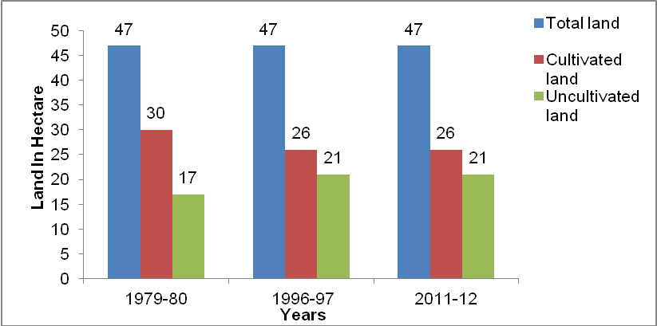
Fig. 1 showing change in land pattern of Khilaru village.

- Langha village land pattern:

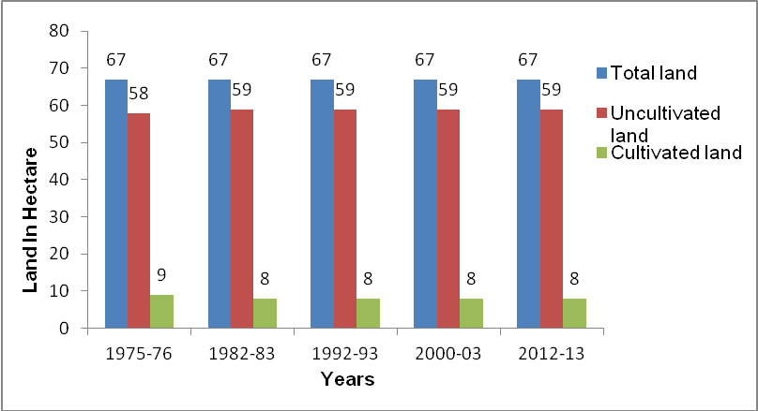
Fig.2 showing change in land pattern of Langha village in subsequent years.

- Land pattern of Drogannu village:

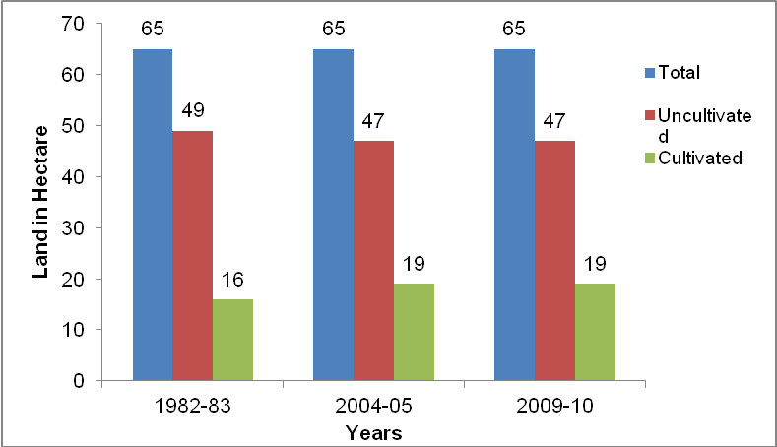
Fig. 3 showing land pattern of Drogannu village.

- Land pattern of Saanh village:

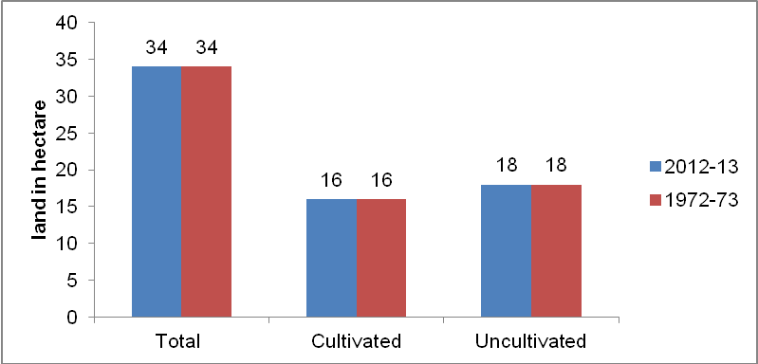
Fig.4 showing land pattern of Saanh village.

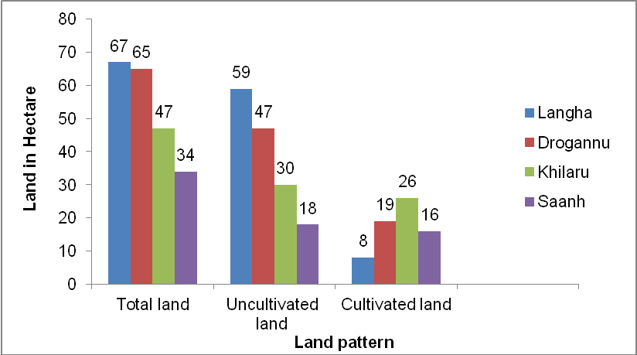
Fig. 5 showing land pattern of four villages Langha, Khilaru, Drogannu and Saanh.

Climate change effects on Socio-economic status
The socio‐economic status has been totally affected by climate change. 10 to 15 years ago, food grains and vegetables were available for 10‐12 months of the year. But now the farmers are totally depend on the markets for food grains and other necessary item. Because of the depleting income, the poor farmers of village now can no longer afford food grains and other necessary items at market rates.
People perception and their responses on climate change in the areas
The people of all the four villages were asked a number of questions to understand their awareness regarding the altered weather conditions, seasonal variations, monsoon arrival, changes in agriculture, and horticulture yields etc. over a period of time.
Unseasonable rain since the last 8‐10 years. Decreasing moisture and increasing heat and drought due to lack of snowfall. 10‐15 years ago snow fall was about 4‐5 feet but after the year 2000 there has been little or no snow fall. Low crop production due to climatic disturbances like variation in the amount of rainfall, snow fall and fluctuations in temperature. Decrease in water level decreasing due to high temperate and lack of rains.
Temperature
According to the information collected from people temperature has increased a lot from the past years. There is more variation in the temperature. However, the month of March is colder than it was in last 2, 3 years. There is also decrease in fog and hoarfrost. There was more snowfall this year. Generally in past days snow remained for 8 -10 days in village but in recent years it remained only for 2-3 days in the villages. People also believed that winter months had become warmer. Hoarfrost (Pala) and winter rains have declined. Duration of fog has decreased. Shivering during winter has decreased.
Rainfall
Feedback, from the people, report changes in intensity and duration of rainfall. Perceptions indicated alternative rainfall, i.e. one year good and timely onset and the next year less and delayed rains. They further point out a significant decrease in the number of cloudy days during monsoon. During the month of march there is more rainfall than the earlier years. Due to which the crop is harvested late due to heavy rainfall in the area this year. This shows there is greater impact of climate on the rainfall pattern.
Agriculture
Agriculture is a key source of livelihood for 74% of the people in Himachal Pradesh. There is major contribution of agriculture and animal husbandry. Main crops of the villages are wheat, maize, and potatoes. For the sowing of crops farmers are dependent upon rainfall. There is decrease in the area under production of these crops. Cow dung was used as manure in past and now few people use it these days. Presently more chemical fertilizers are used by local people for better crop yield. Attack of insect-pest and crop diseased has increased. Crops like Kodra, Siul were grown in past years in the area but now they are not grown.
Dependence upon agriculture for livelihood has decreased. People for their livings are dependent on other sources. Hence, there is decrease in agriculture than that was in past years.
Weeds
Two weeds are common in these villages. These weeds are Lantana camara locally called Vasuti and Kala Phulanu (Ageratina adenophora). They have increased in the forest and in the grass fields. Although these weeds exist throughout the year; their spread is restricted by the winter cold. However, as winters are getting warmer, the spread of these weeds may be intensified. These weeds replaced the grass found in the forest under trees. Due to which there is decrease in the availability of fodder grass in the area.
Water resources
Water resources Baain in local language are in the urge of drying. In the earlier days these are used by people for fresh drinking water but now due to supply of water at their home they are not interested in the maintenance of these. These are the natural sources of water in the area which definitely are going to dry. Now days they are totally ignored by the people. Now only the few are left with clean drinking water.
The percentage values of respondent to each checklist of uses are as follows:
About winters:
- 30 % of people are aware about climate change.
- 90% of people found decrease in the fog from past years.
- 90% of people felt change in the duration of winter (changed from 4 to 2 months).
- 80% of people felt that month of March has become more warm as compared to past years.
- 70% of people felt that hoarfrost (Pala) and winter rains have declined.
- 80% of people found there is more intense sunlight in winters.
About Summer:
- 80% people felt more sweat conditions in summer.
- 70% of people felt increase in the humidity.
About Monsoon:
- All the people found that there is variation of rainfall in the area.
- 60% of people found that number of cloudy days have decreased from past few years.
Decrease in the agricultural production of crops:
- 70% people found decrease in the yield of wheat.
- 90% people found decrease in the yield of maize from past years.
- 80 % of people felt that the yield of potatoes has decreased.
Dependency upon rain:
- The dependency of crops on rain is 100%.
Change in flowering, fruiting and harvesting time of crop:
- 80% of people felt there is change in the flowering, fruiting and harvesting time of crop.
Occurrence of weed:
- 100 % of people felt that there is increase in the weeds from past 5 to 6 years.
Reason of climate change according to villagers
- Increase in human population.
- More pressure on forest for fuel wood, fodder and, timber wood and encroachment.
- Lack of community awareness about the climate change and role of forest in mitigation of climate change.
- Intentional and unintentional forest fire by the human beings, which is increase the carbon dioxide in the atmosphere and disturbances of the monsoon pattern.
- Increase in the use of plastic bags, bottle and other non degradable matter.
- Air pollution is increasing by motor vehicle and factories and hydropower projects.
- Use of more chemical fertilizers to obtain higher yield.
Coping and mitigation strategies:
As people have recently started realizing these changes, there are some minor adaptations practices being taken up by the villagers. It seems that gradually people would come up with more such practices, as they realize the gravity of the situation, in the foreseeable future. Some of these are presented below:
- People's participation is now considered as a prerequisite to success of any land rehabilitation effort. The villagers are aware about change in climate due to deforestation. So peoples are taking part in the afforestration of bare land. Most timber operations are commercially managed, which can simplify through replanting.
- There has been a subsequent increase in the area under cash crops, like tomato, onion, potato, etc., because of less productivity of traditional crops like wheat, maize. Cash crops require less area and generate more output than traditional crops in relatively less time. Cash crops like potatoes, vegetables and fruiting trees like Anar (Punica granatum), Akhrot (Juglans regia) are shown in place of crops due to better environmental conditions for these plants and higher market value.
- People are replacing their buffaloes with cows, as buffaloes need more fodder and require stalled feeding. Cows can be sent off for open and free grazing and they require less fodder compared to buffaloes.
- People have now resorted to using metal doors and windows instead of wooden ones, due to the increased termite attacks.
- Weeds grown around the agricultural field are burned knowing that these are spreading all over eradicating locally found fodder grass.
- Popularization of protected cultivation of horticultural crops the villagers are using growing these in the field.
- Use of fertilizers in place of cow dung is prominent in the field for the high crop production.
Suggestion for mitigating/ reducing the effect of climate change
- Sincere and concerted effort should be made to save and to protect the forest.
- Drive to plantations should be initiated the community level.
- Proper mechanism/devices to control pollution and preserve ecology in the area of hydro electric projects.
- Efforts should be made to create awareness among the people about the effect of climate change and its consequences, through various types of mass media like TV, radio, film, newspapers etc.

Conclusion
According to the people’s, climate has been changing since the last 10‐15 years. The clear indication of climate change has been seen in nature like increasing temperature, unseasonal rain, draughts, loss of nutrients and less snowfall.
The present study was successful in discovering that local people realized that the climate is changing or at least they were aware of an increased variability in the weather. Overall, of course the climate is described as being much warmer, but people's perception of temperature changes should not simply described as an increase or a decrease in annual temperatures. They are mainly related to change distributions. (Vedwan et al. 2001). Weather cycle at the local level is displaying a slight shift and so is the temperature. For example‐ the cold weather is now confined to January and February. The months of July and August now witnesses very hot temperatures instead of usual rainy, warm and humid patterns.

References
- MSSRF, AFPRO (2008) Community level adaptation to climate change, A road map for policy development, November 2008. NAPCC (2008) National Action Plan on Climate change, Prime Ministers council on climate change, Government of India, 30th June 2008.
- Rebetcz M (2000) Public expectations as an element of human perceptions of climate change, climatic change, Springer, Netherlands, Vol. 32, p. 495‐509.
- Scott M.S., Rosenberg NJ, Edmonds JA, Cushman RM and 7 others (1990), Consequences of climate change for human environment, Clim Res. 1:63‐79.
- Fussel, H.M; and Klein, R.J.T (2002). Assessing the vulnerability and adaptation to climate.
- change: “ An Evolution of the conceptual thinking”, Paper presented at W.N.D.P. Expert group meeting on Integrating Disaster Reduction and Adaptation to climate change, Havana.
- Cuba, 17‐19 June, 2002.
- Ravindranath, N.H., Joshi, N.V., Sukumar, R., and Saxena, A. 2006 Impact of climate change on forests of India. Current science, Vol. 90, No. 3, 10 February 2006 pp 354‐361.
- Mst. Karimon Nesha, A Atiq Rahman, Khalid Hasan, Ziauddin Ahmed. 2014 People’s Perception in relation to Climate Change and its Adverse Effects in Rural Bangladesh. Journal of environment and Human (1)32373-8332.
- M. A. Rakib et al. 2014. Climate change: farmers perception and agricultural Activities. Herald Journal of Geography and Regional Planning Vol. 3 (3): 115 - 123.
- Francis Kemausuor et al. 2011. Farmers’ perception of Climate change in the Ejura-Sekyedumase District of Ghana. ARPN Journal of Agricultural and Biological Science, (6)10, 26-37.
- Walter Leal Filho. 2009. Communicating climate change: challenges ahead and action needed. International Journal of Climate Change Strategies and Management (1):1, pp. 6-18.
- Richard J. Bord, et al 1998. Public perceptions of global warming: United States and international perspectives, Climate Research 11:pp. 75–84.
- Ishaya, S. and Abaje, I. B. 2008 Indigenous people’s perception on climate change and adaptation strategies in Jema’a local government area of Kaduna State, Nigeria. Journal of Geography and Regional Planning 1(8), pp. 138-143.
- Cyprian A. Egbe, et al. 2014. Rural Peoples’ Perception to Climate Variability/Change in Cross River State-Nigeria. Journal of Sustainable Development; (7):2: pp.25-36.
- Jokastah Wanzuu Kalungu et al. 2013. Smallholder Farmers’ Perception of the Impacts of Climate Change and Variability on Rain-fed Agricultural Practices in Semi-arid and Sub-humid Regions of Kenya, Journal of Environment and Earth Science, (3)7pp. 129-137.
- Millicent A. Ochieng & James Koske 2013. The Level of Climate Change Awareness and Perception among Primary School Teachers in Kisumu Municipality, Kenya. International Journal of Humanities and Social Science (3) 21:pp 174-181.
- Abu Reza Md. et al, 2014. Climate change impact: Food production and local Perception. American Journal of Environmental Protection. 3(2): 45-50.
- Anita Kumari et al (2012) Climate change - an impact study in Himachal Pradesh International Journal of Farm Sciences 2(2):95-101.
- Jasjit singh Walia (2009) Impact of climate change and Himachal Pradesh’s action plan strategy on forestry. Indian forester 1155-1164.
- Manuel Boissière,et al. 2013 Local Perceptions of Climate Variability and Change in Tropical Forests of Papua, Indonesia, Ecology and Society 18(4): 13.
- Karen Akerlof et al 2010 Public Perceptions of Climate Change as a Human Health Risk: Surveys of the United States, Canada and Malta. Int. J. Environ. Res. Public Health, 7, 2559-2606.
- Rohini P. Devkota 2014Climate Change: Trends and People’s Perception in Nepal Journal of Environmental Protection, 5 pp.255-265.

10/18/2016

