**Geophysical Logging of a Borehole for Supply of Potable Groundwater at Opuama Community, Warri North L.G.A., Delta State, Nigeria**

*Ngah, S.A and **Nwankwoala, H.O

*Institute of Geosciences and Space Technology, Rivers State University of Science and Technology, Nkpolu-Oroworukwo, Port Harcourt, Nigeria

**Department of Geology, University of Port Harcourt, Nigeria

**Abstract:** The study aims at establishing the geophysical characteristics of subsurface lithologies traversed during the borehole drilling, assessment of the potentiality of any existing aquifer(s) as well as to design the borehole if possible for installation of casings, screens and gravel pack. The Spontaneous Potential (SP) and Resistivity (Short and Long Normal) geophysical methods were adopted. The short spacing of the Resistivity log is useful in locating strata interface while the long one provides better information on the formation lithology (grain sizes) as well as fluids in permeable strata. The resistivity values of the sands where considerably low, an indication of presence of high iron contents and saline water zones. On basis of the information deduced from the geo-electric logs, drill cuttings and review of the geology of the area, the freshwater bearing aquifer occur at depth of about 107 - 116m (350 - 380ft). The well completion could be carried out as designed with installation of screens, casings, rice gravels and cement/bentonite groutings. The rice gravels to be installed shall have grain sizes in the range of 0.25mm – 1.0mm with not more than 10% of the material having a grain size less than 0.50mm. It is recommended that investigations of geophysical logging in the groundwater wells in the Niger Delta be carried out for a better constrained permeability and porosity values determination.

[Ngah, S.A and Nwankwoala, H.O. **Geophysical Logging of a Borehole for Supply of Potable Groundwater at Opuama Community, Warri North L.G.A., Delta State, Nigeria.** *N Y Sci J* 2016;9(10):83-88]. ISSN 1554-0200 (print); ISSN 2375-723X (online). <http://www.sciencepub.net/newyork>. 14. doi:[10.7537/marsnys091016.14](http://www.dx.doi.org/10.7537/marsnys091016.14).

**Key Words:***Groundwater, Logging, Borehole, Geophysics, Resistivity, Subsurface lithology*

**Introduction**

The study aims at establishing the geophysical characteristics of subsurface lithologies traversed during the borehole drilling, assessment of the potentiality of any existing aquifer(s) as well as to design the borehole if possible for installation of casings, screens and gravel pack. Downhole logging is used to evaluate the character and thickness of the different geological materials penetrated by wells and test holes (Anomohanran, 2015). Geophysical logging methods provide an additional toolbox to identify groundwater bearing layers in the sub-surface once a borehole is drilled. In general, a tool comprising of several measurements devices is lowered into the borehole and continuous readings of physical values are made and sent via the cable to the surface unit. The interpretation of such data allows a better identification of the subsurface layers regarding groundwater presence and also of thin layers, which often cannot be identified during surface geophysical methods or drilling. With the knowledge of layer type and depth the setting of the casing can be improved and by this the maximum possible yield achieved (Delleur, 2000).

The site is geographically located at Latitude 50 54.292’, Longitude 50 04.240’ and O. D. Elevation of 3 meters. The study area lies within the Niger Delta that covers most areas of Bayelsa, Rivers and parts of Delta State. It consists of broad riverine areas through which the River Niger enters the Atlantic Ocean. It is divided into numerous rivulets which fan out into the sea. It also includes a number of tidal creeks separating small islands of less than 10m above sea level. The major River system in the area consists of New Calabar, Andoni, St. Nicholas and Sombreiro.The thick succession of sediments forming the present Niger Delta has been described as consisting of three lithostratigraphic units namely: Benin Formation (Miocene – Recent) at the top, the Agbada Formation (Eocene) at the middle and Akata Formation (Paleocene) at the base. These materials are believed to have been deposited in a continental fluviatile to deltaic environment. The geological sequence of the quaternary sediments is as follows;

Qa - Alluvium.

Qs - Meander belts, back swamps and fresh water swamps made up of sands, gravels and clays.

Qm - Mangrove swamps made up of sands, clays and mangrove swamps.

Qbr - Abandoned beach ridges made up of sands and pebbles.

Qsd - Sombreiro-Warri Deltaic plain made up of sands, clay and mangrove swamps.

Qp - Coastal Plain Sands made up of sands and clay.

The underlying rock types are generally characterized by good aquifers made up of fine – coarse sands. The sand and clay intercalations constitute a system of aquifers separated by aquitards. The aquifer-aquitard units reoccur several times in the sequence to form the multi-aquifer systems that characterize the area. Lithologic and down-hole geophysical logs from previous shallow and deep water supply borehole projects indicate high tendency for high Iron contents and saltwater occurrence. Depths of boreholes in the area range from 15m to 600m. Several boreholes exist in the area but no technical and water quality information was readily available.

**Methodology**

**Geophysical Methods**

The Spontaneous Potential (SP) and Resistivity (Short and Long Normal) geophysical methods were adopted. The short spacing of the Resistivity log is useful in locating strata interface while the long one provides better information on the formation lithology (grain sizes) as well as fluids in permeable strata. The procedure involved lowering of the multi-electrode probe manually to the bottom of the logged hole while readings were taken at intervals of 0.76m (2.5ft) and later 1.5 (5ft) as the cable was pulled out of the hole. The depth of the logged hole was 116m (380ft). Due consideration was given to the geology of the area, driller’s daily diary and drill samples in the Interpretation of geophysical logs. The field work was done using Keck Resistivity (DR) electric logging system made in Denver, Colorado, USA. It has excellent open hole detector (probes) of higher resolution for geologic beds.

**Results and Interpretations**

|  |  |  |  |  |  |
| --- | --- | --- | --- | --- | --- |
| **S/N Depth (m) Depth (ft)** | | | **Spontaneous (Resistivity ohm)**  **Potential**  **SP(Mv) Short Normal Long Normal** | | |
| 1 | 1.52 | 5.00 | - 310.00 | 1.83 | 0.00 |
| 2 | 3.05 | 10.00 | - 300.00 | 1.52 | 9.14 |
| 3 | 4.57 | 15.00 | - 313.00 | 1.83 | 9.14 |
| 4 | 6.10 | 20.00 | - 312.00 | 1.52 | 6.10 |
| 5 | 7.62 | 25.00 | - 317.00 | 1.22 | 12.19 |
| 6 | 9.15 | 30.00 | - 313.00 | 1.83 | 12.19 |
| 7 | 10.67 | 35.00 | - 315.00 | 0.91 | 12.19 |
| 8 | 12.20 | 40.00 | - 305.00 | 1.83 | 6.10 |
| 9 | 13.72 | 45.00 | - 304.00 | 1.52 | 9.14 |
| 10 | 15.24 | 50.00 | - 306.00 | 1.83 | 6.10 |
| 11 | 16.77 | 55.00 | - 308.00 | 1.83 | 9.14 |
| 12 | 18.29 | 60.00 | - 310.00 | 1.83 | 12.19 |
| 13 | 19.82 | 65.00 | - 309.00 | 1.22 | 9.14 |
| 14 | 21.34 | 70.00 | - 302.00 | 1.52 | 12.19 |
| 15 | 22.87 | 75.00 | - 306.00 | 1.22 | 12.19 |
| 16 | 24.39 | 80.00 | - 300.00 | 1.83 | 6.10 |
| 17 | 25.91 | 85.00 | - 310.00 | 0.61 | 9.14 |
| 18 | 27.44 | 90.00 | - 300.00 | 1.52 | 3.05 |
| 19 | 28.96 | 95.00 | - 305.00 | 0.61 | 6.10 |
| 20 | 30.49 | 100.00 | - 304.00 | 0.61 | 9.14 |
| 21 | 32.01 | 105.00 | - 302.00 | 0.91 | 12.19 |
| 22 | 33.54 | 110.00 | - 300.00 | 0.91 | 9.14 |
| 23 | 35.06 | 115.00 | - 299.00 | 0.61 | 12.19 |
| 24 | 36.59 | 120.00 | - 298.00 | 0.91 | 9.14 |
| 25 | 38.11 | 125.00 | - 300.00 | 0.61 | 9.14 |
| 26 | 39.63 | 130.00 | - 290.00 | 0.30 | 12.19 |
| 27 | 41.16 | 135.00 | - 285.00 | 0.30 | 9.14 |
| 28 | 42.68 | 140.00 | - 290.00 | 0.91 | 15.24 |
| 29 | 44.21 | 145.00 | - 293.00 | 1.22 | 12.19 |
| 30 | 45.73 | 150.00 | - 290.00 | 0.91 | 18.29 |
| 31 | 47.26 | 155.00 | - 280.00 | 0.30 | 12.19 |
| 32 | 48.78 | 160.00 | - 280.00 | 0.61 | 9.14 |
| 33 | 50.30 | 165.00 | - 285.00 | 0.61 | 24.38 |
| 34 | 51.83 | 170.00 | - 280.00 | 0.30 | 3.05 |
| 35 | 53.35 | 175.00 | - 285.00 | 0.30 | 12.19 |
| 36 | 54.88 | 180.00 | - 272.00 | 1.83 | 9.14 |
| 37 | 55.64 | 182.50 | - 270.00 | 2.13 | 9.14 |
| 38 | 56.40 | 185.00 | - 260.00 | 0.91 | 15.24 |
| 39 | 57.16 | 187.50 | - 260.00 | 1.22 | 24.38 |
| 40 | 57.93 | 190.00 | - 258.00 | 0.91 | 24.38 |
| 41 | 58.69 | 192.50 | - 260.00 | 1.22 | 27.43 |
| 42 | 59.45 | 195.00 | - 258.00 | 0.61 | 21.34 |
| 43 | 60.21 | 197.50 | - 260.00 | 0.91 | 24.38 |
| 44 | 60.98 | 200.00 | - 270.00 | 0.61 | 24.38 |
| 45 | 61.74 | 202.50 | - 265.00 | 1.22 | 12.19 |
| 46 | 62.50 | 205.00 | - 260.00 | 0.30 | 15.24 |
| 47 | 63.26 | 207.50 | - 265.00 | 0.61 | 21.34 |
| 48 | 64.02 | 210.00 | - 273.00 | 1.52 | 21.34 |
| 49 | 64.79 | 212.50 | - 272.00 | 1.52 | 15.24 |
| 50 | 65.55 | 215.00 | - 270.00 | 0.30 | 12.19 |
| 51 | 66.31 | 217.50 | - 278.00 | 0.61 | 21.34 |
| 52 | 67.07 | 220.00 | - 275.00 | 0.61 | 12.19 |
| 53 | 67.84 | 222.50 | - 265.00 | 0.61 | 6.10 |
| 54 | 68.60 | 225.00 | - 252.00 | 1.52 | 6.10 |
| 55 | 69.36 | 227.50 | - 247.00 | 1.52 | 21.34 |
| 56 | 70.12 | 230.00 | - 242.00 | 1.52 | 24.38 |
| 57 | 70.88 | 232.50 | - 238.00 | 0.91 | 18.29 |
| 58 | 71.65 | 235.00 | - 240.00 | 2.13 | 24.38 |
| 59 | 72.41 | 237.50 | - 235.00 | 1.83 | 24.38 |
| 60 | 73.17 | 240.00 | - 235.00 | 1.22 | 18.29 |
| 61 | 73.93 | 242.50 | - 230.00 | 0.61 | 15.24 |
| 62 | 74.70 | 245.00 | - 248.00 | 1.22 | 27.43 |
| 63 | 75.46 | 247.50 | - 256.00 | 0.91 | 15.24 |
| 64 | 76.22 | 250.00 | - 255.00 | 1.22 | 12.19 |
| 65 | 76.98 | 252.50 | - 248.00 | 0.91 | 6.10 |
| 66 | 77.74 | 255.00 | - 233.00 | 1.52 | 9.14 |
| 67 | 78.51 | 257.50 | - 225.00 | 1.52 | 12.19 |
| 68 | 79.27 | 260.00 | - 207.00 | 0.30 | 6.10 |
| 69 | 80.03 | 262.50 | - 208.00 | 0.61 | 3.05 |
| 70 | 80.79 | 265.00 | - 207.00 | 1.22 | 6.10 |
| 71 | 81.55 | 267.50 | - 208.00 | 0.61 | 15.24 |
| 72 | 82.32 | 270.00 | - 209.00 | 0.30 | 12.19 |
| 73 | 83.08 | 272.50 | - 212.00 | 0.30 | 6.10 |
| 74 | 83.84 | 275.00 | - 214.00 | 0.91 | 15.24 |
| 75 | 84.60 | 277.50 | - 215.00 | 0.91 | 12.19 |
| 76 | 85.37 | 280.00 | - 220.00 | 1.52 | 9.14 |
| 77 | 86.13 | 282.50 | - 220.00 | 1.52 | 18.29 |
| 78 | 86.89 | 285.00 | - 225.00 | 1.52 | 18.29 |
| 79 | 87.65 | 287.50 | - 223.00 | 1.83 | 21.34 |
| 80 | 88.41 | 290.00 | - 227.00 | 1.52 | 24.38 |
| 81 | 89.18 | 292.50 | - 227.00 | 1.83 | 24.38 |
| 82 | 89.94 | 295.00 | - 235.00 | 0.91 | 18.29 |
| 83 | 90.70 | 297.50 | - 232.00 | 1.22 | 15.24 |
| 84 | 91.46 | 300.00 | - 237.00 | 0.91 | 18.29 |
| 85 | 92.23 | 302.50 | - 238.00 | 0.91 | 12.19 |
| 86 | 92.99 | 305.00 | - 235.00 | 1.52 | 12.19 |
| 87 | 93.75 | 307.50 | - 245.00 | 0.61 | 15.24 |
| 88 | 94.51 | 310.00 | - 235.00 | 1.83 | 30.48 |
| 89 | 95.27 | 312.50 | - 238.00 | 1.52 | 24.38 |
| 90 | 96.04 | 315.00 | - 240.00 | 1.52 | 21.34 |
| 91 | 96.80 | 317.50 | - 250.00 | 0.91 | 9.14 |
| 92 | 97.56 | 320.00 | - 245.00 | 1.22 | 24.38 |
| 93 | 98.32 | 322.50 | - 245.00 | 0.30 | 21.34 |
| 94 | 99.09 | 325.00 | - 240.00 | 0.30 | 15.24 |
| 95 | 99.85 | 327.50 | - 228.00 | 0.30 | 24.38 |
| 96 | 100.61 | 330.00 | - 220.00 | 0.61 | 12.19 |
| 97 | 101.37 | 332.50 | - 220.00 | 0.61 | 15.24 |
| 98 | 102.13 | 335.00 | - 230.00 | 0.30 | 9.14 |
| 99 | 102.90 | 337.50 | - 230.00 | 0.30 | 15.24 |
| 100 | 103.66 | 340.00 | - 226.00 | 0.91 | 12.19 |
| 101 | 104.42 | 342.50 | - 240.00 | 1.52 | 9.14 |
| 102 | 105.18 | 345.00 | - 235.00 | 0.30 | 21.34 |
| 103 | 105.95 | 347.50 | - 240.00 | 0.30 | 18.29 |
| 104 | 106.71 | 350.00 | - 240.00 | 0.30 | 18.29 |
| 105 | 107.47 | 352.50 | - 235.00 | 1.83 | 27.43 |
| 106 | 108.23 | 355.00 | - 270.00 | 0.30 | 27.43 |
| 107 | 108.99 | 357.50 | - 265.00 | 2.44 | 21.34 |
| 108 | 109.76 | 360.00 | - 280.00 | 1.22 | 15.24 |
| 109 | 110.52 | 362.50 | - 278.00 | 2.74 | 27.43 |
| 110 | 111.28 | 365.00 | - 285.00 | 1.52 | 33.53 |
| 111 | 112.04 | 367.50 | - 278.00 | 3.05 | 30.48 |
| 112 | 112.80 | 370.00 | - 280.00 | 3.05 | 27.43 |
| 113 | 113.57 | 372.50 | - 295.00 | 1.22 | 18.29 |
| 114 | 114.33 | 375.00 | - 290.00 | 3.66 | 33.53 |
| 115 | 115.09 | 377.50 | - 310.00 | 2.13 | 30.48 |
| 116 | 115.85 | 380.00 | - 320.00 | 0.61 | 30.48 |

The area is characterized by clays and sands. Variations were slight when the geophysical log and driller’s rock samples were correlated.

The resistivity values of the sands where considerably low, an indication of presence of high iron contents and saline water zones.

A broad look at the log charts showed six major geo-electric zones. The delineated geo-electric zones are presented below;

**Zone 1: From 0 to 52m**

This zone was interpreted to be the topsoil comprising of mainly clay.

**Zone 2: From 53 to 77m**

This low conductive zone was interpreted to be sands.

**Zone 3: From 78m – 82m**

This high conductive zone was interpreted to be clay.

**Zone 4: From 83m – 97m**

This high resistive zone was interpreted as sands.

**Zone 5: From 98m – 106m**

This low conductive zone was interpreted to be clay/sandy clay.

**Zone 6: From 107m – 116m**

This higher resistive zone was interpreted as sands, a potential zone for groundwater exploitation. The geo-electric logs, drill cuttings and review of the geology of the area, the freshwater bearing aquifer occur at depth of about 107 - 116m (350 - 380ft). The well completion could be carried out as designed with installation of screens, casings, rice gravels and cement/bentonite groutings as shown in Fig. 3. The rice gravels to be installed should have grain sizes in the range of 0.25mm – 1.0mm with not more than 10% of the material having a grain size less than 0.50mm. The possible implication is that the material should have well rounded grains and the development of the well using standard methods should follow immediately after cement grouted zone had set. The measured values, graphical presentations, lithological profile and design of the proposed borehole are presented in figures 2 and 3, respectively.



Fig. 1: Borehole Geophysical Charts

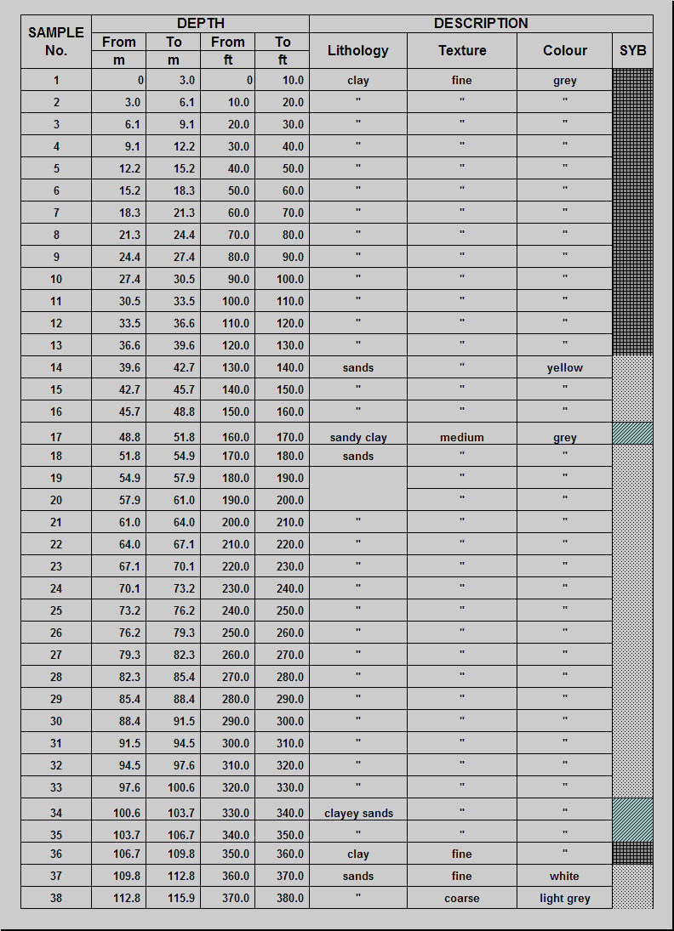

Fig. 2: Lithological Profile

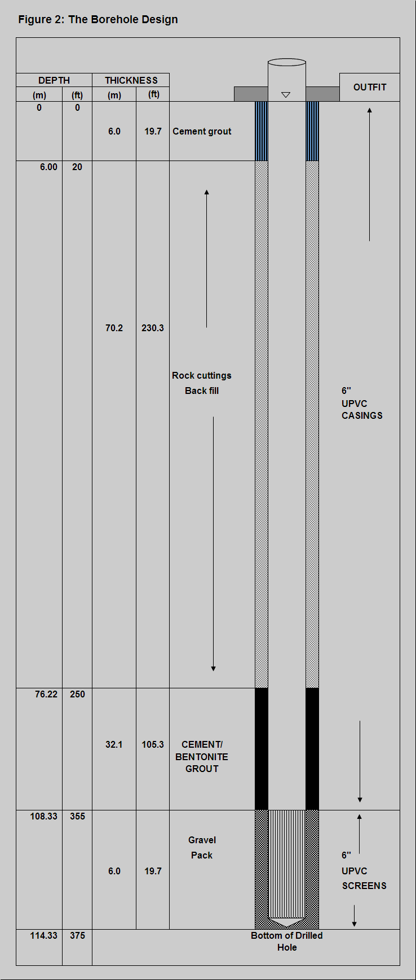

Fig.3: Borehole Design

**Conclusion and Recommendations**

This study revealed that the area is a difficult groundwater terrain in terms of fresh groundwater occurrence. On basis of the information deduced from the geo-electric logs, drill cuttings and review of the geology of the area, the freshwater bearing aquifer occur at depth of about 107 - 116m (350 - 380ft). The development of the well using standard methods should follow immediately after cement grouted zone had set. It is recommended that geophysical borehole logging technique should be applied in every new well drilled. First, the logging operation uses relatively less time compared to the data and information gained through the measurements. Second, onsite data interpretation helps the drilling crew to put the screens for groundwater inflow much more effectively than without, especially in wells with lower yield where the aquifers are not immediately recognized during the drilling process. Third, the data gained will add over time to a larger dataset as a base for groundwater management and decision making. Further, it is recommended to continue the scientific investigations of geophysical logging in the groundwater wells in the Niger Delta for a better constrained permeability and porosity values would be favorable.

**References**

1. Delleur, J.W. 1990. The Handbook of Groundwater Engineering. CRC Press LCC, Boca Raton, FL, U.S.A and Springer, Heidelberg, Germany.
2. Deming, D. 2002. Introduction to Hydrogeology. McGraw– Hill, New York, U.S.A., pp. 498.
3. DGR, 2001. Groundwater Map Guide Book Songkhla Province, Thailand, Department of Groundwater Resources, Thailand, p. 21.
4. DMR, 1998. Geology of Thailand, Department of Mineral Resources, Thailand, pp 482-486.
5. Ellis, D.V. and Singer, J.M. 2008. Well Logging for Earth Scientists. Springer, Dordrecht, The Netherlands, pp 692.
6. Guyod, H. 1952. Electrical well logging fundamentals: Houston, Well Instruments Developing Co., pp 164.
7. Hoelting, B. 1990. Hydrogeologie. Ferdinand Enke, Stuttgart, Germany.
8. Rider, M. 2002. The geological interpretation of well logs. Rider–French Consulting Ltd., Scotland. pp. 280.
9. Scott Keys, W.S. and MacCary, L.M. 1971. Application of borehole geophysics to water–resources investigation. Techniques of Water-Resources Investigations the United States Geological Survey, p 2.
10. Scott Keys, W.S. 1990. Borehole Geophysics Applied to Groundwater Investigations, Techniques of Water Resources Investigations of the U.S. Geological Survey, Book 2, Chapter E2.
11. Anomohanran, O (2015). Hydrogeophysical and hydrogeological investigations of groundwater resources in Delta Central, Nigeria, Journal of Taibah University for Science, 9(1): 57 - 68.

10/18/2016