Modernized technology to address freshwater problem solutions

Jun Hwan Kim

Sardis Secondary School, Chilliwack, BC V2R 2Z6, Canada
junhwankim99@gmail.com

Abstract: In the perspective, upon the general reference scenario (GSS), the situation in the world becomes even more alarming when it’s a reasonably possible to speak about the catastrophe with fresh water on a global scale. Indeed, according to this scenario, by 2025, 40% of the world's population, or 3.1 billion, will have a critical situation with water (Kexp more than 60%) [10; p. 397]. The problem of increasing freshwater scarcity with favorable composition is a recognized problem of international importance [1; p. 132].
[Jun Hwan Kim. Modernized technology to address freshwater problem solutions. N Y Sci J 2016;9(10):30-33]. ISSN 1554-0200 (print); ISSN 2375-723X (online). http://www.sciencepub.net/newyork. 6. doi:10.7537/marsnys091016.06.

Keywords: Modernized technology, freshwater

1. Introduciton
In the perspective, upon the general reference scenario (GSS), the situation in the world becomes even more alarming when it’s a reasonably possible to speak about the catastrophe with fresh water on a global scale. Indeed, according to this scenario, by 2025, 40% of the world's population, or 3.1 billion, will have a critical situation with water (Kexp more than 60%) [10; p. 397]. The problem of increasing freshwater scarcity with favorable composition is a recognized problem of international importance [1; p. 132]. Arid areas of the world are particularly sensitive and vulnerable in this regard. This deficit can be covered by the disposal of salt water after demineralisation, objectively demanded by both society and nature. The greatest success in this subject matter has been reached by US State Administration for the use of salt water [9; p. 47]. According to UN 5.5 recommendation, it’s noted that... there should be to build a plant for the demineralization and recycling of collector-drainage waters for the conservation and protection of surface water resources [6; p. 191].
In highly developed countries - the US, Japan, the Netherlands – there have applied these technologies. Desalinated water is used for irrigation of crops, and brine - for irrigation of tree plantations and salt-tolerant plants (halophytes) and in addition, for gypsum, lime and soda.

2. Methods
Clearly, this problem can be solved in several methods, including:
- establishment of processing methods and technical means make it possible to regulate the water quality for discharge to the irrigation systems;
b) regulation of the quality of drainage water (CDW) in the process of forming them directly to irrigation arrays based on geological, geomorphological and hydrogeological conditions, as well as climatic and reclamation options.
We have chosen the first method. All existing technologies of cleaning and demineralisation of waste, including the collector-drainage, groundwater and lake water can be divided into two large groups. The first group of technologies based on the removal of water-polluting components, the second group of technologies based on the opposite, in particular: from the waste water does not stand out polluting components and pure water molecules.
The first group includes methods of technology technological, biological, chemical, as well as many ways of physics-chemical wastewater treatment (flotation, extraction, adsorption, coagulation, dialysis, reverse osmosis and others.). The second group of methods based on evaporation of the waste water, crystallization of dryness and condensing distillate [5; p. 203].
Using the technology of the first group is preferred in cases where the proportion of contaminants in the wastewater is not significantly weight-restrictive. If the concentration of contaminants in the tens or more grams per liter, it is advisable to use a second group of technologies. It is most promising when demineralization groundwater, drainage, lake water and waste water containing elevated concentrations of chloride, sulfate, carbonate and other inorganic salts. However, existing technologies inherent in the second group is very significant drawback: these technologies are characterized by very high energy content, in other terms, not economical.
State of the art technology is characterized hydrated demineralisation of waste water, which is devoid of the above drawbacks - high energy consumption processes.
In recent years, there have been works continued in this direction, Guo with colleagues in China; Honda, Uchida, Ebinuma, Narita, Tanaka with colleagues et al in Japan; Rasmussen with colleagues in Denmark; Sloan, Holder, Y.F. Makogon, with colleagues, et al in the US; Ripmistera, Bishnu and Englezos groups in Canada; group of Tohidi colleagues in UK group [2; p. 9] and other countries continued work in this area.
Individual success in practical terms reached in the UK, there was created a pilot plant for the production of hydrates capacity of 1 t / d. In Japan, there was built pilot plant for the production of ice - gas hydrate "pills" that can be stored and transported at low temperatures (Yokohama, Tokyo 2000).
In summary, we can say that this is only a list of studies of gas hydrate, but their practical value is immense.

3. Results
Subsequently, attention was paid that the gas hydrates may be used in various industrial processes (section of the gas scattering fog, clouds, etc., and water demineralization).
Kireycheva L.V. and et al. noted that mineralized drainage water is a waste of irrigation and drainage systems. Their utilization or recycling is a serious problem of modern science [3; p. 5]. It is known that the occurrence of deep underground water is saline and can be used only if their demineralization.
The present level of science and technology requires the development of ecological and economical technologies demineralization of water. As noted by scientists Korenev L.A. and Adylova M.K. desalination technologies require the use of expensive equipments and materials, therefore, the problem of the development of cheap technologies is highly relevant [4; p. 117]. When comparing the technical and economic parameters of different ways the most ecological and economical technology was a gas hydrate. Low energy intensity of hydration technology demineralization of natural and waste waters based on the fact that the basic process takes place in a temperature range 0-100S.
Developed solution [7] comprises obtaining the gas hydrate by contacting the hydrate-forming gas and water, separation of hydrate crystals, their washing and decomposition to form a gas and fresh water, and in the hydrate-forming gas as used in the sol-water-soluble gas.
The above criteria is most relevant to carbon dioxide. Thus the formation of carbon dioxide hydrate is carried out in the temperature range 275 - 179⁰ K at pressures of 1400 - 2500 kPa. It is this gas has significant advantages as compared with the gas used in the process of US [8].
Firstly, the carbon dioxide is readily soluble in water (at 0⁰ C degree CO₂ 171.3 mL dissolved in 100 g of water). The second, carbon dioxide hydrate produced in the broadest positive range of temperatures. For maximum temperature of CO₂ hydrate existence is 283.1⁰ K, i.e., positive temperature range hydrate nearly two times wider than that of propane hydrate.
Carbon dioxide is not dangerous to handle (as opposed to the flammable and explosive propane), water CO₂ solutions are non-toxic to humans, so do not need to complete its removal from the final product (fresh water). Carbon dioxide - more widespread in nature and less expensive gas as compared to propane. If the propane can be obtained from underground fuel and associated gas, the CO₂ source is the flue gas, metallurgical, bakery production of alcoholic fermentation, and others.
Formula carbon dioxide hydrate ranges from CO₂⋅6N₂O to CO₂⋅17N₂O (at pressures up to 70 MPa). Lower point quadrupole systems we CO₂ + H₂O (gas - hydrate - ice) is characterized by the following parameter-E: T = 273.1⁰ K; P = 1250 kPa, and the upper point of the quadrupole (gas-hydrate-liquid) - parameters: T = 283.1⁰ K, P = 4490 kPa. At normal atmospheric pressure (P = 101.3 kPa) the existence of a hydrate equilibrium temperature T = 218.1⁰ K (-55⁰ C).
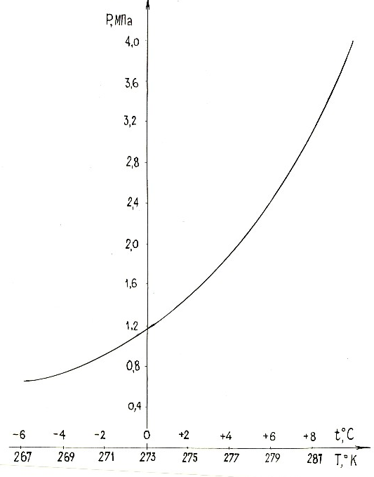

Fig. 1. The conditions of formation of carbon dioxide hydrate
(In the system CO₂ + H₂O field above the curve - the region of existence of hydrates)

For realization of the proposed method are of importance P-T conditions of hydrate formation, since they determine the performance characteristics of water demineralization process and the selection of pumps, compressors and material structural members used devices and systems. Based on the synthesis various literature (often conflicting) data and conducting of special-precision experimental studies, as well as perform calculations using a computer, the following CO₂ hydrate formation conditions in a CO₂ + H₂O system (Fig. 1).
The scheme improved installation (Figure 2), characterized in that as a source of CO₂ for the formation of hydrates to be used under pressure or compressed liquefied carbon dioxide, which greatly simplifies the design.

4. Discussions
Another feature of the proposed modernized solutions - its universality. Therefore, demineralization underground collector-drainage, lake and other waste water can be taken very wide range of indicators: 3 ÷ 12 pH; mineralization - from 3.2 to 200-300 g / l; has a selectivity, i.e. type of pollution - both inorganic and organic. This means that for the demineralization of water, even sharply differing in composition, can be used the same model hydrated installation, and underground and waste waters of many hydro and municipal systems are infinitely united in a common stock for their centralized clearing.
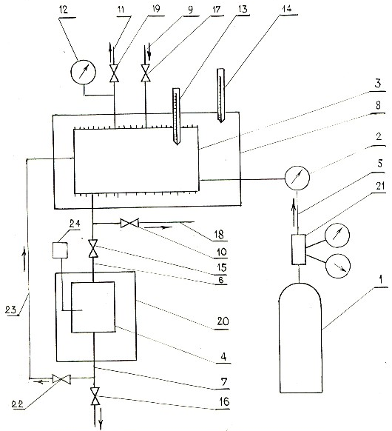
1 bottle of compressed or liquefied carbon dioxide; 2, the gas meter; 3 Camera hydrate; 4-slurry tank; 5,11-gas pipelines; 6,7,18-cutting ditches; 8 termostatirumaya freezer;9.23-water supply; 10,15,16,17,19,22-valve chamber; 12-gauge; 13.14 thermometers; 20-freezer; 21 gear; 24 salimeter.
Fig. 2. Technological scheme of installation of water demineralization

Based on experimental data, as an optimum temperature range adopted interval from 275 to 279⁰ K, which is from 1400 to 2500 kPa-RHR hydrate equilibrium pressure. Temperature ranges 273,1-274,9⁰ K and 279.1 -283.1⁰ To make a modal "margin of safety".
The inventive method comprises preparing demineralizing water gas hydrate by contacting the hydrate-forming gas with a mineralized water, separation of hydrate crystals, their washing and decomposition to form fresh water and gas, and in a gas-hydration use a water-soluble gas, carbon dioxide.
The final product is fresh water demineralization. Hydration technology provides for the following requirements to it: a pH of 6.8 + 7.5; dry residue - not higher than 1.0-1.5 g / l; in chemical, bacterial SOS content, the content of suspended matter and the physical properties of water meets current standards and can be used in various industries (Figure 3). As is known, water salinity from 0.7 to 2.0 g / l are considered good quality for irrigation.

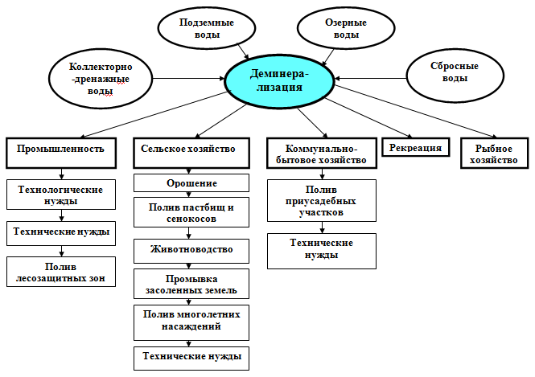
Figure 3. Driving use of demineralized water
The design capacity of the industrial units of demineralization of water - from 50 to 500 m³/ h.

Acknowledgements:
Author is grateful to Dr. Shukhrat Muradov for research and academic support to carry out this work.

Corresponding Author:
Jun Hwan Kim
Sardis Secondary School,
Chilliwack, BC V2R 2Z6, Canada
E-mail: junhwankim99@gmail.com

Reference:
- Bezdnina SY The concept of environmentally sound operation of water systems in the agro-industrial complex // In book: Methods and technology of complex land reclamation and water management of the ecosystem. - M.: VNIIGIM RAAS, 2006. - pp. 132 - 280.
- FA Kuznetsov, VA Istomin, TV Rodionov Gas hydrates: historical review, current status and prospects of investigations // Russian Chemical Journal - Moscow, 2003. - T XLVII.. - Number 3. - pp. 5 - 18.
- LV Kireycheva Drainage on the irrigated lands: past, present and future. - M.: VNIIGIM, 1999. - 184 p.
- Korenev LA Adilova MK Adsorption technology desalinization of drainage water // Coll. scientific. works SANIIRI.- Tashkent, 2003. - pp. 116 - 120.
- Muradov S.O. Scientific substantiation of water resistance of arid areas of the south of Uzbekistan. - Tashkent: Fan, 2012. - 376 p.
- Environmental Performance Reviews. Uzbekistan. Second review. - New York and Geneva: United Nations, 2010. - 245 pp.
- Patent RU № 04339 demineralization method of drainage water / SH.O. Muradov, Valukonis G.YU.// Rasmiy Ahborotnoma. - 2000-№3.
- U.S. Patent № 3.772.893, 1973.
- Khamraev NR, Akhundov MN, AK Ergashev Problems and prospects for sustainable development of the Aral Sea basin countries in the water sector / Pod Society. Ed. Khamraeva NR - Tashkent, 1998. - 88 p.
- Shiklomanov IA, St George VY, Babkin VI, Balonishnikova JA Problems of studying the formation and evaluation of changes in water resources and water supply Russia // Meteorology and Hydrology. - Moscow, 2010. - № 1. - pp 23 - 32.

10/6/2016

