Olive cake as low cost adsorbent for sequestration of Fe(II) and Mn(II) from aqueous solutions

Moataz M. Abdel Hameed¹, Ahmed A. El-kady², Hany H. Abdel Ghafar^{3,4},Gehad G. Mohamed⁵ and Mahmoud S. Rizk⁵

¹Giza Company for Drinking Water and Waste Water, Egypt.
²Food Toxicology and Contaminants Department, National Research Centre, Dokki, Giza, Egypt.
³Chemistry Department, Faculty of Science and Arts- Khulais, University of Jeddah, Saudi Arabia.
⁴Water pollution Department, National Research Centre, Dokki, Giza, Egypt.
⁵Chemistry Department, Faculty of Science, Cairo University, Giza, Egypt.
dr_mezovic@yahoo.com

Abstract: Activated carbon derived from olive cake waste produced by chemical activation using phosphoric acid (AC1) as well as Organosorb 10-CO as a reference carbon (AC2) were used to study their adsorption capacities toward Fe(II) and Mn(II) in a single ion batch experimental mode under different conditions. Initial concentration levels of 50 mg/L for Fe(II) and Mn(II) were incubated with different dose of AC1 and AC2 (0.25, 0.5, 1, 1.5 and 2 g/L) at different contact times (5, 10, 15, 20, 30, 40, 60 and 90 min) to determine the optimum condition of adsorption. These experiments were conducted at ambient temperature (25 ± 1.0 ºC) and two different pH values (3 and 7). The equilibrium time for Fe(II) was 30 min and the optimum dose was 1 g/L for both ACs since 91.6 and 85.6 % of Fe(II) were removed with AC1 and AC2, respectively. However, 60 min was needed to remove 85.5 and 70.5 % for Mn(II) with AC1 and AC2, respectively. The batch experiments for Fe(II) and Mn(II) were performed on solutions with concentrations ranged from 20 to 120 ppm. Removal percentage was determined as a function of sorbate concentration for this adsorption system. The isothermal models applied on this study to show how the adsorption ratios of Fe(II)and Mn(II) on activated carbon match to Langmuir, Freundlich and Dubinin–Kaganer–Radushkevich (DKR) equations adding to that every equation constant has been calculated. The results showed that AC1 hold great capacity to remove Fe(II) and Mn(II) from aqueous media.
[Moataz M. Abdel Hameed, Ahmed A. El-kady, Hany H. Abdel Ghafar, Gehad G. Mohamed, Mahmoud S. Rizk. Olive cake as low cost adsorbent for sequestration of Fe(II) and Mn(II) from aqueous solutions. N Y Sci J 2016;9(8):91-102]. ISSN 1554-0200 (print); ISSN 2375-723X (online). http://www.sciencepub.net/newyork. 14. doi:10.7537/marsnys090816.14.

Keywords: Olive Cake, Activated Carbon, Adsorption, Trace Metals.

- Introduction
Ground water is one of the important sources of water in Egypt in addition to the Nile River as a main source [1]. One of the critical problems in the ground water bodies is the reddish brown color that appears due to the presence of Fe(II) and Mn(II) which exceeded the maximum contaminant levels (MCLs). This color appears when the groundwater exposed to air or other oxidation processes which enhance the precipitation of Fe(III) and Mn(IV) causing reddish brown colors. This color causes a problem by leaving a rusty or brown stain on dishes and utensils that cannot be removed by soaps or detergents. Overtime, iron deposits can reduce the quantity and pressure of the water supply by the accumulation in pipelines [1]. Several approaches were established for the removal of heavy metals from aqueous media such as membrane separation [2], electrochemical precipitation [3], ion exchange [4], preconcentration [5], and adsorption [6-10, 16]. Among these procedures, adsorption is the most user-friendly technique for the removal of heavy metals and seems to be the most versatile and effective if followed by appropriate regeneration steps. Previous reports utilized different locally abundant adsorbents including several agricultural by-products [11-16]. Among the classical wastewater treatments, bio-sorption of heavy metals is an alternative technique, primarily because it utilizes inactive/dead biological materials as sorbents which are generally available at low cost, non hazardous and abound in nature [8,9,17 and 18].
The use of natural materials for heavy metals removal has become a concern in all countries. The use of organic by-products for the preparation of activated carbon is very attractive from the point of view of their contribution to decrease the costs of waste disposal, widely available and environmentally friendly. So, activated carbons were used as adsorbent materials because of their extended surface area, microporous structure, high adsorption capacity and high degree of surface reactivity. Furthermore, the presence of different surface functional groups on activated carbon, especially oxygen groups, leads to the adsorption of ions of heavy metals [19- 20].
The world production of olive oils in 2015/2016 lie around 2.9 million tons which is increased by 22 % from 2014/15. However, the world table olive production is around 2.775 million tons, 97 % comes from the Mediterranean region (IOC). Egypt produced about 25 thousand tons of olive oils in 2015/16 which is constituted about 0.9 % of the world production. Of these 25 thousand tons produced, Egypt consumes about 22 thousand tons and exports only 3 thousand tons (IOC) [21].
Due to their high phytotoxicity of olive oil wastes which is generated during the extraction of olive oils, negative impact on land and environments are observed [22]. Several studies have proven the negative effects of these wastes on soil microbial populations [23], on aquatic ecosystems [24] and even in air medium [25]. So, it is expected to face environmental problems associated with the huge amounts of solid wastes coming from the crude olive cake composed of olive pulp and olive stone. Consequently, olive cake was chosen for several reasons. In addition to its abundance, it is robust, stable and it does not swell in aqueous media. Due to its hydrophobic nature, activated carbon preferentially adsorbs organic matter and can be easily recovered from water suspensions [26].
From the mentioned above, in this study the activated carbon derived from olive cake waste was used to remove Fe(II) and Mn(II) ions from aqueous media by adsorption on its surface including the pores by chemical attraction forces. Different experimental parameters namely contact time, adsorbent dose and initial concentrations of Fe(II) and Mn(II) were optimized.

- Materials and Methods
  - Chemicals and reagents
Ferrous ammonium sulfate hexahydrate (Fe(NH₄)₂(SO₄)₂.6H₂O) was supplied from Scharlau (European Union). Hydrochloric, sulfuric, nitric and ortho-phosphoric (85 %) acids were supplied from Honey Well (Germany). Hydroxylamine hydrochloride (NH₄OH.HCl) was supplied from Alpha Chemika (Mumbai, India). 1,10-phenanthroline monohydrate (C₁₂H₅N₂.H₂O) was supplied from LOBA Chemie (Mumbai, India). Manganese metal and potassium permanganate were supplied from Fisher Scientific Company (New Jersey, USA). Mercuric sulfate (HgSO₄) was supplied from Chem-lab (Belgium). Ammonium persulfate ((NH₄)₂S₂O₃) and silver nitrate were supplied from Oxford lab (Mumbai, India). Glacial acetic acid and ammonium acetate were supplied from El-Nasr Pharmaceutical Chemicals (Egypt). Organosorb 10-CO granular activated carbon (AC2) was provided by Desotec (Roeselare, Belgium).
  - Preparation of reagents
Hydrochloric acid (1:1 v/v), hydroxylamine, ammonium acetate buffer, 1,10-phenanthroline and special reagent for manganese solutions were prepared according to the recommended methods number 3500-Fe B and 3500-Mn B, Standard methods for examination of water and wastewater [27-28].
  - Preparation of sample solution
Stock solution of ferrous was prepared by adding 20 mL of concentrated sulfuric acid slowly to 50 mL distilled water and then 1.404 g ferrous ammonium sulfate was dissolved. Tenth N of potassium permanganate was added until a faint pink color is obtained and then the volume was made up to 1 L with distilled water. Each 1 mL will contain 0.2 mg Fe(II). Working ferrous solution were prepared by pipetting 50 mL from stock solution into a 1 L volumetric flask and diluted to the mark with iron-free distilled water; 1 mL = 10 µg Fe(II) [27].
Stock solution of manganese was prepared by dissolving 1 g manganese metal in 10 mL concentrated nitric acid and diluted to 1 L with 10% hydrochloric acid. Each 1 mL will contain 1 mg Mn(II). Working manganese solutions were prepared by pipetting 50 mL from stock solution and diluted to 1 L with distilled water; 1 mL = 0.05 mg Mn(II) [28].
  - Preparation of activated carbons derived from olive cake waste
The method for the production of activated carbon was given in details in previous work [29]. Briefly, olive cake composed of olive pulp and olive stone was dried using an electrical oven at 120 ºC for 24 h. After that, the dried sample was grounded and sieved into semi fine particles (500- 850 µm). These particles were used for the production of activated carbon under chemical activation scheme by impregnation with phosphoric acid (85 wt. %) at ratio of 1:3 (w/w, olive cake: H₃PO₄). The impregnated solid was activated into furnace tube and the temperature was raised to 500 ºC for 2 h at rate of 5 ºC/ min under forced air. The acid was removed by washing with distilled water till pH 6.8. The carbon product was dried at 110 ºC for 24 h using an electric oven. Organosorb 10-CO was used as a reference adsorbent (AC2).
  - Characterization of biomass and sorbent agents
Physicochemical properties were investigated by several procedures; elemental analyses were conducted with a CHNS elemental analyzer (Thermo Electron Flash EA 1112). The porous structure parameters were determined from nitrogen adsorption isotherms measured at 77 K with NOVA 2200 Gas Sorption Analyser (Quantachrome).
Prior to the measurements, the sample was outgassed overnight at 300 ºC. The specific surface area (S_{BET}) was estimated by Brunauer- Emmett- Teller (BET) equation. The amount of nitrogen adsorbed at the relatively pressure of p/p₀ = 0.96 was employed to determine V_{T}. The micropore volume (V_{DR}) was calculated by applying the Dubinin-Radushkevich equation. The mesopore volume (V_{mes}) was calculated as a difference between the total pore volume (V_{T}) and the micropore volume (V_{DR}).The pore size distributions were determined by means of the Quenched Solid Density Functional Theory (QSDFT).
The surface topography of the AC1 and AC2, the texture and pore structure was carried out using scanning electron microscope (SEM).
  - Experimental
    - Determination of iron and manganese concentration
UV / visible spectrophotometer (Jenway 6715) was used for determination of Fe(II) and Mn(II) at wavelength of 510 and 525 nm, respectively. Precision of Fe(II) and Mn(II) measurements was determined by analyzing in triplicate.
Calibration curves with different concentration levels of Fe(II) and Mn(II) were plotted with correlation coefficient (R² = 0.999) and used for determination of their concentrations.
  - Adsorption study
The adsorption of iron (II) and manganese (II) was conducted at ambient temperature (25 ± 1.0 ºC) and pH values of 3 ± 0.1 and 7± 0.1 for Fe(II) and Mn(II), respectively to avoid the precipitation effects of pH above these values. An amount of 0.1 g of activated carbon was incubated with a 100mL of Fe(II) or Mn(II) with initial concentration of 50 ppm for each. The samples were agitated at 120 rpm using water-bath shaker at 25 ± 1.0 ºC for 5, 10, 15, 20, 30, 40, 60 and 90 min. After the agitation period, the samples were filtrated using 0.45 µm micro-syringe filter. The concentration levels of Fe(II) and Mn(II) were determined by spectrophotometer. For measurement of pH values, the pH meter (Jenway 3510) was calibrated every working day with buffers of pH 4.0 and 10.0.
Adsorption percent (%) was calculated using the equation:
Adsorption percent = [(C₀- C_{f})/C₀]*100 (1)
Where C₀ is the initial concentration of Fe(II) and Mn(II) and C_{f} is their final concentration.
To study the effect of dosage on the retention of Fe(II) and Mn(II) from aqueous solution, five initial doses of activated carbon (0.025, 0.05, 0.1, 0.15 and 0.2 g) were incubated with an initial concentration level of 50 ppm for both each metals in 100mL of aqueous solution at 25 ± 1.0 ºC and pH value of 3 ± 0.1 and 7 ± 0.1 for Fe(II) and Mn(II), respectively. For isotherm study, different concentrations of Fe(II) and Mn(II) (20, 40, 60, 80, 100 and 120 ppm) were incubated with activated carbon (1 g/L) at 25 ± 1.0 ºC and pH value of 3 ± 0.1 and 7 ± 0.1 for Fe(II) and Mn(II), respectively.
All these study also conducted using Organosorb 10-CO as a reference carbon material and a comparison between the results was performed.

- Results and Discussion
  - Characterization of sorbent agents
    - Elemental compositions of the sorbent agents
The results of elemental analyses for biomass, AC1 and AC2 are presented in Table (1).

Table 1. Elemental analyses for biomass (Olive Cake), AC1 and AC2.
Sorbent agents | Elemental contents (%)
 | C | N | H | S
Biomass | 55.86 ± 0.85 | 1.50 ± 0.10 | 7.44 ± 0.14 | Nil
AC1 | 71.58 ± 1.32 | 0.459 ± 0.01 | 4.54 ± 0.13 | Nil
AC2 | 83.46 ± 1.84 | 0.414 ± 0.02 | 0.498 ± 0.01 | 0.956 ± 0.06
Biomass = olive cake; AC1 = AC derived from olive cake waste activated under air; AC2 = Organosorb 10-CO as a reference carbon.

The elemental composition of biomass (olive cake) showed that the carbon contents (56 %) was higher than most of agricultural by-products (44 %). This was due to olive cake is particularly rich in lignin which has complex three dimensions of phenyl propane. The units of these polymers linked by C-C and C-O-C bonds and make its elemental composition to be higher in carbon contents (62 %) [30]. The carbon content of Organosorb 10-CO as a reference carbon (83 %) was higher than that found in produced AC1 (71.6 %).
    - Analysis of porous texture
The specific surface area, texture porosity and pore size distribution (PSD) of AC1 and AC2 were set out in Table (2) and Figure (1).
Referring to Table (2) it is clear that AC2 had specific surface area higher than that found in the produced activated carbon (AC1).
Pore size distribution (PSD), a very important property of adsorbents, determines the fraction of the total pore volume accessible to molecules of a given size and shape.
According to the classification of pore dimensions established by IUPAC, the pore size distributions of Organosorb 10-CO (Figure 1) showed that a vast majority of the pores fall into the range of micropore (d < 2nm). However, the total pore volume (V_{T}) reached 0.676 and 0.432 cm³/g for AC1 and Organosorb 10-CO, respectively. Regarding the mesopore volume (V_{mes}), AC1 recorded 50.7 folds of AC2.

Table 2. Porous texture parameters determined by nitrogen sorption at 77 K.
Activated carbon | S_{BET} (m²/g) | V_{T} (cm³/g) | V_{DR} (cm³/g) | V_{mes} (cm³/g)
AC1 | 835 | 0.676 | 0.321 | 0.355
AC2 | 1000 | 0.432 | 0.425 | 0.007
V_{T} = total pore volume; V_{DR} = micropore volume; V_{mes} = mesopore volume.

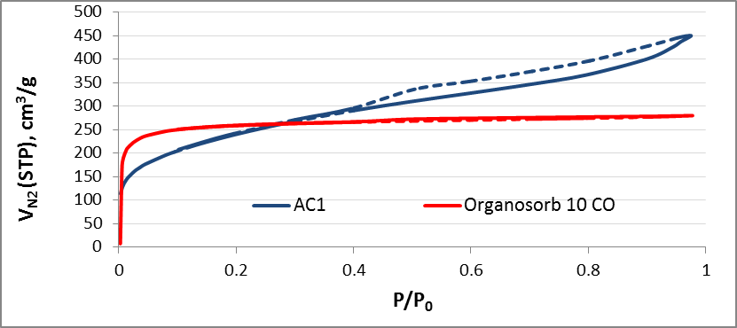
Figure 1. Nitrogen sorption adsorption-desorption isotherms measured at 77 K.

    - SEM photographs
The SEM images reflected the efficiency of thermo-chemical activation by phosphoric acid in increasing the porosity of AC1. Referring to Figure (2) the produced AC1 had external surface full with cavities compared with Organosorb 10-CO. Also, the pores were different sizes and different shapes.

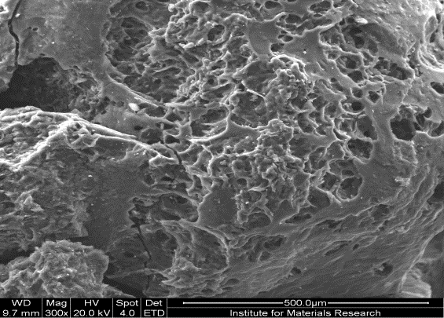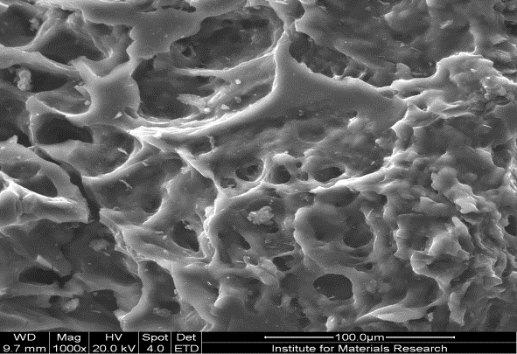
AB
AA
AA
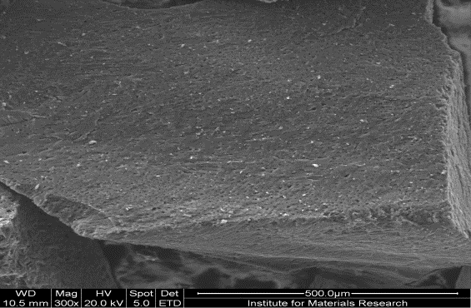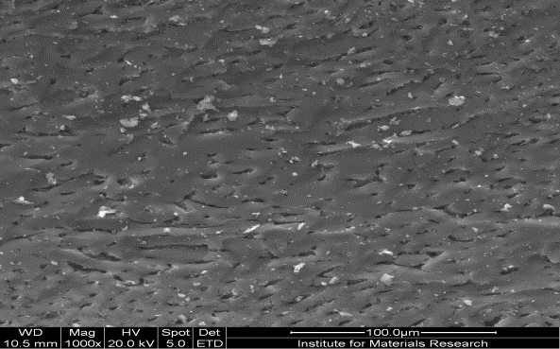
Figure 2. SEM images for (A) AC1 and (B) Organosorb 10-CO (AC2) at magnification of 300x and 1000x.

It was evident from Figure (2) that the external surface of the ACs was highly porous and full of cavities particularly AC1 and the pores had different size and shapes. This texture was beneficial for any adsorption process because large sized pores serve as feeder pores to lower dimension ones, i.e. meso- and micropores [31].

  - Optimum conditions
    - Equilibrium time
The results in Figure (3) illustrated that the equilibrium times for both activated carbon towards Fe(II) were achieved within 30 min at pH 3. However, it needed 60 min to reach the equilibrium time for Mn(II) for both AC1 and AC2 at pH 7 as showed in Figure (4).

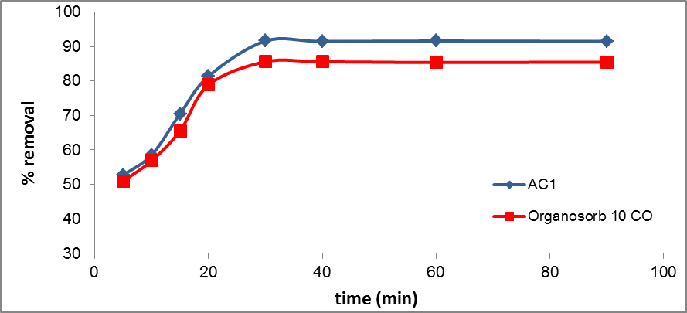
Figure 3. Effect of contact time on Fe(II) adsorption on AC1 and Organosorb 10-CO.
(Dose 0.1%, temperature = 25 ± 1.0 ºC, pH = 3 ± 0.1, initial concentration = 50 ppm).

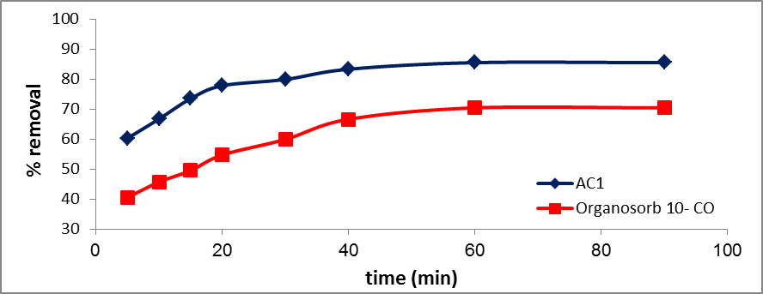
Figure 4. Effect of contact time on Mn(II) removal on AC1 and Organosorb 10-CO.
(Dose 0.1%, temperature = 25 ± 1.0 ºC, pH = 7 ± 0.1, initial concentration = 50 ppm).

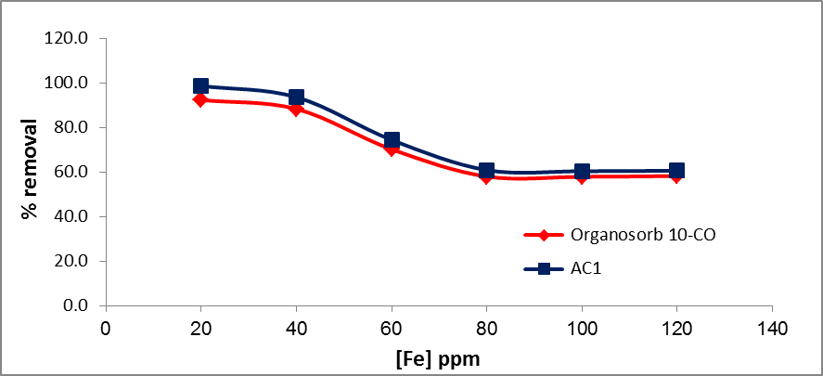
Figure 5. Relation between % removal of Fe(II) vs. its initial concentration.
(Adsorbent dose 0.1%, temperature = 25 ± 1.0 ºC, pH = 3 ± 0.1, time = 30 min).

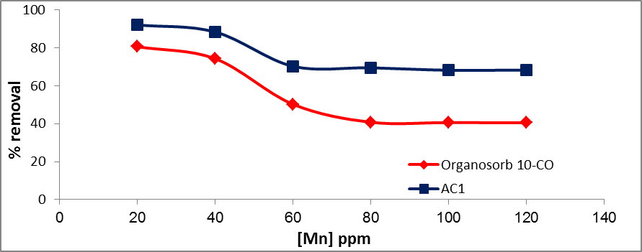
Figure 6. Relation between % removal of Mn(II) vs. its initial concentration.
(Adsorbent dose 0.1%, temperature = 25 ± 1.0ºC, pH = 7 ± 0.1, time = 60 min).

After 30 and 60 min for Fe(II) and Mn(II), respectively, the equilibrium was reached and no more adsorption occurred by increasing the contact time.
    - Detection of optimum concentration
The adsorption of Fe(II) and Mn(II) onto AC1 and Organosorb 10-CO (AC2) as a function of the concentrations of Fe(II) and Mn(II) was studied by varying the concentrations from 20 to 120 ppm while all other parameters are constant. The removal percent by adsorption as a function of Fe(II) and Mn(II) concentrations was illustrated in Figures (5 and 6).
The results indicated that the removal percentage decreased as the concentrations of Fe(II) and Mn(II) increased. This behavior was attributed to the fact that at high concentrations of Fe(II) and Mn(II) there will be less favorable sites available for the adsorption process. The results showed that AC1 had greater adsorption capacity than that for Organosorb 10-CO which mean that, Fe(II) and Mn(II) uptake could mainly be attributed to adsorption mechanism as well as the pores of AC1 which had greater volume than that of Organosorb 10-CO.
    - Effect of adsorbent dose
Different doses of AC1 and AC2 (Organosorb 10-CO ) (0.25 - 2 g/L) were applied at constant concentrations of Fe(II) and Mn(II) (50 ppm for each) at ambient temperature 25 ± 1.0 ºC and constant pH values of 3 ± 0.1 and 7 ± 0.1 for Fe(II) and Mn(II), respectively.
The results in Figures (7 and 8) showed that the optimum AC1 and AC2 doses used for adsorption of 50 ppm of Fe(II) and Mn(II) was 1 g/L. Equilibrium attained by optimum dose was due to saturation of AC1 and Organosorb 10-CO total pore volumes.

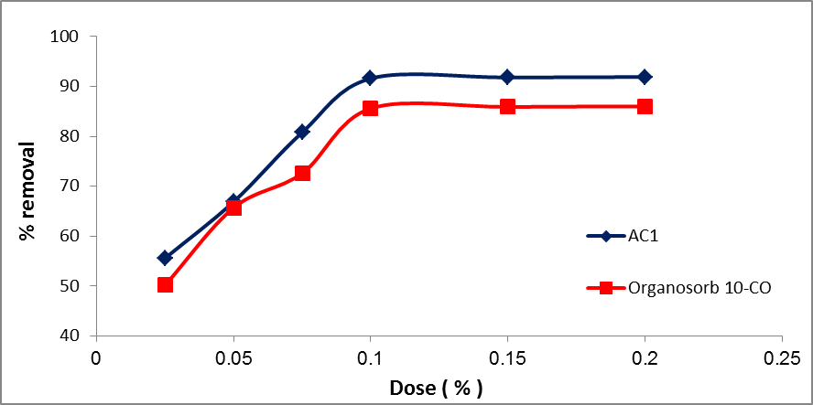
Figure 7. Effect of adsorbent dose on % removal of Fe(II).
(Initial concentration = 50 ppm, temperature = 25 ± 1.0 ºC, pH = 3 ± 0.1, time = 30 min).

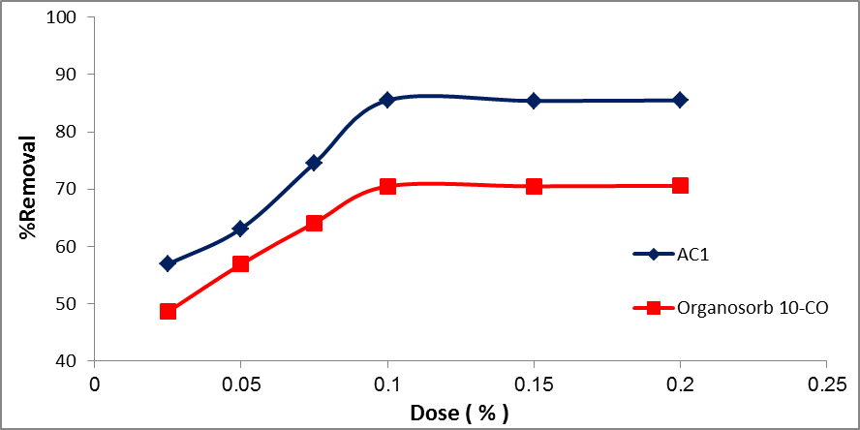
Figure 8. Effect of adsorbent dose on % removal of Mn(II).
(Initial concentration = 50 ppm, temperature = 25 ± 1.0 ºC, pH = 7 ± 0.1, time = 60 min).

  - Isothermal models
The sorption data have been subjected to different sorption isotherms, namely, Langmuir, Freundlich and Dubinin–Kaganer–Radushkevich (DKR) equations.
    - Langmuir isotherm
Langmuir isotherm [32] is presented in equation (2):
C_{e} / C_{ads} = 1 / Qb + C_{e} / Q (2)
Where C_{e} is the equilibrium concentration of Fe(II) and Mn(II) in solution, C_{ads} is the amount of Fe(II) and Mn(II) sorbed per unit mass onto AC1 and AC2, and Q and b are Langmuir constants related to sorption monolayer capacity and sorption energy, respectively. The calculated constants were presented in Table (3).
A linear plot is obtained when C_{e} / C_{ads} is plotted against C_{e} over the entire concentration range of Fe(II) and Mn(II) concentrations investigated (Figures 9 and 10). The Langmuir model effectively and significantly described the sorption data for Fe(II) with R² values of 0.969 and 0.985 with AC1 and AC2, respectively, and for Mn(II) with R² values of 0.802 and 0.96 with AC1 and AC2, respectively.
    - Freundlich adsorption isotherm
The Freundlich adsorption isotherm, (equation 3), one of the most widely used mathematical descriptions, usually fits the experimental data over a wide range of concentrations. This isotherm gives an expression encompassing the surface heterogeneity and the exponential distribution of active sites and their energies. It describes the equilibrium on heterogeneous surfaces and does not assume monolayer capacity [33-35]. The Freundlich adsorption isotherms were also applied to the removal of Fe(II) and Mn(II) on AC1 and AC2 (Figures 11 and 12).

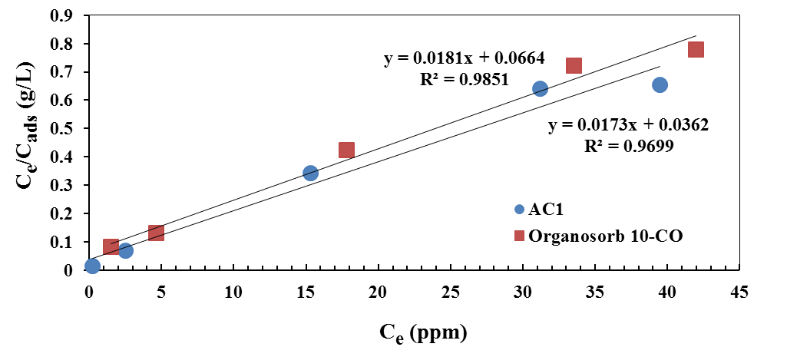
Figure 9. Langmuir isotherm for Fe(II) adsorption onto AC1 and Organosorb 10-CO.

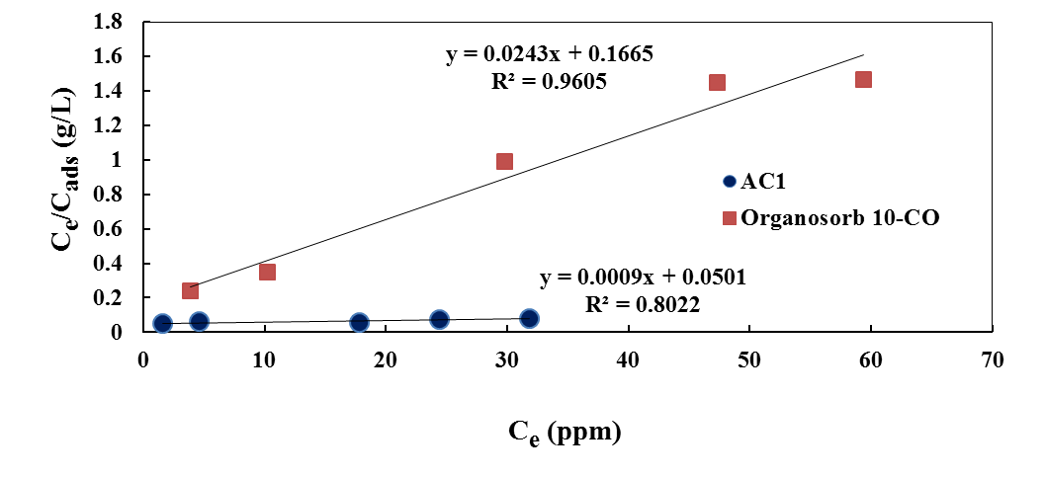
Figure 10. Langmuir isotherm for Mn(II) adsorption onto AC1 and Organosorb 10-CO.

Table 3. Langmuir constants for Fe(II) and Mn(II) adsorption onto AC1 and AC2.
Adsorbed ion | AC1 |  |  |  | (AC2)
 | Q (mg/g) | b (L/mg) | R² |  | Q (mg/g) | b (L/mg) | R²
Fe | 57.8 | 0.4779 | 0.9699 |  | 55.248 | 0.273 | 0.9851
Mn | 1111.1 | 0.0179 | 0.8022 |  | 41.15 | 0.1459 | 0.9605
(R² = Correlation coefficient), Experimental conditions: (1 g of adsorbent/L; 20-120 ppm of Fe(II) and Mn(II); pH = 3 ± 0.1 for Fe(II) and 7 ± 0.1 for Mn(II); T = 25 ± 1 °C).

log C_{ads} = log K + 1/n log C_{e} (3)
Where C_{e} is the equilibrium concentration in ppm, C_{ads} showed that the adsorption seems to follow the Freundlich isotherm model as well as the Langmuir isotherm [36]. The constants K and n are calculated for AC1 and Organosorb 10-CO (Table 4). The value of K is a measure of the adsorption capacity of AC1 and Organosorb 10-CO and it increased as the amount of Fe(II) and Mn(II) removed per unit weight increase and n is a characteristic constant for the adsorption system under study.
A linear plot is obtained when log C_{e} is plotted against log C_{ads} over the entire concentration range of Fe(II) and Mn(II) investigated with R² values for Fe(II) of 0.96 and 0.947 with AC1 and Organosorb 10-CO, respectively, and for Mn(II) of 0.97 and 0.948 with AC1 and Organosorb 10-CO, respectively. The values of K and n can be calculated from the intercept and the slope of this straight line, respectively (Figures 11 and 12).

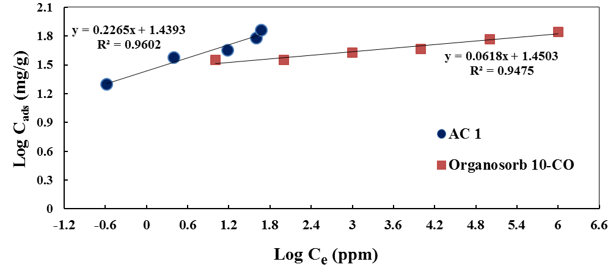
Figure 11. Freundlich isotherm for Fe(II) adsorption onto AC1 and Organosorb 10-CO.

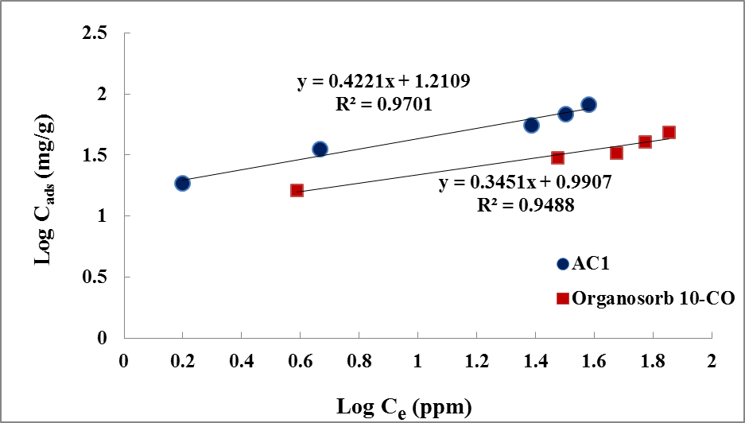
Figure 12. Freundlich isotherm for Mn(II) adsorption onto AC1 and Organosorb 10-CO.

Table 4. Freundlich constants for Fe(II) and Mn(II) adsorption onto AC1 and AC2.
Adsorbed ion | AC1 |  |  |  | Organosorb 10-CO (AC2)
 | K | N | R² |  | K | n | R²
Fe | 27.49 | 4.42 | 0.9602 |  | 41.28 | 14.99 | 0.9471
Mn | 16.252 | 2.37 | 0.9701 |  | 9.788 | 2.89 | 0.9488
(R² = Correlation coefficient), Experimental conditions: (1 g of adsorbent/L; 20-120 ppm of Fe(II) and Mn(II); pH = 3 ± 0.1 for Fe(II) and 7 ± 0.1 for Mn(II); T = 25 ± 1 °C).

    - Dubinin–Kaganer–Radushkevich (DKR) sorption isotherm
The DKR isotherm is an analog of Langmuir type but it does not assume a homogenous surface or a constant sorption potential so it is considered as more general [37]. The Dubinin–Radushkevich isotherm model was used to predict the nature of adsorption processes as physical or chemical [38].
The linearized equation of DKR isotherm can be written as shown:
ln C_{ads} = ln X_{m} ــ β ε² (4)
Where C_{ads} is the amount of metal ions adsorbed per unit mass of adsorbent (mol/g), X_{m} is the maximum sorption capacity, β is the activity coefficient related to mean sorption energy, and ε is the Polanyi potential, which is equal to:
ε = RT ln (1 + 1 / C_{e}) (5)
Where R is the gas constant (J/mol K) and T is the temperature (K). The saturation limit X_{m} may represent the total specific micropore volume of the sorbent. The sorption potential is independent of the temperature but varies according to the nature of sorbent and sorbate [39]. The sorption space in the vicinity of a solid surface is characterized by a series of equipotential surfaces having the same sorption potential. The sorption energy can also be calculated using the following equation:
_{E =} (6)
The data illustrated in Figures (13 and 14) and Tables (5 and 6) represented the D-R plot of the adsorption of Fe(II) and Mn(II) onto AC1 and Organosorb 10-CO (AC2).

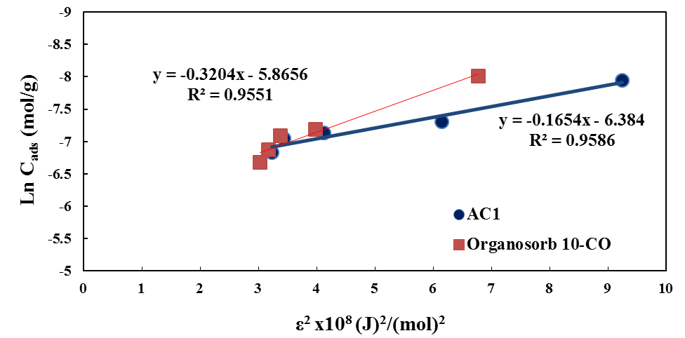
Figure 13. DKR sorption isotherm of Fe(II) onto AC1 and Organosorb 10-CO (AC2).

Table 5. DKR constants for Fe(II) adsorption onto AC1 and AC2.
Adsorbent | DKR isotherm
 |  | X_{m} (mol/g) |  | β (mol²/j²) |  | Sorption energy (E, kJ/mol) |  | R²
AC1 |  | 1.688 x 10⁻³ |  | -0.1654 x 10⁻⁸ |  | 17.387 |  | 0.9586
AC2 |  | 2.835 x 10⁻³ |  | -0.3204 x 10⁻⁸ |  | 12.492 |  | 0.9551
(R² = Correlation coefficient), Experimental conditions: (1 g of adsorbent/L; 20-120 ppm of Fe(II) and Mn(II); pH = 3 ± 0.1 for Fe(II) and 7 ± 0.1 for Mn(II); T = 25 ± 1 °C).

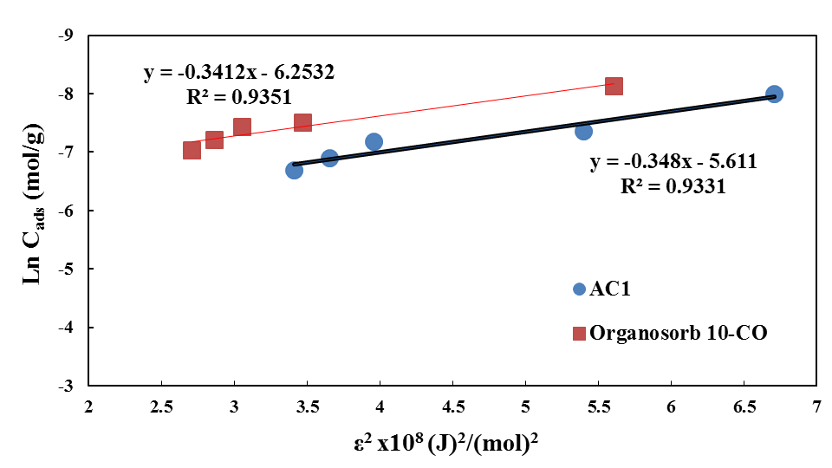
Figure 14. DKR sorption isotherm of Mn(II) onto AC1 and Organosorb 10-CO (AC2).

Table 6. DKR constants for Mn(II) adsorption onto AC1 and AC2.
Adsorbent | DKR isotherm
 |  | X_{m} (mol/g) |  | β (mol²/j²) |  | Sorption energy (E, kJ/mol) |  | R²
AC1 |  | 3.657 x 10⁻³ |  | -0.348 x 10⁻⁸ |  | 11.987 |  | 0.9331
AC2 |  | 1.924 x 10⁻³ |  | -0.3412 x 10⁻⁸ |  | 12.105 |  | 0.9351
(R² = Correlation coefficient), Experimental conditions: (1 g of adsorbent/L; 20-120 ppm of Fe(II) and Mn(II); pH = 3 ± 0.1 for Fe(II) and 7 ± 0.1 for Mn(II); T = 25 ± 1 °C).

It is well known that the mean free energy of adsorption gives information about adsorption mechanism, physical or chemical. If E>8 kJ/mol, the adsorption process occurs chemically and if E<8 kJ/mol, the adsorption process takes place physically [40, 41]. In the current study, the mean adsorption energy was calculated as 17.387 and 12.492 kJ/mol for the adsorption of Fe(II) ion onto AC1 and Organosorb 10-CO, respectively (Table 5), and was calculated as 11.987 and 12.105 kJ/mol for the adsorption of Mn(II) ion onto AC1 and 10-CO, respectively (Table 6). These results indicated that the adsorption process of Fe(II) and Mn(II) onto AC1 and Organosorb 10-CO may be carried out chemically via involving valence forces through sharing or exchange of electrons between sorbent and sorbate [42].

Conclusion
This study was designed to investigate the adsorption behavior of Fe(II) and Mn(II) to activated carbon derived from olive cake biomass and compared to Organosorb 10-CO as a reference carbon. The maximum adsorption capacities were 57.8 and 1111.1 mg/g for Fe(II) and Mn(II) to AC1, respectively, and were 55.248 and 41.15 mg/g for Fe(II) and Mn(II) to Organosorb 10-CO (AC2), respectively, at optimum operating conditions. The results showed that the adsorption of Fe(II) and Mn(II) were fitted to both Langmuir and Freundlich isotherms. The mean free energy values calculated from the D-R plot were 17.387 and 12.492 kJ/mol in case of Fe(II) adsorbed onto AC1 and AC2, respectively, and were 11.987 and 12.105 kJ/mol in case of Mn(II) adsorbed onto AC1 and AC2, respectively. These values indicated that the adsorption type was chemisorptions. Referring to these results activated carbon can be used as an efficient low cost adsorbent for the removal of heavy metals from aqueous solutions.

References
- Water challenges in Egypt, brochure, Ministry of Water Resources and Irrigation (2010).
- Chakravarti, A.K., Chwodhury, S.B., Chakraborty, S., Chakraborty, T., Mukherjee, D.C., Liquid membrane multiple emulsion process of chromium (VI) separation from wastewaters. Colloids Surf. A: Physicochem. Eng. Aspects 103: 59-71, (1995).
- Kongsricharoern, N., Polprasert, C., Chromium removal by a bipolar electrochemical precipitation process. Water Sci. Technol. 34: 109-116, (1996).
- Trgo, M., Peric, J., Medvidovic, N.V., A comparative study in ion exchange kinetics in zinc/lead-modified zeolite–clinoptilite systems. J. Hazard. Mater. 136: 938-945, (2006).
- Hirata, S., Honda, K., Kumamru, T., Trace metal enrichment by automated on-line column preconcentration for flow-injection atomic absorption spectrometry. Anal. Chim. Acta 221: 65-76, (1989).
- Bhattacharya, A.K., Naiya, T.K., Mandal, S.N., Das, S.K., Adsorption, kinetics and equilibrium studies on removal of Cr (VI) from aqueous solution using different low cost adsorbents. Chem. Eng. J. 137: 529-541, (2008).
- Bhattacharya, K.G., Gupta, S.S., Adsorption of a few heavy metals on natural and modified kaolinite and montmorillonite: a review. Adv. Colloid Interface Sci. 140: 114-131, (2008).
- Gupta, V.K., Rastogi, A., Biosorption of lead from aqueous solutions by green algae spirogyra species: kinetics and equilibrium studies. J. Hazard. Mater. 152: 407-414, (2008).
- El-Kady, A.A., Sharaf, H.A., Abbès, S., Ben Salah-Abbès, J., Naguib, K.H., Oueslati, R., Abdel-Wahhab, M.A., Adsorption of Cd2+ ions on an Egyptian montmorillonite and toxicological effects in rats. Appl. Clay Sci. 44: 59-66, (2009).
- Girgis, B.S., El-Kady, A.A., Attia, A.A., Fathy, N.A., Abdel-Wahhab, M.A., Impact of air convection on H3PO4-activated biomass for sequestration of Cu(II) and Cd(II) ions. Carbon Lett. 10: 114-122, (2009).
- Fiol, N., Villaesscusa, I., Martinez, M., Miralles, N., Poch, J., Serarols, J., Sorption of Pb(II), Ni(II), Cu(II) and Cd(II) from aqueous solution by olive stone waste. Sep. Purif. Technol. 50: 132-140, (2006).
- Xuan, Z., Tang, Y., Li, X., Liu, Y., Luo, F., Study on the equilibrium, kinetics and isotherm of biosorption of lead ions onto pretreated chemically modified orange peel. Bio. Eng. J. 31: 160-164, (2006).
- Martinez, M., Miralles, N., Hidalgo, S., Fiol, N., Villaeseasa, I., Poch, J., Removal of lead (II) and cadmium (II) from aqueous solutions using grape stalk waste. J. Hazard. Mater. 133: 203-211, (2006).
- Conrad, K., Bruun, C.B. Hansen, Sorption of zinc and lead on coir. Bioresour. Technol. 98: 89-97, (2007).
- Amarasinghe, B.M.W.P.K., Williams, R.A., Tea waste as a low cost adsorbent for the removal of Cu and Pb from wastewater. Chem. Eng. J. 132: 299-309, (2007).
- Naiya, T.K., Bhattacharya, A.K., Das, S.K., Adsorption of Cd(II) from aqueous solutions using clarified sludge. J. Colloid Interface Sci. 325: 48-56, (2008).
- El-Kady, A.A., Carleer, R., Yperman, J., Farah, J.Y., Optimum conditions for adsorption of lindane by activated carbon derived from Date Stones. World App. Sci. J. 27: 269-279, (2013a).
- El-Kady, A.A., Abdel Ghafar, H. H., Ibrahim, M.B.M., Abdel-Wahhab, M.A., Utilization of activated carbon prepared from agricultural waste for the removal of organophosphorous pesticide from aqueous media. Desalin. Water Treat. 51: 7276-7285, (2013b).
- Afkhami, A., Madrakin, T., Karimi, Z., Effect of the impregnation of carbon with ethylene diamintetra acetic acid on its adsorption capacity for the adsorption of several metals ions. J. Hazard. Mater. 150: 408-412, (2008).
- Al-Asheh, S., Banat, F., Al-Hamed, N., Adsorption of pollutants from aqueous solutions using activated and non-activated oak shells: parametric and fractional factorial design study, part 1. Adsorption 21: 177–188, (2003).
- IOC, Web site of International Olive Council. http://www.internationaloliveoil.org/estaticos/view/131-world-olive-oil-figures, (2016).
- Roig, A., Cayuela, M.L., Sánchez-Monedero, M.A., An overview on olive mill wastes and their valorisation methods. Waste Manage. 26: 960–969, (2006).
- Paredes, M.J., Moreno, E., Ramos-Cormenzana, A., Martinez, J., Characteristics of soil after pollution with wastewaters from olive oil extraction plants. Chemosphere 16: 1557–1564, (1987).
- DellaGreca, M., Monaco, P., Pinto, G., Pollio, A., Previtera, L., Temussi, F., Phytotoxicity of low-molecular-weight phenols from olive mill wastewaters. Bull. Environ. Contam. Toxicol. 67: 352–359, (2001).
- Rana, G., Rinaldi, M., Introna, M.,Volatilisation of substances alter spreading olive oil waste water on the soil in a Mediterranean environment. Agric. Ecosyst. Environ. 96: 49–58, (2003).
- El-Hamouz, A., Hilal, H. S., Nassar, N., Mardawi, Z., Solid olive waste in environmental cleanup: Oil recovery and carbon production for water purification. J. Environ. Manage. 84: 83–92, (2007).
- Standard Methods for examination of water and wastewater, 21st Edition, 2005, Method no. (3500-Fe B).
- Standard Methods for examination of water and wastewater, 21st Edition, 2005, Method no. (3500-Mn B).
- El-Kady, A.A., Carleer, R., Yperman, J., D’Haen, J., Abdel-Ghafar, H.H., Kinetic and Adsorption study of Pb(II) towards different treated activated carbons derived from olive cake wastes. Desalin. Water Treat. 57: 8561- 8574, (2016).
- Demirbas, A., Agricultural based activated carbons for the removal of dyes from aqueous solutions: A review. J. Hazard. Mater. 167: 1-9, (2009).
- Zabaniotou, A., Stavropoulos, G., Skoulou, V., Activated carbon from olive kernels in a two-stage process: Industrial improvement. Bioresour. Technol. 99: 320-326, (2008).
- Langmuir I., The adsorption of gases on plane surfaces of glass, mica and Platinum. J. Am. Chem. Soc. 40: 1361-1403, (1918).
- Prasad, M., Xu, H.Y., Saxena, S., Multi-component sorption of Pb(II), Cu(II) and Zn(II) onto low-cost mineral adsorbent. J. Hazard. Mater. 154: 221-229, (2008).
- Gunay A.E., Arslankaya A., Tosun I., Lead removal from aqueous solution by natural and pretreated clinoptilolite: adsorption equilibrium and kinetics. J. Hazard. Mater. 146: 362-371, (2007).
- Akgul, M., Karabakan, A., Acar, O., Yurum, Y., Removal of silver (I) from aqueous solutions with clinoptilolite. Mic. Mes. Mat. 94: 99-104, (2006).
- Hasany, S.M., Saeed, M.M., Ahmed, M., Sorption and thermodynamic behavior of zinc (II)-thiocyanate complexes onto polyurethane foam from acidic solutions. J. Radioanal. Nucl. Chem. 252: 477-484, (2002).
- Kilislioglu, A., Bilgin, B., Thermodynamic and kinetic investigations of uranium adsorption on amberlite IR-118Hresin. Appl. Radiat Isot. 50: 155–60, (2003).
- Dubinin, M.M., Zaverina, E.D., Radushkevich L.V. Sorption and structure of active carbons I. Adsorption of organic vapors. Zh. Fiz. Khim. 21: 1351–62, (1947).
- Khan, S.A., Rehman, U.R., Khan, M.A., Adsorption of chromium (III), chromium (VI) and silver (I) on bentonite. Waste Manage. 15: 271-282, (1995).
- Sari, A, Tuzen, M., Biosorption of Pb(II) and Cd(II) from aqueous solution using green alga (Ulvalactuca) biomass. J. Hazard. Mater. 152: 302–8, (2008).
- Lodeiro, P., Barriada, J.L., Herrero, R., Sastre, de. Vicente, M.E., The marine macro alga cystoseirabaccata as biosorbent for cadmium(II) and lead(II) removal: kinetic and equilibrium studies. Environ. Pollut. 142: 264–73, (2006).
- Smith, J.M., Chemical engineering kinetics, 3rd Ed. New York: McGraw-Hill. p. 310–22, (1981).

8/26/2016

