**Evaluation Of The Effect Of Ramadan Fasting On Fat-Soluble Antioxidants And Markers Of Oxidative Stress In Healthy Pakistani Subjects**

Abad Khana, *, Zafar Iqbalb, Lateef Ahmada, Waqar Ahmada, Naveed Ullaha, Ismail khanb, Amjad khanb



aDepartment of Pharmacy, University of Swabi, Peshawar-25120,Pakistan.

bDepartment of Pharmacy, University of Peshawar, Peshawar-25120, Pakistan;

* **\*** Dr. Abad Khan

E-mail address: [drabadkhan@uoswabi.edu.pk](mailto:drabadkhan@uoswabi.edu.pk); Cell #: +923339356448, Fax No.0938-490238

**Abstract: Background:** The aim of this study is to evaluate the effect of Ramadan fasting on the fat-soluble antioxidants [all-trans-Retinol (Vitamin A) and α-tocopherol (Vitamin E)] in healthy Pakistani subjects. **Methods:** Thirty(30) healthy male volunteers (aged 30-50 years) with Ramadan fasting have participated in the study. Blood sampling from these subjects was conducted 1 day before and on 15th and 28th days of Ramadan. The serum levels of all-trans-Retinol and α-tocopherol of the collected samples on respective days were measured using liquid-chromatography linked with UV-visible (HPLC-UV). **Results:** In order to assess the profile of these antioxidants we analyzed data by Minitab software at a 95% confidence interval (*p*˂0.05) as significant. The comparison between the samples taken at different time was made applying 2-sample and paired *t*-test. Although slight changes in the levels of all-trans-Retinol on15th and 28th days of Ramadan were found when compared with its levels on 1 day before Ramadan however no significant changes have been found in its values before and Ramadan values. The levels of α-tocopherol on 28th Ramadan have been decreased significantly when compared with its values before Ramadan (*p*<0.0001) while the changes in its values between before Ramadan and on 15th Ramadan were non-significant (*p*=0.0936). **Conclusion:** From our study it is concluded that that there is no significant change in the levels of all-trans-Retinol during the month of Ramadan while the levels of α-tocopherol have been decreased significantly on 28th day of Ramadan however no change has been observed on 15th day of Ramadan when compared with their values before Ramadan. It is therefore suggested that the fasting of Ramadan have effect on the levels of α-tocopherol and food-based interventions might be necessary to modify the diet during Ramadan.

[Abad Khan, Zafar Iqbal, Lateef Ahmad, Waqar Ahmad, Naveed Ullah, Ismail khan, Amjad khan. **Evaluation Of The Effect Of Ramadan Fasting On Fat-Soluble Antioxidants And Markers Of Oxidative Stress In Healthy Pakistani Subjects.** *N Y Sci J* 2016;9(8):84-90]. ISSN 1554-0200 (print); ISSN 2375-723X (online). <http://www.sciencepub.net/newyork>. 13. doi:[10.7537/marsnys090816.13](http://www.dx.doi.org/10.7537/marsnys090816.13).

**Key Words:** Fasting**;** antioxidants; samples; healthy; HPLC-UV

# 

# Introduction

Fasting is defined in Islam as the total abstention from all type of foods and drinks for a specific time period of the day starting from dawn (Sahri) till sunset (Iftar) during the month of Ramadan. Fasting of Ramadan is for one month (29 or 30 days) per lunar year during which only two meals have been taken. The one which is taken at the dawn is called Sahri while the one taken at sunset is called Iftar.**(1, 2)** Muslims fast for 29 or 30 days consecutively during the month of Ramadan each year. It is therefore of interest to know about the effects of Ramadan fasting on human health. The effects of Ramadan fasting on the metabolic profile, antioxidants and biomarkers of oxidative stress might be explored to optimize the diet through necessary interventions.

Vitamin A (all-trans-Retinol) and Vitamin E (α-Tocopherol) are both fat-soluble vitamins/antioxidants that play a vital role in the human body’s antioxidant system. Vitamin A occurs in a variety of forms including pro-vitamin A carotenoids the dietary precursors of retinol. The chemical structure of retinol is given in **Fig. 1 A**. Retinol is found in esterified form in egg, meat, oily salt-water fish, butter, fortified margarine and whole milk. Pro-vitamin A including (α, β, and γ-carotene, lutein, zeaxanthin, and cryptoxanthin) the most active of which is beta carotene are found in green and yellow vegetables and fruits and converted to retinol in humans**.(3)** Vitamin A is formed from the cleavage of beta-carotene and other carotenoids. Studies have shown that all-trans-Retinol is an important antioxidant and biomarker of various diseases. **(4, 5)** Vitamin A exerts its antioxidant function through its hydrophobic polyene units that scavenges singlet oxygen, stabilizes peroxyl radicals and neutralizes thioyl radicals. At normal oxygen tension it is more effective while in oxidative stress it is autoxidized and may act as pro-oxidant. In physiological conditions retinol are deposited in retinoid-binding proteins and protected by other antioxidant in-vivo. The lipid peroxidation propagation is prevented by vitamin A and other carotenoids and hence its antioxidant role is determined4. Similarly Vitamin E collectively used for eight naturally occurring compounds is a fat-soluble vitamin exist in various forms i.e., alpha-(α), beta-(β), gamma-(γ), and delta (δ) tocopherol and tocotrienol in human body the most dominant and crucial of which is α-tocopherol (RRR-α-tocopherol) **(Fig. 1 B)**. It is obtained from natural foods to fulfill the body requirements. The rich sources of alpha-tocopherol are vegetables, fortified cereals, seeds, nuts, oils, meat, fats, poultry, mango, and tomato. It is absorbed from small intestine and metabolized in the liver where α-tocopherol is resecreted through hepatic α-tocopherol transfer protein (α-TTP) and the rest forms of vitamin E are eliminated. Serum level of α-tocopherol is therefore higher as compared with its others forms**(6-10)**. Vitamin E is an important antioxidant of the human body that combats against free radicals and minimize the risk of oxidative stress along with its other roles in the immune function, cell signaling, regulation of gene expression and other metabolic processes. It also inhibit cell proliferation and differentiation and platelet aggregation via inhibition of protein kinase C in smooth muscles cells, monocytes, and platelets and suppression of arachidonic acid metabolism, thereby mounting prostacycline release from endothelium, that dilate blood vessels and inhibit platelet aggregation, respectively. **(6-10)**

Several studies have reported improvements in metabolic profile in healthy subjects11, 12 and diabetic patients13 during the month of Ramadan while some other studies have not found significant changes in these parameters during this month**(14, 15).** Studies till date have found controversial effects of Ramadan fasting on antioxidants status. In a study reduction in malondialdehyde (MDA) level in red blood cells while no change in serum or plasma level have been reported**(16).** Similarly no change in the concentration of glutathione as well activities of glutathione peroxidase and catalase in red blood cells have been observed. The decreased plasma levels of β-cryptoxanthin and total carotenoids have been reported however plasma levels of vitamin C, β-carotene, lycopene, and lutein were not changed significantly during Ramadan fasting. In this study no changes have been reported for the plasma levels of α-tocopherol, γ-tocopherol, retinol, α-carotene, and zeaxanthin16. In another study Chaouachi et al., 2009**(17)** have reported an increase in blood levels of vitamin A and a decrease in blood levels of vitamin E in healthy subjects during Ramadan. Due to these controversial results extensive studies are required to study the effects of Ramadan on human health and explore the changes in human body’s antioxidants and metabolic profile associated with fasting of Ramadan.

The aim of the current study was to evaluate the effect of Ramadan fasting on the fat-soluble antioxidants and biomarkers of oxidative stress including all-trans-retinol (vitamin A) and α-tocopherol (vitamin E) in diet-controlled healthy Pakistani research scholars. This study is the part of our complex study to investigate the effect of Ramadan fasting on the antioxidants, micronutrients, and biomarkers of oxidative stress. In the light of these studies food-based interventions might be suggested to modify the diet and fulfill the deficiency.

# Materials and Methods

## Selection of Subjects

Thirty healthy Pakistani subjects (men aged 30-50 years) were participated in this clinical study after detailed interviews including questions related to their social life, medical history, and nutritional history. These subjects were selected randomly from research scholars in Department of Pharmacy, University of Peshawar after their willingness to take part in the study. A written informed *consent letter* was signed from each participant at the beginning of this study. This study was conducted in accordance with the guidelines of the Declaration of Helsinki during Ramadan (August 10 to September 8, 2010) in Pakistan. The study was approved by the ethical committee Department of Pharmacy, University of Peshawar.

## 

## Inclusion Criteria

Inclusion in this study was based on the normal physical and biochemical evaluation of laboratory investigations including, blood pressure (BP), fasting blood glucose (FBG), blood cholesterol, serum creatinine, liver function tests (LFTs), lipid profile, serum electrolytes profile, routine urinalysis, complete blood count (CBC) and blood Hb. The tests were carried out in pathology laboratory of Hayatabad Medical Complex (HMC), Peshawar. The normal control subjects having neither any type of disease nor smokers. The volunteers considered for this study have not consumed any multivitamins, antioxidants, alcohol, and any other medicines in the recent past.

## Samples Collection

All the participants were kept on uniform diet during this whole study. Blood samples were collected from the participants after a 14-hour fast on three different days: 1 day before Ramadan (D1), on day 15 (D15) and day 28 (D28) of Ramadan, respectively. Blood samples 1 day before Ramadan were collected at 9:00-10:00 am while during Ramadan these were collected at 11:00-12:00 pm. The difference in the time of collection of samples before and during Ramadan was due to the last meal taken before and during Ramadan. Since the dinner was taken at 9:00-12:00 pm before Ramadan while the sehri was taken at 1:00-3:00 am during Ramadan. Each subject has been treated as his own control by comparing the values of antioxidants before Ramadan to those during Ramadan.

## Samples Preparation

The blood samples from all the participants were collected in Gel and clot activator tubes (≈ 5 mL) and were centrifuged at 1600 × g for 10 min at 5 ºC to separate the serum**.(18)** The serum samples were then stored at ‒80 ºC until analysis. The samples were thawed and spiked with internal standard (IS) solution (12.5 µL of IS stock solution 10µg/mL) to keep its concentration 0.5 µg/ml in the final dilution. The all-trans-retinol and α-tocopherol were then extracted with liquid-liquid extraction procedure from these samples. To the serum (250 µL) sample a mixture (750 µL) of ethanol-methanol (95:5, v/v) was added for deproteination followed by extraction with a mixture (1000 µL) of n-hexane-dichloromethane (70:30, v/v) containing BHT (10 µg/mL). The whole mixture was vortexed and centrifuged at 1600 × g for 10 min at 5 ºC. The extraction process was repeated thrice and the clear supernatant was transferred to Eppendorf tubes. The supernatant was then evaporated under nitrogen and the residues were reconstituted with methanol before injection to HPLC system.

## Method

The study was performed using a Perkin Elmer HPLC system (Norwalk, USA) consisted of a pump (series 200), on-line vacuum degasser (series 200), autosampler (series 200), column oven (series 200), linked by a Pe Nelson network chromatography interface (NCI) 900 with a UV/VIS detector (series 200). The whole HPLC system was controlled by Perkin Elmer Total Chrom Workstation Software (version 6.3.1). The analysis was performed on chromatographic columns; Kromasil 100 C18 column (150 mm × 4.6 mm, 5 μm; Thames Restek, UK), at 292 nm wavelength using methanol-water (99:1, v/v), as mobile phase at a flow rate of 1.5 mL/min. The retinyl acetate was applied as internal standard.

## Statistical analysis

The statistical tools such as mean (X) ± standard deviation (SD), and relative standard deviation (%RSD) were applied for the quantification of these antioxidants in human serum. The values of all-trans-retinol and α-tocopherol in all the participants at different time points were compared applying unpaired and paired student’s *t*-tests and one-way analysis of variance (ANOVA), considering *p* ˂ 0.05 as significant.

# Results

**Serum biochemical analyses**

The fasting blood glucose (FBG) level, blood pressure (BP), total cholesterol, triglyceride, LDL, HDL, and VLDL of healthy subjects are given in **Table 1**. The mean plasma blood glucose levels are 124.3 mg/dL with SD of 16.08 before Ramadan while its values decreased significantly during Ramadan having values of 112.7 mg/dL with SD of 9.08. Similarly the values of triglyceride have been decreased significantly during Ramadan; however the mean values of systolic blood pressure, diastolic blood pressure, total cholesterol, LDL, HDL, and VLDL have not been change significantly as presented in **Table 1**.

**Quantification of Serum Vitamins A and E levels in Healthy Subjects**

The all-trans-retinol (Vitamin A) and α-tocopherol (vitamin E) were quantified in the serum samples of healthy subjects. The respective values of vitamin A before Ramadan, 15th Ramadan, and 28th Ramadan are; 0.9450 µg/mL± 0.1505, 0.9340 µg/mL ± 0.1522, and 0.9494 µg/mL ± 0.1574, respectively. Similarly the corresponding mean values with SD of vitamin E before Ramadan, on 15th, and on 28th Ramadan are; 6.660 µg/mL ± 1.950, 6.235 µg/mL ± 1.727, and 5.442 µg/mL ± 1.861, respectively as given in **Table 2**. Although slight variations were found in the before Ramadan and during Ramadan values of all-trans-Retinol however no significant changes were recorded for its values before and during Ramadan as represented in **Table 2** and **Figure 2**. On the other hand although the changes in the concentration of α-tocopherol before Ramadan and 15th Ramadan were not significant (p= 0.0936), however the changes in its values before Ramadan and 28th Ramadan were highly significant (p<0.0001). The respective values of α-tocopherol before Ramadan, 15th Ramadan, and 28th Ramadan with its variations are given in **Table 3** and represented in **Figure 3.** The overlay of chromatograms showing the serum concentration of vitamin A and vitamin E obtained from healthy subjects is shown in **Fig. 4.**

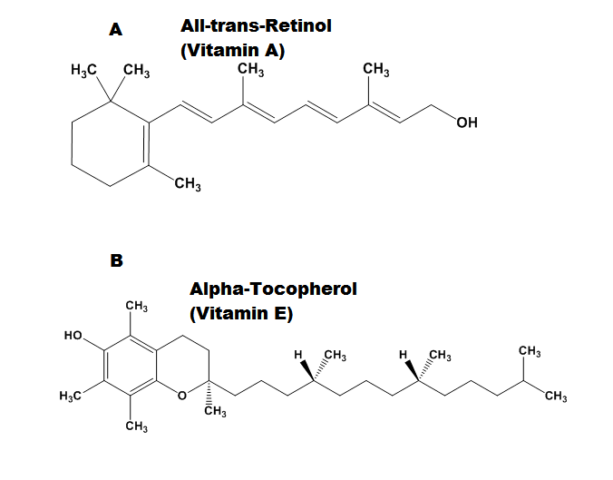

**Figure 1.** **A.** Chemical structure of all-trans- Retinol (vitamin A). **B.** Chemical structure of α-Tocopherol (A).

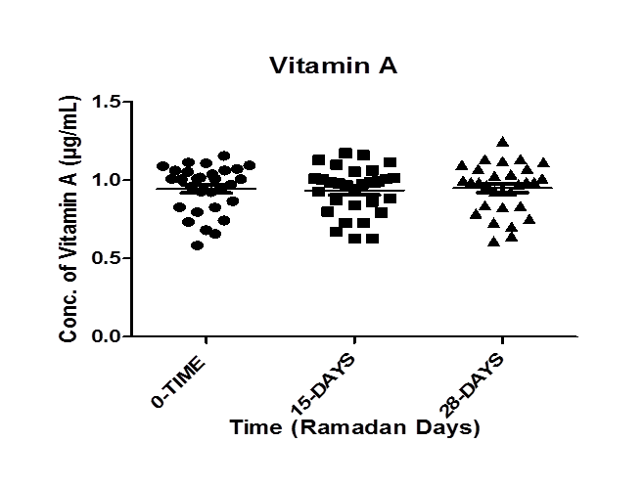

**Figure 1:** The graphical representation of all-trans-Retinol (Vitamin A) before Ramadan (0-Time), 15th Day, and 28th Day of Ramadan (n=30).

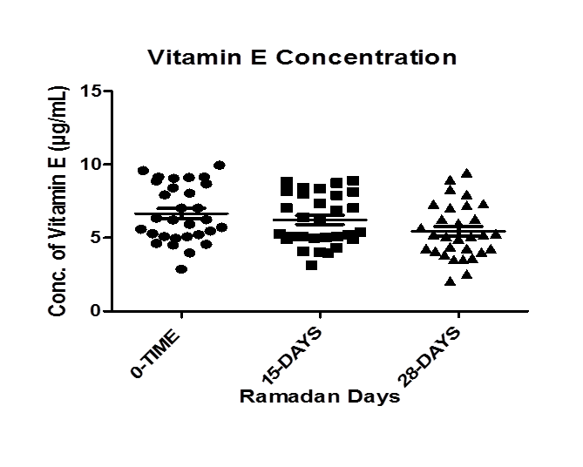

**Figure 2:** The graphical representation of α-tocopherol (Vitamin E) before Ramadan (0-Time), 15th Day, and 28th Day of Ramadan. (n=30).

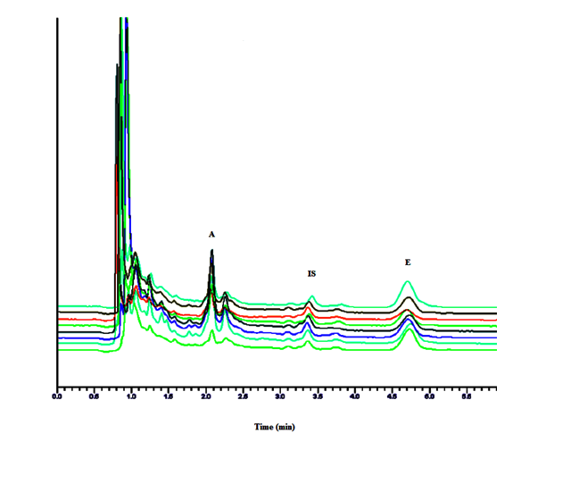

Figure 4. Serum Concentration of Vitamins A and E in Healthy Subjects.

*Peaks;* A: Vitamin A; IS: Internal Standard; and E: Vitamin E.

**Table 1. Clinical Characteristics and Laboratory Tests of Health Subjects (n=30).**

|  |  |
| --- | --- |
| **Variables Before Ramadan** | **During Ramadan** |
| **Mean age (years) 40.0 ± 5.5** | **---------------------** |
| **Body weight (kg) 65.57 ± 5.48** | **---------------------** |
| **Hemoglobin (g/l) 145.65 ± 9.85** | **143.46 ± 7.38** |
| **Glucose (mg/dl) 124.3 ± 16.08** | **112.7 ± 9.08 a** |
| **HbAIC (%) 5.4 ± 0.16** | **4.8 ± 0.23** |
| **Systolic BP (mmHg) 126.33 ± 5.88** | **124.54 ± 4.38** |
| **Diastolic BP (mmHg) 90.10 ± 5.39** | **88.65 ± 5.72** |
| **Total cholesterol (mg/dL) 184.97 ± 9.91** | **179.26 ± 6.53** |
| **LDL-Cholesterol (mg/dL) 112.03 ± 5.41** | **109.03 ± 6.55** |
| **Triglycerides (mg/dL) 102.67 ± 4.14** | **91.45 ± 5.64 a** |
| **HDL-Cholesterol (mg/dL) 54.27 ± 5.73** | **51.76 ± 6.23** |
| **VLDL-Cholesterol (mg/dL) 29.67 ± 3.16** | **30.15 ± 2.64** |

**Note: Data are expressed as means ± standard deviation (n = 30). a denote significant differences (p <0.05).**

**Table 2. Descriptive statistics of all-trans-Retinol (Vitamin A) and α-tocopherol (Vitamin E) before and during Ramadan. (n=30)**

|  |  |  |  |  |  |
| --- | --- | --- | --- | --- | --- |
| **Antioxidans** | **Time** | **Mean** | **Std. Deviation** | **Minimum** | **Maximum** |
| **All-trans-retinol(Vitamin A) (Conc. µg/mL)** | **Before Ramadan** | 0.9450 | 0.1505 | 0.5832 | 1.155 |
| **15th Ramadan** | 0.9340 | 0.1522 | 0.6278 | 1.172 |
| **28th Ramadan** | 0.9494 | 0.1574 | 0.6102 | 1.248 |
| **Alpha-tocopherol (Vitamin E) (Conc. µg/mL)** | **Before Ramadan** | 6.660 | 1.950 | 2.874 | 9.960 |
| **15th Ramadan** | 6.235 | 1.727 | 3.123 | 8.908 |
| **28th Ramadan** | 5.442 | 1.861 | 2.068 | 9.459 |

**Table 3. Profile of all-trans-Retinol (Vitamin A) and α-tocopherol (Vitamin E) before Ramadan (0-Time), 15th Ramadan, and 28th Ramadan. (n=30)**

|  |  |  |  |  |  |
| --- | --- | --- | --- | --- | --- |
| **Antioxidans** | **Before Ramadan (0 Time)** | **15th Ramadan** | **Two-tailedp-value** | **28th Ramadan** | **Two-tailedp-value** |
| **All-trans-retinol**  **(Vitamin A)**  **(Conc. µg/mL)** | 0.9450 ± 0.1505 | 0.9340 ± 0.1522 | 0.3063 | 0.9494 ± 0.1574 | 0.6807 |
| **Alpha-tocopherol**  **(Vitamin E)**  **(Conc. µg/mL)** | 6.660 ± 1.950 | 6.235 ± 1.727 | 0.0936 | 5.442 ± 1.861 | < 0.0001 |

**Note: All values are mean ± SDs obtained from Paired-samples t-test (p <0.05).**

# 4. Discussion

The association of antioxidants and Ramadan fasting has been reported in previous two studies; however our study is the first well-controlled dietary study to evaluate the effect of Ramadan fasting on fat-soluble antioxidants. The fat-soluble antioxidants and biomarkers of oxidative stress such as all-trans-Retinol (Vitamin A) and α-tocopherol (Vitamin E) were investigated during Ramadan to show the effect of Ramadan fasting on the values of these antioxidants and make the necessary diet-based interventions to restore the deficiency of these micronutrients. A little effect of Ramadan fasting on the biochemical parameters like body weight, hemoglobin, systolic and diastolic BP, LDL- and HDL-cholesterol and total cholesterol has been noted, while a significant effect on the blood glucose and triglycerides levels was observed. The decrease in the concentration of blood glucose**(16 19-21)** and triglycerides have been reported in several studies.**(11, 16, 22)** while some other studies have reported no change in blood glucose **(23, 24)** and triglycerides levels.**(21, 23, 24-27)** We have found non-significant changes in the serum level of all-trans-Retinol during Ramadan. The small changes observed in its values during Ramadan might be diet-based as egg, meat, fish, fruits and vegetables were includes in the diet taken during Ramadan in comparison with the diet before Ramadan. Since the diet taken during Ramadan is the rich source of vitamin A and this type of diet was taken more regularly during Ramadan in comparison with the diet taken before Ramadan therefore a slight increase in individual subjects has been observed. Overall the vitamin A level has not been affected during Ramadan. Similarly no significant changes have been found between the levels of α-tocopherol before Ramadan and on 15th Ramadan; however the changes in its levels between before Ramadan and on 28th Ramadan were highly significant. There is no suitable explanation for the decrease; however it has been observed that after half of the Ramadan the intake of diet in most of the participants was decreased that might be the possible reason of decrease in the levels of α-tocopherol. Some other possible reasons of the decrease might be variations in the sampling time, instruments and protocols, hydration status of the subjects, and pharmacokinetic parameters.

The results of our study are in contradiction to the studies conducted by Ibrahim et al., 2008 where no change in levels of retinol and α-tocopherol have been observed16 and studies conducted by Chaouachi et al., 2009, where increase in the levels of all-trans-retinol and decrease in the levels of α-tocopherol were reported**17**. In summary it can be concluded that no change in the levels of all-trans-Retinol during Ramadan has been observed while a decrease in the levels of α-tocopherol has been noted in the last decade of Ramadan; however it is suggested that these studies might be carried out on a large scale on whole body antioxidants and biochemical parameters in a more controlled dietary environment to show the effect of Ramadan fasting on these antioxidants and biomarkers of oxidative stress. Moreover it is also recommended to include vegetables and fruits in the Ramadan diet to restore the deficiency of α-tocopherol during Ramadan.

# Conflict of interest

The authors have no personal or financial conflict of interest.

# Author contributions

Abad khan contributed to samples collection, analysis, design and drafting of the manuscript. Zafar Iqbal contributed to the supervision and statistical analysis of this study. Lateef Ahmad, Waqar Ahmad, Naveed Ullah, Ismail Khan and Amjad Khan contributed in the collection of samples during the study. All authors read the manuscript and approved the final version of this manuscript.

# Guarantor

Zafar Iqbal is the guarantor of this study.

# Acknowledgements

# We are thankful to Higher Education Commission (HEC) of Pakistan for funding this project.

# References

1. Asemi Z, Samimi M, Taghizadeh M, Esmaillzadeh A. Effects of Ramadan Fasting on Glucose Homeostasis, Lipid Profiles, Inflammation and Oxidative Stress in Women with Polycystic Ovary Syndrome in Kashan, Iran. *Arch Iran Med. (AIM)* 2015;18(12).

2. Trepanowski JF, Bloomer RJ. The impact of religious fasting on human health. *Nutr J.* 2010;9(1):1.

3. Ronning M, Knodt C. The Rate of Absorption of Vitamin A Natural Esters and of Carotene by Male Holstein Calves as Measured by Changes in Blood Plasma Levels1. *J Dairy Sci.* 1952;35(4):320-323.

4. Corol DI, Dorobantu I, Toma N, Nitu R. Diversity of biological functions of carotenoids. *Rom Biotech Letters* 2002;8:1067-1074.

5. Hozawa A, Jacobs Jr DR, Steffes MW, Gross MD, Steffen LM, Lee DH. Relationships of circulating carotenoid concentrations with several markers of inflammation, oxidative stress, and endothelial dysfunction: the Coronary Artery Risk Development in Young Adults (CARDIA)/Young Adult Longitudinal Trends in Antioxidants (YALTA) study. *Clin Chem.* 2007;53(3):447.

6. Traber MG. Vitamin E regulatory mechanisms. Annu Rev Nutr 2007;27:347-362.

7. Sen CK, Khanna S, Roy S. Tocotrienols: Vitamin E beyond tocopherols. *Life sci.* 2006;78(18):2088-2098.

8. Dietrich M, Traber MG, Jacques PF, Cross CE, Hu Y, Block G. Does -tocopherol play a role in the primary prevention of heart disease and cancer? A review. *J Am Coll Nutr.* 2006;25(4):292.

9. Sesso HD, Buring JE, Christen WG, Kurth T, Belanger C, MacFadyen J, et al. Vitamins E and C in the Prevention of Cardiovascular Disease in Men. JAMA: *J Am Med Assoc.* 2008;300(18):2123.

10. Antioxidants IoMPoD, Compounds R. Dietary reference intakes for vitamin C, vitamin E, selenium, and carotenoids: a report of the Panel on Dietary Antioxidants and Related Compounds, Subcommittees on Upper Reference Levels of Nutrients and of Interpretation and Use of Dietary Reference Intakes, and the Standing Committee on the Scientific Evaluation of Dietary Reference Intakes, Food and Nutrition Board, Institute of Medicine: *National Academies Press;* 2000.

11. Adlouni A, Ghalim N, Benslimane A, Lecerf J, Saile R. Fasting during Ramadan induces a marked increase in high-density lipoprotein cholesterol and decrease in low-density lipoprotein cholesterol. *Ann Nutr Metab*.1997;41(4):242-249.

12. Lamri-Senhadji M, El Kebir B, Belleville J, Bouchenak M. Assessment of dietary consumption and time-course of changes in serum lipids and lipoproteins before, during and after Ramadan in young Algerian adults. *Singapore Med J*. 2009;50(3):288 – 294.

13. Bener A, Yousafzai MT. Effect of Ramadan fasting on diabetes mellitus: a population-based study in Qatar. *J Egypt Public Health Assoc*.2014;89(2):47-52.

14. Akanji A, Mojiminiyi O, Abdella N. Beneficial changes in serum apo A-1 and its ratio to apo B and HDL in stable hyperlipidaemic subjects after Ramadan fasting in Kuwait. *Eur J Clin Nutr.* 2000;54(6):508-513.

15. Maislos M, Khamaysi N, Assali A, Abou-Rabiah Y, Zvili I, Shany S. Marked increase in plasma high-density-lipoprotein cholesterol after prolonged fasting during Ramadan. *Am J Clin Nutr.* 1993;57(5):640-642.

16. Ibrahim WH, Habib HM, Jarrar AH, Al Baz SA. Effect of Ramadan fasting on markers of oxidative stress and serum biochemical markers of cellular damage in healthy subjects. *Ann Nutr Metab.* 2008;53(3-4):175-181.

17. Chaouachi A, Coutts AJ, Wong DP, Roky R, Mbazaa A, Amri M, et al. Haematological, inflammatory, and immunological responses in elite judo athletes maintaining high training loads during Ramadan. *Appl Physiol Nutr Metab.* 2009;34(5):907-915.

18. Khan A, Khan MI, Iqbal Z, Shah Y, Ahmad L, Watson DG. An optimized and validated RP-HPLC/UV detection method for simultaneous determination of all-trans-Retinol (Vitamin A) and α-Tocopherol (Vitamin E) in human serum: Comparison of different particulate reversed-phase HPLC columns. *J Chromatogr B Biomed Sci Appl.* 2010;878(25):2339-2347.

19. Aybak M, Türkoğlu A, Şermet A, Denli O. Effect of Ramadan fasting on platelet aggregation in healthy male subjects. *Eur J Appl Physiol Occup Physiol*. 1996; 73(6): 552-556.

20. Iraki L, Bogdan A, Hakkou F, Amrani N, Abkari A, Touitou Y. Ramadan Diet Restrictions Modify the Circadian Time Structure in Humans. A Study on Plasma Gastrin, Insulin, Glucose, and Calcium and on Gastric pH 1. *J Clin Endocrinol Metab.* 1997;82(4):1261-1273.

21. Ziaee V, Razaei M, Ahmadinejad Z, Shaikh H, Yousefi R, Yarmohammadi L, et al. The changes of metabolic profile and weight during Ramadan fasting. *Singapore Med J*. 2006;47(5):409-414.

22. Gumaa K, Mustafa K, Mahmoud N, Gader A. The effects of fasting in Ramadan. *Br J Nutr.* 1978;40(03):573-581.

23. El Ati J, Beji C, Danguir J. Increased fat oxidation during Ramadan fasting in healthy women: an adaptative mechanism for body-weight maintenance. *Am J Clin Nutr.* 1995;62(2):302-307.

24. Maislos M, Abou-Rabiah Y, Zuili I, Iordash S, Shany S. Gorging and plasma HDL-cholesterol--the Ramadan model. *Eur J Clin Nutr.* 1998;52(2):127-130.

25. Aksungar FB, Topkaya AE, Akyildiz M. Interleukin-6, C-reactive protein and biochemical parameters during prolonged intermittent fasting. *Ann Nutr Metab*. 2007;51(1):88-95.

26. Benli Aksungar F, Eren A, Ure S, Teskin O, Ates G. Effects of intermittent fasting on serum lipid levels, coagulation status and plasma homocysteine levels. *Ann Nutr Metab*. 2005;49(2):77-82.

27. Fedail SS, Murphy D, Salih S, Bolton C, Harvey R. Changes in certain blood constituents during Ramadan. *Am J Clin Nutr*.1982;36(2):350-353.

8/24/2016