Assessment of Microbial Quality of Cow Milk Products (Kindirimo, Nono and Wara) Sold in Bida Metropolis, Niger State, Nigeria.

Yahaya Abdulwahid Abaukaka¹, Emumwen Evbaziegbere Gideon², Semeeu Oladimeji Olaniyi³, Abdullahi Muhammed³

^{1.}Department of Medical Microbiology, Federal Medical Centre, Bida, Nigeria
aabaukaka@gmail.com

Abstract: The microbial assessment of three cow milk products sold in Bida metropolis, Niger State where analyzed. A total of 150 samples were collected from different individual (the Milkers) from Angwa-Fulani market and other part of Bida metropolis where other milk-products are sold. 50 samples were collected each for, Kindirimo, Nono and wara. Coagulase Negative Staphylococcus was the most predominant bacterial isolated with the percentage frequency of 22.0%, 10.0% and 6.0% for Wara, Nono and Kindirimo respectively, follow by Escherichia coli which had percentage frequeny of 14.0% for Wara only. Streptococcus species had percentage frequency of 12.0% for Wara only, then Staphylococcus aureus and Lactobacillus species had 10.0% and 2.0% for Wara and Nono respectively. Other bacteria isolated include Proteus species 10.0%, Listeria species 6.0%, Pseudomona species 2.0%, Klebsiella species 8.0%, Enterobacter species 4.0%, from Wara, Alkaligens Species 2.0%, from both Wara and Nono. From the findings of this study its concluded that cow milk product such as Wara are of poor microbial quality and hazardous for human consumption. This is supported by evidence of pathogenic bacteria isolated in this study which may be due to poor or unhygienic practices and surrounding environment during the processing of the product (wara). Also Nono and Kindirimo showed some level of poor microbial quality which may pose pathogenic zoonosis.
[Abaukaka YA, Emumwen EG, Oladimeji SO, Abdullahi M. Assessment of Microbial Quality of Cow Milk Products (Kindirimo, Nono and Wara) Sold in Bida Metropolis, Niger State, Nigeria. N Y Sci J 2016;9(8):72-76]. ISSN 1554-0200 (print); ISSN 2375-723X (online). http://www.sciencepub.net/newyork. 11. doi:10.7537/marsnys090816.11.

Keywords: Kindirimo, Nono, wara, microbial quality and zoonosis

1. Introduction
Milk is an important source of nutrients to human and animals. It is meant to be the essential food for the offspring of mammals as is almost complete food (Pandey and Voskuil, 2011). Cow milk is a perishable product and an ideal medium for the growth of a wide variety of bacteria (Parekh and Subhash, 2008). When it is secreted from a healthy udder, raw milk contains only a very few bacteria of about 500 to 1,000 bacteria per milliliter (Omore et al., 2005; Pandey and Voskuil, 2011). After milking environmental contamination occurs, which in turns increases the total bacteria count up to 50,000 per ml or may even reach several million bacteria per milliliter (Pandey and Voskuil, 2011).
Fresh milk drawn from a healthy cow normally contains a low microbial activity particularly with bacterial load of less than 103 cfu/ml (Chatterjee et al., 2006; Lingathurai et al., 2009), but the load may increase up to 100 fold or more once it is stored for some time at ambient temperature (Lingathurai et al., 2009). It contains lipids, proteins (casein, whey), carbohydrates (lactose), amino acids, vitamins and minerals (calcium), essential for growth (Haug et al., 2007; Javaid et al., 2009; Laba et al., 2013). Microbial contamination in cow milk may cause milk-borne diseases to humans while others are known to cause milk spoilage. Sources of microbial contamination in milk include primary microbial contamination from the infected or sick lactating animal. The secondary causes of microbial contamination occur along the milk value chain which may include contamination during milking by milkers, milk handlers, unsanitary utensils and/or milking equipment’s and water supplies used in sanitary activities. Other secondary sources of microbial contamination occur during milk handling, transportation and storage. There is tertiary microbial contamination which occurs mainly due to re-contamination of milk after being processed due to unhygienic conditions and/or poor or improper handling and storage of milk during consumption (Parekh and Subhash, 2008).
Nono is local uncontrolled fermented cow milk product which forms a major part of the marketable food in Northern part of Nigeria. They are produced mainly by the nomadic Fulani (Egwaikhide et al., 2014). It is produced from non-pasteurized cow milk collected in a container called calabash and allowed to ferment naturally for 24 hours (Eka and Ohaba, 1977; Olusupo et al., 1996; Makwin et al., 2014). It can also be produced by the addition of large volume of water to the curdle sour milk called “Kindirimo” which is then stirred with a T-shaped stick to a liquid of fine consistency. The most commonly product often mixed with nono is called “Fura” (a dumping made of millet or maize) to made a preparation called fura da nono. (Egwaikhide et al., 2014).
Kindrimo is produced locally through pasteurization of cow milk which are prepared by heating to boiling point and allowed to cool at room temperature, and then milk butter from the previous day production is added to it at the rate of 0.5-1% of the amount of milk to be processed, and then left overnight to become sour until it coagulate (Odunfa, 1988; Makwin et al., 2014).
Wara is a white soft non-ripened cheese produced by the addition of extract from the plant (Calotropis procera) to the non-pasteurized whole milk from cattle (Adeyemi and Umar, 1994; Uzeh, et al., 2006). Common bacteria reported to be isolated from cow milk include Staphylococcus species, Listeria species, Salmonella species, Escherichia coli, Campylobacter species, Mycobacterium species, Brucella species, Coxiella burnetii, Yersinia species, Pseudomonas aeroginosa and Corynebacterium ulcerans. Others are Proteus species, Leptospira species, Clostridium species, Streptococcus species, Klebsiella species, Enterobacter species. and Bacillus species. (Shirima et al., 2003; Sivapalasingams et al., 2004; Al-Tahiri, 2005; Donkor et al., 2007; Parekh and Subhash, 2008).
Few examples of milk-borne diseases which are transmitted to consumers and pose a risk to public health are bovine tuberculosis, brucellosis, anthrax, listeriosis, salmonellosis, leptospirosis, Q fever, campylobacteriosis and E. coli O157:H7 as an emerged new milk-borne bacterial pathogen reported recently with a very serious health effects (Sivapalasingams et al., 2004).
According to U.S. Food and Drug Administration (FDA), theses harmful bacteria can seriously affect the health of anyone who drinks raw milk, or eats foods made from raw milk. However, the bacteria in raw milk can be especially dangerous to people with weakened immune systems, older adults, pregnant women, and children. In fact, the CDC analysis found that foodborne illness from raw milk especially affected children and teenagers.
Therefore, proper milking, cleaning and sanitizing procedures of equipment and environment used are important tools to ensure quality of milk and milk products. Many countries have implemented laws and regulations concerning the composition and hygienic quality of milk and milk products to protect both the consumers and the public health (Pandey and Voskuil, 2011).

2. Material and Methods
A total of 150 samples were collected from different individual (the Milkers) from Angwa-Fulani market and other part of Bida metropolis where other milk-products are sold. 50 samples were collected each for, Kindirimo, Nono and wara. Approximately 10mls of each samples were aseptically collected into sterile screw capped sterile universal sample bottle. Cow milk products (Kindirimo, Nono and Wara) was drawn from pooled containers containing milk products which are sold to the public within Bida Metropolis. All samples were coded with random numbers for identification and stored in a cool box with ice packs and transported to the Laboratory for analysis.
One milliliter of each sample (Kindirimo, Nono and Wara) was inoculated into a Nutrient broth and incubated at 37ºC for 18-24 hours. After incubation, the inoculated Nutrient broth was sub-cultured onto plates of blood agar, Chocolate agar, MacConkey agar, and salmonella and shigella agar, and further incubated at 37ºC for 18-24 hours. The colonial appearance of bacteria colonies isolated were evaluated, gram stained and further subjected to different biochemical test for complete analysis.
Catalase Test: This test differentiates catalase-positive micrococcal and staphylococcal species from catalase-negative streptococcal species. It is also used to defferntiate some other organism such as Listeria specias, Enterobacteriaceae (Citrobacter species, Escherichia coli, Enterobacter species,) etc.
Coagulase Test: The test was used to differentiate Staphylococcus aureus (positive) from coagulase-negative staphylococci (negative).
Indole Test: This test was used to identify organisms that produce the enzyme tryptophanase. E.g. Escherichia coli etc.
Oxidase Test (Kovac’s Method): This test determines the presence of cytochrome oxidase activity in microorganisms for the identification of oxidase-negative Enterobacteriaceae, differentiating them from other gram-negative bacilli. E.g. Pseudomonas aeruginosa, Alcaligens, and Campylobacter species.
Triple Sugar Iron Agar (TSI): TSI was used to determine whether a gram negative rod ferments glucose and lactose or sucrose and forms hydrogen sulfide (H₂S). The test is used primarily to differentiate members of the Enterobacteriaceae family from other gram-negative rods. E.g. Escherichia coli, Salmonella typhimurium, Shigella flexneri, Proteus mirabilis etc.
Auramine O: is a diarylmethane dye used as a fluorescent stain. it was used for identification of Mycobacterium species.

3. Results
Table 1 shows the percentage occurrence frequency of bacteria isolates from three different cow milk products (Wara, Nono and kindirimo). Coagulase Negative Staphylococcus was the most predominant bacterial isolated with the percentage frequency of 22.0%, 10.0% and 6.0% for Wara, Nono and Kindirimo respectively, follow by Escherichia coli which had percentage frequeny of 14.0% for Wara only. Streptococcus species had percentage frequency of 12.0% for Wara only, then Staphylococcus aureus and Lactobacillus species had 10.0% and 2.0% for Wara and Nono respectively. Other bacteria isolated include Proteus species 10.0%, Listeria species 6.0%, Pseudomona species 2.0%, Klebsiella species 8.0%, Enterobacter species 4.0%, from Wara, Alkaligens Species 2.0%, from both Wara and Nono.

Table 1: Frequency of Bacteria Isolates identified in 150 Cow milk products (Kindirimo, Nono and Wara) samples collected within Bida metropolis.
Isolates | Wara (%)  (N=50) | Nono (%)  (N=50) | Kindirimo (%)  (N=50) | Total (%)  (N=150)
Escherichia coli | 14.0 | 0 | 0 | 14.0
Proteus species | 10.0 | 0 | 0 | 10.0
Pseudomonas species | 2.0 | 0 | 0 | 2.0
Staphylococcus aureus | 10.0 | 2.0 | 0 | 12.0
Coagulase Negative Staphylococcus | 22.0 | 10.0 | 6.0 | 38.0
Klebsiella species | 8.0 | 0 | 0 | 8.0
Enterobacter species | 4.0 | 0 | 0 | 4.0
Streptococcus species | 12.0 | 0 | 0 | 12.0
Lactobacillus species | 10.0 | 2.0 | 0 | 12.0
Listeria species | 6.0 | 0 | 0 | 6.0
Alkaligens species | 2.0 | 2.0 | 0 | 4.0

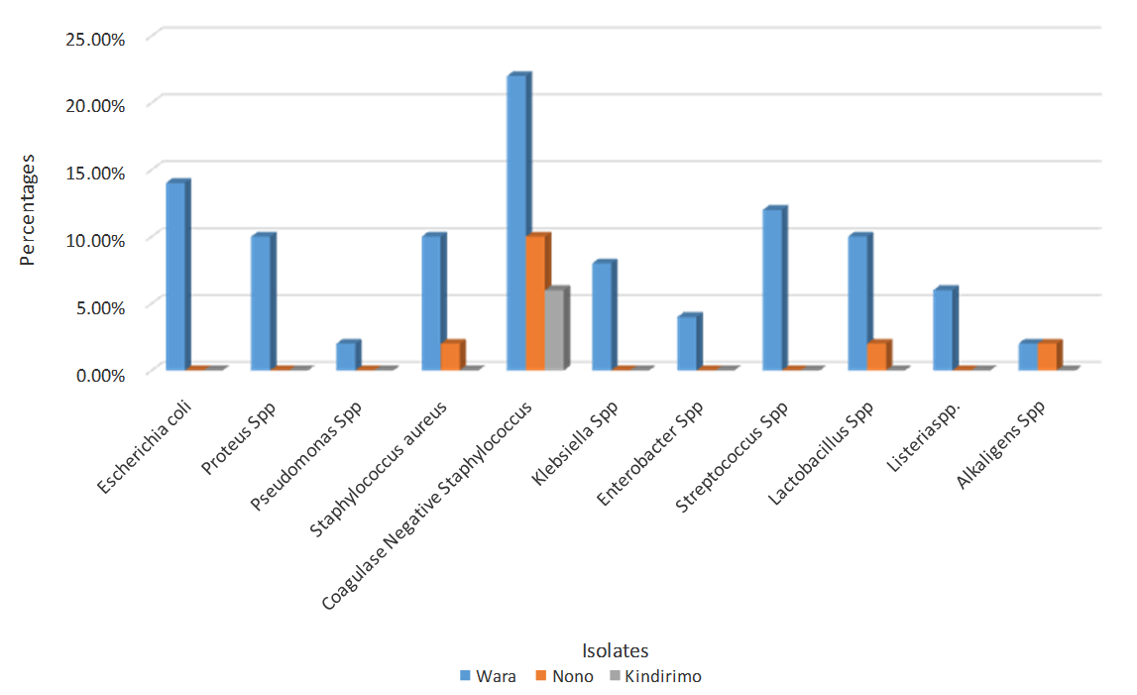
Figure 1. Bar Chart showing the occurrence of bacteria isolated from three different cow milk products (Wara, Nono and kindirimo).

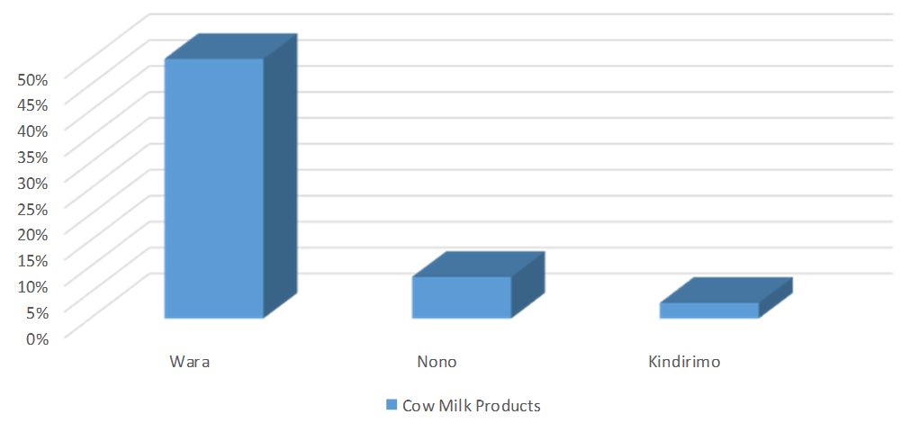
Figure 2. Bar Chart showing the incidence of bacteria isolate in Wara, Nono and Kindirimo.

4. Discussions
This study was designed to assess the bacterial quality of cow milk products (Wara, Nono and Kindirimo) sold within Bida metropolis, Niger state, Nigeria. This is due to the fact that cow milk products produced and sold by nomadic Fulanis in bida and other parts of Nigeria are not regulated by any agency e.g. NAFDAC (National Agency for Food and Drug Administration and Control), SON (Standard Organization of Nigeria), FDA (Food and Drug Administration) etc. and such products may pose health hazard due to the contamination with pathogens. Findings showed that there had been a misconception regarding the pathogenic contamination associated with cow milk products among the consumers and non-consumers. This is due to the fact that Fulani women who market the products are known to be unhygienic in some of their domestic practices such as water used in cleaning hands and milking equipment, storage containers and duration of storage which may increase the risk of contaminating the products.
This study isolated bacteria that are members of the enterobacteriaceae (Such as Escherichia coli 14.0%, klebsiella species 8.0%, Proteus Species10.0% and Enterobacter species 4.0%) which are example of probable fecal contamination from water used to process the products. Coagulase negative staphylococcus has the highest percentage (22.0%, 10.0% and 6.0% in Wara, Nono and Kindirimo respectively) which may be due to contamination from hand and containers used for storage. The presence of bacteria such as Alkaligenes, Bacillus, Enterobacter and klebsiella specias shows similarity with these findings of Roseline et al., 2006 (Microbiological and Nutritional Qualities of Dairy Products: Nono and Wara) in Lagos, Nigeria.
The isolation of Listeria species 6.0% (from Wara) in this study are similar to previous studies that reported presence of Listeria species in raw cow milk by (Yakubu et al., 2012) in Nigeria and (Sharma et al., 2012) India. All these bacteria contaminations are causative agent of disease condition such as Gastroenteritis, Listeriosis etc. and also food born intoxication which pose a major threat to public health.
From the findings of this study its concluded that cow milk product such as Wara are of poor microbial quality and hazardous for human consumption. This is supported by evidence of pathogenic bacteria isolated in this study which may be due to poor or unhygienic practices and surrounding environment during the processing of the product (wara). It’s advisable that individual who consume this product should heat it (the Wara) to boiling point as it reduced the microbial Also Nono and Kindirimo showed some level of poor microbial quality which may pose pathogenic zoonosis.
Routine assessment of microbial quality of cow milk products consumed by the general public has to be encourage in other to safeguard the public from zoonotic infection. This should be done through the involvement of authorities such as NAFDAC, WHO, SON, FDA etc. with the help of Medical Laboratory Scientist.

Acknowledgements:
Authors are grateful to all the staff of Medical Microbiology Department, Federal Medical Centre, Bida, Nigeria and staffs of National Youth Service Corps (N.Y.S.C) Bida Zone, Niger State, Nigeria for the approval of the research project as part of community development service (CDS)

Corresponding Author:
Yahaya Abdulwahid Abaukaka
Department of Medical Microbiology, Federal Medical Centre, Bida, Nigeria
Telephone: +2348156003576
E-mail: aabaukaka@gmail.com

References
- Adeyemi, I. A. and Umar, S. Effect of method of manufacture on quality characteristics of kunun-zaki, a millet-based beverage. Nigerian Food Journal 1994;(12):34-41.
- Al-Tahiri, R. A comparison on microbial conditions between traditional dairy products sold in Karak and same products produced by modern dairies. Pakistan Journal of Nutrition 2005;4(5): 345-348.
- Chatterjee SN, Bhattacharjee I, Chatterjee SK, Chandra G. Microbiological examination of milk in Tarakeswar, India with special reference to coliforms. African. Journal of Biotechnology 2006;5(15):1383-1385.
- Donkor, E.S., Aning, K.G. and Quaye, J. Bacterial contaminations of informally marketed raw milk in Ghana. Ghana Medical Journal 2007;41(2): 58-61.
- Egwaikhide P.A., Malu P.S., Lawal U., Adelagun R.O and Andrew C. Physico-Chemical and Microbiological Analysis of Fermented Cow Milk (Nono) Consumed Within Kaduna Town, North-Western Nigeria. Food Science and Quality Management 2014;(29) 44-48.
- Haug, A, A.T. Hostmark, O.M. Harstad. Bovine milk in human nutrition. a review Lipidsin Health and Disease 2007;(6) 25
- Javaid S.B, Gadahi J.A, Khaskeli M, Bhutto M.B, Kumbher S and Panhwar A.H. Physical and chemical quality of market milk sold at Tandojam, Pakistan. Pakistan Veterinary Journal 2009;29(1):27-31.
- Laba SA, Udosek CE. Bacteriological Quality of Raw Cow Milk in Ilorin, North Central Nigeria. Nature and Science 2013;11(10):73-79.
- Lingathurai S, Vellathurai P, Vendan SE, Prem AAA. A comparative study on the microbiological and chemical composition of cow milk from different locations in Madurai, Tamil Nadu. Indian Journal of Science and Technology 2009;2(2):51-54.
- Makwin Danladi Makut, Mary Azumi Nyam, Tarfena Yoila Amapu and Abbul-Mutalib Ahmed. Antibiogram of Bacteria Isolated from Locally Processed Cow Milk Products Sold in Keffi Metropolis, Nasarawa State, Nigeria. Journal of Biology, Agriculture and Healthcare 2014;4(4):19-25.
- Odunfa, S.A. Microbiological quality of yoghurt and milk drink samples in Ibadan, a Nigerian city. Journal of Agriculture 1988;(2):43-46.
- Omore A., Lore, T., Staal, S., Kutwa, J., Ouma, R., Arimi, S. and Kang’ethe, E. Addressing the public health and quality concerns towards marketed milk in Kenya. Smallholder Dairy Project Research and Development 2005;92(7):9146-168.
- Pandey, G.S. and Voskuil, G.C.S. (2011). Manual on Milk safety, quality and hygiene. Golden Valley Agricultural Research Trust, Zambia. 52pp.
- Parekh, T.S. and Subhash, R. Molecular and bacteriological examination of milk from different milch animals with special reference to Coliforms. Current Research in Bacteriology 2008;1(2): 56-63.
- Roseline E, Uzeh, Regina E, Ohenhen, Ayodeji K. Rojugbokan. Microbiological and Nutritional Qualities of Dairy Products: Nono and Wara. Nature and Science 2006;4(3): 37-40.
- Sharma D, Sharma P.K. and Malik A. Prevalence and antimicrobial susceptibility of drug resistant Staphylococcus aureus in raw milk of dairy cattle. International Research Journal of Microbiology 2011;2(11): 466-470.
- Shirima G.M, Fitzpatrick J, Cleaveland S. Kambarage D.M, Kazwala R.R, Kunda J. and French N.P. Participatory survey on zoonotic diseases affecting livestock keeping communities in Tanzania. Journal of Animal and Veterinary Advances 2003;2(4): 253-258.
- Sivapalasingams S, Friedman C.R, Cohen L. and Tauxe, R.V. Fresh produce: a growing cause of outbreaks of foodborne illness in the United States. Journal of Food Protection 2004;67(10): 2342-2353.
- Yakubu, Y, Salihu, M.D, Faleke O.O, Abubakar, M.B, Junaidu, A.U, Magaji, A.A, Gulumbe, M.L. and Aliyu, R.M. Prevalence and antibiotic susceptibility of Listeria monocytogenes in raw milk from cattle herds within Sokoto Metropolis, Nigeria. Sokoto Journal of Veterinary Sciences 2014;10(2): 13-64.

8/21/2016

