Investigation of Radioactivity Level in Vegetable Crops along Benue River Basin at Yola, Nigeria

John F. Wansah ¹, Sulaiman A. Abdurrahman ¹, Jacob B. Akeredolu ², Actor J. Ocheje ², Amaitem J. Iseh ², and Cookey Iyen ²

¹ Department of Physics, Modibbo Adama University of Technology Yola, Yola
² Department of Pure and Applied Physics, Federal University Wukari, Wukari
fomunyuydzesinyuy@gmail.com

Abstract: The presence and level of Natural Occurring Radioactive Materials (NORM) in some commonly cultivated vegetable crops along the Benue River Basin, Yola were investigated. The area is situated approximately between latitude 9° 12' N and longitude 12° 29' E Jimeta (Yola North), Adamawa State, Nigeria. The crops samples were harvested and dried at room temperature to a constant weight, powdered and sieved to pass through 2mm mesh and ground further to grain size of about 125μm. The Camberra passive gamma spectrometer with well calibrated high purity germanium detector at Centre of Energy Research and Training, Ahmadu Bello University, Zaria was used to detect Alpha and Beta activities. The mean values of Alpha and Beta activities obtained in African Spinach were 8.64×10⁻⁵ ± 3.60×10⁻⁵ Bq/g and 39.37×10⁻³ ± 2.853×10⁻³ Bq/g, respectively; while the mean values of Alpha and Beta activities obtained in Rosella were 10.15×10⁻⁵ ± 3.335×10⁻⁵ Bq/g and 99.56×10⁻³ ± 2.811×10⁻³ Bq/g, respectively; and the mean values of Alpha and Beta activities obtained in Lettuce were 1.218×10⁻⁴ ± 4.945×10⁻⁵ Bq/g and 373.6×10⁻³ ± 3.967×10⁻³ Bq/g respectively. The Beta activity on each sample was higher than the Alpha activity but both values were lower than the recommended permissible activity concentrations limits in vegetables and therefore do not pose an immediate health risks to vegetable consumers in Jimeta, Yola.
[John F. Wansah, Sulaiman A. Abdurrahman, Jacob B. Akeredolu, Actor J. Ocheje, Amaitem J. Iseh and Cookey Iyen. Investigation of Radioactivity Level in Vegetable Crops along Benue River Basin at Yola, Nigeria. N Y Sci J 2016;9(8):67-71]. ISSN 1554-0200 (print); ISSN 2375-723X (online). http://www.sciencepub.net/newyork. 10. doi:10.7537/marsnys090816.10.

Keywords: Radioactive; vegetable crops; gamma spectrometer; alpha activity; beta activity

1. Introduction
Man is continuously exposed to background ionizing radiation emitting from Naturally Occurring Radioactive Materials (NORM) and waste dumpsites. The origin of these radioactive materials is the earth crust, but they find their way into soil, building materials, air, water, food and the human body itself (Odunaike et al., 2008a). So human beings are continuously exposed to ionizing radiations which are naturally present in the environment. Waste generation and disposals have also contributed in no small measure to the increased levels of human radiation exposures. Human radiation exposure could either be external due to the concentrations of ⁴⁰K, ²²⁶Ra and ²³²Th in soil or internal due to inhalation of radon and its progenies in dust and fumes from waste disposal sites (Jibiri et al., 2014). The world-wide average specific activity of ⁴⁰K, ²²⁶Ra and ²³²Th in the earth's crust is estimated to be 412, 35 and 45 Bqkg⁻¹ respectively (UNSCEAR, 2008). Knowledge of radiation exposure levels at waste dumpsites enables one to assess any possible radiological risk to human health and environment due to waste generation and disposal. Various radioactivity measurements have shown the existence of traces of radionuclide in the staple food consumed in Nigeria (Jibiri et al., 2007; Eyebiokin et al., 2005). It was also revealed that staple food stuffs consumed in Nigeria contain traces of radionuclide (Jibiri et al., 2007). It has also been established that vegetation and environmental fields in Nigeria contain traces of radionuclides (Akinloye and Olomo, 2005). All these are contained in the domestic wastes which are indiscriminately dumped in open fields, rivers and even along roadsides. In addition, industrial wastes that are liable to contain traces of radionuclide are also dumped indiscriminately. Consequently, the radionuclide contents in the waste dumpsites, if not properly managed emit mixed radiation to the environment (Odunaike et al., 2008a). The arbitrary and indiscriminate dumping of wastes in dumpsites is considered to be of grave health risk to the populace as it causes soil pollution and underground water pollution which can be a threat to human health (Odunaike et al, 2008a). The dumping of large amount of waste materials in sites without adequate soil protection measures results in soil surface and groundwater pollution (Namasivayam et al., 2001; Avwiri et al., 2011). Dumpsite contain mixed waste of different sorts ranging from domestic waste, agricultural waste, chemical toxic wastes, hazardous industrial waste, medical waste, metal scraps and other debris. These wastes constitute a small fraction of the municipal solid waste (MSW), so the potential environmental and health hazards could be deleterious if not properly handled. The disposal of the waste without adequate management, particularly the radioactive contaminants expose the populace to radiation hazard (Odunaike et al., 2008a). Radioactivity in some waste dumpsites has been studied (Akinloye, and Olomo, 2005; Odunaike, et al., 2008b; Eja et al., 2010; Ojoawo, et al., 2011).
The Earth is naturally radioactive, and about 90% of human radiation exposure arises from natural sources such as cosmic radiation, exposure to radon gas and terrestrial radionuclides (Lee et al., 2004). Gamma rays are known to be highly penetrating and are products of the radioactive materials containing radon gas that may be ingested or inhaled into the human body from waste dumpsites. If inhaled the aerosols containing radon may attach themselves to the lungs where gamma rays emitted in the decay may pose increase risk of lung cancer, eye cataracts and mental imbalances to man (Odunaike et al., 2008a). It is therefore important to monitor the terrestrial background ionizing radiation mainly from waste dumpsites. Researchers have found a strong correlation between radiation exposure and health hazard on man and its effects on environmental ecosystem which are attributed to domestic waste, agricultural waste, chemical toxic waste, radiation waste, hazardous industrial waste, medical waste, metal scraps and other debris in waste dumpsites (Odunaike et al., 2008a). The objective of this study is therefore to evaluate the activity concentrations of alpha and beta particles in some edible leave samples from Doubeli waste dumpsite in order to assess the radiological implications on the population of Jimeta, Yola. This study therefore will be useful for establishing baseline information on natural radionuclides present in Doubeli waste dumpsite where manure is collected into the adjacent crop farms. The location of Jimeta, Yola is latitude 9° 12' N and longitude 12° 29' E as shown in Fig. 1, the dumpsite and some farms where the vegetable crops are cultivated are shown in Figs. 2 and 3.

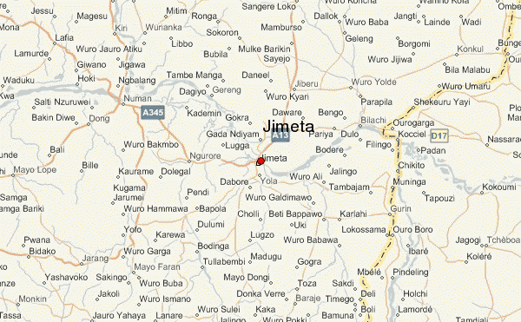
Fig.1: Location of Jimeta, Yola (http://www.weather.forecast.com/location/Jimeta)

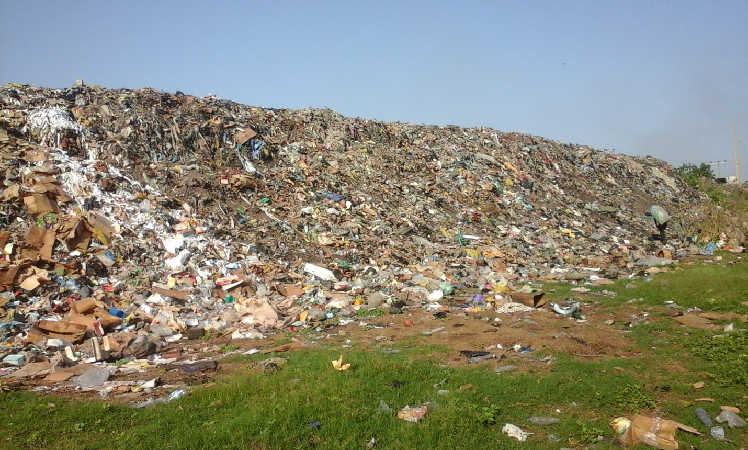
Fig. 2: Part of Doubeli Waste Dumpsite, Jimeta

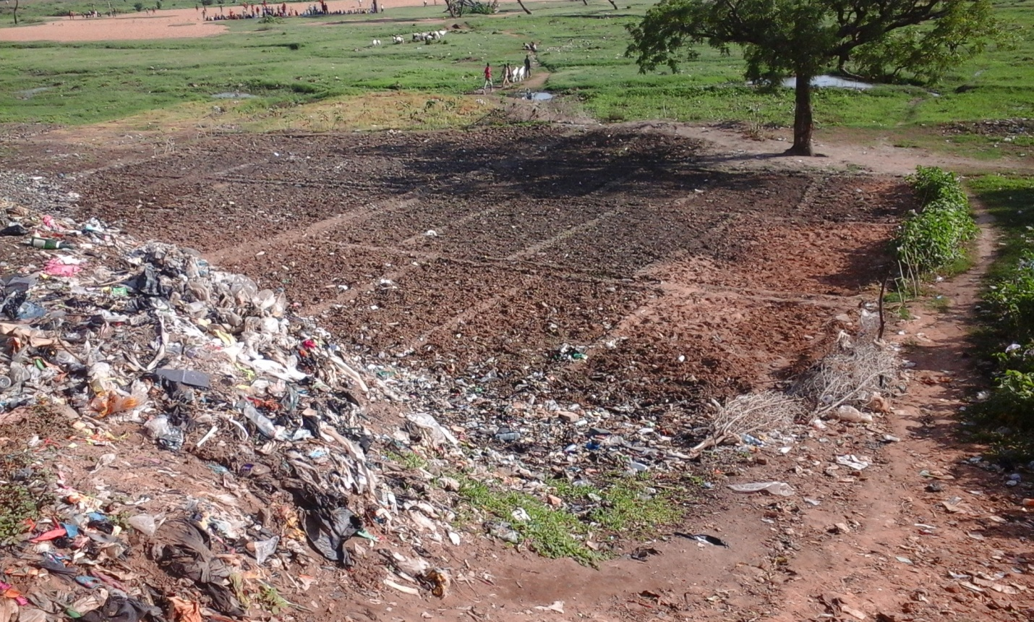
Fig. 3: Farms along Doubeli Waste Dumpsite

Theory
The radioactive decay of radionuclide in a given sample at a time is given as:

(1)

where dN is the change in the number of nuclides during a time interval dt, 𝛌 is the decay constant and the negative sign indicates that N decreases as time t increases. Rearranging:

(2)

Solving equation 2 by integration and taking natural log yields:

N = N₀e^{-𝛌t} (3)
where N₀ is the number of atoms of the radionuclide at time t = 0. The activity of a radionuclide is given by

A_{t} = A₀e^{-𝛌t} (4)
where A₀ is the activity at time t = 0 and A_{t} is the activity at time t. At half-life, N = N₀/2 and t =T_{1/2,} so equation 3 transforms to
N₀/2 = N₀e^{-𝛌T1/2} (5)
Solving equation 5, we obtain

T_{1/2} = (6)

2. Materials and Methods
Random sampling was used to collect reasonable quantity of the vegetable samples from the farms along the dumpsites at Doubeli, Jimeta. Soil samples surrounding each plant, which covers 20 cm x 30 cm were also collected. The soil was dug up 15 – 30 cm deep using hand trowel. A reasonable quantity of the soil sample was transferred into a very clean polythene bag after mixing it up thoroughly. Afterwards, the vegetables and the soil samples were taken to the laboratory at the Centre for Energy Research and Training (CERT, ABU Zaria). The vegetables were washed with tap water and cut into pieces of about 1cm using a clean sharp knife and placed in a room to dry at room temperature by wind without direct sun light. The knife and the container were washed and rinsed to avoid contamination of the samples. The samples were taken to X-RD laboratory in Material Science and Development Section (MSDS), CERT, ABU Zaria, powdered and sieved to pass through 2 mm mesh and ground further to grain size of about 125 μm. Drops of organic liquid binder (toluene and polyvinylchloride) were added to the samples and ground until it was homogenous and the liquid binder evaporated into the atmosphere. The samples were then put into a set of dynes of 19mm in diameter and pressurized to produce pellets (circular disc of about 19mm in diameter and 0.5g). The pellets were taken for alpha and beta radioactivity count using the gas-filled proportional counter. Soil samples were analyzed using X-Ray Fluorescence (X-RF) spectroscopy.

3. Results
The concentrations of the alpha nuclides in the vegetable samples were recorded as follows: in African Spinach the mean value of alpha activity was 8.64×10⁻⁵ ± 3.60×10⁻⁵ Bq/g; in Rosella the mean value of the alpha activity was 1.015×10⁻⁴ ± 3.335×10⁻⁵ Bq/g; in Lettuce the mean value of alpha activity was 1.218×10⁻⁴ ± 4.945×10⁻⁵ Bq/g; and in soil sample the mean value of the alpha activity was 2.33×10⁻⁴ ± 5.56×10⁻⁵ Bq/g. Alpha activities in soil and leaves are shown in Fig. 4. The alpha activity in the soil was higher than in the leave samples.

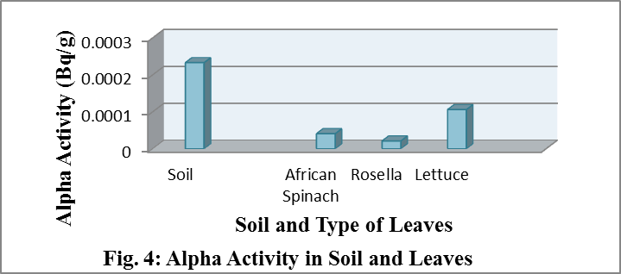

The concentrations of the beta nuclides in the vegetable samples were recorded as follows: in African Spinach the mean value of beta activity was 0.03937 ± 0.002853 Bq/g; in Rosella the mean value of the beta activity was 0.09956 ± 0.002811 Bq/g; in Lettuce the mean value of beta activity was 0.3736 ± 0.003967 Bq/g; and in soil sample the mean value of the beta activity was 2.33×10⁻⁴ ± 5.56×10⁻⁵ Bq/g. Beta activities in soil and leaves are shown in Fig. 5. The beta activity in the soil was higher than in the leave samples.

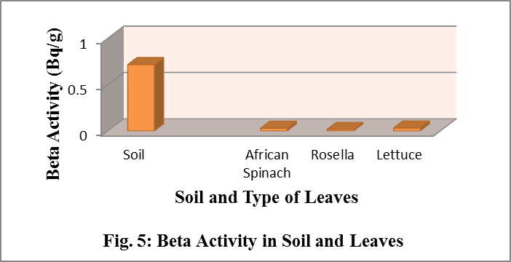

4. Discussion
According to Dersee and Pflugbeil, (2011) the permissible limits for cesium-137 for vegetables, fruits and berries is 0.074 Bqg⁻¹; to Tchokossa et al., (2013), the mean specific activity of 40-K in vegetables ranged between 0.036.48 – 0,068.02 Bqg⁻¹ with the lowest specific activity of 0.032.56 ± 0.003.15 Bqg⁻¹ in Fresh Maize leaf (Zea mays) and highest of 0.069.20 ± 0.006.28 Bqg⁻¹ in cassava leaf (Manihot esculentun linn); and to Biswas et al., (2015) the gross alpha activity for vegetable samples ranges from 0.23 to 1.81x 10⁻³ Bqg⁻¹ with an average of 1.0 ± 0.11 x 10⁻³ Bqg⁻¹ the gross beta activity for vegetable samples ranges from 0.305 to 1.676 Bqg⁻¹ with an average of 0.930 ± 0.003.27 Bqg⁻¹. The gross alpha and beta spectrometry analysis of these vegetables (African Spinach, Rosella, Lettuce) shows that the activity concentrations measured were lower than the recommended permissible concentration limits in vegetables and therefore do not pose an immediate health risks to vegetable consumers in Jimeta, Yola.

5. Conclusion
Gross alpha and beta spectrometry has been used to determine the radioactivity concentrations of three vegetable samples commonly consumed along Benue River in Jimeta, Yola North. The average values of alpha and beta activities in African Spinach, Rosella and Lettuce were below the recommended activity concentration in food sample by the International Council on Radiological Protection. These values though very low may indicate no immediate health risks but may cause long-term health challenges to vegetable consumers in Jimeta, Yola. Therefore, waste materials should be adequately sorted out before disposing in municipal dumpsites and government should regularly monitor radiation levels in these dumpsites and environs.

Acknowledgements:
Authors are grateful to the Centre for Energy Research and Training (CERT), Ahmadu Bello University Zaria, Nigeria for the analysis of this work.

Corresponding Author:
John F. Wansah
Department of Physics,
Modibbo Adama University of Technology Yola, Yola, Nigeria
E-mail: fomunyuydzesinyuy@gmail.com

References
1. Odunaike RK, Laoye JA, Alausa SK, Ijeoma GC, Adelaja AD. Radiation emission characterization of waste dumpsites in the city of Ibadan in Oyo State of Nigeria. Res J of Env Tox 2008a; 2(2):100-103.
2. Jibiri NN, Isinkaye MO, Momoh HA. Assessment of radiation exposure levels at Alaba e-waste dumpsite in comparison with municipal waste dumpsites in southwest Nigeria. J of Rad Res and Ap Sc 2014; 7:536-541.
3. UNSCEAR. Sources and effects of ionizing radiation, Report of the United Nations Scientific Committee on the Effects of Atomic Radiation to the General Assembly, United Nations, New York, USA, 2008.
4. Eyebiokin MR, Arogunio AM, Oboh G, Balogun FA, Rabiu AB. Activity concentration and absorbed dose equivalent of commonly consumed vegetable in Ondo State, Nigeria. Nig J Phy 2005; 17S:187-191.
5. Jibiri NN, Farai IP, Alausa SK. Activity concentration of Ra-226, Th-228 and K-40 in different food crops from a high background radiation area in Bisichi Jos Plateau State, Nigeria. Rad Env Biophy 2007; 46:53-59.
6. Akinloye MK, Olomo JB. The radioactivity in some grasses in the environment of nuclear research facilities located within the OAU, Ile-Ife, Nigeria. Nig J Phy 2005; 17S: 219-225.
7. Namasivayam C, Radhika R, Suba S. Uptake of dyes by a promising locally available agricultural solid waste. Waste Man 2001; 21:381-387.
8. Avwiri GO, Nte FU, Olanrewaju AI. Determination of radionuclides concentration of landfill at Eliozu, Port Harcourt, Rivers State, Nigeria. Sc Afr 2011; 10(1):46-57.
9. Odunaike RK, Alausa SK, Oyebanjo OA, Ijeoma GC, Alo AO. Measurement of radiation level in refuse dumps across Lagos metropolis, Southwestern Part of Nigeria. Env Res J 2008b; 2:174-176.
10. Eja ME, Alobi NO, Ikpeme EM, Ogri OR, Iyang AO. Environmental and public health-related assessment of solid waste management in Uyo, Akwa Ibom State, Nigeria. World J of Ap Sc &Tech 2010; 2(1):110-123.
11. Ojoawo S, Agbede O, Sangodoyin A. On the physical composition of solid wastes in selected dumpsites of Ogbomosoland, South-Western Nigeria. J of Wat Res & Prot 2011; 3:661-666.
12. Lee EM, Menezes G, Flinch EC. Natural radioactivity in building material in the Republic of Ireland. Health Phy 2004; 86:378-388.
13. Jimeta, http://www.weather.forecast. com/location/Jimeta retrieved on 08/08/2016.
14. Dersee T, Pflugbeil S. Officially permissible limits for radioactively contaminated food in the European Union and Japan, International Physicians for the Prevention of Nuclear War (IPPNW), Foodwatch, Berlin, 2011:32.
15. Tchokossa P, Olomo JB, Balogun FA, Adesanmi CA. Assessment of radioactivity contents of food in the oil and gas producing areas in Delta State, Nigeria. Int J of Sc &Tech 2013; 3(4):245-250.
16. Biswas S, Ferdous J, Begum A, Ferdous N. Study of gross alpha and gross beta radioactivities in environmental samples. J Sc Res 2015; 7(1-2):35-44.

8/21/2016

