The toxic effect of aluminum on cell division and chromosome morphology of black seeds plant (Nigella sativa L.) in relation to seed germination and radicle growth

A. A. El-Ghamery*, E. A. Abdel-Azeem, M. M. Mansour and E. S. Abd Al-Mouty

Botany & Microbiology Department, Faculty of Science, Al-Azhar University, Nasr City, Cairo, Egypt
*ma_mousa.@azhar.edu.eg

Abstract: The effect of aluminum (Al³⁺) was evaluated in black seeds plant (Nigella sativa L.). Different aluminum concentrations as well as different exposure times were applied to investigate cytogenetical alterations in black seeds plant (Nigella sativa L.) meristem cells. Different concentrations of Al³⁺ (Al.Cl₃.6H₂O) ranging from 200 to 5000 ppm were tested for different durations of 6, 12, 18, 24 and 36h. In this plant, following the treatments, germination percentage, radicle growth and mitotic index were declined by increasing the concentration and treatment duration. Radicle length was depressed but not blocked by the applied concentration. The treatments with the concentrations more than 3000 ppm for 36h were toxic and nearly inhibited cell division. The inhibition of mitotic activity induced by Al³⁺ is paralleled with a reduction in germination percentage and root growth. There was a gradual increase in metaphase frequency in all treatments with increasing concentration and treatment time. Increase metaphase frequency was accompanied by deceased frequency of the other mitotic division stages. The mitotic investigation of dividing cells in root tip cells of the studied plant revealed an abundance of dose-dependent of abnormalities for each treatment. Al³⁺ induced a number of abnormalities as dominant types. These types include irregular prophase, vacuolated nucleus, stickiness, disturbed meta- and anaphase, C-meta- and C-anaphases, laggards, chromosomal bridges. In addition, less frequent types were also recorded such as diagonal, fragment, unequal distribution and micronuclei. In conclusion, aluminum is significantly stressful in Nigella sativa L. culminating in morphological and cytological alterations.
[El-Ghamery AA, Abdel-Azeem EA, Mansour MM and Abd Al-Mouty ES. The toxic effect of aluminum on cell division and chromosome morphology of black seeds plant (Nigella sativa L.) in relation to seed germination and radicle growth. N Y Sci J 2016;9(8):30-43]. ISSN 1554-0200 (print); ISSN 2375-723X (online). http://www.sciencepub.net/newyork. 7. doi:10.7537/marsnys090816.07.

Keywords: Aluminum toxicity, AlCl₃, Nigella sativa, seed germination, root growth, mitotic activity, chromosomal aberrations

1. Introduction
Heavy metals are significant environmental pollutants and their toxicity is a problem of increasing significance for ecological, evolutionary, nutritional and environmental reasons (Nagajyoti et al., 2010 and Jaishankar et al., 2014). The increase of heavy metals potential in nature and industrial environment cause mutagenic and carcinogenic effects (Pandey and Upadhyay, 2010). Heavy metals toxicity in plants varies with plant species, specific metal, concentration, chemical form and soil composition and pH, as many heavy metals are considered to be essential for plant growth. Plants are stationary, and roots of a plant are the primary contact site for heavy metal ions. Aluminum, as a light metal, is sometimes counted as heavy metal in view of its toxicity (Blann and Ahmed 2014).
Aluminum element (Al) is the third most abundant metallic element found in the earth’s crust after oxygen and silicon (Gupta et al., 2013). Acid toxicity is mainly caused by a lack of essential nutrients in the soil and excessive toxic metals in the plant root zone. Of the toxic metals, aluminum is the most prevalent and most toxic. Aluminum is one of the most abundant minerals in the soil; comprising approximately 7% (Biao et al., 2013). Saxena and Misra (2010) considered aluminum toxicity as a major inhibitor on limiting plant growth that affects large agricultural areas, which resulted in decrease crop yields principally in acid aluminum has no biological role and is a toxic non-essential metal to microorganisms (Olaniran et al., 2013).
A large part of the literature dealing with effects of Al on plant growth refers to Al as a non-essential and toxic element. The best descriptive symptom of Al toxicity in plants as indicated by Foy (1974) appears as inhibition of root growth, which can only be explained by an inhibitory effect of Al on cell division. It is well known that roots are the primary target of aluminum phytotoxic (Doncheva et al., 2005 and Li et al., 2015), in which Al exposure causes inhibition of cell elongation and cell division, leading to root stunting accompanied by reducing water and nutrient uptake (Panda et al., 2009). The initial and most dramatic symptom of Al toxicity is inhibition of root elongation or root growth (Barceló and Poschenrieder, 2002) where the Al inhibited root cell division after hours or even days of exposure, thus reducing water and nutrient uptake, consequently resulting in poor plant growth and yield (Wang et al., 2006). The major consequences of Al exposure are the decrease of plant production and the inhibition of root growth. The root growth inhibition may be directly/indirectly responsible for the loss of plant production (Silva, 2012). Root elongation is a reliable parameter used in the bioassay and quantitative of heavy metals toxicity, because root growth is particularly sensitive to toxic metals (Sahi and Singh, 1996).
The works related to aluminum effect seed germination, root growth and cell division have been mainly undergone in some species like Allium cepa (Fiskesjö, 1988 and Qin et al., 2010), Allium sativum (Roy et al., 1989), Triticum aestivum (Aniol, 1995), Vicia faba (Zhang, 1995), Arabidopsis thaliana (Richards et al., 1998), Sorghum bicolor (Peixoto et al., 2001), Hordeum vulgare (Pan et al., 2001), Oryza rufipogon (Cao et al., 2011), Helianthus annuus (Chakravarty and Srivastava, 1992; Kumar and Srivastava, 2006 and Li et al., 2015), Glycine max (Noya et al., 2014) and Zea mays (Liu and Jiang, 2001; Doncheva et al., 2005; Vardar et al., 2011 and Alvarez Bello et al., 2012). In this concern, Yi et al. (2010) demonstrated that aluminum chloride is a clear clastogenic/genotoxic and cytotoxic agent in Vicia root cells. No reports or limited information are available about the cytotoxicity effects of Al on root cell in black seeds plant (Nigella sativa L.). Therefore, the observation of the root-tip constitutes a rapid and sensitive method for environmental monitoring. El-Ghamery et al. (2002 and 2003) considered Nigella sativa L., a species of large an economical importance, as a very well characterized cytogenetically following its treatment with Zn²⁺ and Ni²⁺. So, it can serve as useful biomarkers for detection of Al toxicity or as cytogenetic test could be used for the genotoxicity monitoring of aluminum compounds contamination. Thus, the present study aims to investigate, by cytogenetic tests, the effect of aluminum exposure to Nigella sativa L. and also to understand the toxic mechanisms of aluminum involved.

2. Material and Methods
2.1. Seed Germination Test
Healthy and uniform size seeds of black seeds plant (Nigella sativa L.) obtained from Sods Research Station in Bani Swif, Egypt and aluminum chloride (AlCl₃. 6H₂O) provided or supplied from LOBA chemi 107, Wodehouse Road, Mubai 40005, India. The aluminum substance is dissolved in redistilled water and the applied concentrations were 200, 400, 800, 1000, 3000 and 5000 ppm after a preliminary test which showed that concentrations higher than 5000 ppm applied for 36 h exerted toxic effect on cells. To evaluate the rate of seed germination of black seeds plant (Nigella sativa L.) under the stress of Al³⁺, seeds of the plant presoaked in distilled water for 6h, were placed directly in different concentrations of Al³⁺, ranging from 200 to 5000 ppm for different treatment times (6, 12, 18, 24 and 36h). For each treatment, a triplicate of 30 seeds was used. Seeds were surface sterilized with 10% sodium hypochlorite for ten minutes then washed with sterile distilled water and placed on sterile filter paper in the Petri dishes. Fresh test solutions were added to the Petri dishes and the plates were placed in the dark for different treatment times at 24 ± 1°C to facilitate linear growth. The treated seeds (30 for each treatment) were washed carefully with distilled water then transferred to Petri-dishes containing filter paper moistened with distilled water and allowed to germinate at room temperature 24 ± 1°C for 5-7 days. Control seeds were treated with distilled water. Radicle length 5 mm was considered as germinated. The germinated seeds were counted and the percentages were calculated.
2.2. Radicle Growth Investigation
To study the effect of Al³⁺ on radicle growth, the seeds were germinated in distilled water till appearance the radicle. Thirty of the germinated seeds were immersed in suitable amount of each tested concentrations of 200, 400, 800, 1000, 3000 and 5000 ppm of aluminum chloride (Al Cl₃) for the different times of 6, 12, 18, 24 and 36 hours. Similarly, 25 germinated seeds were soaked in distilled water for the same period was run with each treatment as the control. Following the treatments, the treated seedlings together with each control samples were kept in the dark at 23-25ºC, in order to minimize the fluctuation in the rate of cell division (Evans et al., 1957). At the end of each treatment time, the length of the radicle was measured. The relative change of radicle length was calculated as a percentage of the variance from the control or expressed as percent of controls.
2.3. Cytological Examination
Ten germinated seeds, with radicle 2-3 cm long, were treated with different concentrations for different times. Control germinated seeds were placed in distilled water. After each treatment, the roots were cut off and immediately fixed in glacial acetic acid: absolute ethyl alcohol (1:3 v/v) for overnight. The root tips were stained by using the Feulgen squash technique. At least three slides for each treatment were examined to determine the mitotic index (MI) and the frequency of mitotic phases. Dividing cells in the same slides were analyzed for determination of the percentage of different types of abnormalities and their total percentages of abnormalities were also calculated.

2.4. Statistical Analysis
Each treatment was made in three replicates. For statistical analysis, one-way ANOVA (Sigma Plot 13.0 software) SPSS was used to determine significance at p < 0.05 and at P < 0.01.

3. Results
Results of effects of Al³⁺ on the percentage of seed germination of the tested plant are represented in Fig. (1-A). The frequency of seed germination, as shown in figure (1-A), was found to be affected by AlCl₃ at different applied concentrations. The inhibition effect increased with increasing concentration of AlCl₃. A significant reduction in total seed germination percentage was observed starting at the AlCl₃ concentration of 200 ppm compared with the control values. The highest concentration (5000 ppm) caused a reduction of about 54% in percentage of germinated seeds compared with the control. Moreover, results revealed that the percentage of germination was over than 80 % at the concentrations of 200-800 but about 50%-80% at concentrations of 1000-5000, which indicate that AlCl₃ is toxic at higher concentrations.
To evaluate the Al³⁺ toxicity on the radicle elongation, black seeds plant (Nigella sativa L.) roots were exposed to different concentrations of AlCl₃ (200, 400, 800, 1000, 3000 and 5000 ppm) and the average root lengths were measured up to 120h.The effects of Al³⁺ on radicle growth of Nigella sativa L.varied with the Al³⁺ concentration and treatment time. There was a significant inhibition of radicle growth in seedlings treated with 200 ppm and 5000 ppm of Al (Fig. 1-B) during the whole course of treatment. Versus the control there was hardly any root growth with 5000 ppm of Al. Whereas there was no toxic effect At 200 ppm of Al. Radicle elongation as T/ C ratio were reduced to 50 % in 800 ppm, 14 % in 3000 ppm, 7 % in 5000 ppm, compare to the control length value (100 %) after 36 h period (Fig. 1-B). Although the radicle growths were not significantly affected up to 24 h, they started decreasing and exhibited a stationary phase up to 36 h. The results revealed the intensive inhibition occurred in 5000 ppm of AlCl₃. In general, the root morphology was nearly normal for all the treatments without showing an obvious difference in its appearance of color and rigidity.
Results of the microscopic evaluation of the effects of Al³⁺ on mitotic cells are presented in (Fig. 1-c) and Table 1. Root tips of black seeds plant exposed to different concentrations of Al³⁺ showed that compared to control, mitotic division inhibition was concentration dependent at all concentrations used in this study for each treatment time. The mitotic index (MI) showed significant differences in comparison with the control for all Al³⁺ treatments. Maximum reduction in MI was observed with the treatment of 5000 ppm for 36h, where the MI was 0.34 lower than the value seen in the control. There were no dividing cells at the 5000 ppm concentrations of Al with some stages of the mitotic division.
Effect of Al³⁺ on the different mitotic phases is given in Table (1). For each treatment time, the increase or decrease in the frequency of each stage was negatively correlated to the increase of the concentration compared to the control value. For 6 and 12h, the increase of the frequencies of metaphase and anaphase was on the expanse of the frequencies of the other stages. For 18h, the increase of the frequencies of prophase and metaphase was only recorded for almost all concentrations of Al, In contrast for 24h, the increase of the frequencies of prophase and telophase was on the expanse of the frequencies of the other stages. For 36h, the increase of the frequencies of metaphase was only recorded on the expanse of the frequencies of the other stages.
Results in Table (1) also, show the frequency of abnormalities in each mitotic phase and the total percentages of abnormalities induced in root tip cells of tested plant. With respect to chromosomal abnormalities, all treatments showed significant differences compared with the control. The percentage of aberrant cells at all the tested concentrations of Al increased as concentration of Al increased, the number of dividing cells aberrant cells increased as the mitotic indices decreased Table (1). The total frequency of abnormal dividing cells is clearly a dose and treatment time dependent. For each treatment time (6, 12, 18, 24 and 36 hours), increasing the concentration from 200 ppm to 5000 ppm gradually increased the frequency of total abnormal cells with all treatment times. The frequency of the total abnormal dividing cells following 6 hours treatment ranged from 63.22% to 84.62 % and from 78.69% to 100% for 12 hours treatment compared to their respective control values of 2.22% and 3.08, respectively. Also, the frequency of the abnormal dividing cells was ranged from 80.39% to 100 % for 18 hours treatment compared to its respective control value of 2.50. At the 24 and 36 hour treatments, the all tested concentrations of Al Cl₃ induced 100% of abnormalities.
Al³⁺ treatments induced a considerable range of chromosomal abnormalities in all stages of mitosis in root tip cells of black seeds plant (Nigella sativa L.) plant (Table 1). From the results, at 6 hours treatment the percentages of prophase were more than that at metaphase stage for almost all treatments. Also at the treatment for 6 hours, telophase stage was the less affected by Al Cl₃ treatment than the other stages whereas the percentages anaphase stage were more

than at metaphase stage for almost all treatments. No abnormal cells were observed at ana-telophases for the 5000 ppm treatment with 6h treatment time. At 12 hours, the treatment with 5000 ppm applied for 12 hours, the total percentages of abnormalities induced at metaphase (54.55%) were higher than that induced at anaphase stage (27.27%) and telophase stage (18.18%). No abnormalities were recorded at prophase stages. At 18 hours treatments the percentage of abnormalities at prophase stage was higher than those at other stages for each applied concentration. The percentages of abnormalities were in the following sequence: prophase > metaphase > telophase > anaphase. At 24 hours treatments, the percentages of abnormal cells at metaphase stage were more than at other stages for all concentrations except the 5000 ppm. The percentages of abnormalities were in the following sequence: metaphase > prophase > telophase > anaphase. No abnormalities were recorded at metaphase and anaphase stages for the treatments with the 5000 ppm of Al Cl₃. At 36 hours treatments, only one abnormal cell was recorded at prophase and telophase stages for the treatments with the 5000 ppm of Al Cl_{3.} The percentages of abnormal cells at prophase stage were more than at other stages for almost the all concentrations in contrast to percentages of abnormal cells at telophase stage. The percentages of abnormal cells at metaphase stage were more than at anaphase stages for almost the all concentrations.

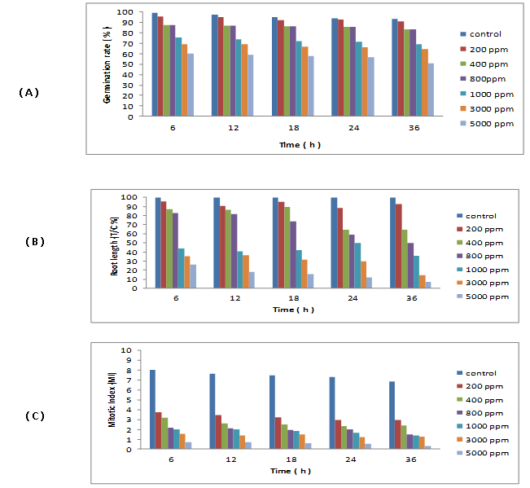
Figure 1. Effect of different concentrations of (AlCl₃) on germination percentage (A) root length as T/C % (B) and mitotic index (MI) (C) in Nigella sativa

Table 1. Frequency of mitotic phases and the percentage of total abnormal mitotic phases after treatment of Nigella sativa root tips with different concentrations of (AlCl₃) for 6, 12, 18, 24 and 36 hours
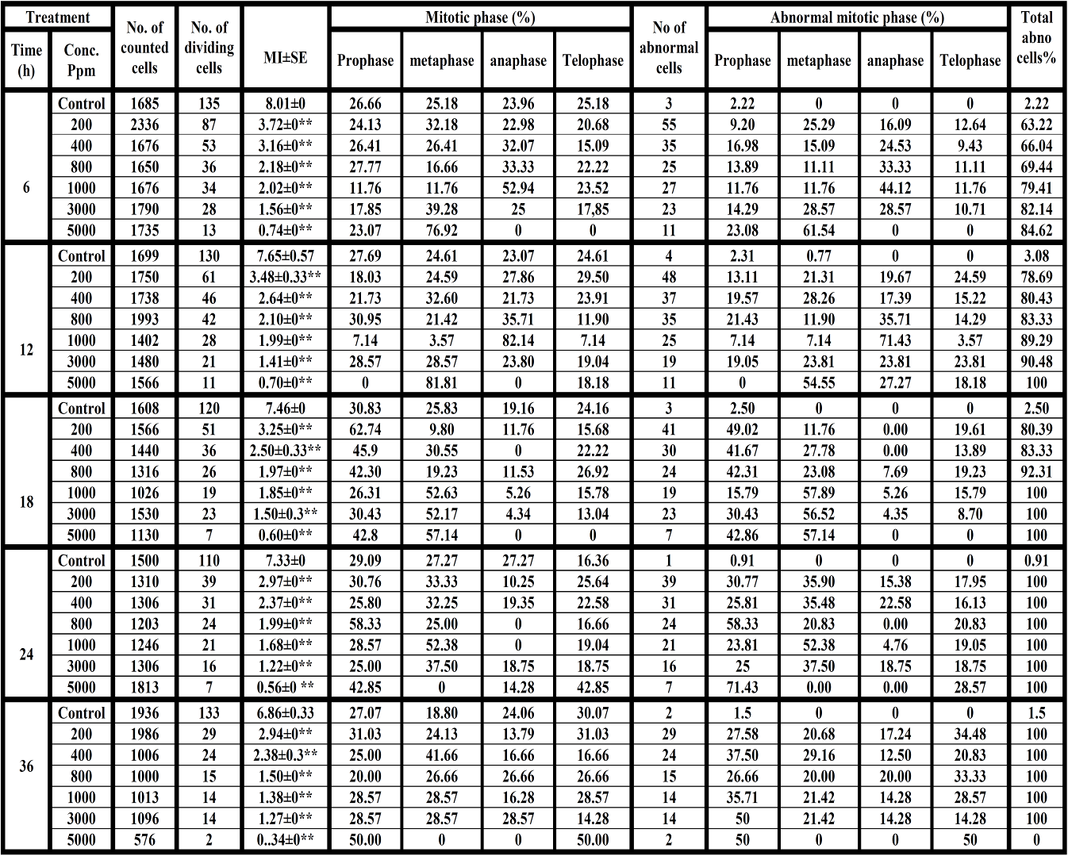
S.E., Standard error; * Significant at level 5% (p ≤ 0.05); ** Significant at level 1% (p ≤ 0.01)

Frequencies of the different types of abnormalities induced in root tip cells of Nigella sativa following the treatment with aluminum chloride are given in Table (2). At prophase stage: three types of chromosomal abnormalities were recorded such as irregular prophase, vacuolated prophase and sticky. The irregular prophase was the most common abnormal type induced by almost all treatments (25 of the 30 different treatments). The other two types (vacuolated nucleus and sticky prophase) were recorded in 15 and 13 of the 30 different treatments for the first and the second types, respectively. At metaphase stage: four types were recorded in the following order: sticky metaphase, C-metaphase, disturbed metaphase and fragment chromosome at metaphase. The last type was the lowest common of abnormality at this stage whereas stickiness was the most frequent type. In addition, C-anaphase type was recorded in a few cells. At anaphase stage: cells with abnormal anaphase according to their frequencies were in the following sequence: stickiness, bridges, forwarded chromosome(s), diagonal (depolarized), disturbed anaphase and star anaphase were observed in some treatments but with low frequency. The cells with sticky chromosome were the most frequent type whereas the forwarded chromosome and star chromosomes were the less frequent types. At telophase stage: only the sticky chromosomes were recorded in all abnormal cells. In this investigation, there is no correlation between the frequency of each observed type of abnormalities and the increasing of the concentration for each treatment time. Moreover, a little number of cells was observed with a micronucleus at interphase stage.

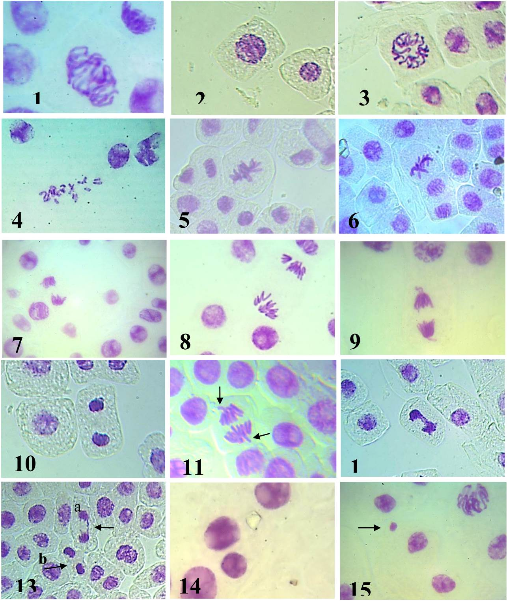
Figure 2. Some types of abnormalities induced in Nigella sativa root tip cells by different treatments of AlCl₃. (1) Irregular prophase. (2) Sticky prophase. (3) Vacuolated nucleus at prophase. (4) C-metaphase. (5) Sticky metaphase. (6) Fragment at metaphase. (7) Diagonal anaphase. (8) Tetra polar anaphase. (9) Sticky anaphase with forward chromosomes. (10) Sticky telophase. (11) Anaphase with forward chromosomes. (12) Multibridges at anaphase. (13-a) Single bridge at anaphase. (13-b) Sticky telophase. (14) Unequal sized nucleus. (15) Micronucleus.

Table 2. Types and percentages of mitotic abnormalities and the percentage of total abnormalities induced by different concentrations of (AlCl₃) in root tips of Nigella sativa after different treatment times
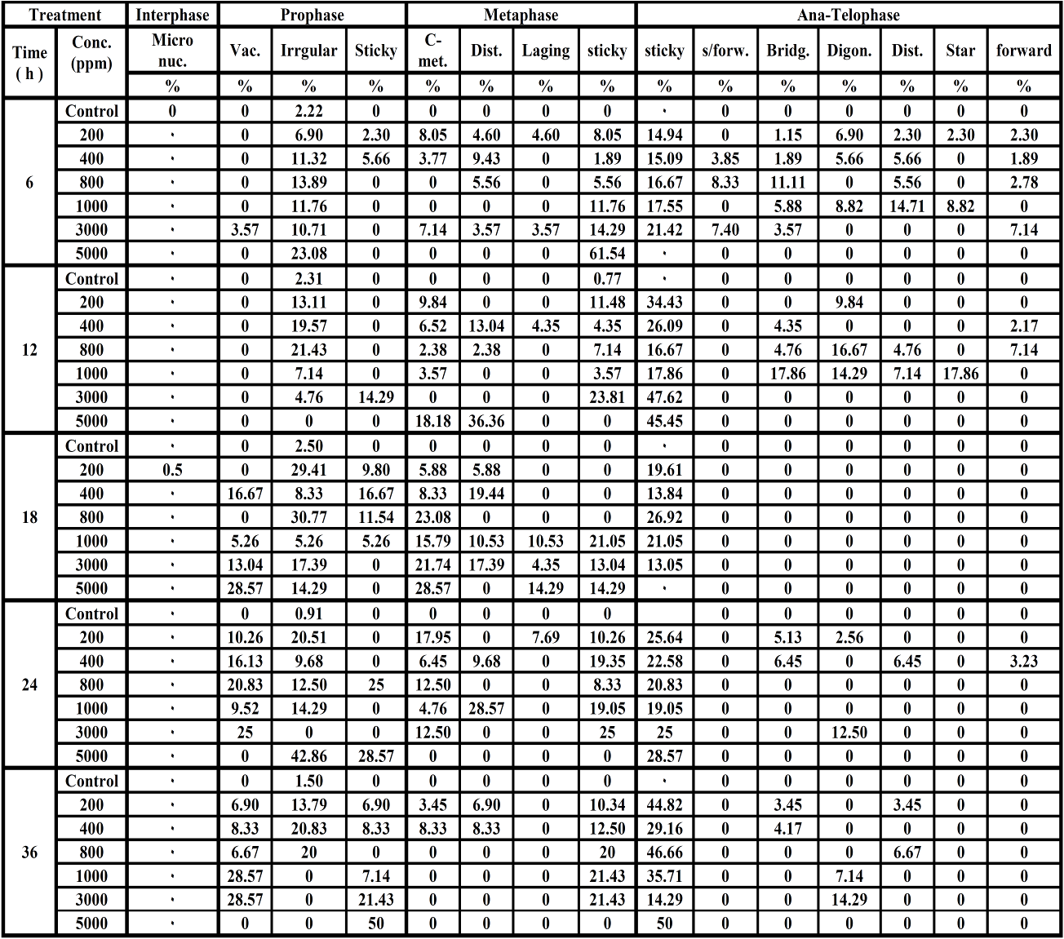

4. Discussion
Germination assay is especially effective to indicate phytotoxicity of soil contaminants and seed germination is considered the most sensitive parameter for evaluating the phytotoxicity of heavy metals (Valerio et al., 2007). Our results revealed that a significant reduction in total germination percentage was observed compared with control, starting at the Al concentration of 200 ppm. The highest concentration (5000 ppm) caused a reduction in total percentages of germinated seeds to a half value of the control. So, germination of the treated seeds was not completely inhibited. A similar result was observed where a reduction in the seed germination percentages has been observed under the action of aluminum for various varieties of barley (Hordeum vulgare) grains and the germination percentage was lower than the control value (Synzynys et al., 2013). Also, a decrease in the total percentage of germination was observed in the treatment of Lactuca sativa (Palmieri et al., 2014), Zea mays (Liu & Jiang, 2001 and Nasrin, 2013) and Platycodon grandiflorum (Zhu et al., 2010) with different concentrations of Al which demonstrates the toxicity of Al. These effects represent a serious hazard to plants because of the extreme importance of the root as an organ involved in obtaining nutrients and water. In contrast, the seed germination is not affected by Al whereas root and seedling developments are reduced following the treatment of white spruce (Picea glauca) seeds Nosko et al. (1988), wheat Triticum aestivum grains (Jamal et al., 2006) and Nicotiana tabacum seeds (Vandar et al., 2006). This metal has been reported not to inhibit germination found, however germination time was delayed, but impaire the growth of new roots and seedling establishment (Nosko, et al., 1988 and Rellén-Álvarez, et al., 2006). The decrease in seed germination can be attributed to the accelerated breakdown of stored food material in seeds by the application of Al (Nasrin, 2013), which has no physiological activity (Lasat, 2002) in contrast to other essential mineral nutrients such as Ni and Zn.
Radicle elongation is the combination of cell division and cell elongation. Inhibition of radicle growth is considered to be primarily the result of inhibited cell elongation and expansion, prior to inhibiting cell division (Vardar et al., 2007). The previous studies represent that root apex (root cap, meristem and elongation zone) is the first target of Al toxicity. Although several toxic effects of Al on plant growth have been proposed, the mechanism of Al toxicity is still to be clarified. For this reason, the present study demonstrates the effects of different Al concentrations on Nigella sativa root growth which has been suggested that radicle growth inhibition is the most evident symptom of Al toxicity. A Similar radicle growth inhibition was detected within different times and concentrations treatments in different plants such as Allium cepa (Liu et al., 1993b; De Campos & Viccini, 2003; Qin et al., 2010 and Achary et al., 2013), Hordeum vulgare (Pan et al., 2001 and Wang et al., 2006), Zea mays (Liu and Jiang, 2001; Barceló & Poschenrieder, 2002; De Campos & Viccini, 2003 and Nasrin, 2013), Vicia faba (Liu et al., 1993c and Pan et al., 2001), Triticum aestivum (Jamal et al., 2001), Triticum turgidum (Frantzios et al., 2000), Oryza sativa (Mohanty et al., 2004, de Macêda et al., 2009 and Alvarez Bello et al., 2012), Lactuca sativa (Palmieri et al., 2014), Glycine max (Yu et al.2011 and Noya et al., 2014), Arachis hypoganea (Huang et al., 2014), Helianthus annuus (Chakravanty & Sirvastava, 1992; Kumar and Srivastava, 2006 and Li et al., 2015), Platycodon grandiflorum (Zhu et al., 2010) and Nicotiana tabacum (Vandar et al., 2006).
In agreement with previous studies, we observed that all applied Al concentrations inhibited the radicle growth and the highest radicle growth inhibition was at 36 h with 5000 ppm of AlCl₃ of about of 93 % of the control value. In this concern, Barceló and Poschenrieder (2002) and De Campos & Viccini (2003) concluded that the most evident symptom of Al toxicity is root growth inhibition, which can be detected within 30 min (Ma et al., 2002 and De Campos & Viccini, 2003) to 2 hours (Kochian, 1995; Zheng and Yang, 2005; Doncheva et al., 2005; Arroyave et al., 2011). It has been suggested that inhibition of root growth induced by Al may result from disturbance of the cell divisions in the root meristematic zone (Doncheva et al., 2005). Also Liu et al. (1993a) concluded that the poisoning by Al³⁺ of the root tip cells of Allium sativum may result from the uptake and accumulation of Al and inhibition of Ca uptake, distribution of physiological activities of calmodulin (CaM) and the inhibition of some enzyme reactions. Al interactions with intracellular constituents, such as calmodulin, and DNA (Matsumoto et al., 1976 and Yamamoto et al., 2001). In this respect, retardation of root and seedling growth were either due to the toxicity of the metal ions through disturbance of the physiological processes and induction of chromosomal abnormalities (Synzynys et al., 2013) or affect root metabolism, which shows sensitivity to Al³⁺ toxicity by a reduction in lateral root size. This is due to reductions in both new cell formation and cell elongation in the extension region of the root (Aremu and Meshitsuka, 2005). In contrast Al at concentration as low as 5-10μM stimulated the root growth in A. cepa (Achary et al., 2013) and also within low concentration of 1.4 mmol/l in Oryza rufipogon (Cao et al., 2011).
Previous investigations started to look at the cell cycle (de)regulation induced by Al, with some works focusing unbalances on mitosis phase and very few on other interphase phases (Silva, 2012). In our study, different mitotic phases in Nigella sativa following the treatment with Al showed a different response in deceasing or increasing in their frequencies than the control values. It is also provided evidence that the treatments had adverse effect on the normal progression of the mitotic cell cycle. It is clear that there was an increase in the percentage of dividing cells in metaphase with 3 treatment times and 2 treatment times in prophase whereas with one treatment time in anaphase and telophase. Wojciechowska and Kocik (1983) reported that an increase in the number of the divided in prophase stage was connected with the increase in telophase stage in root tip cells of Vicia faba treated by Al whereas Andrade et al. (2010) found that Al reduces the percentage of prophase and metaphase cells, reflecting a reduction in MI. Also, Doncheva et al. (2005) reported that Al-induced alterations in the number and the position of dividing cells in root tips. Prolonged exposures of treatments lead to Al interactions with the root cell division and the cytoskeleton (Silva, 2012). As well as, Al impaired the activity of the root meristem as indicated by reduction in its number of mitotic figures (de Macêdo et al., 2009). Our result may indicate that Al³⁺ blocks mitosis at the end of prophase and is considered as pro-metaphase or metaphase inhibitor. In this respect, Frantzios et al. (2000) concluded that the effect of Al on Triticum turgidum mitotic cells is greatly disturbed organization and function of the mitotic apparatus, as well as inhibition of cells from entering mitosis. Cell cycle analysis indicate that the number of cells in each phase of mitosis changed in Al-exposed root tips, providing the indication of Al-induced abnormal progress through mitosis. Data in this study, demonstrate that Al induces cell cycle checkpoints defects in Nigella sativa root tips as reported by Yi et al. (2010) in Vicia faba root tip cells.
The inhibition of mitotic activity was almost time and concentration dependent. In this study, cell division decreased as exposure to Al increased for each treatment time, however, the mitotic activity in treated root tip cells of Nigella sativa never reached zero but reach to a minimum value of 0.34 ± 0. In contrast, the treatments of Vicia faba root tip cells with Al induced pycnosis formation which indicates complete inhibition of mitosis in root meristematic cells (Yi et al., 2010). Al-induced inhibition of cell division in root tip menistems as a primary effect of aluminium has been reported (Wojciechowska and Kocik, 1983). Decrease of mitotic activity was reported as a consequence of Al exposure in root tips of several species such as onion (Dovgalyuk et al., 2001a; De Campos & Viccini, 2003 and Qin et al., 2010), wheat (Frantzios et al., 2001 and Rayburn et al., 2002), rice (Mohanty et al., 2004 and de Macêda et al., 2009 and Alvarez Bello et al., 2012), maize (Llugany et al., 1995; Liu and Jiang, 2001; De Campos & Viccini, 2003 and Doncheva et al., 2005), barley (Budikova and Durcekova, 2004; Wang et al., 2006 and Synzynys et al., 2013), bean (Wojciechowska and Kocik, 1983; Marienfeld et al., 2000; Pan et al., 2001; Liu et al., 1993c and Abdel Hamied et al., 2008), garlic (Liu et al., 1993a) and sunflower (Chakravanty & Sirvastava, 1992; Kumar and Srivastava, 2006 and Li et al., 2015).
However, Doncheva et al. (2005) reported that inhibition of cell division (decrease of S-phase cells) in the proximal meristem after 5 min Al exposure and inhibition of root cell division in the apical meristem within 10 or 30 minutes. According to Posmyk et al. (2008), cell mitotic activity inhibition involves disturbances in the basic processes occurring during all the cell cycle phases. Moreover, the reduction of MI in treated roots is probably due to disturbances in the cell cycle as well as chromatin dysfunction, which is induced by interactions between DNA and the metal (Andrade et al., 2010). In this concern, Maksymiec (2007) considered cell cycle inhibition as the basis for root growth inhibition. In this respect, Roy et al. (1989) concluded that Al has a cytotoxic effect on root tip cell of Allium sativum during a time course study. Matsumoto et al. (1976) suggested that Al could bind to DNA of pea cell and inhibit its synthesis. When a great deal of Al³⁺ penetrates the cell, Al³⁺ ions associate directly with DNA and chromatin and the template activity of DNA for the RNA synthesis is reduced (Morimura and Matsumoto, 1978). Chromatin becomes more condensed and aggregated resulting in low transcriptional activity and this could be the cause of chromosomal damage and mitotic abnormalities (Zhang, 1995). Further evidences for the decrease in the MI could be either due to Al-induced DNA synthesis blockage (Mohanty et al., 2004) or Al interacts with double-stranded DNA and influences its function (Wu et al., 2005).
Aluminum produced a number of mitotic and chromosomal abnormalities in root tip cells of Nigella sativa which varied in their frequencies in the different mitotic stages. Similar to the finding of Roy et al. (1989) and Dovgalvuk et al. (2001a &b), the total abnormalities induced in present study increased with increasing the concentrations and treatment time. In this concern, Grant (1994) stated that mitotic aberrations are generally regarded as the results of an action on the spindle apparatus, whereas chromosomal aberrations indicate effects on chromosome directly or indirectly and the induction of these types provide a variable genetic assay for screening environmental pollution. The induction of abnormalities following the treatment of different plants with Al was previously recorded such as barley (Zhang, 1995; Patra et al., 2000; Pan et al., 2001 and Synzynys et al., 2013), wheat (Rayburn & Wetzel, 2002 and Rayburn et al., 2002), onion (Liu et al., 1993b; De Campos & Viccini, 2003; Qin et al., 2010; Achary & Panda, 2010), bean ((Wojciechowska and Kocik, 1983; Liu et al., 1993c; Abdel Hamied et al., 2008; Zhang et al., 2009 and Yi et al., 2010), garlic (liu et al., 1993a), rice (Mohanty et al., 2004 and de Macêda et al., 2009), sunflower (Chakravanty & Sirvastava, 1992; Kumar and Srivastava, 2006 and Li et al., 2015) and lettuce (Palmieri et al., 2014). Mohanty et al. (2004) reported that cytological alterations seem to be due to the phytotoxic properties of Al. Presumably, the dissociation of the metabolic salt AlCl₃ altered the ionic environment of the cell, which might have led to a physiological change in nucleoprotein or denaturation of protein reflected as chromosomal aberrations.
Of these types of aberrations, stickiness, as a most frequent type, was recorded in the different mitotic phases in root tip cells of Nigella sativa treated with aluminum chloride. This type was recorded following treatment of different plants with Al (Patra et al., 2000; Rayburn et al., 2002; De Campos & Viccini, 2003; Mohanty et al., 2004; Kumar and Srivastava, 2006; Zhang et al., 2014 and Li et al., 2015). Chromosome stickiness consisted of pro- metaphase sticky chromosomes and ana-telophases sticky bridges. The induction of this type reflected the toxicity of aluminum which is most likely irreversible, and probably led to cell death (Pan et al. 2001 and Zhang et al., 2014). Stickiness has been attributed to either the effect of aluminum on the denaturing activity of Al on nuclear proteins such as DNA topoisomerase II, which might also interfere with chromosome segregation (Panda and Panda, 2002), or binding with nucleic acids, mainly DNA, causes serious changes in their physic-chemical properties (El-Ghamery et al. 2002 & 2003 and Synzynys et al., 2013), or chromatin condensation of the nucleus (Zhang, 1995). Moreover, sticky chromosomes can cause loss of genetic material. Subsequently, the cell-division process occurs irregularly, with some chromosomes not adhering to the assembled chromosomal complex and being lost during the cell cycle.
The observation of C-metaphase as the second frequent type of abnormalities at metaphase and some cells C-anaphase at anaphase stage indicates either the action of the aluminum on the spindle fibers which involved in the processes of chromosome movement through regulation and control of de-polymerization and polymerization of the microtubules and preventing the continuation of the mitotic cycle (Li and Sun, 1991) or the spindle apparatus was only impaired or it is one of the consequences of inactivation of spindle apparatus connected with the delay in the division of centromere. As a result of this disorder, the cell cycle is interrupted in metaphase and the chromosomes are seen scattered and condensed with very well-defined centromeres (Fiskesjö, 1985). These dose-independent changes were observed at all concentrations. Both sticky chromosomes and C-metaphase cells are abnormalities that characterize the aneugenic action of the aluminum (Leme and Marin-Morales, 2009). The induction of some cells with disturbed metaphase chromosomes may suggest that aluminum likes other heavy metals causing partial disturbance in the spindle apparatus or partial suppression of spindle formation (El-Ghamery et al., 2003). Consequently, a few cells with multipolar were also observed at ana-teolphase referred to the effect of aluminum by causing splitting of the spindle-fibers into more than two directions (Dovgalyuk et al., 2001a) or partial suppression of spindle formation (El-Ghamery et al., 2003).
At higher concentration, the occurrence of strongly stained nuclei throughout this study, characterized as condensed nuclei, is also an alteration of the normal structure of the nuclei. Nuclear condensation is a feature that is associated with the process of programmed cell death (Andrade et al. 2010).
In similar to the results of De Campos and Viccini (2003) and Li et al. (2015), a great increase in the occurrence of bridges in maize and sunflower, respectively, has been observed. We have observed not only anaphases with simple bridge, but also, with two, three and multiple bridges. An increase of anaphases with more than one bridge was detected more frequently in higher aluminum concentrations. The decrease of anaphase with single bridge was probably due to the increase of the other anaphase bridge type. One hypothesis to explain the increase in the number of bridges with or without fragments per abnormal anaphase can be related to disturbances caused by aluminum on spindle and DNA organization (Frantzios, et al. 2000). Chromosome bridges may have occurred due to the chromosomal stickiness and subsequent failure of free anaphase separation or may be attributed to an unequal translocation or inversion of chromosome segment. In the present investigation, a noticed few cells with fragments in the root tips is probably formed by acentric chromosome and also as a result of inversion. Fragmentation might have arisen due to stickiness of chromosomes and consequent failure of separation of chromatids to poles (El-Ghamery et al., 2003). Bridges lead to chromosome breakage and formation of acentric chromosome fragments which – free-floating in the cytoplasm - can be enveloped by membranes and produce micronuclei where a many cells were recorded with a micronucleus. The induction of micronuclei indicates that some mitotic cells can enter into mitotic (M) phase with DNA damage. In this study, micronuclei, which probably, arose from both clastogenic and aneugenic actions of the aluminum as suggested by Dovgalyuk et al. (2001b). The majority of micronuclei observed may have derived from a single chromosome that was lost from the whole set of chromosomes in the cell (De Campos and Viccini, 2003 and EL-Ghamery et al., 2003).

5. Conclusion
In conclusion, Mohanty et al. (2004) reported that the occurrence of different types of chromosomal aberrations, reduction in the amount of nuclear DNA and persistence of the phytotoxic effect at the post-treatment stage with aluminum on rice plant. Whereas our results demonstrate that aluminum chloride is a clear clastogenic/genotoxic and cytotoxic agent in Nigella sativa root cells. Also, the data about root growth and germination have provided new indicator for Al toxicity and tolerance where the higher concentrations applied did not stop the germination and kill the root. On the other hand, further studies for mechanism of the induction of mitotic aberrations (sticky chromosomes and micronuclei) by Al can allow new insights into the mutagenic effect of Al toxicity on plant nuclear material and the adaptation mechanism of plant to Al toxic environment.

Corresponding Author:
Prof. Dr. A. A. El-Ghamery
Botany & Microbiology Department
Faculty of Science
Al-Azhar University, Nasr City, Cairo, Egypt
E-mail: ma_mousa.@azhar.edu.eg

References
- Abdel-Hamied, N. R.; Atef, A. A. H.; Abdel-Hady, E. A. and El-Ansary, A. M. F. (2008): Protective role of vitamin C against genotoxicity of aluminium sulphate in Vicia faba.The Journal of Genetic Engineering and Biotech., 6 (1): 10-19.
- Achary,V. M. M. and Panda, B. B. (2010): Aluminium-induced DNA-damage and adaptive response to genotoxic stress in plant cells are mediated through reactive oxygen intermediates. Mutagenesis, 25: 201–209.
- Achary,V. M. M.; Parinandi, N. L. and Panda, B. B. (2013): Calcium channel blockers against aluminium-induced DNA-damage and adaptive esponse to genetoxic stress in plant cells. Mutation Res., (751): 130-138.
- Alvarez Bello, I.; Reynaldo Escobar, I.; Sánchez Testillano, P. and Risueño, M. del C. 2012. Aluminium effects on cell division and elongation in rice seedlings (Oryza sativa L.). Cultivos Tropicales, 33 (1): 35- 40.
- Andrade, L. F.; Davide, L. C. and Gedraite, L. S. (2010): The effect of cyanide compounds, fluorides, aluminum, and inorganic oxides present in spent pot liner on germination and root tip cells of Lactuca sativa. Ecotoxicology and Environmental Safety, 73: 626 - 631.
- Aniol, A., (1995): Physiological aspects of aluminium tolerance associated with the long arm of chromosome 2D of the wheat (Triticum aestivum L.) genome. Theor. Appl. Genet., 91: 510-516.
- Aremu, D. A. and Meshitsuka, S. (2005): Accumulation of aluminum by primary cultures astrocytes aluminum amino acid complex and its apoptotic effect. Brain Res., 1031: 284 – 296.
- Arroyave, C.; Barcelo, J.; Poschenrieder, C. and Tolra, R. (2011): Aluminium-induced changes in root epidermal cell patterning, a distinctive feature of hyper resistance to Al in Brachiaria decumbens. J. Inorg. Biochem.., 105:1477-1483.
- Barceló, J. and Poschenrieder, C. (2002): Fast root growth responses, root exudates, and internal detoxification as clues to the mechanisms of aluminium toxicity and resistance: a review. Environ. Exp. Bot., 48: 75-92.
- Biao, M.; Zhou, M.; Sun, D. and Li, C. (2013). Molecular approaches unravel the mechanism of acid soil tolerance in plants. The Crop Journal, (1): 9 1 – 1 0 4.
- Blannn, A. and Ahmed, N. (2014): Blood science: Principles and pathology, John Wiley & Sons, Chichester, West Sussex,
- Budiková, S. and Ďurĉeková, K. (2004): Aluminium accumulation in roots of Al-sensitive barley cultivar changes root cell structure and induces callose synthesis. Biologia, 59 (13): 215-220.
- Cao, Y.; Lou, Y.; Han, Y.; Shi, J.; Wang, Y.; Wang, W. and Ming, F., 2011. Al toxicity leads to enhanced cell division and changed photosynthesis in Oryza rufipogon L. Mol. Biol. Rep., 38 (8): 4839-4846.
- Chakravarty, B. and Srivastava, S. (1992): Toxicity of some heavy metals In Vivo and In Vitro in Helianthus. Mutation Res., (283): 287-294.
- De Campos J. M. S. and Viccini, L. F. (2003): Cytotoxicity of aluminum on meristematic cells of Zea mays and Allium cepa. Caryologia, 56 (1): 65-73.
- De Macêdo, C. E. C.; Jan, V. V. S.; Kinet, J. M. and Lutts, S. (2009): Effects of aluminium on root growth and apical root cells in rice (Oryza sativa L.) cultivars. Reliability of screening tests to detect Al resistance at the seedling stage. Acta Physiol. Plant, 31: 1255 - 1262.
- Doncheva, S. Amen´ os, M.; Poschenrieder, C. and Barcel´o, J. (2005): Root cell patterning: a primary target for aluminium toxicity in maize. Journal of Experimental Botany, 56 (414): 1213 – 1220.
- Dovgalyuk, A. I.; Kalinyak T. B. and Blume, Ya. B. (2001a): Assesment of phyto- and cytotoxic effects of heavy metals and aluminum compounds using onion apical root meristem. TSitologiia i genetika, 35 (1): 3 - 9.
- Dovgalyuk, A. I.; Kalinyak,T. B. and Blume, Ya. B. (2001b): Cytogenetic effects of toxic metal salts on apical meristem cells of Allium cepa L. seeding roots. TSitologiia i genetika, 35 (2): 3 -10.
- El-Ghamery, A. A. and El-Yousser, M. A. (2002): Induction of somatic-cell abnormalities in black cumin and wheat root meristems caused by nickel sulphate in relation to germination and root growth. Al-Azhar Bull. Sci., 13(1): 89 -104.
- El-Ghamery, A. A.: El-Kholy, M. A. and El-Yousser, M. A. (2003): Evaluation of cytological effects of Zn ²⁺ in relation to germination and root growth of Nigella sativa L. and Triticum aestivum L. Mutation Research, (537): 29 - 41.
- Evans, H. J. Meary, G. J. and Tomkinson, S. N. (1957): The use of colchicine as an indicator of mitotic rate in bread bean root meristem. J. Genet., 55: 487.
- Fiskesjo, G. (1985): The Allium test as a standard in environmental monitoring. Hereditas, 102(1): 99-112.
- Fiskesjo, G. (1988): The Allium test-an alternative in environmental studies: The relative toxicity of metal ions. Mutat. Res., 197: 243-260.
- Foy, C. D. (1974): Effect of aluminium on plant growth, In: E.W. Carson (Ed.), The Plant Root and its Environment, Charlottesville, Univ. Press of Virginia, Charlottsville, pp. 601 – 642.
- Frantzios, G.; Galatis, B. and Apostolakos, P. (2001): Aluminium effects on microtubule organization in dividing root-tip cells of Triticum turgidum. II. Cytokinetic cells. Journal of Plant Research, 114: 157–170.
- Frantzios, G.; Galatis, B. and Apostolakos, P. (2000): Aluminium effects on microtubule organization in dividing root-tip cells of Triticum turgidum. I. Mitotic cells. New Phytol., 145: 211–224.
- Grant, W. F. (1994): The present status of higher plant bioassays for the detection of environmental mutagens. Mutat. Res., (310): 175–185.
- Gupta, N.; Gaurav, S. S. and Kumar, A. (2013): Molecular basis of aluminium toxicity in plants: A Review. American Journal of Plant Sciences, (4): 21-37.
- Huang, W. J.; Oo, T. L.; He, H. Y.; Wang, A. Q.; Zhan, J.; Li, C. Z.; Wei, S. Q. and He, L. F. (2014): Aluminum induces rapidly mitochondria -dependent programmed cell death in Al-sensitive peanut root tips. Botanical Studies, 55: 67-78.
- Jaishankar, M.; Mathew, B. B.; Shah, M. S. Murthy, T. P. K. and Gowda, K. R. S. (2014): Biosorption of few heavy metal ions using agricultural wastes. Journal of Environment Pollution and Human Health, 2 (1): 1– 6.
- Jamal, S. N.; Iqbal, M. Z. and Athar, M. (2006): Phytotoxic effect of aluminum and chromium on the germination and early growth of wheat (Triticum aestivum) varieties Anmol and Kiran. International Journal of Enviornmental Science and Technology, 3 (4): 411-41.
- Kochian, L. V. (1995): Cellular mechanisms of aluminum toxicity and resistance in plants. Annual Review of Plant Physiology and Plant Molecular Biology, 46:237-260.
- Kumar, G. and Srivastava, S. (2006). Mechanism of aluminum cytotoxicity in meristematic cells of Helianthus annuus L. Journal of Phytological Research, 19 (2) pp. 175-178.
- Lasat, M. M. (2002): Phytoextraction of toxic metals. A review of biological mechanism. J. Environ. Quality, 31: 109 - 120.
- Leme, D. M. and Marin-Morales, M. A. (2009): Allium cepa test in environmental monitoring: A review on its application. Mutat. Res., 682: 71-81.
- Li, J. and Sun, J. D. Y. (1991): A study on CaM distribution in cells of living things. Chinese J. Cell Biol., 13(1): 1- 6.
- Li, M.; Qin, R.; Jiang, W. and Liu, D. 2015. Cytogenetical effects of aluminum on root meristem cells of Helianthus annuus L. Botanical Sciences, 93 (1): 1-8.
- Liu, D. H. and Jiang, W. S., (2001): Effects of Al³⁺ on root growth, cell division, and nucleoli in toot tip cells of Zea mays. L. Israel Journal of Plant Sciences, 49: 21-26.
- Liu, D. H.; Jiang, W. S. and Li, D. S. (1993a): Effects of aluminium ion on root growth, cell division, and nucleoli of garlic (Allium sativum L.). Environmental Pollution, 82 (3): 295 – 299.
- Liu, D. H.; Jiang, W. S. and Li, M. X. (1993b): Effects of A1³⁺ on root growth and cell division of Allium-cepa. Acta Agricultural Boreal-Silica, 8: 35– 41.
- Liu, D.; Jiang, W. S. and Wang, H. L. (1993c): Effects of A1³⁺ on root growth, cell growth, cell division and nucleolus of Vicia faba. Chin. J. bot., 5: 138-144.
- Liu, Q.; Yang, J. L.; He, L. S.; Li, Y. Y. and Zheng, S. J. (2008): Effect of aluminum on cell wall, plasma membrane, antioxidants and root elongation in triticale, Biologia Plantarum, 52 (1): 87–92.
- Llugany, M.; Poschenrieder, C and Barcelo, J. (1995): Monitoring of aluminium-induced inhibition of root elongation in four maize cultivars differing in tolerance to aluminium and proton toxicity. Physiologia Plantarum, 93 (2): 265–271.
- Ma, Q.; Rengel, Z. and Kuo, J. (2002): Aluminium toxicity in rye (Secale cereale): root growth and dynamics of cytoplasmic Ca²⁺ in intact root tips. Annals of Botany, 89 (2): 241–244.
- Maksymiec, W. (2007): signaling responses in plants to heavy metal stress. Acta Physiol. Plant., 29: 177-187.
- Marienfeld, S.; Schmohl, N.; Klein, M.; Schröder, W. H.; Kuhn, A. J.; and Horst, W. J. (2000): Localisation of aluminium in root tips of Zea mays and Vicia faba. Journal of Plant Physiology, 156 (5-6): 666 – 671.
- Matsumoto, H.; Hirasawa, E.; Torikai, H. and Takahashi, E. (1976): Localization of pea roots treated by aluminum. Plant Cell Physiol., 17: 127-137.
- Mohanty, S.; Das, A. B.; Das, P. and Mohanty, P. (2004): Effect of a low dose of aluminum on mitotic and meiotic activity, 4C DNA content, and pollen sterility in rice, Oryza sativa L. cv. Lalat. Ecotoxicology and Environmental Safety, 59 (1): 70 – 75.
- Morimura, S. and Matsumoto, H. (1978): Effect of aluminium on some properties and template activity of purified pea DNA. Plant Cell Physiol., 19: 429 - 436.
- Nagajyoti, P. C.; Lee, K. D. and Sreekanth, T. V. M. (2010): Heavy metals, occurrence and toxicity for plants: a review. Environ. Chem. Lett., 8:199 –216.
- Nasrin, N. (2013): Germination and seedling growth of maize (Zea mays L.) seeds in toxicity of aluminum and nickel. Merit Research Journal of Environmental Science and Toxicology, 1(5): 110-113.
- Nosko, P.; Brassard, P.; Kramer, J. R. and Kershaw, K. A. (1988): The effect of aluminum on seed germination and early seedling establishment growth and respiration of white spruce (Picea glauca). Can. J. Bot., 66: 2305-2310.
- Noya, A. I.; Ghulamahdi, M.; Sopandie, D.; Sutandi, A. and Melati, M. (2014): Interactive effect of aluminum and iron on several soybean genotype grown in nutrient solution. Asian Journal of Plant Sciences, 13(1): 18-25.
- Olaniran, A. O.; Balgobind, A. and Pillay, B. (2013): Bioavailability of heavy metals in soil: impact on microbial biodegradation of organic compounds and possible improvement strategies. Int. J. Mol. Sci., 14(5): 10197 – 10228.
- Palmieri, M. J.; Luberb, J.; Andrade-Vieiraa, L. F.; Davidea, L. C. (2014): Cytotoxic and phytotoxic effects of the main chemical components of spent pot-liner: A comparative approach. Mutation Research, 763: 30 – 35.
- Pan, J. W.; Zhu, M. Y. and Chen, H. (2001): Aluminum- induced cell death in root-tip cells of barley. Environmental and Experimental Botany, 46: 71-79.
- Panda, B. B. and Panda, K. K. (2002): Genotoxicity and mutagenicity of metals in plants. In: M. N. V. Prasad & K. Strzalka (Eds.), Physiology and Biochemistry of Metal Toxicity and Tolerance in Plants, Kluwer Academic Publishers, Amsterdam,The Netherlands, pp. 95–414.
- Panda, S. K.; Baluska, F. and Matsumoto, H. 2009. Aluminum stress signaling in plants. Plant Signaling Behavior, 4 (7): 592 – 597.
- Pandey, R. M. and Upadhyay, S. K. (2010): Cytological effect of heavy metals on root meristem cells of Vicia faba L. Toxicological & Environmental Chemistry, 92(1): 89 – 96.
- Patra, J.; Baisakhi, B.; Mohapatro, M. K. and Panda, B. B. (2000): Aluminium triggers genotoxic adaptation to methyl mercuric chloride and ethylmethane sulfonate, but not to maleic hydrazide in plant cells In Vivo. Mutat. Res., 43: 51–59.
- Peixoto, P. H. P.; Cambraia, J.; Santanna, R.; Mosquim, P. R. and Moreira, M. A. (2001): Aluminum effects on fatty acid composition and lipid peroxidation of a purified plasma membrane fraction of root apices of two sorghum cultivars. Journal of Plant Nutrition, 24 (7): 1061-1070.
- Posmyk, M. M.; Kontek, R. and Jana, K. M. (2008): Red cabbage extract limits copper stress injury in meristematic cells of Vicia faba. Acta Physiol. Plant, 30: 481-491.
- Qin, R.; Jiao. Y.; Zhang, S.; Jiang, W.; Liu, D. (2010). Effects of aluminum on nucleoli in root tip cells and selected physiological and biochemical characters in Allium cepa var. agrogarum L. Plant Biology, 10: 225 - 235.
- Rayburn, A. L. and Wetzel, J. B. (2002): Flow cytometric analyses of intraplant nuclear DNA content variation induced by sticky chromosomes. Cytometry, 49:36 – 41.
- Rayburn, A. L.; Wetzel, J. B and V. C. Baligar, V. C. (2002): Mitotic analysis of sticky chromosomes in aluminum tolerant and susceptible wheat lines grown in soils of differing aluminum saturation. Euphytica, 127: 193 – 199.
- Rellén-Álvarez, R.; Ortega-Villasante, C.; Alvarez-Ffernandez, A.; del Campo, F. F. and Hernandez, L. E. (2006): Stress response of Zea mays to cadmium and mercury. Plant Soil, 279: 41-50.
- Richards, K. D.; Schott, E. J.; Sharma, Y. K.; Davis, K. R. and Gardner, R. C. (1998): Aluminum induces oxidative stress genes in Arabidopsis thaliana. Plant Physiol., 116(1): 409-418.
- Roy, A. K..; Sharma, A. and Talukder, G. (1989): A time course study on effects of aluminium on mitotic cell division in Allium sativum. Mutat. Res., 227: 221–226.
- Sahi, A. N. and Singh, R. N. (1996): Fly-ash induced chromosomal aberrations in Allium cepa. Cytobios, 86: 23-28.
- Saxena, P. and Misra, N. (2010): Remediation of heavy metal contaminated tropical land. In: I. Sherameti & A. Varma, Soil Heavy Metals, Springer-Verlag, Berlin, pp. 431–78.
- Silva, S. (2012): Aluminium toxicity targets in plants. J. Bot., 2012: 1-8.
- Synzynys, B. I.; Amosova, N. V. and Ulyanenko, L. N. (2013): Sensitivity of barley varieties to aluminum ions: Separately effects and combine with iron ions. American Journal of Plant Sciences, 4: 49-52.
- Valerio, M. E.; Garcia, J. F. and Peinado, F. M. (2007): Determination of phytotoxicity of soluble elements in soils, based on a bioassay with lettuce (Lactuca sativa L.), Sci. Total Environ., 378: 63 –66.
- Vardar, F. and Ünal, M. (2007): Aluminum toxicity and resistance in higher plants. Advanced in Molecular Biology, (1): 1-12.
- Vardar, F. İsmailoğlu, I. İnan, D. and Ünal, M. (2011). Determination of stress responses induced by aluminum in maize (Zea mays). Acta Biologica Hungarica., 62(20):156 –170.
- Vardar, F.; Arıcan, E. and Gözükırmızı, N. (2006): Effects of aluminum on In Vitro root growth and seed germination of tobacco (Nicotiana tabacum L.). Advances in Food Sciences, 28 (2): 85-88.
- Wang, J.; Raman, H.; Zhang, G.; Mendham, N. and Zhou, M. (2006): Aluminium tolerance in barley (Hordeum vulgare L.): physiological mechanisms, genetics and screening methods. J. Zhejiang Univ. Science B, 7 (10): 769 -787.
- Wojciechowska, B. and Kocik, H. (1983): Effect of AlCl₃ and Al So₄ on the root meristems of Vicia faba L. Acta Soc. Bot. Pol., 52: 185-195.
- Wu, J.; Du, F.; Zhang, P.; Khan, I.A.; Chen, J. and Liang, Y. (2005): Thermodynamics of the interaction of aluminum ions with DNA: Implications for the biological function of aluminum. J. Inorg. Biochem., 99: 1145-1154.
- Yamamoto, Y.; Kobayashi, Y. and Matsumoto, H. (2001): Lipid peroxidation is an early symptom triggered by aluminum but not only the primary cause of elongation inhibition in pea roots. Plant Physiol., 125: 199 – 208.
- Yi, M.; Yi, H.; Li, H. and Wu, L. (2010): Aluminum induces chromosome aberrations, micronuclei, and cell cycle dysfunction in root cells of Vicia faba. Environmental Toxicology, 25(2): 124 –129,
- Yu, H. N.; Liu, P.; Wang, Z. Y.; Chen, W. R. and Xu, G. D. (2011): The effect of aluminum on the root growth and cell ultrastructure of two soybean genotypes. Crop Prot., 30: 323-328.
- Zhang, H., Zhang, S., Meng, Q., Zou, J., Jiang, W., Liu, D. (2009). Effects of aluminum on nucleoli in root tip cells root growth and the antioxidant defense system in Vicia faba L. Acta Biol. Cracov., 51: 99 – 106.
- Zhang, H.; Jiang, Z.; Qin, R.; Zhang, H.; Zou, J.; Jiang, W. and Liu, D. (2014): Accumulation and cellular toxicity of aluminum in seedling of Pinus massoniana. BMC Plant Biology, 14: 264. (16 pages).
- Zhang, Y. (1995): Effects of aluminum chloride on the nucleus and nucleolus in root tip cells of Hordeum vulgare. Mutation Research, 335(2):137 – 142.
- Zheng, S. J. and Yang, J. L. (2005): Target sites of aluminum phytotoxicity. Biol. Plant., 49: 321 – 331.
- Zhu, L..; Wang, J.; Fang, X.; Wang, Y.; Hao, J.; Weiwei, M and Jiao, T. (2010): Effect of seed soaking with aluminum on seed germination and seedling physiology of (Platycodon grandiflorum). Zhongguo Zhong Yao Za Zhi, 35(24): 3255-9. (Article in Chinese).

8/17/2016

