Using newrb for analysts’ equity forecasts

Seyed Mohammad Hoseini Khorami

Department of accounting, Safashahr Branch, Islamic Azad University, Safashahr, Iran
E-mail: sm_hoseini28@yahoo.com

Abstract: A neural network (NN), in the case of artificial neurons called artificial neural network (ANN) is an interconnected group of natural or artificial neurons that uses a mathematical or computational model for information processing based on a connectionist approach to computation. This study utilizes newrb technique. The function newrb creates and trains an RBF neural network. In this way, it examines 42 samples from 2005 to 2012. The results shows that the method demonstrate about 99% for train data and test data performance of classification rate.
[Seyed Mohammad Hoseini Khorami. Using newrb for analysts’ equity forecasts. N Y Sci J 2016;9(7):1-5]. ISSN 1554-0200 (print); ISSN 2375-723X (online). http://www.sciencepub.net/newyork. 16. doi:10.7537/marsnys090716.01.

Keywords: newrb function, artificial neural network.

1. Introduction
Neural networks, as used in artificial intelligence, have traditionally been viewed as simplified models of neural processing in the brain, even though the relation between this model and brain biological architecture is debated, as it is not clear to what degree artificial neural networks mirror brain function.
Recent work has demonstrated that neural networks (NNs) represent an efficient tool for modeling a variety of geophysical transfer functions. Thanks to their non-parametric nature, regression by means of NNs has been successfully applied by different authors (Buckton and O’Mongain 1999, Keiner and Brown 1999, Gross et al. 2000, Cipollini et al. 2001) to model the relationship between satellite-received radiances and OAP concentrations. In this paper, we investigate two different NN architectures and make a comparison of their performances. RBF networks are three-layer networks, whose output nodes form a linear combination of the basic functions (usually of the Gaussian type) computed by the hidden layer nodes. Each node provides a significant non-zero response only when the input falls within a small localized region of the input space.
This study uses different classification methods to find the best solutions and also to create the framework for predicting forecast equity. The objective of this study is to present a model in order to forecast equity from 2005 to 2012 using newrb.

2. Material and Methods
In the study area used 12 charactristics that is following:

Table 1. Chracteristices of input data
Elements | Maximum | Minimum | Average | STDEV
Notes receivable | 5253206 | 3885 | 1261087 | 1399529
Inventory | 688701 | 0 | 120072 | 163515
Inventory stock and other inventory | 2542277 | 0 | 636372 | 623930
Advance payment | 2521124 | 39 | 326940 | 655760
Long-term assets | 17363330 | 54030 | 4689123 | 4879249
Notes payable | 5695291 | 16278 | 1478423 | 1763770
prepaid | 3139402 | 3068 | 704671 | 791798
spare parts | 9726510 | 0 | 1653372 | 2447987
Cash | 1182705 | 900 | 214590 | 308493
Long-term liability | 3001470 | 0 | 368339 | 759892
Short-term investments | 3564611 | -3868050 | 270927 | 1794244
equity | 5253206 | 3885 | 1261087 | 1399529

The function newrb iteratively creates a radial basis network one neuron at a time. Neurons are added to the network until the sum-squared error falls beneath an error goal or a maximum number of neurons has been reached. The call for this function is:
net = newrb(P,T,GOAL,SPREAD)
The function newrb takes matrices of input and target vectors, P and T, and design parameters GOAL and, SPREAD, and returns the desired network.
The design method of newrb is similar to that of newrbe. The difference is that newrb creates neurons one at a time. At each iteration the input vector that results in lowering the network error the most, is used to create a radbas neuron. The error of the new network is checked, and if low enough newrb is finished. Otherwise the next neuron is added. This procedure is repeated until the error goal is met, or the maximum number of neurons is reached.
designing a radial basis network often takes much less time than training a sigmoid/linear network, and can sometimes result in fewer neurons being used, as can be seen in the next demonstration.
Radial basis networks can be used to approximate functions. newrb adds neurons to the hidden layer of a radial basis network until it meets the specified mean squared error goal.
net = newrb(P,T,goal,spread,MN,DF) takes two of these arguments,
P R-by-Q matrix of Q input vectors
T S-by-Q matrix of Q target class vectors
goal Mean squared error goal (default = 0.0)
spread Spread of radial basis functions (default = 1.0)
MN Maximum number of neurons (default is Q)
DF Number of neurons to add between displays (default = 25)

3. Results
in the study used newrb function the show in thhe following:
NEWRB, neurons = 0, MSE = 0.506321
NEWRB, neurons = 2, MSE = 0.0496654
NEWRB, neurons = 3, MSE = 0.0103193
NEWRB, neurons = 4, MSE = 0.00296928
NEWRB, neurons = 5, MSE = 0.00249247
NEWRB, neurons = 6, MSE = 0.0024331
NEWRB, neurons = 7, MSE = 0.00238815
NEWRB, neurons = 8, MSE = 0.00235325
NEWRB, neurons = 9, MSE = 0.00234853
NEWRB, neurons = 10, MSE = 0.00233756
NEWRB, neurons = 11, MSE = 0.00233661
NEWRB, neurons = 12, MSE = 0.00232898
NEWRB, neurons = 13, MSE = 0.00232898
NEWRB, neurons = 14, MSE = 0.00232896
NEWRB, neurons = 15, MSE = 0.0023241
NEWRB, neurons = 16, MSE = 0.0023241
NEWRB, neurons = 17, MSE = 0.00232412
NEWRB, neurons = 18, MSE = 0.00232412
NEWRB, neurons = 19, MSE = 0.00232415
NEWRB, neurons = 20, MSE = 0.00232415
NEWRB, neurons = 21, MSE = 0.00232418
NEWRB, neurons = 22, MSE = 0.00232418
NEWRB, neurons = 23, MSE = 0.00232405
NEWRB, neurons = 24, MSE = 0.00232405
NEWRB, neurons = 25, MSE = 0.00232406
NEWRB, neurons = 26, MSE = 0.00232406
NEWRB, neurons = 27, MSE = 0.00232407
NEWRB, neurons = 28, MSE = 0.00232407
NEWRB, neurons = 29, MSE = 0.00232407
NEWRB, neurons = 30, MSE = 0.00232407
NEWRB, neurons = 31, MSE = 0.00232407
NEWRB, neurons = 32, MSE = 0.00232407
NEWRB, neurons = 33, MSE = 0.00232407
NEWRB, neurons = 34, MSE = 0.00232407
NEWRB, neurons = 35, MSE = 0.00232407
NEWRB, neurons = 36, MSE = 0.00232407
NEWRB, neurons = 37, MSE = 0.00232408
NEWRB, neurons = 38, MSE = 0.00232408
NEWRB, neurons = 39, MSE = 0.00232408
NEWRB, neurons = 40, MSE = 0.00232408
NEWRB, neurons = 41, MSE = 0.00232408
NEWRB, neurons = 42, MSE = 0.00232408
NEWRB, neurons = 43, MSE = 0.00232408
NEWRB, neurons = 44, MSE = 0.00232408
NEWRB, neurons = 45, MSE = 0.00232408
NEWRB, neurons = 46, MSE = 0.00232408
NEWRB, neurons = 47, MSE = 0.00232408
NEWRB, neurons = 48, MSE = 0.00232408
NEWRB, neurons = 49, MSE = 0.00232408
NEWRB, neurons = 50, MSE = 0.00232408
NEWRB, neurons = 51, MSE = 0.00232372
NEWRB, neurons = 52, MSE = 0.0023238
NEWRB, neurons = 53, MSE = 0.0023238
NEWRB, neurons = 54, MSE = 0.0023238
NEWRB, neurons = 55, MSE = 0.00232379
NEWRB, neurons = 56, MSE = 0.00232379
NEWRB, neurons = 57, MSE = 0.00232379
NEWRB, neurons = 58, MSE = 0.00232378
NEWRB, neurons = 59, MSE = 0.00232378
NEWRB, neurons = 60, MSE = 0.00232378
NEWRB, neurons = 61, MSE = 0.00232378
NEWRB, neurons = 62, MSE = 0.00232378
NEWRB, neurons = 63, MSE = 0.00232378
NEWRB, neurons = 64, MSE = 0.00232378
NEWRB, neurons = 65, MSE = 0.00232378
NEWRB, neurons = 66, MSE = 0.00232378
NEWRB, neurons = 67, MSE = 0.00232378
NEWRB, neurons = 68, MSE = 0.00232378
NEWRB, neurons = 69, MSE = 0.00232378
NEWRB, neurons = 70, MSE = 0.00232378
NEWRB, neurons = 71, MSE = 0.00232378
NEWRB, neurons = 72, MSE = 0.00232378
NEWRB, neurons = 73, MSE = 0.00232378
NEWRB, neurons = 74, MSE = 0.00232378
NEWRB, neurons = 75, MSE = 0.00232233
NEWRB, neurons = 76, MSE = 0.00232233
NEWRB, neurons = 77, MSE = 0.00232232
NEWRB, neurons = 78, MSE = 0.00232269
NEWRB, neurons = 79, MSE = 0.00232269
NEWRB, neurons = 80, MSE = 0.00232269
NEWRB, neurons = 81, MSE = 0.00232268
NEWRB, neurons = 82, MSE = 0.00232268
NEWRB, neurons = 83, MSE = 0.00232269
NEWRB, neurons = 84, MSE = 0.00232269
NEWRB, neurons = 85, MSE = 0.00232267
NEWRB, neurons = 86, MSE = 0.00232267
NEWRB, neurons = 87, MSE = 0.00232267
NEWRB, neurons = 88, MSE = 0.00232267
NEWRB, neurons = 89, MSE = 0.00232267
NEWRB, neurons = 90, MSE = 0.00232263
NEWRB, neurons = 91, MSE = 0.00232263
NEWRB, neurons = 92, MSE = 0.00232262
NEWRB, neurons = 93, MSE = 0.00232262
NEWRB, neurons = 94, MSE = 0.00232261
NEWRB, neurons = 95, MSE = 0.00232253
NEWRB, neurons = 96, MSE = 0.00232253
NEWRB, neurons = 97, MSE = 0.00232253
NEWRB, neurons = 98, MSE = 0.00232253
NEWRB, neurons = 99, MSE = 0.00232255
NEWRB, neurons = 100, MSE = 0.00232255
The results of the recearch is show in Figure 1 to Figure 4.

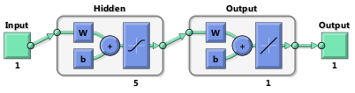
Figure 1. newrb for the research to forecast equity

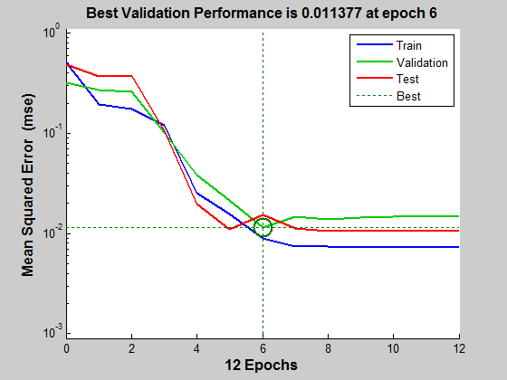
Figure 2. Best validation performance for the research to forecast equity

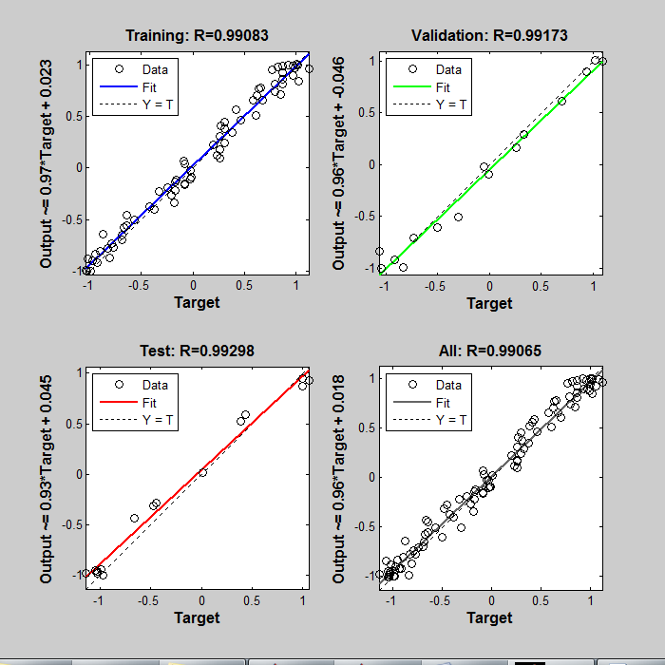
Figure 3. The results of the newrb method for to forecast equity

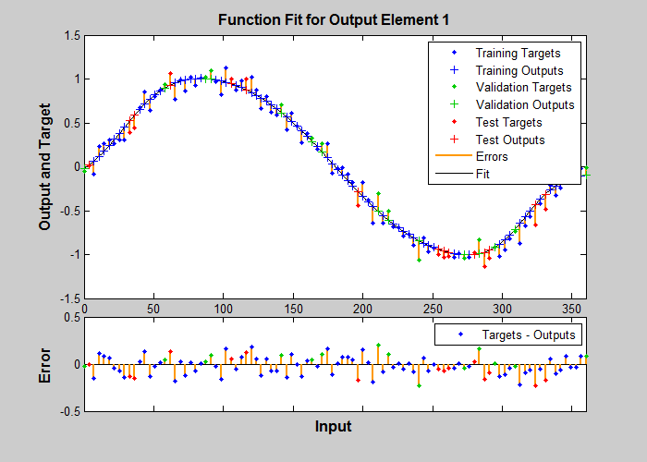
Figure 4. Function fit for outputs elements (equity)

4. Discussions
In the research were used 11 input that involve Cash، Short-Term Investments، Notes Receivable, Inventory، Spare Parts, Inventory Stock and Other Inventory, Advance Payment, Long-Term Assets, Notes Payable, Prepaid, Long-Term Liability that applied for clustering equity. For predicting forecast equity used newrb method. According to results, the method demonstrate about 99% for train data and test data performance of classification rate.

References
- D. Buckton, E. O’Mongain, and S. Danaher, “The use of neural networks for the estimation of oceanic constituents based on the MERIS instrument,” Int. J. Remote Sens., vol. 20, pp. 1841–1851, 1999.
- L. E. Keiner and C. W. Brown, “Estimating oceanic chlorophyll concentrations with neural networks,” Int. J. Remote Sens., vol. 20, pp. 189–194, 1999.
- L. Gross, S. Thiria, R. Frouin, and B. G. Mitchell, “Artificial neural network for modeling the transfer function between marine reflectance and phytoplankton pigment concentration,” J. Geophys. Res., vol. 105, no. C2, pp. 3483–3495, 2000.
- P. Cipollini, G. Corsini, M. Diani, and R. Grasso, “Retrieval of sea water optically active parameters from hyperspectral data by means of generalized radial basis function neural network,” IEEE Trans. Neural Networks, vol. 39, pp. 1508–1524, Nov. 2001.

6/21/2016

