An Evaluation Of The Phytochemical And Antimicrobial Profiles Of Vernonia Amygdalina And Bark Of Magnifera indica

Matthew Egbobor Eja¹, Joseph Ubi Otu¹, Nsor Odo Alobi², Uno Agbo Uno², Magdalene Obi-Abang²

¹Department of Biological Sciences, Cross River University of Technology, P.M.B 1123, Calabar, Nigeria.
²Department of Chemical Sciences, Cross River University of Technology, Calabar, Nigeria.
Kingenyi4gold@yahoo.com

Abstract: Since the emergence of tetracycline – resistant bacterium, Shegella dysenteriae in 1953, there has been a lot of research on the production of semi-synthetic drugs against several emerging drug-resistant bacteria. In this regard, herbal scientists have contributed very little. This study investigated the phytochemical compositions and antimicrobial effects of Vernonia amygdalina (E₁) and the bark of Magnifera indica (E₂) in combination with themselves and conventional drugs, Ampicillin (AmP) and Chloramphenicol (CPC), against Salmonella species isolated from poultry farms. Broth dilution and disc diffusion methods were respectively applied to determine the sensitivity of Salmonella species and the minimum inhibitory concentrations (MICs) of the plants affecting Salmonella species; the phytochemical analysis was carried out using standard methods. Results revealed that E₁ possessed greater antimicrobial effect on Salmonella species (Zone of inhibition: 9.06+0.66 to 15.12+0.61mm) than E₂ (Zone of inhibition: 0.0 to 12.10+0.20mm); while Salmonella was resistant to E₂. The combination of E₁ and E₂ gave antagonistic results with E₁ antagonizing E₂. There was significant difference (p < 0.05) between E₁ and E₂, and the combination of each of the plants and antibiotics. The maximum zone of inhibition of E₁ + AMP (21.66+0.97mm) indicateing better effectivity than E₂ + AMP (13.77+0.86mm). Also, E₁ + CPC has the same advantage over E₂ + CPC. There was antagonism in 100% of the isolates when E₁ and E₂ were combined. However, E₁ + AMP and E₁ + CPC resulted in synergism in 93% and 100% of the isolates respectively, indicating a possible hope in the fight against antimicrobial resistance. Also, the MIC of E₁ (3.12mg/ml) affected 38.46% of the isolates unlike that of E₂ (6.25mg/ml) which affected 12.82% of the isolates, thus confirming E₁ as having greater effectivity than E₂. In conclusion, Vernonia amygdalina in combination with ampicillin and chloramphenicol could be drugs of choice against resistant Salmonella species.
[Matthew Egbobor Eja, Joseph Ubi Otu, Nsor Odo Alobi, Uno Agbo Uno, Magdalene Obi-Abang. An Evaluation Of The Phytochemical And Antimicrobial Profiles Of Vernonia Amygdalina And Bark Of Magnifera indica. N Y Sci J 2016;9(6):85-94]. ISSN 1554-0200 (print); ISSN 2375-723X (online). http://www.sciencepub.net/newyork. 14. doi:10.7537/marsnys09061614.

Keywords: Phytochemical profiles, antimicrobial effects, conventionaldrugs, Vernonia amygdalina, Magnifera indica.

Introduction
The emergence of resistant strains of pathogens to antibiotics has remained a global concern since the last five decades. It started with the discovery of tetracycle-resistant bacterium, Shigella dysenteriae in 1953, following the discovery of tetracycline in the 1940s (MMBR, 2001). The routine use of antibiotics in medicinal and agricultural practices has resulted in widespread antibiotic resistance and development of genetic mechanisms efficient in the dissemination of antibiotic resistant genes, especially among gram-negative organisms (Ackers et al., 2000).
The frequency of isolation of Salmonella strains resistant to one or more antibiotics has also risen all over the world. An example is a recent newcomer to the food safety pathogen list, Salmonella typhimurium phage type DT104, which possesses resistance to multiple antibiotics, including ampicillin, tetracycline and streptomycin (Jones, 2005).
Okeke et al. (2005) state that, in developing countries where household subsistence farming is common, a large proportion of the population has close contact with food animals (poultry) and, if resistant organisms are common in animals, the chance that they will be transmitted to human beings is more likely.
Therefore, research is still on-going on the production of synthetic resistance – free antibiotics. Herbal scientists are also researching on alternative sources of resistance-free drugs from medicinal plants, but their contribution is little. However, a few studies on the sensitivity of bacteria to some plants have recently been carried out. Eja et al. (2011) examined the antimicrobial synergy of garlic (Allium sativum) and utazi (Gongronema latifolium) on Escherichia coli and Staphylococcus aureus, and observed some synergy in the combination of garlic and ampicillin against S. aureus besides additive and antagonistic reactions between utazi and ciprofloxacin. Also, antimicrobial and phytochemical effects against E. coli and S. aureus have been observed by Enyi-Idoh et al. (2011). Atangwho et al. (2009) have worked on the comparative chemical composition of some antidiabetic medical plants, Azadirachta indica, Vernonia amygdalina and Gongronema latifolium and identified useful phytochemical components including alkaloids and a few other relatively antibacterial components. Andy et al. (2008) have observed some synergy when Lansianthera africana or Heinsia crinata in combination with chloramphenicol was tested against Candida albicans. These give hope of medicinal plants as alternative sources of resistance-free drugs.
V. amygdalina (bitter leaf) is a member of the family, Asteraceceae. It is a small shrub that typically grows up to a height of 2-5cm tall in tropical Africa. Its bark is rough; and it is commonly called “bitter leaf” because of its bitter taste. The Nigerian common names are ewuro (Yoruba), etidot (Ibibio), onugbu (Igbo), ityuna (Tiv), chusar-doki (Hausa), etc. (Kokwaro, 2009). It is used locally for the treatment of intestinal infections, reduction in fever and diabetics and headache (Ejike, 2011).
Magnifera indica, commonly known as mango, belongs to the family, Anacerdiaeceae which consists of about sixty genera and six hundred species (Akinpelu and Onakoya, 2006). It is one of the most popular fruit-bearing trees in the world (Kabuki et al., 2000). It is used in native Africa for treating mouth – Salmonella – related infections in children such as diarrhoea, dysentery, typhoid and throat fever. The bark of mango has been found to possess anti-helminthic and anti-allergic properties (Campbell et al., 2003; Abdalla et al., 2007).
The aim of this study was to investigate the phytochemical and antimicrobial potency of two common plants, Vernonia amygdalina (bitter leaf) and the bark of Magnifera indica (mango) on Salmonella species isolated from poultry farms by staff of the Microbiology Laboratory of the Department of Biological Sciences, Cross River University of Technology, Calabar.

2. Materials and Methods
2.1 Sources of test organisms and plants
Fourteen Salmonella isolates from Unical, Almond and Sandra Poultry Farms were obtained from the Microbiology Laboratory of Cross River University of Technology (CRUTECH), and used for the sensitivity tests against Vernonia amygdalina and Magnifera indica. The two plants were obtained from the Botanical Garden of CRUTECH, Calabar.

2.2 Preparation of the plants extracts
The plant samples were thoroughly washed and then air-dried gently in an air circulating oven in the laboratory, and individually ground manually into fine powder, using a manual grinder (Corona, Landers and CIA, SA) (Nwinuka et al., 2006). The powder of each sample was sieved through mesh 300µm (Nwinuka et al., 2006). The powdered sample of each of the plant (50g) was transferred into a soxhlet apparatus for the complete extraction of the plant extracts, using absolute ethanol as the extraction solvent.
2.3 Preparation of extract and conventional drug concentrations for sensitivity test
The ethanolic extract (10mg) was dissolved in 1ml of dimethyl sulfoxide (DMSO) to obtain a concentration of 10mg/ml, marked solution 1. When 0.1ml of solution 1 was dissolved in 9.9ml of DMSO, a solution of concentration 1.0mg/ml was obtained, which was referred to as solution 2. Incorporation of 1ml from solution 2 into 9ml of DMSO gave solution 3 with a final concentration of 100µg/ml, which was used to impregnate the discs, or combined with conventional antibiotics (ampicillin and chloramphenicol in a volume ratio of 0.1:0.1
Chloramphenicol and ampicillin were selected to be tested in combination with the plants because of reported development of resistance by environmentally isolated Salmonella strains to these drugs (Prescott et al., 2005; Patterson, 2006). Ampicillin (500mg) was dissolved in deionized water and DMSO as a solubility agent and the volume made up to 50.0ml at room temperature (Mukhtar and Huda, 2005), giving a concentration of 10mg/ml. Further dilutions as with the extracts were made to obtain a solution with a concentration of 1mg/ml. By incorporating 1ml of the solution into 9ml of DMSO, a final concentration of 100µg/ml was obtained. Chloramphenicol (250mg) was dissolved in deionized water and DMSO and the volume was made up to 25.0ml at room temperature. This gave a concentration of 10mg/ml. Further dilutions as stated above were made to obtain 100µg/ml. To test the extract combined with ampicillin or chloramphenicol, equal volumes of extracts and ampicillin or chloramphenicol (0.1:0.1) were mixed and the mixture tested along with the individual extracts and the drugs separately.
2.4 Testing for antimicrobial effects of extracts along with ampicillin and chloramphenicol
A disc diffusion technique using the Kirby-Bauer method (Prescott et al., 2005; Eja et al., 2011) was applied in testing pure cultures of the Salmonella isolates for their antimicrobial sensitivities.
The discs used for the test were punched from Whatman No. 1 filter paper. The discs were 5mm in diameter. They were sterilized and then impregnated with the extracts separately (Onyeaba et al., 2004). Five agar plates for each test organism per plant were inoculated with 0.1ml broth culture of test organisms and spread with a glass rod shaped like a hockey stick, and incubated at 37ºC for 24h. The antibiotics, ampicillin (AMP) and chloramphenicol (CPX) were used as controls for comparison with the extracts (Eja et al., 2011). After incubation, the plates were observed for zones of inhibition.
2.5 Testing for minimum inhibitory concentration of extracts
In the determination of minimum inhibitory concentration (MIC), a standard inoculums was first prepared. This involved transferring a portion of pure culture of each isolate into tryptone soya broth (oxoid CM129) and incubating at room temperature overnight (Eja et al., 2011). The overnight broth culture (0.1ml) was diluted with 1ml of distilled water in the ratio of 1:1000 to give a final dilution of 10⁻³ of the standard inoculums (Adoum et al., 1997) following which the dilution susceptibility technique (Cheesbrough, 2000) was applied. The reciprocal of 10⁻³ equivalent to 10³ was the number of organisms in the standard inoculums used for the MIC test. In this technique Muella-Hinton broth containing various concentrations of the plant extracts was prepared. In the preparation, 1ml from the different dilutions of the extracts was added to 10 labelled test tubes containing 9ml Muella-Hinton broth to obtain final concentrations of 5000, 2500, 1250, up to 0mg/ml, and incubated at 37ºC for 16-20h. The presence or absence of growth for each concentration was recorded at the end of incubation. The MIC was taken as the lowest concentration of the extracts resulting in no growth after 16-20h of incubation.
2.6 Synergy test
The plant extracts (0.1:0.1) were combined with each other, and separately combined with antibiotics (ampicillin and chloramphenicol).
2.7 Phytochemical screening of the plant extracts
A qualitative analysis of the plant extracts was carried out using the methods of Cuilei (1982), Sofowora (1984) and Gundiza (1985).
2.8 Statistical analysis
Differences, if any, between the two plants with respect to their MIC, and in combination with each other and with the antibiotics, using statistical analysis of variance (ANOVA) (Bailey, 1981; Miller and Miller, 1986), was carried out.

3. Results
3.1 Phytochemical screening
The result of the phytochemical screening of the two plants is shown in Table 1 which shows that both plants possess varying concentrations of glycosides, flavonoid, polyphenols, saponins, alkaloids, tannins, phlabotinnins and steroids. However, the levels of most of these bioactive components appeared to be higher in V. amygdalina than M. indica. Tannins and polyphenols were observed to be present at the same levels in both plants.
3.2 Testing for antibacterial effects of extracts on Salmonella species
The effects of ethanolic leaf extracts of V. amygdalina (E₁) and the bark of Magnifera indica (E₂) and their combinations on Salmonella isolates are represented in Table 2. The table shows that E₁ possessed reasonable antibacterial effect (Zone of inhibition: 9.06+0.66 to 15.12+0.61mm) on Salmonella, unlike E₂ which had little or no effect (Zone of inhibition from 0.0 to 12.10+0.20mm) on Salmonella species. In the combination of E₁ and E₂, E₁ antagonised or interfered with E₂ in all the tests against Salmonella species. That means that the combined effect is less than that of a more potent extract acting alone (Oko and Itah, 2014).
3.3 Testing for antibacterial effects of extract of V. amygdalina in combination with Ampicillin (AMP) and Chloramphenicol (CPC) on Salmonella species
The effects of the extract in combination with ampicillin and chloramphenicol are shown in Table 3. The table shows that all the combinations against Salmonella isolates from broilers, layers, soil impacted litters and control soil, exhibited synergistic effect. That is, the joint effect of E₁ and AMP was greater than the sum of effects of each of the extracts acting alone (Ok and Itah, 2014). Regarding the combined effect of E₁ and CPC on Salmonella species, there was synergism in almost all the tests.
3.4 Testing for antibacterial effect of extract of M. indica in combination with Ampicillin (AMP) and Chloramphenicol (CPC) on Salmonella species
The effects of the extract of M. indica in combination with AMP and CPC are represented in Table 4. All the combinations of M. indica extract with AMP revealed antagonistic effect on Salmonella species with the exception of layers litters from all the farms and litter impacted soil from the University Poultry Farm which showed synergism. Also, with the exception of isolates of layers litters from University and Almond Farms, and broilers litter impacted soil from University Farm, besides broilers litters from Sandra and Almond Farms, other combinations of E₂ with CPC revealed antagonistic effects.
3.5 Percentage representation of Salmonella isolates under the effect of ethanolic extract of V. amygdalina in combination with Ampicillin and Chloramphenicol
Figure 1 represents the percentage of Salmonella isolates affected by ethanolic extract of V. amygdalina in combination with M. indica, AMP and CPC. The figure revealed that there was antagonism between E₁ and E₂ in 100% of the isolates tested, 93% for E₁ + AMP (Synergism and 100% for E₁ + CPC antagonism).
3.6 Percentage representation of Salmonella isolates under the effect of ethnaolic extract of the bark of Magnifera indica in combination with Ampicillin and Chloramphenicol
Figure 2 represents the percentage of Salmonella isolates affected when E₂ was combined with Ampicillin and Chloramphenicol. The figure reveals 71% antagonism and 29% synergy for E₂ + AMP, and 100% antagonism for E₂ + CPC.
3.7 Percentage representation of Salmonella isolates inhibited by various concentrations of Vernonia amygdalina
Figure 3 represents the percentage of Salmonella isolates inhibited by various concentrations of V. amygdalina. The figure shows that 38.46% test organisms were inhibited at 3.12mg/ml, 30.77% at 6.25mg/ml, 15.38% at 12.50mg/ml, 20.51% at 25mg/ml and 10.25% at 50mg/ml, indicating the effectiveness of the plant.
3.8 Percentage representation of Salmonella isolates inhibited by various concentrations of Magnifera indica
Figure 4 represents the percentage of Salmonella isolates inhibited by various concentrations of the bark of M. indica. The figure shows that 12.52% test organisms were inhibited at 6.25mg/ml, 23.08% at 12.50%, 23.08% at 25mg/ml, 25.3% at 50mg/ml and 15.38% at 100mg/ml, indicating less effectivity than E₂.

Table 1: Results of phytochemical screening from ethanolic leaf extract of Vernonia amygdalina and bark of Mangifera indica
S/N | Name of sample (plants) | Alkaloids | Flavonoids | Tannins | Glycosides | Saponins | Polyphenols | Phlabotinnins | Steroids
1. | E₁^{c} | +++ | +++ | +++ | +++ | +++ | +++ | - | +++
2. | E₂^{c} | ++ | ++ | +++ | ++ | + | +++ | ++ | ++
E₁ = Vernonia amygdalina; E₂ = Mangifera indica; e = Ethanolic; + = Low concentration of bioactive substances; ++ = Moderate concentration of bioactive substances; +++ = High concentration of bioactive substances; - = Absence

Table 2: Effect of ethanolic leaf extract of Vernonia amygdalina (E₁) and the bark of Magnifera indica (E₂) and their combination on Salmonella organisms
Isolate | Mean zones of inhibition (mm)
 | E₁ | E₂ | E₂ + E₂
ªLL  ªBIS  ªLIS  ªCS  ªBL  ^{b}BIS  ^{b}LIS  ^{b}BL  ^{b}LL  ^{c}BL  ^{c}BIS  ^{c}LL  ^{c}CS  ^{c}LIS | 10.83+0.35  10.77+0.63  10.08+0.50  15.12+0.61  9.06+0.66  13.00+0.26  12.06+0.50  9.00+0.50  12.16+0.50  9.66+0.14  10.12+0.40  10.50+0.50  14.00+0.20  10.50+0.50 | 00*  00*  00*  3.55+0.10  00*  00*  00*  00*  00*  00*  00*  00*  00*  00* | 00*  00*  6.0+0.25  10.12+0.66  8.16+0.66  00  8.0+0.50  8.0+0.50  8.0+0.50  7.0+0.50  9.33+0.50  7.66+0.98  12.10+0.20  9.0+0.70
LL = Layers litter; BL = Broilers litter; BIS = Broilers litter impacted soil; LIS = Layers litter impacted soil; CS = Control soil; a = Unical Poultry farm; b = Sandra poultry farm; c = Almond poultry farm; * = Salmonella was resistant to E₂ or E₁ + E₂.

Table 3: Effect of ethanolic leaf extract of Vernonia amygdalina in combination with ampicillin and chloramphenicol on Salmonella organisms
 | Mean zones of inhibition
Isolate | E₁ | AMP | E₁+AMP | CPC | E₁+CPC
ªLL  ªBIS  ªLIS  ªCS  ªBL  ^{b}BIS  ^{b}LIS  ^{b}BL  ^{b}LL  ^{c}BL  ^{c}BIS  ^{c}LL  ^{c}CS  ^{c}LIS | 10.83+0.35  10.77+0.63  10.08+0.50  15.12+0.61  9.06+0.66  13.00+0.26  12.06+0.50  9.00+0.50  12.16+0.50  9.66+0.14  10.12+0.40  10.50+0.50  14.00+0.20  10.50+0.50 | 3.16+0.78  13.22+0.66  10.66+0.62  14.98+0.66  13.66+0.56  14.50+0.50  14.33+0.30  19.67+0.57  9.44+0.40  13.83+0.35  12.66+0.74  11.50+0.50  15.33+0.72  14.00+0.50 | 13.99+0.20  21.66+0.20  21.66+0.97  17.77+0.57  13.74+0.30  16.99+0.67^{s}  15.22+0.47^{s}  13.66+0.61  15.33+0.61^{s}  17.99+0.86^{s}  17.99+0.86^{s}  14.49+0.20^{s}  16.33+0.35^{s}  14.11+0.50^{s} | 18.00+0.50  17.21+0.21  15.09+0.85  22.88+0.60  18.55+0.25  18.44+0.30  14.66+0.46  16.66+0.50  15.16+0.46  14.16+0.61  16.46+0.46  18.50+0.50  19.83+0.35  16.44+0.60 | 21.66+0.35  19.88+0.20  17.74+0.50  31.55+0.94  22.66+0.93  21.16+0.61  17.11+0.57  20.22+0.30  17.16+0.61  18.50+0.50  17.49+0.45  18.60+0.61  20.50+0.50  20.50+0.50
LL = Layers litter; BL = Broilers litter; BIS = Broilers litter impacted soil; LIS = Layers litter impacted soil; CS = Control soil; a = Unical Poultry farm; b = Sandra poultry farm; c = Almond poultry farm; S = Synergistic effect exhibited; + = All the combinations exhibiting synergistic effect.

Table 4: Effect of ethanolic extract of Magnifera indica in combination with Ampicillin and Chloramphenicol on Salmonella isolates
 | Mean zones of inhibition
Isolate | E₁ | AMP | E₁+AMP^{K} | CPC | E₁+CPC^{K}
ªLL  ªBIS  ªLIS  ªCS  ªBL  ^{b}BIS  ^{b}LIS  ^{b}BL  ^{b}LL  ^{c}BL  ^{c}BIS  ^{c}LL  ^{c}CS  ^{c}LIS | 0.00  0.00  0.00  3.55+0.10  0.00  0.00  0.00  0.00  0.00  0.00  0.00  0.00  0.00  0.00 | 3.16+0.78  13.22+0.66  10.66+0.62  14.98+0.66  13.66+0.56  14.50+0.50  14.33+0.30  19.67+0.57  9.44+0.40  13.83+0.35  12.66+0.74  11.50+0.50  15.33+0.72  14.00+0.50 | 13.99+0.20  21.66+0.20  21.66+0.97  17.77+0.57  13.74+0.30  16.99+0.67^{s}  15.22+0.47^{s}  13.66+0.61  15.33+0.61^{s}  17.99+0.86^{s}  17.99+0.86^{s}  14.49+0.20^{s}  16.33+0.35^{s}  14.11+0.50^{s} | 18.00+0.50  17.21+0.21  15.09+0.85  22.88+0.60  18.55+0.25  18.44+0.30  14.66+0.46  16.66+0.50  15.16+0.46  14.16+0.16  16.46+0.46  18.50+0.50  19.83+0.35  16.44+0.60 | 21.66+0.35  19.88+0.20  17.74+0.50  31.55+0.94  22.66+0.93  21.16+0.61  17.11+0.57  20.22+0.30  17.16+0.61  18.50+0.50  17.49+0.45  18.6+0.61  20.50+0.50  20.50+0.50
LL = Layers litter; BL = Broilers litter; BIS = Broilers litter impacted soil; LIS = Layers litter impacted soil; CS = Control soil; a = Unical Poultry farm; b = Sandra poultry farm; c = Almond poultry farm; k = over 71% antagonistic.

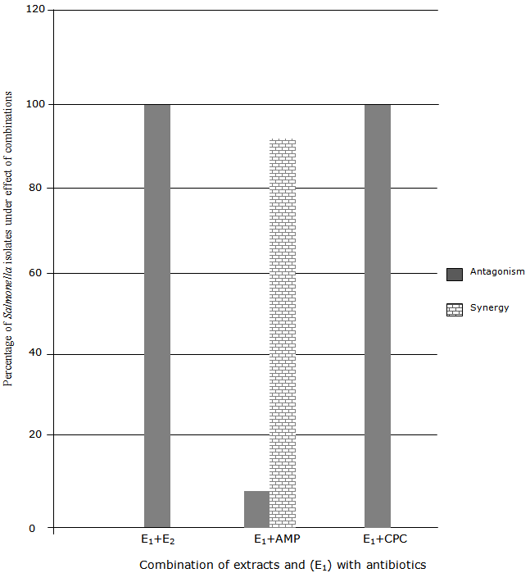
Figure 1: Percentage representation of the effect of ethanolic extract of V. amygdalina in combination with Ampicillin and Chloramphenicol on Salmonella isolates

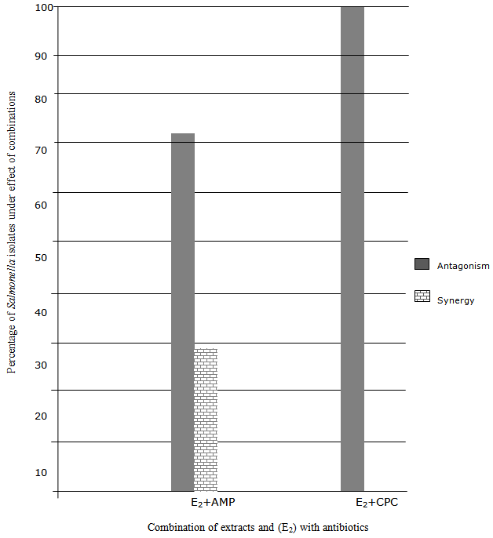
Figure 2: Percentage representation of the effect of ethanolic extract of the bark of Mangifera indica in combination with Ampicillin and Chloramphenicol on Salmonella isolates

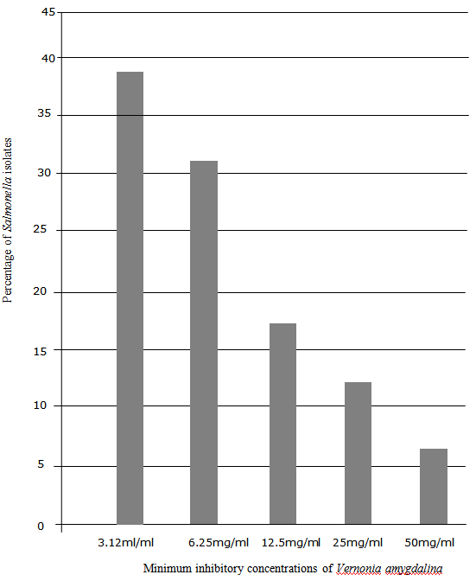
Figure 3: Percentage inhibition of concentrations of leaf extract of Vernonia amygdalina on Salmonella isolates

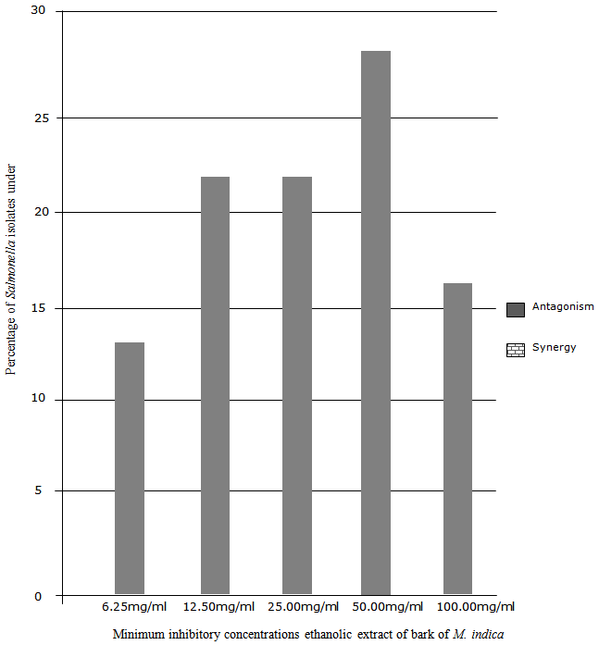
Figure 4: Percentage inhibition of concentrations of M. indica onSalmonella isolates

Discussion
The phytochemical screening of the leaf of V. amygdalina and the bark of M. indica revealed varying proportions of bioactive substances such as alkaloids, saponins, glycosides, polyphenol, tannins, flavonoids and steroids. These bioactive substances reported by several researchers, are indicative of the potential medicinal values of the plants in which they appear (Enyi-Idoh et al., 2011; Alobi et al., 2012; Alobi et al., 2015). Also, Madunagu et al. (1990) have demonstrated the occurrence of different concentrations of phlobatinnins, glycosides, saponins, alkaloids, polyphenol, tannins and flavonoids in the bark of M. indica. The result revealed that, although M. indica contained phlabatinnins which was not present in V. amygdalina, V. amygdalina contained more concentrations of bioactive substances, e.g., alkaloids, flavonoids, glycosides, saponins, polyphenols and steroids, indicating greater medicinal potential than M. indica. The variation in the phytochemical composition and concentration in both plants may explain why the extracts of the two plants had different effects and minimum inhibitory actions on Salmonella species. Ahmad et al. (1998) and Eloff (1998) report that ethanolic extracts of some medicinal plants lack antimicrobial activities, thus confirming the poor effect of M. indica on the test organism.
In this study, however, V. amygdalina (E₁) and M. indica (E₂) individually revealed some levels of antimicrobial effect on Salmonella species, although E₁ (zone of inhibition: 9.06+0.66 to 15.12+0.61mm) showed greater effect than E₂ (zone of inhibition: 0.0 to 12.10+0.20mm). In effect, Salmonella species was resistant to E₂. This agrees with other findings (Kabuki et al., 2000; Mboto et al., 2009; Olamide and Agu, 2013; Hodul et al., 2013). However, a combination of E₁ and E₂ resulted in antagonism, i.e., the combined effect of E₁ and E₂ was less than that of a more potent drug (or plant) acting alone (Oko and Itah, 2014). A combination of E₁ and CPC tested against Salmonella species revealed synergism in all the isolates, while E₂ + AmP revealed antagonism except when tested against Salmonella isolates from layers from all the farms and impacted soil, which showed synergism, i.e., the joint effect was greater than the sum effects of each plant extract acting alone (Oko and Itah, 2014). However, antagonism was most prevalent in the combination of E₂ and CPC against the isolates. There was a significant difference (p < 0.05) between the extracts and their combinations, and between their combinations with AMP and CPC with respect to their effectivity. There was also significant difference (p < 0.05) between Salmonella isolates with respect to their sensitivities to extracts singly, or in combination. It was observed that E₁ had a greater effect on Salmonella isolates from control soil (zone of inhibition: 14.00+0.20 to 15.12+0.61mm) than E₂ (zone of inhibition: 0.00 to 3.55+0.10mm) (Table 4); the effects of E₁ or E₂ on Salmonella species from control soil were highest among the effects on Salmonella species from other sources. This indicates that isolates from control soil were more susceptible to both plant extracts than isolates from poultry litter and poultry impacted soil, which are reported to be resistant to conventional antibiotics resulting from the incorporation of antibiotics into poultry feed formulations (Smith, 2005; Arikpo et al., 2006; Eja et al., 2012). These results indicate that some medicinal plants in combination with some conventional drugs can help solve the problem of antibiotic resistance experienced globally today. The combined effect of Allium sativum and ciprofloxazone or ampicillin, has been demonstrated by Eja et al. (2011). Elsewhere Lasianthera africana or Heinsia crinata in combination with CPC against Staphylococcus aureus, Salmonella typhi and Candida albicans, has revealed similar results (Andy et al., 2008).
Of the fourteen isolates tested, the combination of E₁ and E₂ exhibited antagonism in 100%; E₁ + AMP exhibited synergism in 93% of the isolates, and antagonism in 7% of the isolate, while E₁ + CPC exhibited antagonism in 100% of the isolates. This indicates that V. amygdalina in combination with ampicillin can be effective against antibiotic resistant Salmonella species. However, E₂ + AMP resulted in synergism in only 29% of the isolates in which case E₁ + AMP was better. Elsewhere, the reactions of medicinal plants in combination with conventional drugs have been demonstrated (Andy et al., 2008; Eja et al., 2011).
Accordingly, the percentage of isolates under the effect of the minimum inhibitory concentration (3.12mg/ml) of E₁ on Salmonella isolates was 38.46%, whereas the percentage of isolates under the effect of the minimum inhibitory concentration of E₂ (6.25mg/ml) was 12.82% which still proves that E₁ possesses greater antimicrobial potential than E₂. Even at a concentration of 50mg/ml, E₂ gave 12.82% of isolates inhibited, as against 20.51% inhibited by 25mg/ml of E₁.

5. Conclusion
The demonstration of antimicrobial activity of Vernonia amygdalina and the bark of Magnifera indica in this study indicates that the two plants are antimicrobial at various concentrations. V. amygdalina is more effective especially when combined with ampicillin. However, the bacterial isolates varied in their degree of susceptibility to the plant extracts. Thus, this study has demonstrated that it is feasible to use Vernonia amygdalina especially, in treating Salmonella infection under the current increasing development of resistance to conventional drugs by microorganisms.

Correspondence:
Matthew E. Eja,
Department of Biological Sciences,
Cross River University of Technology,
Calabar, Nigeria
Kingenyi4gold@yahoo.com

References
1. Abdalla, A. E., Darwish, S. M., Ayad, E. H., El-Hamahmy, R. M. Egyptian mango product 2: Antioxidant and antimicrobial activities of extracts and oil from mango seed kernel. Food Chem. 2007; 103:1141-1152.
2. Abdul, H., Samra, A., Tahir, N., Muhammad, I. U., Ijaz, A., Syeda, A., Shabbir, H. Antimicrobial effect of Magnifera indica leaf extract against antibiotic sensitive and multi-drug resistant Salmonella typhi. Pakistan J. Pharmacol. Sc. 2013; 24(4):715-719.
3. Ackers, M., Puhr, N. D., Tauxe, R. V., Mintz, E. D. Laboratory-base surveillance of Salmonella serotype Typhi infections in the United States. J. Clin. Microbiol. 2000; 283:2668-2763.
4. Ahmad, I. D., Memood, E. Z., Mohammad, F. Screening of some Indian medicinal plants for their antimicrobial properties. J. Ethopharmacol. 1998; 63:183-193.
5. Alobi, N. O., Ikpeme, E. M., Okoi, A. I., Etim, K. D., Eja, M. E. Phytochemical and nutritional profiles of Lasianthera africana, Heinsia crinata and Gongronema latifolium. N.Y. Sc. J. 2012; 5(3):45-48.
6. Alobi, N.O., Eja, M. E., Okoi, A. I., Uno, U. A., Bassey, G. A. Comparative evaluation of the nutritional composition of Andrographis paniculata and Gongronema latifolium. N.Y. Sc. J. 2015; 8(12):16-20.
7. Andy, I. E., Eja, M. E., Mboto, C. I. An evaluation of the antimicrobial potency of Lasianthera africana (BEAUV) and Heinsia crinata (G. Taylor) on Escherichia coli, Salmonella typhi, Staphylococcus aureus and Candida albicans. 2008; 4(1):25-29.
8. Arikpo, G. E., Eja, M. E., Ikpeme, E. M., Ofon, U. A., Enyi-Idoh, K. H., Udosen, G. Antimicrobial resistance patterns in a Calabar Poultry, Cross River State, Nigeria. Nig. J. Microbiol. 2006; 20(3):1244-1251.
9. Atangwho, I. J., Ebong, P. E., Eyong, E. U., Williams, I. O., Eteng, M. U., Egbung, G. E. Comparative chemical composition of some antidiabetic medicinal plants: Azadirachta indica, Vernonia amygdalina and Gongronema latifolium. Afr. J. Biotech. 2009; 8:4685-4689.
10. Atinpelu, D. A., Onakoya, T. M. Antimicrobial activities of medicinal plants used in folklore remedies in South-Western Nigeria. Afr. J. Biotech. 2006; 7:1078-1081.
11. Bailey, N. T. J. Statistical method in biology. 2nd edn. Hodder and Stoughton, London. 1981; pp. 216.
12. Campbell, R. J., Ledesma, N. H., Campbell, C. W. Tropical mangos, “How to grow the world’s most delicious fruit”: 1st ed. Fairchild Tropical Garden, Miami, Florida. 2002; pp. 222-507.
13. Cheesbrough, M. District laboratory practices in tropical countries. Part II. Cambridge University Press, United Kingdom. 2000; pp. 182-187.
14. Cuilei, J. Methodology of analysis of vegetable drugs: Practical manuals on the industrial utilization of medicinal and aromatic plants. Centr. Blvd. 1982; pp. 66-67.
15. Eja, M. E., Arikpo, G. E., Enyi-Idoh, K. H., Ikpeme, E. M. An evaluation of the antimicrobial synergy of Garlic (Allium sativum) and Utazi (Gongronema latifolium) on Escherichia coli and Staphylococcus aureus. Malaysian J. Microbiol. 2011; 7(1):49-53.
16. Eja, M. E., Arikpo, G. E., Enyi-Idoh, K. H., Ikpeme, E. M. An evaluation of the antimicrobial synergy of Garlic (Allium sativum) and Utazi (Gongronema latifolium) on Escherichia coli and Staphylococcus aureus. Mal. J. Microbiol. 2011; 7(1):49-53.
17. Eja, M. E., Udoekong, N. S., Ikpeme, E. M., Enyi-Idoh, K. H., Lennox, J. A., Etim, K. D. Antibiogram studies and extended beta-lactamase activity profile of Salmonella-like species isolated from poultry soil of the University of Uyo, Nigeria. Malaysian J. Microbiol. 2012; 8(4):280-284.
18. Ejike, H. C. Current perspective on the medicinal potential of Vernonia amygdalina. J. Med. Plant Res. 2011; 5(7):1051-1061.
19. Eloff, J. N. Which extractant should be used for the screening and isolation of antimicrobial components from plants? J. Ethnopharmacol. 1998; 60:1-8.
20. Enyi-Idoh, K. H., Utsalo, S. J., Epoke, J., Eja, M. E., Arikpo, G. E., Etim, S. E., Oruche, A. N. Antibacterial and phytochemical studies of Allium sativum. N.Y. Sc. J. 2011; 4(4):123-128.
21. Gundiza, M. Phytochemical screening of Zimbabwean medicinal plants. The Cente for Afr. J. Med. 1985; 31:328.
22. Jones, B. D. Salmonella gene invasion regulation: A story of environmental awareness. The J. Microbiol. 2005; 43:110-117.
23. Kabuki, T., Hakajima, H., Arai, M., Ueda, S., Kuwabara, Y., Dosako, S. Characterization of novel antimicrobial compounds from Mango (Magnifera indica L.) Kernel seeds. Food Chem. 2000; 71:61-66.
24. Kokwaro, J. Medicinal plants in East Africa (3rd ed.), Nairobi, Kenya: University of Nairobi Press. 2009.
25. Madunagu, B. E., Ebana, R. U., Ekpe, E. D. Antimicrobial and antifungal activity of some medicinal plants of Akwa Ibom State. West Afr. J. Biotech. Appl. Chem. 1990; 35:25-30.
26. Mboto, C. I., Eja, M. E., Adegoke, A. A., Iwatt, G. D., Asikong, B. E., Takon, I., Udo, S. M., Akeh, M. Phytochemical properties and antimicrobial activities of combined effect of extracts of the leaves of Garcinia kola, Vernonia amygdalina and honey on some medically important microorganisms. Afr. J. Microbiol. Res. 2009; 3(9):57-559.
27. Miller, J. C. and Miller, J. N. Statistics for analytical chemistry. Ellis Horwood, Chichester. 1986; pp. 202.
28. MMBR. Tetracycline antibiotics: Mode of action, application, molecular biology, and epidemiology of bacterial resistance. Microbial. Molecul. Biol. Rev. 2001; 65(2):232-260.
29. Murkhtar, M. D. and Huda, M. Prevention of tinea capitis in primary school and sensitivity of etiologic agents to Pistia stratiotes extracts. Nig. J. Microbiol. 2005; 19(1-2):412-419.
30. Nwinuka, N. M., Ibeh, G. O., Ekeke, G. I. Antimicrobial properties of some commonly used spices. Global J. Pure. Appl. Sc. 2006; 12(1):73-77.
31. Okeke, I. N., Laximinarayan, R., Butha, Z. A., Duse, A. G., Jenkins, P., O’Brian, T. F., Pablos-Mendez, A. Antimicrobial resistance in developing countries. Part I: Recent Trends and Current status. Lan. Inf. Dis. 2005; 5:481-493.
32. Oko, J. O., Itah, A. Y. Basic pharmaceutical microbiology. Ahmadu Bello University Press Limited, Zaria. 2014; pp. 28-39.
33. Olamide, S. O., Agu, G. C. The assessment of the antimicrobial activities of Ocimum gratissimum (Wild Basil) and Vernonia amygdalina (Bitter leaf) on some enteric pathogens causing dysentery or diarrhea in patients. Int. J. Engr. Sc. 2013; 2(9):83-96.
34. Onyeaba, R. A., Ugbogu, O. C., Okeke, C. U., Iroakasi, O. Studies on the antimicrobial effects of garlic (Allium sativum Linn), Ginger (Zingiber officinale Roscoe) and lime (Citrus aurantifolia Linn). Afr. J. Biotech. 2004; 3:552-554.
35. Patterson, D. L. Resistance in Gram-negative bacteria: Enterobacteriaceae. Am. J. Med. 2006; 119, 20-28.
36. Prescott, L. M., Hardley, J. P., Klein, D. A. Microbiology. 6th edn. McGraw-Hill, Boston. 2005; pp. 992.
37. Smith, W. T. Feed chicken properly cooperative extension. Extension Series of Mississippi State Universsit. 2005; pp. 58-60.
38. Sofowora, E. A. Medicinal plants and traditional medicine in Africa. 4th edition. John Willey and Sons, New York. 1984; pp. 26-105.

6/18/2016

