Effect of roof-top Positioned Photovoltaics Panel's Tilt Angle on Catchable Solar Radiation (Case Study: Rasht Region, Iran)

Hafez Abdolkarimi Komleh¹ (Author for correspondence), Mohammad Mehdi Raeis Samiei²

¹ Master of Architecture, Department of Architecture, Rasht Branch, Islamic Azad University, Rasht, Iran; Hafez.Abdolkarimi@Gmail.com
² Assistant Professor, Department of Architecture, The University Of Guilan, Rasht, Iran; R_samiei@guilan.ac.ir

Abstract – Solar radiation is a source of energy that is free, clean, and without damaging impacts on the environment. In addition, it can be directly and/or indirectly converted into other forms of energy and thus it is the most unique type of renewable energy sources in the world. Photovoltaic panels are one of the most promising technologies for renewable energies to supply required energy of the structures in the future. When solar panels are installed on the roofs of buildings, knowing the optimal tilt angle is important in order to have the most energy annually or quarterly. In fact, changes in the tilt angle influences the solar radiation received by the surface of panels. In this study, the optimal tilt angle of photovoltaic panels in Rasht City, Iran with latitude of 37.12⁰ North was obtained based on mathematical model of Liu & Jordan and regarding data from the Rasht City’s Bureau of Meteorology. Results showed that regions with latitude and climate similar to Rasht City, solar equipment at an angle of 31.16 degrees respect to the horizon and to the south has the maximum annual amount of radiation received from the sun. In addition, the optimal average seasonal angle in the summer and winter months are zero and 65.31 degrees, respectively.
[Hafez Abdolkarimi Komleh, Mohammad Mehdi Raeis Samiei. Effect of roof-top Positioned Photovoltaics Panel's Tilt Angle on Catchable Solar Radiation (Case Study: Rasht Region, Iran). N Y Sci J 2016;9(6):77-84]. ISSN 1554-0200 (print); ISSN 2375-723X (online). http://www.sciencepub.net/newyork. 13. doi:10.7537/marsnys09061613.

Keywords: Solar Energy, Optimal Tilt Angle, Photovoltaic Panel, radiation Intensity.

- Introduction
Energy is the most important pillar of human development in all fields from industry to agriculture and transport. Among the different types of energy, solar energy is free, clean, and has no emissions. Solar energy is widely used to generate electricity using photovoltaic systems. Due to having numerous advantages, photovoltaic systems are rapidly expanding and play a significant role in the technology of electric power generation. Solar radiation is one of the most important factors determining the efficiency of photovoltaic systems. Photovoltaic cells can have a significant impact on the amount of energy received from the sun, so it is essential to take into account their utilization in the early stages of design. It should be noted that photovoltaics are cost-effective under certain conditions [1, 2]. In design process, buildings elements and coordination with solar passive systems are considered. Likewise, in design and placement of optimal tilt of photovoltaics and feasibility of power generation facades should be considered by an architect.
Earth receives solar energy in the form of solar radiation. In general, the amount of solar energy is dependent on two main factors: (a) time: hours, days, and seasons (b) position: latitude. In addition, the ground coverage type and sky cloudiness have also impacts on the amount of radiant energy from the sun. Of course, the most received energy radiation occurs when the sun's rays shine vertically on the surface.
Dry deserts with low clouds (high transparency rate) receive the highest amount of solar radiation. Radiation in these areas is often 6 kWh/m² per a day. This figure in the northern regions is close to 6.3 kWh/m² per a day. In Iran, the maximum radiation value is 5.5 kWh/m² per a day. Iran is among the countries where the high amount of solar radiation is received. In most parts of Iran, due to dry climate, a relatively high amount of radiation is available. To harvest this type of energy, photovoltaic panels and solar collectors are utilized. What is important in the construction of this equipment is to get the high amount of solar radiation. So to get the maximum amount of energy, a flat surface approximately perpendicular to the direction of radiation should be employed. This is possible using the sun tracking detector. However, photovoltaic’s optimal tilt angle can be used because of the high cost of this equipment. Several authors have presented various empirical patterns of panel’s angle with respect to horizon. For example, Hottle [3] proposed the angle of β=Φ+20, where Φ is the latitude. Heywood [4] presented the angle of β=Φ-10. And, Yellot [5] indicated the range of β±Φ+20 with minus and addition symbols in summer and winter, respectively. In addition, Lunde [6] denoted optimal tilt angle as β±Φ+15; while, Duffe-Beckman [7] estimated this angle β=15±(Φ+15). Furthermore, EL-Kassaby and Hassab [8] expressed a theoretical pattern in order to obtain daily optimal tilt angle in any latitudes.
So far, various works have been reported in order to get optimal tilt angles of solar collectors in different parts of the world. In all the reported research, optimal tilt angle has been a function of the latitude of the position under study (Talebi Zadeh et al [9], Runsheng and Tong [10], Hossein et al [11], Olgen [12], Moghadam et al [13] ).
Nijegorodor et al., proposed a method based on mathematical optimization for different parts of the world in various months of a year in terms of latitude in order to get the maximum amount of energy [14]. In 2012, Talebi Zadeh et al. implemented the obtained relations by Nijegorodor et al on latitude in the range between 20⁰ to 40⁰ toward the north, and then, they improved these relationships. Table I compares these values.
Φ: latitude of the position in degrees

Table I. Comparison of the relationships proposed for monthly optimal tilt (Talebizadeh et al., 2012; Nijegorovo, 1997)
Talebizadeh et al., | Nijegorodov | Month
0.99φ + 24.63 | 0.89 φ + 29 | Jan
0.66φ + 26.28 | 0.97 φ + 17 | Feb
1.27φ − 8.64 | ϕ + 4 | Mar
0.89φ − 11.88 | φ − 10 | Apr
0.38φ − 9.37 | 0.93 φ − 24 | May
0.02φ − 2.92 | 0.87 φ − 34 | Jun
0.14φ − 4.22 | 0.89 φ − 30 | Jul
0.39φ − 0.41 | 0.97 φ − 17 | Aug
0.18φ + 23.08 | φ − 2 | Sep
0.66φ + 23.08 | φ + 12 | Oct
0.99φ + 23.19 | 0.93 φ + 25 | Nov
0.92φ + 29.18 | 0.87 φ + 34 | Dec

Annual tilt degree for Syria with latitude of 32 to 37⁰N is 39⁰. The results of the investigations on solar collector’s performance in this country indicated that by using collector’s optimal tilt compared to the collectors installed on flat surface, received energy from the sun monthly, seasonally, and annually are improved by 28%, 26%, and 16%, respectively [15].
Experiments implemented in Medina City showed that when solar panels’ tilts are adjusted on a monthly basis, an 8% of improvement is achieved in comparison to the constant tilt over a year [16].
Given that the amount of solar radiation is highly dependent on geographical location and climatic conditions, such studies need to be done in each area separately. The aim of this study was to obtain the optimum tilt angle of solar panels for Rasht City with latitude 37.12⁰ N on the basis of a mathematical model. Panels are placed toward south direction in northern hemisphere and their position angles fall in the range from zero to 90 degrees. Thus, the radiation is estimated with increments of 5 degrees per month. And, the angle at which maximum radiation occurs considered as the optimal angle.
The aim of the paper is to maximize the use of solar power and to get the maximum output of photovoltaic systems. In this study, based on the mathematical model proposed by Liu & Jordan and according to data obtained from the Rasht City’s Bureau of Meteorology, the amount of solar radiation on inclined surfaces for seasonal, monthly, and annual review was obtained for latitude 37.12⁰ N. Then, in order to receive the highest amount of radiation, photovoltaic panels’ direction and angle with regard to the horizon will be obtained.

- Materials and Methods
Solar radiation data in different locations as total radiation on a horizontal surface is usually available. And the mathematical models along with data on the horizontal surface are used to calculate solar radiation energy on inclined surfaces. The average monthly radiation on inclined surfaces is the sum of the components of direct radiation, scattered radiation, and reflected radiation.

H_{T}= H_{B}+ H_{D}+ H_{R} (1)

where H is total radiation on horizon surface (W.m²), R is radiation rate, H_{T} is total radiation on inclined surface (W.m⁻²), HB, HD, and HR are respectively direct radiation, scattered radiation, and reflected radiation on inclined surface.
The amount of total radiation in the horizontal surface is recorded by measurement instruments at weather stations in each region. In order to calculate the total solar radiation on inclined surfaces, many mathematical models have been developed. These models differ only in how to calculate the scattered radiation. (Liu and Jordan, 1960; Koronakis, 1986; Rindle et al., 1990; Tian et al., 2001; Badescu, 2002) [17-21].
The most common model used in various studies is the model proposed by Liu & Jordan in which the radiation coefficient is obtained by Eq. (2):

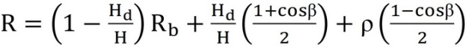 (2)

where Rb is direct radiation rate that is obtained for northern hemisphere by Eq. (3):

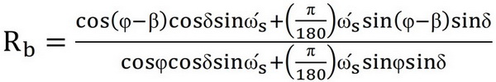 (3)

where 𝜹 is deviation angle of Earth axis in a day of interest put in -23.50 ≤ δ ≤ 23.50.

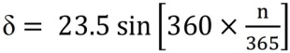 (4)

where n is total days of a year from April to the day of interest.
Sunrise angle on horizon surface (ωs) and sunrise angle on inclined surface (ώs) are obtained by Eq. (5):

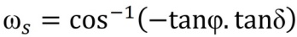 (5)

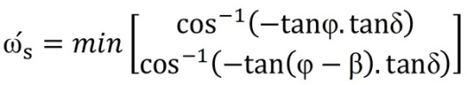 (6)

Air filter coefficient (Kth) indicates the proportion of the total radiation on the horizontal surface to the radiation on the same level if placed outside the Earth's atmosphere.

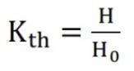 (7)

Radiation beyond the atmosphere (H0) is obtained by Eq. (8):

(8)
ISC is sun constant that is 1367 W as mentioned in literature.
The prediction of scattered radiation to total radiation (Kdh), there exist various mathematical models. Ibrahim Pour et al [22], compared some of these models and finally they selected the model proposed in "Orgill and Hollands [24]" as an appropriate model for different climates in Iran. In this model, the ratio of scattered radiation to total radiation is obtained by Eq. (9) based on the air filter coefficients’ range:

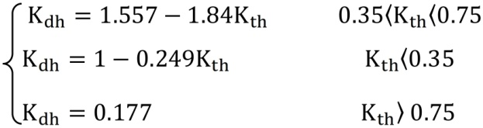 (9)

where ρ is reflection ratio of Earth that changes, based on region coverage, in the range between 0.2 and 0.8. Due to stony coverage in this study, this ratio is considered 0.3.
Based on the above equations, the air filter ratio and the scattered radiation ratio were calculated for different months in Rasht City. Total radiation on the horizon surface for 10 consecutive years, 2002 to 2012, was obtained from Rasht City’s Bureau of Meteorology. Then, the average of radiation was determined. Finally, substituting all the values in Eq. (1) for tilts from 0 to 90 degrees, the angle in which the radiation was the highest was considered as optimal tilt in each month. Using the optimal tilt obtained for each month, quarter and annual tilt were calculated.

- Results and discussion
The angle of panels with respect to the horizon is important due to the angle of the sun relative to the horizon. Obviously, the more the radiation on energy-receiving surfaces is perpendicular, the higher the energy efficiency of the samples. Since the angle of the sun relative to the horizon is different on different days of the year, the average received radiation on the surface during the months of a year can be taken as a comparison benchmark for surfaces receiving radiation. Since in the Northern Hemisphere, photovoltaic panels are mainly placed toward south to get more energy (γ=0), this angle changes from zero (the horizon) to 90 degrees south. Accordingly, a surface with a dimension of one meter by one meter in size is considered as a sample by Ecotect Analysis and the incoming radiation on the surface of this sample was calculated. The work procedure is as follows: sample surface is placed toward the south and creates different angles with an increment of 5 degrees by the ground. This is repeated until the surface completely changes to vertical position. The result is examples that each of them experience different radiations during the year (Figure 1). Therefore, in order to determine the best tilt based on the proposed mathematical model and with the help of the relationships mentioned in Section 2, the necessary calculations were performed. The results for the Rasht City in different months are shown in Table 2 and Figures 2 and 3.

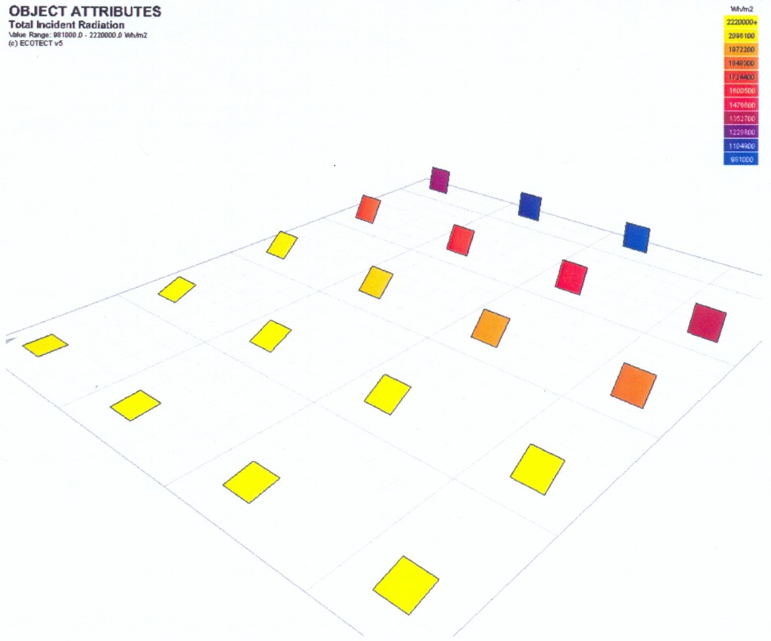
Figure 1. Schematic diagram of the impact of angle relative to horizon on received energy by plates (Ecotect Analysis)
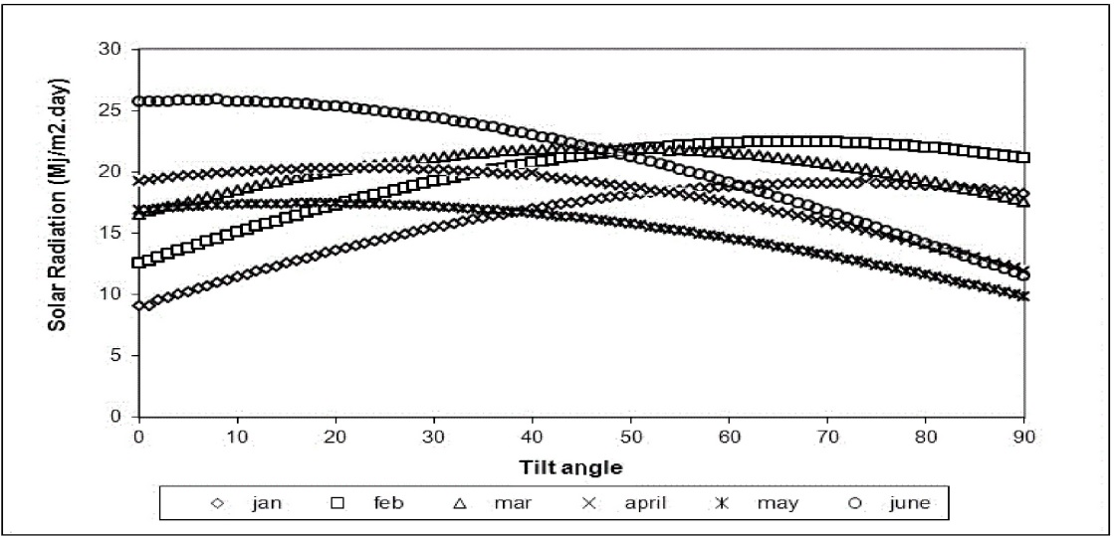
Figure (2). Average solar radiation achievable on inclined surfaces between January and June in Rasht City

Table (2). Air filter coefficients and the ratio of calculated scattered radiation in different months in Rasht City
Kdh | Kth | Month
0.56 | 0.54 | Jan
0.69 | 0.47 | Feb
0.69 | 0.47 | Mar
0.67 | 0.48 | Apr
0.64 | 0.50 | May
0.40 | 0.63 | Jun
0.34 | 0.66 | Jul
0.27 | 0.70 | Aug
0.25 | 0.71 | Sep
0.23 | 0.72 | Oct
0.49 | 0.58 | Nov
0.53 | 0.56 | Dec

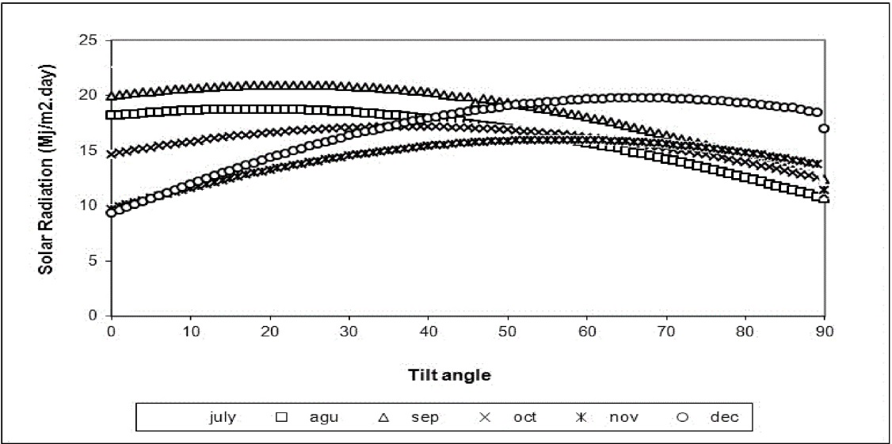
Figure (3). Average solar radiation achievable on inclined surfaces between July and December in Rasht City

Seasonal average angle is obtained by averaging optimal monthly angles in each season. Constant seasonal angle is also obtained from the average of optimal angles in all months which is close to that location’s latitude.
Table 3 shows the optimal tilt angles for solar panels using the present work; while Table 4 presents the amount of solar radiation received by the inclined surface seasonally and annually Rasht City. Using the optimum monthly angle, the maximum amount of energy is received from the sun in June (25.62 Mj/m²) while the minimum amount is recorded in January (16.29 Mj/m²). It is noteworthy that by both the seasonal and annual optimization, these two months are respectively again the months when the maximum and minimum radiation energy is received. If it is supposed for the system to annually absorb the highest amount of radiation energy, September and January are considered as months when the maximum and minimum energy received respectively are 20.17 Mj/m².day and 16.29 Mj/m^{2.}day.

Table (3). Optimal monthly tilt angle in degrees and absorbed radiation energy by panels in these angles in Rasht City
H_{apt} Mj/m². day | β _{apt} (°) | Months | H_{apt} Mj/m². day | β_{apt} (°) | Months
22.13 | 0 | Jul | 16.29 | 69 | Jan
17.96 | 0 | Aug | 20.23 | 65 | Feb
20.17 | 22 | Sep | 19.5 | 43 | Mar
18.09 | 40 | Oct | 21.14 | 23 | Apr
14.01 | 50 | Nov | 17.18 | 0 | May
16.7 | 62 | Dec | 25.62 | 0 | June

Table (4). Seasonal average tilt angle in degrees and absorbed radiation energy by panels in these angles in Rasht City
Yearly average |  |  | Seasonal average
H_{apt}  Mj/m². day | β_{apt} (°) | H_{apt}  Mj/m². day | β_{apt} (°) |  | Seasons | Months
17.41 | 31.16 | 17.2 | 65.31 | Winter |  | Dec
13.91 |  | 16.6 |  |  |  | Jan
17.31 |  | 20.01 |  |  |  | Feb
19.51 |  | 19.05 | 22 | Spring |  | Mar
21.06 |  | 21.14 |  |  |  | Apr
15.38 |  | 16.1 |  |  |  | May
22.71 |  | 26.19 | 0 | Summer |  | Jun
18.6 |  | 22.15 |  |  |  | July
15.91 |  | 17.98 |  |  |  | Aug
20 |  | 19.64 | 37.33 | Autumn |  | Sep
18.11 |  | 18.51 |  |  |  | Oct
13.34 |  | 13.69 |  |  |  | Nov

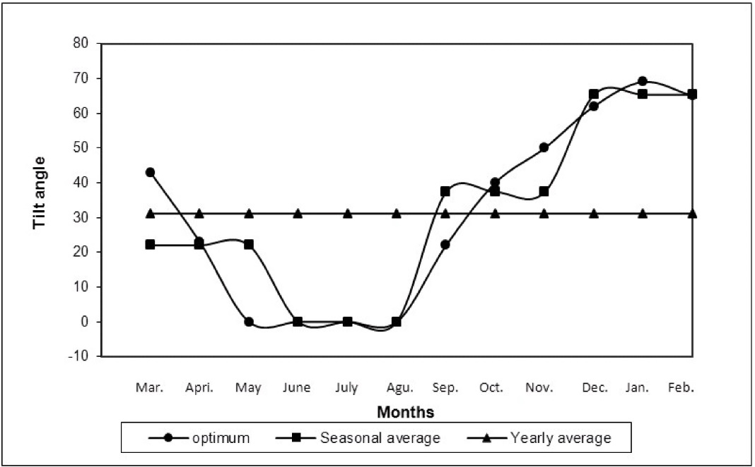
Figure (4). Optimal monthly, seasonal, and annual angles for each month in degrees

Using the values presented in Tables 3 and 4, by employing different optimization methods, one can obtain total energy received in a year. The results are provided in Table 5. Analyzing the data in Table 5 indicates that the amount of energy received from the sun in one year at the optimum seasonal angle compared to the optimum monthly angle is reduced by less than 1%. While, the amount of received energy reduction in annual optimum angle in comparison to the optimum monthly angle is 6.9%.

Table (5). Annual received energy from sun on solar panels using optimum monthly, seasonally, and annual angles in Rasht City
β _{apt} (y) | β _{apt} (s) | β _{apt} (m) | Optimum tilt angle
6499 | 6934 | 6982 | H_{total} (Mj/m²)

- Conclusion
According to the results, the optimal seasonal average angle in summer is zero, while in the winter months it is 65.31 degrees that are relatively consistent with the proposed model by Heywood. In addition, the optimum monthly angle is zero. The lowest monthly radiation at this angle is related to May standing at 17.18 Mj/m².day. This angle increased in the winter months up to 69 degrees in January with received radiation of 16.29 Mj/m².day. The results of comparing the annual total received energy in different monthly, quarterly, and annual angles show that if monthly changes are impossible in the angle of the panels, one can use optimal seasonal angle. The reduction in radiation received in this state is negligible compared to monthly state. Annual optimal tilt angle considered as a constant angle in all seasons is 31.16 degrees.

References
- Thomas, R. (Ed.). Photovoltaics and architecture. Taylor & Francis, 2012.
- Eiffert, P., & Kiss, G.J. Building-intergrated photovoltaic designs for commercial and institutional structures: a sourcebook for architect. DIANE Publishing, 2000.
- H.C. Hottel, Performance of flat-plate solar energy collectors. IN: Space Heating with Solar Energy, Proc. Course Solar-Symposium. MIT Press, Cambrigde 1954.
- Heywood H. Operational experience with solar water heating. J Inst Heat Vent Energy 1971:39:69-9.
- H.J. Yellott, Utilization of Sun and Sky Radiation for Heating and cooling of Building. ASHRAE15, 31-42(1973).
- Lunde PJ. Solar thermal engineering. New York: Wiley; 1980.
- Duffie JA, Beckam WA. Solar engineering of Thermal Processes. New York, Wiley, 1991.
- El-Kassaby MM, Hassb MH. Investigation of a variable tilt angle Australian type solar collector. Renewable Energy 1994; 4(3): 327-32
- Talebizadeh P., Mehrabian M. A., and Abdolzadeh K., “Solar angles impact on received energy by solar collectors.” Journal of Energy Engineering and Management, Volume 2, Number 4, 2012, pages 23-12.
- Runsheng T. Tong, W. 2004. Optimum tilt angle for solar collectors used in China. Applied Energy. 79 (3): 239-248.
- Hussein, H. M. S., Ahmad, G. E. and El-Ghetany, H. H. 2004. Performance evaluation of photovoltaic modules at different tilt angles and orientations. Energy Conversion and Management. 45: 2441-2452.
- Ulgen, K. 2006. Optimum tilt angle for solar collectors. Energy sources, part A: recovery, utilization and environmental effects. 28 (13): 1171-1180.
- Moghadam, H., Farshchi Tabrizi, F. and Zolfaghari Sharak, A. 2011. Optimization of solar flat collector inclination. Desalination. 265: 107-111.
- Nijegorodov, N., Adedoyin, J. A., Devan, K. R. S. 1997. A new analytical-empirical model for the instantaneous diffuse radiation and experimental investigation of its validity. Renewable Energy, 11 (3): 341-350.
- Sheikar, K., "Optimum tilt angle and orientation for solar collectors in Syria", Energy Conversion and Management, Vol. 50, pp. 2439-2448, 2009.
- Benghanem, M. Optimization of tilt angle for solar panel: Case study for Madinah, Saudi Arabia. Applied Energy. 88: pp. 1427-1433, 2011.
- Liu, B. Y. H., Jordan, R. C. The interrelationship and characteristics and distribution of direct, diffuse and total solar radiation, solar energy, Vol. 3, No. 4, pp. 1-19, 1960.
- Koronakis, S. On the choice of the angle of tilt for south facing solar collectors in the Athens basin area. Solar Energy, Vol. 3, No. 36, pp. 217-225, 1986.
- Reindel, D. T., Beckman, W. A., and Duffie, J. A. Evaluation of tilted surface radiation models. Solar Energy, Vol. 1, No. 45, pp. 9-17, 1990.
- Tiam, Y. Q., Davies-Colley, R. J., Gong, P., Thorrold, B. W. Estimating Solar radiation on slopes of arbitrary aspect. Agriculture and Forest Meteorology. Vol. 1, No. 109, pp. 67-74, 2001.
- Badescu, V. A new kind of cloudy sky model to compute instantaneous values of diffuse and global solar irradiance. Theoretical and Applied Climatology. 72: pp. 127-136, 2002.
- Ebrahim pour, E. Marefat, M., Niri, H., "Comparison of Varios techniques for climates in Iran", Sientific and Research Journal of Geographical Space. Vol 9 (27): 1-21, 2009.
- Lubitz, W. D. 2011. Effect of manual tilt adjustments on incident irradiance on fixed and tracking solar panels. Applied Energy. 88: 1710-1719.
- Orgill JF, Hollands KGT. 1977. Correlation equation for hourly diffuse radiation on a horizontal surface. Solar Energy, Vol. 19(4), pp: 357–9.
- Skeiker, K. 2009. Optimum tilt angle and orientation for solar collectors in Syria. Energy Conversion and Management. 50: 2439-2448.
- H.C. Hottel, Performance of flat-plate solar energy collectors. IN: Space Heating with Solar. Energy, Proc. Course Solar-Symposium. MIT Press, Cambrigde (1954).
- Klein, S, A. and J.C. Theilacker, An Algorithm for Calculating Monthly Average Radiation on Inclined Surfaces, Trans ASME 103,29(1981).
- Qiu, G., and Riffat, S.B., "Optimum tile angle of solar collectors and its impact on performance", International Journal of Ambient Energy, Vol. 24, pp. 13-20, 2003.
- Morcos, V. H., "Optimum tile angle and orientation for solar collectors in Assiut/Egypt", Renewable Energy, Vol. 4(3), pp. 291-298, 1994.
- Abdulaziz, M., "Optimum tile angle for solar collection systems", International Journal of Solar Energy, Vol. 14, pp. 191-202, 1994.
- Hartley, L.E., Martinez-Lozano, J.A., Utrillas, M.P., inclination of a solar collector to maximize the incident solar radiation", Renewable Energy, Vol. 6, pp.180-298, 1999.
- Oladiran, M. T., "Mean global radiation captured by inclined collectors at various surface azimuth angles in Nigeria", Applied Energy, Vol. 52 (4), pp. 317-330, 1995.
- Azmi, M., Yakup, M., and Malik, A. Q., "Optimum tilt angle and orientation for solar collector in Brunei Darussalam", Renewable Energy, Vol. 24, pp. 223-234, 2001.
- Shariah, A., Al-Akhras, M.A., and Al-Omari, I.A., "Optimizing the tilt angle of solar collectors", Renewable Energy, Vol. 12, pp. 587-598, 2002.
- Elminir, H. K., Ghitas, A.E., El-Hussainy, F., Hamid, R., Beheary, M.M., and Abdel-Moneim, K.M., "Optimum solar flat plate collector slope, Case study for Helwan Egypt", Energy Conversion and Management, Vol. 47, pp. 624-637. 2006.
- Gopinathan, K. K., Maliehe, N.B., and Mpholo, M. I., "Study on the intercepted insolation as a function of slope and azimuth of the surface", Energy, Vol. 32, pp. 213-220, 2007.
- Gunerhan, H., and Hepbasli, A., "Determination of the optimum tilt angle of solar collectors for building applications", Building and Environment, Vol. 42, pp. 779-783. 2007.
- Abdolzade, M., Talebizadeh, P., Mehrabian, M. A., and Keshavarz, S. A., "Developing New Models to Predict Optimum Slop Angle of Solar Collectors for Any Latitude in Iran", 10th International Conference on Sustainable Energy Technologies (SET2011), Istanbul, Turkey, 4-7 Sep. 2011.
- Abdolzadeh M., Jafari, S., Rahnema M. and Ameri M. "Determining optimum angles of fixed solar panels to get the maximum radiation energy in Kerman City". International Journal of Engineering of the University of Science and Technology, Vol. 19, Number 10, 2008, pages 91-98.

6/18/2016

