Studies Of 1, 4-Dihydropyridine Derivatives For Anti-Breast Cancer (MCF-7) Activities: Combinations Of DFT-QSAR And Docking Methods.

Oyebamiji Kolawole Abel and Semire Banjo

Department of Pure and Applied Chemistry, Ladoke Akintola University of Technology, Ogbomoso, Nigeria.
bsemire@lautech.edu.ng

Abstract: A series of 1,4-dihydropyridine (1, 4-DHP) derivatives were studied for inhibitory activity against human breast cancer (MCF-7) cell using Density Functional theory (DFT), Quantitative Structure Activity Relation (QSAR) and docking approaches. Some of the calculated molecular descriptors such as log P, solvation energy and average electronic charges on heteroatoms showed that each of these descriptors has a fair relationship with observed anticancer activity. However, the quantitative structure-activity relationship (QSAR) analysis indicated that the energy of lowest unoccupied molecular orbital (LUMO), dipole moment, solvation energy and average of average electronic charges on heteroatoms as being critical factors for the observed biological activity. The QSAR model predicted bioactivity (IC₅₀) agreed well with the experimental IC₅₀. All these compounds were docked against cancer cell receptors (1HI7) and the binding free energy of ligand-receptor interactions agreed with the observed bioactivity (IC₅₀) of the 1, 4-DHPs with the receptor.
[Oyebamiji Kolawole Abel and Semire Banjo. Studies of 1, 4-Dihydropyridine Derivatives For Anti-Breast Cancer (MCF-7) Activities: Combinations of DFT-QSAR And Docking Methods. N Y Sci J 2016;9(6):58-66]. ISSN 1554-0200 (print); ISSN 2375-723X (online). http://www.sciencepub.net/newyork. 10. doi:10.7537/marsnys09061610.

Keywords: 1, 4-Dihydropyridine derivatives, DFT, QSAR, Docking

Introduction
Cancer is considered medically to be unrestrained cell growth that develops tumor, well known as malignant neoplasia. It may move from one end to the other in the body through bloodstream or lymphatic system. Human beings are affected with over 1000 diverse cancers. The basis for variety and complications of cancer is not still fully understood (Anand 2008). Moreover, reasons attached to the causes of cancer are considered to be obesity, exposure to radiation and tobacco, infections and destruction of genes; these factors lead to mutation of cancer. (Pantea et al 2013). The treatment of cancer can be with surgery, chemotherapy and radiation therapy. Cancer can affect both children and adult, though few cases have been recorded for children (Jemal, 2011).
In 1970, MCF-7(human breast cancer) cell line was first isolated from the malignant adenocarcinoma breast tissue of an old woman. It is the acronym of Michigan Cancer Foundation - 7, pointing to an institute in Detroit where the cell line was established. MCF-7 cells became useful for the studies of in vitro breast cancer since many perfect features particular to the mammary epithelium are retained in the cell line (Larson et al, 2015, Ansari et al, 2015, Zhang et al, 2014, Zhang et al, 2012). Worldwide, breast cancer is one of the severe malignancies. Regardless of intensive work to control cancer, yet, the death of women through cancer still remains the second-leading. Therefore, several studies have centered on the field of drug resistance in order to improve cancer chemotherapy and management (Gottesman, 2002 and Harris et al., 2000).
1, 4-Dihydropyridines (DHPs) are essential class of N-heterocyclic scaffolds with low molecular weight which serve as important ligands for biological receptors in the field of medicine (Johnson et al., 1963). In 1882, these compounds were firstly described by Arthur Hantzsch by modification of structure which involves additions, reductions and condensations in the 1, 2 and 6-positions of the dihydropyridine ring. Therefore, the structural features of the 1, 4-Dihydropyridines have been acknowledged as important parameters for their bioactivity as drugs that treat angina pectoris. Several DHPs have been commercialized such as amlodipine, felodipine, isradipine, lacidipine, nicardipine, nitrendipine, nifedipine and nemadipine (Aanandhi et al., 2010). DHPs medicinal properties include the followings; anti-inflammatory, neuro- and radio-protective effects, anti-inflammatory, HIV protease inhibition and in the treatment of Alzheimer’s disease, antioxidants, anti-microbial, bronchodilator, anti-tumor, anti-ulcer activities, anti-diabetic agents and anti-tubercular agents (Mohammed, 2014). Many DPHs act as an inhibitor of enzymes, which play a major role in the survival of many diseases such as cancer and many DPHs derivatives have higher lipophilic properties (Wendt et al., 2007).
Quantitative Structural Activity Relationship (QSAR) is a statistical model which relates a set of structural descriptors of a chemical compound to its biological activity (Hansch, 1969). The QSAR has typically been used for drug design, discovery and development and has gained wide applicability for correlating molecular information with not only biological activities but also with other physicochemical properties (Ramsden, 1990). The uses of QSAR studies include prediction of pharmacokinetic properties such as ADME (absorption, distribution, metabolism and excretion) and toxicity. QSAR has been used widely to predict the toxicity of substances in bulk form most especially drug‐like compounds. QSAR models are very useful in case of the classic chemicals but the concept of nano‐QSAR is still under development (Dahl et al, 2014).
The discovery of small molecules used for protein – protein interface target have many challenges like form of characteristic protein – protein interface and suppleness of proteins. Docking assists the study of interactions between ligand and receptor by recognizing the appropriate active sites in receptor. The calculation of interaction energy could be in terms of dock score, since scoring are arithmetic method employed to predict the power of the interaction that are non-covalent between two molecules after docking (Taylor et al 2002 and Jain 2006).
In view of the above, quantum chemical method using density functional theory (DFT) method, QSAR study and virtual screening as well as binding energy calculations of six; 2-Amino-4-(4-chlorophenyl)-6-(2-mercapto-4-methyl-1-phenyl-1H-imidazol-5-yl)nicotivtino-nitrile (A₁), 2-Amino-6-(2-mercapto-4-methyl-1-phenyl-1H-imidazol-5-yl)-4-(4-methoxyphenyl) nicoti-nonitrile (A₂), 2-Amino-4-(2-hydroxyphenyl)-6-(2-mercapto-4-methyl-1-phenyl-1H-imidazol-5-yl)nicoti-nonitrile (A₃), 4-(4-Chlorophenyl)-6-(2-mercapto-4-methyl-1-phenyl-1H-imidazol-5-yl)-2-oxo-1,2-dihyd-ropyridine-3-carbonitrile (A₄), 4-(2-Hydroxyphenyl)-6-(2-mercapto-4-methyl-1-phenyl-1H-imidazol-5-yl)-2-oxo-1,2-dihyd-ropyridine-3-carbonitrile (A₅) and Ethyl 6-(2-mercapto-4-methyl-1-phenyl-1H-imidazol-5-yl)-4-(4-methoxyphenyl)-2-oxo-1,2-dihydropyridine-3-carboxylate (A₆) taken from work of Abbas and co-workers (Abbas et al., 2015) are considered in this present paper. This paper is focused using DFT method to calculate molecular descriptors that describe bioactivity of these selected compounds as well as development of QSAR model that predicts experimentally observed bioactivity from calculated molecular descriptors. The optimized structures of these compounds are docked with MCF-7 (PDB: 1HI7) for the estimation of free energy of binding as well as predicting suitable formation of the compounds in the binding purse of the receptor which may assist in understanding in the inhibitory mechanism of breast cancer cell by 1,4-DHPs. Finally, the bioactivities of the compounds are correlated to the free energy of interactions between the compounds (ligands) and the receptor (MCF-7).

Computational Methods
Quantum Chemical Method

Figure 1: The schematic structures of the studied molecules (Abbas et al., 2015)

The equilibrium geometries for the 1, 4-DPHs derivatives considered in this research work were optimized at Density Functional Theory (DFT) with the standard 6-31G (d, p) basis set. The DFT method used consists of the three-parameter density functional, that includes Becke’s gradient exchange correction (Becke, 1993) and the Lee, Yang, Parr correlation functional (i.e. B3LYP). The choice of the selected functional and basis sets was attributed to the accuracy of DFT calculations. The sufficiency of polarized split-valence 6-31G (d,p) basis sets has been proved for calculation of the excited properties of ligands (Jacquemin et al 2008); therefore 6-31G(d,p) basis set was used in research work. The molecules under study shown in Figure I were taken from Abbas et al, (2015) and optimized to calculate molecular descriptors that described the bioactivity (IC₅₀). These optimized structures are considered to be suitable for docking of the studied molecules with receptors. Some of the molecular parameters calculated are; the LUMO, the HOMO, dipole moment and global molecular descriptors such as chemical hardness, softness and chemical potential. Solvation energy using SM5.4 model, a semi-empirical method (AM1) as implemented on the quantum chemical software package used. All quantum chemical calculations were performed using Spartan ’14 by wavefunction Inc.
QSAR Model Using Multiple Linear Regressions (Mlr)
A quantitative structure-activity relationship (QSAR) was investigated based on the biological activity of a compound which is a function of its physicochemical properties (Pourbasheer et al., 2009 and Riahi et al., 2009). The most commonly used statistical and mathematical method i.e. multiple linear regression (MLR) analysis was applied to create QSAR models in order to obtain statistical data values, such as, correlation coefficient (r), standard deviation (s), R², F-test, t-test. The obtained QSAR models were evaluated using generated data to predict the anti-cancer activity of the 1, 4-DHPs. The software used for QSAR models in this paper is statistical program for social sciences (SPSS). Moreover, the QSAR model was validated using statistical equations by considering cross validation (R²), Adjusted R², standard error, Chi-square, Root Mean Square Error (RMSE) and F-test. Cross validation governs how reliable a QSAR model can be used for a particular set of data. It is also used as an analytic instrument to estimate the prognostic control of an equation. Therefore, it is calculated using equation (1).
$CV.R^{2}=1-\frac{Ʃ(Ү obs-Ү cal)^{2}}{Ʃ(Ү obs-Ῡobs)^{2}}$ (1)
The R² adjusted could be calculated using equation (2)
$R_{a}^{2}= \frac{\left(N-1\right)×R^{2 }-P}{N-1-P}$ (2)
So, the QSAR model could be considered prognostic, if$R_{Pred}^{2}>0.6$.
Docking And Scoring
The MCF-7 receptor (PDB: 1HI7) was downloaded from protein data bank (Williams et al. 2001) was repaired and ligand, water molecules, and cofactors were removed from the proteins using discovery studio (Biovia, 200). The ligands and the receptor were converted to pdbqt format using autodock tool and the docking was carried out using AutoDock Vina, which was motivated by Darwinian evolution theory to be iterative optimization method (Sapna et al., 2014).

Result And Discussion
Molecular Descriptors
In this study, calculated molecular descriptors such as solvation energy, weight, hydrophobicity (Log P), volume (V), Area, polar surface area (PSA), ovality, dipole moment (DM), heteroatoms (average of mulliken charges on all heteroatoms), HOMO, and LUMO energies obtained are shown in Table 1. The HOMO and the LUMO are vital descriptors that offer realistic qualitative facts about the excitation properties of molecules (Bouachrine et al, 2009, Yang et al, 2005 and Semire et al, 2012). The calculated HOMO are -5.59 eV for A₁, -5.43 eV for A₂, -5.40 eV for A₃, -5.91eV for A₄, -5.68eV for A₅ and -5.47eV for A₆ while the LUMO are -1.87eV for A1, -1.61eV for A₂, -1.56eV for A₃, -2.32eV for A₄, -2.01eV for A₅ and -1.47eV for A₆. Therefore, the calculated electronic descriptors band gaps which are essentially left over ranges of energy not covered by any band and a result of the finite widths of the energy bands (Walter et al, 1966) for A₁ to A₆ are 3.72eV, 3.82eV, 3.84eV, 3.59eV, 3.67eV and 4.00eV respectively (Table 1). The band gap could be ordered as A₆ < A₃ < A₂ < A₁ < A₅ < A₄. The lower the band gap, the easier the excitation and the better the ability of a molecule to donate an electron (s) to the surrounding. Therefore, it is expected that band gap play a crucial role in protein – ligand interaction. However, in this work, no effective correlation between the band gap and bioactivity of 1, 4- DHPs are observed.
Moreover, the calculated log P tells about the compound’s ability to dissolve into lipophilic (non-aqueous) solutions. It is needed for the compounds to permeate through the various biological membranes. Lipophilicity is typically measured as the compounds distribution between non-aqueous and aqueous phase and it reveals the biological activity of ligands (Khaled et al, 2011). On the other hand, Log P is an estimate of a compound’s overall lipophilicity, a value that influence its behavior in a range of biological membranes, hepatetic clearance, lack of selectivity and non-specific toxicity (Hughes et al., 2008). The problems are likely to be encountered in oral absorption if the compound have log P higher than 5 (Meanwell, 2011). The calculated log P are 3.40 for A₁, 2.72 for A₂, 2.45 for A₃, 3.16 for A₄, 2.22 for A₅ and 2.61 for A₆, therefore, compounds A₁ to A₆ are effective in term of lipophilicity. The calculated values for ovality which is the degree of deviation from perfect circularity of the cross section of the core or cladding of fiber (Leach, 2001) are 1.58, 1.59, 1.57, 1.56, 1.55 and 1.66 for A₁, A₂, A₃, A₄, A₅ and A₆ respectively. The solvation energy is calculated using SM5.4 model based on semi-empirical (AM1) wave functions (Chambers et al, 1996) which are the sum of two terms: the energy required to create a cavity in the solvent (water) and the energy of the electrostatic interaction between the solvent and the solute once the solute/molecule is “placed” in the cavity. The calculated solvation energies for A₁ to A₆ are -4.5.08 kJ/mol, -50.50 kJ/mol, -61.66 kJ/mol, -49.25 kJ/mol, -64.83 kJ/mol and -52.22 kJ/mol respectively. Therefore, A₃ and A₅ were better in term of solvation energy since increased solvation energy contributed to the drug resistance.
Also, the dipole moment which is the product of the magnitude of the charge and the distance of separation between the charges (Binod, 2008) is calculated to be 3.75 debye for A₁, 2.57 debye for A₂, 0.86 debye for A₃, 9.12 debye for A₄, 5.96 debye for A₅ and 5.55 debye for A₆. Since the nature of non-bonded interactions such as dipole – dipole interaction are relevant in ligand – receptor interactions; this has been accounted to contribute about 3 to 5kJ/mol (David et al., 2002) to the ligand – receptor energy of interactions. However, large value of dipole moment has been attributed to the anomalous property of individual molecule (Debenedetti, 2003), therefore compounds A₁-A₆ are desirable in term dipole moment values because they have moderate values. Each calculated molecular descriptor was examined for any correlation with bioactivity (IC₅₀), however, only solvation energy, average electronic charges on heteroatoms (heteroatom) and Log P showed a kind of fair relationship. The heteroatom, solvation energy and Log P fitted into bioactivity with R² = 0.6297, 0.9437 and 0.5592 values respectively as shown in Figure 2.

Table 1: The calculated molecular descriptors from the compounds A₁-A₆ for anti – breast cancer
Mol | HOMO  (eV) | LUMO  (eV) | B G | DM (Debye) | ᶮ | µ | ω | H | MW (amu) | Log p | Ovality | A  (A²) | V  (A³) | PSA (A²)
A₁ | -5.59 | -1.87 | 3.72 | 3.75 | 1.86 | -3.73 | 3.74 | -2.80 | 417.92 | 3.4 | 1.58 | 412.65 | 398.02 | 52.74
A₂ | -5.43 | -1.61 | 3.82 | 2.57 | 1.91 | -3.52 | 3.24 | -3.31 | 413.51 | 2.72 | 1.59 | 426.51 | 411.38 | 59.66
A₃ | -5.4 | -1.56 | 3.84 | 0.86 | 1.92 | -3.48 | 3.15 | -2.80 | 399.48 | 2.45 | 1.57 | 405.12 | 391.53 | 70.19
A₄ | -5.91 | -2.32 | 3.59 | 9.12 | 1.80 | -4.12 | 4.72 | -2.64 | 418.91 | 3.16 | 1.56 | 407.54 | 395.27 | 47.91
A₅ | -5.68 | -2.01 | 3.67 | 5.96 | 1.84 | -3.85 | 4.03 | -3.21 | 400.46 | 2.22 | 1.55 | 399.90 | 388.72 | 64.78
A₆ | -5.47 | -1.47 | 4.00 | 5.55 | 2.00 | -3.47 | 3.01 | -3.62 | 461.54 | 2.61 | 1.66 | 475.24 | 456.30 | 58.68

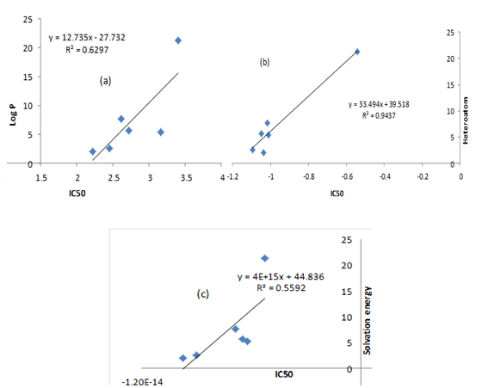
Figure 2: Correlation between IC₅₀ and (a) Log P, (b) Heteroatom and (c) Solvation energy.

QSAR Model Using Multiple Linear Regressions
The correlation between the IC₅₀ and heteroatom (0.971) as well as solvation energy (0.747) are objectively allied. Some of the descriptors are justly correlated to one another, for example, heteroatom is positively correlated to solvation energy by 0.624 while LUMO is negatively correlated to dipole moment by -0.757 as shown in table 2. Therefore, the choice of effective molecular descriptors for valid analysis is a function of Pearson correlation, albeit, the making of reliable model involved huge quantity of molecules.

Table 2: Pearson’s correlation matrix for descriptors
 | IC50 | LUMO | DM | HETEROATOM | S.E
IC50 | 1.000
LUMO | -0.014 | 1.000
DM | -0.069 | -0.757 | 1.000
HETEROATOM | 0.971 | -0.161 | -0.022 | 1.000
SE | 0.747 | -0.113 | 0.200 | 0.624 | 1.000

Moreover, breast cancer cell line has been widely used to investigate breast cancer pathobiology and new therapies (Jessica et al, 2009). Therefore, the biological activities of six experimental molecules are probed into and four descriptors are selected among the calculated molecular descriptors in order to avoid multi-collinearity as shown in equation 3.
The established QSAR model linked the activities of these compounds to their cytotoxicity as shown in figure 3.

Figure 3: Correlation between experimental and predicted IC₅₀

The IC₅₀ predicted through QSAR model are replicative of the experimental IC₅₀ as shown in Table 2 with fitting factor (R²) 0.999. This showed that the QSAR model reproduced the observed cytotoxicity of these compounds. Therefore, putting together of certain descriptors such as LUMO, dipole moment, heteroatom and solvation energy described the anti-breast cancer activity of the studied compounds.
Also, R², CV.R²,$R_{a}^{2}$ as shown in table 3 are calculated regression parameters for 1, 4-DHPs used in the authentication of QSAR model for anti-breast cancer activity. The R² which is equal to 0.999 showed a fairly fitness. This exposed the effectiveness of the model as shown in equation 3. The value for calculated CV.R² was greater than 0.5 (standard) (Marrero, 2004) which show its reliability and acceptability. The calculated $R_{a}^{2}$ was greater than 0.6 (standard), therefore, the QSAR model would be predictive.
Docking And Scoring
The ligand - protein (receptor) intermolecular interactions between the studied 1, 4- DHPs and 1HI7 (Williams et al., 2001) are also investigated. The docking simulation of each compound (ligand) produced nine conformations and the best conformation is assumed to be the conformation with highest free energy of binding (i.e. more negative value) in each docking. The free energies of the interactions also known as binding energies for compounds A₁-A₆ are displayed in Table 3. Therefore, the calculated free binding energies are -4.80 kcal/mol for A₁, -5.20 kcal/mol for A₂, -4.70 kcal/mol for A₃, -5.20 kcal/mol for A₄, -5.20 kcal/mol for A₅ and -5.10 kcal/mol for A₆. The interaction between the ligand and the receptor are shown in table 4 and the free energies of interactions or docking affinities of these compounds are also compared with their bioactivities as shown in Figure 3. It can be observed that binding energy and bioactivities are related except for A₃; thus the higher the binding energy the better the affinity.

Table 3: Stepwise regression result for anti-breast cancer activity
Equation | N | p | R² | CV. R² | $$R_{a}^{2}$$
53.893 + 4.172 (LUMO) + 0.125(DM) + 29.909 (H) + 1.256 X 10¹⁵ (S E) ---------3 | 6 | 4 | 0.999 | 0.999 | 0.995

Table 4: Docking scores of conformations of the studied 1, 4-dihydropyridine derivatives.
Mode | Affinity (Kcal/Mol)
A₁ | -4.80
A₂ | -5.20
A₃ | -4.70
A₄ | -5.20
A₅ | -5.20
A₆ | -5.10

Table 5: Interactions between Ligands and 1HI7 receptor.
Mol | H-Bond Between Amino Acid and Drug | Distance
A₁ | (i) PHE 34, LIG: N (ii) PHE-34 LIG:N | 3.3, 2.2
A₂ | (i) ARG 14, LIG: O | 2.6
A₃ | (i) PHE 34, LIG: (ii) PHE-34 LIG:N | 3.3, 2.2
A₄ | (i) THR 8, LIG: N | 2.9
A₅ | - GLU 13, LIG: O  - GLU 13, LIG: N  - PRO47, LIG N | 2.9,  3.6,  3.1
A₆ | (i) GLU 13, LIG: O (ii) THR 49, LIG: O | 3.4, 2.2

Figure 4: Relationship between IC₅₀ and binding energies.

- 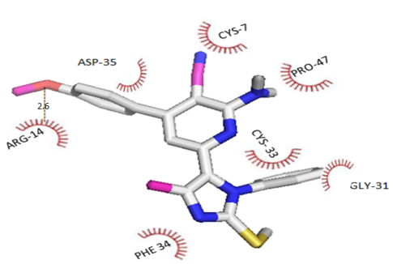
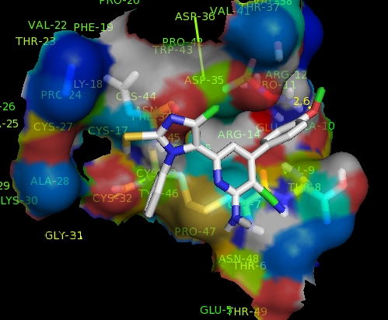

(b)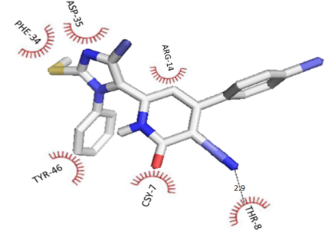
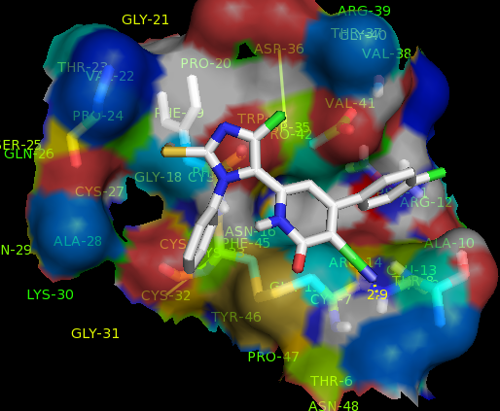

(c) 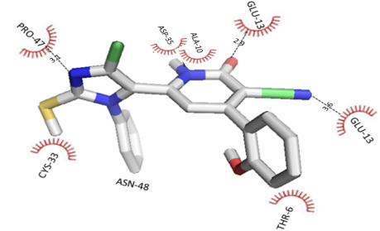
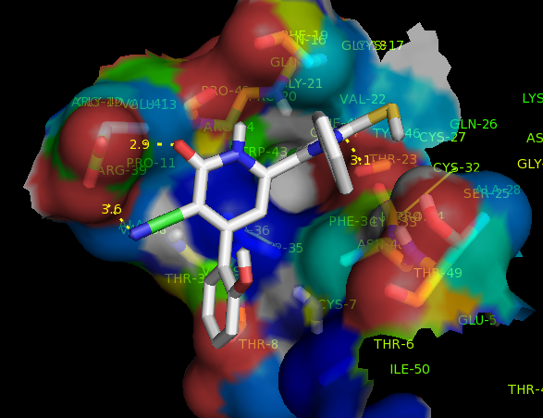

Figure 5: Binding interactions: (a) for A₂, (b) for A₄ and (c) for A₅ with 1HI7

Conclusion
1, 4-dihydropyridines have been found to play several roles clinically such as antibacterial, antifungal, antihypertensive, anticonvulsant, anti-inflammatory and anticancer. In this research work, quantum chemical method using density functional theory (DFT) method, QSAR study and molecular docking were performed on six selected 1,4-DHPs. The results of the QSAR models showed that the calculated molecular descriptors using quantum chemical method correlate to the electronic properties of the molecules to their bioactivities. Therefore, the QSAR models developed reproduced the experimental bioactivities of these compounds against MCF-7. Thereto, the results from docking simulations predicted stable conformations of the drug-like molecules (i.e.1,4-DHPs) inside the active gouge of the receptors as well as the free energy of interactions; thus given inside to important parameters/factors which could affect the potency of any drug

Reference
- Aanandhi, V.M., Kalvikkarasi S, Navamani AK, Shanmugasundaram P. Synthesis, characterization and In-vitro antioxidant activity of Mannich bases of novel 1, 4-dihydropyridines derivatives. Res. J. of Pharm, Bio. and Chem Sci 2010; 926.
- Abbas I., Gomha S., Elaasser M., Bauomi M. Synthesis and biological evaluation of new pyridines containing imidazole moiety as antimicrobial and anticancer agents. Turk J of Chem 2015; 1410 – 25.
- Anand P., et.al. Cancer is a preventable disease that requires major lifestyle changes. Pharm. Res 2008;25 (9):2097-2016.
- Ansari, A. et al. Secondary anchor targeted cell release. Biotechnol Bioeng 2015.
- Bansal, R., Narang, G., Calle, C., Carron, R., Pemberton, K. and Harvey, A. Synthesis of 4-(Carbonyloxyphenyl)-1,4-Dihydropyridines as Potential antihypertensive Agents. Drug Dev. Res 2013;74(1):50–61.
- Becke, A.D. Density functional thermochemistry. III. The role of exact exchange. J. of phy Chem 1993;98:5648 – 5652.
- Binod, S. Tutorials for chemistry learning II, France 2008.
- Biovia, Wateridge vista drive, San Diego, CA 92121, USA 2005.
- Bouachrine, M., Hamidi, M., Bouzzine, S.M., and Taoufik, H. Theoretical study on the structure and electronic properties of new materials based on thiophene and oxadiazole. J of Chem Res 2009;10:29-37.
- Chambers, C.C., Hawkins, G.D., Cramer, C.J., Truhlar DG. Computational Thermochemistry. J of Chem Phys 1996;100:16385-16389.
- Dahl, G.E., Jaitly, N., Salakhutdinov, R. Multi-task Neural Networks for QSAR Predictions. 2104;1231.
- David, F.L.L. and Howard, B.B. Molecular binding interactions: their estimation and rationalization in QSARs in terms of theoretically derived parameters, the sci world Journal 2002;2:1776 – 1802.
- Debenedetti P. Condensed Matter. J of Phy 2003;15:1669.
- Gottesman, M.M. Mechanisms of cancer drug resistance. Annu Rev Med 2002;53: 615-627.
- Hansch, C. A quantitative approach to biochemical structure‐activity relationships. Acc of Chem Res 1969;2:232‐239.
- Harris, R.E., Alshafie, G.A., Abou-Issa, H., & Seiber, K. Chemoprevention of breast cancer in rats by celecoxib, a cyclooxygenase 2 inhibitor. Cancer Res 2000; 60(8):2101-2103.
- Hughes, J.D et al., Physicochemical drug properties associated with in vivo toxicological outcomes. Bioorg. Med Chem Lett 2008;18(17):4872 – 5.
- Jacquemin, D., Perpete, EA., Ciofini, I., Adamo, C. Accurate simulation of optical properties in dyes. Acc of chem Res 2008;42:326 – 3344.
- Jain, A.N. Scoring functions for protein-ligand docking. Current Protein Peptide Sci 2006;7 (5):407-420.
- Jemal, A., et.al. Global cancer statistics. A can J for clin 2011;61(2):69-90.
- Jessica, K., Keyan, S., Melanie, B., Yoon-La, C., Luc, G., Jeet, G., Kevin, A.K., Tina, H., Pei, W., Adi, F.G., John, D.M., Jonathan, R.P. Molecular Profiling of Breast Cancer Cell Lines Defines Relevant Tumor Models and Provides a Resource for Cancer Gene Discovery. Plos one 2009;4(7).
- Johnson, T.B and Hahn, D.A. Pyrimidines: Their amino and amino oxy derivatives, Ame chem soc 1933;13(2):193 -303.
- Khaled, A., Petri, R., Sampo, M., Olavi, P. Metabolism of α-Thujone in human hepatic preparations in vitro. xenobiotica 2011;41:101-111.
- Larson, B. & Sherman, H. Automated, Kinetic Imaging of Cell Migration and Invasion Assays using Corning FluoroBlo Inserts, Corning Application Note 2015.
- Leach, A.R. Molecular modeling: principles and applications, Englewood cliffs, NJ, pretence Hall 2001.
- Manisha, G., Jaspreet, K.D., Sukriti, G., Chetna, T., Rabia, H., and Abhinav, G. Development of Dual Inhibitors against Alzheimer’s Disease Using Fragment-Based QSAR and Molecular Docking. Hindaw Pub Corp BioMed Res Int 2014.
- Meanwell, N.A. Synopsis of some recent tactical application of biostereses in drug design. J of med chem 2011;54(8):2529 – 2591.
- Mohammed, H.A.A. Synthesis, Characterization, Docking Studies and Bio-Efficacy Evaluation of Novel 1, 4-Dihydropyridine Derivatives. Int J of Sci Res 2014;3(10): 2277 – 8179.
- Pantea, P., Ravi, S., Elena, P.. Influence of Far Infrared Radiation on cytotoxicity of Human Breast Cancer (MCF7) cells: experimental evaluation. IWBBIO Proceedings 2013.
- Pourbasheer, E., Riahi, S., Ganjali, M.R., Norouzi, P. Application of genetic algorithm-support vector machine, (GA–SVM) for prediction of BK-channels activity. Eur J of Med Chem 2009;44:5023–5028.
- Ramsden, C. A. Quantitative Drug Design of comprehensive Medicinal Chemistry, Oxford. 1990; 4.
- Riahi, S., Pourbasheer, E., Ganjali, M.R., Norouzi, P. Investigation of different linear and nonlinear chemometric methods for modeling of retention index of essential oil components: concerns to support vector machine. J Hazard Mat 2009;166 ,853–859.
- Sapna R., Ajeet, Arvind, K. Designing of Sulfanilamide/Sulfacetamide Derivatives as Human Topoisomerase II Inhibitor: A Docking Approach, Ame J of Pharm Sci 2014;2(2):42-46.
- Semire, B., Oyebamiji, A. and Ahmad, M. Theoretical Study on Structure and Electronic Properties of 2, 5-Bis [4-N, N-Diethylaminostyryl] Thiophene and Its Furan and Pyrrole Derivatives Using Density Functional Theory (Dft). Pak J of Chem 2012;2(4):166-173.
- Spartan 14, wavefunction, INC, Irvine CA 92612, USA.
- Taylor, R.D., Jewsbury, P.J, Essex, J.W. A review of protein-small molecule docking methods. J of Computer-Aided Mol Des 2002;16:151-166.
- Walter, A.H., Benjamin, W.A. Pseudo-potentials in the theory of metals, New York 1966.
- Wendt, M.D., Sun, C., Kunzer, A., Sauer, D., Sarris, K., Yu, L.D., Nettesheim, G., Chen, J., Jin, S. Bioorgan and Med Chem Let 2007;17:3122-3129.
- Williams, M.A., Westley, B.R., May, F.E., Feeney, J. The solution structure of the Disulphide-linked Dimeric of the Human Trefoil protein Tffi. FEBS let 2001; 493:70.
- Yang, L., Feng, J., and Ren, A. Theoretical studies on the electronic and optical properties of two thiophene–fluorene based π-conjugated copolymers. Polymer 2005;46:10970-10982.
- Zhang, K. et al. Block-cell-printing for live single-cell printing. PNAS 2014;111:2948-2953.
- Zhang, W. et al. Microfluidics separation reveals the stem-cell–like deformability of tumor-initiating cells. PNAS 2012;109:18707-18712.

6/13/2016

