Effects of Compost Manure on Performances of Watermelon (Citrullus Lanatus) and on Soil Properties in Ikorodu Agro-Ecological Zone, South Western Nigeria

Godonu, K. G., *Sanni, K. O. and Sodola, O. O.

Department of Crop Production and Horticulture
Lagos State Polytechnic, Ikorodu, Lagos State, Nigeria
*sunny_kenny2000@yahoo.com

Abstract: Soils condition and its fertility status are vital for the agricultural production. A field study was carried out to evaluate the influence of compost on the growth and yield performances of watermelon (Citrullus lanatus) at the Teaching and Research Farm, Lagos State Polytechnic, Ikorodu, Nigeria in experiments consisting of four treatments laid out in a randomized complete block design replicated thrice. The treatments consisted of 300kg/ha⁻¹, 250kg/ha⁻¹, 200kg/ha⁻¹ and 0kg/ha⁻¹ (control). Growth and yield attributes studies were plant height, number of leaves and vine length at 2, 4, 6 and 8 weeks after planting (WAP), number of days to 50% flowering, fruit weight and fruit diameter. The results obtained shows that there were significant differences among treatments in most parameters during the growing period for growth attributes under study and compost application resulted in an increase in growth and yield attributes compared to unfertilized plot. Post soil analysis shows that all the treatments reduced the soil pH from 6.20 to a range between 5.56-5.86 and, magnesium, organic carbon, total nitrogen and CEC increased and available phosphorus, calcium and sodium decreased Compost incorporated at 300kg/ha⁻¹ produced significant higher vegetative growth and yield attributes at harvest than other treatments and the findings suggested that 300 kg/ha⁻¹ of compost would supply sufficient nutrients required for the optimum growth and yield of watermelon and improves the soil physiochemical properties in Ikorodu area of Lagos, Nigeria.
[Godonu, K. G., Sanni, K. O. and Sodola, O. O. Effects of Compost Manure on Performances of Watermelon (Citrullus Lanatus) and on Soil Properties in Ikorodu Agro-Ecological Zone, South Western Nigeria. N Y Sci J 2016;9(6):43-49]. ISSN 1554-0200 (print); ISSN 2375-723X (online). http://www.sciencepub.net/newyork. 7. doi:10.7537/marsnys09061607.

Keyword: fruit diameter, Post soil analysis, vegetative growth, watermelon, yield attributes

Introduction
One of the major draw backs of sustainable crop production in Nigeria is the inherent low soil fertility and unfavourable soil physical properties such as bulk density (Adekiya and Ojeniyi (2002). Most vegetable plants requires nutrient such as N,P,K, Mg, Ca, Na for optimum growth and yield, these nutrients are specific in function and must be supplied to the plant at the right time and in the right quantity (Shuka and Naik, 1993).
Continuous cropping and injudicious use of inorganic fertilizer are liable to change soil properties due to imbalanced fertilization have been recognized as one of the important factor that limits crop productivity. Bush fallow which had been an efficient, balanced and sustainable system for soil productivity and fertility restoration in the past is presently unsustainable due to high population pressure and other human activities which have resulted in reduced fallow period (Steiner K.G. 1991). The use of inorganic fertilizer has not been helpful under intensive agriculture because it is often associated with reduced crop yield, soil acidity and nutrient imbalance (Obi and Ebo, 1995; Ojeniyi, 2000; Ayoola and Adeniyan, 2008). Moreover chemical fertilisers are expensive for the resource poor farmers and not readily available when required (Jansen Van Rensburg et al., 2004). The growing awareness regarding improvement of environmental conditions, public health and food safety has increased the demand for organically produced food has led to interest in alternate forms of agriculture in the world which necessitates evaluating the performance of organic manure as safer alternatives of improving soil fertility and crop productivity compared to inorganic fertilizer (Morgan and Murdoch, 2000; Yiridoe et al 2005; Ramesh et al 2010; Naik et al 2012; Ismaeil et al 2012; Adesina, 2013). Hence, the objective of this study was to evaluate the effect of different levels of compost on the growth and yield performance of watermelon (Citrullus lanatus) in Ikorodu.

Materials and Methods
Experimental site and land preparation
The study was carried out on a 221 m² of land at the Teaching and Research Farms, Lagos State Polytechnic, Ikorodu, Nigeria. The area lies between latitude 5° north and longitude 3°16’and 3°18’east of the equator. It has an altitude of 50 m above sea level with a mean average temperature of 25°C and 29°C with December–February being the hottest months. The annual rainfall ranges between 1000-1500 mm, and relative humidity between 65-68% (LASPOTECH Metrological station, 2014). The experimental plot was ploughed to pulverize the soil for easy working of the soil. The plots were marked out and divided into twelve plots, each plot with 3m x 3m and a spacing of 1m between plots.
Soil sampling
Top soil samples of 20 cm- 30 cm deep were collected randomly from five spots using soil auger from the experimental plot and mixed together to form a composite sample. It was air dried, sieved with a 2 mm mesh-size sieve and taken to the laboratory to determine the soil’s physicochemical properties using standard laboratory procedures (Olsen et al 1954; Jackson, 1973; Page et al 1982; Okalebo et al 2002). The soil was slightly acidic (pH 6.20) and sandy loan in texture, having 1.77% organic carbon, 0.18% total nitrogen, 4.04 ppm available phosphorus, 0.25, 2.67, 1.17 and 0.78 cmol/kg of potassium, calcium, magnesium and sodium respectively (Table 1).
Experimental layout and treatment application
The experiment was arranged in a Randomized Complete Block Design (RCBD) with three replicates. Water melon seeds was purchased from fruits stall, Mile 12 market, Lagos Nigeria and was sown directly on the field at two seeds per hole with a spacing of 1m x 1m, a week after germination this was thin to one vigorous seedling per stand. Compost (0 kgha⁻¹, 200 kgha⁻¹, 250 kgha⁻¹ and 300 kgha⁻¹) which were incorporated into the soil at planting. All agronomic practices such as weeding, irrigation and insect pest control required for successful cultivation of watermelon were carried out as at when.
Data collection and statistical analysis
Data collection and sampling for growth and yields were done at 30 and 60 d after transplanting (DAT). Three plants were randomly selected from the two middle rows in each plot were selected and tagged for data collection and sampling for growth and yields assessment. Data for watermelon vegetative growth performance (Plant height, number of leaves, vine length) were taken at 2, 4, 6 and 8 weeks after planting respectively and number of days to 50% flowering. While data on yield (number of fruits, fruit weight and fruit diameter) were recorded at harvest. Data collected were subjected to Analysis of Variance (ANOVA) using the SPSS software (SPSS, 2011) and Least Significant Differences (LSD) at 5% probability level was used to separate significant treatment means (Gomez and Gomez, 1984).

Results
Effects of Compost Manure on Experimental Soil Physical and Chemical Properties

Table 1: Analysis of soil physio-chemical properties
Sample code | Pre-soil | 250 kg ha⁻¹ | Post-soil Analysis (300 kg ha⁻¹) | 200 kg ha⁻¹ | 0 kg ha⁻¹
pH (H₂O) | 6.20 | 5.72 | 5.86 | 5.60 | 5.56
Ca (cmol/kg) | 2.67 | 1.20 | 1.26 | 1.18 | 1.18
Na (cmol/kg) | 0.78 | 0.64 | 0.83 | 0.57 | 0.60
K (cmol/kg) | 0.25 | 0.19 | 0.28 | 0.22 | 1.02
Mg (cmol/kg) | 1.17 | 2.33 | 2.50 | 2.11 | 1.83
H⁺ | 0.10 | 0.11 | 0.12 | 0.10 | 0.10
C.E.C | 4.97 | 5.08 | 5.14 | 5.01 | 4.99
Av. P (ppm) | 4.04 | 3.94 | 4.09 | 3.91 | 3.88
%C | 1.77 | 1.90 | 2.06 | 1.93 | 1.25
T.N | 0.18 | 0.20 | 0.21 | 0.16 | 0.12
Bulk Density | 1.39 | 1.28 | 1.41 | 1.34 | 1.37
Porosity (%) | 47.4 | 48.3 | 48.9 | 47.7 | 47.2
Sand (%) | 71.3 | 71.3 | 72.8 | 71.1 | 69.6
Clay (%) | 13.8 | 15.5 | 13.6 | 14.3 | 14.8
Silt (%) | 14.9 | 13.2 | 13.6 | 15.0 | 15.9

The result of the soil analysis shows that the soil was sandy loam in texture with high proportion of sand both before and after experiment. The soil before cropping was slightly acidic in nature (pH 6.20) and at crop harvest the soil becomes acidic due to reduce pH ranges 5.56-5.86 (Table 1). The experimental soil was well suitable for the cultivation of watermelon which requires well drained sandy loam with a pH of between 5.5-5.80. The soil was low in organic carbon, total nitrogen, available phosphorus and exchangeable cations recommended for sustainable crop production in agro-ecological zones of Nigeria (Akinrinde and Obigbesan, 2000). The low nutrient status of the soil clearly indicates that watermelon will definitely benefit from the application of compost to the experimental site. Magnesium, Cation Exchange Capacity, potassium, organic carbon, and total nitrogen were marginally increased compared to Calcium, sodium and available phosphorus in soil incorporated with compost. The bulk density for pre copping soil analysis was 1.39, but the results from the post-soil analysis showed that bulk density in plots incorporated with 300 kg ha⁻¹ compost increased slightly (1.4), while other compost incorporated decreased in the following order 200 kg ha⁻¹ (1.34) >, 0 kg ha⁻¹ (1.30) >, 250 kg ha⁻¹ (1.28) ) respectively.
Effects of compost manure application rate on vegetative growth performance of water melon
Results obtained from the study indicated that plant height, number of leaves and vine length, increased significantly (p<0.05) with an increase in compost application rate and age of plants (Figure 1-3). At low compost rates (200 kg ha⁻¹), the plants produced comparable number of leaves to those in the unfertilised control, whereas higher rates (250 kg ha⁻¹) compost resulted in highest number of leaves both at 4, 6 and 8 WAP respectively (Figure 1).
Plant height was directly proportional to the increased in compost rate and age of water melon plots fertilized with 300 kg ha⁻¹ compost rates produced the tallest plants at the different ages of water melon and not significantly different (p>0.05) from those enriched with 250 kg ha⁻¹ of compost but was significantly different (p<0.05) compared to plant height observed from plot amended with 250 kg ha⁻¹ compost and those grown in the unfertilised control plots which produced the shortest plants (Figure 2). Similar trends was observed for plant vine length and the order compost influence on water melon vine length growth was 300 kg ha^{-1 >} 250 kg ha⁻¹ > 200 kg ha⁻¹ > 0 kg ha⁻¹ (Figure 3). Statistically, there was significant difference (p<0.05) in vine length growth based on the compost application rates.

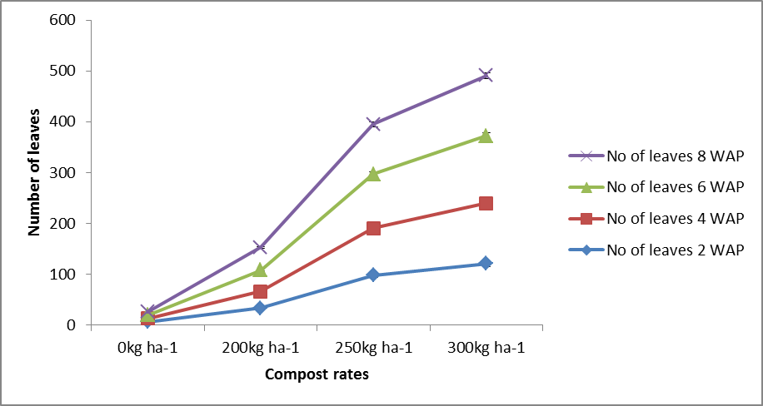
Figure 1: Effect of compost on number of leaves

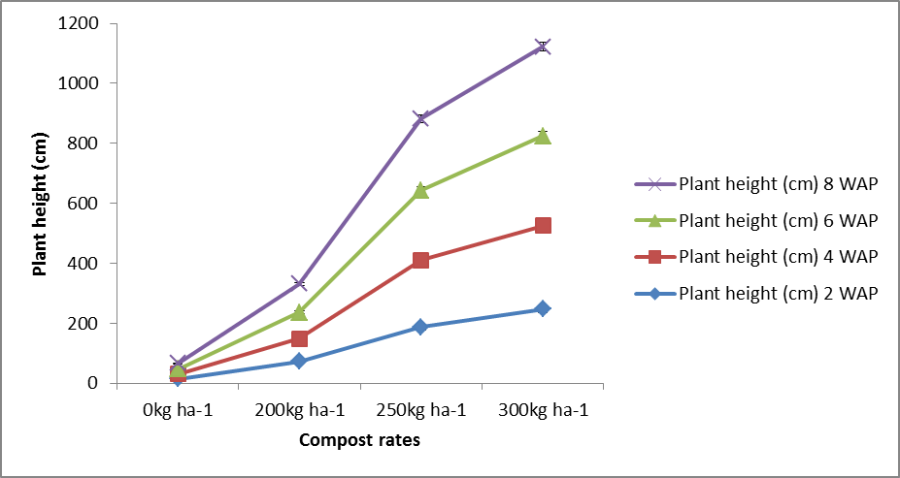
Figure 2: Effect of compost on plant height (cm).

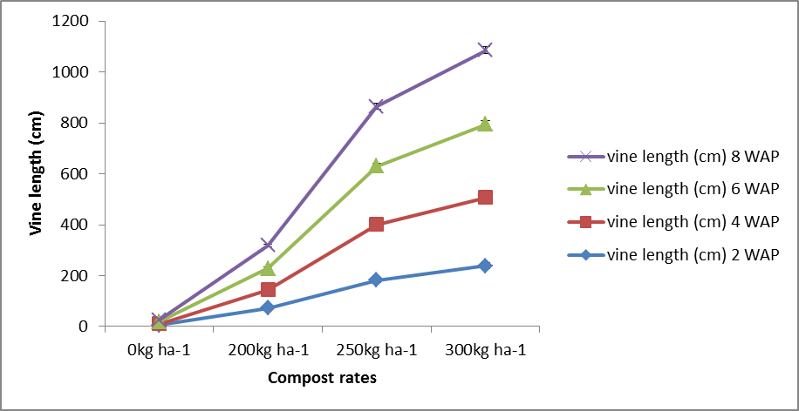
Figure 3: Effect of compost on vine length

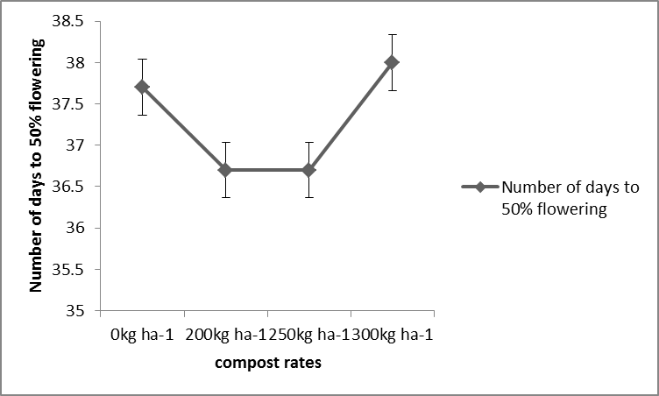
Figure 4: Number of days to 50% flowering

Number of days to 50% flowering of watermelon
The result in Figure 4 shows that variable rates of compost used in this study do not have significant effects (p>0.05) on watermelon number of days to 50% flowering. However, plots that received 200 kg ha⁻¹ and 250 kg ha⁻¹ flowered earlier than other treated plots; closely followed by watermelon planted in control plots and 3000 kg ha⁻¹ treated plots flowered last (Figure 4).
Effect of Compost manure on Yield attributes of Watermelon.
The data regarding yield attributes grown shows that watermelon yield was significantly influenced (p<0.05) by the varying rates of compost incorporated into the experimental soil (Figure 5). It is evident from the result that the maximum fresh weight (9.4 kg) was recorded in plots incorporated with 300 kg ha⁻¹ compost and minimum fruit weight (4.16 kg) was harvested from plots fertilized with 250 kg ha⁻¹ compost. Fruit diameter was not significantly (p>0.05) influenced by the application of compost (Figure 5). However, watermelon planted on plots fertilized with 200 kg ha⁻¹ produced the biggest fruits (27.19cm), followed by 250 kg ha⁻¹(26.73 cm), 300 kg ha⁻¹ (26.63 cm) and watermelon planted in control plots produced the smallest fruits (26.51 cm).

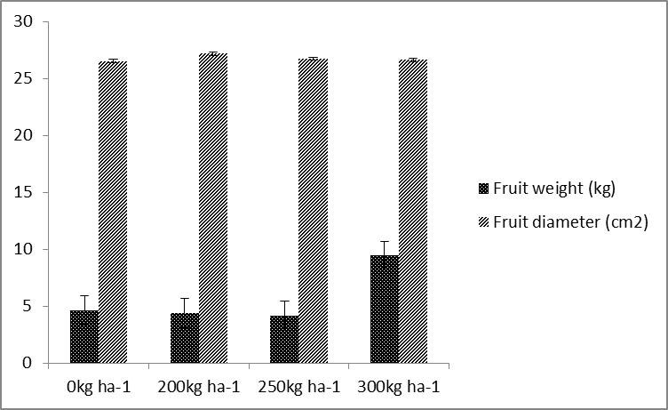
Figure 5: Effects of compost on yield attributes.

Discussion
Application of organic materials have potential of not only improving crop yield, but also reducing dependence on fossil fuel based inorganic fertilizers, thereby reducing hazards caused by continuous and indiscriminate use of chemical fertilizers. The role of organic manures in maintaining soil fertility and their influence on growth and development of crop has been well documented [Sultan, 1995; Singh et al 1997]. The role of organic manures in maintaining soil fertility and their influence on growth and development of crop has been well documented [Sultan, 1995; Singh et al 1997; Afolabi and Adesina, 2011; Adesina and Sanni, 2013; Adesina et al 2014]. Besides influencing the physio chemical properties of soil, organic manures plays an important role in improving soil permeability to air and water and water stable aggregates. They are also known to contain growth promoting substances, increases phosphorus mobilization, enhance microbial activity and prevent nitrogen loss by leaching thus improves nutrient uptake resulting in greater growth, yield and yield components (Shinde et al 1992; Singh et al 1994; Sultan, 1995; Mondal and Chettri, 1998; Pandey et al 1999; Nevens and Reheul, 2003).
The significant growth and yield performance of watermelon fertilized with compost over the control recorded in this study is due to the low fertility status of the experimental soil and agreed with the findings of (Messiaen, 1992; Sanni et al 2013; Aniekwe and Nwokwu, 2015) that watermelon responds well to organic manure which may contain essential nutrient elements associated with high photosynthetic activities to have promoted vigorous vegetative growth and root development, increment of meristematic and physiological activities in the plants due to adequate plant nutrient supply coupled with improved soil properties that resulted (John et al 2004). Incorporation of compost showed an improved yield in comparison to unfertilized plots indicating that compost had positive response on yield parameters of watermelon, which might be due to higher retention and availability of all the essential nutrients which are required for satisfactory growth, yield and quality of plants as well as improvement in soil physical and biological properties (Kamara and Lahai 1997; Priyadarshani et al 2013).
The varying yield response to the different rates of compost might be attributed to the nature and amount of nutrients present in the manures, their decomposition and nutrient release pattern in the soils (Mubarik, 1999). Increased plant yield may also be due to increased soil aggregate stability which might have favored the beneficial microbes which in turn could have contributed to improve biomass production (Basso and Ritchie, 2005; Bwenya and Terokun, 2001). This increase could possibly be because of long term and easy availability of nutrients and their uptake from higher proportions of compost.
Significant increase in watermelon vegetative growth parameters (vine length, number of leaves and plant height) was recorded with increase in the rate of compost incorporated into the experimental soil). The results obtained is in conformity with the findings of Lawal (2000); Agba et al. (2005) and Abdel et al. (2005) who reported increase in growth and yield component of watermelon in respond to increased level of fertilizer application.
The reason for this increase could be ascribed to the efficient use of all available resources for plant and roots because of slow and continued supply of nutrients as well as more water absorption due to larger amounts of nutrients in the soil as the amount of manure increased (Jagadeeswari and Kumaraswamy, 2000; Swarup and Yaduvanshi, 2000; Van-Averbeke and Yoganathan, 2003; Ogunlela et al., 2005; Pimentel et al., 2005; Kuntashula et al., 2006). Manure application resulted in improved vegetative growth compared to the unfertilised control plots and these appear to indicate that addition of compost at 300kg ha⁻¹ provided sufficient nutrients for maximum vegetative growth and the nutrients were partitioned towards stem elongation and leaf production.
The low nutrient status (organic carbon, N, P, K. Ca and Mg) of the soil is the characteristic nature of soils in the agro ecological zone which is below the critical level required for sustainable crop production in Southwest Nigeria (Akinrinde Obigbesan 2000). The reduction in the soil pH value at harvest confirms the study of Sanni (2016) who observed that soil pH in Ikorodu agro ecological reduced from 6.20 to a range of 5.58-5.87 at crop harvest from soil fertilized with 200 kg/ha⁻¹ NPK 15-15-15 fertilizer, 200 kg/ha⁻¹compost, 25 t ha⁻¹cow dung. The marginal increase recorded for Mg, K, CEC, total N and organic carbon from plots incorporated with varying level of compost might be due to the increased in the amount of nitrogen present in the various rates of compost applied which improved microbial activity that led to enhanced production and mineralization of organic matter from natural (native) source in soil and this support the previous result reported by Sanni (2016).

Conclusion
Application of compost resulted in an increase in watermelon growth and yield attributes, as well as improved the soil physiochemical properties. Compost incorporated at 300kg/ha⁻¹ produced significant higher vegetative growth and yield attributes at harvest than other treatments and the findings suggested that 300 kg/ha⁻¹ of compost would supply sufficient nutrients required for the optimum growth and yield of watermelon in the study area.

References
- Abdel, A.M., Eldesuki, R.M., Salman, S.R. and Hussein, S.D. (2005). Performance of some snap bean varieties as affected by different levels of mineral fertilizers, J. Agro. 4: 242-247.
- Adekiya, A. O. and Ojeniyi, S. O. (2002). Evaluation of tomato growth and soil properties under method of seedling bed preparation in an Alfisol in the rainforest zone of Southwest Nigeria. Soil Tillage Research, 64:275 – 279.
- Adesina J. M.,Sanni K. O., Afolabi L. A. and Eleduma A. F. (2014) Effect of Variable Rate of Poultry Manure on the Growth and Yield of Pepper (Capsicum annum) in South Western Nigeria. Academic Arena, 6(1): 9-13.
- Adesina, J. M. (2013) Exploration of Erythrina Excelsa Baker and Aneilema Beniniense (P. Beauv.) Kunth Aqueous Extracts For The Management of Flea Beetles (Podagrica Spp) On Okra (Abelmoschus esculentus). Nat Sci 2013;11(12):210-215.
- Adesina, J. M. and Sanni, K. O. (2013) Comparative effects of different organic manure on agronomic performances of Corchorus olitorus in Rainforest Agro-ecological zone of South Western Nigeria. International Journal of Agronomy and Agricultural Research, 3 (1): 1 – 5.
- Afolabi, L. A. and Adesina, J. M. (2011) Comparative and Cumulative effects of different Organic manures on the Growth and Yield of Tomato (Solanium lycopersicum) in south western Nigeria. Journal of Applied and Environmental Science, 6 (3) 17 – 22.
- Agba, O.A. and Enga, V.E. (2005). Response of Cucumber (Cucumissativun L.) to Nitrogen in cross river state of Nigeria, Global J. Agric. Sci. 4: 145.
- Akinrinde, E.A. and Obigbesan. G.O. (2000). Evaluation of the fertility status of selected soils for crop production in five ecological zones of Nigeria. Proceedings 26th Annual Conference of Soil Science Society of Nigeria, Ibadan, Nigeria. pp. 279-288.
- Aniekwe, L. and Nwokwu, G. (2015). Effects of Organic Manure Sources on the Growth and Yield of Watermelon in Abakaliki, Southeastern Nigeria. International Journal of Science and Research, 4(1):1923-1927.
- Ayoola, O. T. and O. N. Adeniyan (2008). Influence of poultry manure and NPK fertilizer on yield and yield com-ponents of crops under different cropping systems in south west Nigeria. African Journal of Biotechnology.5 (15), 1386-1392.
- Basso, B. and Ritchie, J.T. (2005) Impact of compost manure and inorganic fertilizer on nitrate leaching and yield for a 6 year maize alfalfa rotation in Michigan, Agriculture, Ecosystems and Environment, vol-108, pp. 309-341.
- Bwenya, S. and Terokun, O.A. (2001) Effect of Cassia spectabilis, cow dung and their combination on growth and grain yield of maize, Seventh Eastern and Southern Africa Regional Maize Conference, Nairobi, Kenya, pp. 361-406.
- Gomez, K. A. and Gomez, A. A. (1984). Statistical Procedures for Agricultural Research. 2nd Edn, John Wiley and Sons, New York, USA.
- Ismaeil, F. M., Abusuwar, A. O. and El-Naim, A. M. (2012). Influence of Chicken Manure on Growth and Yield of Forage Sorghum (Sorghum Bicolor L.Moench). International Journal of Agriculture and Forestry, 2(2):56-60.
- Jackson, M. L. (1973). Soil Chemical Analysis. Second edition. Prentice Hall of India Pvt. Ltd., New Delhi, p 498.
- Jagadeeswari, P.V. and K. Kumaraswamy. 2000. Long-term effects of manure-fertilizer schedules on the yield of and nutrient uptake by rice crop in a permanent manorial experiment. J. Indian Soc. Soil Sci., 48: 833-836.
- Jansen Van Rensburg, W. S., Venter, S. L., Netshiluvhi, T. R., Van Den Heever, E. and De Ronde, J. A. (2004) Role of indigenous leafy vegetables in combating hunger and malnutrition. S. Afr. J. Bot. 70 52-59.
- John, L.W., Jamer, D.B., Samuel, L.T. and Warner, L.W., (2004). Soil fertility and fertilizers: An Introduction to nutrient management, Pearson Education, India, pp 106-153.
- Kamara A.Y and Lahai M.T. (1997). Differential response of sweet potato (Ipomoea batatas) to green manuring with elephant grass (Pennisetum purpureum) and spear grass (Imperata cylindrica) on a Ferralitic soil in Sierra Leone. Tropenlandwirt 98. 229-235.
- Kuntashula, E., G. Shileshi, P.L. Mafongoya and J. Banda, 2006. Farmer participatory evaluation of the potential for organic vegetable production in the wetlands of Zambia. Outlook Agr., 35(4): 299-305.
- LASPOTECH Meteorological station. Lagos State Polytechnic, Ikorodu 2014.
- Lawal, A.B. (2000). Response of cucumber to intercropping with maize and varying rates of farmyard manure and inorganic fertilizer, Agriculture and Environment. 2(1): 78-83.
- Messiaen, C-M., 1992. The tropical vegetable garden, Macmillan press ltd, London and Basingstoke in cooperation with CTA, The Netherlands, 514 pp.
- Mondal, S.S.; Chettri, M. Integrated Nutrient Management for Sustaining Productivity and Fertility Under Rice (Oryza sativa)-Based Cropping System. Indian J. Agr. Sci. 1998, 68 (7), 337–340.
- Morgan, K. and Murdoch, J. (2000). Organic vs. conventional agriculture: knowledge, power and innovation in the food chain. Geoforum, 31(2), 159-173.
- Mubarik A. Evaluation of green manure technology in tropical lowland rice systems. Field Crops Research. 61 (1): 61-78.1999.
- Naik, R. H., Devakumar, N., Rao, G. E., Vijaya, N., Imran Khan, H. S. and Subha, S. (2012). Performance of botanical and fungal formulation for pest management in organic okra production system. JBiopest, 5 (Supplementary): 12-16.
- Nevens F, Reheul D (2003). The application of vegetable, fruit and garden waste (VFG) compost in addition to cattle slurry in a silage maize monoculture: nitrogen availability and use. European J Agron 19: 189-203.
- Obi ME, Ebo PO (1995). The effect of different management practices on the soil physical properties and maize production in severely degraded soil in southern Nigeria. Biological Resource technology. pp. 51: 117-123.
- Ogunlela V.B., M.T. Masarirambi and S.M. Makuza, 2005. The effects of cattle manure application on pod yield and yield indices of okra (Abelmoschus esculenta L. Moench) in a semi arid and subtropical environment. J. Food Agric. Environ., 3(1): 5-15.
- Ojeniyi SO (2000) .Effect of goat manure on soil nutrients and okra yield in a rain forest area of Nigeria. Applied Tropical Agriculture 5:20-23.
- Okalebo JR, Gathua KW and Woomer PL (2002) Laboratory Methods of Soil and Water Analysis: A Working Manual (2nd edn.) Nairobi, Kenya. SACRED Africa. 128 pp.
- Olsen, S. R., Cole, C. V., Watanabe, F. S. and Dean, L. (1954). Estimation of available phosphorus in soils by extraction with sodium bicarbonate, U. S. Dept. Agron. Cire. p 929.
- Page, A.L., Miller, R. H. and Kuny, D. R. (1982). Methods of Soil Analysis. Part 2. 2nd ed., pp 403-430. American Soc. Agron., Inc., Soil Sci. Soc. American Inc. Madison, Wisconsin, USA.
- Pandey, N.; Sarawgi, A.K.; Rastogi, N.K.; Tripathi, R.S. Effect of Farmyard Manure and Chemical N Fertilizer on Grain Yield and Quality of Scented Rice (Oryza sativa) Varieties. Indian J. Agr. Sci. 1999, 69 (9), 621–623.
- Pimentel, D., P. Hepperly, J. Hanson, D. Douds and R. Sidel, 2005. Environmental, energetic and economic comparisons of organic and conventional farming systems. BioSci., 55(7): 573-582.
- Priyadarshani, N.D.N., Amarasinghe, M.K.T.K., Subasinghe, S., Palihakkara, I.R. and Kumarasinghe, H.K.M.S. (2013). Effect of organic and inorganic fertilizers on biomass production, oil yield and quality of vetiver (Vetiveria zizanioides L.) The Journal of Agricultural Sciences, 8(1):28-35.
- Ramesh, P., Panwar, N. R., Singh, A. B., Ramana, S., Yadav, S. K., Shrivastava, R., & Rao, A. S. (2010). Status of organic farming in India.Current Science, 98(9), 1190-1194.
- Sanni, K. O. (2016). Effect of compost, cow dung and NPK 15-15-15 fertilizer on growth and yield performance of Amaranth (Amaranthus hybridus). International Journal of Advances in Scientific Research 2016; 2(03): 076-082.
- Sanni, K. O., Ewulo, B. S., and Adesina, J. M (2013) Growth and yield performances of water melon Citrullus lanatus (Thomb) on soil amended with poultry manure and N.P.K 15-15-15 fertilizer in Ikorodu, Nigeria. In: J. A. Adediran, J. O. Saka, A. G. Ibrahim, M. O. Adenekan, A. O. Atere and V. A. Adeyemi (eds). Revamping Nigerian Agriculture through Transformation Agenda: The way forward. Proceedings of 47th Annual Conference Agricultural Society of Nigeria, held at Federal College of Animal Health and Production Technology, Ibadan, Nigeria from 4th – 8th November, 2013. pp. 1027-1031.
- Shinde, P. H., Naik, R.L., Nazirkar, R.B., Kadam, S.K. and Khaire, V.M. (1992). Evalution of vermicompost. Procedings of National Seminar on Organic Farming; 19-21April, 1992; Pune. College of Agriculture, Pune, pp. 54-55.
- Shuka, V. and Naik, L. B. (1993). Agro-technique for Solanaceous Vegetables, In: Advance in horticulture, Vol. 5. Malhotra publishing house, New Delhi, India, Pp. 364 – 399.
- Singh, K.P., Rinwa, R.S., Harbir, S. and Kathuria, M.K. (1997). Substitution of chemical fertilizers with vermicompost in cereal based cropping system [abstract]. In: Abstracts, 3rd IFOAM-ASIA Scientific Conference and General Assembly; 1-4 December, 1997, Bangalore, India.p.3. Abstract No. 8.1.7.
- Singh, Y.; Singh, B.; Khera, T.S.; Meelu, O.P. (1994). Integrated Management of Green Manure, Farmyard Manure, and Nitrogen Fertilizer in a Rice-Wheat Rotation in Northeastern India. Arid Soil Res. Rehab. 8 (2), 199–205.
- SPSS Inc., 2011. SPSS Statistics 17.0, SPSS Inc., Chicago, IL, USA.
- Steiner, K.G. (1991). Alleviating soil fertility constraints to increased crop production in West Africa Mokwunye A. U. (ed.) pp 69-91. 1991.
- Sultan, I. (1995). Earthworms in soil fertility management. In: Thampan, P.K. (ed.), Organic in soil health and crop production. Peekay Tree Crops Development Foundation, Cochin, pp. 78-100.
- Swarup, A. and Yaduvanshi, N.P.S. (2000). Effect of Integrated nutrient management on soil properties and yield of rice in Alkali soils. J. Indian Soc. Soil Sci., 48: 279-282.
- Van-Averbeke, W. and S. Yoganathan, 2003. Using Kraal Manure as Fertilizer. Department of Agriculture Cape Town, University of Fort Hare, Republic of South Africa. Retrieved form: http://www.daff.gov.za/docs/Infopaks/KraalManure.pdf. (Accessed on: May 28, 2016).
- Yiridoe, E. K., Bonti-Ankomah, S., & Martin, R. C. (2005). Comparison of consumer perceptions and preference toward organic versus conventionally produced foods: a review and update of the literature. Renewable Agriculture and Food Systems, 20(04), 193-205.

6/9/2016

