Development and Evaluation of a Multipurpose Juice Extractor

Aremu, Ademola. K. and Ogunlade, Clement A.

Department of Agricultural and Environmental Engineering, University of Ibadan, Nigeria
ademolaomooroye@gmail.com

Abstract: A portable multipurpose extractor was developed for extracting juice from some tropical fruits (pineapple, orange and watermelon). The machine was fabricated using locally available materials (basically stainless steel); the main functional parts of the machine include a cylindrical drum (30cm length x 20cm diameter), screw rod (28cm long), sieve and a hopper (10.2 x 6.4 x 7.5 cm). The machine was evaluated in accordance with standard evaluation methods. Three test trials were carried out each with varying sieve opening diameter (0.5, 1, 1.5 and 2 mm) for both peeled and unpeeled fruits. The time taken for juice extraction, mass of juice extracted, mass of fruits and residual wastes were recorded and used to obtain the juice yield, extraction efficiency and losses. Peeled and unpeeled orange, pineapple and watermelon have the highest juice yield and extraction efficiency of 45, 46.5, and 50.8, 60.1, 55.3, 47.6 and 67.4, 50.8, 31.8, 46.3 and 38.2, 52.2 respectively. Highest juice yield and extraction efficiency was obtained with 2mm diameter sieve. The sieve diameter had a significant effect on the percent juice yield, extraction efficiency and extraction loss of the machine.
[Aremu, A. K., Ogunlade, C. A. Development and Evaluation of a Multipurpose Juice Extractor. N Y Sci J 2016;9(6):7-14]. ISSN 1554-0200 (print); ISSN 2375-723X (online). http://www.sciencepub.net/newyork. 2. doi:10.7537/marsnys09061602.

Keywords: Tropical Fruits, Juice Extractor, Extraction Efficiency, Juice Yield, Extraction Loss

1. Introduction
Fruits are important components of human diet because of the large contents of vitamins A, B, C and minerals like Calcium and Iron, which meets daily nutrients requirements and good health. Most fruits are seasonal in availability and highly perishable in natural states and fresh forms because of their high water content (70-90%) which aids chemical deterioration (Taylor, 1998) however, adequate storage and processing technology of these fruits into forms that can easily be stored, preserved, packaged or consumed is essential as it will play an important role in contributing to self-sufficiency in food production. Nigeria as a developing country is fast attaining technological advancement to meet the ever increasing demands of her teeming population. The country is so blessed with various fruits yet; fruit juice or modernized juice extractors are still being imported while those produced in the country are expensive and cannot be afforded by peasant farmers and rural dwellers.
Fruit juice extraction methods in time past is crude, people apply pressure with hand and mouth during squeezing of the fruit in order to get the juice out of the fruit (for citrus and cashew) and other methods like peeling and eating raw (for fruits like pineapple, pawpaw and watermelon). These methods are primitive and consume both time and energy and the production is very low. Fruit juice production in rural and urban areas is essential to enable local farmers produce high quality and quantity of juice and reduce wastage of fresh fruits therefore, there is need for agricultural and food engineers, to produce affordable machines that will extract juice from fruits in their raw forms. The main objective of this research was to design, construct and evaluate a portable multipurpose juice extractor for use in both urban and rural areas.

2. Material and Methods
Design Analyses and Calculations
Factors considered in the design of the juice extractor include flexibility, simplicity, availability and choice of material of construction (stainless steel was used being a food contact surface), cost, ease of maintenance and aesthetics.
The modulus of elasticity of orange fruits ranges from 121 to 195 Pa (Pallotino et al., 2014), coefficient of friction of orange on steel is 20.2⁰ (Sharifi et al., 2007). It was assumed that adults of average power 0.075 kW will conveniently operate the machine at a speed of 60 rpm. Force (F) is applied to the fruits at a distance (X) from the rotating plate to the end (stationary plate) as shown in Figure 1:

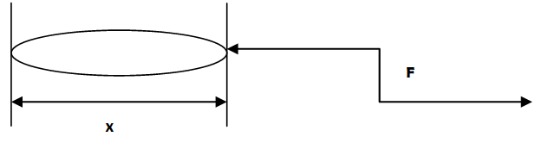Figure 1: Analysis of Force applied to the fruits

The turning moment transmitted by the shaft is given as:
$T=F x X$ (1)
T is the turning moment (202.5 Nm), F is the force (675N; CCOHS (2015) and Reinhold (1986) reported that where a worker can support his body or feet against a firm structure, a force of 675N can be developed) and X is the distance at which the fruits will be compressed and extracted (0.3m).
The pressure required to compress and rupture fruits based on maximum applicable load is given as:
$P=\frac{F}{A}$ (2)
Where: P is the pressure developed to rupture fruits (2683 N/m²), A is the cross sectional area (0.2516 m²). Power required to compress fruits and extract juice on maximum applicable load (P) is given as:
$P=2πNT$ (3)
Where: N is the speed (60rpm), T is the turning moment (202.5Nm).
The average force developed to operate the machine (675N) is greater than average burst force 418.9 N reported by Churchill et al., (1980) hence, the machine will easily extract juice out of the fruits.
Design of Shaft
- Shaft Criterion: the extractor shaft is to be designed on the basis of torsional load only which involves analyses of strength and rigidity. The required diameter for a solid shaft having torsional load only was obtained from ASME code equation (Hall et al., 1980):
$D^{3}=\frac{16T}{S}$ (4)
Where: S is the allowable stress (55MPa for shaft without keyway), D is the shaft diameter (27mm), T is the Torque (63Nm).
- Torsional Deflection: the design of shaft for torsional rigidity is based on permissible angle of twist for steel 3⁰ (Surrender, 1979). For limiting the twisting to the given limit, the angle of twist (rad) is given as:
$Ø=\frac{TL}{GJ}$ (5)
Where: Ø is the angle of twist (3⁰), T is the Torque, D is the diameter of shaft permissible for torsional deflection (25mm), G is the modulus of rigidity of shaft material (80GN/m²) and J is the polar moment of inertia for shaft section given as:
$J={\frac{πD}{32}}^{4}$ (for a circular shaft) (6)
Substituting for D in equations (5) and (6),
$D^{4}=\frac{32TL}{πGØ}$ (7)
Thus, for both stress and twist to be within permissible limit, a stainless steel shaft of 28mm was used.
Design of the Extraction Chamber
This chamber was designed on basis of internal pressure. The housing is treated as thin walled cylinder then, using the standard stress (stiffness) analysis to thin walled pressure vessels (Surrender, 1979), the maximum shear stress is given as:
$ƴ=\frac{Pr}{4t}$ (8)
where: $ƴ$ is the maximum shear stress the cylinder will be subjected to at failure by yield (for steel, ultimate yield stress with a factor of safety of 2 is 70 MN/m²), P is the internal Pressure of cylinder (35MN/m²), r is the internal radius of cylinder (0.2m), t is the thickness of cylinder (12.5 mm).
The various machine parts, materials used for construction, processes and reasons for choice of material is presented in Table 1.

Table 1: Machine Parts and Material Selection
S/NO | Machine Parts | Material recommended | Reasons | Processes involved
1 | Cylindrical Drum | Stainless Steel | Does not discolor food, High strength and rigidity, Resistance to pitting and easily machined. | Cutting, Rolling and welding.
2 | Juice Presser | Stainless Steel | Does not cause food discoloration, Good Corrosion resistance, Easily machined. | Cutting and welding
3 | Perforated Screen(Filter) | Stainless Steel | Does not discolor food and a good corrosion resistance. | Cutting, Punching and Welding.
 | Bolt And Nut | Mild Steel | Can withstand bending and shear forces. | Machining operation.
5 | Juice Collector | Plastic | Does not discolor food, Does not corrode and very cheap.
6 | Machine Base/ Stand | Square Pipe | Very cheap and light | Cutting, Welding

Principle of Operation of the Juice
Extractor
The fruits are fed into the hopper and the screw rod is turned manually which rotates in the cylinder drum, conveys and compresses the fruits. The cylinder has an opening at the base to allow the passage of the juice with mesh steel plate to sieve the suspension. The juice extracted is filtered through the sieve into the collector bin.
The exploded and isometric design of extraction drum and screw-rod handle is presented in Figures 1, 2 and 3 respectively
Sample Preparation and Performance
Evaluation of the Machine
Tropical fruits (orange, pineapple and watermelon) were procured from Bodija International market in Ibadan, Oyo State Nigeria. The fruits were cleaned and sorted, the fruits were divided into two samples each, the first samples were peeled while the second samples were unpeeled. The machine performance test was carried out by feeding known mass of peeled and unpeeled fruits through the hopper into the cylindrical drum where crushing, compression and extraction of juice takes place; the machine was operated until the materials fed into the machine are completely extracted. The time taken for extraction, mass of fruit fed into the machine, mass of juice extracted and mass of residual waste were recorded.
The juice constant of the fruit (in decimal) was also calculated and recorded. Each experiment was replicated three times for both peeled and unpeeled pineapple, orange and water melon using the four set of sieves. Plate 1a and b shows the juice extraction process from peeled orange and the extracted orange juice. The following indices described by Tressler and Joslyn (1961) and reported by Oguntuyi (2013), Kasozi and Kasisira (2005), Abulude et al. (2007), Samaila et al. (2008), Aye and Abugh (2012) were used to calculate the juice yield, extraction efficiency and extraction loss of the machine while the juice constant was obtained from the ratio of sum of masses of juice extracted and juice in chaff to the mass of fruit fed in as presented in Equation 4. The mass of juice in chaff was determined using the method of ASAE (1983) as applied by Oje (1993), Oyeleke and Olaniyan (2007), Aviara et al. (2008), Olaniyan (2010), Adebayo et al. (2014), Olaniyan and Obajemihi (2014).
- Juice yield, J_{Y}, % = $\frac{100×WJE}{WJE+WRW}$ (9)
- Extraction Efficiency, % = $\frac{100×WJE}{X×WFS}$ (10)
- Extraction Loss % = $\frac{100×\{WFS-\left(WJE+WRW\right)\}}{WFS}$ (11)
- Juice Constant, X = $\frac{\left(WJE+Wjc\right)}{Wi}$ (12)
Where: W_{JE} is Mass of juice extracted in grams, W_{RW} is the Mass of residual waste in grams, W_{FS} is the Mass of fed sample in grams, X is the juice constant of fruits in decimal

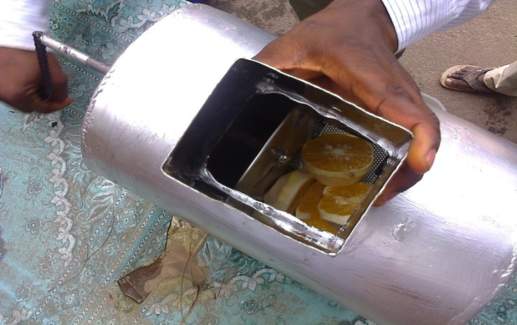
(a)

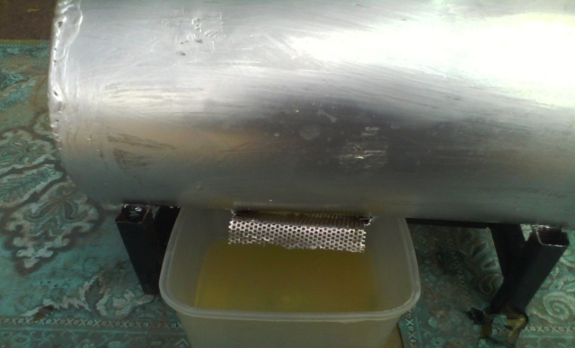
(b)
Plate 1: a-Juice Extraction from Peeled Orange; b- Extracted Orange Juice

3. Results
A portable multi-purpose juice extractor was developed and evaluated using four different sieves with varying mesh diameter (0.5mm, 1.0mm, 1.5mm, 2.0mm). The juice constants for peeled and unpeeled pineapple, orange and water melon were respectively found to be 0.8 and 0.78, 0.78 and 0.76, and 0.91 and 0.88. Each experiment was replicated three times for both peeled and unpeeled pine apple, orange and water melon, the average percent juice yield, extraction efficiency and extraction loss for peeled and unpeeled pineapple, orange and water melon are presented in Table 2.

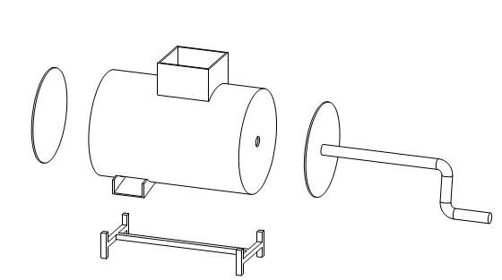
6
2
1
5
4
3
KEY
- END PLATE
- CYLINDER DRUM
- HOPPER
- INTERNAL SCREW PLATE
- HAND LEVER/ SCREW
- SEAT/ FRAME
Figure 1: Exploded view of the Machine

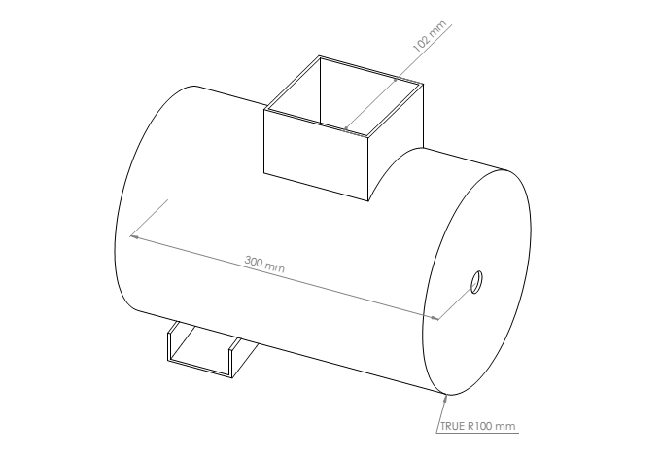
Figure 2: Isometric View of the Extraction Drum
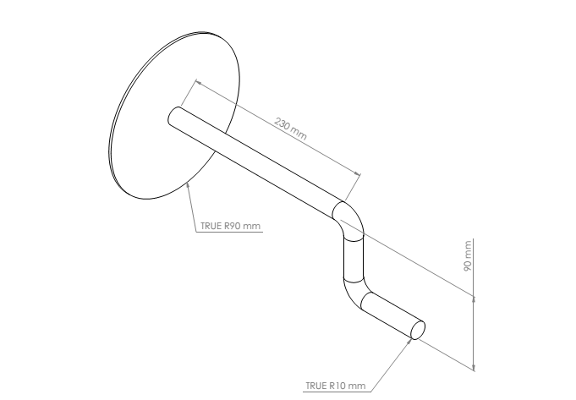
Figure 3: Isometric View of the Screw-Rod and the Handle

Table 2: Average Machine Performance Index
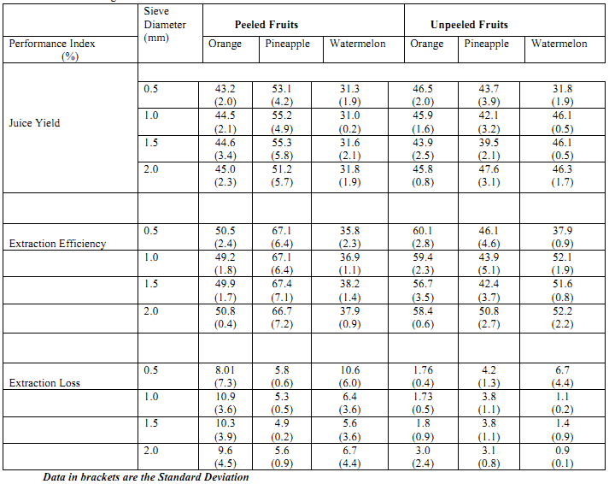

4. Discussions
Sieve diameter had significant effects on the performance of the machine, highest juice yield was obtained for peeled orange using 2.0 mm sieve diameter while sieve diameter 0.5 mm shows the highest juice yield for unpeeled orange, 1.5 mm shows the highest juice yield for peeled pineapple while the highest juice yield was obtained for unpeeled pineapple using 2.0 mm diameter, 2.0 mm sieve diameter shows the highest juice for both peeled and unpeeled watermelon. The effect of sieve diameter on the percent extraction efficiency and juice yield of the portable multi-purpose juice extractor is presented in Figures 4 and 5.
Regression equations obtained for the juice yield and extraction efficiency for sieves 1, 2, 3 and 4 as presented below:
- Regression equations for juice yield of the machine using sieves 1, 2, 3 and 4 respectively:
$y=1.246x+40.251 (R^{2}=78.5)$ (13)
$y=0.9083x+40.976 (R^{2}=77.3)$ (14)
$y=1.0614x+40.257 (R^{2}=79.6)$ (15)
$y=0.6654x+41.176 (R^{2}=81.5)$ (16)
- Regression equations for extraction efficiency of the machine using sieves 1, 2, 3 and 4 respectively:
$e=0.6654x+41.176 (R^{2}=87.4)$ (17)
$e=0.6654x+41.176 (R^{2}=79.9)$ (18)
$e=0.6654x+41.176 (R^{2}=75.1)$ (19)
$e=0.6654x+41.176 (R^{2}=89.3)$ (20)
Where: y is the percent juice yield, x is the sieve diameter (mm) and e is the percent extraction efficiency.

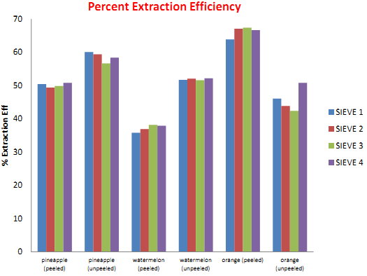
Figure 4: Effects of Sieve Diameter on Percent Extraction Efficiency

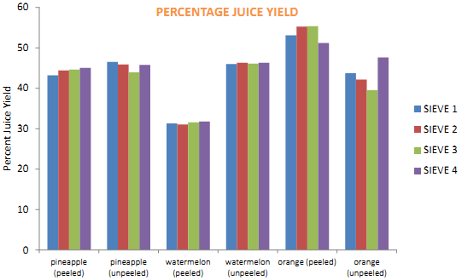
Figure 5: Effects of Sieve Diameter on Percent Juice Yield

Moreover, maximum juice yield for peeled and unpeeled orange, pineapple and watermelon was obtained to be 45 and 46.5, 55.3 and 47.6, 31.8 and 46.3 % respectively and the optimum extraction efficiency for peeled and unpeeled orange, pineapple and watermelon was obtained to be 50.8 and 60.1, 67.4 and 50.8, 37.9 and 52.2 % respectively while the highest extraction loss obtained for peeled and unpeeled orange, pineapple and watermelon was 10.86 and 3.0, 5.77 and 4.22, 10.6 and 6.7 % respectively. The values obtained for juice extraction and extraction efficiency are slightly lowered than findings reported by Aviara et al. (2013) for a multi-purpose juice extractor having a percentage juice yield for peeled and unpeeled pineapple, orange and watermelon of 79.1 and 68.7 %, 77 and 69.2%, and 89.5 and 89.7 % respectively; extraction efficiency of 96.9 %, 94.3 % and 96.6% for peeled pineapple, oranges and watermelon and their respective unpeeled value of 83.6 %, 84.2 % and 97.1 %; and extraction loss of peeled and unpeeled fruits of 2.1 and 2.7 % (pineapple), 2.1 and 2.5% (orange), and 2.9 and 2.6 % (watermelon), this may be due to mechanized multi-purpose juice extractor used by Aviara et al. (2013). Moreover, Adebayo et al. (2014) reported an extraction efficiency of 87.5% and extraction loss of 12.5% for a portable motorized pineapple juice extractor, Raji and Olofin (2011) reported extraction efficiencies of 97.9 and 98.9% for leaf and protein using a motorized leaf protein extraction machine, Olaniyan (2010) reported 41.6 and 57.4% juice yield and extraction efficiency for a small scale orange juice extractor, Oyeleke and Olaniyan,(2007) reported maximum juice yields of 76, 83.3, 82.75, 96 and 71.4% for orange, grape, tangerine, watermelon and pineapple respectively with corresponding extraction efficiency of 86.3, 95.2, 94.1, 98 and 81.3%, Olaniyan and Obajemihi (2014) reported average juice yield, extraction efficiency and extraction loss of 34.56, 55.14 and 10.15% respectively for a small scale mango juice extractor.

5.0 Conclusions
A multi-purpose juice extractor was developed and evaluated using orange, watermelon and pineapple in both peeled and unpeeled form. Extensive tests were performed to determine the extraction efficiency, juice yield and extraction loss of the machine. However, the following conclusions were drawn:
- Maximum juice yield for peeled and unpeeled orange, pineapple and watermelon was obtained to be 45 and 46.5, 55.3 and 47.6, 31.8 and 46.3 % respectively.
- Highest extraction efficiency for peeled and unpeeled orange, pineapple and watermelon was obtained to be 50.8 and 60.1, 67.4 and 50.8, 37.9 and 52.2 % respectively.
- Sieve diameter had an effect on the percent juice yield, extraction efficiency and extraction loss of the machine.
- The machine is cost-effective, simple to operate and maintain, it is therefore recommended for small local fruit processors and rural dwellers.

Acknowledgements:
Authors are grateful to the Department of Agricultural and Environmental Engineering, Faculty of Technology, University of Ibadan, Nigeria for support to carry out this work.

Corresponding Author:
Dr. AREMU, Ademola K.
Department of Agricultural and Environmental Engineering,
Faculty of Technology,
University of Ibadan, Nigeria
E-mail: ademolaomooroye@gmail.com

References
- Taylor, A. O. (1998): Training manual for UNDP/ UNIDO. Training programme for women Entrepreneurs in food processing industries.
- Pallotino, F., Costa, C., Menesatti, P and Moresi, M. (2014). Compression testing of orange fruits.
- Sharifi, M., S. Rafiee, A. Keyhani, A. Jafari, H. Mobli, A. Rajabipour, and A. Akram (2007). Some physical properties of orange (var. Tompson). Int. Agrophysics, 2007, 21, 391-397
- CCOHS (2015). Canadian Center for Occupational Health and Safety. Available online athttp://www.ccohs.ca/oshanswers/ergonomics/push1.html Retrieved 24th August, 2015
- Reinhold, V. N. (1986). Ergonomic design for people at work, Vol. 2, Eastman Kodak company
- Churchill, D. B., Summer, H. R. and Whitney, J. D. (1980). Peel strength of orange varieties. Transactions of ASAE 1980, Pp 173-176
- Tressler, D. K. and Joslyn, M. A. (1961): Fruit and Vegetable Juice Technology First edition. AVI publication Co, Inc west port, Connecticut page 155-156Tilman D. Causes, consequences and ethics of biodiversity. Nature 2000;405(4):208-11.
- Oguntuyi, V. F. (2013). Evaluation of development and performance of a manually operated orange juice extracting machine. International Journal of Research Development, Vol. 2(1): 257-264.
- Kasozi, G. and Kasisira, L. L. (2005). Design and performance of a banana juice extractor. African Crop Science Conference Proceedings, Vol. 7. pp. 1381-1384.
- Abulude, F. O., Elemide, A. O., Ogunkoya, M. O. and Adesanya, W. O. (2007). Design and performance evaluation of a juice extractor constructed in Nigeria. Research Journal of Applied Sciences 2 (1): 31-34.
- Samaila, R. S., Olotu, F. B. and Obiakor, S. I. (2008). Development of a manually operated fruits juice extractor. Journal of Agricultural Engineering and Technology (JAET), Vol. 16 (No 2): 22 -28.
- Aye, S. A. and Abugh A. (2012). Design and construction of an orange juice extractor. Proceedings of the World congress on Engineering, Vol. III, WCE July 4th-6th, London, U. K.
- Oje, K. (1993). Some engineering properties of the vetianut. Journal of Agricultural Engineering and Technology 1: 38-45.
- Oyeleke, F. I. and Olaniyan, A. M. (2007): Extraction of Juice from some tropical fruits using a small scale multi- fruit juice extractor. African Crop Science Conference Proceedings, 8:1803-1808.
- Aviara, N. A, Shittu, S. K. and Hague, M. A. (2008). Development and Performance evaluation of a guna seed extractor. Agricultural Engineering; CIGR E-journal, Manuscript PM 07 036, 10:1- 20.
- Olaniyan, A. M. (2010). Development of a small scale orange juice extractor. Journal of Science and Technology. Vol. 47 (1): 105-108.
- Adebayo, A. A., Unigbe, O. M. and Atanda, E. O. (2014). Fabrication and performance evaluation of a portable motorized pineapple juice extractor. Innovative Systems Design and Engineering. Vol. 5 (8): 22-29.
- Olaniyan A. M. and Obajeminihi, O. I. (2014). Design, development and test of a sm,all scale mango juice extractor. Journal of Agricultural Science and technology B 4: 1-7.
- Aviara, N. A., Lawal, A. A., Nyam, D. S. and Bamisaye, J. (2013). Development and performance evaluation of a multi-purpose juice extractor. Global Journal of Engineering, Design and Technology, Vol. 2(2): 16 -21.
- Adebayo, A. A., Unigbe, O. M. and Atanda, E. O. (2014). Fabrication and performance evaluation of a portable motorized pineapple juice extractor. Innovative Systems Design and Engineering. Vol. 5 (8): 22-29.
- Raji, A. O. and Olofin, A. F. (2011). Design and development of leaf protein juice extraction machine. Journal of Industrial Research and Technology, Vol. 3(1): 69-77.

5/29/2016

