Assessment of the Antioxidants Profile of Newly Diagnosed Diabetic Patients using RP-HPLC Coupled with UV-Visible and Electrochemical Detector

Abad Khanª, Zafar Iqbal^{b}, Muhammad Imran Khan^{c}, Lateef Ahmadª, Ismail khan^{b}, Amjad khan^{d}

ªDepartment of Pharmacy, University of Swabi, Peshawar-25120, Pakistan
^{b}Department of Pharmacy, University of Peshawar, Peshawar-25120, Pakistan
^{c} Department of Pharmacy, Women Institute of Learning, Abbotabad, Pakistan ^{d}Department of Pharmacy, Abasyn University of Peshawar, Pakistan
Email: drabadkhan@uoswabi.edu.pk

Abstract: The plasma and red blood cells antioxidants profile of newly diagnosed diabetic patients [(n=30), (age 55.65 ± 4.62 years), (blood sugar 288.54 ± 103.78 mg/dl)] were compared to those of the control subjects [(n=30), (age 50.0 ± 5.5 years), (blood sugar 124.3 ± 16.08mg/dl)] using liquid-chromatography linked with UV-visible (HPLC-UV) and electrochemical detector (HPLC-ECD) in order to assess their antioxidants profile. The data was analyzed by Minitab software at a 95% confidence interval (p˂ 0.05) as significant. The comparison between the two groups was made applying 2-sample and paired t-test. The antioxidants profile of diabetic patients was lower than that of control group while the oxidized/ reduced ratios of these antioxidants were higher in diabetic patients than that of control group. It is concluded that antioxidants profile is diminished in diabetic patients and might be used as biomarkers of diabetes. This study might be correlated with oxidative stress induced alterations in the antioxidants profile of diabetic patients and the antioxidants intervention might be recommended in diabetes.
[Abad Khan, Zafar Iqbal, Muhammad Imran Khan, Lateef hmad, Ismail khan, Amjad khan. Assessment of the Antioxidants Profile of Newly Diagnosed Diabetic Patients using RP-HPLC Coupled with UV-Visible and Electrochemical Detector. N Y Sci J 2016;9(5):79-95]. ISSN 1554-0200 (print); ISSN 2375-723X (online). http://www.sciencepub.net/newyork. 13. doi:10.7537/marsnys090516.13.

Key Words: antioxidants; diabetic patients; oxidative stress; plasma;control; HPLC-ECD

1. Introduction
Oxidative stress, an imbalance between oxidants and antioxidants in favor of the oxidants potentially leading to damage, is believed to be implicated in the etiopathology of a number of diseases including cancer, atherosclerosis, arthritis, neurodegenerative disorders, coronary heart disease and other conditions (Semeraro et al., 2009; Valko et al., 2007). However, the power of oxidants to modify molecules in a deleterious fashion is blunted by an array of intracellular and extracellular antioxidants, which may be defined as “substances that when present at low concentrations compared with that of an oxidizable substrate significantly delay or inhibit oxidation of that substrate”. These reactive oxygen species (ROS) and reactive nitrogen species (RNS) interact with various cell components i.e. membranes, cytoplasm and nucleus causing damage. Although the cell has a defensive system that provides protection against these substances through various enzymes and antioxidants. However, various factors including drugs, malnutrition, pollutants, radiations and different pathologies can imbalance the equilibrium of ROS/antioxidants, resulting in oxidative stress (Niederländer et al., 2008; Somogyi et al., 2007). Aerobes including humans are capable of tolerating oxygen via electron-transport chain, and body’s antioxidant system comprised of both enzymatic and non-enzymatic antioxidants. The antioxidants system of the biological system is the most valuable due to its direct removal of oxidants and responsible for maximum protection of the body (Johansen et al., 2005; Evans et al., 2003).Antioxidants inhibit autooxidation of free radicals, protecting oxidizable lipids, fats, and fatty acids of the cell membrane from autooxidation, and control deleterious oxidative effects on the metabolic processes of the body, as a result of which normal growth and functions of body cells and tissues are maintained (Budnikov and Ziyatdinova, 2005). Antioxidant enzymes include superoxide dismutase (SOD), catalase, glutathione peroxidase, and heme oxygenase. Non-enzymatic antioxidants include fat-soluble vitamins such as, vitamins A (alltrans-retinol), and E (α-tocopherol) and water soluble antioxidants like vitamin C (ascorbic acid), glutathione (GSH), and lipoic acid (LA) protecting cell membrane of human body from peroxidation (Yuan et al., 2006; Azzi et al., 2003).
Diabetes frequencyrising all over the world. Diabetes along with others non communicable diseases are the major threat to human health. Approximately 8 to 14 million people in the developing world die every year because of diabetes, cardiovascular diseases, cancer, and chronic respiratory diseases. According to International Diabetes Federation (IDF), released Diabetes Atlas, the highest rates of this disease occurs in the developing countries. In 2010 about 218 million people have suffered from diabetes mellitus worldwide (Ahmad et al., 2009; Ichinose et al., 2000). Oxidative stress is involved in the pathophysiology of hypertension and diabetes and its associated cardiovascular complications affecting more than one fourth of the world adult population (Choi et al., 2008; Pennathur and Heinecke., 2007; Touyz, 2004).
Hyperglycemia promote oxidative stress by generating O₂^{.-} through auto-oxidation of glucose, non-enzymatic glycation of protein, and formation of advanced glycation end products (AGEs) (Madamanchi and Vendrov., 2005). Several studies have proved that there is elevation of certain oxidative stress biomarkers and depletion of antioxidants in diabetes mellitus (Laight et al., 2000). A number of studies conducted have reported low levels of ascorbic acid, and alpha-tocopherol in diabetic patients as compared with normal control (Banerjee, 1982; Merzouk et al., 2003; Stankova et al., 1984; Will and Byers, 1996). Low molecular weight antioxidants (LMWA) are very important indicator of oxidative stress as the adducts of these compounds formed by the attack of ROS on these compounds are very much selective and specific to these compounds. Evaluation of the ratio between oxidant/reductant forms of these compounds such as AA/DHA, DHLA/LA, and GSH/GSSG is a good indicator of oxidative stress. The total antioxidant activity of a biological system is the most commonly used approach because decrease in the level of one antioxidant may be responsible for overall decrease of antioxidants levels and is usually determined by various methods including biochemical, immunihistological, spectroscopial, and electrochemical (Kohen and Nyska, 2002; Prior and Cao, 1999). Therefore antioxidants therapy has been considered to be effective in the cure of diabetes. There is a need to evaluate the complete antioxidant profile of patients with respect to normal subjects and highlight the basic mechanisms of antioxidants biochemical action that will lead to an optimal antioxidant therapy in oxidative stress associated pathologies (Laight et al., 2000).
This research will evaluate the basic mechanisms of ROS/RNS, their basic pathways through which they induce these diseases and the role that antioxidants interventions may play in the controlling of oxidative stress and reduction of cardiovascular diseases (Bahorun et al., 2006). This research will mainly focus on the accurate and precise HPLC-UV and HPLCECD quantification of various antioxidants including water and fat-soluble vitamins, aminothiols, and lipoic acid (LA) in normal volunteers as well as in patients diagnosed for the first with diabetes. This study will assess the effects of oxidative stress on the body antioxidants level as well as correlation of oxidative stress to diabetes mellitus.
- Materials And Methods
  - Selection of Subjects
Age- and gender-matched subjects including both normal control group and newly diagnosed diabetic patients (Type 2 diabetes) were selected for this clinical study after detailed interviews including questions related to their social life, medical history, and nutritional history. Control group volunteers were selected randomly from general population after their willingness to take part in the study. The diabetic patients were selected under the supervision of qualified staff from out-patients departments (OPDs), of endocrinology wards of Hayatabad Medical Complex (HMC). These patients were diagnosed for the first time with diabetes and they havenot been taken any type therapy for diabetes so for. A written informed consent letter was signed from each participant at the beginning of this study. The study was approved by the ethical committee Department of Pharmacy, University of Peshawar.
  - Inclusion Criteria
Inclusion in this study was based on the normal physical and biochemical evaluation of laboratory investigations including, blood pressure (BP), fasting blood glucose (FBG), blood cholesterol, serum creatinine, liver function tests (LFTs), lipid profile, serum electrolytes profile, routine urinalysis, complete blood count (CBC)and blood Hb. The tests for both normal control group and patients were carried out in pathology laboratory of Hayatabad Medical Complex (HMC), Peshawar.
The normal control subjects having neither any type of disease nor smokers. The volunteers considered for this study have not consumed any multivitamins, antioxidants, alcohol, and any other medicines in the recent past. The patients who have diagnosed for the first time as diabetic (Type 2 diabetes)were selected from the clinical setup. Only those patients who were diagnosed for the first time as diabetic and who having neither any other type disease nor smokers or taking multivitamins, antioxidants, alcohol, and any other medicines were included in this study.
  - Measurement of Fasting blood glucose
Fasting blood glucose (FBG) in normal control group was measured for a week. The mean blood glucose was taken as the average of these readings. The data of the diabetic patients was obtained from the Hayatabad Medical Complex (HMC), Peshawar
(Pakistan).
  - Biological Samples Collection
Blood samples (≈ 4 mL) were collected in the morning after overnight fasting from the veins of both patients and normal control groups (age- and gendermatched) in Gel and clot activator tubes (≈ 5 mL), ethylene diamintetraacetic acid (EDTA) tubes (≈ 5 mL), and borosilicate glass tubes (≈ 5 mL) for serum, plasma, and whole blood samples, respectively. The study protocol was approved by the ethical committee of Department of Pharmacy, University of Peshawar and ethical committee of Hayatabad Medical Complex (HMC), Peshawar (Pakistan). Whole blood, plasma and erythrocyte samples were added an equal volume of 10% metaphosphoric acid MPA aqueous solution immediately after separation and vortexed.
    - Serum Samples Preparation for the determination of Vitamins A & E
Serum samples were prepared as reported by khan et al., 2010. Since both vitamins are light and heat sensitive, antioxidants such as ascorbic acid and BHT were incorporated into the samples, during sample preparation as stabilizers, and the process of sample preparation and handling was carried out in dim light and at room temperature (25°C) (Khan et al., 2010).
    - Plasma Samples Preparation for the quantification of LA & DHLA
Samples preparation was carried out as reported by Khan et al., 2011 (Khan et al., 2011). The clear solution was separated and transferred to autosampler vial and 20 µL sample was injected into HPLC system.
    - Plasma & Erythrocytes (RBCs) Samples Preparation for the quantification of Ascorbic acid and Aminothiols
Plasma and RBCs samples were prepared as reported by khan et al., 2011(Khan et al., 2011). Liquid-liquid extraction from plasma and erythrocytes was carried out and after centrifugation the clear supernatant was separated, transferred to autosampler vial, followed by injection (5 µL) into HPLC system.
  - Methods of analysis
Various HPLC methods including HPLCUV/Vis and HPLC-ECD have been developed for the determination of these antioxidants. These methods were optimized and validated in accordance with standard guidelines (Khan et al., 2010; (Khan et al., 2011).
  - Statistical Interpretation and Correlations of Data
Various statistical tools such as mean (X) ± standard deviation (SD), standard error of mean (SEM), and relative standard deviation (%RSD) were applied for the quantification of different antioxidants in human serum, plasma, erythrocytes and whole blood samples. The differences and correlation among different antioxidants in the same group and different groups were established applying unpaired and paired student’s t tests and one-way analysis of variance (ANOVA), considering p ˂ 0.05 as significant.

- Results
The fasting blood glucose (FBG) level, total cholesterol, triglyceride, LDL, HDL, and VLDL of both control subjects and diabetic patients were determined and plotted as shown in the graph Fig. 1 A. The difference of FBG between control and patients was greater as compared with other parameters. The mean plasma blood glucose level of control group and diabetic patients are 124.3 and 288.54 mg/dL with SD of 16.08 and 103.78 (pvalue˂0.001), respectively. Similarly, the mean values of total cholesterol, triglyceride, LDL, HDL, and VLDL for both control and diabetic groups are given in Table 1 and represented in Fig. 1A. Highly significant differences (P˂0.001) were found in total cholesterol, LDL, triglyceride, and VLDL values between control group and diabetic patients as shown in Table 1.
  - Quantification of Serum Vitamins A and E level in Control Group and Diabetic Patients
Vitamin A and vitamin E were quantified in the serum samples of control group and diabetic patients.The mean values of vitamin A are 0.797 µg/mL, with SD of (±0.247), (2.782 ± 0.862 µmol/L), while that of vitamin E are 2.386 µg/mL with SD of(±0.937), (5.549 ± 2.175 µmol/L), as given in Table 2. These values are within the permissible limits as reported by others studies (Thibeault et al., 2009; Semeraro et al., 2009). However greater variations of vitamin E values in control group are found with (±SD) of 0.937µg/mL. The mean values with (±SD) of control group are shown in Fig. 1B.
The corresponding mean values of vitamins A and E in diabetic patients are 0.534 ± 0.177µg/mL (1.864 ± 0.618 µmol/L), and 1.682 ± 0.565µg/mL, (3.905 ± 1.312 µmol/L) (Table 2), respectively. The overlay of chromatograms showing the serum concentration of vitamin A and vitamin E obtained from different diabetic patients is shown in Fig. 1B. Highly significant differences in vitamin A and vitamin E values are observed between control group and diabetic patients, with p-value (˂ 0.0001) and (˂ 0.001), respectively. The decrease in vitamin A level is higher than vitamin E in serum of diabetic patients when compared with control group as shown in Table 2 and Fig. 1B. Overall lower values of both antioxidants vitamins are recorded in diabetic patients in comparison with control group. The overlay of chromatograms showing the serum concentration of vitamin A and vitamin E in control group and diabetic patients is given in Fig. 1C.
  - Quantification of Plasma Lipoic acid (LA) and Dihydrolipoic acid (DHLA)in Control Group and
Diabetic Patients
Lipoic acid (LA) and dihydrolipoic acid (DHLA) plasma level were measured in control group and diabetic patients. The data was analyzed by Manitab software applying 2 samples t-test and paired t-test at a 95% significance level. The obtained plasma values of LA and DHLA are in acceptable range and are in accordance with the reported values (Singh and Jialal., 2008; Teichert and Preiss., 1992; Ross, 2006).The overlay of chromatograms showing the plasma concentration of LA and DHLA in control group and diabetic patients is given in Fig. 1D.The data is expressed as mean (±SD) in Table 2.The mean values of LA and DHLA are shown in Fig. 1E, respectively. The mean (±SD) plasma LA values determined for control group are 0.058 ± 0.008, µg/mL (0.283 ± 0.039 µmol/L). Similarly, DHLA plasma values of control group are; 0.163 ± 0.008µg/mL (0.782 ± 0.042 µmol/L). The mean (±SD) plasma LA values in diabetic patients are; 0.072 ± 0.100, µg/mL (0.349 ± 0.049 µmol/L), and no significant difference (p>0.43) is found between control and diabetic groups. The highest plasma values of LA are recorded in diabetic group in comparison with control group. However, these differences are non-significant due to large variations of individual LA plasma values in diabetic patients. The DHLA plasma values of 0.118 ± 0.022 µg/mL (0.565 ± 0.105 µmol/L), for diabetic group are recorded and that are significantly lower compared with control group (p<0.0001). In contrast to DHLA plasma level small variations are present in LA plasma values in diabetic patients.
The present studies show significant decrease in DHLA plasma level in diabetic patients in comparison with control group. On the other hand LA plasma level is higher in these patients as compared with control group. This may be due to the conversion of DHLA to its oxidized form (LA) in patients.
  - Quantification of Plasma Ascorbic acid (AA), Dehydroascorbic acid (DHA), and Aminothiols
The plasma AA, DHA and thiols were quantified in control group and diabetic patients using HPLCECD method (Khan et al., 2011).
The respective plasma values of diabetic patients were compared with the plasma values of control group applying 2 sample t-test and paired t-test using Minitab software. The concerned values expressed as mean (±SD) are given in Table 2 and represented graphically in Fig. 2 A, respectively. The present values are lower than those reported by Karlsen et al. 2005, however these values are within the permissible range.
    - Quantification of Plasma Ascorbic acid (AA), Dehydroascorbic acid (DHA) in Control Group and Diabetic Patients
The mean (±SD) plasma AA concentration in control group is5.646 µg/mLwith (±SD) of 1.519µg/mL (32.06 ± 8.62 µmol/L). The greater variation in AA concentration is found in control group. Similarly, DHA values reported for control group are 0.7678 ± 0.0935µg/mL (4.41 ± 0.537 µmol/L). The observed values are lower than those reported by Karlsen et al. 2005; however these values are within the permissible range as reported by others. The low level of AA and DHA is may be due to the loss of these antioxidants during storage as reported (Khan et al., 2011).
The mean (±SD) plasma AA concentration in diabetic group is 2.537 ± 0.711 µg/mL (14.404 ± 4.037 µmol/L), that is significantly lower (p<0.0001) as compared with its respective values in control group (n=30).The DHA plasma values in diabetic group (n=35) are; 1.1579 ± 0.2194 µg/mL (6.650 ± 1.260 µmol/L), and are significantly higher (p<0.0001) when compared with control group (n=30). The lower concentration of AA is found in diabetes group in comparison with control group. On the other hand higher values of DHA are found in diabetic group in comparison with control group. Overall the total ascorbic acid TAA values are lower in diabetic patients in comparison with control group. The low level of AA and DHA may be due to the loss of these antioxidants in diabetes or during sample storage.
3.3.2. Quantification of Plasma Cysteine (Cys) and Cystine (CySS) Concentrationin Control Group and Diabetic Patients
The plasma Cys and CySS were quantified in control group and diabetic patients. The respective values expressed as mean (±SD) are given in Table 2 and represented graphically in Fig. 2 B.
The mean (±SD) plasma Cys values for control group are; 24.585 ± 3.406, µg/mL (203.18 ± 28.11 µmol/L). The corresponding values of CySS are; 7.628 ± 2.349, µg/mL (31.74 ± 9.78 µmol/L) for control group. Although greater variations are found in the plasma Cys and CySS level of control group, however the obtained values are within the permissible limits (Melnyk et al., 1999).The mean (±SD) plasma Cys values for diabetic patients are; 15.468 ±4.486µg/mL (127.676 ± 37.028 µmol/L).The highly significant difference in Cys values is found between diabetic patients and age- and sex-matched control group (p< 0.0001).The corresponding CySS values are; 5.310 ± 1.250µg/mL (22.09 ± 5.201 µmol/L) in diabetic group. The highly significant differences in CySS values are there between diabetic group and control group (p<0.0001).
Overall higher values of total plasma cysteine are found in control group as compared with diabetic patients which showed that in the patients the total cysteine content is decreased.
3.3.3. Plasma Glutathione (GSH) and Glutathione disulfide (GSSG) Concentration in Control Group and Diabetic Patients
The plasma concentration of GSH and GSSG are expressed as mean (±SD) as shown in Table 2, and represented in Fig 2 C. The observed plasma GSH level (Mean ± SD) in control group is 1.8021 ± 0.4221µg/mL (5.863 ± 1.373 µmol/L). The higher plasma level of GSH is reported for control group with greater variations in the individual concentration in comparison with patients where smaller plasma level is found with little variations in the individual plasma GSH concentration. Similarly, the GSSG plasma concentration (Mean ± SD) is 0.942 ± 0.245µg/mL (1.537 ± 0.399 µmol/L) in control group. The plasma GSH level (Mean ± SD) in diabetic group is; 1.3548 ± 0.3015µg/mL (4.409 ± 0.981 µmol/L). The highly significant differences are found in plasma GSH concentration in diabetic groups with reference to control group (p<0.0001). The GSSG plasma concentration (Mean ± SD) is; 1.189 ± 0.159 µg/mL (1.941 ± 0.259 µmol/L) in diabetic patients. The highest plasma GSSG concentration is found in diabetic patients in comparison with control group. The highly significant differences in GSSG values are found in diabetic group with respect to its values in control group (p<0.0001). The data showed that more GSSH are formed in diabetic patients when compared with control group, however; the total tGSH (GSH + GSSG) level is higher in control group in comparison with diabetic groups which means that glutathione level is decreased in patients as compared with normal group. Although the total glutathione level is decreased in patients when compared with control however, the reported values are in the permissible range as reported by other studies (Melnyk et al., 1999; McMenamin et al., 2009).
3.3.4. Plasma Homocysteine (Hcy), Methionine (Met), and Acetylcysteine (NAC) in Control Group and Diabetic Group
The plasma Hcy, Met and NAC were quantified in control group and diabetic patients. The data was expressed as mean (±SD) as shown in Table 2, and graphically represented by Fig. 2 D.
The plasma values (Mean ± SD) of Hcy in control group are; 1.2567 ± 0.4335 µg/mL (9.298 ± 3.20 µmol/L). The plasma methionine values reported for control group are; 3.744 ±1.015µg/mL (25.092 ± 6.802 µmol/L). The higher plasma values of Met while lower plasma values of Hcy are recorded for control group in comparison with patients. Similarly, NAC values detected in the plasma of control group are; 0.790 ± 0.277 µg/mL (4.840 ± 1.697 µmol/L).
The plasma values (Mean ± SD) of Hcyin diabetic group are; 1.9506 ± 0.3091 (µg/mL) (14.425 ± 2.550 µmol/L), with highly significant difference in Hcy values when compared with plasma values of control group (p<0.0001). The plasma methionine (Met) values (Mean ± SD) reported for diabetic groups are; 3.123 ± 1.067µg/mL (20.930 ± 7.150 µmol/L). The significant differences are found for Met values in diabetic patients with respect to control group (p<0.019).The plasma NAC values (Mean ± SD) in diabetic groupare; 0.489 ±0.192µg/mL (2.996 ± 1.164 µmol/L). The significant differences in plasma NAC values are found between control group and diabetic patients (p< 0.0001). The higher values of homocysteine (Hcy) are recorded in diabetic patients with respect to plasma values of control group. The highly significant differences in Hcy values are found between diabetic patients with respect to control group. The higher plasma values of Hcy are found in patients with respect to plasma values of control group, while higher values of Met and NAC were recorded for control group with respect to plasma values of patients.
3.4. Quantification of Antioxidants and Biomarkers in RBCs of Control Group and
Diabetic Patients
The various antioxidants and biomarkers were quantified in RBCs of control group and diabetic patients using HPLC-ECD method (Khan et al., 2011).
The respective RBCs values of diabetic patients were compared with the plasma values of control group applying 2 sample t-test and paired t-test using Minitab software. These values are expressed as mean (±SD) as given in Table 3 and represented graphically in Fig. 3, respectively.
3.4.1. RBCs Ascorbic acid (AA) and Dehydroascorbic acid (DHA) in Control Group, and Diabetic Patients
The AA concentration (Mean ± SD) measured in RBCs of control and diabetes groups are; 5.878 ±
1.460µg/mL (33.375 ± 8.289 µmol/L), 3.252 ± 1.225 µg/mL (18.465 ± 6.955 µmol/L), respectively as shown in Table 3. The higher RBCs level of AA is found in control group with greater variations in individual concentration in comparison with diabetic patients. The highly significant differences are found in RBCs, AA concentration of diabetic group when compared with control group (p˂0.0001). The mean RBCs values of AA in diabetic patients with respect to control group are presented graphically in Fig. 3A.
The DHA concentration (Mean ± SD), quantified in RBCs of control group, and diabetic patients are; 0.730 ± 0.085µg/mL (4.193 ± 0.488 µmol/L), and 0.881 ± 0.120µg/mL (5.060 ± 0.689 µmol/L), respectively. The significant variations of AA are found between control group and diabetic patients (p˂0.0001). The total ascorbic acid (AA + DHA) concentration in control group is higher than diabetic patients, however; the DHA concentration of RBCs is higher in patients than control group. The mean (±SD) values of DHA in diabetic patients with respect to control group are shown in Table 3. The (Mean ± SD) RBCs values of diabetic patients with respect to control group are represented graphically in Fig. 3A.
The observed RBCs values of these analytes are in permissible range and parallel to the reported values (Mendiratta et al., 1998).
3.4.2. RBCs Cysteine (Cys) and Cystine (CySS)
Concentration in Control and Diabetic Groups
The RBCs, Cys values (Mean ± SD) in control group and diabetic patients are; 1.188 ± 0.196µg/mL (9.806 ± 1.618 µmol/L), and 0.746 ± 0.106µg/mL (6.158 ± 0.875 µmol/L), respectively. The highly significant difference is found in Cys concentration between control group and diabetic patients (p= 0.001). Similarly, the CySS concentration (Mean ± SD) in control and diabetes groups are; 4.107 ± 0.894µg/mL (17.091 ± 3.720 µmol/L), and3.352 ± 0.726 µg/mL (13.949 ± 3.021 µmol/L), respectively. The difference in RBCs, CySS concentration between control and diabetic groups is non-significant (p=0.33). The RBCs values ofCys and CySS for diabetic patients with respect to control group are shown in Tables 3. The corresponding values of Cys and CySS in diabetic patients with respect to control group are presented in Fig. 3A. The higher Cys, and lower CySS values are observed in control group when compared with diabetic group.
3.4.3. RBCs Glutathione reduced (GSH) and
Glutathione oxidized (GSSG) concentration in
Control and Diabetic Groups
The GSH level (Mean ± SD) of RBCs in control and in diabetes groups are; 701.52 ± 16.37µg/mL (2282.702 ± 53.267 µmol/L), and 616.49 ± 39.55 µg/mL (2006.02 ± 128.69 µmol/L), respectively. The highly significant differences in RBCs, GSH concentration are found between control group and diabetes group (p˂0.0001). The GSH values of control group are higher than diabetic group. The greater variations in individual RBCs, GSH concentration are found in diabetes group when compared with control group where small variations are observed.
The RBCs, GSSG values (Mean ± SD) of RBCs are; 17.485 ± 3.291µg/mL (28.541 ± 5.372 µmol/L), and 29.447 ± 3.380µg/mL (48.066 ± 5.517 µmol/L), in control group and diabetic patients, respectively. The highly significant variations in concentration of GSSG in RBCs are found between control group and patients (p˂0.0001). The higher GSSG values are reported in diabetes and control groups, respectively. The observed RBCs values of these analytes are in permissible range and parallel to the reported values (Klemm et al., 2001; Michaelsen et al., 2009; Cereser et al., 2001; Unt et al., 2008).
The RBCs values of GSH and GSSG for diabetic patients with respect to control group are shown in Tables 3. The respective mean values of GSH and GSSG in diabetic patients with respect to control group are presented in Fig. 3 C. The GSH level is higher in control group in comparison with patients, while GSSG values are higher in patients than its respective values in control group. The higher GSSG concentration in patients is may be due to GSH conversion into GSSG in patients in comparison with control group; however the total glutathione level (GSH + GSSG) is higher in control group with respect to patients.
3.4.4. RBCs Homocystein (Hcy), Methionine (Met), and N-acetylcysteine (NAC) Concentration in
Control and Diabetes Groups
The RBCs’s, Hcy level (Mean ± SD) in control and in diabetes groups are; 0.532 ± 0.061µg/mL (3.935 ± 0.451 µmol/L), and 0.771 ± 0.079 µg/mL (5.704 ± 0.584 µmol/L), respectively. The differences in Hcy values are highly significant in diabetic groups when compared with control group (p˂0.0001). The higher Hcy values are reported in RBCs of diabetic group with respect to control group. The Met values (Mean ± SD) are; 3.627 ± 0.554µg/mL (24.308 ± 3.713 µmol/L), and 3.157 ± 0.546µg/mL (21.158 ± 3.659 µmol/L), for control, and diabetes groups, respectively. The differences in RBCs, Met concentration are significant for diabetic patients when compared with RBCs, Met values of control group (p= 0.043). The higher Met values are reported for control group in comparison with diabetic patients.
The NAC values (Mean ± SD) are; 0.178 ± 0.026µg/mL (1.090 ± 0.159 µmol/L), and 0.130 ± 0.043µg/mL (0.797 ± 0.263 µmol/L), for control, and diabetes groups, respectively. The differences are highly significant for diabetic patients (p˂0.0001), when compared with the respective RBCs, NAC values of control group. The observed RBCs values of these analytes are in permissible range (Giustarini et al., 2008; Mercier et al., 2006; Johnson and Bergeim., 1995).
The RBCs values of Hcy, Met and NAC for diabetic patients with respect to control group are shown in Tables 3. The corresponding values of Hcy, Met and NAC in diabetic patients with respect to control group are presented in Fig. 3D. The results show that Hcy level are higher in patients when compared with control group, while Met and NAC levels are higher in control group in comparison with diabetic patients.
3.5. Ratios of Various Antioxidants in Plasma/Serum of Control Group and Diabetic Patients
The ratios of various antioxidants in serum/plasma were determined in control group and diabetic patients considering 95% confidence interval (p˂0.05) as significant, as shown Table 4. The concentration ratios (Mean ± SD) of vitamin A to vitamin E in serum samples of control group and diabetic patients are; 0.360 ± 0.134, and 0.333 ± 0.096, respectively. The difference between the two ratiosis non-significant (p>0.36). The observed values showing that the concentration of these vitamins changed in the same ratio in diabetic patients with respect to control group. The ratios of vitamin A to AAare; 0.146 ± 0.051, and 0.220 ± 0.074, in control group and diabetic patients, respectively. The variations in the ratios are highly significant (p˂0.0001), showing the greater decrease in AA values with respect to vitamin A concentration in diabetic patients in comparison to their respective values in control group. The ratios of vitamin E to AA in control group and diabetic patients are; 0.448 ± 0.193, and 0.676 ± 0.176, respectively, with highly significant variations in ratios between patients and control group (p˂0.0001), showing the greater decrease in the concentration of AA in diabetic patients with respect to its corresponding values in control group. The ratio of LA to DHLA in plasma of control group is (0.358 ± 0.042), and in diabetic patients is (0.599 ± 0.685), showing the significant decrease in DHLA concentration in diabetic patients with respect to its concentration in control group (p˂0.046). The LA to AA ratios are; 0.011 ± 0.003and 0.030 ± 0.039in control group and diabetic patients, respectively, showing significant variations between the two groups (p˂0.0001). The observed values showing the significant increase in plasma LA values and significant decrease in plasma AA values in diabetic patients in comparison with their respective values in control group. The decrease in AA to DHA ratio from control group (7.411 ± 2.04), to diabetic group is (2.186 ± 0.477), with highly significant variations between the two groups (p˂0.0001). The observed values showing the highly significant decrease in AA values and highly significant increase in DHA values in diabetic patients with respect to their corresponding values in control group.The AA to CySS plasma concentration (Mean ± SD) ratio is decreased from (0.836 ± 0.421)in control group to (0.504 ± 0.195) in diabetic patients with significant difference between the two groups (p=0.003),showing the decrease in plasma AA values or increase in plasma CySS values in diabetic patients in comparison with their respective values in control group. The plasma concentration (Mean ± SD) ratio of Cys/CySS decreased from (3.223 ± 1.449) in control group to (2.913 ± 1.589), in diabetic patients with significant variations between the two groups (p=0.01), showing a significant decrease in plasma Cys values and increase in plasma CySS values in diabetic patients when compared with their respective plasma values of control group. Similarly, highly significant increase (p˂0.0001), in GSSG values is occurred in plasma of diabetic patients as the (Mean ± SD) ratio of GSH to GSSG is decreased from (1.971 ± 0.462), in control group to (1.123 ± 0.477), in diabetic patients as given in Table 4. The reported values are in the permissible range as reported by other studies (Klemm et al., 2001; Michaelsen et al., 2009; Cereser et al., 2001; Unt et al., 2008).
The GSH/AA concentration (Mean ± SD) ratios in control group was (0.341 ±0.117), and in diabetic group was (0.583±0.328), showing highly significant decrease in AA values in diabetic group in comparison with its respective values in control group (p=0.0002). Since the total ascorbic acid (AA+DHA), plasma level in control group was higher (6.413 ±1.542µg/mL), than its respective value in diabetic group (3.694 ± 0.870µg/mL), with highly significant variations between the two groups (p˂ 0.0001). The observed values therefore showing that there was greater decrease in AA values in diabetic patients with respect to its plasma value in control group as given Table 4. The plasma Hcy/Met, ratios in control group and diabetic patients are; 0.336, and 0.625, respectively with significant variations between the two groups (p 0.001). The observed values showing the increase in Hcy and decrease in Met level in plasma of diabetic patients with respect to their respective plasma values in control group as shown in Table 4. The higher Hcy/Met ratio confirmed that Hcy level is increased in oxidative stress induced pathologies and it will be used as a good biomarker of oxidative stress (Melnyk et al., 1999).
3.6. Ratio of Various Anti-oxidants in RBC of Control Group and Diabetic Patients
The ratios of various antioxidants in RBCs were determined in control group and diabetic patients considering 95% confidence interval (p˂ 0.05) as significant, as shown Table 4.
The decrease in RBCs AA to DHA (Mean ± SD) ratio from control group (8.182 ± 2.390) to diabetic group (3.720 ± 1.380), with highly significant difference between the two groups (p˂0.0001), showing the highly significant decrease in AA values and highly significant increase in DHA values in diabetic patients with respect to their values in control group. The RBCs, Cys/CySS concentration (Mean ± SD) ratio is decreased from (0.289± 0.022) in control group to (0.222± 0.015), in diabetic group with significant difference between the two groups (p ˂ 0.001), showing a significant decrease in RBCs, Cys values and increase in RBCs, CySS values in diabetic patients when compared with their respective RBCs values of control group.
The RBCs, AA/CySS concentration (Mean ± SD) ratios decreased from (1.495 ± 0.496) in control group to (0.954 ± 0.247), in diabetic patients with significant difference between the two groups (p˂0.0001), showing the significant decrease in RBCs, AA values and an increase in CySS values in diabetic patients in comparison with their respective values in control group. Similarly, highly significant increase (p˂0.0001), in GSSG values and highly significant decrease (p˂0.0001) in GSH values is observed in RBCs of diabetic patients with respect to their corresponding values in RBCs of control group as the ratio of GSH to GSSG concentration (Mean ± SD) is decreased from (41.58 ± 8.250) in control group to (21.11 ± 1.900), in diabetic patients. The reported values are in the permissible range as reported by other studies (Klemm et al., 2001; Michaelsen et al., 2009; Cereser et al., 2001; Unt et al., 2008).
The RBCs, AA/GSH concentration (Mean ± SD) ratios are (0.008 ± 0.002), and (0.005 ± 0.002) in control group and diabetic patients, respectively showing highly significant decrease of AA/GSH ratio in diabetic patients with respect to its ratio in control group (p˂0.0001). It shows that both AA and GSH level are significantly decreased in RBCs of diabetic patients in comparison with their respective values in control group as given in Table 4.
The RBCs total ascorbic acid (AA + DHA) values are; (6.610 ± 1.460 µg/mL), and (4.130 ± 1.240 µg/mL), in control group and diabetic patients, respectively showing that total ascorbic acid level is decreased significantly (p˂0.0001), in diabetic patients with respect to its value in RBCs of control group as shown in Table 4.
The RBCs, Cys/CySS concentration (Mean ± SD) ratio is decreased from (0.289 ± 0.022) in control group to (0.222± 0.015), in diabetic group with significant difference between the two groups (p ˂ 0.001), showing a significant decrease in RBCs, Cys values and increase in RBCs, CySS values in diabetic patients when compared with their respective RBCs values of control group.
The RBCs, Hcy/Met, ratios in control group and diabetic patients are; 0.147, and 0.244, respectively with highly significant variations between the two groups (p˂ 0.0001). The observed values showing the significant increase in Hcy and decrease in Met level in RBCs of diabetic patients with respect to their respective RBCs values in control group as shown in Table 4. The higher Hcy/Met ratio confirmed that Hcy level is increased in oxidative stress induced pathologies and it will be used as a good biomarker of oxidative stress (Melnyk et al., 1999).

Table 1. Clinical characteristics and laboratory tests of control group and diabetic patients.
Variables | Controls (n=30) | Patients (n=30) | P-value
Mean age (years) | 50.0 ± 5.5 | 55.65 ± 4.62 | 0.45
Body weight (kg) | 65.57 ± 5.48 | 64.57 ± 5.52 | 0.55
Hemoglobin (g/l) | 145.65 ± 9.85 | 140.44 ± 12.45 | 0.06
Glucose (mg/dl) | 124.3 ± 16.08 | 288.54 ± 103.78 | 0.001
HbAIC (%) | 5.4 ± 0.16 | 8.52 ± 0.25 | 0.043
Total cholesterol (mg/dL) | 184.97±9.91 | 236.25±4.84 | 0.001
LDL-Cholesterol (mg/dL) | 112.03±5.41 | 139.54±3.42 | 0.001
Triglycerides (mg/dL) | 102.67 ± 4.14 | 130.63±3.17 | 0.001
HDL-Cholesterol (mg/dL) | 54.27±5.73 | 49.23±3.24 | 0.046
VLDL-Cholesterol (mg/dL) | 29.67±3.16 | 41.23±3.26 | 0.001

Table 2. Serum/Plasma levels of various antioxidants and parameters of control and diabetic patients.
Parameters | Control Subjects (n=30) (µg/mL) |  | Control  Subjects (n=30 (µmol/L) |  | Diabetic Patients (n=30) (µg/mL) |  | Diabetic  Patients (n=30) (µmol/L) |  | pvalue
Conc. | Mean | ± SD | Mean | ± SD | Mean | ± SD | Mean | ± SD
Vitamin A | 0.7970 | 0.2472 | 2.782 | 0.862 | 0.5342 | 0.1771 | 1.864 | 0.618 | p< 0.0001
Vitamin E | 2.386 | 0.937 | 5.549 | 2.175 | 1.6824 | 0.5654 | 3.905 | 1.312 | p> 0.0009
Lipoic Acid (LA) | 0.05845 | 0.0082 | 0.283 | 0.039 | 2.537 | 0.711 | 0.349 | 0.486 | p< 0.0001
Dehydrolipoic Acid (DHLA) | 0.16281 | 0.0088 | 0.782 | 0.042 | 1.1579 | 0.2194 | 0.565 | 0.105 | p< 0.0001
Ascorbic Acid  (AA) | 5.646 | 1.519 | 32.060 | 8.620 | 0.0721 | 0. 0104 | 14.40 | 4.037 | p>  0.43
Dehydroascorbic acid (DHA) | 0.7678 | 0.0935 | 4.413 | 0.537 | 0.11780 | 0.02182 | 6.650 | 1.260 | p<0.0001
Cystine (CySS) | 7.628 | 2.349 | 31.74 | 9.78 | 5.310 | 1.250 | 22.09 | 5.201 | p< 0.0001
Cysteine (Cys) | 24.585 | 3.406 | 203.18 | 28.11 | 15.468 | 4.486 | 127.68 | 37.03 | p< 0.0001
Homocysteine (Hcy) | 1.2567 | 0.4335 | 9.298 | 3.20 | 1.9506 | 0.3091 | 14.43 | 2.550 | p< 0.0001
Methionine (Met) | 3.744 | 1.015 | 25.092 | 6.802 | 3.123 | 1.067 | 20.93 | 7.150 | p<  0.019
N-acetylcysteine (NAC) | 0.7902 | 0.277 | 4.840 | 1.697 | 0.4894 | 0.1919 | 2.996 | 1.164 | p< 0.0001
Glutathione  Reduced (GSH) | 1.8021 | 0.4221 | 5.863 | 1.373 | 1.3548 | 0.3015 | 4.409 | 0.981 | p< 0.0001
Glutathione  Oxidized (GSSG) | 0.9422 | 0.245 | 1.537 | 0.399 | 1.1899 | 0.1593 | 1.941 | 0.259 | p< 0.0001

Table 3. RBCs profile of antioxidants and aminothiols in Control and Diabetic groups.
Parameters | Control  Group (n=30) (µg/mL) | Control Group  (n=30) (µmol/L) | Diabetic  Patients (n=30) (µg/mL) | Diabetic Patients (n=30) (µmol/L) | p-value
 | Mean ± SD |  | Mean ± SD
Ascorbic acid (AA) | 5.878 ± 1.460 | 33.375±8.289 | 3.252 ± 1.225 | 18.465±6.955 | p˂0.0001
Dehydroascorbic acid (DHAA) | 0.730 ± 0.085 | 4.193±0.488 | 0.881 ± 0.120 | 5.060±0.689 | p˂0.0001
Cysteine (Cys) | 1.188 ± 0.196 | 9.806±1.618 | 0.746 ± 0.106 | 6.158±0.875 | p= 0.001
Cystine (CySS) | 4.107 ± 0.894 | 17.091±3.720 | 3.352 ± 0.726 | 13.949±3.021 | p=0.33
Homocysteine (Hcy) | 0.532 ± 0.061 | 3.935±0.451 | 0.771 ± 0.079 | 5.704±0.584 | p˂0.0001
Methionine (Met) | 3.627 ± 0.554 | 24.308±3.713 | 3.157 ± 0.546 | 21.158±3.659 | p=0.043
N-acetylecysteine (NAC) | 0.178 ± 0.026 | 1.090±0.159 | 0.130 ± 0.043 | 0.797±0.263 | p˂ 0.0001
Glutathione  Reduced (GSH) | 701.52 ± 16.37 | 2282.702±53.267 | 616.49± 39.55 | 2006.02±128.69 | p˂0.0001
Glutathione  Oxidized (GSSG) | 17.485 ± 3.291 | 28.541±5.372 | 29.447± 3.380 | 48.066±5.517 | p˂0.0001

Table 4. Ratio of various anti-oxidants in Plasma and RBCs of Control group and Diabetic patients.
PLASMA SAMPLES |  |  |  |  |  | RBCs SAMPLES
Parameters ratio | Control Group (n=30) |  | Diabetic Group  (n=30) |  |  | Control Group (n=30) |  | Diabetic Group (n=30)
 | Mean | SD | Mean | SD | p-value | Mean | ± SD | Mean | ± SD | p-value
VA/VE | 0.360 | 0.134 | 0.333 | 0.096 | 0.360 | ------ | ------ | ------- | -------- | -------
VA/AA | 0.146 | 0.051 | 0.220 | 0.074 | 0.0001 | ------ | ------ | ------- | -------- | -------
VE/AA | 0.448 | 0.193 | 0.676 | 0.176 | 0.0001 | ------ | ------ | ------- | ------- | -------
LA/DHLA | 0.358 | 0.042 | 0.599 | 0.685 | 0.0460 | ------ | ------ | ------ | ------- | -------
LA/AA | 0.011 | 0.003 | 0.030 | 0.039 | 0.0001 | ------ | ------ | ------- | ------- | -------
AA/DHA | 7.411 | 2.041 | 2.186 | 0.477 | 0.00001 | 8.182 | 2.390 | 3.720 | 1.380 | p˂0.0001
Cys/CySS | 3.223 | 1.449 | 2.913 | 1.589 | 0.01 | 0.289 | 0.022 | 0.222 | 0.015 | p˂0.001
AA/CySS | 0.836 | 0.422 | 0.504 | 0.195 | 0.0030 | 1.495 | 0.496 | 0.954 | 0.247 | p˂0.0001
GSH/GSSG | 1.971 | 0.462 | 1.123 | 0.210 | 0.00001 | 41.58 | 8.250 | 21.11 | 1.900 | p˂0.0001
AA /GSH | 3.136 | 0.117 | 1.872 | 0.236 | 0.010 | 0.008 | 0.002 | 0.005 | 0.002 | p˂0.0001
Hcy/Met | 0.336 | 0.043 | 0.625 | 0.029 | 0.001 | 0.147 | 0.011 | 0.244 | 0.014 | p˂0.0001
AA+DHA | 6.413 | 1.542 | 3.694 | 0.870 | 0.00001 | 6.609 | 1.457 | 4.130 | 1.240 | p˂0.0001

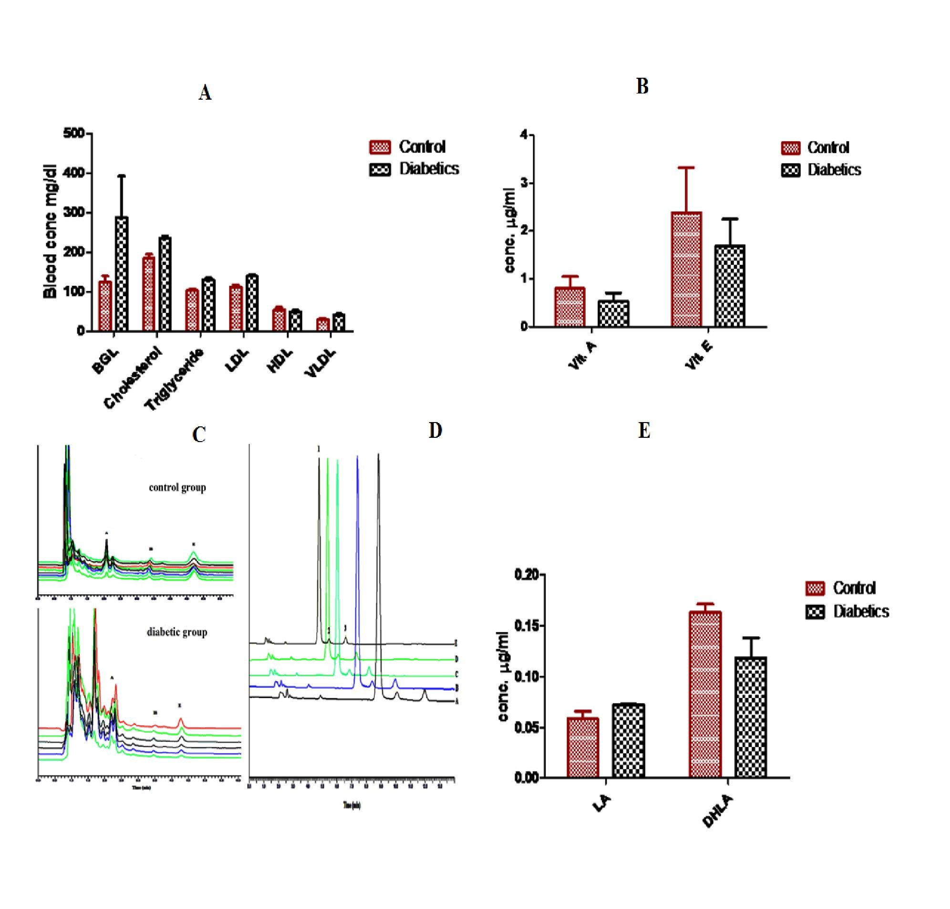

Figure 1. (A) Serum Concentration of Vitamins A and E in Control Group and Diabetic Patients. Peaks; A: Vitamin A; IS: Internal Standard; and E: Vitamin E. (B) Representative chromatograms showing LA, DHLA and IS in blank plasma. Peaks; 1. LA; 2. DHLA; and 3. IS. (C) Plasma level of various biochemical parameters in control group and diabetic patients. (D) Mean serum level of vitamin A and vitamin E in control group and diabetic patients with standard bars showing (SD).(E) Mean plasma level of Lipoic acid (LA) and Dihydro-Lipoic acid (DHLA) in control group and diabetic patients with standard bars showing SD.

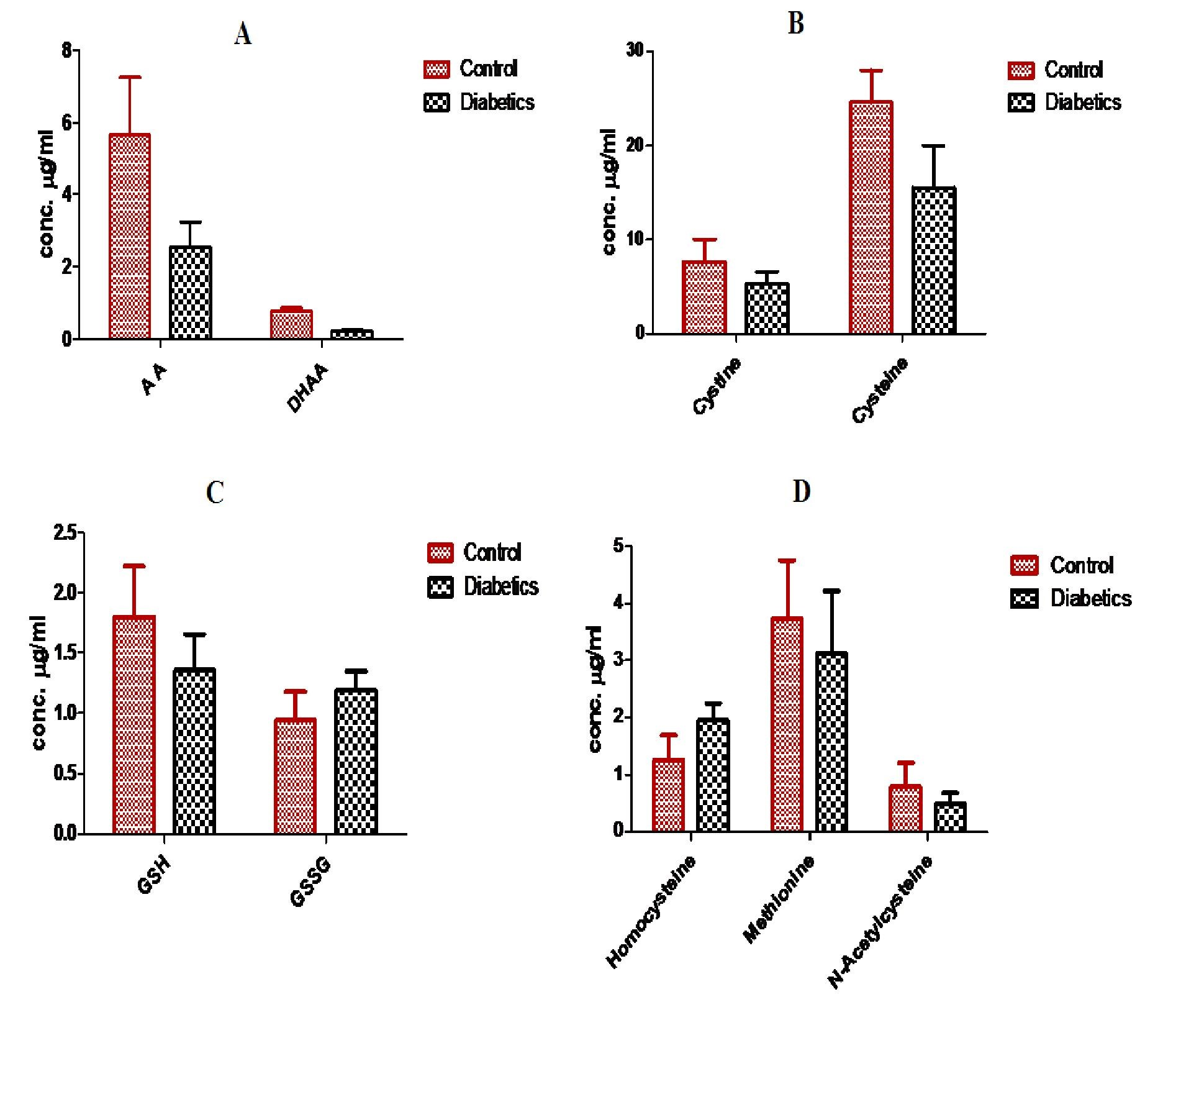

Figure 2. A. Mean plasma level of Ascorbic acid (AA) and Dehydroascorbic acid (DHA) in control group and diabetic patients.B. Mean plasma level of Plasma Cystine (CySS) and Cysteine (Cys) in control group and diabetic patients. C. Mean plasma level of GSH and GSSG in control group and diabetic patients. D. Plasma level (Mean ± SD) of Homocysteine (Hcy), methionine (Met) and N-acetylcysteine (NAC) in control group and diabetic patients.
Note: Standard bars showing SD of mean values.

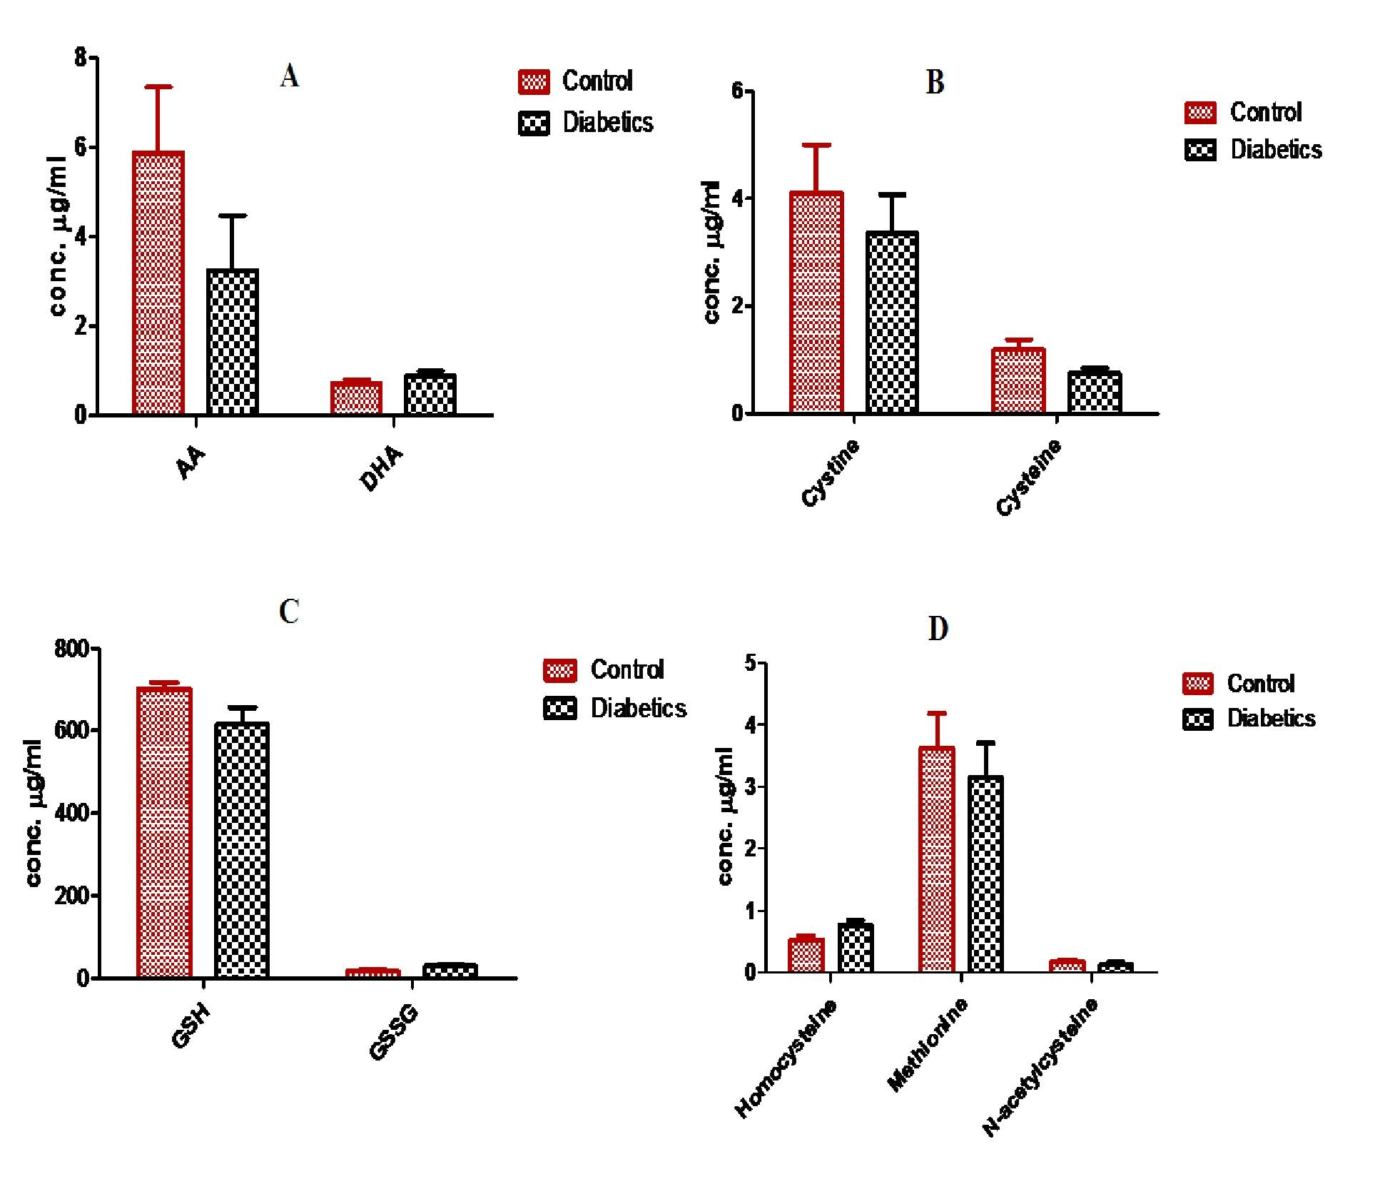

Figure 3. A. Mean RBCs level of Ascorbic acid (AA) and Dehydroascorbic acid (DHA) in control group and diabetic patients.B. Mean RBCs level of cystine (CySS) and cysteine (Cys) in control group and diabetic patients. C. Mean RBCs level of GSH and GSSG in control group and diabetic patients. D. RBCs level of Homocysteine, methionine and N-acetylcysteine in control group and diabetic patients. Note: standard bars showing SD of mean values.

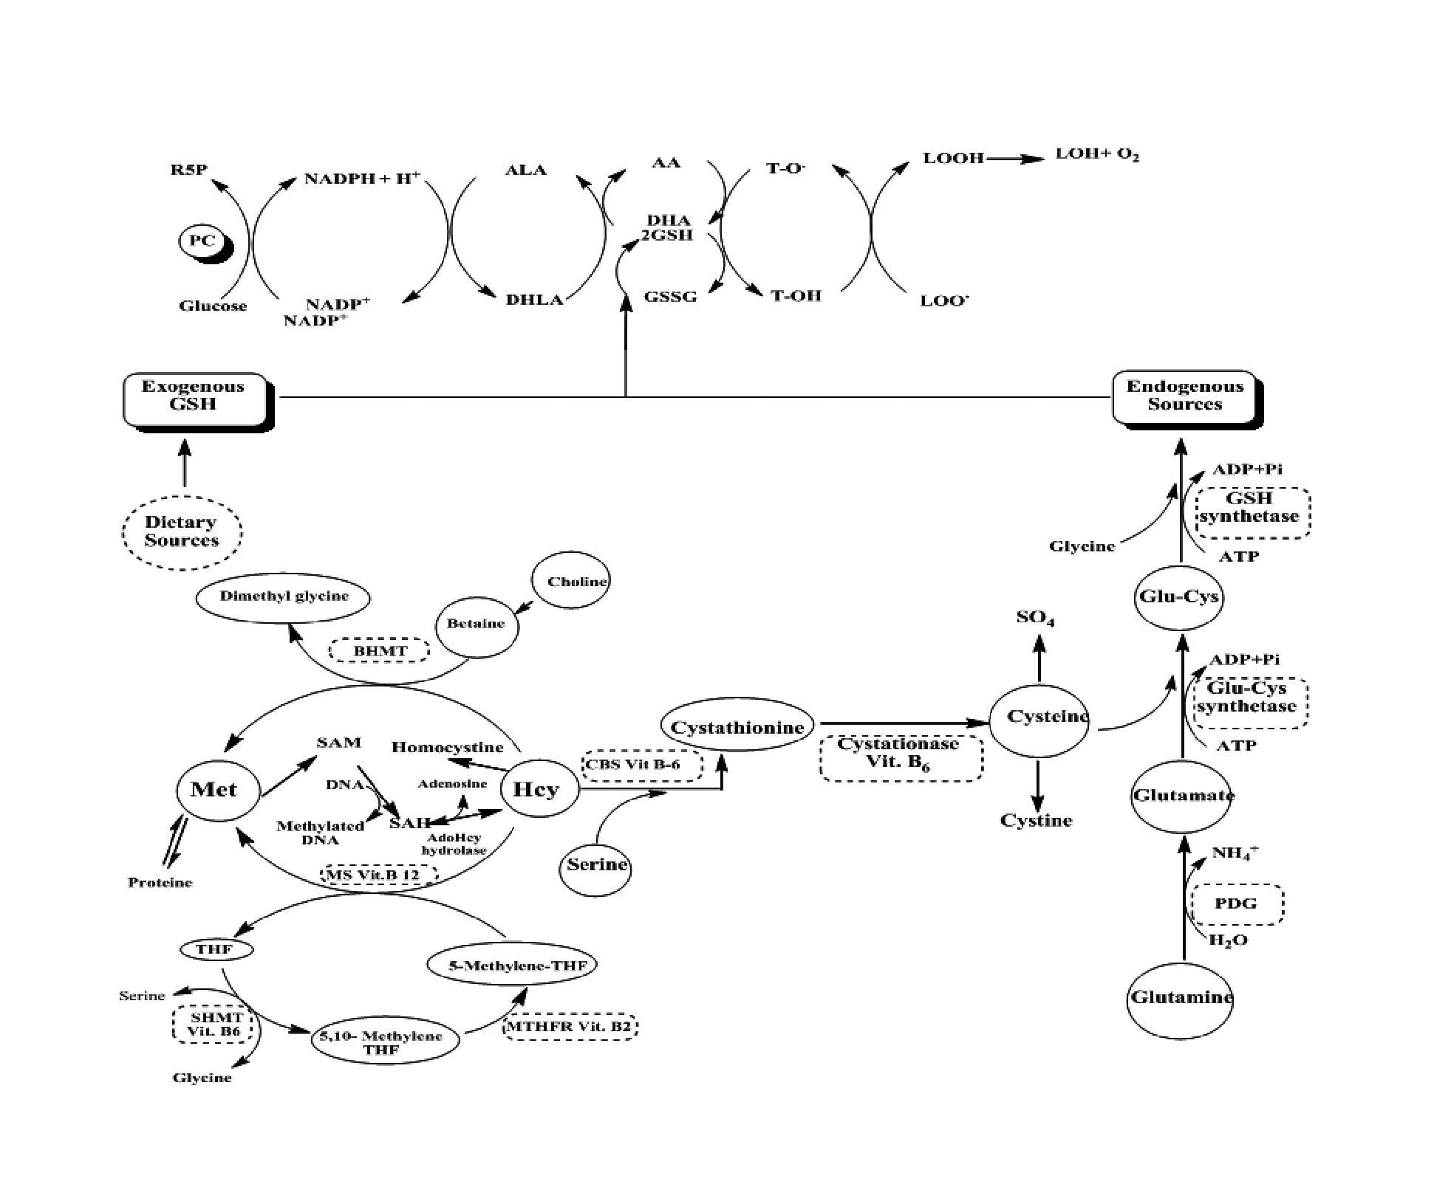

Figure 4. Antioxidants network and their inter-correlation.
THF; Tetrahydrofolate. SAM; S-adenosylmethionine.SAH; S-adenosylhomocysteine. MS; Methionine Synthase. CBC; Cystathionine beta synthase. MTHFR; Methylenetetrahydrofolate reductase. Glut-Cys; glutamylcysteine. Cys-Glu; cysteinylglycine. GSH-P_{X}; Glutathione Peroxidase. GSH-R; Glutathione reductase. GSH-T; Glutathione S-Transferase. LOO•; Lipid peroxyl radical; LOOH; Lipid hydroperoxide.

4. Discussions
From the molar concentration of various antioxidants in plasma (Table 4) as well as in RBCs (Table 4), it is concluded that there is an overall decrease in the molar concentration of reduced form of various antioxidants in diabetic patients with respect to their corresponding molar concentration in control group. Although the corresponding increase in the oxidized form of these antioxidants with respect to their reduced form occurred in patients in comparison with their values in control group, however the total level of these antioxidants is low in comparison with their level in control group.
The data is correlated keeping in view the mutual relationship of these antioxidants within the body and it is concluded that different antioxidants can work together in a network to recycle each other and complete the cycle. Therefore a decrease in the concentration of one antioxidant would result in the corresponding decrease of another antioxidant concentration and since overall decrease in the total concentration of these antioxidant might occur. It may also be concluded that for working of this network each antioxidant will be available at its appropriate concentration otherwise the corresponding antioxidant will be recycled and may present at its prooxidant state that may leads to provoking or initiation of oxidativ0e stress and consequently oxidative stress induced pathological conditions including cardiovascular abnormalities like diabetes mellitus.
The antioxidant network and their mutual correlation is shown in Fig. 4, where it has been explained how different antioxidants work together and recycle each other. NADPH + H⁺ acquired from pentose phosphate pathway fuels the entire antioxidant network. It recycles ALA to its reduced form (DHLA), which recycles AA and GSH from their oxidized forms that in turns recycle α-tocopherol from its α-tocopheryl radical formed by reducing lipid peroxyl radical and thus completing the whole cycle. Cysteine the essential and rate limiting factor of GSH is obtained from homocysteine pathway and any problem in methionine-homocysteine pathway will lead to endogenous GSH deficiency. The Hcy level has been increased with subsequent decrease in Cys values in disease with respect to their level in control group.
Although antioxidants interventions in certain pathologies have been found controversial however in certain conditions the antioxidants therapy may be suggested for the inhibition of initiation and progression of different pathologies caused by oxidative stress. For recommendation of antioxidants intervention in oxidative stress induced pathological conditions further investigations and clinical trials on large scale would be necessary. Since the plasma redox state is maintained by several factors such as dietary antioxidants including vitamins A, E, and C, sulfur amino acids such as Cys, Met, and other micronutrients. Therefore, controlled nutritional studies can specifically utilize extracellular redox measurements to explore mechanistic links between diet, health status, and disease. Thus, advances in understanding extracellular thiol/disulfide redox provide the basis for optimizing definition of nutrient requirements and improving nutritional intervention on an individualized basis.

5. Concluding Remarks And Future Perspective
The present work was carried out to find the possible potential role of oxidative stress in cardiovascular diseases particularly in diabetes mellitus. Antioxidants profile was evaluated in control, and diabetic groups to assess the involvement of oxidative stress in the initiation and progression of diabetes mellitus. The vital antioxidants of human antioxidant defense system such as vitamins A, C, E, and thiols like ALA, Cys, and GSH were quantified in plasma and RBCs of control group and newly diagnosed patients having diabetes mellitus and who have not taken any medication or therapy previously. Our laboratory findings show that the antioxidant profile of patients was decreased with respect to that of control group which might prove the potential role of oxidative stress in the pathogenesis of diabetes mellitus. The low antioxidant profile and higher biomarker index of patients with respect to normal group further confirm the hypothesis that oxidative stress might be the possible cause of these diseases or it may play a crucial role in the initiation and progression of these diseases. Since large variations were found in the individual antioxidant profile of control group as well as patients the other multifactorial causes such as gender, age, sex differentials, demographic variations, dietary changes, and life-style may not be overruled. In the perspective of this work where there were several limitations regarding to dietary data, individual genotyping, and small number of participating volunteers, it is not the ultimate landmark. However, new ideas will be put forward in the light of these findings and a mechanistic approach will be adopted to evaluate further possible role of oxidative stress in these pathologies.

Acknowledgments
We are thankful to Higher Education Commission (HEC) of Pakistan for funding this project.

Declaration of Interest
The authors report no declarations of interest. The authors alone are responsible for the content and writing of this article.

Corresponding Author
Dr. Abad Khan
Cell #: +923339356448
E-mail address: drabadkhan@uoswabi.edu.pk
Fax No.0938-490238

References
- Semeraro A, Altieri I, Patriarca M, Menditto A. Evaluation of uncertainty of measurement from method validation data: An application to the simultaneous determination of retinol and [alpha]tocopherol in human serum by HPLC. J Chrom B 2009;877(11-12):1209-1215.
- Valko M, Leibfritz D, Moncol J, Cronin M, Mazur M, Telser J. Free radicals and antioxidants in normal physiological functions and human disease. Int J Bioch and Cell Biol 2007;39(1):4484.
- Niederländer HAG, van Beek TA, Bartasiute A, Koleva II. Antioxidant activity assays on-line with liquid chromatography. J Chromatogr A 2008;1210(2):121-134.
- Somogyi A, Rosta K, Pusztai P, Tulassay Z, Nagy G. Antioxidant measurements. Physiological measurement 2007;28:R41.
- Johansen JS, Harris AK, Rychly DJ, Ergul A. Oxidative stress and the use of antioxidants in diabetes: linking basic science to clinical practice. Cardiovas Diabetol 2005;4(1):5.
- Evans JL, Goldfine ID, Maddux BA, Grodsky
GM. Are Oxidative Stress- Activated Signaling Pathways Mediators of Insulin Resistance and Cell Dysfunction? Diabetes 2003;52(1):1.
- Budnikov GK, Ziyatdinova GK. Antioxitants As analytes in Analytical Chemistry. Journal of analytical chemistry 2005; 60(7):600-613.
- Yuan JM, Gao YT, Ong CN, Ross RK, Yu MC.
Prediagnostic level of serum retinol in relation to reduced risk of hepatocellular carcinoma. J Natl Cancer Inst 2006;98(7):482-90.
- Azzi A, Gysin R, Kempná P, et al. The role of [alpha]-tocopherol in preventing disease: from epidemiology to molecular events. Molecular Aspects of Medicine 2003;24(6):325-36.
- Ahmad M, Khan MA, Khan AS. Oxidative stress and level of iron indices in coronary heart disease patients. J Ayub Med Coll Abbottabad 2009;21(2).
- Ichinose K, Kawasaki E, Eguchi K. Recent advancement of understanding pathogenesis of type 1 diabetes and potential relevance to diabetic nephropathy. American Journal of Nephrology 2000;27(6):554-64.
- Choi SW, Benzie IF, Ma SW, Strain JJ, Hannigan BM. Acute hyperglycemia and oxidative stress: direct cause and effect? Free Radic Biol Med 2008;44(7):1217-31.
- Pennathur S, Heinecke JW. Mechanisms for oxidative stress in diabetic cardiovascular disease. Antioxid Redox Signal 2007;9(7):955-69.
- Touyz R. Reactive oxygen species, vascular oxidative stress, and redox signaling in hypertension: what is the clinical significance? Hypertension 2004;44(3):248-252.
- Madamanchi NR, Vendrov A, Runge MS. Oxidative stress and vascular disease. Arterioscler Thromb VascBiol 2005;25:29-38.
- Laight D, Carrier M, Änggård E. Antioxidants, diabetes and endothelial dysfunction. Cardiovascular research 2000;47(3):457.
- Banerjee A. Blood dehydroascorbic acid and diabetes mellitus in human beings. Annals of clinical biochemistry 1982;19(Pt 2):65.
- Merzouk S, Hichami A, Madani S, et al. Antioxidant status and levels of different vitamins determined by high performance liquid chromatography in diabetic subjects with multiple complications. General physiology and biophysics 2003;22(1):15-28.
- Stankova L, Riddle M, Larned J, et al. Plasma ascorbate concentrations and blood cell dehydroascorbate transport in patients with diabetes mellitus* 1. Metabolism 1984;33(4):34753.
- Will JC, Byers T. Does diabetes mellitus increase the requirement for vitamin C? Nutrition reviews 1996;54(7):193-202.
- Kohen R, Nyska A. Oxidation of biological systems: oxidative stress phenomena, antioxidants, redox reactions, and methods for their quantification. Toxicol Pathol 2002;30(6):620-50.
- Prior RL, Cao G. In vivo total antioxidant capacity: comparison of different analytical methods1. Free Radical Biology and Medicine 1999;27(11-12):1173-1181.
- Bahorun T, Soobrattee M, Luximon-Ramma V, Aruoma O. Free radicals and antioxidants in cardiovascular health and disease.Internet Journal of Medical Update 2006;1(2):24-40.
- Khan A, Khan MI, Iqbal Z, Shah Y, Ahmad L, Watson DG. An optimized and validated RPHPLC/UV detection method for simultaneous determination of All-trans-retinol (Vitamin A) and [alpha]-tocopherol (Vitamin E) in human serum: Comparison of different particulate reversed-phase HPLC columns. J Chromatogr B 2010.
- Khan A, Iqbal Z, Watson DG, et al. Simultaneous Determination of Lipoic Acid (LA) and Dihydrolipoic Acid (DHLA) in human plasma using high-performance liquid chromatography coupled with electrochemical detection. J Chromatogr B 2011.
- Khan A, Khan MI, Iqbal Z, et al. A new HPLC method for the simultaneous determination of ascorbic acid and aminothiols in human plasma and erythrocytes using electrochemical detection. Talanta 2011.
- Thibeault D, Su H, MacNamara E, Schipper HM. Isocratic rapid liquid chromatographic method for simultaneous determination of carotenoids, retinol, and tocopherols in human serum. J Chromatogr B 2009;877(11-12):1077-83.
- Singh U, Jialal I. Alpha lipoic acid supplementation and diabetes. Nutrition reviews 2008;66(11):646-657.
- Teichert J, Preiss R. HPLC-methods for determination of lipoic acid and its reduced form in human plasma. International journal of clinical pharmacology, therapy, and toxicology 1992;30(11):511.
- Ross SM. Clinical applications of lipoic acid in type II diabetes mellitus. Holistic Nursing Practice 2006;20(6):305.
- Melnyk S, Pogribna M, Pogribny I, Hine R, James S. A new HPLC method for the simultaneous determination of oxidized and reduced plasma aminothiols using coulometric electrochemical detection. J Nutritional Biochem1999;10(8):490-497.
- McMenamin ME, Himmelfarb J, Nolin TD. Simultaneous analysis of multiple aminothiols in human plasma by high performance liquid chromatography with fluorescence detection. J Chromatogr B 2009;877(28):3274-3281.
- Mendiratta S, Qu Z, May JM. Erythrocyte ascorbate recycling: antioxidant effects in blood. Free Radic Biol Med 1998;24(5):789-97.
- Klemm A, Voigt C, Friedrich M, et al. Determination of erythrocyte antioxidant capacity in haemodialysis patients using electron paramagnetic resonance. Nephrology Dialysis Transplantation 2001;16(11):2166.
- Michaelsen JT, Dehnert S, Giustarini D, Beckmann B, Tsikas D. HPLC analysis of human erythrocytic glutathione forms using OPA and N-acetyl-cysteine ethyl ester: Evidence for nitriteinduced GSH oxidation to GSSG. J Chromatogr B 2009;877(28):3405-17.
- Cereser C, Guichard J, Drai J, et al. Quantitation of reduced and total glutathione at the femtomole level by high-performance liquid chromatography with fluorescence detection: application to red blood cells and cultured fibroblasts. Free Radic Biol Med 2001;752(1):123-32.
- Unt E, Kairane C, Vaher I, Zilmer M. Red blood cell and whole blood glutathione redox status in endurance-trained men following a ski marathon. J Biol Chem 2008;7:344-349.
- Giustarini D, Milzani A, Dalle-Donne I, Rossi R. Red blood cells as a physiological source of glutathione for extracellular fluids. Blood Cells, Molecules, and Diseases 2008;40(2):174-179.
- Mercier S, Breuillé D, Buffière C, et al. Methionine kinetics are altered in the elderly both in the basal state and after vaccination. The American journal of clinical nutrition. 2006;83(2):291.
- Johnson CA, Bergeim O. The distribution of free amino acids between erythrocytes and plasma in man. J Biol Chem 1951;188(2):833.

5/25/2016

