**Validation of modified HPLC method for determination of oxytetracycline, tetracycline and doxycycline in chicken meat and liver**

S.A. Shama1, Abd el azim S. El Sharkawy1, A.H. Mahmoud2, Heba M. Hassan 3, Shaimaa H. Nassar 3.

1Chemistry Department, Faculty of Science, Banha University

2Animal Health Research Institute, Dokki, Egypt

3National Laboratory for Veterinary Quality Control on Poultry Production, Dokki, P.O. Box 246, Giza 12618, Egypt

[shimaa.nassar.chemist@gmail.com](mailto:shimaa.nassar.chemist@gmail.com)

**Abstract:** A high performance liquid chromatography method utilizing ultraviolet detection (HPLC-UV) was developed and validated to determine tetracyclines residues in chicken meat and liver samples. The separation of three tetracyclines residues; oxytetracycline, tetracycline and doxycycline was carried out on a reverse–phase C8 column with a gradient elution. A mobile phase system consisted of a mixture of methanol, acetonitrile and 0.03M oxalic acid. UV detector set 351nm with 25 minute analysis time. The extraction with citrate buffer pH 4 was performed and followed by SPE cartridge clean up step. Calibration curves for oxytetracycline, tetracycline and doxycycline showed good linear ties (r2 > 0.990) at concentrations ranged from 50 to 1000 ng/mL. The limits of detection (LODs) and quantifications (LOQs) for oxytetracycline, tetracycline and doxycycline were found to be 16.66, 8.33, 16.66 μg/kg and 50, 25, 50 μg/kg respectively. The recoveries of oxytetracycline, tetracycline and doxycycline, at 100 and 200 μg/kg spiked samples were higher than 80% for all compounds. The analytical method was successfully applied to chicken meat and liver samples.

[S. A. Shama, Abd el azim S. El Sharkawy, A.H. Mahmoud,HebaM. Hassan, Shaimaa H. Nassar. **Validation of modified HPLC method for determination of oxytetracycline, tetracycline and doxycycline in chicken meat and liver.** *N Y Sci J* 2016;9(5):68-74]. ISSN 1554-0200 (print); ISSN 2375-723X (online). <http://www.sciencepub.net/newyork>. 11. doi:[10.7537/marsnys09051611](http://www.dx.doi.org/10.7537/marsnys09051611).

**Keywords:** Residues, tetracyclines, chicken, HPLC, UV

**1. Introduction**

Tetracyclines are broad-spectrum antibiotics used routinely in veterinary medicine for the treatment and prevention of some infectious animal diseases. Tetracyclines have been used worldwide for prevention and control of bacterial poultry diseases.

The occurrence of antibiotic residues in human food arising from its veterinary abuse which causes toxic or allergic reactions.

To prevent consumers from suffering with the possible health problems, the authorities have regulated the use of veterinary drugs by setting the maximum residue limits (MRLs) or by prohibiting the use of many substances. According to the US Food and Drug Administration (FDA), the European Union (EU) have established MRLs for TCs in food of animal origin at 200μg/kg for muscle and 600μg/kg for liver.

This study focuses on this group of antibiotics in developing method that can be utilized to investigate their residues in poultry tissues matrix. Multiresidue methods which will simultaneously determine more than one class of veterinary drugs in any matrix are still limited and are largely confined to liquid chromatography–mass spectrometry (LC–MS) methods [1], [2]. LC–MS methods are capable of identifying individual antibiotics within a class but involve relatively expensive and complex instrumentation which may not always be available for routine monitoring.LC–MS methods can be valuable when confirmation is required but are not always necessary for quantitation. LC with ultraviolet detection (UVD) has been reported for quantification of oxytetracycline, tetracycline and doxycycline as separated antibiotics or mixed. UV-detectors were the most commonly used because they are more readily available and convenient to use in many labs so in this study wide range of wave lengths were tested to monitor the separated and mixed TCS. The wave length 351 nm was selected as optimum detection wave length for TCS determination and used in this study.

A challenge is presented in the simultaneous extraction and analysis of more than one antibiotic in the same method. The aim of this study is to develop a method for determination of selected antibiotic residues of tetracyclines (oxytetracycline, tetracycline and doxycycline) in high poultry tissues matrix. The method involves sample clean up with solid phase Extraction (SPE) and analytical determination with high performance liquid chromatography (HPLC) coupled with ultraviolet detector (UV).

**2. Experimental**

**2.1. Materials**

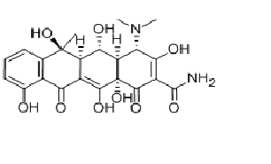

Fig.1: Chemical structure of oxytetracycline.

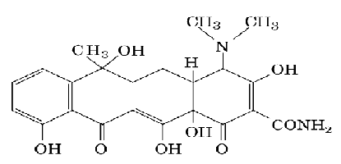

Fig.2: Chemical structure of tetracycline.

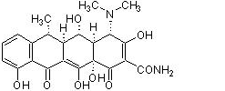

Fig.3: Chemical structure of Doxycycline.

Standards of oxytetracycline, tetracycline and doxycycline were supplied by SIGMA-ALDRICH.

Methanol and acetonitrile were of HPLC-grade. Trichloroacetic acid,citric acid monohydrate, sodium citrate trihydrate and Oxalic acid were of analytical grade. Water was purified before use in a Milli-Q system (Millipore, Bedford, MA, USA).

Solid phase extraction (SPE) of Strata C18-E cartridge (500 mg, 6 ml; phenemonex, Milford, MA, USA) was used for clean up the extracts.

Acrodiscs:(syringe filters): Millex HV13 filters (0.45 μm 13 mm id) (Millipore, USA).

**2.2. Apparatus**

Agilent Series 1200 quaternary gradient pump, Series 1200 auto sampler, Series 1200 UV Vis detector, and HPLC 2D Chemstation software.

The chromatographic column was a reversed-phase column C8 (Zorbax column, 4.6 mm i.d., 250 mm, 5 µm, Agilent Co.).

Cooling centrifuge capable of operating at 4°C, pH Meter, ultrasonic bath (Buhler, Germany), SPE vacuum manifold and homogenizer (Mechanika Precyzyjna) were used for sample preparation.

**2.3. Standard solutions**

Stock standard solution of each TC compound was prepared by dissolving 10 mg of the compound in 10 ml of methanol to obtain a final concentration of 1 mg ml-1. Stock standard solutions were put in amber glass to prevent the photo-degradation and stored at 20 ᵒC and were stable for at least 4 weeks. Stock solutions were diluted with methanol to give a series of working standard solutions (25, 50, 100, 250, 500, 1000ng) that were prepared weekly [3].

**2.4. Fortification of samples**

The negative chicken samples were spiked with TCs standard mixture at two levels of 100ng and 200ng of each compound per gram meat, while 300ng and 600ng of each compound per gram liver were used. Fortified samples were allowed to stand at4 ᵒC for at least half-hour before analysis [3].

2.5. Preparation of samples and extraction procedure) [4], [5].

* Weigh 5 g sample, blended in a high speed tissue blender.
* Add 3mL of citrate buffer.
* The mixture was vortexed at high speed for 5 minute.
* Incubated for 5 min at room temperature.
* Centrifuged at 3,500 rpm for10 min in a cooling centrifuge.

The extraction was repeated by adding 2mL of citrate buffer.

**2.6. Clean up technique**

The supernatant was filtered and loaded on SPE cartridge, previously conditioned with 3mL of methanol and 2mL of water. The cartridge containing the sample was washed with 5 ml of water, and then tetracyclines were eluted [6] then 1mL of eluent was filtered through 0.45μm nylon filter; 100μL of the aliquot was injected into the HPLC system.

**2.7. Chromatographic separation**

The gradient elution by using mixture of methanol (A), acetonitrile (B) and 0.03M oxalic acid (C) was applied [3].

The chromatographic column: was a reversed-phase column (Extend-C8, Zorbax column, 4.6 mm, 250 mm, 5 µm), adjusted at 35ᵒC.

Flow Rate: 1mL/min.

Injection volume: 100µL.

**2.8. Detection and quantitation**

Detection and Quantification: using UV detector at 351nm, quantification was integrated by HPLC 2D Chemstation software interfaced to a personal computer.

**3. Results and discussion**

**3.1. Optimization of chromatographic conditions:**

**3.1.1. Selection of optimum detection wavelength:**

In multi-residue analysis of tetracyclines (Oxytetracycline, Tetracycline and Doxycycline) in tissue samples, HPLC with (DAD) detector is getting popularity, as a wide UV spectrum (scanning range) but UV-detectors were the most commonly used because they are more readily available and convenient to use in many labs so in this study wide range of wave lengths were tested to monitor the separated and mixed TCS. The wave length 351 nm was selected as optimum detection wave length for TCS determination and used in this study.

In this study an RP-C8 column was employed at 35°C temperature due to its ability to separate each component of TCS [7] and give satisfactory chromatograms but at using C18 the separation of the mixed TCs and peak shapes were not good. The results of response factor at 351nm were 85.65, 98.46 and 69.25 for OTC, TC and DC respectively.

**3.1.2. Selection of suitable mobile phase**

Both isocratic mobile phases (methanol/acetonitrile/0.03M oxalic acid (20:20:60 v/v/v) and gradient mobile phases elution were evaluated for their efficiency to separate TCs. the obtained data revealed that isocratic elution was not possible since the TCs presented very different retention behavior [7] so, a gradient program was necessary to obtain satisfactory chromatogram[3]. The use of gradient elution starting with a high percentage of oxalate buffer provide got chromatographic peak resolution due to the tendency oxalate to block the residual silanols group on the stationary phase [4]. From another side, it was reported that when the methanol concentration increased in the mobile phase the elution time become short [8]. However, the gradient mobile phase still required more time but had the advantage that spacing of the early and the late eluting peaks was more uniform as well as the late eluting peaks were as sharp as those eluting earlier. So, the gradient mobile phase was chosen to use throughout this study.

**3.1.3. Sample Extraction Optimization:**

Sample extraction was performed using widely acceptable citrate buffer. The effect of pH of the sample matrix on the extraction efficacy of tetracyclines was evaluated using different buffer solutions with pH 2.5-4.5.A high extraction efficacy for all three tetracyclines was obtained at pH values of 3.5 and 4.0, and an obvious decrease was found when pH was away from this limits. The pKa values of oxytetracycline, tetracycline and doxycycline are in the range of 2.7-3.5, in this study the pH of extraction solution was determined at 3.8 in order to be devoid of these unusual effects. The ion-exchange interactions of protonated drugs increase in acidic environment thereby an increase in the extraction efficacy.

**3.1.4. Clean up optimization:**

Solid phase extraction technique using strata C18-E cartridge was tested for its ability to isolate TCs from different matrixes, Blank samples (5 g) were spiked with TCs at two levels, i.e. 100ng and 200ng for chicken meat; 300 and 600 ng for liver samples. The spiked extracts were cleaned up and the rates of recoveries were determined. In this study was observed that methanol followed by water wash was more efficient in removing interfering substances.

(Table 1)

|  |  |  |  |
| --- | --- | --- | --- |
| TC | Added  (ng) | Founded  (ng) | Recovery  (%) |
|  | Chicken Meat | |  |
| Oxytetracycline | 100 | 92 | 92 |
|  | 200 | 185 | 92.5 |
| Tetracycline | 100 | 93.2 | 93.2 |
|  | 200 | 188 | 93.5 |
| Doxycycline | 100 | 85 | 85 |
|  | 200 | 171 | 85.5 |
|  | Chicken Liver | |  |
| Oxytetracycline | 300 | 245 | 81.6 |
|  | 600 | 502 | 83.6 |
| Tetracycline | 300 | 260 | 86.6 |
|  | 600 | 482 | 80.3 |
| Doxycycline | 300 | 243.66 | 81.22 |
|  | 600 | 480 | 82.5 |

**3.2. The suggested method**

From this discussion, it could be suggested an HPLC method with UV detector set at 351 nm for determining three tetracyclines (oxetetracycline, tetracycline and doxycycline) residues in chicken meat and liver. The suggested method involves extraction of the tissues with citrate buffer, followed by clean up on solid phase extraction. The separation is achieved on Agilent C8 analytical column (25 cm _ 4.6 mm I.D., 5 lm) by a multistep gradient elution operated at flow rate 1 ml min_1. So, validation of the suggested method was stated.

**3.3. Method validation**

**3.3.1. System Precision:**

Precision is the closeness of agreement among a set of results. Chicken meat samples were spiked at 100ng/g and 200ng/g and chicken liver at 300ng/g and 600ng/g, in 18 replicates for each spiked sample. Acceptance criteria: Relative standard deviation (RSD) ≤ 1% according to International Conference on Harmonisation [9].

**3.3.2. Linearity and range:**

Linearity is performed by preparing (50.100.50.500.1000ng) different concentrations of drug standard. Linearity is defined by the squared correlation coefficient, where the calculated coefficient (r2) ranged from 0.9901 to 0.9968 for each tetracycline had own linear equation.

**3.3.3. Selectivity and specificity:**

Verification of selectivity is conducted by evaluating the spiked standard response following extraction from different chicken tissues. Acceptance criteria: there is no interference between the pure standard and peaks of any impurities or extracted solvents according to International Conference on Harmonisation [9].

**3.3.4. Accuracy and recovery:**

In this case trueness is the closeness of the mean of a set of measurement results to the actual (true) value and Accuracy was determined over the range of 50%, 100% and 200% of the sample concentration. Calculated amount of each of tetracyclines which added in spiked sample to attain 50%, 100% and 200% of sample concentration. Each spiked sample was prepared in triplicate at each level and injected. The chromatograms were recorded and from the peak area of drug, % recovery was calculated from regression equation as shown in (Table 1).The tissue samples of chicken are spiked by adding known quantities of TCs. Those samples are analyzed against standard solutions of same concentrations. The accuracy is then calculated from the test results as a percentage recovery.

**3.3.5. Limit of detection (LOD):**

It is considered to be the quantity yielding a detector response which gives signal to noise ratio 3:1 according to International Conference on Harmonisation [9].

It could be observed that LOD of the suggested method 16.66, 8.33, 16.66ng for oxytetracycline, tetracycline and doxycycline.

**4.1.5.6. Limit of quantification (LOQ):**

It is the lowest amount that can be analyzed within acceptable precision and accuracy which gives signal to noise ratio 10:1 according to International Conference on Harmonisation [9]. It could be observed that LOQ of the suggested method was 50, 25 and 50ng for oxytetracycline, tetracycline and doxycycline**.**

**4. Method application:**

A total of 75 local chicken samples were analyzed for tetracyclines residues 25for oxytetracycline, 25 for tetracycline and 25 for doxycycline. The samples consist of 15 meat samples and 10 liver samples for each antibiotic.

The results revealed that the incidence of antibiotic residues could be detected in local chicken meat and liver samples as follow 8(32%), 5(20%) for tetracycline, 6(28%), 3(12%) for oxytetracycline and 6(24%), 5(20%) for doxycycline.

Tetracycline in positive samples was detected and quantified The results revealed that 8 out of 15(53.33%) muscle samples contains tetracycline residues which ranged from 0.01880 to 1.08746μg/gm with mean 0.32325μg/gm.

And also about 5 out of 10(50%) liver samples contains tetracycline residues which ranged from 0.07329 to2.12895μg/gm with mean 1.03523μg/gm and found that 6out of 25 samples contain tetracycline residues above the maximum residue limits (MRLs) while 7 samples within (MRLs). The maximum residue limits (MRLs) for tetracycline residues as follow: 0.2 and 0.6μg/g for muscles, liver, respectively according to the international standard limits that reported by FAO and/Codex Alimentrus , FAO and EU[10,11].

**Table (2): precision and accuracy of the suggested method for tetracyclines in chicken samples :( n=18)**

|  |  |  |  |  |
| --- | --- | --- | --- | --- |
| Drug | Parameter | Validation samples levels(ng/ml) | | |
| 50% | 100% | 150% |
| 100 | 200 | 300 |
| Oxytetracycline | Average(ng/ml) | 92 | 185 | 245 |
|  | SD(ng/ml) | 2.5 | 3.2 | 4.5 |
|  | Precision(RSD%) | 2.72 | 1.73 | 1.84 |
|  | Accuracy(%) | 92 | 92.5 | 81.66 |
| Tetracycline | Average(ng/ml) | 93.2 | 188 | 260 |
|  | SD(ng/ml) | 1.5 | 3.2 | 3.5 |
|  | Precision(RSD%) | 1.61 | 1.7 | 1.35 |
|  | Accuracy(%) | 93.2 | 94 | 86.66 |
| Doxycycline | Average(ng/ml) | 85 | 171 | 233 |
|  | SD(ng/ml) | 4.9 | 3.8 | 6.8 |
|  | Precision(RSD%) | 5.7 | 2.22 | 2.9 |
|  | Accuracy(%) | 85 | 85.5 | 77.66 |

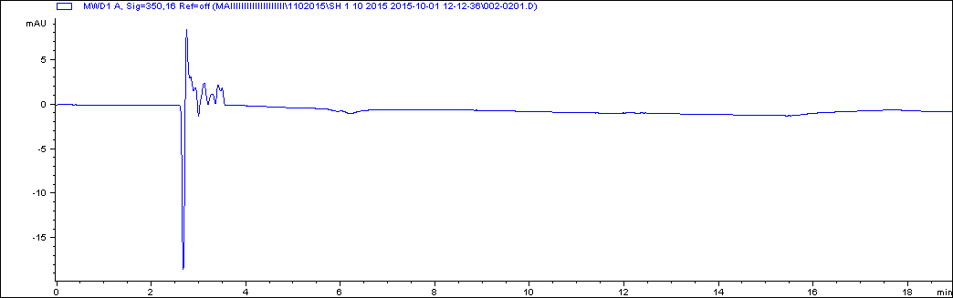

Fig.4: Chromatogram of blank chicken meat sample.

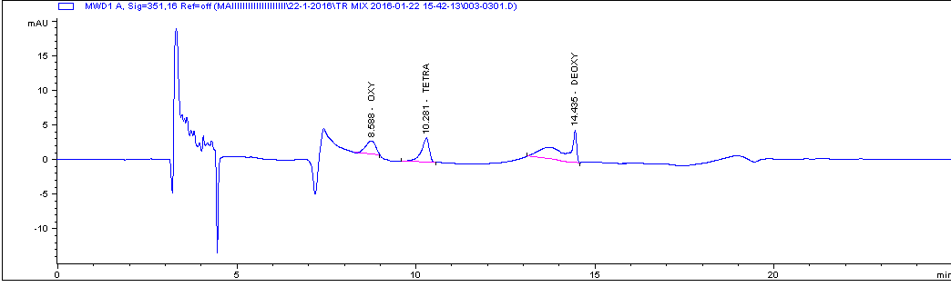

Fig.5: Chromatogram of spiked chicken muscle sample with 200ng g-1 of tetracycline mixed standards.

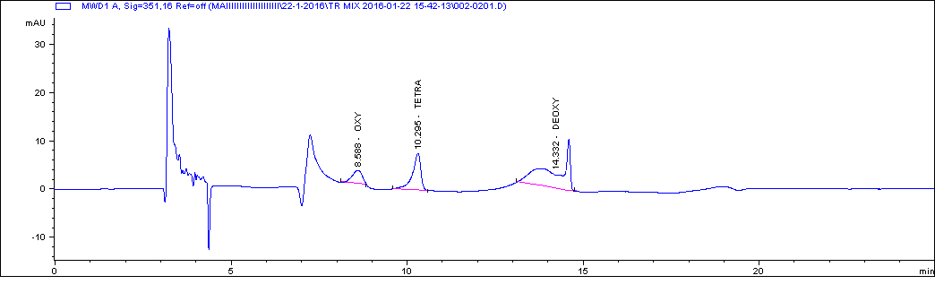

Fig.5: Chromatogram of spiked chicken liver sample with 600ng g-1 of tetracycline mixed standards.

Oxytetracycline in positive samples was detected and quantified The results revealed that 7 out of 15(46.66%) muscle samples contains oxytetracycline residues which ranged from 0.07134 to 0.24415 μg/gm with mean 0.14030μg/gm.

And also about 4 out of 10(40%) liver samples contains oxytetracyclin residues which ranged from 0.24135 to 1.0304μg/gm with mean 0.5326μg/gm and found that 5out of 25 samples contain oxytetracycline residues above the maximum residue limits (MRLs) while 6 samples within (MRLs). The maximum residue limits (MRLs) for oxytetracycline residues as follow: 0.2 and 0.6μg/g for muscles, liver, respectively.

Doxycycline in positive samples was detected and quantified The results revealed that 6 out of 15(40%) muscle samples contains doxycycline residues which ranged from 0.07654 to 0.65385μg/gm with mean0.336941μg/gm.

And also about 4 out of 10(40%) liver samples contains doxycycline residues which ranged from 0.21504 to 0.94514μg/gm with mean 0.52814μg/gm and found that 5out of 25 samples contain doxycycline residues above the maximum residue limits (MRLs) while 5 samples within (MRLs).

Nearly similar result obtained by Alaa El-din who recorded 55.55% in muscles samples and 55.55% in liver samples contained oxytetracycline residues[12], while Abd El-Monem declared that muscles and liver contain 40% and 60% respectively oxytetracycline residues[13]. A higher result obtained by Iqbal who showed that the incidence of oxytertacycline was 100% in samples [14]. And also, lower results detected by De Wasch [15], which detect residues of tetracycline antibiotics in pork and chicken meat.

**5. Conclusions**

The aim of this work was to develop and validate a specific, Rapid and simple multiresidue method for determining oxytetracycline, tetracycline and doxycycline in chicken meat sample by using HPLC–UV detector and C8 column and using it for determination of tetracycline residues in local chicken meat and liver samples saving time as it one method used for detection of more than one antibiotic, saving chemicals and reagents and decrease the run time.

**References:**

1. L. Hui, K.J. Philip, B. Sherri, et al., Analysis of veterinary drug residues in shrimp (2006): a multi-class method by liquid chromatography– quadrupole ion trap mass spectrometry, J. Chromatogr. B 836 22–38.
2. R. Romero-Gonza´ lez, J.C.Lo´ pez-Martı´nez, E. Go´mez-Mila´ n, et al. (2007): Simultaneous determination of selected veterinary antibiotics in gilthead seabream (SparusAurata) by liquid chromatography–mass spectrometry, J. Chromatogr. B857142–148.
3. A.R. Shalaby, Nadia A. Salama, S.H. Abou-Raya, Wafaa H. Emama, F.M. Mehaya (2011) :Validation of HPLC method for determination of tetracycline residues inchicken meat and liver, Food Chemistry 124 1660–1666.
4. Samanidou, V. F., Nikolaidou, K. I., & Papadoyannis, I. N. (2005): Development and validation of an HPLC confirmatory method for the determination of tetracycline antibiotics residues in bovine muscle according to the European Union regulation 2002/657/EC. Journal of Separation Science, 28,2247–2258.
5. Schneider, M. J., Braden, S. E., Reyes-Herrera, I., & Donoghue, D. J. (2007): Simultaneous determination of fluoroquinolones and tetracyclines in chicken muscle using HPLC with fluorescence detection. Journal of Chromatography B, 846, 8–13.
6. Cheng, Y. F., Phillips, D. J., & Neue, U. (1997): Simple and rugged SPE method for the determination of tetracycline antibiotics in serum by HPLC using a volatile mobile phase. Chromatographia, 44, 187–190.
7. Vinas, P., Balsalobre, N., Lopez-Erroz, C., & Hernandez-Cordoba, M. (2004): Liquid chromatography with ultraviolet absorbance detection for the analysis of tetracycline residues in honey. Journal of Chromatography A, 102, 125–129.
8. Lu, H., Jiang, Y., Li, H., Chen, F., & Wong, M. (2004): Simultaneous determination of oxytetracycline, doxycycline, tetracycline and chlortetracycline in tetracycline antibiotics by high-performance liquid chromatography with fluorescence detection. Chromatographia, 60, 259–264.
9. ICH: International Conference of Harmonisation of Technical Requirements for Registration of Pharmaceutical for Human Use.
10. FAO/WHO (1999): Evaluation of certain veterinary drug residues in food. Thirty sixth report of the joint FAO/WHO Expert Committee on food additives. WHO Technical Report Series, 799.
11. Maximum Residue Limits (MRLs) and risk management recommendations (RMRs) for residues of veterinary drugs in foods CAC/MRL 2-2015 updated as at the 38 th Session of the Codex Alimentarius Commission (July 2015).
12. Alaa El-din M.A. Morshdy; Adel I. El-Atabany and Mohammed Awaad Rezk (2015): Studies on Antibiotic Residues in Imported and Locally Frozen Chicken Meat, 2nd Conference of Food Safety, Suez Canal University, Faculty of Veterinary Medicine Volume I August Page 168-177.
13. Abd El. Monem K. M., Soliman M. R. and Saad S. M. (2002): Oxytetracycline residues in Broiler carcasses produced by closed and open system. Journal of Egyptian Veterinary Medical Association, 62 (6a): 119-124.
14. Iqbal Z. (2000): Determination of tetracycline residues in poultry meat and eggs using HPLC. M.Sc. Thesis, University Agriculture Faisalabad, Pakistan.
15. Katia De Wasch, Lieve Okerman, Siska Croubels, Hubert De Brabander, Jan Van Hoofa and Patrick De Backerb Analyst (1998): Detection of residues of tetracycline antibiotics in pork and chicken meat: correlation between results of screening and confirmatory tests, 123, 2737–2741.

5/23/2016