The Effect of Marketing Mix On Customer Satisfaction An Empirical Study at Saudi Telecom Company (S.T.C)

Dr. Amir AbouElnaga1and Mr. Zyad Omar AL-Nasser2

¹Assistant Professor -Director of Postgraduate studies, College of Business Administration, Dar Al Uloom University, Riyadh, Kingdom of Saudi Arabia.
²MBA, General Manager, MASAR TECH.& Brand Manager ELM, Riyadh, Kingdom of Saudi Arabia.
amirzaki78@hotmail.com

Abstract: This study aims to investigate the impact of marketing mix elements on customer satisfaction at Study Saudi Telecom Company (S.T.C). This study is analytical study using simple questionnaire to find out the relationships between marketing mix and its effect on customer satisfaction at Saudi Telecom Company (STC) also deceptive study has been used based on the collection and analysis of results of studies, reports, periodicals and books related to the topic of study. Researcher has distributed simple questionnaire on (103 STC customers) while the response were (73 customers) during 12 and 13 March 2016.Based on statistical analysis the 56 % from samples reply between strongly agree and agree about STC marketing mix which reflect that STC really looking for satisfy its customers and 22% between strongly disagree and disagree about STC services, however the main factor which increase this percentage to be 22% was service providers because some of STC customers not satisfy form service providers which require from STC company to allocate enough budget for training and development to its employees in order to enhance their competencies for dealing with customers properly also continuous improvement in services quality is considered an important factors in STC performance. Based on result H1 hypothesisis accepted which mean there is a relationships between marketing mix and customer satisfaction at Saudi Telecom Company (STC).
[Amir Abou Elnaga and Zyad Omar AL-Nasser. The Effect of Marketing Mix On Customer Satisfaction An Empirical Study at Saudi Telecom Company (S.T.C). N Y Sci J 2016;9(5):45-54]. ISSN 1554-0200 (print); ISSN 2375-723X (online). http://www.sciencepub.net/newyork. 8. doi:10.7537/marsnys09051608.

Keywords: Marketing mix(7ps), customer satisfaction, Saudi Telecom Company (STC)

1- Introduction
Saudi Arabia’s telecommunications sector is growing at a remarkable rate. Facilities and services are constantly being expanded to accommodate the Kingdom’s growing market. The Ministry of Telecommunications and Information Technology oversees all modern communications technologies in the Kingdom. The major provider in Saudi Arabia is the partially privatized Saudi Telecommunications Company (STC), one of the largest telecom services operators in the world. A second company, Mobily, also provides mobile phone service. Embassy of Saudi Arabia (2016).
Telecom services revenues in Saudi Arabia have been steadily growing at a CAGR of around 12%, increasing from about SR 20 billion (US $5.3 billion) in 2001 to SR 71 billion (US $ 18.9 billion) in 2012. Wireless communication technology, particularly cellular networks have spread rapidly throughout Saudi Arabia within the past decades making it the main form of telecommunication in the area. One manifestation of this is the move from analog to cellular system phones whereby, the proportion of analog versus digital users has steadily decreased. Additionally, the number of mobile telephone service providers has increased dramatically, to include Zain, Saudi Telecom Company (STC) and Mobily. The existence of these three main players has given way to high competition in a wide range of areas in pursuit of attracting customers and keeping present ones. Consequently, these companies were forced to develop aggressive marketing strategies aimed at improving service quality, price, product offerings, etc. in order to maintain customer base and attract new consumers. With this strong competition, it would be interesting to examine the effect of these strategies on customer decision making of mobile service providers. Thus, this study aims to identify the relationship between Marketing on Customer Satisfaction in Saudi Telecom.
2- Research Problem
Researchers has found through pilot study that companies are spending large amount of investment on the marketing mix components (product, price. place, promotion, people, process and physical to keep their product at the top of the customer’s mind. It is important to analyze the impact of proving quality of service, network coverage, quality of SMS, mobile internet, customer service, promotion schemes etc. to ensure that mobile users receive the greatest benefits from the telecom services as part they spending on learning environments. Hence, it is important to analyze customer satisfaction of telecommunication industry in Saudi Arabia for STC.
3- Research objectives
By reviewing studies, reports, periodicals and books related to the topic of study, researchers can identify the main objectives of this research at the following objectives.
- Identify main components of marketing mix 7Ps
- Identify the meaning of customer satisfaction.
- Identify the role of marketing mix 7Ps on customer satisfaction.
- To examine the relationship marketing and marketing mix and its effect on customer satisfaction Saudi Telecom Company (STC).
4- Research Methodology and Samples
This study is analytical study using simple questionnaire to find out the relationships between marketing mix and its effect on customer satisfaction Saudi Telecom Company (STC) also deceptive study has been used based on the collection and analysis of results of studies, reports, periodicals and books related to the topic of study.
Researcher has distributed simple questionnaire on (103 STC customers) while the response were (73 customers) during 12 and 13 March 2016.
5-Research Questions
Based on research problems, the following questions have been formulated:
1- What are the relationship between marketing mix and customer satisfaction?
2- How does Saudi Telecom Company (STC) satisfy their customers?
3 - Is STC applied all marketing mix 7Ps?
6- Research hypothesis
H0: - there is no relationships between marketing mix and customer satisfaction at Saudi Telecom Company (STC).
H1: - there is a relationships between marketing mix and customer satisfaction at Saudi Telecom Company (STC).
7- Research limitation
1- This research has been applied in 12 and 13 March 2016, questionnaire has been distributed among STC customers on mentioned days.
2- independent variable has been analyzed through one simple questions to each variable from marketing mix in order to get whole picture about the relationship between marketing mix and customer satisfaction at Saudi Telecom Company (STC).
8- Theoretical Framework
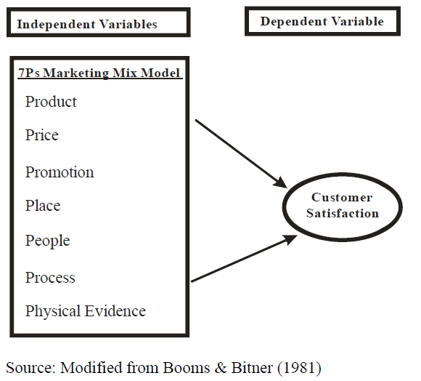

8.1 Saudi Telecom Company (STC) Background
Saudi Telecom Company (STC) was established as an independent joint stock company in 1998, when the government separated the telecommunication services from the Post, Telegraph and Telephone Ministry. In 2002, the government sold its 30% stake in the company via an IPO. STC was the only company offering telecommunication services in the Kingdom until 2003, when the VSAT (Very Small Aperture Terminal) market was liberalized. STC’s monopoly in GSM (mobile) market was ended in 2004, when the second mobile license was granted to Etihad Etisalat Company (Mobily); in March 2007, the third license was granted to a consortium led by Zain of Kuwait for USD 6.1 billion. STC’s monopoly in fixed line market was ended in April 2007, when three fixed line licenses were granted to the consortia led by Bahrain Telecommunication (Batelco), Hong Kong’s PCCW and US based Verizon Communications respectively. In spite of increasing competition in the GSM and fixed line markets, STC remains the only integrated telecom operator in Saudi Arabia offering mobile, landline, internet services, data transmission, leased lines and public telephones.
A company can satisfy its customers by proving qualitative services with low price. Telecommunication is most useful media for purpose of quick routing. It encompasses multiple services providers, including telephone companies, cables system operator, internet service providers (ISP), wireless carriers and satellite operators (Robert W. and Jon Eisenberg, 2006). Saudi Telecom Company (STC) is the first telecom communication company in Saudi Arabia which provided landlines and mobile services.
8.2 Marketing Management Definition
Marketing management can be defined as follows: "The analysis, planning, implementation and monitoring of programs to create, provide and maintain a profitable transactions process with the buyers, in order to achieve organizational goals (Cutler, 2000). Marketing management is the analysis, planning, implementation and controlling of programs to achieve organizational goals. It involves programs made to establish and maintain beneficial exchanges with buyers (Lavak, 1382). The application, tracking and review of a company are marketing resources and activities.
Also defined as the scope of a business' marketing management depends on the size of the business and the industry in which the business operates. Effective marketing management will use a company's resources to increase its customer base, improve customer opinions of the company's products and services, and increase the company's perceived value.
Marketing management is the organizational discipline which focuses on the practical application of marketing orientation, techniques and methods inside enterprises and organizations and on the management of a firm's marketing resources and activities.
Globalization has led firms to market beyond borders of their home countries, making international marketing highly significant and an integral part of a firm's marketing strategy. [Joshi, Rakesh Mohan, (2005)]. Marketing managers are often responsible for influencing the level, timing, and composition of customer demand accepted definition of the term. In part, this is because the role of a marketing manager can vary significantly based on a business's size, corporate culture, and industry context. For example, in a large consumer products company, the marketing manager may act as the overall general manager of his or her assigned product. [Kotler, Keller (2006)]. To create an effective, cost-efficient marketing management strategy, firms must possess a detailed, objective understanding of their own business and the market in which they operate. [Clancy, Kevin J.; Peter C (2000)]. In analyzing these issues, the discipline of marketing management often overlaps with the related discipline of strategic planning.

Table 1: Summary of Marketing definitions
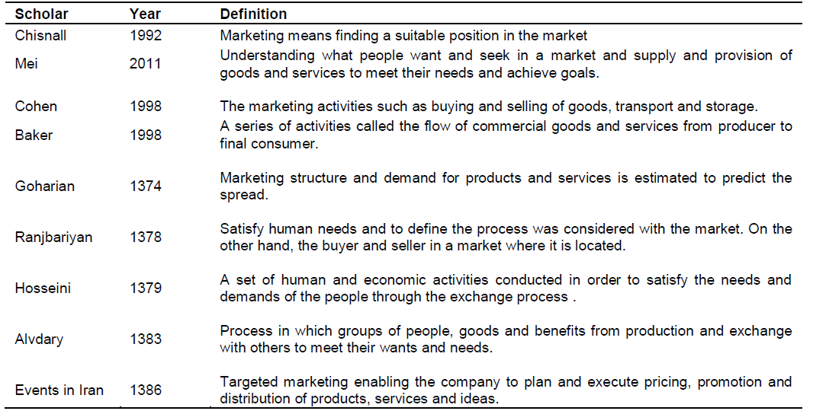Source: Saeidi Pour, Kamran Nazari and Mostafa Emami (2013), The effect of marketing mix in attracting customer Case study of Saderat Bank in Kermanshah Province Bahman

8.3 Marketing Mix:
The marketing mix refers to the set of actions, or tactics, that a company uses to promote its brand or product in the market. The 7Ps make up a typical marketing mix - Product definition, Price, place, promotion, people, process and physical evidence. However, nowadays, the marketing mix increasingly includes several other Ps like Packaging, Positioning, People and even Politics as vital mix elements.
8.3.1 Marketing mix (7P’s)
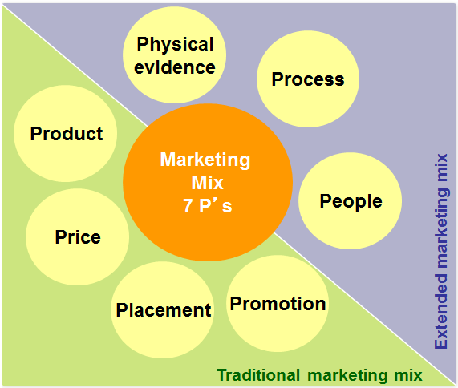

8.3.2 Product definition
Product refers to the goods and services offered by the organization. According to Borden (1984) product is characterized by quality, design, features, brand name and sizes. Armstrong and Kotler (2006) defined product as, “Anything that can be offered to a market for attention, acquisition, use, or consumption that might satisfy a want or need.” The product in service industry is intangible in nature. Like physical products such as a pen or a television, service products cannot be measured. Service Product is defined as the extent to which a service organization develops a comprehensive service offer to meet customers’ needs and wants in highly competitive markets. Ferrell and Hartline (2005) state the product as the core of the marketing mix strategy. Through unique features and attributes of products, marketers can differentiate their product from their competitors.
STC products and services

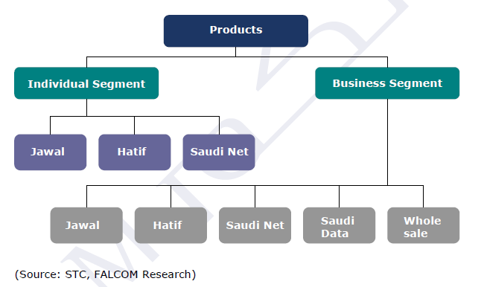

The product in this case will be the telecommunication services which STC offers to its customers. STC offers exclusively structured products to its individual and business segment customers through various brands thus attaining customer segmentation and generating brand consciousness. (Source: STC, FALCOM Research).
Jawal – Includes range of mobile services like prepaid (offered under the brand name “Sawa” and “Lana”), postpaid services, family Al Jawal (for families), messaging services, 3G services, roaming services and entertainment services.
Hatif – Includes services such as card phones, landline services, prepaid card services, public telephones and business services offered to both individual and business segments.
Saudi Net – Includes internet services through broadband, DSL and internet cards.
Saudi Data – Includes services such as IP-VPN, VSAT, Sky IP service and other value added services mainly for business segment.
Wholesale – Includes national and international telecommunication infrastructure solutions.
STC: Offer Wholesale Services With the objective to harness the wholesale opportunity, STC aims to expand its international network and continue offering quality services and operations to its national and international clients.
- STC was awarded as the Best Wholesaler in the Middle East in 2008 by Telecoms World, for operating the most sophisticated, fastest-growing network with quality and sustainability across the region.
- STC entered into strategic partnerships with a number of international operators to establish regional and continental marine cables that are projected to raise the capacity of STC’s global network by more than 400%. The cables are established between India and Western Europe, “MENA”, “EIG”, and “EASSY”.
- The Company possesses four international voice and data MPLS, connected via more than 460 direct paths to international operators.
8.3.3 Price definition
Pricing is the second most important element in the marketing mix and acts as a weapon to counteract competitors as well as ensures survival of the firm. According to Kotler (2008), “Price is the amount of money charged for a product or service, or the total values that consumers exchange for the benefits of having or using the product or service. Pricing of services is rather more difficult than pricing of goods. Due to the intangible nature of services, price becomes a crucial quality indicator. Peter and Donnelly (2007) found in their study that price is the factor in which customers focus more than other attributes while making purchase decisions. Even when deciding to purchase from a service provider, consumers usually think whether or not they received their value for money.
STC was able to charge higher tariffs prior to 2004, when it had a monopoly in the Saudi telecommunication market, however, after the entry of Mobily in 2005 and Zain in 2008, there has been an increase in price competition among the three players, thus increasing the price elasticity of demand. Also, prior to 2004, only postpaid and fixed line services were offered in Saudi Arabia and the customer base was concentrated towards high usage customers, however, with the launch of pre-paid services, the customer base has expanded and price competition has increased further.
8.3.4 Place definition
Hirankitti (2009) described place as the ease of access which potential customer associates to a service such as location and distribution. Place in case of services determine where is the service product going to be performed. Place involves both time and place consideration. In terms of time, place allows the customer to gain access to the service when it is convenient for them to buy. In terms of place, distribution (place) makes services available to customers in locations which are accessible and convenient to them. Firm should pay attention to how it can deliver the product at the right time and at the right place, and which channel should be used to deliver the product (Copley, 2004).
STC has distribution agreements with the biggest dealers across all cities of Saudi Arabia. STC also has an online portal which allows customers to undertake several services such as bill payment, service setting modifications and up gradation etc.
8.3.5 Promotion definition
Marketing communication mix (Promotion mix) consists of the blend of advertising, personal selling, sales promotion, public relations and direct marketing tools. A communication program plays three vital roles such as provide information, persuade target customers, and encourage them to take action (Lovelock and Wright, 2002).
Promotion being an important component of mix service marketing considered from the aspect of declaration mix, personal selling, public relations and direct marketing instruments used by organization for advertisement and marketing.
The promotional activities can influence consumers’ perception, their emotions, their experience as well as their purchasing pattern. Individual sales people, TV, radio, Internet, magazine, press, billboards and all types of conventional and nonconventional media can be used for promotional activities. In service marketing, communication tools are especially important because they help to create powerful images and a sense of credibility, confidence and reassurance (Lovelock and Gummesson, 2004). Without effective communications, prospects may never learn of a service firm's existence, what it has to offer them or how to use its products to best advantage.
STC advertises its products across the kingdom through public banners, media and e-channels; offers various discount offers (both on price and volumes) and shopping vouchers to its customers; and has developed various brands for creating brand loyalty among its customers. STC’s advertising expenses and sales commissions were SR 1.85 billion in 2008 (227% higher than 2007 levels) and represented 4% of 2008’s operating revenues.
8.3.6 People definition
People refer to the employees who produce and deliver the service. Service encounter occurs when employees and consumers meet together and these encounters have strong influence on the customer’s perception of service quality (Hartline and Ferrell, 1996). Personnel are also considered as the key element in a customer-centered organization as well as a way to differentiate variables with product, services, channel, and image (Kotler, 2000).
People are an essential ingredient in service provision; recruiting and training the right staff is required to create a competitive advantage.
STC offers high quality of service with different categories having the right people is essential because they are as much a part of business offering as the products/services are offering.
8.3.7 Process definition
Process is the implementation of actions and functions. It increases value for products with low cost and high advantage to customer. Process is more important for service products. Hirankitti, (2009) stated that the pace of the process as well as the skill of the service providers is clearly revealed to the customer. It also forms the basis of consumer satisfaction with the purchase. Therefore, process management ensures the availability and consistence of quality of service. Technology has remarkable influence on the growth of service delivery options (Dabholkar and Bagozzi, 2002). More and more banks have adopted latest technological tools to deliver their services and this has resulted in reduced costs, creation of value-added services for customers (Zhu 2002), and the facilitation of their employees' jobs and ultimately, the provision of self-service options for customers (Dabholkar and Bagozzi, 2002).
Based on STC website: STC try to satisfy its customer by delivering good services in a clear and appropriate process.

8.3.8Physical evidence definition
Physical evidence is about where the service is being delivered. Service cannot be displayed like goods. Due to intangible characteristics of service, customers often rely on tangible cues or physical evidence to evaluate the service before its purchase and to assess their satisfaction with the service during and after consumption. Physical Evidence is that which can be easily associated with the product. Therefore firms should create a suitable environment to highlight the fact to the customers (Rathmell, 1974). This element of 7P’s holds great importance because the customer normally judges the quality of the service provided through it (Rafiq and Ahmed, 1995). The components of the physical evidence are called as services cape which includes the facility exterior i.e. exterior design, signage, parking, landscape, surrounding environment and facility interior i.e. interior design, equipment, physical layout, air quality, temperature, comfort of the seating, the appearance of the staff.
STC is looking to help customers in all sectors to achieve new level of productivity, agility and cost saving through cloud adoption and Cisco’s Application Centric Infrastructure (ACI) is a data center and cloud solution which offer full visibility and integrated management of both physical and virtual networked IT resources. STC customer receive the bills and others not physically printed (in the case of PDFs) they are still receiving a “physical product”.
9- Customer satisfaction
Customer satisfaction (CS) plays an important, if not a critical role in a firm's success. The significant role of customers‟ satisfaction is a necessary foundation for a company to retain the existing customers and also the key element in any customers‟ retention strategy in the future (Guo et al., 2009; Oliver, 1999). According to Kotler (2006), “One key to customers‟ retention is customers‟ satisfaction; a satisfied customer stays loyal longer”. The result of a successful customer satisfaction strategy leads to customer loyalty (Kuo et al., 2009). With satisfaction customers, pharmaceutical companies can maximize their profitability, market share, and investment return (Anderson, and Lehmann, 1994). Satisfaction physicians are willing to recommend drugs to others (patients) (Sweidan and Kalaskar 2012). Hence, physician‟ satisfaction is very important element for pharmaceutical companies in the pharmaceutical industry (Sweidan et al 2012).
Cardozo's (1965) initial study of customer effort, expectations and satisfaction. Despite many attempts to measure and explain customer satisfaction, there still does not appear to be a consensus regarding its definition (Giese and Cote, 2000). Customer satisfaction is typically defined as a post consumption evaluative judgment concerning a specific product or service (Gundersen, Olsson, 1996). It is the result of an evaluative process that contrasts pre purchase expectations with perceptions of performance during and after the consumption experience (Oliver, 1980).
The most widely accepted conceptualization of the customer satisfaction concept is the expectancy disconfirmation theory (Barsky, 1992; Oh and Parks, 1997; McQuitty, and Wiley, 2000). The theory was developed by Oliver (1980), who proposed that satisfaction level is a result of the difference between expected and perceived performance. Satisfaction (positive disconfirmation) occurs when product or service is better than expected. On the other hand, a performance worse than expected results with dissatisfaction (negative disconfirmation).
Studies show that customer satisfaction may have direct and indirect impact on business results. Anderson et al. (1994), Yeung et al. (2002), concluded that customer satisfaction positively affects business profitability. Dabholkar (1993) is of the view that customer satisfaction is a kind of emotional, which leads to an overall, world attitude of quality, which is based on kind of internal expectation.
10- Relationship Marketing Mix Elements (Four Ps) with Required components
Consumers (Four Cs)
Nina Kurnia Hikmawati (2015), Marketing mix is a series of marketing tools that work together to influence the market (market place) in order to achieve certain goals of the company. Elements of the marketing mix (four Ps) associated with the components required by customers (the customers' four Cs) as described as follows:

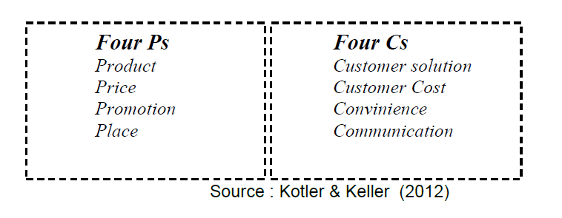

11- Results and finding
Based on questionnaire which has been distributed on randomly sample of 73 customers of STC company during in 12 and 13 March 2016

Questions | Strongly Agree | Agree | Nature | Disagree | Strongly Disagree
1- Products and Services
Do you think STC provide good services quality? | 40 | 11 | 10 | 7 | 5
2- STC services prices
Do you think STC has acceptable prices for its services? | 20 | 29 | 7 | 9 | 8
3- Place
Do you think STC has good places in KSA? | 25 | 12 | 10 | 11 | 15
4-Promotion
Do you think STC has good promotion to its services in KSA? | 25 | 17 | 9 | 13 | 9
5-People
Do you think service provider is cooperative at STC? | 20 | 10 | 7 | 11 | 25
6-process
Do you think STC provide good process for its services and suitable for you? | 24 | 17 | 13 | 10 | 9
7-Physical evidences
Do you think STC has a good physical evidences and suitable environment to deliver its services? | 29 | 14 | 11 | 11 | 8
Average | 26 | 15 | 9 | 10 | 11
Standard Deviation (SD) | 7 | 6 | 2 | 2 | 6
Median | 25 | 14 | 10 | 11 | 9
Mode | 20 | 17 | 10 | 11 | 8

Based on above statistical analysis the 56 % from samples reply between strongly agree and agree about STC marketing mix which reflect that STC really looking for satisfy its customers and 22% between strongly disagree and disagree about STC services, however the main factor which increase this percentage was service provider which require from STC company to provide more training courses to its employees in order to enable them to interact perfectly with customer so STC should focus on the following points:
1- Provide customer services training courses by allocate enough budget for this issue.
2- Higher employees with positive attitude toward customers.
3- Emphasis on continuous improvement in services quality in all aspect.
Based on result H1 hypothesis is accepted which mean there is a relationships between marketing mix and customer satisfaction at Saudi Telecom Company (STC).

Conclusion
The study aimed to find out the relation between the marketing mix components and customer satisfaction at Study Saudi Telecom Company (S.T.C) at kingdom of Saudi Arabia. The finding of the study shows that there is a significant positive relationship among the seven elements of marketing mix and customer satisfaction.
Based on statistical analysis the 56% from samples reply between strongly agree and agree about STC marketing mix which reflect that STC really looking for satisfy its customers and 22% between strongly disagree and disagree about STC services, however the main factor which increase this percentage was service provider which require from STC company to provide more training courses to its employees in order to enable them to interact perfectly with customer so STC should allocate enough budget for training and development in order to enhance competencies for dealing with STC customers also continuous improvement in services quality is considered an important factors in STC performance.

Recommendation
1- It is recommended to other researchers to investigate the impact of marketing mix on customer satisfaction on STC by studying each components in marketing mix in depth.
2- It is also is recommended to other researchers to find out the relationships marketing mix and customer satisfaction on STC due to demographic variables like gender, income …etc.

References
- Anderson, Eugene W., Claes Fornell, and Donald R. Lehmann. (1994). "Customer Satisfaction, Market Share, and Profitability: Findings from Sweden." Journal of Marketing 58 (July): 53-66.
- Barsky, J.D. & Labagh, R. (1992). A strategy for customer satisfaction. The Cornell Hotel and Restaurant Administration Quarterly, 35(3): 32-40.
- Berry, L.L., Wall, E. A., and Carbone, L. P. (2006). Service clues and customer assessment of the service experience: Lessons from Marketing. The Academy of Management Perspectives Archives, 20(2), 43-57.
- Bitner, M. J. (1992). Services capes: The impact of physical surroundings on customers and employees. Journal of Marketing, 56(2), 57-71.
- Borden, N. H. (1984). The concept of marketing mix. Journal of Advertising Research, 1(9), 2-7. Constantine’s, E. (2004). Influencing the Online Consumer's Behavior: The Web Experience. Internet Research, 111.
- Bour. B, & Nazari. K & Emami M, (2013), The effect of marketing mix in attracting customers: Case study of Saderat Bank in Kermanshah Province, African Journal of Business Management, Vol. 7(34), pp. 3272-3280, 14 September, 2013.
- Booms, B. H., & Bitner, M. J. (1981). Marketing Strategies and Organization Structures for Service firms, In Donnelly, J.H. & George, W.R. (eds), Marketing of Services, IL: American Marketing Association, Chicago, 47-51.
- Cardozo, R.N. (1965). An experimental study of customer effort, expectation and satisfaction. Journal of Marketing Research, 2: 244-249.
- Clancy, Kevin J.; Peter C. Kriegafsd (2000). Counter intuitive Marketing. The Free Press. ISBN 0-684-85555-0.
- Copley, P. (2004). Marketing Communications Management: Concepts and Theories, Cases and Practices. Oxford: Butterworth-Heinemann.
- Cutler RP (2000). "Principles of Marketing" translation Parsayyan A. (1383), published Birthdays.
- Dabholkar P. & Bagozzi, R. (2002). An attitudinal Model of Technology-based Self-Service: Moderating effects of Consumers Traits and Situational Factors. Journal of Academy of Marketing Science, 30(3), 184-201.
- Dabholkar, P., (1993). A Measurement of Service Quality for Retail Stores: Scale Development and Validation, Journal of the Academy of Marketing Science, 24(1), 3-16
- Ferrell, O. C., & Hartline, M. D. (2005). Marketing Strategy. (3rd ed.). Mason, Ohio: South-Western Thomson.
- Giese, J.L. & Cote, J. A. (2000). Defining Customer Satisfaction. Academy of Marketing Science Review, http://www.amsreview.org/articles/giese01-2000.pdf. [Accessed the 18th of July 2007].
- Guo, L., Xiao, J. J., & Tang, C. (2009). Understanding the psychological process underlying customer satisfaction and retention in a relational service. Journal of Business Research, 62, 1152.1159.
- Gundersen, M. G., Heide, M. & Olsson, U. H. (1996). Hotel Guest satisfaction among Business Travellers: What Are the Important Factors? The Cornell Hotel and Restaurant Administration Quarterly, 37(2): 72-81.
- Hartline, M. D., & Ferrell, O. C. (1996). The management of customer contact service employees. Journal of Marketing, 60(4), 52-70.
- Hirankitti, P., Mechinda, P., & Manjing, S. (2009). Marketing Strategies of Thai Spa Operators in Bangkok Metropolitan. Paper presented at the International Conference on Applied Business Research (ICABR), St. Julians, Malta.
- Hikmawati N. (2015) influence of marketing relations and marketing mix on customer's trust on mobile service providers in Indonesia International Journal of Economics, Commerce and Management, Vol. III, Issue 11, November 2015.
- Joshi, Rakesh Mohan, (2005) International Marketing, Oxford University Press, New Delhi and New York ISBN 0-19-567123-6.
- Kalaskar, P. B., and Sager P. N (2012). Factors influencing prescription behavior of physicians
- Kotler, P. (2000). Marketing Management. (10th ed). New Jersey: Prentice Hall.
- Kotler, Philip & Armstrong, Gary (2006). Principles of marketing (11th ed). New York: Pearson.
- Kuo, Y-F., Wu, C-M., and Deng, W-J. (2009), “The relationships among service quality, perceived value, customer satisfaction, and post-purchase intention in mobile value-added services”, Computers in Human Behavior, 25, 887-896.
- Lavak C (1382). "Marketing of Services", translated Tajzadeh Artaxerxes, the publishing, printing.
- Lovelock, C. &Gummesson, E. (2004). Whither services marketing? In search of a new paradigm and freshperspectives. Journal of Services Research, 7(1), 20-41.
- Lovelock, C., & Wright, L. (2002). Principles of Service Marketing and Management. USA: Prentice Hall.
- Milligan, J. W. (1997). What do customers want from you: Everything! US Bank, 107(12), 38-45.
- McQuitty, S., Finn, A. & Wiley, J. B. (2000). Systematically Varying Customer Satisfaction and its Implications for Product Choice. Academy of Marketing Science Review,
- Oliver, R.L. (1980). A Cognitive Model of the Antecedents and Consequences of Satisfaction Decisions. Journal of Marketing Research, 17: 460-469.
- Oliver, R.L. (1999). Whence consumer loyalty? Journal of Marketing, 63(Special issue), 33–44.
- Philip Kotler, Philip.; Kevin Lane Keller (2006). Marketing Management, 12th ed. Pearson Prentice Hall. ISBN 0-13-145757-8.
- Peter, P. J., & Donnelly, J. H. (2007). Marketing Management: Knowledge and Skills. (8th ed.). New York: McGraw-Hill.
- Rafiq, M., & Ahmed, P. K. (1995). Using the 7Ps as a generic marketing mix: An exploratory survey of UK and European marketing academics. Marketing Intelligence & Planning, 13(9), 4-15.
- Reena, N (2012), A study on factors influencing brand loyalty in mobile service providers among college of business students of University Utara Malaysia. Thesis unpublished University Utara Malaysia.
- Rathmell, J. M. (1974). Marketing in the service sector. Cambridge: Winthrop. Sarker, M. A. H., Aimin, W., & Begum, S. (2012). Investigating the Impact of Marketing Mix Elements on Tourists’ Satisfaction: An Empirical Study on East Lake. European Journal of Business and Management, 4.
- Robert W. Lucky and Jon Eisenberg (2006), Editors, Committee on Telecommunications Research and Development, National Research Council Santos.
- Sweidan, G., Al-Dmour, H., Zu‟bi M.F, & Al-Dmour, R. (2012). The effect of relationship marketing on customer Loyalty in the Jordanian pharmaceutical industry. European Journal of Economics, Finance and Administrative Sciences, 53,153-172.
- Yeung, M. C. H., Ging, L. & Ennew, C. T. (2002). Customer satisfaction and profitability: A reappraisal of the nature of the relationship. Journal of Targeting, Measurement and Analysis for Marketing, 11(1): 24-33
- http://www.stc.com.sa. The Royal Embassy of Saudi Arabia, www.saudiembassy.net.

5/18/2016

