The Ichthyiofauna And Physico-Chemical Properties Of Kugbo Creek In The Niger Delta, Nigeria

*¹Edoghotu, A. J., ²George, U. U. and ³Hart, A. I.

¹Department of Biology. Ignatius Ajuru University of Education, Rumuolumeni, Port Harcourt
²Department of Zoology and Environmental Biology, University of Calabar, Cross River State, Nigeria.
³Department of Animal and Environmental Biology, University of Port Harcourt, Port Harcourt.
E-mail: azibodiedoghotu@gmail.com

Abstract: Ichthyiofauna of Kugbo Creek system was studied in nine stations of three zones (brackish, freshwater and in between) of the creek. Biweekly samples of 24 months showed a total of 87 finfish species belonging to 31 families. Zone one (Fresh water) had 50 species of which pelagic and 15 demarsal. Zone 2 had had 51 species in open waters and 20 species in demersal sample. While zone three (brackish water) had 47 species in open water and 9 demarsal species obtained at the banks of the creek. Dominant family of the open brackish waters was Cichilidae with 12 representative species. This was followed by Bagridae and Characidae with 5 species each. The entire 24 months samples of both fresh water zones were dominated by Xenomistus nigri of the family Notopteridae with 7,323 individuals of the family Notopteridae with 784 individuals’ fish which occurred all year round. This was followed by Epetoichthys calabaricus of the family Polypteridae with 1,306 individual. However, the brackish region (zone 3) was dominated by Tilapia zilli of the family Cichilidae. Fish found in sample were of the families Chanidae, Claridae, Gymnachidae, Nandidae, Notopteridae, Osteoglossidae, Polypteridae, Malapteridae and Phractolemidae were only found in fresh water and not brackish, while Syngnathidae, Sphyraenidae, Sciaenidae, Pomadasyidae, Polynemidae, Mugilidae, Lutjanidae and Carangidae were caught in the brackish station. Others were caught in all the 3 zones. Mean value range of limnological characteristics were temperature 25.6ºC ± 1.1 – 30.8ºC ± 2.5; depth profile 110cm ± 113 – 479cm ± 160; flow rate 4.3cms⁻¹ ± 0.7 – 7.6 cms⁻¹ ± 3.4; transparency 34.9cm ± 2.7- 265.0cm ± 58.9; TSS 38 mg / l ± 9 – 615 mg / l ± 55; and DO 2.9 mg / l ± 0.9 – 8.2 mg / l ± 4.06.
[Edoghotu, AJ., George, UU., Hart, AI. The Ichthyiofauna And Physico-Chemical Properties Of Kugbo Creek In The Niger Delta, Nigeria. N Y Sci J 2016;9(4):65-74]. ISSN 1554-0200 (print); ISSN 2375-723X (online). http://www.sciencepub.net/newyork. 11. doi:10.7537/marsnys09041611.

Keywords: Ichthyiofauna, Fisheries, Kugbo Creeks, Conservation, Niger Delta, Nigeria.

1.0 Introduction
Kugbo creek is one of the Niger Delta networks of creeks. Its water is brown in late wet to early dry months due to its link with both Orashi and Nun rivers, which in turn are linked to River Niger. The water is black in early wet season due to water received from adjoining swamps and flood plains with decaying debris, but transparent or clear to bottom in shallow points of mid to late dry season due to incursion of saline water. There exist several natural resources including Non-Timber Forest Products (NTFP) and Timber Forest Products (TFP). The system supports several human activities such as fishing, transportation, dredging, lumbering, urbanization and oil exploration. Among the rich resources of the creek system is its fisheries, which apart from being a major source of protein food, provide income to the fisher folk and other inhabitants along the creek. In spite of these economic benefits, there is no information about the fisheries of this creek.
Human population of communities along the creek increases annually, with increasing fishing pressure and waste generated. This has implications on water quality. In recent times, there had been threat signals on this fishery. The fisher communities, particularly the local fisher folk had made unprecedented complains, on the reduction in fish population and dwindling catch, which was attributed to anthropogenic activities of industrialization, pollutant discharge, occlusion of water body by Eichhornia crassipes (water hyacinth) that may not provide or allow good breeding grounds to fresh water fishes. Other activities that may have contributed to declining environmental quality and fish production include over fishing, oil exploration activities by companies. There has been need to conserve the aquatic resources, which include fish for sustainability.
Surface water quality attributes were not constant. They change in response to daily, seasonal and climatic rhythms. For instance, aquatic plants like their terrestrial counterparts breathe in oxygen at night and produce carbon dioxide that lead to decreased pH at night due to the presence of carbonic acids. However, during the day, pH increases when plants incorporate carbon dioxide in photosynthesis and oxygen is produced. Aquatic organisms naturally are adapted to these fluctuations. Globally, fisheries are threatened by varying factors. Some of the more serious threats include pollution, loss of habitat, invasive species, parasites, illegal fishing methods and overfishing (Thomsen et al., 2014; Fernando, 2014; Welcome, 2001; Maitland and Morgan, 2001 and Avise (1990). Fish mortality is caused by several factors such as over fishing (King, 1991), predation (Otobo, 1993), environmental stress (Song, et. al., 2014); parasitic diseases and fishing activity (King, 1991).Rate of exploitation is an index that estimates levels of the fisheries utilization. Exploitation rate value is therefore based on the facts that sustainable yield is optimized when fishing mortality coefficient equals natural mortality (Pauly, 1983).
Adverse environmental conditions decrease ability of organisms to maintain effective immunological system, thereby increasing susceptibility to diseases (Kham and Thulin, 1991). Fish is not an exception. Acute or chronic pollution of surface water can increase the level of unspecific immunity to disease. Several studies around the globe have revealed variety of fish species of importance to man. In Europe for instance, several such studies have been undertaken, with proper documentation of the Ichthyofauna. Fish distribution studies in African aquatic systems are documented in several literatures. Sydenham (1977) studied fish distribution in River Ogun of Western Nigeria. A great percentage of West African and in particular Nigerian inland waters are yet to be studied. In the Niger Delta region of Nigeria, not much of the limnology, ichthyology, and fisheries have been described relative to the developed parts of the world. The extensive Niger Delta systems support numerous flood plains, lakes (Welcome 1979), swamps and rivers (Abowei 2000).
In the Niger Delta, fish consumption accounts for about 80% protein diet and provides job for about 50% of the population. Some of the few fisheries studies in the area include Wright (1986), Chindah and Osuamkpe (1994), Allison et. al., (1997), Ogamba (1998), Nweke (2000), and Amakiri (2005), on Bonny River estuaries. Other studies were those of Alfred- Ockiya (1998) on Kolo Creek, Hart and Abowei (1998) on lower Nun River, Hart and Set (1999) on Brass River, Sikoki and Zabby (2006) on the middle reaches of Imo River, and Davis (2009) on Okpoka Creek. But so far no work had been done on the fish and fisheries of Kugbo creek.
Fish occur in varying transects of aquatic systems. These include vertical plane (i.e. Surface water, mid water and bottom, horizontal or lateral plain (i.e. convex, central and concave) setting of the water body (Allison and Okadi, 2009). Thus, knowledge of species distribution provides information on whether a particular fish species is demersal, pelagic, etc; hence providing further information on choice of fishing gear to be used. Distribution and abundance are veritable aspect of fish stock assessment studies. Knowledge of these will however enhance management and production. Abundance to a large extent is a function of recruitment (Allison et al 1997) and is a major source of variability in fish population (Clark 1979 and Bankole 1990).
Aside fresh water, Nigeria is endowed with a maritime area of 46.300 km² and inland waters of 12.2million ha., yet production rate is still at 400,000 metric tonnes, which is about 50% deficit to meeting Nigerian fish need per annum of at least 1.5million metric tons. The bulk of fish is from artisanal fisheries. This form of local production is inadequate to meet our demand. Therefore, Nigeria imports about 49.5% of fish consumed (Okorie, 2003). There is therefore need to increase domestic fish supply by developing a proper management strategy for the Nigerian fisheries resources. Thus, creating jobs and food for all and rural dwellers in particular. It is hoped that the study shall uncover the fish species of Kugbo Creek and provide documented scientific evidence of the status, species distribution and abundance of the creek fisheries and enhance proper management.

2.0 Material and Methods
Physicochemical studies of relevance to this research were considered in accordance with APHA (1976) methods. Secchi disc measurement was done with a chord graduated at one-meter interval, to determine water transparency. Fractions of a meter were estimated with a 30 cm rule and rounded off to the nearest centimeter.
Water flow rate was estimated by finding the average of 3 distance / time ratio serial measurements of the time (t), for a cork (float) to go through the distance, d of a 10 m marked at the creek bank of each station and pegged both ends. Flow rate therefore = (d₁/t₁) + (d₂/t₂) + (d₃/t₃).
To estimate depth profile at each station, a marine rope graduated at 0.5 m intervals was tied at one end to a weight that served as sink, was lowered into the water until the attached sink reached the bottom. The point at which the water level reached the rope was marked. The marine rope and sink were howled up and the total length covered by water determined by the total 0.5 cm intervals submerged. Additional fractions of 0.5 m were estimated with ruler and added to the former.
Temperature was measured in situ with mercury-in-bulb thermometer and rounded off to the nearest 0.1⁰C. Turbidity Samples were collected in 1-liter plastic cans. Analysis was done in the laboratory with an electrical conductance instrument (Horiba, model U-10). Total dissolved solid samples were also collected in 1-liter plastic cans and analyzed with Horiba electric conductance instrument. Dissolved oxygen (DO) samples were collected in 60 ml BOD glass bottles. Inclusion of air bobbles during sample collection was avoided by allowing sample remain underwater below surface for at least one minute before fixing stopper while still immersed in the water to remove trapped bubbles. Samples so collected were fixed immediately after collection by first adding 0.5 ml of manganese sulfate solution, followed by 0.5 ml alkaline-iodide-azide reagent, well below sample surface. Again, caution was taken by replacing stopper carefully to exclude air bubbles. Samples were mixed by inversion for at least 15 times. Precipitate gradually settled at the bottom, leaving a clear supernatant above the hydrogen floc. It was again shaken and taken to the laboratory where analysis was completed.
Fisheries study involved observation, identification, and fishing gears selectivity. Efforts were made to assess non-conventional locally used fishing gears, and identify those recommendable, if need be. However, there were some variations in fishing methods and gears among zones. Common fishing gears used was nets, hooks and traps. Fish sampling was carried out in the three zones of the study area with gill net fleets. Nine nets with mesh sizes of ¾’, 1’, 1 ½’, 1 ¾’, 2’, 2 ½’, 3 ½’, 4’, and 7’ stretched mesh were employed. Each net is about 20 m long and 3 m wide. Surface area of each net is 60 m² and fleet area of 540 m². Catches of each zone were isolated and transported in cool boxes to the laboratory for analysis. Total number and weight of each species per station were recorded. Similarly, total number of length (cm) and weight (g) of each fish were recorded. Weight of each fish was obtained by weighing samples on a digital meter balance, model scout-pro 601, to the nearest 0.1 g. The fish were weighed after draining water from buccal cavity and blot-drying samples. Total length of fish species were measured and read to the nearest centimeter with a meter rule. Sampling was done twice per month (biweekly). Regime for each day was six hours for two years (March 2009 to February 2011).
Identification of fish specimens was according to the descriptions contained in Idodo-Ume (2003), Reed (1967), and FAO (1990). Seasonal variations, abundance and frequency of occurrence were established for the three zones sampled. To determine the abundance, seasonal variation and distribution of fish, number and weights of fish caught were divided into two groups. Those of November, December, January, February, March, and April were designated dry season samples. While those caught in May, June, July, August, September and October were rainy season samples.

3.0 Results
3.1 Limnological Characteristics
Result on the study is presented in Figures 1 -4 and Tables 1-4. Temperature varied between 25⁰C and 34⁰C throughout the period sampled. Maximum temperature was 34⁰C in dry season early April sampling of station 8, while minimum temperature of 25⁰C was in wet season in early August to October sampling of fresh water stations 1 to 4. Similarly, mean values per station ranged from 25.6⁰C ± 1.1 to 30.8 ± 2.5. Temperature was generally low within wet months and relatively high in the dry months during the period sampled (Fig. 1). Depth Profile was observed to be higher in wet months than in dry months. The variation reflected among stations. Maximum stations’ depth along the creek was 925 cm in station 9 during early February and minimum (56 cm) in station 4 during late April sampling of March 2010 to February 2011 phase. Mean depth values ranged from 110 cm ± 113 to 479 cm ± 160 (Fig. 2). Flow Rate in stations sampled varied narrowly throughout the period sampled. Values ranged between 2.5 cm / s in station 5 during late August sampling of March 2009 to February 2010 phase to 15 cm / s in stations 1 and 2 during late December of the March 2009 to February 2010 sampling phase. Similarly, mean flow rate values ranged from 4.3 cm / s ± 0.7 to 7.6 cm / s ± 3.4 (Fig. 3). Secchi Disc measurements for transparency values also varied widely relative to others. Values ranged from 25 cm in station 4 of March 2009 to February 2010 phase sampling during early October to 900 cm in station 9 during early December sampling of March 2010 to February 2011 phase sampling. Data showed increase in values from freshwater stations to brackish water. Mean values ranged from 34.9 cm ± 2.7 to 265.0 cm ± 58.87 (Fig. 4).
Total Suspend Solids (TSS) values were relatively higher in wet than dry seasons. They also decreased from fresh to brackish water stations. Values varied with a wide range of 25 mg / l in station 8 during late March sampling of March 2009 to February 2010 sampling phase to 881 mg / l in station 7 also in late March sample of March 2010 to February 2011 sampling phase. TSS mean values varied between 38 mg / l ± 9 and 615 mg / l ± 55 (Fig. 5). DO values ranged between 1.7mg / l in station 3 during early March of March 2009 to February 2010 Sampling phase and 13 mg / l in station 9 in late May also of March 2009 to February 2010 sampling phase. Mean value ranged from 2.9 mg / l ± 0.9 to 8.2 mg / l ± 4.06 (Fig. 6).

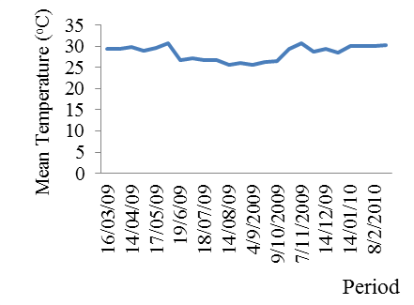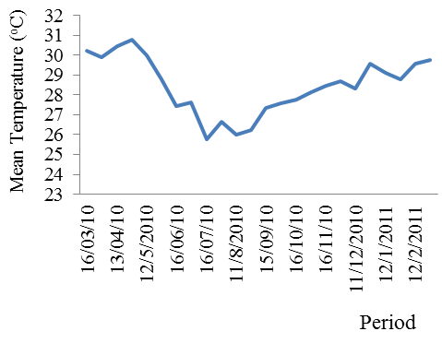
Figure 1: Temporal variations in mean temperature (ºC) of Kugbo Creek during March 2009 – February 2011.

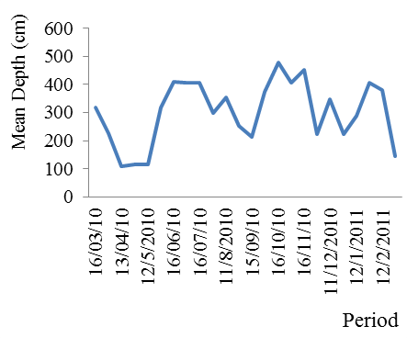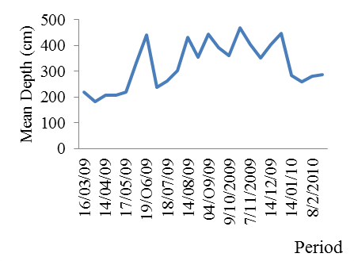
Figure 2: Spatial variations in mean depth (cm) of Kugbo Creek during March 2009- February 2011

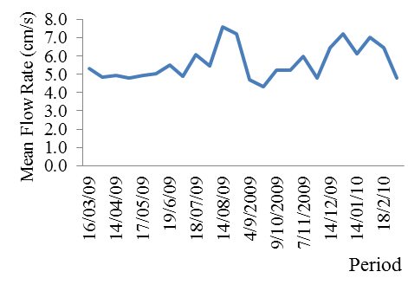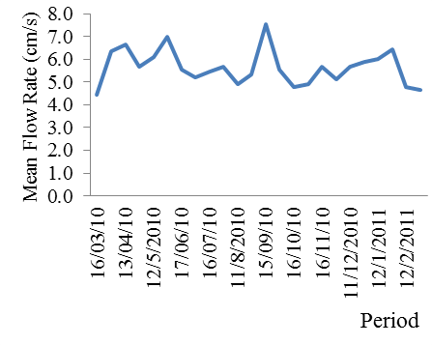
Figure 3: Spatial variation in mean flow rate (cm/s) of Kugbo Creek during March 2009 - February 2011.

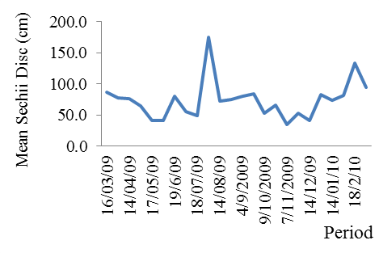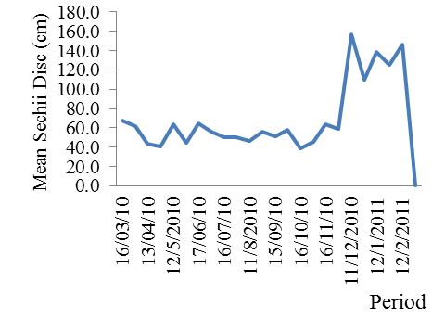
Figure 4: Spatial variations in mean secchi disc (cm) of Kugbo Creek during March 2009 – February 2011.
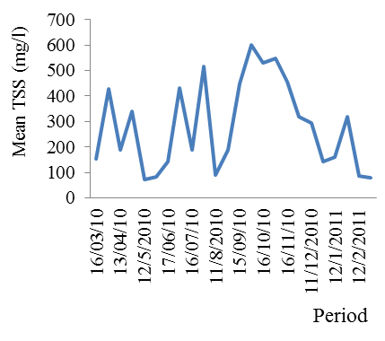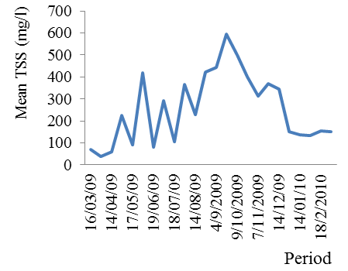Figure 5: Spatial variations in mean total suspended solids (TSS), mg/l, of Kugbo Creek during March 2009 – February 2011.

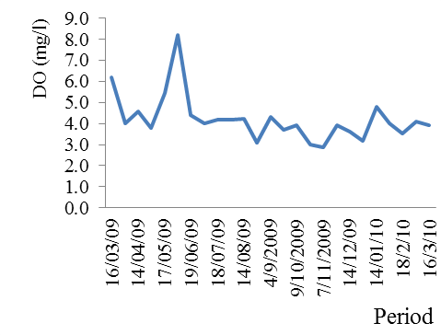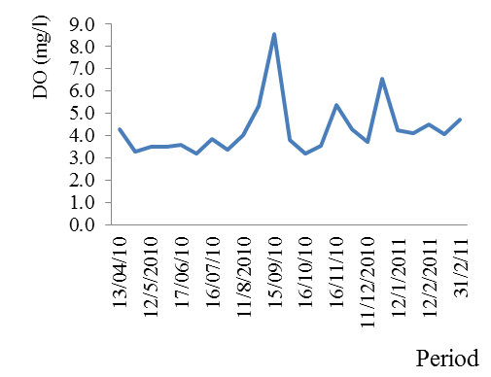
Figure 6: Spatial variations in mean DO (mg/l) of Kugbo Creek during March 2009 - February 2011.

3.2 Ichthyiofaunal Composition and Assemblage
Ichthyiofaunal occurrence and distribution in the creek showed a total of 87 species belonging to 31 families were found in samples during the study period. Fish species were distributed in all the three zones studied (Table 1). Pelagic species were 18 families, while 5 families were demersal. Those found in both habitats were 8 families. The fresh water zone (zone 1) had 50 species found in pelagic or open waters and 15 demarsal. Zone 2 had 51 species in open waters and 20 species in demersal sample. While zone three (brackish water) had 47 species in open water and 9 demarsal species obtained at the banks of the creek. Dominant family of the open brackish waters was Cichilidae with 12 representative species. This was followed by Bagridae and Characidae with 5 species each. The entire 24 months samples of both fresh water zones were dominated by Xenomistus nigri of the family Notopteridae with 7,323 individuals of the family Notopteridae with 784 individuals fish which occurred all year round. This was followed by Erpetoichthys calabaricus of the family Polypteridae with 1,306 individual. However, the brackish region (zone 3) was dominated by Tilapia zilli of the family Cichilidae. Fish found in sample were of the families Chanidae, Claridae, Gymnachidae, Nandidae, Notopteridae, Osteoglossidae, Polypteridae, Malapteridae and Phractolemidae were only found in fresh water and not brackish, while Syngnathidae, Sphyraenidae, Sciaenidae, Pomadasyidae, Polynemidae, Mugilidae, Lujanidae and Carangidae were caught in the brackish station. Others were caught in all 3 the zones.
There was marked seasonal variation in both number and biomass of fish caught during the study period. Higher values were obtained in dry months than wet. Dry season had the total catch of 28141 numbers of individual fish representing 63.4 % and a biomass of 6097739.2 g or 65.7 % biomass. Also, zone 1 had highest number of fish and biomass which were 20056 (45.2%) and 4133943.3 g (45.2%) of the total catch respectively. Least catch was in zone three with 11084 (25.0 %) and 2284372.3g (25.0%) (Table 2 and 3) respectively. Catch biomass per boat was 7.6kg while mean catch per boat per year was 3.8kg and total biomass per km2 was 0.1ton /km2 (Table 4). Analysis of variance (ANOVA) showed high significant difference between seasonal means (F=**11.96, df=1, P=0.05). Similarly, there was significant different among zones (F=*4.94, df=2, P=0.05).

Table 1: Check-List of Fish Families and Species that Occurred in Samples in Kugbo Creek during the Study Period (March 2009 - February 2011).
Finfish Family/ Species | Fresh water (Zone One) | Inter-medium (Zone Two) | Brackish (Zone Three)
ANABANTIDAE
Centropoma kingsley | + | + | -
BAGRIDAE
Auchenoglanis montel | + | + | -
A. occidentalis | + | + | -
Chrysichthys spp. | - | + | +
C. furcatus | + | + | +
C. walker | + | + | +
C. auratus | + | + | +
C. nigrodigitatus | - | + | +
C. aluuensis | + | + | +
CARANGIDAE
`Trachinotus goreensis | + | + | +
CHARACIDAE
Alestes dentex sethente | + | + | +
A. macrolepidotus | + | + | +
Brycinus longipinnis | + | + | +
B.nurse | + | + | -
Arnoldichthys spilopterus | + | + | -
Micralestes elongatus | + | + | +
M. humilis | + | + | +
CHANNIDAE
Parachanna africana | + | + | -
P.obscura | + | + | -
CICHLIDAE
Chromidotilapia guantheri | + | + | +
Oreochromis aureus | + | + | +
O.niloticus | + | + | +
Sarotheradon macrocephala | + | + | +
Hemichromis faciatus | + | + | +
H.bimaculatus | + | + | +
Pelvicachromis pulcher | + | + | -
Tilapia spp. | - | + | +
T. dageti | - | - | +
T. mariae | + | + | +
T.guineensis | - | + | +
T. zilli | + | + | +
CITHARINIDAE
Citharidium ansorgii | - | - | +
Citharinus citharus | - | + | +
CLARIDAE
Clarias sp. | + | + | -
C. macromystax | + | + | -
C. buthupogon | + | + | +
C. agboyiensis | + | + | -
C. camerunesis | + | + | +
Gymnallabes typus | + | + | -
ELEOTRIDAE
Eleotris senegalensis | + | + | +
E. Africana | - | - | +
Bostrychus africanus | + | + | +
CONGRIDAE
Cynopontitus ferox | - | - | +
GYMNARCHIDAE
Gymnarchus niloticus | + | + | -
HEPSETIDAE
Hepsetus odoe | + | + | +
LUJANIDAE
Lutjanus agennes | - | + | +
L. dentatus | - | - | +
MALAPTERURIDAE
Malapterurus electricus | + | + | -
MORMYRIDAE
Gnathonemus deboensis | + | + | +
G. cyprinoides | + | + | -
G. petersii | + | + | -
Isictithys henryi | + | + | -
MONODACTYLIDAE
Psettias sebae | - | - | +
MUGILIDAE
Mugil curema | - | + | +
M.cephalus | - | - | +
NANDIDAE
P olycentropsis abbreviata | + | + | -
NOTOPTERIDAE
Papyrocranus afer | + | + | +
Xenomystus nigri | + | + | -
OSTEOGLOSSIDAE
Heterotis niloticus | + | + | -
PHRACTOLAEMIDAE
Phractolaemus ansogei | + | + | -
POMADASYIDAE
Pomadasys perotti | - | - | +
Plectorhinchus macrolepis | - | - | +
POLYNEMIDAE
Polydactylus quadrifilis | - | - | +
POLYPTERIDAE
Erpetoichthys calabaricus | + | + | -
SCHILBEIDAE
Schilbe uranoscopus | + | + | +
SCIAENIDAE
Pseudotolithus moorii | - | - | +
SPHYRAENIDAE
Sphyraena barracuda | - | - | +
S. sphyaena | - | - | +
SYNGNATHIDAE
Syngnathus spp | - | - | +
PROTOPTERIDAE
Protopterus annectens | + | + | -
CLUPEIDAE
Sardinella | - | - | +
PANTODONTIDAE
Pontodon bucholzi | + | - | -

Table 2: Seasonal Variations in Biomass and Number of Fish Caught in Kugbo Creek during the Study Period (March, 2009 – February, 2011).
Season | Total number of fish | Percentage number of fish | Biomass of fish | Percentage Biomass
Wet Season | 16244 | 36.5 | 3050581.8 | 34.3
Dry season | 28141 | 63.4 | 6097739.2 | 65.7
Total | 44385 | 100 | 9148321 | 100

Table 3: Biomass and Number of Fish Caught in Various Sampling Zones during the Study Period (March, 2009 – February, 2011).
Sample stations | Number of fish | Percentage number of fish (%) | Biomass of fish (g) | Percentage biomass of fish (%)
Zone 1 | 20056 | 45.2 | 4133943.3 | 45.2
Zone 2 | 13245 | 29.8 | 2730005.4 | 29.8
Zone 3 | 11084 | 25.0 | 2284372.3 | 25.0
Total | 44385 | 100 | 9148321 | 100

Table 4: Estimated vital production parameters of exploited finfish from Frame Survey during the Study Period (March, 2009 – February, 2011).
1 | Number of canoes | 1208
2 | Total catch biomass (kg) | 9148.3
3 | Mean catch biomass per boat (kg) | 7.6
4 | Mean catch biomass per boat per year | 3.8
5 | Total catch biomass per year (ton) | 4.6
6 | Total area sampled (km²) | 172 (km²)
7 | Total catch biomass per km² | 0.1(tons/km²)

4.0 Discussions
The variation of temperature within 25⁰C and 34⁰C was in agreement with those observed in other shallow creeks of the Niger Delta (Chindah 1998; Edoghotu and Aleleye-Wokoma. 2007). Temperature increase from low values of 25⁰C in station one up stream freshwater region to higher values of 35⁰C is attributed to the fact that the up steam region of the creek has a lot of vegetation cover that provides shade, thus limiting direct heat of the sun, while downstream, there are no such vegetation cover Hence the high temperature. Also, rainy season temperature values were lower than that of dry season due to the cool weather condition of wet season with less sun-shine.
Depth values revealed that the creek is shallow as maximum value recorded is 925 cm. The depth is attributed to silting process that had been on in the creek over the years as evident in total suspended solids and secchi disc result.
Values were in agreement with that of other similar studies, Chindah and Osuampke (1994); Edoghotu (1998). Mean range values of 4.3 cms⁻¹ ± 0.7 and 7.6 cms⁻¹ ± 3.4 for flow rate in the Kugbo creek was also within the limit of other observations.
Measurement on secchi disc for transparency showed poor light penetration into the water body. This was evident in the mean transparency per station with value range of 34.89 cm ± 2.67 to 265.00 cm ± 58.87, and was attributed to the high suspended matter observed that created shading effect. Observed values of Total Suspended Solids were high. Values were as high as 881mgl⁻¹, recorded in wet months, depicting rapid ongoing silting process. However, it was minimal in the dry season as values low as 25mgl⁻¹ was observed. Seasonally, values were also higher in wet than dry season due to erosion that is associated with wet season.
DO level was generally low as maximum value was 13 mgl⁻¹. Values ranged from 2.9 mgl⁻¹ ± 0.84 to 8.2 mgl⁻¹ ± 4.1. Values for DO observed during the study were within limits previously reported by other authors. The 87 species of 31 families of fin fish found in this study is relatively higher than that of Abowei (2000) with 36 species in 22 families of the lower fresh water reaches of River Nun; 44 species of Lown-McConnel, (1964) on Riepennime River; 46 species in 20 families of Okereke (1990) in Otamiri River; Imo State, and observed 41 species in Kolo Creek of Alfred-Ockiya (1998). Other comparable but higher results in Nigeria are Nwadiaro (1989) of Oguta lake (98 species), Reid and Syndenham (1979); 58 species from Ikpoba River, Binnin City, Imevbore (1975) 70 species from River Niger; 120 species from lower Benue River; Victor and Tetteh (1988). The most common and efficient fishing methods found along the creek was indigenous fish ponds. They were abundant in fresh water zone 1, followed by zone 2 and were fished during the dry season which resulted in the high number of fish and biomass in the dry season and that of the fresh water zones 1 and 2 respectively constituting more than 85% of gear types and fishing methods. Thus its contribution was highest in zones 1 and 2 where they were more concentrated, giving rise to the observed high fish landing of 4133943.3 g (45.2%) and 2730005.4 g (29.8%) biomass in zones 1 and 2 respectively. Similarly, seasonal variation showed both highest numbers, 28141 (63.4%) individuals and biomass of 6097739.2g (65.7%) in dry season due to the contribution of the local ponds which were fished exclusively during this season. This observation no doubt, has reflected in the ANOVA among seasons and that of zones, with high significance in dry season and zone 1 and 2 respectively as further revealed by Duncan’s multiple range test.

Acknowledgements:
I wish to acknowledge my friend, Professor Alex Chuks Chindah, of blessed memory, of the Institute of Pollution Studies (IPS), Rivers State University of Science and Technology, Port Harcourt; for his immense contributions and assistance during the preliminary stages of this work before his demise. I also appreciate the professional advice of Professor Frances D. Sikoki of the Department of Animal and Environmental Biology (AEB), University of Port Harcourt; to me during the period of this research.

Corresponding Author:
Dr. Edoghotu, A. J
Department of Biology. Ignatius Ajuru University of Education, Rumuolumeni, Port Harcourt
E-mail: azibodiedoghotu@gmail.com

References
- Abowei J. F. N. (2000). Fish Stock Assessment in the Freshwater Reaches of the Lower Nun Rivers, Bayelsa State Nigeria (Ph.D Thesis). University of Port Harcourt. Nigeria. Pp. 197.
- Amakiri, E. N. (2005). Aspects of the Biology of Psudotolithus elongantus (Bbowdich, 1825) of Bonny Estuary, Niger Delta, Nigeria (M. Sc. Thesis). Rivers State University of Science and Technology, Port Harcourt. Pp 99.
- APHA, (1976). Standard Methods for the Examination of Water and Waste Water, 14th edition, N.Y., American Public Health Asociation, Pp.1193.
- Allison, M. T., Gabriel, U. U., Inko-Tariah, M. B. Dawils O. A. and Uedeme-Naa, N. (1997). The Fish Assemblage of Elechi Creek, Rivers state, Nigeria, Niger Delta. Biologia, 2(1): 90-96.
- Alison M. E. and Okadi, D. (2009). Species Distribution and Abundance in the Niger Deltta. Nigerian Journal of Fisheries, 4(1):13-18.
- Alfred-Okiya, J. f. (1996). Studies on the Ichthyofauna of Kolo Creek. Rivers State, Niger Delta. Biologia, 1(2): 24 – 28.
- Avise J. C. (1990) Flocks of African Fisheries. Nature. 347:512-513.
- Chindah A. C. and Osuampke, A. (1994). The Fish Assemblage of the Lower Bonny River, Niger Delta, Nigeria, Africa. J. Ecol. 32: 58-65.
- Clark S. H. (1979). Application of Bottom Trawl Survey. Fisheries, 4(3): 9-15.
- Edogbotu, A. J. (1998). The Ecological Quotients (EQ) of Point Sources of Pollution along Kugbo creek, Port Harcourt. M.Sc. Thesis, Rivers state, University of Science and Technology, Port Harcourt (unpublished). Pp. 112.
- Ekeh, I. B. (1990). The fish community of an Unlam Stream Owerri South. M.Sc Thesis. Dept. of Zoology. University of Port Harcourt, Pp. 142.
- Fagade S. O. and Olaniyan, C. I. O. (1972). The Biology of the West African Shad Ethmolosa fimbriata in the Lagos lagoon. J. Hydrobiol. 4: 519- 534.
- Fagade, S. O. (1983). The Biology of Chromidotilapia gunteri from a Small Lake: The Fisheries of Some Physico-Chemical Conditions and Fish Catch in the Fresh Water Reaches of the Lower Nun Rivers. Niger Delta. International journal of science and technology, No. 2: 161- 169.
- Fernando M. P., Simoes, J. R., Lima-Junior, D. P., Orsi, M. L. and Agostinho A. A. (2014). A Serious New Threat to Brazilian Freshwater Ecosystems: The Naturalization of Nonnative Fish by Decree. Conservation Letters. 7.1:55-60.
- Imerbore, A. M. A. (1975): Fish Populations in the Newly Created L. Kanji, The transition from Rivers to lake-Eds: A.M.A. Imevbore & O. S. Adegore, Ile-Ife, University of Ife press, Nigeria. Pp. 420.
- Ita, E. O and Maclahili, A. (1997). The Current Status of Fish Stock and Fisheries in Kanji Lake. The Nigerian- German (Gtz) 115(3): 463-475.
- Imebore. A. M. A. (1971). Floating Vegetation of Lake Kainji, Nigeria. Nature London. 203: 599-600.
- Khan. R. A and Thulin, J. (1991): Influence Aquatic Animals. Advances in Parasitology. 30: 302-238. Kaijji lake Fisheries Promotion Project, New Bussa. Pp. 128.
- King, R.P. (1991). Some Aspects of the Reproductive Strategy of Illisha africana (book 1795) (teleost, dupudae) in Qua Iboe Estuary, Nigeria. Cybium, 15(3): 239-251.
- Lioyd, R. (1992): Pollution and Freshwater Fish, Fishing News Books, Oxford UK., Pp.192.
- Maitland, P. S. and Morgan, N.C. (2001). Conservation Management of Freshwater Habitats: Lakes, Rivers and Wetlands. Boston, MA: Kluwer Academic Publishers. 670Pp.
- Mann, M. J. (1962). Fish Production from the Nigerian Shores of Lake Chad, 1: 61. Fed. Fisheries. Lagos: 50Pp.
- Nwandiaro, C. S. (1989). Icthyiofauna of lake Oguta, a Shallow Lake in Southern Nigeria, Arch. Hychobiol. 115(3):164-475.
- Nweke, A. N. (2000). Impact of Organic Pollution on Micro-benthos and Fish Fauna of Elechi Creek (Ph.D. Thesis). Department of biological science, Rivers State University of Science and Technology, pp. 24 - 287.
- Nwadukwe, F. O. (1995). Species Abundance and Seasonal Variations in Catch from two Mangrove Habitats in Lagos Lagoon. Envi. Ecol. 13: 121-128.
- Otobo, A. J. T. (1993). The Ecology and Fishery of the Pygmy herring (Sierrathensa kinesis (thysvan Den Audenarde, 1969) in the Nun Rivers and Taylor Creek of the Niger Delta (Ph. D. Thesis). University of Port Harcourt, pp.298.
- Okereke, F. O. (1990). Studies on the Fish Fauna of Otamiri River, Imo state, Nigeria (M.Sc. Theris). University of Port Harcourt, Choba (unpurlished). 63pp.
- Otobo, F. O. (1974). The Potentials for Clupeid Fisheries in Lake Kainji, Nigeria. Afri. Jr. Hydro-Biol. Fisheries 3:124-134.
- Ogamba, N. E. (1998). Base Line Survey of the Fisheries of Elechi Creek (M.Sc. Thesis). Department of Biological Science, Rivers State University of Science and Technology, Port Harcourt Pp14 – 91.
- Pauly, D. (1983). Some Simple Methods for the Assessment of Tropical Fish Stock. FAO Fish. Tech. Paper 234:52.
- Raid, G. M.A and Syderiham, D. H. J. (1979). A Checklist of Lower Benue River Fishes and Ichthyo-geographical Review of the Benue River (West-Africa) J. Native. Hist. 13: 41-67.
- Sikoki F. D. and N. Zabbey (2006). Aspects of Fisheries of the Middle Reaches of Imo Rivers, Niger Delta, Nigeria. Env. Ecd. 24(2): 309-312.
- Sikoki, F. D. and Hart, A. I. (1999) studies on the Fish and Fisheries of the Brass Rivers System and Adjoining Coastal Waters in Bayelsa State, Nigeria. Journal of applied science and environmental management, 2: 63-67.
- Simon, I., (2007). Finfish Assemblage of the lower Benue River, Nigeria. Post Graduate Diploma Thesis. Rivers State University of Science and Technology, Port Harcourt. Pp 102.
- Song,J., Collin, S. P. and Popper, A. N. (2015). The Sensory World of Fish and Fisheries: The Impact of Human Activities. An International Conference to Evaluate the Effects of Environmental Changes on the Sensory World of Fish /Aquatic Animals and Fisheries. Integrative zoology, 10:1-3.
- Sydenham, D. H. J. (1977). The Qualitative Composition and Longitudinal Zonation of the Fish Fauna of River Ogun, Western Nigeria- Review Zool. Afri. 91: 974-996.
- Thomsen, M. S., Wernberg, T., Olden, J. D. Byers J. E., Bruno, J. F., Silliman, B. R. and Schield, D. R. (2014). Forty years of Experiment on aquatic invasive species: are study biases limiting our understanding of impact? Neobiota 22: (1-2).
- Welcome, R. L. (2001). Inland Fisheries: Ecology and Management. Oxford, U.K.: Blackwell science.
- Wright, J. M. (1986). The Ecology of Fishes in Shallow Water Creeks in Nigeria. J. Fish Biol. 29:431-441.

4/19/2016

