**Genotypic Detection of Resistance in Bacteria Associated With Urethral Catheterised Patients at a Tertiary Hospital in Abia State, Nigeria**

1&2Iwu, J. O. 2Chikere, C.B. and 2Otokunefor, T.O.

1Federal Medical Centre Umuahia, Abia State, Nigeria

2Department of Microbiology, University of Port Harcourt, Rivers state, Nigeria

**Abstract:** The increasing rate of catheter associated urinary tract infection (CAUTI) represents a major public health concern. This study investigated the incidence of plasmid-mediated extended spectrum β-lactamases (ESBL) in clinical isolates associated with CAUTI in patients at a Tertiary Hospital in Abia State, Nigeria. A total of 1000 urine specimens from 1000 patients on urethral catheter were cultured, bacterial isolates identified using Analytical Profile Index followed by antibiogram determination. Detection of plasmid-borne ESBL genes CTX-M, SHV and OXA in isolates was done by PCR. Molecular characterization of isolates with 16SrRNA gene identified them as *Klebsiella pneumoniae*, *Lysinibacillus sphaericus, Serratia* sp., *Alcaligenes faecalis* strains, *Escherichia coli* strains, *Strenotrophomonas* sp.*, Providencia rettgeri, Serratia s*p. *Staphylococcus sciuri, Flavobacterium mizutaii, Pseudomonas aeruginosa* strains, *Shigella flexneri*,*Proteus vulgaris*,*Bacillus pumilus*, *Enterococcus faecalis*, *Shigella flexneri*, *Bacillus megaterium* and *Bacillus toyonensis.*All sequences were deposited in GenBank under accession numbers KT984383-KT984405. The organisms showed 100% resistance to Cotrimoxazole and Cloxacillin while 99% to Cefixime, 98% to Tetracycline, 96% to Augmentin, 94% to Erythromycin and Streptomycin, 93% to Ceftazidime and Cefuroxime, 89% to Nitrofurantoin, 83% to Chloramphenicol, 77% to Ciprofloxacin and 67% to Gentamycin. *Staphylococcus* was the most abundant uropathogen with a prevalence rate of 85.4%, followed by *Pseudomonas* 7.0%, *Klebsiella* 4.4*%, E.coli* 2.2% and *Proteus* 1.0%. ANOVA showed insignificant difference between means for the various parameters examined at P ≤ 0.05. Out of the 40 bacterial isolates screened for plasmid-borne ESBL genes, 51% harbored SHV genes, 49% had CTX-M genes while none was found with OXA genes. With the emergence of ESBL resistance in these clinical isolates, therapeutic options may become very restricted to physicians if appropriate measures to stop or reduce this trend are not enforced.

[Iwu, J. O., Chikere, C.B. and Otokunefor, T.V. **Genotypic Detection of Resistance in Bacteria Associated With Urethral Catheterised Patients at a Tertiary Hospital in Abia State, Nigeria.** *N Y Sci J* 2016;9(4):32-45]. ISSN 1554-0200 (print); ISSN 2375-723X (online). <http://www.sciencepub.net/newyork>. 6. doi:[10.7537/marsnys09041606](http://www.dx.doi.org/10.7537/marsnys09041606).

**Keywords:** ESBL; Antibiogram; CAUTI; Genotypic Detection; Resistance; Bacteria Associated

**1. Introduction**

The origin, and spread of multi drug resistance (MDR) strains or determinants, or both may accounts for excess of MDR. The major reason for spread of resistance to multiple antibiotics is horizontal gene transfer. Better clarification and understanding of MDR is to divide the explanations into origin and spread. It is important to understand according to Poole (2005), “that a single biochemical mechanism may induce resistance to more than one drug”, as in that of bacterial efflux pumps (Alekshun and Levy, 2007), which reduces intracellular antibiotic concentrations by removing antibiotics out of cells thereby causing resistance to the antibiotic.

It has been documented and also a common knowledge that variety of efflux systems are antibiotic specific (Poole 2005), while some may induce resistance to multiple drug classes, also a common knowledge that efflux pumps could provide low-level drug resistance (Pumbwe *et al.,* 2006; Chang *et al.,* 2007). Cell wall thickening affects the penetration of antibiotics with large molecular size inducing resistance like in *S. aureus* against vancomycin and daptomycin antibiotics (Pumbwe *et al.,* 2006*)*.

Single biochemical mechanism confers multiple resistance, a hypothesis, which may be confirmed or rejected by standard bacterial genetics, as well as corresponding strains MICs of different drugs. Whereby it is the only mechanism that causes resistance, then phenotypes could be seen together with no exclution. Li *et al.* (2004) said that “when efflux pump gene *ifrA* in *Mycobacterium* *smegmatis* is removed, there will be reduction inthe MIC to multiple drugs, and over expression of same gene may lead to increase resistance for multiple drugs” one other hypothesis tasted is the diversity as well as the intensity of antimicrobial used in hospitals which selects for genetic changes and substrate specificity of inhibition mechanisms. Blazquez *et al.* (2000) reported that “evolution of Plasmid-borne TEM beta-lactamases evolution and the exposure to penicillin and cephalosporin revealed dual specificity on two related compounds; also change of sequence evolved that mimicked isolates seen in human while exposure of plasmid containing isolates to either of the two antimicrobial agents result to sequence changes in beta-lactamase that ordinarily could not be present previously in human isolates”.

The effectiveness of different drugs in the treatment of infections (Neyfakh *et al.,* 1991; Pages *et al.,* 2009), depends on the efficient efflux pump inhibitors of which this mechanism is very important. Study by Gupta *et al.* (2013) proves that one of the efflux inhibitors is verapamil, which enhances rapid anti tuberculosis drug effectiveness in mic but clinically, the use of efflux pump inhibitors are limited. Clinically available drugs or agents for example, “Verapamil and reserpine though their host pharmacological effects reduced their use as antimicrobial drugs” (Neyfakh *et al.,* 1991; Ughachukwu *et al.,* 2012).

Hall (2012) “stated that multiple drug resistance isolates are genetically linked and they are physically close on bacterial chromosomes or on the same horizontally transmitted element, as in plasmid or conjugative transposon”. Roberts *et al.* (2009) therefore, admitted that “if a strain acquires one resistance phenotype that means it could have acquired other horizontally transmitted elements, like transposons, integrons, and plasmids, which may acquire other new elements within a space of time” (Hall, 2012.). The genetic components transposons expresses or encodes transposases which enables other genomic regions to be incorporated (Alekshun and Levy*,* 2007). Hall (2012) studies revealed that “gene cassettes are harbored in integrons which through site-specific recompenses encoded by the integrons themselves. Chromosome or plasmid may habor trnsposons and integrons though they can be transmitted between species such as transformation, transduction, and conjugation but it is not yet clear on the genetic mechanisms of these mobile genetic elements” (Roberts *et al.,* 2009*)*.

Following the findings of Courvalin *et al.* (1986), some of these mobile genetic elements example “Conjugative transposon Tn*1545* in *S. pneumoniae* has genes for multiple antibiotics resistance with the tendency to enter a new bacterial host cell by conjugation or transposition to another genomic region”. Reports of Nordmann *et al.* (2012) has shown that “*Enterobacteriaceae* integrons contain genes resistance to antibiotics like beta-lactams, aminoglycosides, sulfonamides, and chloramphenicol. Though, some *Enterobacteriaceae* have plasmids without integrons yet they habor antibiotic resistance genes/trait for multiple drug classes, like, amino glycosides, beta lactams, tetracycline, chloramphenicol, and sulfamethoxazole” (Huang *et al.,* 2012). However, there may be advantage in resistance for one strain because it enables isolates of that species to withstand the host when treated for another disease with an agent that destroys that species.

Bergstrom *et al.* (2004) stated that “ theoretical studies of one such approach, known as antimicrobial cycling, shows that cycling reduces such contacts only under restricted conditions,though in practice, cycling strategies may be difficult to implement and to study” (Fridkin, 2003*)*. Alternative strategy, by Abel *et al.* (2014) called “adjustable cycling,” meaning “if treatment is changed when not effective in patients, has been believed and shown in theoretical model to suppress the emergence of MDR in many settings.” Fridkin (2003) pointed out that “the clinical implication of these linked determinants lies on their persistence as linked group and polished understanding of the selective pressures that preserved and allowed the proliferation of these multidrug resistance elements may improve the ability to reduce their frequency.” As a matter of fact, Speed of mutation determines variation in bacterial lineages.

ESBLs are product of point mutation of major amino acids in the parent cell and some genes of resistance identified according to Paterson and Bonomo (2005), were, “TEM-1, TEM-2 and SHV-1 but their spectrum profile permits hydrolysis of Oxyimino-cephalosporins and monobactams, however, 7-alphamethoxy-cephalosporins (Cephamycins), are not included, though, some beta-lactamase inhibitors like, Clavulanic acid, Sulbactam and Tazobactam are known to inhibit ESBL organisms” (Bradford, 2001). There is continuous mutation among ESBLs that results to formation of new enzymes demonstrating expanded substrate profiles (Pitout *et al.,* 2005). Anothher gene CTX-M was identified between late 1990s and early 2000s, from *Escherichia coli* which causes urinary tract infection (Pitout *et al.,* 2005). ESBLs producing CTX-M have about 40% similarity with TEM and SHV enzymes (Livermore *et al.,* 2007), however, the rest of ESBL enzymes are not common and their epidemiological data are very limited (Kiratisin *et al.,* 2008).

ESBLs are classified based on their structural difference, and amino acid sequence, of which more than 300 variants identified are clustered into nine (Bali *et al.,* 2010). It is now a standard by Robberts *et al.* (2009) and Kohner *et al.* (2009) to “screen for ESBL in routine antimicrobial susceptibility testing according to the Clinical Laboratory Standards Institute (CLSI) recommendations, using the beta lactam ring group of drugs followed by phenotypic confirmation for the positive cases based on demonstrating the effectiveness of the screening antibiotic in the presence of a beta lactamase inhibitor (Clinical Laboratory Standards Institute, 2011).” Robberts *et al.* (2009) advised that “results should be issued based on preventing inappropriate use of cephalosporins or monobactams in the setting of ESBL production.” In 1988, Bauernfeind *et al.* (1989) revealed a case of plasmid-mediated AmpC beta-lactamases. Also, Bauernfeind *et al.,* 1989 reported that “AMPC beta lactamases confer transferable resistance to the cephamycins, and they are not inhibited by beta-lactamase inhibitors.” Moland *et al.* (2006) noted that isolates with both ESBL and AmpC are more frequent. But in response to this development,Thomson (2001) and Robberts *et al.* (2009), both concluded that “the effect of this combination will negatively affect the result of current ESBL screening and confirmatory testing because the two enzyme groups have overlapping hydrolysis spectra though inability to detect ESBLs can put the health of patient at risk because of the reported false susceptibility to cephalosporins” (Thomson 2001), though how AmpC production results to uncertainty about the accuracy of CLSI on ESBL confirmatory tests is yet not clear.

One of the major reason for their resistance is arbitrary use of antibiotics in the treatment of infection though early detection of the antibiotic pattern is important for treatment (Bazzaz *et al.,* 2009). The frequency of ESBLs among clinical strains differs from one region to another, variations in countries and institutions have been recorded. The gene blaSHV-15 is reported to be common and frequent and always associated with a variant of *Escherichia coli* (Valverde *et al.,* 2004). ESBL genes *bla*TEM and *bla*SHV have been documented to be related to cross infection in hospitals. In an investigation conducted by Reddy *et al.* (2007) in Chicago, “the rate of ESBL gene carriage among high risk and hospitalized patients increased from 1.3% to 3.2%, and bacteriaemia developed in 8.5% of all previously identified ESBL gene carriers during hospitalization and in Spain, an increase was also observed in faecal carriage in hospitalized patients from 0.3% in 1991 to 11.8% in 2003” (Murat *et al.,* 2010).

In Nigeria, Murat *et al.* (2010) identified ESBL producing *E. aerogenes* recovered from blood sample of patient admitted to a tertiary care hospital. Chow *et al.* (2000) have reported that” members belonging to Enterobacteriaceae family evade antibacterial treatment by the over expression of chromosomal AmpC beta lactamase and further complications are emerging with Class A ESBL producing strains.” Though some hospitals may not find it convenience to carry out routine check for ESBL producing organisms but studies by Mathai *et al.* (2001), shows that the percentage of ceftazidine resistance among isolates of *K. pneumoniae*, “ranges from 5 to 10% for non-intensive care unit (non-ICU) and ICU isolates, respectively”. ESBL producing isolates are product of mutation with unique hydrolytic properties that has enzymes to digest β-lactam antibiotic, that carrys oxyimino group such as oxyimino-cephalosporins but are inhibited by clavulanate and tazobactam. This study investigated the incidence of plasmid-mediated extended spectrum β-lactamases (ESBL) in clinical isolates associated with CAUTI in patients at a tertiary hospital in Abia State, Nigeria.

**2. Materials And Method**

**2.1. Area of Study:** This study was carried at Federal Medical Centre, Umuahia, Abia State, Nigeria. Umuahia is a cosmopolitan city located in the South East region of Nigeria mostly populated by indigenes and people from other parts of the country. The Federal Medical Centre, Umuahia remains the most attended public health facility in the state. Amongst other infections, urinary tract infections account among the major causes of hospital attendance in the state.The hospital contains approximately 1,800 beds with many sub-specialties like ENT unit, O&G unit, Sugery, Medicine, Peadiatrics, mental health, A&E, G.O.P.D and many branches of laboratory units. The hospital remains the first tertiary institution in Nigeria to have and *do in-vitro* fertilization (IVF) if not in West Africa or Africa at large. Abia state is estimated to be approximately 2.84million in 2006.

**2.2. Sample collection:** Specimen urine was collected from either the catheter tubes or the uribag to avoid missing organisms associated with the catheter. The urine samples were transported within 30 minutes of collection to the laboratory for analysis, patients with already existing urinary tract infection wer excluded.

**2.3. Culturing, Isolation and Identification:** The samples were cultured using cystein, lycin, electrolyte deficiency (CLED) ager plate under strict aseptic procedure (Cheesbrough, 2000). Using the calibrated loop method with a loop diameter of 4mm, 10ul of uncentrifuged specimen was transferred onto the agar plate and streaked without flaming the loop for isolation and incubated at 350c-370c for 24hr. The single colony type cultures were identified using standard microbiological methods up to genus/species level wherever applicable.

**2.4. Antibiogram of bacterial isolates:** Antibiotic sensitivity testing was done following the Kirby-Bauer disc diffusion method according to the Clinical and Laboratory Standards Institute (CLSI, 2011) guideline. The antibiotics tested were broad-spectrum penicillin, third generation cephalosporin, fourth generation cephalosporin, quinolones, tetracycline, macrolides, aminoglycosides and sulphonamides (Hemidia, India).

**2.5. Molecular Studies**

**2.5.1. DNA extraction:** Extraction was done using a ZR bacterial DNA mini prep extraction kit supplied by Inqaba South Africa. A heavy growth of the pure culture of *bacterial* isolates was suspended in 200µl of isotonic buffer into a ZR bashing bead lysis tubes, 750µl of lysis solution was added to the tube. The tubes were secured in a bead beater fitted with a 2µl tube holder assembly and processed at maximum speed for 5 minutes. The ZR bashing bead lysis tubes were centrifuged at 10,000x*g* for 1 minute. Four hundred (400µl) of supernatant was transferred to a Zymo-Spin IV spin Filter (orange top) in a collection tube and centrifuged at 7000 xg for 1 min. One thousand two hundred (1200µl) of bacterial DNA binding buffer was added to the filtrate in the collection tubes bringing the final volume to 1600µl, 800µ l was then transferred to a Zymo-Spin IIC column in a collection tube and centrifuged at 10,000x*g* for 1 minute, the flow through was discarded from the collection tube. The remaining volume was transferred to the same Zymo-spin and spun. Two hundred (200µl) of the DNA Pre- buffer was added to the Zymo-spin IIC in a new collection tube and spun at 10,000x*g* for 1 minute followed by the addition of 500 µl of bacterial DNA Wash Buffer and centrifuged at 10,000x*g* for 1 minute. The Zymo-spin IIC column was transferred to a clean 1.5µl centrifuge tube, 100µl of DNA elution buffer was added to the colum matrix and centrifuged at 10,000 *xg* for 30 seconds to elute the DNA. The ultrapure DNA was then stored at -20oc for other downstream reaction.

**2.5.2. Plasmid extraction:** Extraction was done using a ZR plasmid miniprepTM-classic extraction kit supplied by Inqaba South Africa. 0.5 to 5µl of bacterial culture in a clear 1.5µl tube was centrifuged at full speed for 15 to 20second in a micro centrifuge (Denvile scientific Inc.). The supernatant was discarded. 200µl of P1 buffer (red) was added to the tube and pellet re-suspended completely by vortexing Then, 200µl of P2 buffer (green) was added and mixed by inverting the tube 2 -4 times. Cells were completely lyzed when the solution appeared clear, purple, and viscous. Thereafter, 400µl of p3 buffer (yellow) was added and mixed gently but thoroughly (No vortexing). The sample turned yellow when the neutralization was completed. The lysate was allowed to incubate at room temperature for 1- 2 min and samples were centrifuged for 2min. Zymo-spin TM 11N column was placed in a collection tube and the supernatant from the step above was transferred into the Zymo–spin TM 11N column. When pipetting the supernatant, care was taken to avoid disturbing the green pellet to avoid transferring any cellular debris to the column. The Zymo–spin TM11N/collection tube assembly was centrifuged for 30s. The flow-through in the collection tube was discarded, making sure the flow –through does not touch the bottom of the column. The Zymo-spin TM11N column was returned to the collection tube. Then, 200µl of Endo-wash buffer was added to the column and centrifuged for 30s. After, 400µl of plasmid wash buffer was added to the column and centrifuged for 1min. The column was transferred into a clean 1.5µl micro centrifuge tube and then 30µl of DNA elution buffer was added to the column and centrifuged for 30s to elute the plasmid DNA.

**2.5.3. PCR amplification of CTX-M, SHV and OXA resistant genes.**

The CTX-M gene was amplified using the primer set CTX-M/F: CGCTTTGCGATGTGCAG and CTX-M/R: ACCGCGATATCGTTGGT, SHV gene was amplified with the primer set SHV/F: CGCCTGTGTATTATCTCCCT and SHV/R: CGAGTAGTCCACCAGATCCT while OXA gene was amplified using the primer set OXA-1/F: AGCCGTTAAAATTAAGCCC and OXA-1/R: CTTGATTGAAGGGTTGGGCG on an ABI 9700 Applied Biosystems thermal cycler in a final volume of 25ml for 35 cycles. The PCR mix included: the X2 Dream taq Master mix (Inqaba Biotec, South Africa) comprising taq polymerase, DNTPs and MgCl, the primers at a concentration of 0.4M and the individual extracted DNA representing each resistant was gene used as template. The PCR conditions were as follows: Initial denaturation, 95ºC for 5 minutes; denaturation, 95ºC for 30 seconds; annealing, 52ºC for 30s; extension, 72ºC for 30 seconds for 35 cycles and final extension, 72ºC for 5 minutes. The PCR products were resolved on a 1% agarose gel at 120V for 15 minutes and visualized in a UV transilluminator.

**2.5.4. 16S rRNA amplification:** The 16s RRNA region of the rRNA genes of the isolates were amplified using the 27F and 1492R primers on an ABI 9700 Applied Biosystems thermal cycler in a final volume of 25 microlitres for 35 cycles. The PCR mix included: the X2 Dream taq Master mix supplied by Inqaba, South Africa (taq polymerase, DNTPs, MgCl), the primers at a concentration of 0.4M and the extracted DNA as template. The PCR conditions were as follows: Initial denaturation, 95ºC for 5 minutes; denaturation, 95ºC for 30 seconds; anealing, 52ºC for 30 seconds; extension, 72ºC for 30 seconds for 35 cycles and final extension, 72ºC for 5 minutes. The product was resolved on a 1% agarose gel at 120V for 15 minutes and visualized on a UV transilluminator (Fastgene-UV Transilluminator).

**2.5.5. 16S rRNA sequencing:** The amplified 16S products were sequenced on a 3500 genetic analyzer using the Big dye termination technique by Inqaba Biotec South Africa.

**2.6. Phylogenetic analysis:** The sequences were edited using the bioinformatics algorithm BioEdit, similar sequences were downloaded from the National Biotechnology Information Center (NCBI) data base using BLASTN, and these sequences were aligned using ClustalX. The evolutionary history was inferred using the neighbour-joining method in MEGA 6.0. The bootstrap consensus tree inferred from 500 replicates is taken to represent the evolutionary history of the taxa analyzed. Branches corresponding to partitions reproduced in less than 50% bootstrap replicates were collapsed. The evolutionary distances were computed using the Jukes-Cantor method Tamura *et al*., (2013) and are in the units of the number of base substitutions per site.

**3. Results**

Figure 1 shows other clinical conditions of patients used in this study and this include congestive cardiac failure (15%), acute abdomen (10%) and cerebrovascular accident (9%) which are also age related. The remaining clinical conditions that lead to catheterization cut across to all ages and their occurrence are minimal as shown by their degree of percentage occurrence 5% and 6%.

Figure 2 reveals that a total of 58.4% of the isolates were gram positive while 10% were gram negative, tracing it down to Figure 3, shows that the gram positive were *Staphylococcus* spp. while the gram negative were *Pseudomonas* spp.*, E*. *coli*, *Klebsiella* spp. and *Proteus* spp.

Resistant and subsceptibility pattern of the organisms as shown in Figure 4a- 4b reveals that no single antibiotic used in this study was sensitive to all the isolates.

Table 1 shows samples with positive and negative electrophrotic bands. Table 2 shows analysis of 16s rRNA sequence. Table 3 shows phenotypic, genotypic identification and primer genes. A comparative analysis of the various identification and gene primers shows that the molecular identifications were to a large extent different from the phenotypic results. Table 4 shows molecular and biochemical identification and 16s sequence matches for bacteria isolates recovered from catheter urine in patients. Some factors may account for that, it may be that we were dealing with contaminants and also noted that catheter urine are always polymicrobial in nature, possibly what we thought to be pure culture may not be 100% pure. None of the isolates contain OXA gene as seen in Figure 9, while some contain both CTX-M gene and SHV genes.

Table 1 reveals that apart from gentamycin, Ciprofloxacin, Augmetin, and Ofloxacin, E. *coli* was 100% resistance to other drugs used in this study while *Klebsialle* had similar behaviour apart from Ceftazidine, Gentamycin, Nitrofuretion, Chloremphenicole, Ofloxacin and Augumetin. Also *Proteus* had similar pattern apart from Gentamycin, Cefuroxime, Chloremphenicole and ofloxacin. The whole organisms had 100% resistant to cotrimoxazole, Cefuroxime, Streptomycin and tetracycline. This may be due to common drug abuse and the drugs are available to every chemist shope.figure 8 highlighted the total percentage of resistance of the organisms to each drug: Cloxacillin (99.85%), Cefixime (98.98%), Augmetin (95.47%), Cotrimoxazole (100.0%), and Ceftazidine (92.98%). This demonstrates high degree of resistance to commonly used antibiotics.

The electrophoretic bands of the amplicons as shown in Figure 6, reveals the base pair (BP) of the 16S rRNA to be almost 1500bp, the negative control can be observed immediately after sample 15, a well without noticeable band would be seen. Some of the isolates without positive bands may be as a result of technical errors during the procedure, like omitting to mix the sample with the master mix which implys that the master mix was subjected to amplification without the sample DNA which acts as the template or the isolates do not have the nucleotide sequence of the genes used as primers.

Figure 7 reveals the base pair of the CTX-M gene used to be 550bp, some sample did not show positive bands which may be that the primer gene was not contained in those isolates and therefore was unable to be amplified because the CTX-M primer was unable to define the nucleotid sequence for amplification. The same thing happens in Figure 8, where the base pair of SHV gene was 293bp. There are various sub classes of CTX-M, SHV and OXA which invariably may account for the negative bands as the class used in this study may not be the class those negative band isolates possess. About 55% of the isolates showed positive SHV gene while 52.5% showed negative. No organism possess the OXA gene used in this study, 22.5% of the isolates had both CTX-M and SHV genes while 10% never had any of the primer genes used in this study (Figure 9). The evolutionary tree of the organisms defined the similarity of the isolates to their ancestral parents (Figure 10). One striking thing can be noticed in Figure 10, *E. coli* had close evolutionary link to *Shigella* spp. Table 4 reflects the accession number of the isolates from the catheter urine (KT) and its equivalent similarity from the gene bank (GI) with the corresponding primer gene.

**Figure 1: Indication for catheterization**

**Figure 2: Preliminary identification by gram staining**

**Figure 4a: Analysis of antibiotic susceptibility and resistant patterns of individual organism**

**Figure 4b: Analysis of antibiotic susceptibility and resistant patterns of individual organism Continued**

**Figure 5: Ttotal percentage resistance/susceptibility of the organisms to each drug**

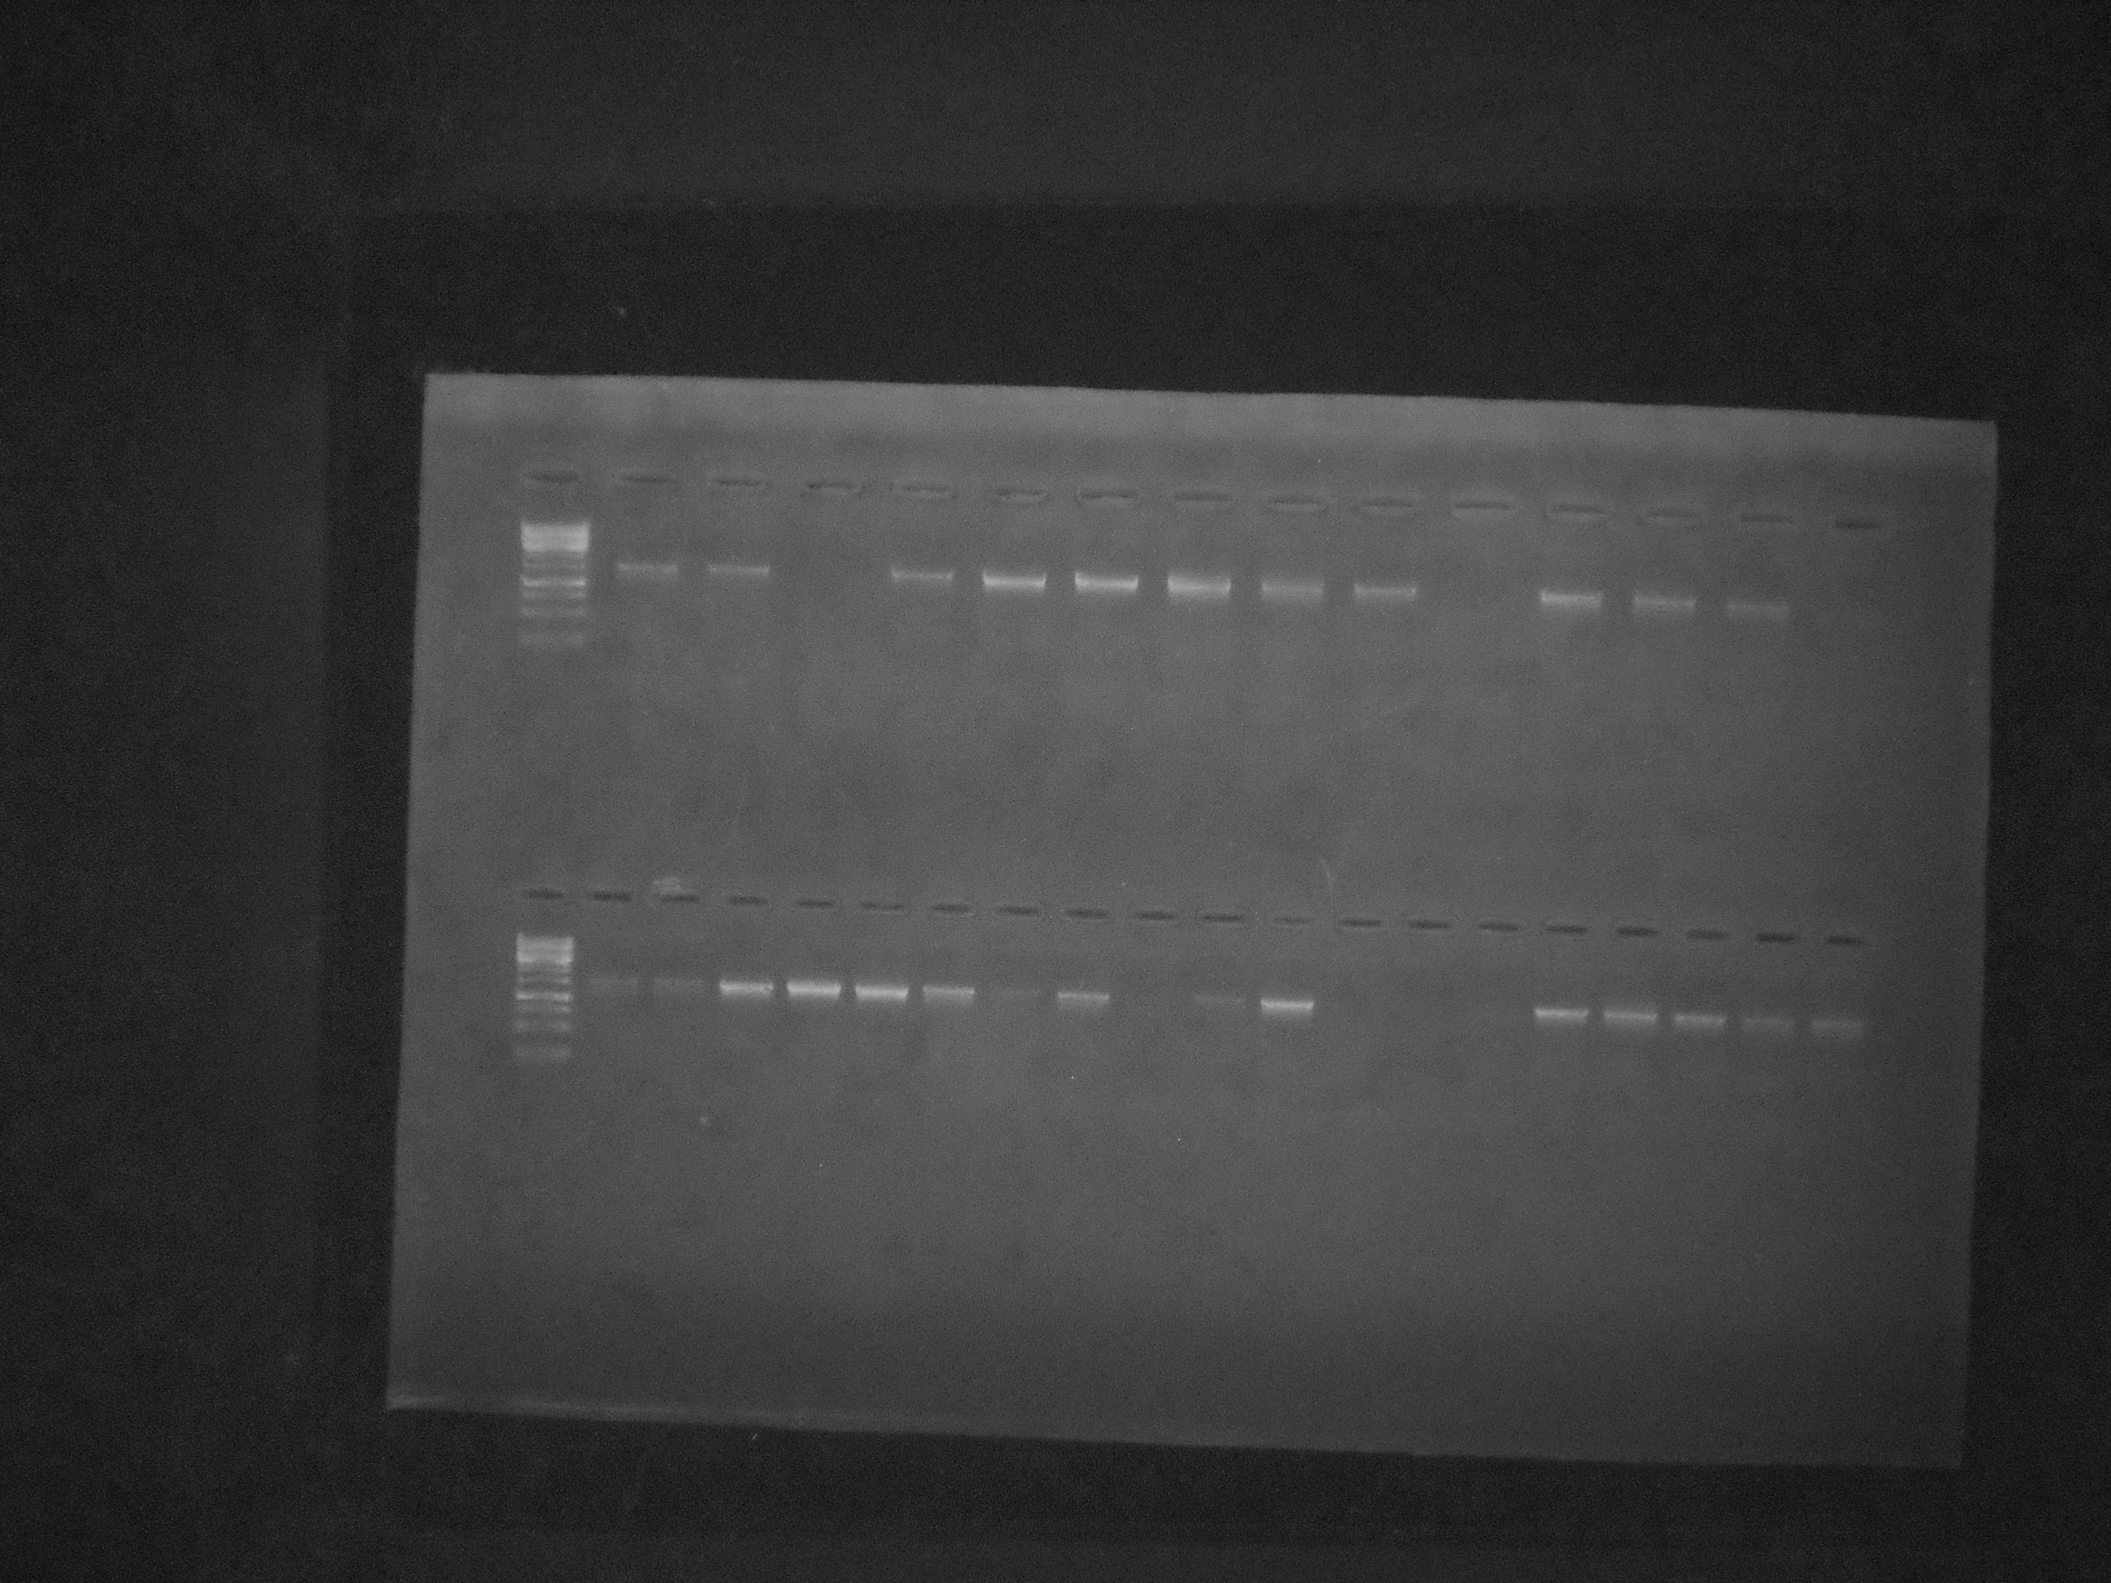



16S rRNA gene (1492bp)

3000bp

1500bp

L16 L17 18 L19 L20 L21 L22 L23 L24 L25 L26 L27 L28 L29 L30 L31 L32 L33 L35 Ll35

**Figure 6: Agarose gel electrophoresis for the 16S rRNA gene bands** (1492bp) of the various isolates (L1and L16: 1kb ladder, L4: L12, L16, L25, L28-30 represent failed amplification)

L1 S1 S2 S3 S4 S5 S6 S7 S8 S9 S10 S11 S12 S13 S14 S15 S16 S17 S18 S19

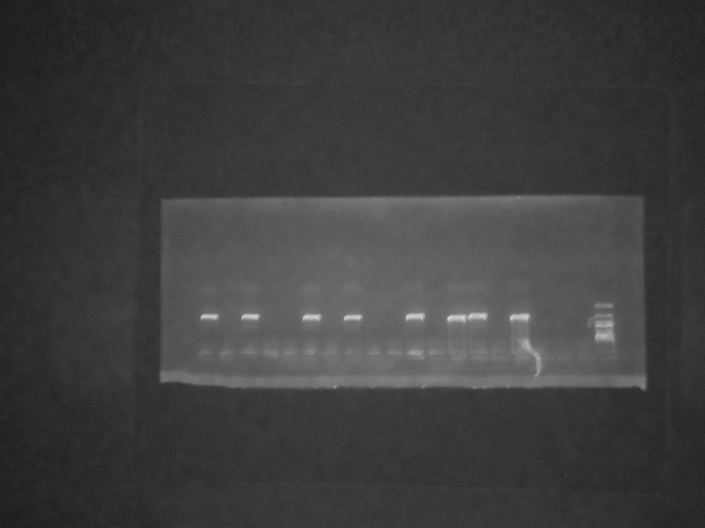

500bp

CTX-M (550bp)

**Figure 7: Agarose gel electrophoresis showing CTX-M positive and negative gene amplification (L: Ladder 1kb)**

L s1 s 2 s3 s 4 s 5 s 6 s 7 s 8 s9 s10 s11 s12 s13 L

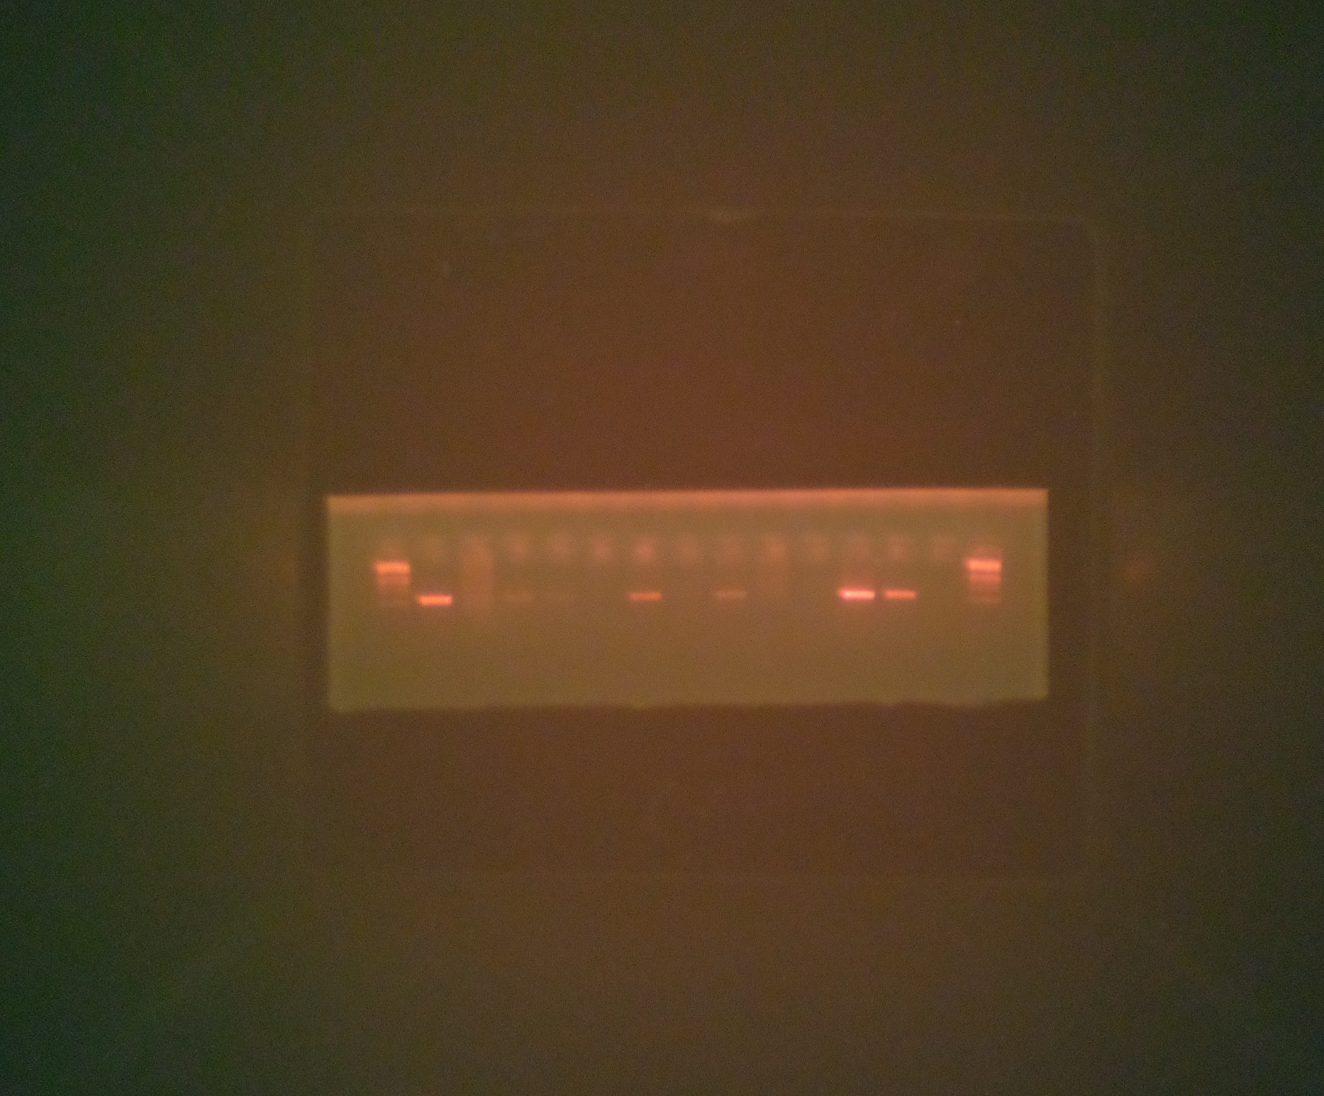

SHV (293bp)

250 bp

**Figure 8: Agarose gel electrophoresis showing SHV positive and negative gene amplification (L: Ladder 1kb)**

**Table 1: Sample with positive and negative electrophrotic bands.**

|  |  |  |  |  |
| --- | --- | --- | --- | --- |
| S/N | Sp.code | CTX- | SHV | OXA |
| 1 | L34 | + | + | - |
| 2 | G1 | - | + | - |
| 3 | Q3 | + | - | - |
| 4 | Q4 | - | + | - |
| 5 | Q1 | - | - | - |
| 6 | D10 | + | + | - |
| 7 | S3A | - | + | - |
| 8 | L1 | + | - | - |
| 9 | R5 | + | + | - |
| 10 | E5 | + | + | - |
| 11 | D3 | + | - | - |
| 12 | K7 | + | + | - |
| 13 | S1 | - | + | - |
| 14 | Q7 | + | - | - |
| 15 | O10B | - | + | - |
| 16 | 2B | + | + | - |
| 17 | M10 | - | + | - |
| 18 | N5 | - | + | - |
| 19 | C8 | + | - | - |
| 20 | C7 | - | + | - |
| 21 | C4 | - | - | - |
| 22 | V7 | + | + | - |
| 23 | T1 | + | - | - |
| 24 | P3 | + | - | - |
| 25 | T2 | - | + | - |
| 26 | V10A | + | - | - |
| 27 | D9 | + | - | - |
| 28 | V10B | - | + | - |
| 29 | F10 | + | + | - |
| 30 | L9 | + | + | - |
| 31 | D6 | - | + | - |
| 32 | Q5 | + | - | - |
| 33 | R6 | - | + | - |
| 34 | O7 | + | - | - |
| 35 | C3 | - | + | - |
| 36 | E5 | - | + | - |
| 37 | N2 | + | - | - |
| 38 | P5 | + | - | - |
| 39 | Q6 | - | - | - |
| 40 | C3B | - | - | - |

**Figure 9: Number and percentage of isolates that possess CTX-M, SHV and OXA genes**

**Table 2: Analysis of 16s rRNA sequence**

|  |  |  |  |  |
| --- | --- | --- | --- | --- |
| Code | Organism name | % Similarity | Strain | Accesion number |
| L34 | *Klebsielle Pneumonia e* | 100 |  | Gi 472825496 |
| G1 | *Pseudomonas Aeruginosa* | 100 |  | Gi 827343460 |
| Q4 | *Lysinipacillus Sphaericus* |  |  | Gi 675600442 |
| Q1 | *Serratia Sp* | 56.12 | INBIO 40520 | Gi 702102248 |
| D10 | *Alcaligenes Faecalis* | 100 |  | Gi 772459625 |
| E5 | *Alcaligenes Faecalis* | 78.57 | 518 | Gi 780582590 |
| D3 | *Escherichia coli* | 100 | GM4792 | Gi 827616213 |
| 2B | *Stenotrophomonas sp* | 74.49 |  | Gi 401878554 |
| M10 | *Providentia Rettgeri* | 100 | ALK 045 | Gi 455509102 |
| N5 | *Escherichia coli* | 100 | LAC+ | Gi 827616213 |
| C8 | *Serratia sp* | 100 | INBIO 4041 | Gi 702102236 |
| C7 | *Staphylococcus Sciuri* | 100 | 2218 | Gi 806826967 |
| C4 | *Flavobacterium Mizutaii* | 53.06 |  | Gi 110238629 |
| V7 | *Pseudomonas aeruginosa* | 100 |  | Gi 827343479 |
| T7 | *Shigelia Flexneri* | 100 | G1663 | Gi 828440138 |
| D9 | *Proteus Vulgaris* | 100 | T3-41 | Gi 451935969 |
| D6 | *Bacillus pumilus* | 100 |  | Gi 773554231 |
| Q5 | *Alcaligenes Faecalis* | 100 | 518 | Gi 780582590 |
| Q5 | *Alcaligenes Faecalis* | 100 | 518 | Gi 780582590 |
| Q7 | *Bacillus Sp.* | 100 | DB14629 | Gi 84350705 |
| C3 | *Enterococcus Faecalis* | 86.73 |  | Gi 817373934 |
| N2 | *Shigella Flexneri* | 100 | GI663 | Gi 828440138 |
| P5 | *Pseudomonas aeruginosa* | 100 |  | Gi 827343479 |
| Q6 | *Baccillus Megaterium* | 61.22 | BM1 | Gi 822680179 |
| K3B | *Baccilus Toyonensis* | 76.53 | LR | Gi 828177963 |

**Table 3: Phenotypic, genotypic identification and primer genes**

|  |  |  |  |  |
| --- | --- | --- | --- | --- |
| CODE | PHENOTYPIC ID | GENOTYPIC ID | CTX-M | SHV |
| B7 | *Staphylococcus aureus* |  |  |  |
| D10 | *Staphylococcus aureus* | *Alcaligenis faecalis*Strain CIFT MFB 14415 (VRL20) | + | + |
| C7 | *Staphylococcus aureus* | *Staphylococcus sciuri* Subsp. *Sciuri* Strain P2-5-b-1 |  |  |
| D2 | *Micrococcus various* |  |  |  |
| D3 | *Staphylococcus aureus* | *E. coli* Strain PepF2 | + | - |
| D6 | *Staphylococcus aureus* | *Bacillus pumillus* Isolate NBES – 14 | - | + |
| C7 | *Staphylococcus canosus* |  | - | + |
| C2 | *Staphylococcus leutus* |  |  |  |
| C3 | *Staphylococcus warneri* | *Enterococcus faecalis* Strain 29al | - | + |
| C4 | *Staphylococcus xylosus* | *Flavobacterium mizutaii* Isolate chi | - | - |
| N5 | *E. coli* | *E. coli* GM4792 Lac + Complete | - | + |
| G1 | *E. coli* | *Pseudomonas acrymose* Strain 3-4-b-1 | - | + |
| K3B | *Bacillus licheniformis* | *Bacillus toxonensis* Strain LR 3 – 3 | - | - |
| Q6 | *Bacillus subtilis* | *Bacillus subtillis* Strain BSMO |  |  |
| O7 | *Bacillus coagulaus* |  | + | - |
| P4 | *Micrococcus sp.* |  |  |  |
| F5 | *Staphylococcus leutus* |  |  |  |
| Q5 | *Proteus vulgaris* | *Alcaligenes faecali* Strain CIFT MB 14415 (VRL 20) | + | - |
| M1 | *Proteus mirabilis* |  |  |  |
| E5 | *Proteus penneri* | *Alcaligenes faecalis* Strain 518 | + | + |
| L1 | *Proteus rettgeri* |  | + | - |
| Q4 | *Klebsiella oxytoca* | *Lysinibacillus sphaericus* Strain L2 | - | + |
| V10B | *Klebsiella azaenae* |  | - | + |
| L9 | *Klebsiella pneumonia* |  | + | + |
| C8 | *Klebsiella pneumonia* | *Serratia nematodiphila* gene | + | - |
| R5 | *Klebsiella rhinoscleromatis* |  | + | + |
| O10B | *Klebsiella rhinoscleromatis* |  | - | + |
| L3A | *Klebsiella rhinoscleromatis* | *Klebsiella pneumonia* Strain 8 | + | + |
| Q7 | *Klebsiella rhinoscleromatis* |  | + | - |
| T2 | *Enterobacter aerogenes* | *E. coli* GM4792 Lac – genome | - | + |
| S4 | *Enterobacter aerogenes* |  | - | + |
| S9 | *Enterobacter aerogenes* |  | - | - |
| P3 | *Enterobacter aerogenes* |  | + | - |
| M10 | *Enterobacter intermedius* | *Providencia rettgeri* Strain ALK 045 | - | + |
| 2B | *Enterobacter intermedius* | *Stenotrophomas* sp. 2352 | + | + |
| S3A | *Enterobacter intermedius* |  | - | + |
| T4 | *Enterobacter cloacae* |  |  |  |
| D9 | *Klebsiella oxytoca* | *Proteus vulgaris* Strain T3 – 41 | + | - |
| Q1 | *Klebsiella ozaenae* | *Serratia Spp.* INBio – 40520 | - | - |
| N2 | *Klebsiella ozaenae* | *E. coli* GM4792 Lac + genome | + | - |
| S7 | *Pseudomonas maltei* |  |  |  |
| Q3 | *Pseudomonas stutzeri* |  | + | - |
| R6 | *Pseudomonas copaciae* |  | - | + |
| P4B | *Pseudomonas aeruginosa* |  |  |  |
| E5 | *Pseudomonas aeruginosa* |  | - | + |
| K7 | *Pseudomonas mendocine* |  | + | + |
| P5 | *Pseudomonas mendocine* | *Pseudomonas aeruginosa* Strain 2-4-b-1 | + | - |
| F10 | *Pseudomonas luteola* |  | + | + |
| V7 | *Pseudomonas luteola* | *Pseudomonas aeruginosa* Strain 2-4-b-1 | + | + |
| V10A | *Pseudomonas luteola* |  | + | - |
| T1 | *Pseudomonas oryzihabitaus* |  | + | + |

**Table 4: Molecular and biochemical identification and 16s sequence matches for bacteria isolates recovered from catheter urine in patients.**

|  |  |  |  |  |  |
| --- | --- | --- | --- | --- | --- |
| S/N | Code | Tentative identification | Genbank accession number | Genbank cultured organism | Accession number(%) identity |
| 1 | L34 | *Klebsiella pneumoniae* | KT984383 | *Klebsiella pneumonia strain* | Gi472825496 (100) |
| 2 | G1 | *E.Coli* | KT984384 | *Pseudomonas aureginosa strain* | Gi827343460 (100) |
| 4 | Q4 | *Klebsiella oxytoca* | KT984385 | *Lysinibacillus sphaericus strain* | Gi675600442 (100) |
| 5 | Q1 | *Klebsiella pneumoniae* | KT984386 | *Serratia SP* | Gi702102248 (56.12) |
| 6 | D10 | *Staphylococcus aures* | KT984387 | *Alcaligenes faecalis* | Gi772459625 (100) |
| 10 | E5 | *Proteus penneri* | KT984388 | *Alcaligenes faecalis* | Gi780582590 (78.57) |
| 11 | D3 | *Staphylococcus aures* | KT984389 | *E.coli strain* | Gi827616213 (100) |
| 16 | 2B | *Enterobacter intermedius* | KT984390 | *Strenotrophomonas SP* | Gi401878554 (74.49) |
| 17 | M10 | *Enterobacter intermedius* | KT984391 | *Providencia rettgeri* | Gi455509102 (100) |
| 18 | N5 | *E.coli* | KT984392 | *E.coli* | Gi827616213 (100) |
| 19 | C8 | *Klebsiella pneumoniae* | KT984393 | *Serratia SP* | Gi702102236 (100) |
| 20 | C7 | *Staphylococcus lentus* | KT984394 | *Staphylococcus sciuri* | Gi806826967 (100) |
| 21 | C4 | *Staphylococcus xylosus* | KT984395 | *Flavobacterium mizutaii* | Gi110238629 (53.06) |
| 22 | V7 | *Chryseomonas luteolo* | KT984396 | *Pseudomonas aeruginosa* | Gi827343479 (100) |
| 25 | T2 | *Enterobacter aerogenes* | KT984397 | *Shigella flexneri* | Gi828440138 (100) |
| 27 | D9 | *Klebsiella pneumoniae* | KT984398 | *Proteus vulgaris* | Gi451935969 (100) |
| 31 | D6 | *Staphylococcus aures* | KT984399 | *Bacillus pumilus* | Gi773554231 (100) |
| 32 | Q5 | *Proteus vulgaris* | KT984400 | *Alcaligenes faecalis* | Gi780582590 (100) |
| 35 | C3 | *Staphylococcus carnosus* | KT984401 | *Enterococcus faecalis* | Gi817373934 (86.73) |
| 37 | N2 | *Klebsialla pneumoniae* | KT984402 | *Shigella flexneri* | Gi828440138 (100) |
| 38 | P5 | *Pseudomonas mendocine* | KT984403 | *Pseudomonas aeruginosa* | Gi827343479 (100) |
| 39 | Q6 | *Paenibacillus macerans* | KT984404 | *Bacillum megaterium* | Gi822680179 (61.22) |
| 40 | K3B | *Bacillus liche niformis* | KT984405 | *Bacillus toyonensis* | Gi828177963 (76.53) |

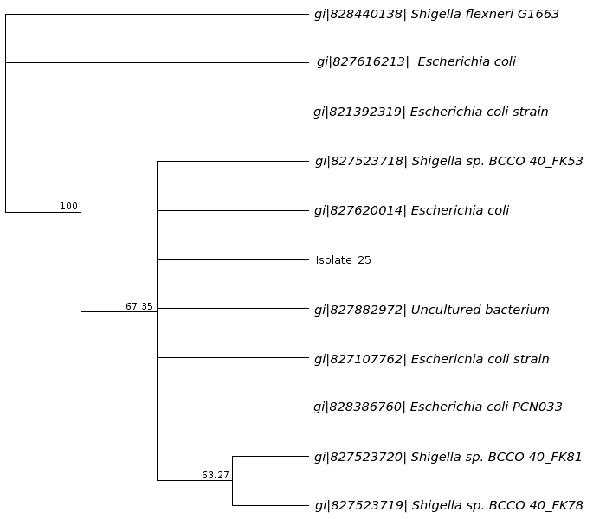

**Figure 10: Sample T2 similarity of *E.coli* and *Shigella***

**4. Discussion**

This study investigated the incidence of plasmid-mediated extended spectrum β-lactamases (ESBL) in clinical isolates associated with CAUTI in patients at a tertiary hospital in Abia State, Nigeria. Common organisms isolated from the study were *Staphylococcus spp., Klebsiella spp., E. coli, Proteus* spp*., Serretia* spp*., Enterobacter* spp., *Providentia rettegeri and Pseudomonas* spp. This is in agreement with the work done by Benge (1998), Johnson *et al.* (1999) and Braunwald *et al.* (2001).

The predominant organism found in the study was gram positive *cocci* (*Staphylococcus* spp.), though this is not in agreement with the work done by Hynicwiez & Hynicwiez (2001) and Wilson and Gaido (2004), in their work, the predominant organism was *Enterococcus* spp*.* According to Braunwald et al. (2001), many catheter associated urinary tract infection (CAUTI) isolated organisms display greater anti-microbial resistance than organisms that cause community acquired urinary tract infections (UTIS). This is true with our study as shown in Figure 4a and 4b. Taiwo and Aderomumu (2006) reported that above 68% of the isolated pathogens showed resistance from two to nine antimicrobials. This is similar to the occurrence of antibiotic resistance in this study. Maki and Tambyah (2000) also reported that the enteric gram negative organisms found in the catheterized urinary tract are those that are commonly associated with multidrug resistance. Figure 4a and 4b reveals similar occurrence. The rate of resistance to widely used antibiotics was high for gram negative bacteria corresponding to the report of Lagarlo and Loab (2000).

Since the urine specimens were collected from different wards, the antibiotic resistance pattern varies. This is also in agreement with report of Vogel and Rochette (2004). Drug abuse could account for the high degree resistance by these organisms as seen in Cotrimoxazole (100%) tetracycline (98%), Cloxacillin (98%) which are more commonly available. A steady increase in resistance to cephalosporins has been previously reported by Bradford (2006). This is similar to our findings.

ESBLs are rapidly expanding and they share only 40% identity with SHV genes according to Livermore *et al.* (2007), this report is a true reflection of Figure 9 in this study. Enterobactereciae mostly *E. coli* producing novel ESBLs, the CTX-M genes where identified predominantly from communities as a cause of urinary tract infections (Pitout *et al* 2005). In this study however, the sample population were hospital patients and the predominant genes were SHV (24%) while CTX-M was 22%. This close range of the two genes may be due to their close relationship identity (they share 40% common identity). Kiratisn *et al.* (2008) had also reported that outside TEM, SHV, and CTX-M, other ESBL enzymes are less often encountered. This could explain the 100% absence of OXA gene amongst the isolates used in the study.

According to Lee *et al.* (2006), *Klebsialla pneumoniae* and *E. coli* are the main pathogens producing ESBLs, others were *Pseudomonas* spp. but in this study all the organisms produces ESBLs apart from 4 isolates, though Figure 9, remains in agreement with Lee et al. (2006) findings. The most prevalent gene is SHV according to Valverde *et al.* (2004) which also holds true in this study as seen in Figure 9. The appearance of SHV and CTX-m gene or TEM may be related to cross infection in hospitals as reported by Reddy *et al.* (2007). But considering Figure 9, some organisms contain both CTX-M and SHV genes meaning that this may be evidence of cross infections according to Reddy *et al*. (2007).

Foxman (2010) reported that UTIs are very hard to treat with antibiotics which is true with this study as CAUTI posed much difficulty to be eradicated due to resistance by the organisms (Figure 4a-4b and Figure 5). The best way to define and identify the presence of beta-lactamase gene is by genetic method PCR and sequencing which are standard methods as reported by Alfaresi and Elkoush (2010). This standard methods have also enable our study to arrive on common ESBLs possessed by the isolates used in the study. According to Queenan and Bush (2007), bacteria transmission of Carbapenemase genes is related to the mobile genetic elements such as plasmids and transposons, invariably, plasmids had been extracted from the isolates used in the study and some of their ESBL genes identified (Figure 9). The genetic tree seen in Figure 10 reveals a close evolutionary tree between *E. coli and Shigella* spp.

**5. Conclusion**

This study has established the fact that no single antibiotic used in this study was potent enough to eliminate all the organisms isolated. Plasmid is a mobile genetic element which mediated resistance to the isolated organisms through (CTX – M and SHV genes) though other genes may be involved but for this study, only two were implicated. Almost all the isolated organisms possess plasmid for their effective resistance to antibiotics. Drugs like Cotrimoxazole and tetracycline should no longer be used in treating CAUTI as they have almost 100% resistance by all the isolates. This study has further shown that there is a close evolutionary relationship between *E. coli and Shigella* spp.*,* noted from the genetic tree. The 16S rRNA of the isolates used in this study have a molecular weight of approximately 1,500 base pair, while the plasmid DNA has genes of 550 bp and 293bp. Treatmenmt of CAUTI should be based on sensitivity results since CAUTI organisms are turning up to be superbug. Prescription of antibiotics shoud be able to capture the correct dosage and duration to prevent development of resistance by CAUTI organisms

**References**

1. Abel, Z. P., Kouyos, R., Abel, S., Viechtbauer, W. and Bonhoeffer, S. (2014). Cycling empirical antibiotic therapy in hospitals: meta-analysis and models. *Plos Pathogens.*10 (6):1004225.
2. Alekshun, M. N. and Levy, S. B. (2007). Molecular mechanisms of antibacterial multi-drug resistance. *Cell*. 128 (6):1037 – 1050.
3. Bali, E. B., Leyla, A. and Nedim, S. (2010). Phenotypic and molecular characterization of SHV, TEM, CTX-M and extended-spectrum beta lactamase produced by *Escherichia coli, Acinetobacter baumannii* and *Klebsiella* isolates in a Turkish hospital. *African Journal of Microbiology Research.* 4(8): 650-654.
4. Bazzaz, B. S., Naderinasab, M., Mohamadpoor, A. H., Farshahzadeh, Z., Ahmadi, S. and Yousefi, F. (2009). The prevalence of extended spectrum Beta-lactamases producing *Escherichia coli* and *Klebsiella pneumonia* among clinical isolates from a general hospital in Iran. *Acta Microbiologica et Immunologica Hungarica*. 56(1): 89 - 99.
5. Benge, G. R. (1988). Bactericidal activity of human serum against *Kfebsiella* from different sources. *Journal of Medical Microbiology.* 27(1):11 - 15.
6. Bergstrom, C. T., Lo, M. and Lipsitch, M. (2004). Ecological theory suggests thatantimicrobial cycling will not reduce antimicrobial resistance in hospitals. *Proceedings of the National Academy of Sciences of the U. S. A.*101(36):13285–13290.
7. Blazquez, J., Morosini, M. I., Negri, M. C. and Baquero, F. (2000). Selection ofnaturally occurring extended-spectrum TEM beta-lactamase variants by fluctuating beta-lactam pressure. *Antimicrobial Agents and Chemotherapy.* 44(8): 2182 – 2184.
8. Bradford, P. A. (2001). Extended-spectrum beta-lactamases in the 21st century: characterization, epidemiology, and detection of this important resistance threat*.Clinical Microbiology Reviews.* 14(4): 933 - 951.
9. Braunwald, E., Fauci, A. S., Kasper, D. L., Hauser, S. L., Longo, D. L. and Jameson, J. L. (2001). Harrison's Principles of Internal Medicine, 15th ed. Vol. 2. McGraw-Hilt, New York USA. pp. l620 - 1625.
10. Chang, T. M., Lu, P. L, Li, H. H, Chang, C. Y., Chen, T. C. and Chang, L. L. (2007). Characterization of fluoroquinolone resistance mechanisms and their correlation with the degree of resistance to clinically used fluoroquino-lones among Escherichia coli isolates. *Journal of Chemotherapy.* 19(5):488 – 494.
11. Cheesbrough, M. (2000). District laboratory Practice in Tropical Countries part 2: Cambridge University press UK. pp. 434.
12. Chow, J. W., Fine, M. J., Shales, D. M., Quinn, J. P., Hooper, D. C. and Johnson, M. P. (1991). *Enterobacter bacteremia*: Clinical features and emergence of antibiotic resistance during therapy. *Annals of Internal medicine*. 115(8):585 - 590.
13. Courvalin, P. and Carlier, C. (1986). Transposable multiple antibiotic resistance in Streptococcus pneumoniae. *Molecular and General Genetics.* 205(2):291 – 297.
14. Foxman, B. (2002). Epidemiology of urinary tract infection: Incidence, morbidity and economic costs. *American Journal of Medicine.* 113(1A): 5 - 13.
15. Fridkin, S. K. (2003). Routine cycling of antimicrobial agents as an infec-tion-control measure. *Clinical Infectious Diseases.*36:1438 – 1444.
16. Gupta, S., Tyagi, S., Almeida, D. V., Maiga, M. C., Ammerman, N. C. and Bishai, W. R. (2013). Acceleration of tuberculosis treatment by adjunctive therapywith verapamil as an efflux inhibitor. Am J Respir Crit Care Med 188: 600 – 607.
17. Hall, R. M. (2012). Integrons and gene cassettes: hotspots of diversity inbacterial genomes. *Annals of the New York Academy of Sciences.*1267:71 – 78.
18. Huang, X. Z., Frye, J. G., Chahine, M. A., Glenn, L. M., Ake, J. A., Su, W., Nikolich, M. P. and Lesho, E. P. (2012). Characteristics of plasmids in multi-drug-resistant Enterobacteriaceae isolated during prospective surveillance of a newly opened hospital in Iraq. *PLoS One* 7 (7):e40360.
19. Hynicwiez, K. and Hymcwicz, W. (2001). Antibiotic susceptibility of bacterial strains isolated from urinary tract infection in Poland. *Journal of Antimicrobial Chemotherapy.* 47(6):773 - 780.
20. Johnson, J. R., Delavari, P. and Azar, M. (1999). Activities of a nitrofurazone-containing urinary catheter and a silver hydrogel catheter against multidrug-resistant bacteria characteristic of catheter-associated urinary tract infection. *Antimicrobial agents and Chemotherapy.* 43(12): 2990 - 2995.
21. Lagerlov, P. and Loeb, M. (2000). Improving doctors' prescribing behavior through reflection on guidelines and prescription feedback: A randomised controlled study.*Quality in Health Care.* 9(3):159 - 165.
22. Lee, S. Y., Kotapati, S., Kuti, J. L., Nightingale, C. H. and Nicolau, D. P. (2006). Impact of extended-spectrum beta-lactamase-producing *Escherichia coli* and *Klebsiella* species on clinical outcomes and hospital costs: a matched cohort study*. Infection Control and Hospital Epidemiology.* 27(11): 1226 - 1232.
23. Li, X. Z., Zhang, L, Nikaido H. 2004. Efflux pump-mediated intrinsic drugresistance in Mycobacterium smegmatis. *Antimicrobial Agents and Chemotherapy.* 48(7):2415 – 2423.
24. Livermore, D. M., Canton, R., Gniadkowski, M., Nordmann, P., Rossolini, G. M., Arlet, G., Ayala, J., Coque, T. M., Kern-Zdanowicz, I., Luzzaro, F., Poirel, L. and Woodford, N. (2007). CTX-M: changing the face of ESBLs in Europe*.Journal of Antimicrobial Chemotherapy*. 59(2): 165 - 174.
25. Murat, K., Kayode, F., Sinem, T., Fetiye, K., Fatma, B. and Haluk, V. (2010). Characterization of ESBL (SHV-12) producing clinical isolate *of Enterobacter aerogenes* from a tertiary care hospital in Nigeria. *Annals of Clinical Microbiology and Antimicrobials*. 9(1):1 - 5.
26. Neyfakh, A. A., Bidnenko, V. E. and Chen, L. B. (1991). Efflux-mediated multidrugresistance in Bacillus subtilis: similarities and dissimilarities with the mammalian system. *Proceedings of the National Academy of Sciences of the U. S. A.* 88(11):4781 – 4785.
27. Nordmann, P., Dortet, L. and Poirel, L. (2012). Carbapenem resistance inEnterobacteriaceae: here is the storm! *Trends in Molecular Medicine.* 18(5):263 – 272.
28. Pages, J. M. and Amaral, L. (2009). Mechanisms of drug efflux and strategies tocombat them: challenging the efflux pump of Gram-negative bacteria. *Biochimica et Biophysica Acta* 1794(5):826 – 833.
29. Paterson, D. L. and Bonomo, R. A. (2005). Extended-spectrum beta-actamases: a clinical update*. Clinical Microbiology Reviews.* 18(4):657 – 686.
30. Pitout, J. D., Nordmann, P., Laupland, K. B. and Poirel, L. (2005). Emergence of Enterobacteriaceae producing extended-spectrum beta-lactamases (ESBLs) in the community. *Journal of Antimicrobial Chemotherapy* 56(1): 52 - 59.
31. Poole, K. (2005). Efflux-mediated antimicrobial resistance. *Journal of Antimicrobial Chemotherapy.* 56(1):20 – 51.
32. Pumbwe, L., Chang, A., Smith, R. L., Wexler, H. M. (2006). Clinical significance of overexpression of multiple RND-family efflux pumps in *Bacteroides fragilis* isolates. *Journal of Antimicrobial Chemotherapy.* 58(3):543 – 548.
33. Queenan, A. M. and Bush K. C. (2007). The versatile beta-lactamases. *ClinicalMicrobiology Reviews*. 20(3):440 – 458.
34. Reddy, P., Malczynski, M., Obias, A., Reiner, S., Jin, N. and Huang, J. (2007). Screening for extended beta lactamase producing Enterobacteriaceae among high risk patients and rates of subsequent bacteraemia. *Clinical Infectious Diseases*. 45(7):846 – 52.
35. Roberts, A. P. and Mullany, P. (2009). A modular master on the move: theTn916 family of mobile genetic elements. *Trends in Microbiology*. 17(6):251–258.
36. Taiwo, S. S. and Aderounmu, A. O. A. (2006). Catheter Associated Urinary Tract Infection: Aetiologic Agents and Antimicrobial Susceptibility Pattern in Ladoke Akintola University Teaching Hospital, Osogbo, Nigeria*. African Journal of Biomedical Research*. 9(2006): 141 - 148.
37. Ughachukwu, P. and Unekwe, P. (2012). Efflux pump-mediated resistance inchemotherapy. *Annals of Medical and Health Sciences Research,* 2(2):191 – 198.
38. Valverde, A., Corque, T. M., Sanchez-Moreno, M. P., Rollan, A., Baquero, F. and Canton, R. (2004). Dramatic increase in prevalence of faecal carriage of extended spectrum Beta-lactamases producing Enterobacteriaceae during non outbreak situations in Spain. *Journal of Clinical Microbiology*. 42(10): 4769 - 75.
39. Wilson, M. L. and Gaido, L. (2004). Laboratory diagnosis of urinary tract infections in adult patients. *Clinical Infectious Diseases,* 38(8):1150 - 1158.

Find these references

1. Alfaresi and Elkoush (2010).
2. Bauernfeind *et al.* (1989)
3. Clinical Laboratory Standards Institute 2011
4. Kiratisin *et al.,* 2008).
5. Kiratisn *et al.* (2008)
6. Kohner *et al.* (2009)
7. Maki and Tambyah (2000)
8. Mathai *et al.,(* 2001),
9. Moland *et al.* (2006)
10. Thomson (2001) and
11. Vogel and Rochette (2004).

4/13/2016