**Reconstruction of Gluteal Deformities"post intramuscular injection"A plastic surgery symphony**

Emad Hussein ElSayed, Ayman Abdelmoety Ibrahim, and Barakat Abdelrahim Mahmoud

Department of Plastic Surgery, Faculty of Medicine, AlAzhar University (Girls branch), Cairo, Egypt

[Emad_plast@hotmail.com](mailto:Emad_plast@hotmail.com)

**Abstract:** Gluteal deformities which results from a wrong intramuscular injection or an infection follow this injection are not uncommon. These deformities vary in severity according to the magnitude of the predisposing infection and to the age that occurs in as affection during the childhood is more aggressive and destructive than in adulthood. When plastic surgeons face these deformities he has to recall all his expertise in different aesthetic and reconstructive surgeries in order to get satisfactory results for him and for the patient. Using of different plastic surgery tools should be in harmony and in proper need with a long term planning and multiple sessions so you will reach the best result that you wish.

[Emad Hussein ElSayed, Ayman Abdelmoety Ibrahim, and Barakat Abdelrahim Mahmoud. **Reconstruction of Gluteal Deformities "post intramuscular injection" A plastic surgery symphony.** *N Y Sci J* 2016;9(3):116-123]. ISSN 1554-0200 (print); ISSN 2375-723X (online). <http://www.sciencepub.net/newyork>. 18. doi:[10.7537/marsnys09031618](http://www.dx.doi.org/10.7537/marsnys09031618).

**Keywords:** Gluteal reconstruction

**1. Introduction:**

Currently, patient demand is increased for procedures to improve the form and size of the gluteal region. Although gluteal augmentation and lifting are the most common aesthetic requirements for the gluteal area, some patients need gluteal reduction. ***(Jorge A Mejia 2012).***

On the other hand, the literatures that deal with the reconstruction of the gluteal deformities that occur post traumatic or infections results from a wrong intramuscular injections, are much lesser despite the magnitude of these problems in the affected patients is much more than those seeking only aesthetic appearance.

The functional purpose of the buttocks musculature is to establish a stable [gait](https://en.wikipedia.org/wiki/Gait) (balanced walk). For the man or the woman who requires the surgical correction of either a defect or a deformity of the gluteal region; therefore, the restoration of anatomic function (if possible) is the therapeutic consideration that determines which gluteoplasty procedure will effectively correct the damaged muscles of the buttocks. The applicable techniques are multiple include the surgical insertion of [synthetic](https://en.wikipedia.org/wiki/Allopathic_medicine) gluteal implants; [autologous tissue flaps](https://en.wikipedia.org/wiki/Flap_(surgery)); the excision of damaged tissues; lipoinjection augmentation; and [liposuction](https://en.wikipedia.org/wiki/Liposuction) reduction to correct the defect or deformity caused by a post traumatic injury to the buttocks muscles***. (Reisman et al., 2011)***

Anatomically, the mass of each [buttock](https://en.wikipedia.org/wiki/Buttocks) principally comprises two muscles; the [gluteus maximus muscle](https://en.wikipedia.org/wiki/Gluteus_maximus_muscle) and the [gluteus medius muscle](https://en.wikipedia.org/wiki/Gluteus_medius_muscle) which are covered by a layer of [subcutaneous fat](https://en.wikipedia.org/wiki/Adipose_tissue). The upper aspects of the buttocks end at the [iliac crest](https://en.wikipedia.org/wiki/Iliac_crest) (the upper edges of the wings of the [ilium](https://en.wikipedia.org/wiki/Ilium_(bone)), and the upper lateral margins of the [greater pelvis](https://en.wikipedia.org/wiki/Greater_pelvis)), and the lower aspects of the buttocks end at the [horizontal gluteal crease](https://en.wikipedia.org/wiki/Gluteal_sulcus), where the buttocks anatomy joins back of the upper portion of the thighs. The gluteus maximus muscle has two points of insertion: (i) the upper one-third or superior part of the (coarse line) [linea aspera](https://en.wikipedia.org/wiki/Linea_aspera) of the [femur](https://en.wikipedia.org/wiki/Femur), and (ii) the superior part of the [iliotibial tract](https://en.wikipedia.org/wiki/Iliotibial_tract) (a long, fibrous reinforcement of the deep [fascia lata](https://en.wikipedia.org/wiki/Fascia_lata) of the thigh). The left and the right gluteus maximus muscles (the buttock cheeks) are vertically divided by the [intergluteal cleft](https://en.wikipedia.org/wiki/Intergluteal_cleft) which contains the [anus](https://en.wikipedia.org/wiki/Human_anus)***. (Reisman et al., 2011)***

Correction of the defects and deformities of the muscles of the gluteal region (the buttocks and the thighs) of the human body cannot be realized with medical therapy; thus, for example, a treatment with cellulite-diminishing cream is ineffective. So the resolution of the defects and deformities of the gluteal region can be realized only surgically; yet, the assessment of the degree of severity of the injury organizes treatment therapies into three types: (i) buttocks augmentation, (ii) buttocks reduction, and (ii) contour irregularity treatments that combine surgery and liposculpture (fat-removal and fat-injection). ***(Reisman and Azita, 2011)***

To sculpt rounded contours and to reconstruct the irregular shaped buttocks, superficial liposculpture allows the plastic surgeon to control the injected fat volume. Moreover, superficial liposuction can be combined with other treatment methods for contouring the gluteal region to achieve the required functional, anatomic correction, and the aesthetic enhancement to satisfy the patient needs. ***(Centeno and Young, 2006; Cuenca et al., 2006)***

The key to successful gluteal fat grafting is familiarity with the technique, knowledge of the gluteal topography, and understanding of the patient's goals. With experience, the surgeon can predict the amount of volume needing to be grafted to produce the desired result. Although the aim of every surgeon is to produce the desired augmentation of the gluteal region by autologous fat grafting in one stage, the patient should be advised that a secondary procedure may be needed to accomplish the desired result***. (Beatriz et al., 2011)***

In a study in contouring the gluteal region with tumescent liposculpture indicated that effective gluteal-region contouring is best achieved by tailoring the liposuction (reduction) and the lipoinjection (augmentation) techniques to the anatomic topography of the body areas to be corrected. ***(Avendaño et al., 2011)***

Furthermore, another study that searches in contouring of the gluteal region in women, indicated that natural contours of the buttocks and the thighs are effectively achieved with a combined gluteoplasty of liposculpture, which reduces the need for more aggressive surgical procedures such as lifting or prosthetic augmentation, decreases the risk of medical complications, a much less wound recovery time, and no or very minute post-operative scarring. Combined with any buttocks correction method, superficial liposculpture facilitates the treatment of contour irregularities, which may help with surgical revision of scars, and the correction of gluteal region contour depressions. ***(Ali, 2011)***

A more close study to our subject, study was done in China on twelve patients with bilateral gluteal concave deformities associated with repeated intragluteal injections were operated on from June 2006 to June 2010. The deformities were classified as major or minor. Overall satisfaction with body appearance after gluteal fat grafting and liposculpture was rated on a scale of 1 (poor), 2 (fair), 3 (good), 4 (very good), and 5 (excellent). The evaluation was performed at 3-44 months after surgery. The average volume of fat injected was 196.9 ± 41.4 ml. No serious adverse events occurred. One patient with major deformity had one additional fat grafting procedure. One patient developed cellulitis in the feet and lower legs, upon which the grafted areas were incised and drained on suspicion of infection but with negative cultures. The patient recovered uneventfully with intravenous antibiotic application for 7 days. At the office visit nine cases judged that their appearance after the operation as "very good" (4) to "excellent" (5) and three cases responded that their contour was "good." Improvement in skin texture and alleviation of the pigmentation in the concave area were observed in all cases during the 3-44-month follow-up intervals after the fat grafting, and softening of the hypertrophic scar was also observed as early as 1 month after the fat grafting and continuously improved during the 12-month follow-up***. (Wang et al., 2013)***

**2. Patients and Methods:**

Over five years from 2010 to 2015, ten females were seeking of gluteal reconstruction after deformities and depressions resulted from intramuscular injections either in childhood or in adult life. These deformities vary in severity from only concave depression without scaring, depressed scars from incisions for abscess drainage, to severely deformed buttocks.

Each patient had a uniformed tailored plan for her to solve her problem, either simple fat grafting under the depressed area when there was no fibrous adhesions below, or through division of the fibrous adhesions by a sharp cannula prior to fat grafting. Surgical reconstruction of the depressed scars by Z plasty also play an important role, or in more complicated case a multi stages reconstruction in the form of surgical correction of the scars then a combined liposculpture and fat grafting later on.

Regarding fat grafting we followed the concept of fat transport without exposing the harvested fat to any physical or chemical agents like centrifugation or adding any substances to the collected fat prior to grafting. We used manual syringe suction with care to decrease the negative pressure used to harvest fat cells. The cannula for suction was 3mm in diameter and for injection was 1.5 – 2 mm with syringes 50ml for suction and 3 – 5 ml for injection. In one case which had strong fibrous adhesions we had to use a cannula with a sharp tip to cut these fibrous bands to ensure a round curvature during fat grafting.

**Small syringes**

The amount of the injected fat ranged from 200ml and 400ml which grafted in multiple levels in the subcutaneous tissues not intramuscular, also multiple tracts in the same level. The harvested fat by using the tumescent technique was left in the syringes used in suction in a vertical position for 15 to 20 minutes before grafting and the separated fluid was discarded and the sedimented fat transport to the small syringes just prior to grafting. The donor sites were flanks, lower abdomen, trochanteric area, or the contralateral buttock.

Two patients were done under local anesthesia as it was a small defect not need more than local only, and the rest were done under general or spinal anesthesia in both harvesting and grafting.

All patients were marked before operation and the sites for suction or injection were precisely determined. The position was prone during grafting but in case of harvesting fat from the abdomen first the patient was supine then after taking the proper amount of fat the position was changed to prone.

After finishing the patient wear a pressure garment on table, the first case we used adhesive Elastoplast tape over both donor and recipient areas. All cases were received a preoperative intravenous antibiotic one gram only of Ceftriaxone and a postoperative simple oral antibiotics with non-steroidal anti-inflammatory and anti-edematous agent for five days post-operative.

Follow up was scheduled after the 1st postoperative week then one month, three months, and six months postoperative. The assessment of the fat resorption was clinically determined and it was up to fifty percent from the grafted fat at most.

**3. Results:**

All cases passed without serious complications, no infection or collection only some bruises and ecchymosis both in donor and recipient sites which were self-limited within the 1st week. Widening of the scar of the Z plasty occurred in two patients without need to use anti scar measures.

Regarding patient's satisfaction, it was good and no one asked for revision and in one case which was the most difficult deformity we offer to her another session of fat grafting to reach the optimum result but she was satisfied with the result she had and refused the last stage.

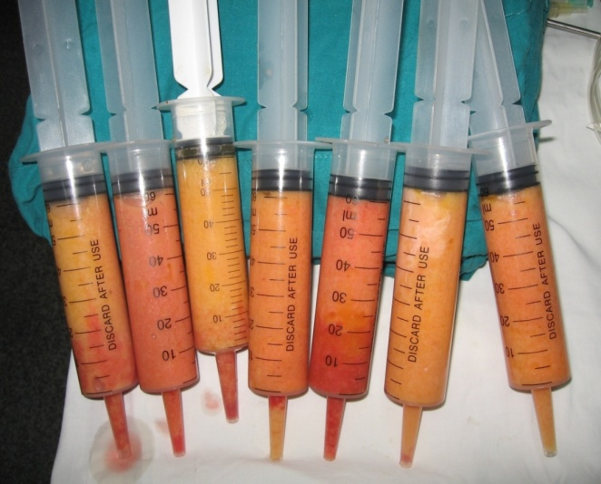

**Fig. 1** The aspirated fat is left to sediment only without centrifugation, before grafting it is transferred to another

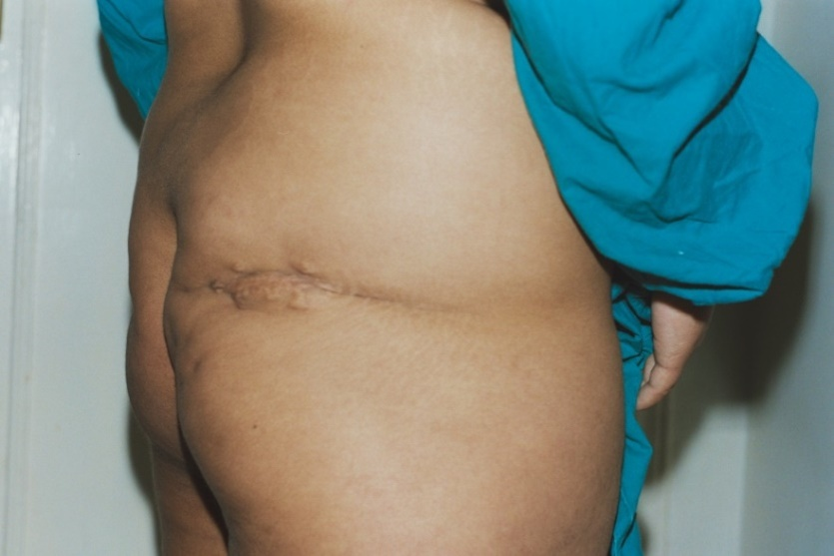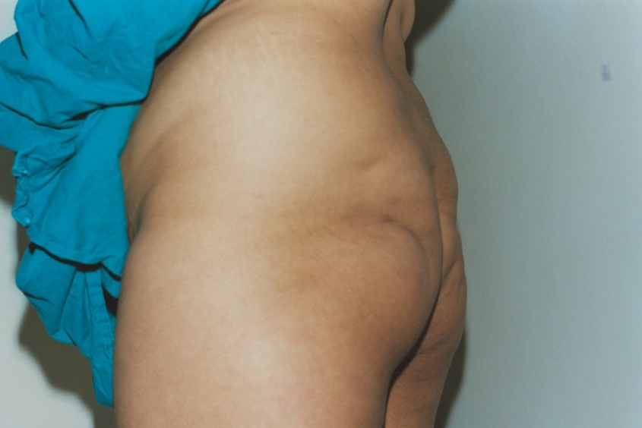

**Fig. 2** showed a preoperative depression in the left buttock and depressed scar in the right buttock due to incision and drainage of an abscess in the childhood. The fibrous adhesions below the scar were cut by a sharp tip cannula prior to fat grafting.

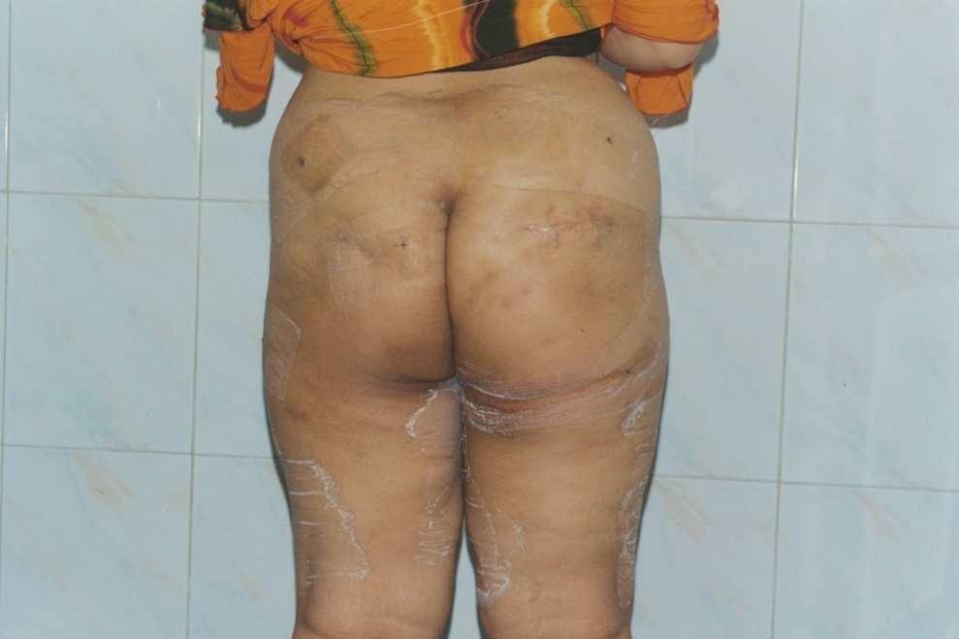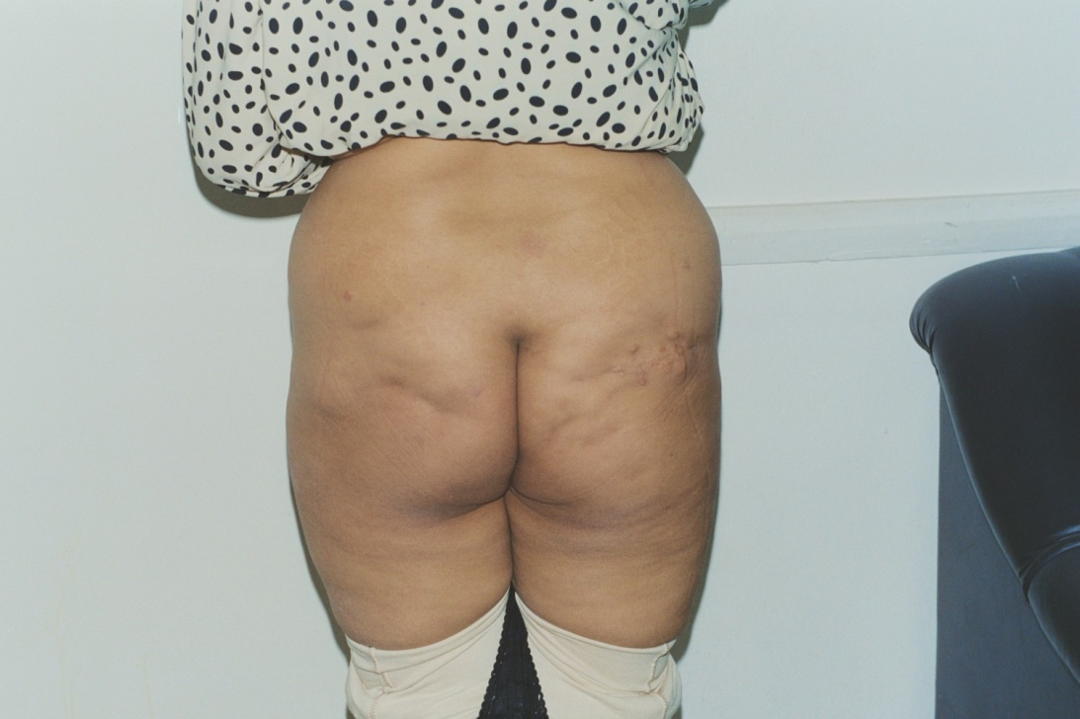

**Fig. 3** One week post with the marks of Elastoplast tape then three months later showed good improvement. This was the 1st case done and it was better if we reduced the supra gluteal flanks areas which was not done for fear of making suction near the grafted area at the beginning.

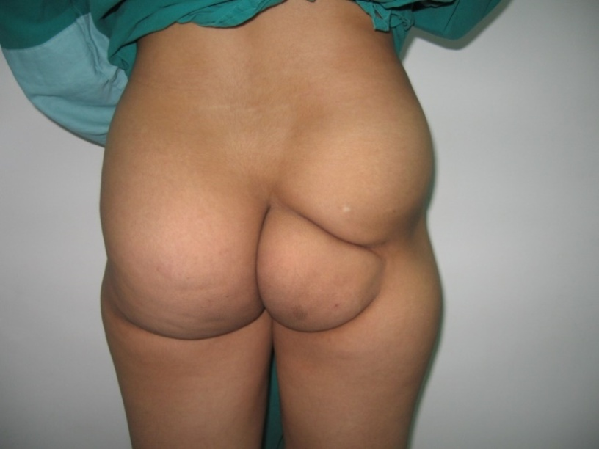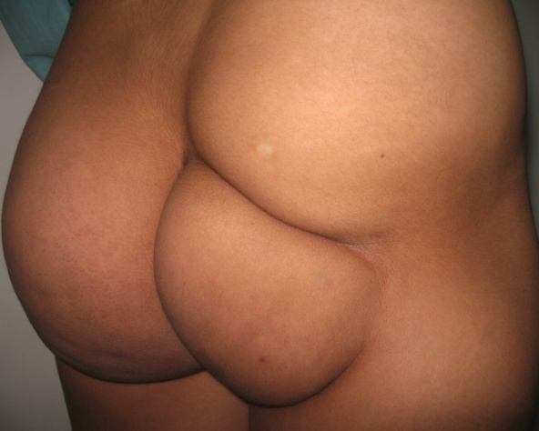

**Fig. 3** The most interesting case with right buttock severely hypoplastic and a deep furrow dividing it with concave area supra trochanteric due to wrong intramuscular injection in early childhood.

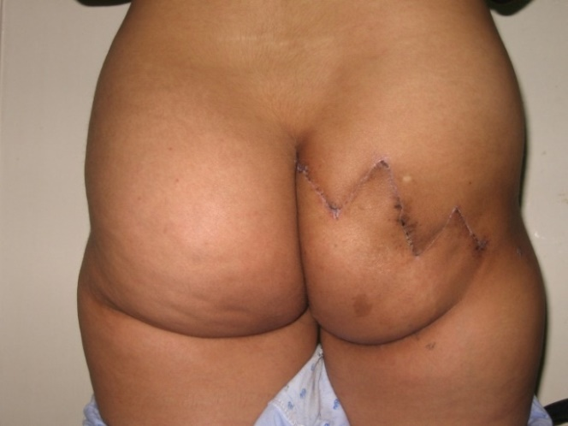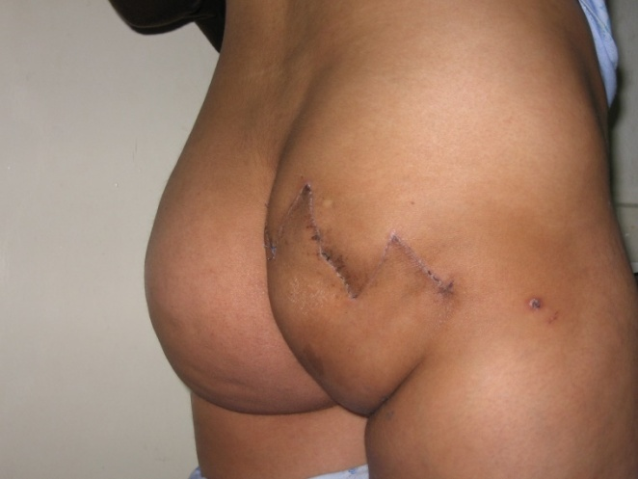

**Fig. 4** after the 1st stage which was the surgical correction of the divided right buttock by 2 Z palsties, a ten days postoperative.

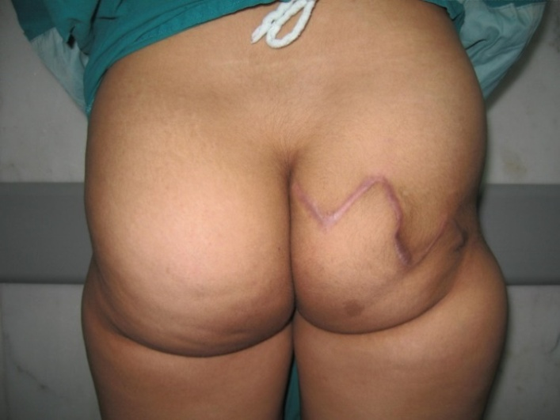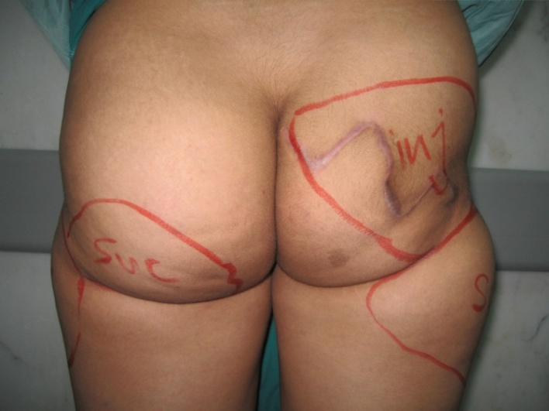

**Fig. 5** Three months postoperative and starting the 2nd stage of reconstruction in the form of liposculpture and fat grafting at the same time, the preoperative marks determined the areas for suction and grafting.

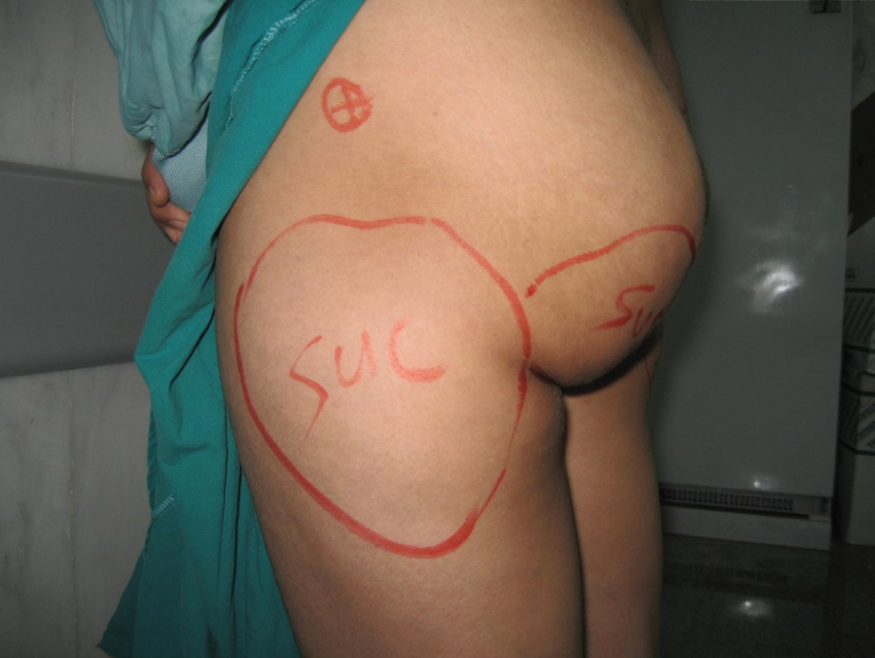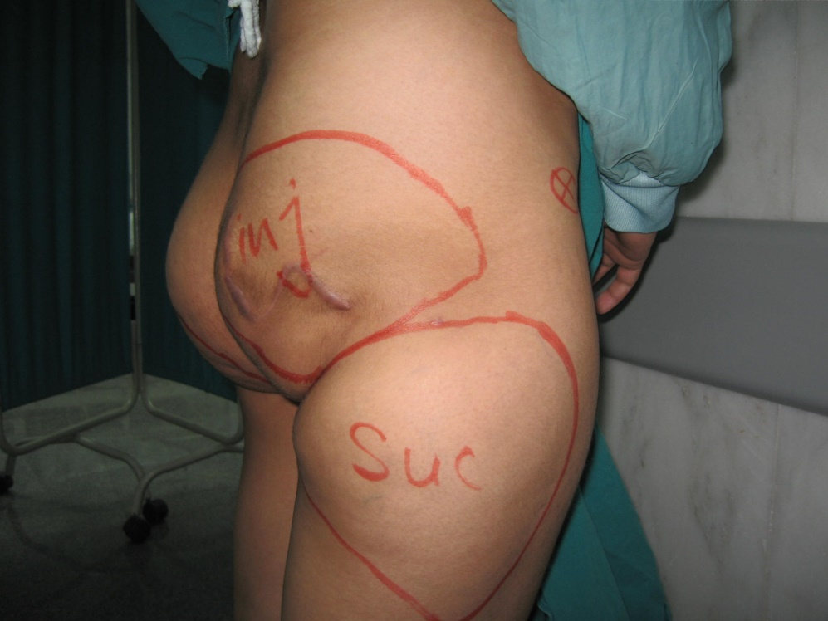

**Fig. 6** Preoperative marks for suction and injection with reduction of the normal left buttock volume at the same time utilizing the coming fat from it to augment the affected right side.

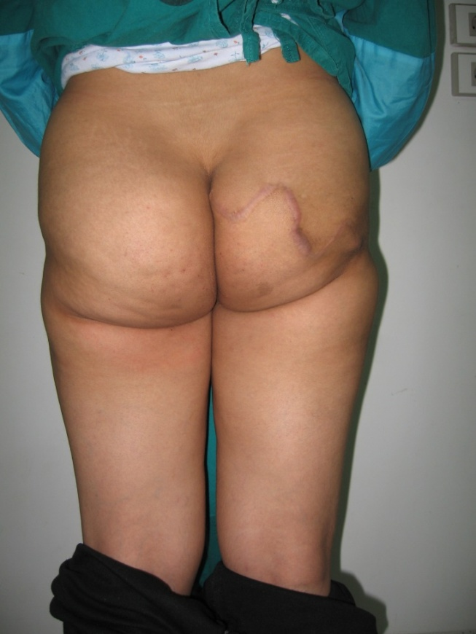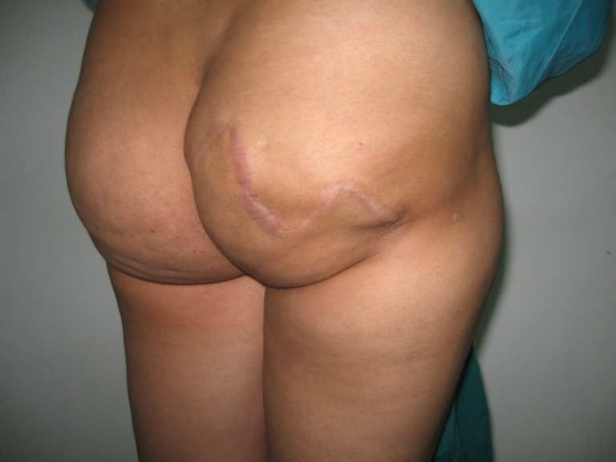

**Fig. 7** Three months post fat grafting with a satisfactory result and near equal buttocks with rounded contour.

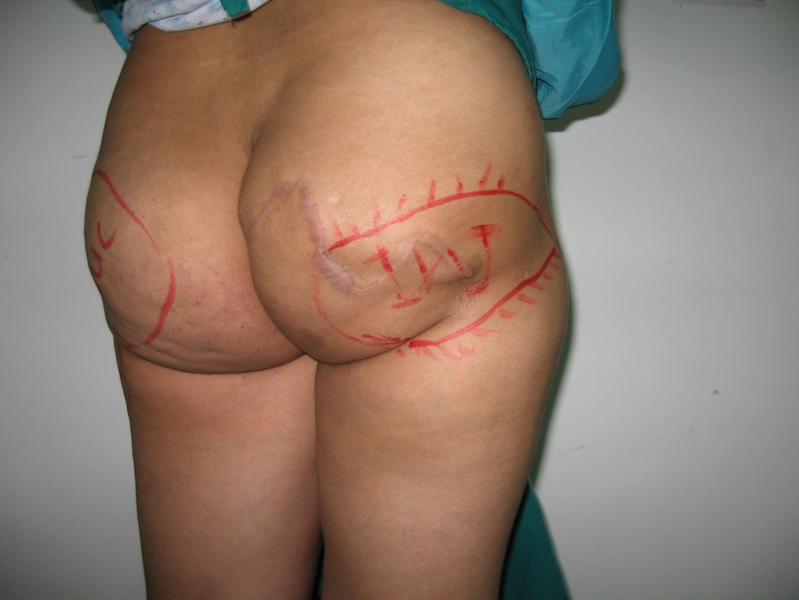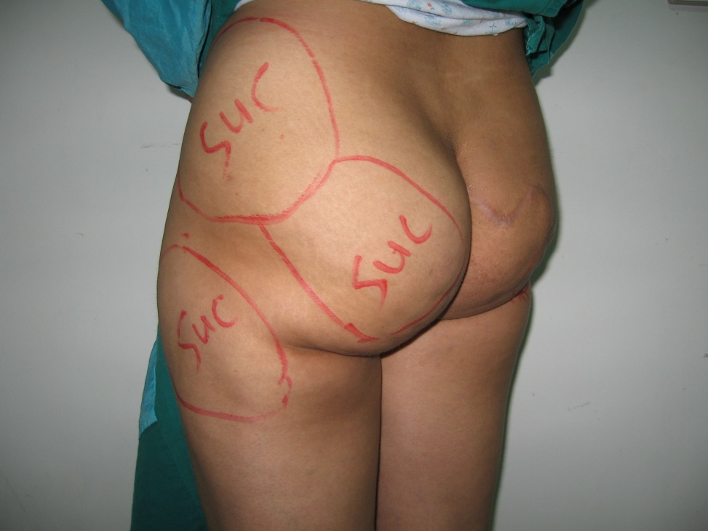

**Fig. 8** Marking for the plan of the 3rd stage of liposculpture and grafting to get an optimum result, but unfortunately the patient refused as she was satisfied by the result she got and does not want more in her opinion.

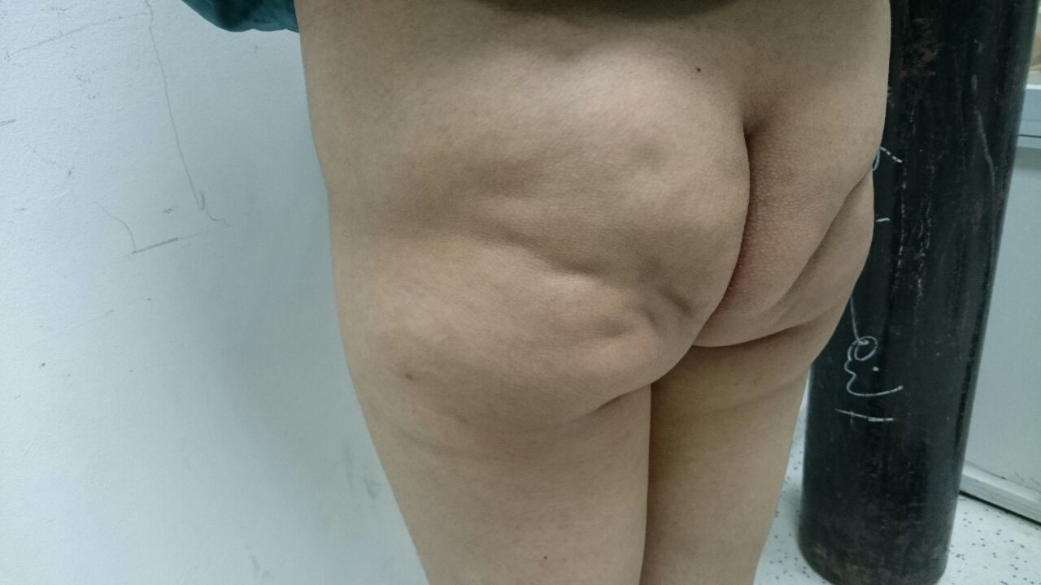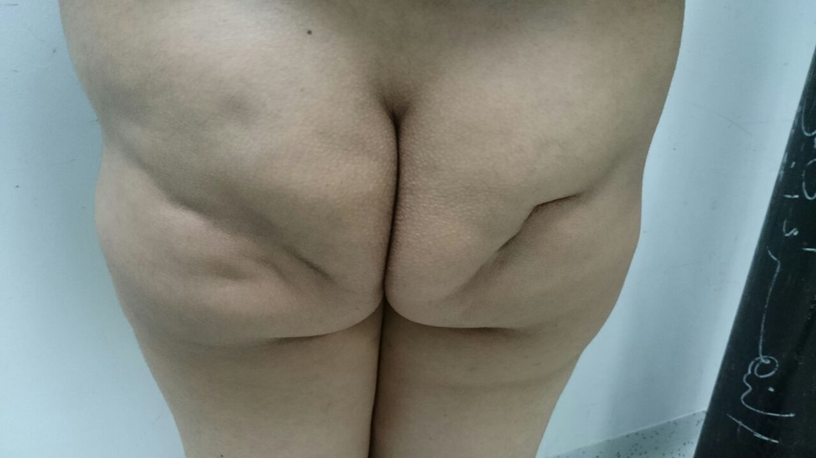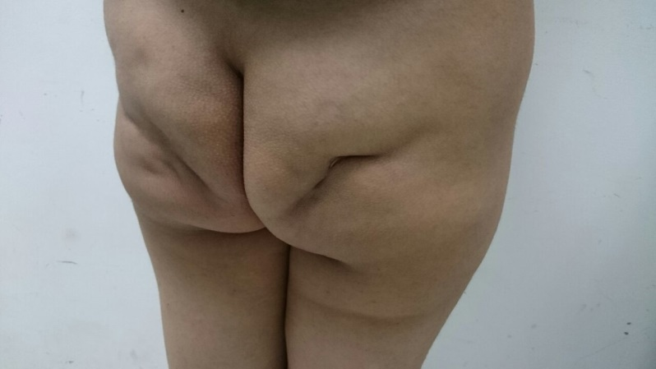

**Fig.9** Femalepatient with bilateral depressed scars post intramuscular injection.

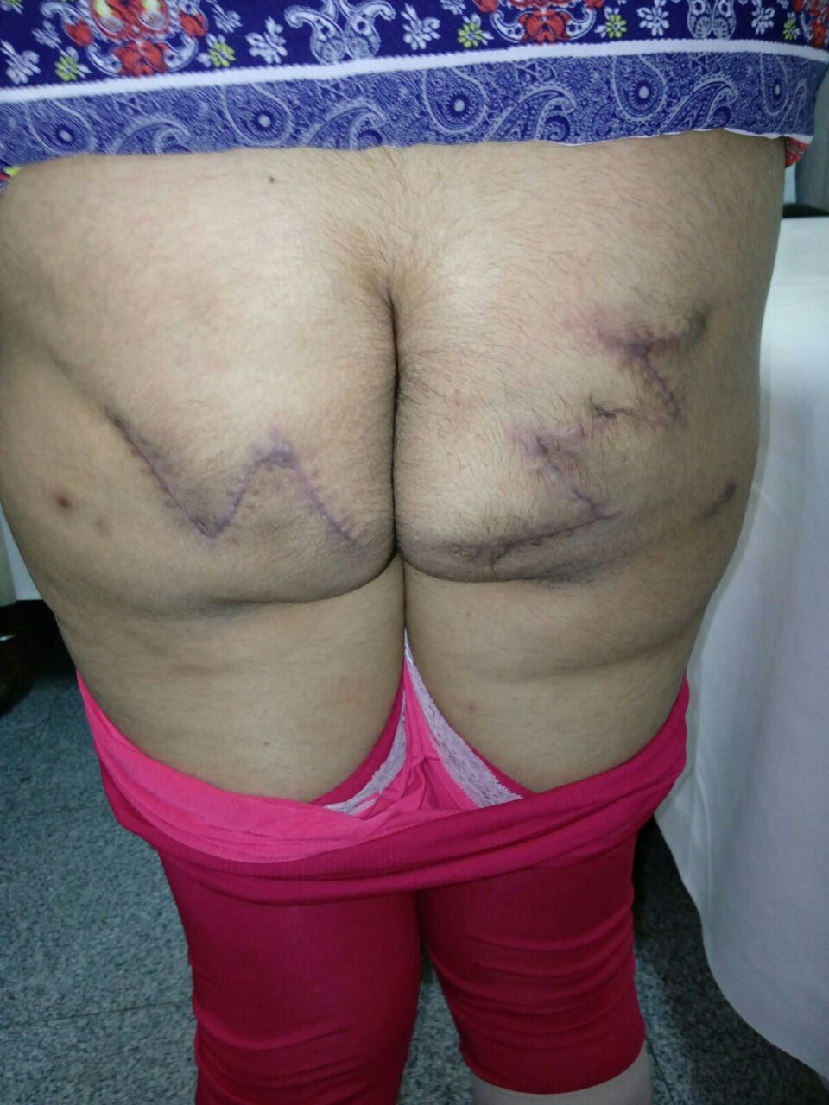

**Fig.** 10 One month postoperative with surgical correction by Z plasty only. This patient need also liposuction in the flanks to be done later on.

**4. Discussion:**

The deformities resulting from wrong intramuscular injections or infection which may follow these injections is a common gluteal deformities. But due to many factors such as shame, community traditions, or bad ideas about plastic and reconstructive surgery, all may decrease the number of patients seeking for solution to their problem.

Contouring of the deformed gluteal region is a challenge, it's clearly difficult than cases of reduction or augmentation, and need planning and creation with good counseling of the patients. The wide spread use of liposculpture give a hope to solve these deformities either alone or in conjunction with surgery.

In our community, although a limited number of patients asking for solution to these deformities, the magnitude of the problem is much bigger, as many patients feeling shame to ask for reconstruction of this area specially if they are males. In our community, so many cases of intramuscular injections are done by unprofessional medical staffs that are not following the accurate measures for intramuscular injection regarding sterilization, site of injection in the buttock, and dealing with any complications if occurred.

The term (beautiful buttock) is not a new expression, and the technique of Brazilian Buttock is worldwide popular in the last thirty years, and with the evolution of using fat graft and adipose tissue derived stem cells, this technique became more popular***. (Toledo, 2015).*** This in none deformed buttocks, so the deformed gluteal region should take the priority.

Due to wide spread of gluteal enhancement either by fat grafting or implants or silicon injection, the radiologists forced to search in the changes that may occur in case of imaging of the gluteal region for any cause. ***(Frank et al., 2014)***. This may help in refinement of the techniques used and make a better future for this subject. Also regarding injection of a big volume of fat graft, the volumetric scan of the gluteal region by Magnetic Resonance Imaging (MRI) and 3D scan which used in a study to assess fat survival in breast augmentation the authors found it's very useful in follow up the grafted fat ***(Herold et al., 2013)***. In the same manner these could be used in follow up of the grafted fat in the gluteal region for better assessment, but in this study we depended on the clinical evaluation and the patient's opinion only, so we are hoping in the future to make a more precise evaluation using these tools.

The combination of liposculpture and surgery to contour the buttocks deformities post intramuscular injection is not described in frequently in the literatures. In this subject ***(Wang et al., 2013)*** described using fat graft only without surgery in comparison with our work, which may be due to severity of the cases. This should raise in our minds the need for improving the education of the medical staff about intramuscular injection and its hazards with prohibition of doing this by non-medical professionals to decrease the complications. Also improving the general knowledge about these deformities as it's could be correctable either in patients or in medical staff as general doctors and general surgeons because they are the 1st to discover these deformities.

**Conclusion:**

Gluteal deformities that occur post intramuscular injection is a correctable deformity, the plastic surgeon should use all tools for recontouring the buttocks either individually or collectively to get the best results. Care should be taken during teaching the junior staff and nurses regarding site and depth of the intramuscular injection and off course sterilization precautions.

**References:**

1. Ali A. Contouring of the Gluteal Region in Women: Enhancement and Augmentation. Annals of Plastic Surgery. 2011;67(3):209–214.
2. Avendaño–Valenzuela G, Guerrerosantos J. Contouring the Gluteal Region with Tumescent Liposculpture. Aesthetic Surgery Journal. 2011;31(2):200–213.
3. Beatriz Nicareta, LuizHaroldo Pereira, ArisSterodimas, Yves Gérard Illouz. Autologous gluteal lipograft. Aesthetic Plastic Surgery 2011, 35 (2): 216-24.
4. Centeno RF, Young VL. Clinical Anatomy in Aesthetic Gluteal Body Contouring Surgery. Clinics in Plastic Surgery. 2006;33(3):347–358.
5. Cuenca–Guerra R, Lugo–Beltrán I. Beautiful Buttocks: Characteristics and Surgical Techniques. Clinics in Plastic Surgery. 2006;33(3):321–332.
6. [Frank SJ](http://www.ncbi.nlm.nih.gov/pubmed/?term=Frank%20SJ%5BAuthor%5D&cauthor=true&cauthor_uid=24240204), [Flusberg M](http://www.ncbi.nlm.nih.gov/pubmed/?term=Flusberg%20M%5BAuthor%5D&cauthor=true&cauthor_uid=24240204), [Friedman S](http://www.ncbi.nlm.nih.gov/pubmed/?term=Friedman%20S%5BAuthor%5D&cauthor=true&cauthor_uid=24240204), [Sternschein M](http://www.ncbi.nlm.nih.gov/pubmed/?term=Sternschein%20M%5BAuthor%5D&cauthor=true&cauthor_uid=24240204), [Wolf EL](http://www.ncbi.nlm.nih.gov/pubmed/?term=Wolf%20EL%5BAuthor%5D&cauthor=true&cauthor_uid=24240204), [Stein MW](http://www.ncbi.nlm.nih.gov/pubmed/?term=Stein%20MW%5BAuthor%5D&cauthor=true&cauthor_uid=24240204). Aesthetic surgery of the buttocks: imaging appearance. [Skeletal Radiol.](http://www.ncbi.nlm.nih.gov/pubmed/24240204) 2014;43(2):133-9.
7. [Herold C](http://www.ncbi.nlm.nih.gov/pubmed/?term=Herold%20C%5BAuthor%5D&cauthor=true&cauthor_uid=23354764), [Ueberreiter K](http://www.ncbi.nlm.nih.gov/pubmed/?term=Ueberreiter%20K%5BAuthor%5D&cauthor=true&cauthor_uid=23354764), [Busche MN](http://www.ncbi.nlm.nih.gov/pubmed/?term=Busche%20MN%5BAuthor%5D&cauthor=true&cauthor_uid=23354764), [Vogt PM](http://www.ncbi.nlm.nih.gov/pubmed/?term=Vogt%20PM%5BAuthor%5D&cauthor=true&cauthor_uid=23354764). Autologous fat transplantation: volumetric tools for estimation of volume survival. A systematic review. [Aesthetic Plast Surg.](http://www.ncbi.nlm.nih.gov/pubmed/23354764) 2013;37(2):380-7.
8. Jorge Alirio Mejia. Gluteal reduction: a new technique with tightening, lifting, and reshaping effects on the buttocks. Aesthetic Plastic Surgery 2012, 36 (3): 550-6.
9. Reisman N, Madjidi A, Caputy G, Talavera Fco., Matarasso A, Slenkovich N. Buttocks Contouring. (21 march 2011) eMedicine.com.
10. Reisman NL, Azita M. Buttocks Contouring Treatment & Management (23 August 2011) eMedicine.medscape.com.
11. [Toledo LS](http://www.ncbi.nlm.nih.gov/pubmed/?term=Toledo%20LS%5BAuthor%5D&cauthor=true&cauthor_uid=25827567). Gluteal augmentation with fat grafting: the Brazilian buttock technique: 30 years' experience. [Clin Plast Surg.](http://www.ncbi.nlm.nih.gov/pubmed/25827567) 2015 Apr;42(2):253-61.
12. Wang G, Ren Y, Cao W, Yang Y, Li S. Liposculpture and fat grafting for aesthetic correction of the gluteal concave deformity associated with multiple intragluteal injection of penicillin in childhood. Aesthetic Plast Surg. 2013;37(1):39-45.

3/25/2016