Studying the Effect of Pile-Soil Interface Properties on Piles Subjected To Negative Skin Friction

Mahmoud M. El-Meligy¹; Ayman I. Mahmoud² and Sherif M. Mohamed³

¹ Professor, ² Assist. prof , and ³ Teaching Assistant , Structural Engineering Dept, Faculty of Engineering, Mansoura University, Egypt.
atahrany@hotmail.com

Abstract: For piles constructed in compressible soils, geotechnical engineers had to deal with the concerns of negative skin friction (NSF) on pile capacity and settlement. Presence of negative skin friction or downdrag causes an additional load on the pile, this load is called dragload. Neglecting the effect of negative skin friction may cause a lot of sophisticated problems. Downdrag is a very complex problem influenced by many factors such as pile characteristics, soil shear strength parameters, pile-soil relative movement and pile-soil interface properties. In this study, Numerical work was carried out to study the effect of soil-pile interface properties on the value of negative skin friction on piles. Two dimensional and three dimensional finite element models are used to simulate and analyze the pile-soil interaction problem of negative skin friction. Detailed parametric study was carried out to investigate the effect of different factors on magnitude and distribution of negative skin friction along the pile length, the value of dragload sustained by the pile and neutral plane (NP) location. These factors include pile-soil interface friction coefficient, pile-soil limiting displacement, the order of mesh element used, pile material, pile section shape and using bituminous coating.
[Mahmoud M. El-Meligy; Ayman I. Mahmoud and Sherif M. Mohamed. Studying the Effect of Pile-Soil Interface Properties on Piles Subjected To Negative Skin Friction. N Y Sci J 2016;9(3):103-115]. ISSN 1554-0200 (print); ISSN 2375-723X (online). http://www.sciencepub.net/newyork. 17. doi:10.7537/marsnys09031617.

Keywords: Negative skin friction, Neutral plane, Pile-soil interface, Downdrag.

- Introduction
Relative displacement between pile and soil produces shear stress along the pile-soil interface. In the usual case of pile loading, the structural load applied to the top of the pile causes the pile to move downward with the respect to the soil. The shear stresses along the pile-soil interface act upward, this is the case for positive skin friction (PSF). If the pile is constructed through a compressible soils such as soft clay, peat, recent fill, it is possible for the soil to move downward relative to the pile. The settlement of the soil may be caused by application of surcharge loading, lowering of the water table, compression of recent fill under its own weight and the oscillation of sea water level in case of piles supporting coastal structures. In this case, where surrounding soil actually settles more than the pile, the shear force along pile shaft actually acts downward instead of upward, reducing the capacity of the pile by adding additional load. This phenomenon is called negative skin friction (NSF) or downdrag. Negative skin friction is time dependent issue because it is related to the magnitude of excess pore water pressure during consolidation process. Fellenius [1] defined the neutral plane (NP) as the plane where the relative movement between pile and soil equal zero. Fellenius [2,3,4], Blanchet et al. [5] and Indraratna et al. [6] conducted field tests on instrumented piles. They found that drag force may be large enough to reduce the pile capacity and/or to overstress the pile's material causing fracture or perhaps structural failure of the pile.
Many methods have been proposed to determine the magnitude and distribution of NSF. Terzaghi and Peck [7] proposed the first analytical method to calculate the dragload. There are mainly two methods for the estimation of skin friction: the α method and the β method in calculating skin friction (fs) for piles in clay [8,9]. These methods have been applied to calculate NSF. The α method, fs=α.Cu where Cu is the average undrained shear strength of clay along the length of the pile, α is an empirical adhesion factor. While the β method, fs=β. σ′v where σ′v is the average vertical effective stress in the soil along the pile before driving, β is an empirical factor; β=(1−sinϕ′)tanδ for normally consolidated clay; β=(1−sinϕ′)OCR0.5.tanδ for overconsolidated clay, δ is the friction angle of the pile-soil interface.
Numerical modeling with the finite element method (FEM) is well-recognized as a powerful tool for studying the effect of negative skin friction on piles. Lee et al. [10] carried out a finite element numerical analysis. This analysis showed that end bearing piles can sustain more dragload than friction piles. The reason for that is that friction piles moves downwards during soil settlement. Chen et al. [11] concluded that the one dimensional consolidation theory of Terzaghi overestimates the dragload affecting the pile. Jeong et al. [12] studied the effect of pile head loading on the value of dragload. Increasing the value of pile head loading decreases the value of expected dragload.
In this paper, two dimensional and three dimensional models are developed to analyze the NSF problem of piles. Many parameters are used to study the effect of pile-soil interface properties on NSF values. The influence factors, such as: pile-soil interface friction coefficient, the value of limiting displacement, the order of mesh element used, pile material, pile section shape and using bituminous coating were analyzed and discussed.

2..Numerical Modeling
2.1.The Two Dimensional Model (2D)
Axisymmetric FEM model is developed using Abaqus/CAE for the case of a single pile with uniform radial cross section where the symmetry condition in this problem is considered by coinciding the symmetrical line with the axis of the pile. The pile is assumed to be embedded in contact with surrounding soil.
2.1.1Geometry of the 2D Model
To satisfy sufficient accuracy, the width of the model (W) is assumed equal 0.6 times the pile length (L) from the pile's center, or 25 times the pile diameter (D) from the pile's center, whatever is farther from the pile shaft [13]. The mesh bottom (H) is placed at distance of 0.7 times the pile length (L) from the pile tip [14]. Figure (1) presents the geometry of the 2D model.
2.1.2 The Boundary conditions for 2D Model
The bottom boundary line of the mesh is considered as fixed in both vertical and horizontal directions (i.e No displacement is permitted at the bottom of the mesh). The vertical boundary on the left side is a symmetrical line. The vertical boundary on the right side is fixed in the horizontal direction (i.e in 'x 'direction) but free in the vertical direction (i.e in 'y' direction).
2.1.3 Mesh Generation for 2D Model
The element named by (CAX8R) is used for pile simulation which means eight-node bilinear axisymmetric quadrilateral, reduced integration, hourglass control elements, while element (CAX8RP) are selected to simulate soil elements which means eight-node axisymmetric quadrilateral, bilinear displacement, bilinear pore pressure, reduced integration elements [15]. As shown in figure (1), the mesh is designed to be denser closed to the pile as the stresses expected to concentrated at this area.
2.2.The Three Dimensional Model (3D)
3D FEM model is constructed using Abaqus/CAE for a single pile. The pile is assumed to be embedded in perfect contact with surrounding soil.
2.2.1.Geometry of the 3D Model
As mentioned before in section 2.1.1, a full 3D model is modeled to simulate a pile in a full contact with surrounding soil. Figure (2) presents the geometry of the numerical model.
2.2.2.The Boundary conditions for the 3D Model
The bottom boundary of the model is considered to be fixed in both all directions. The vertical boundaries are fixed in the horizontal directions but free in the vertical direction.

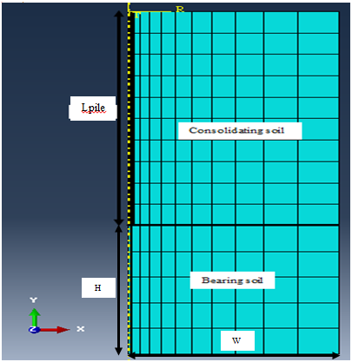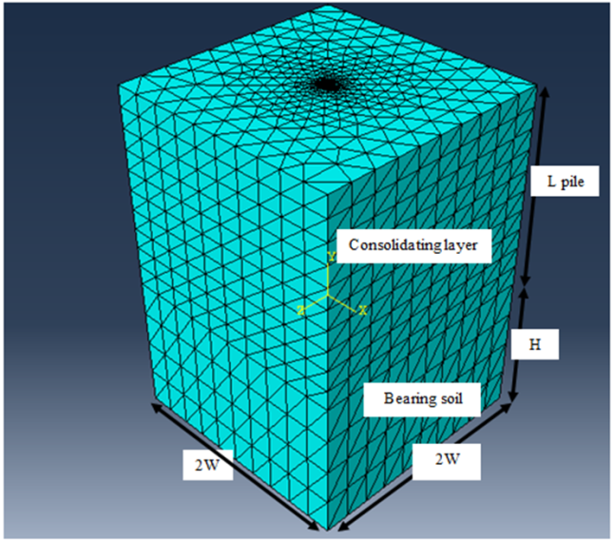
Fig.(1): Geometry and generation of mesh for the 2D model Fig.(2): Geometry and generation of mesh for the 3D model

2.2.3.Mesh Generation for 3D Model
Pile was simulated by using element named by (C3D10M) which means ten-node modified tetrahedron, with hourglass control, While soil was simulated by using element called (C3D10MP) which means ten-node modified displacement and pore pressure tetrahedron, with hourglass control, as shown in figure (2).
  - The Contact Properties
The Abaqus/CAE program supports a great variety of data concerning the contact surfaces. An interface of zero thickness is used to allow soil slip at the soil–pile interface [15]. Abaqus/CAE uses the Coulomb frictional law where frictional behavior is specified by an interface friction coefficient (μ) and a limiting displacement (γ_{crit}) (see Figure (3)). The compressive normal effective stress σ_{v}' between two contact surfaces was multiplied by an interface friction coefficient μ to give a limiting frictional shear stress μ × σ_{v}'. As shown in Figure (4), the interface elements of zero thickness can only transfer shear forces across their surfaces when σ_{v}' acts on them. When contact occurs, the relationship between the shear force and the normal pressure is governed by a modified Coulomb’s friction theory. Thus, these elements are completely defined by their geometry, a friction coefficient μ, where μ = tan (δ), an elastic stiffness and a limiting displacement γ_{crit} used to provide convergence. If the shear stress applied along the surfaces was less than μ × σ_{v}' the surfaces would stick. The nodes of the soil elements in contact with a pile could slide along it when soil slip occurs. The limiting shear displacement and interface friction coefficient values were typical values obtained from the research by Lee et al. [10]. The pile–soil interaction in the analysis was governed by varying a limiting shear displacement and an interface friction coefficient μ, where μ = tan (δ) and δ is the interface friction angle. A limiting shear displacement of 5 mm was assumed to achieve full mobilization of the interface friction. The similar value was used by Lee et al. [10].

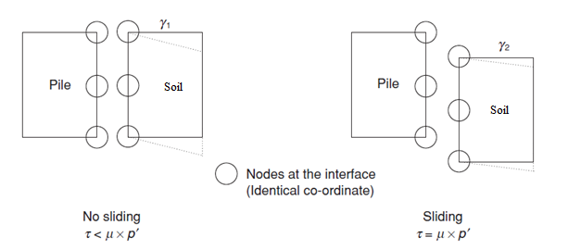
Fig.(3): Interface Modeling [10]

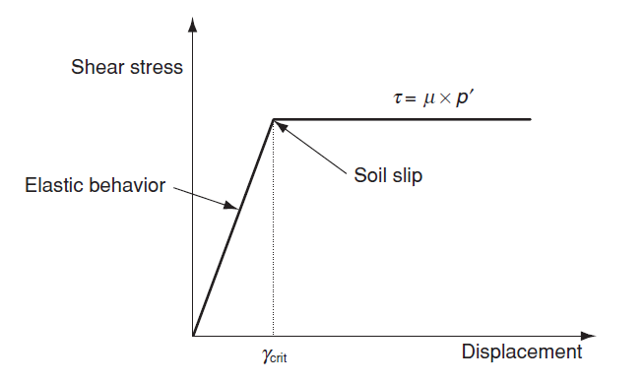
Fig.(4): Behavior of interface element [10]

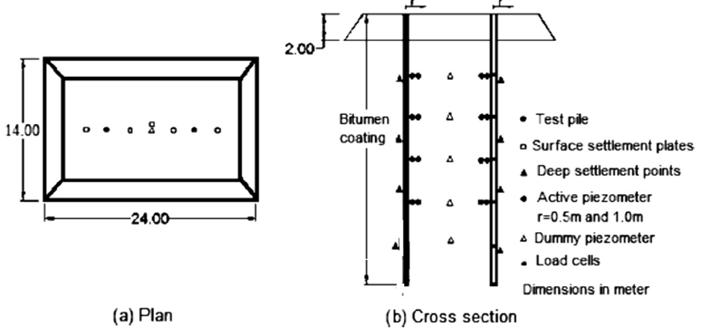
Fig.(5): Plan and Cross section for tested piles [6]

Numerical back analysis is performed on a long term field test in a high rise building in Bangkok supported on piles. Bangkok soft clay consolidation results a negative skin friction along the pile shaft. Indraratna et al. [6] conducted field test on two precast concrete driven piles in a site in Bangkok. The soil profile at the test site consist of a weathered clay with thickness of 4m, underlain by a soft clay layer with 16 m thickness, overlying a 5 m thick medium to stiff clay layer, then finally sand starts at depth of 25 m below the ground surface. The used piles are 0.4 m in diameters and with length of 25 m. One of the two piles was coated with bitumen and the other was uncoated (regular pile). An embankment with a height of 2 m took place around the piles. The embankment dimensions were 24 m by 14 m, as shown in figure (5). Those piles were observed and monitored for 265 days after the embankment took place. Indraratna et al. [6] modeled the clay stratum as a modified Cam Clay material, while the sands are described by linear elastic-perfectly plastic materials following the Mohr-Coulomb yield criteria. The input parameters used by Indraratna et al. [6] are listed in table(1). The pile is modeled as an isotropic linearly elastic material having similar material properties as concrete, as shown in table (2).Frictional properties for pile-soil interface surface used by Indraratna et al.[6] are summarized in table (3).
2.4.1. Skin Friction
Figures (6,7) show the distribution of shaft skin friction for both coated and uncoated piles. Negative and positive signs refer to negative skin friction (NSF) and positive skin friction (PSF) respectively. The results for both 2D and 3D models are compared with field measurements after 265 days. The good agreement between FEM results and field measurements proves that numerical modeling using Abaqus/CAE program can be accepted to be used in studying NSF.

Table(1). Modified Cam-clay parameters used in model verification adopted in Indraratna et al.[6].
Hydraulic Conductivity coeff  K*10⁻⁵ (m/d) | Elastic modulus (MPa) | Poission's ratio υ | ϕ' | M | λ | κ | e_{o} | Density  γ (kN/m³) | Depth (m) | Soil type
67.6 | 4.9 | 0.33 | --- | 1.05 | 0.182 | 0.053 | 1.67 | 17 | 0-4 | Weathered clay
5.5 | 4.9 | 0.33 | --- | 0.97 | 0.514 | 0.084 | 3.05 | 15 | 4-10 | Soft clay
2.63 | 4.9 | 0.33 | --- | 0.98 | 0.323 | 0.063 | 2.08 | 17 | 10-20 | Soft clay
3.72 | 6.37 | 0.33 | --- | 0.9 | 0.116 | 0.027 | 1.2 | 17 | 20-25 | Medium to stiff clay
3.72 | 27.44 | 0.33 | 33 | ---- | ---- | ---- | 1.2 | 19.5 | 25-40 | Sand

Table(2). Material properties for used piles [6].
Poission's ratio υ | Elastic modulus (GPa) | Density  γ (kN/m³) | Diameter (m) | Depth (m) | Material
0.33 | 29.4 | 24.5 | 0.40 | 0-25 | pile

Table (3). The frictional coefficient properties at pile-soil
μ = β/ K_{o} | K_{o} | β Value | Material
0.083 | 0.60 | 0.05 | Coated pile
0.25 | 0.60 | 0.15 | Uncoated pile
interface for coated and uncoated piles [6].

2.4.2 Soil and pile settlements
Figure (8) is constructed to represent a comparison between soil settlement from field data and soil settlement from 2D and 3D FEM models. Near ground surface, 2D modeling results underestimate the values of soil settlement. Both 2D and 3D simulations overestimate settlement values in soft clay layers.
Figures (9,10) show a comparison between soil settlement and uncoated pile settlement values along the soil-pile interface at different times (3, 53 and 265 days) after applying the embankment load. For pile settlement, it is obvious that pile settlement is almost constant along the embedded depth and pile settlement values are almost the same in both 2D and 3D analyses. As expected, both figures show that settlement of soft layers increase with time.
Pile-soil relative displacement is the mean reason for the generation of skin friction. Near ground surface, relative displacement has large values. These values decrease gradually until we reach the point of zero relative displacement. This location is called neutral plane (NP). In figures (9,10), dashed line indicates the location of NP with time. The NP location moves downward during time procedure and divides the pile into two regions. At the top region of the pile, the soil settles more than the pile causing the mobilization of NSF. The mobilized NSF pulls the pile downward. Beneath that region, the pile settles more than the soil, and then PSF is mobilized. Table (4) summarizes the results shown in figures (8,9 and 10).
2.4.3 Neutral Plane
Neutral plane (NP) is the location of zero relative displacement between soil and pile. Also the value of skin friction equals zero at NP. The path of NP development with time and average degree of consolidation (Uavg %) is shown in figure (11). To get the average degree of consolidation, the difference between the initial and the current excess pore water pressure is divided by the initial excess pore water pressure. As shown in figure (11), NP location moves downwards as the consolidation proceeds. The field results ends at t = 265 days [6], which corresponding to Uavg % = 80%. 2D simulation results of NP agree well with field result more than 3D model.

Table(4). Comparison between 2D & 3D models
Output |  | 2D analysis | 3D analysis
soil settlement at ground level (mm) | 3 days | 84.10 | 96.24
 | 53 days | 138.42 | 192.46
 | 265 days | 252.19 | 296.17
soil settlement at pile tip (mm) | 3 days | 4.26 | 4.87
 | 53 days | 14.60 | 15.62
 | 265 days | 17.52 | 18.20
Neutral plane location from ground level (m) | 3 days | 10.50 | 8.70
 | 53 days | 12.80 | 14.20
 | 265 days | 17.90 | 18.10

Fig.(6): Comparison between 2D and 3D FEM models with field data for coated pile

Fig.(7): Comparison between 2D and 3D FEM models with field data for Uncoated pile

Fig.(8): Comparison between Soil settlement results from field data and 2D & 3D FEM models.

Fig.(9): 2D FEM results for pile and soil settlements with depth

Fig.(10): 3D FEM results for pile and soil settlements with depth

Table (5). Different parameters used in analysis
Consolidation time | k_{o} | γ_{crit}  (mm) | μ | Surcharge load  (kPa)
5 years | 0.65 | 5 | 0.3 | 100

3. Analysis and Results
Further data with these mentioned in (2.1, 2.2), a pile with diameter 0.5m and depth of 20m is constructed totally embedded in a consolidating layer. The consolidating layer ends at the pile tip. The width of the model (W) is taken to be 12.5m, while the thickness of the bearing layer (H) equal to 14m, figure (1,2).
Parameters used in this numerical analysis are listed in table (5). The Modified Cam-clay model is used for modeling consolidated layer as shown in table (6). while Mohr coulomb model properties is used for modeling the bearing layer, as shown in table (7) and the pile is modeled as an isotropic linearly elastic material, table (8).

Fig.(11): Neutral plane location with time and average degree of consolidation

Table (6). Consolidating layer properties used in analysis
Hydraulic Conductivity coeff  K (m/s) | Elastic modulus (MPa) | Poission's ratio υ | M | λ | κ | e_{o} | Density  γ (kN/m³) | Material
1*10⁻⁸ | 5.0 | 0.33 | 0.9 | 0.2 | 0.01 | 1.2 | 18 | Consolidating layer

Table (7). Bearing layer properties used in analysis
Hydraulic Conductivity coeff  K (m/s) | Elastic modulus (MPa) | Poission's ratio υ | Friction angle ϕ | Cohesive strength c (kPa) | e_{o} | Density  γ (kN/m³) | Material
1*10⁻⁵ | 50 | 0.33 | 35º | 0.0 | 0.90 | 20 | Bearing layer

Table (8). Pile properties used in analysis
Poission's ratio υ | Elastic modulus (kPa) | Pile length  (m) | Pile Diameter  (m) | Density  γ (kN/m³) | Material
0.33 | 2.1*10⁷ | 20 | 0.5 | 25 | pile

A number of factors are believed to have an influence on the values of skin friction, dragload value and the location of neutral plane. These factors are: pile-soil interface frictional coefficient, limiting displacement, order of mesh element used, pile material, pile section shape and using bituminous coating piles.
3.1.Effect of Pile Interface Frictional coefficient
The pile–soil interface strength plays a principal role in the problem of negative skin friction on piles. As mentioned before that the shearing force is the result of multiplying the normal force by an interface frictional coefficient, μ = tan(δ), where, δ is the frictional angle between the pile-soil which varies from 6° to 21° [16]. Correspondingly, the μ value will vary from 0.1 to 0.4.
As shown in figure (12), both NSF and PSF increase with the increase in the value of pile-soil interface friction coefficient μ in both 2D and 3D analyses. For each μ value, a small difference is found in NSF and PSF between 2D and 3D analyses. 3D model results are always greater that 2D model results for the same μ value.
Increasing the value of μ led to an increase in the dragload value. Reducing the value of pile-soil interface friction coefficient μ makes the interface unable to afford shear stress, and to resist the soil movement. Figure (13) shows a directly proportional relationship between the dragload and μ in both 2D and 3D models.

Fig.(12): Distribution of skin friction for different pile-soil interface coefficients

Fig.(13): Effect of pile-soil interface coefficient on dragload

Fig.(14): Effect of pile-soil interface coefficient on Neutral plane location

From figure (14), the location of the neutral plane moves upwards with the increase of the frictional coefficient μ. So that it can be concluded that the location of neutral plane is inversely proportional with the value of the frictional coefficient μ. And, a slight difference is noticed between 2D and 3D models results.
3.2.Effect of Limiting Displacement
As mentioned before in section (2.3), a limiting shear displacement (γcrit) of 5 mm was assumed in this investigation to achieve full mobilization of the interface friction. Similar value was used by Lee et al. [10]. The range from 3 to 7 mm is used to run the analysis in order to study the influence of this limiting displacement on NSF.
As shown in figure (15), the values of skin friction in the upper part of the pile are almost the same for both 2D and 3D analyses with slight difference. On the other hand, the influence of changing limiting displacement (γcrit) in the lower part of the pile shows the inverse trend. As a conclusion, the value of limiting displacement has a slight influence on skin friction values and distribution.
Increasing the value of limiting displacement (γcrit) has a minimum effect on pile dragload value. Figure (16) shows that 2D dragload results decrease in a very slow rate by increasing the value of limiting displacement. The same trend was observed for 3D dragload results. 3D results overestimate the values of dragload more than 2D results.
The location of the neutral plane approximately for both 2D and 3D model is the same for different value of limiting displacement (γcrit) as shown in figure (17). So, it can be concluded that the limiting displacement has a very limited effect on the location of neutral plane.

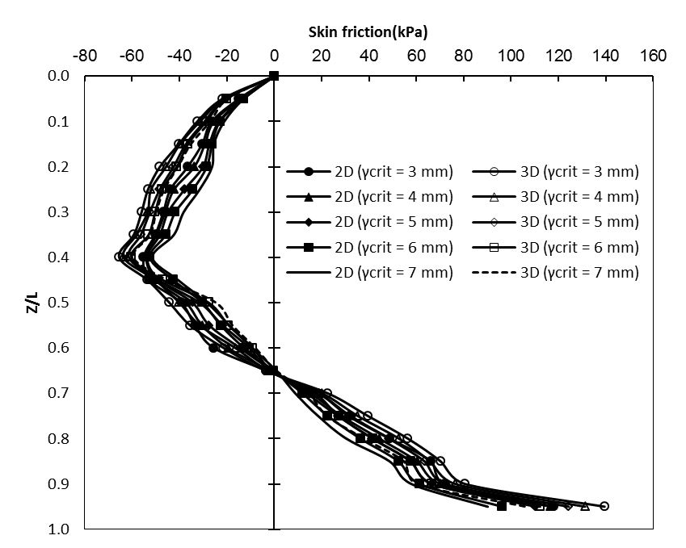
Fig.(15): Distribution of skin friction for different limiting displacements values

Fig.(16): Effect of Limiting displacement value on dragload

Fig.(17): Effect of Limiting displacement value on Neutral plane location

3.3. Effect of Used Mesh Element
As mentioned before in section (2.1.3), an element of type (CAX8RP) is used to simulate soil elements in 2D model. While element (C3D10MP) were used to generate meshes for soil in 3D analysis, as shown in section (2.2.3). These elements are second order elements [15]. In order to investigate the effect of mesh element order on the values of NSF, a first order element (CAX4RP) is used for 2D analysis which means 4-node bilinear displacement and pore pressure, reduced integration with hourglass control and an element of (C3D8RP) is used in remeshing 3D model which means 8-node brick, trilinear displacement, trilinear pore pressure, reduced integration, hourglass control.
As shown in figure (18), the values of skin friction in models remeshed by first order mesh elements are greater than values of those used second order elements. Using second order mesh elements gives very close results for 2D and 3D models and the same trend be observed for first order mesh elements. Comparison between first order and second order mesh elements shows that first order elements overestimate the value of skin friction even NSF or PSF.
Using first order mesh elements causes an obvious increase in pile dragload value. Figure (19) shows that 2D and 3D dragload results by using first order mesh elements are very close. But these results overestimate the values of dragload obtained by using second order mesh elements. From figure (18), the location of the neutral plane approximately is the same for different mesh elements types for both 2D and 3D model. So, it can also be concluded that using first order or second order mesh elements types has a minimal effect on the location of neutral plane, while it has a significant effect on the dragload.

Fig.(18): Distribution of skin friction for different mesh element types

3D (C3D8RP)
2D (CAX8RP)
2D (CAX4RP)
3D (C3D10MP)
Fig.(19): Effect of mesh element type on dragload

3.4.Effect of Pile Material
Pile used in this analysis was a concrete pile with modulus of elasticity of 2.1*107 kPa. In order to study the effect of changing pile material, a steel pipe pile filled with concrete is used with modulus of elasticity of 2.1*108 kPa, density of 78kN/m3 and Poission's ratio of 0.2. This steel pile has the same length and diameter of concrete pile used before. The frictional coefficient μ = tan(δ), where δ = 20o for steel material [17].
It can be observed from Figure (20), that the effect of changing pile material from concrete to steel on the value of skin friction on the pile shaft is found to be small. The variation in results between 2D modeling and 3D modeling is too close.
Figure (21) shows that the dragload values for piles with the same material are close for both 2D and 3D modeling. Also it can be noticed that using steel piles make the pile subjected to greater value of dragload. The location of neutral plane was found to be the same, whatever the pile material is steel or concrete, as shown in figure (20). Using 2D and 3D modeling give the same values for the location of neutral plane.

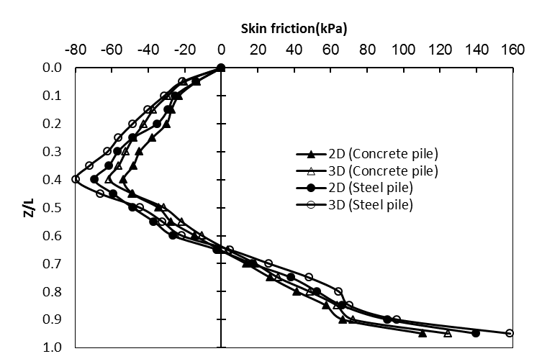
Fig.(20): Distribution of skin friction for different pile materials

Fig.(21): Effect of changing pile material on dragload

3.5.Effect of Pile Section Shape
The problem was reanalyzed using a hollow steel pipe pile instead of steel solid pile, to investigate the effect of pile section shape on the results. The pipe is assumed to have outer and inner diameters as 0.5m and 0.3m respectively.
Figure (22) demonstrates that the effect of changing pile section shape on the value of skin friction on the pile is found to be small for both 2D and 3D analysis. A slight difference was found between 2D and 3D results.
Dragload values for piles with the same section shape are almost the same for both 2D and 3D modeling, as shown in figure (23). But a slight difference was found between solid steel piles and hollow ones.
The neutral plane is almost the same for solid and hollow pipe piles, as shown in figure (22). A slight difference was found between 2D and 3D modeling for the location of neutral plane.

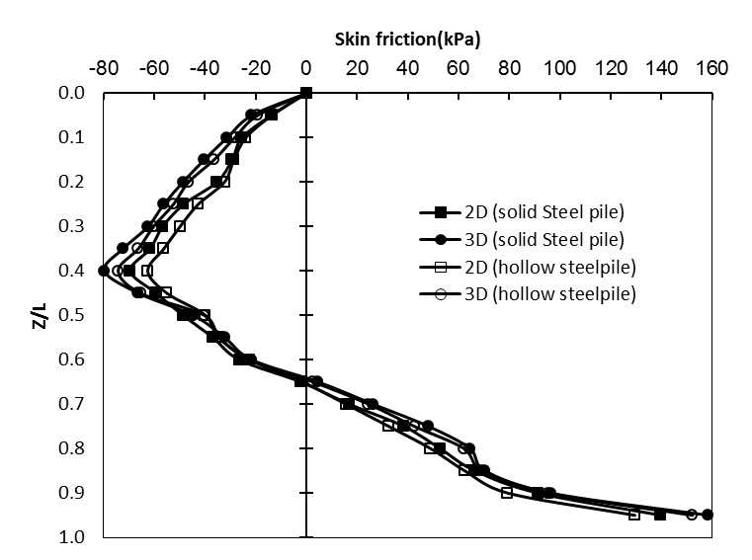
Fig.(22): Distribution of skin friction for different pile section shapes

Fig.(23): Effect of changing pile section shape on dragload

3.6.Effect of Pile Surface Coating
Usage of some materials as bitumen to reduce the value of dragload effects on the pile have been reported in many researches [6,18,19]. In these researches, to simulate bitumen coated pile a β value of 0.033 is used which is corresponding to a frictional coefficient μ of 0.05.
From figure (24), both negative and positive skin friction are significantly decreased due to bituminous coating on pile shaft. 2D and 3D results are approximately the same. Figure (25) shows that dragload affected totally by using bituminous coating technique; dragload has reduced by about 72% to 75% for both 2D and 3D results.
The location of neutral plane in 2D and 3D analysis moves downwards with the presence of bitumen coating. A slight difference was found between 2D and 3D modeling for the location of neutral plane.

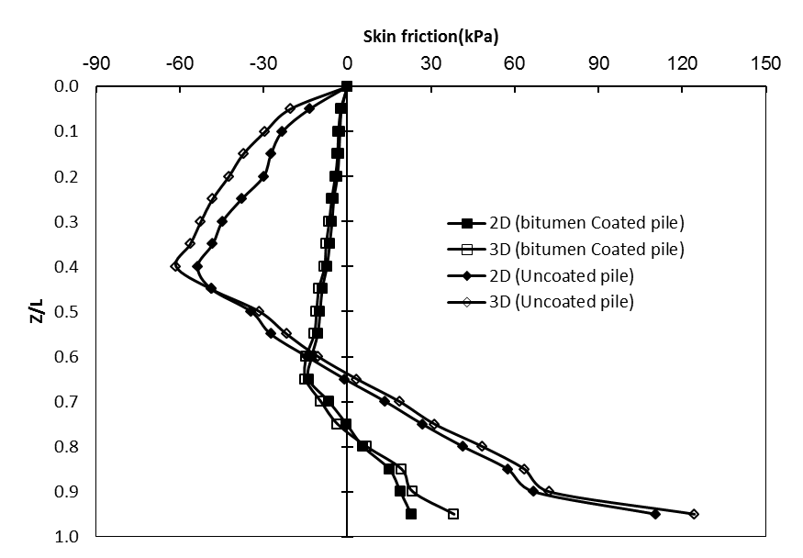
Fig.(24): Distribution of skin friction for different pile materials and shapes

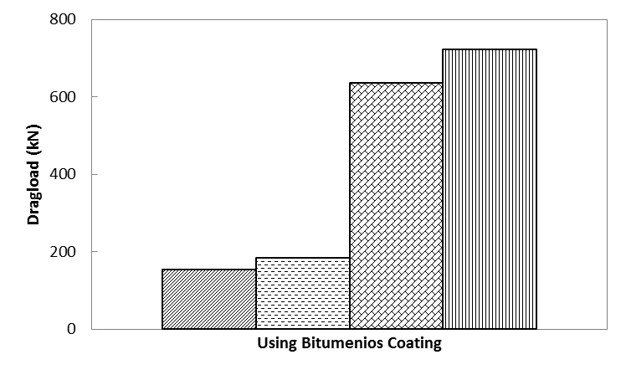
Fig.(25): Distribution of skin friction for different pile materials and shapes

4. Conclusions
In this study, the effect of pile-soil interface properties on piles subjected to negative skin friction is numerically investigated. Verification analysis between field data and finite element model shows that the finite element method can predict negative skin friction problems with high accuracy. A numerical study including the effect of pile-soil interface friction coefficient value, effect of limiting displacement, the order of mesh element used, the effect of different pile materials, the effect of pile section shape and the effect of using bitumen coated piles have been studied in 2D and 3D.
The following conclusions could be drawn from the study:
- Increasing the value of friction coefficient μ causes the increase of both the negative and positive skin, and consequently increases the dragload values. The location of neutral plane is inversely proportional with the value of the frictional coefficient μ.
- The location of neutral plane and the distribution of skin friction are influenced in a minor way by the value of limiting displacement. Dragload is slightly affected by the value of limiting displacement.
- Mesh elements with first order degree overestimates the skin friction and dragload compared with mesh elements with second order degree. However, the location of neutral plane is nearly the same for both mesh elements.
- Using steel or concrete piles has no effect on the location of the neutral plane, and skin friction and dragload values were slightly affected.
- Neutral plane location is almost the same even if the pile is solid steel pile or hollow steel pile. Moreover, good agreement between the results for both negative and positive skin friction.
- Bituminous coating for piles has a significant effect to reduce both skin friction and dragload values. The neutral plane depth increase due to the usage of bitumen coated piles.
References
- B.H. Fellenius, (1984) Negative skin friction and settlement of piles, in: Proceedings of 2nd International Semina, Pile Foundations, Nanyang Technological Institue, Singapore.
- B.H. Fellenius (1972), Downdrag on piles due to negative skin friction, Canadian Geotechnical Journal 9 (4): 323–337.
- B.H. Fellenius (2006), Results from long-term measurements in piles of dragload and downdrag, Canadian Geotechnical Journal 43 (4): 409–430.
- B.H. Fellenius, Broms BB (1969) Negative skin friction for long piles driven in clay. In: Proceedings of the 7th international conference on soil mechanics and foundation engineering, Mexico, pp 93–97.
- R. Blanchet, F. Tavenas, R. Garneau (1980), Behavior of friction piles in soft sensitive clays, Canadian Geotechnical Journal 17: 203–224.
- Indraratna B, Balasubramaniam AS, Phamvan P, Wong YK (1992) Development of negative skin friction on driven piles in soft Bangkok clay. Can Geotech J 29(3):393–404.
- Terzaghi K, Peck RB (1948) Soil mechanics in engineering practice. Wiley, New York.
- Meyerhof GG (1976) Bearing capacity and settlement of pile foundations. ASCE J Geotech Eng Div 102(3):195–228.
- O’Neill MW (2001) Side resistance in piles and drilled shafts. ASCE J Geotech Geoenviron Eng 127(1):3–16.
- Lee CJ, Ng CWW, Jeong SS (2009) The effect of negative skin friction on piles and pile groups. In: Bull JW (ed) Linear and non-linear numerical analysis of foundations. Taylor & Francis, London.
- R.P. Chen, W.H. Zhou, Y.M. Chen (2009), Influences of soil consolidation and pile load on the development of negative skin friction of a pile, Computers and Geotechnics 36: 1265–1271.
- S. Jeong, J. Lee, C.J. Lee(2004), Slip effect at the pile–soil interface on dragload, Computers and Geotechnics 31: 115–126.
- Trochanis, A. F. and Worth C. P. (1988) A three dimensional non-linear study of piles leading to the development of a simplified model. A technical report of research, The national science foundation, Carnegie Mellon.
- Randolph, M.F. and Worth, C. P. (1978) Analysis of Deformation of Vertically Loaded Piles. ASCE J Geotech Eng Div 104(3):1465–1488.
- ABAQUS/CAE User's Manual v6.10, Simula Company, Dassault S., 2009.
- Potyondy JG (1961) Skin friction between various soils and construction materials. Geotechnique 11(4):339–353.
- Egyptian code for soil mechanic, foundations design and implementation, ECCS-202/4, v6, 2001.
- Clemente FM Jr (1981) Downdrag on bitumen coated piles in a warm climate. In: Proceedings of the 10th international conference on soil mechanics and foundation engineering, Stockholm, pp 673–676.
- Walker LK, Le P, Darvall L (1973) Dragdown on coated and uncoated piles. In: Proceedings of the 8th international conference on soil mechanics and foundation engineering, Moscow, pp 257–262.

3/25/2016

