**Influence of Solar Radiation on Localized Irrigation Efficiency in sandy soil-Ismailia Governorate.**

A. K. Mahmoud

Department of Chemical and Soil physics, Desert Research Center (DRC), Cairo, Egypt

[amr_73@yahoo.com](mailto:amr_73@yahoo.com)

**Abstract:** Sundry previous studies have modeled the impact of climate parameters on crop water requirements and hence future water resource needs for irrigated agriculture. Fewer have considered the impacts on performance of irrigation systems and on required water management. Doubtless; that the solar radiation has an impacts on different irrigation components which lead to effect on irrigation performance. Thus; the experiment was conducted to assess the influence of solar radiation and different amounts of water on clogging ratio (CR) and absolute Uniformity Emission (EUa) for localized irrigation with cultivated two crops Bottle Gourd and Broccoli at Ismailia. Hence; experiment was laid out on split plot design with two factors. First; factor is water quantity which comprise into two treatments (Q1 and Q2) approximately (50% and 100%) from total water applied for two crops. Second factor is localized irrigation system which comprise into two treatments (drip and mini-sprinkler). The results revealed that the1% of clogging ratio under mini-sprinkler needs to 195.65 (MJ/m2) SR with Q1 and needs to 306.9 (MJ/m2) SR with Q2. Moreover; 1% of clogging ratio for drip irrigation system needs for 172 (MJ/m2) SR under Q1 and to 263(MJ/m2) SR under Q2. Further; to acquire 1% decreasing on (EUa) needs to 585.1(MJ/m2) for drip and needs to 948.6 (MJ/m2) for mini-sprinkler under Q2. However; for decreasing 1% (EUa) needs to 434.7(MJ/m2) for drip and to 500.8 (MJ/m2) for mini-sprinkler under Q1.On the other hand; the highest means values for yield production were appeared with drip irrigation system for both crops Bottle Gourd and Broccoli by 4.2 (ton/fed) and 7.9 (ton/fed) respectively.

[A. K. Mahmoud. **Influence of Solar Radiation on Localized Irrigation Efficiency in sandy soil-Ismailia Governorate.** *N Y Sci J* 2016;9(3):53-60]. ISSN 1554-0200 (print); ISSN 2375-723X (online). <http://www.sciencepub.net/newyork>. 10. doi:[10.7537/marsnys09031610](http://www.dx.doi.org/10.7537/marsnys09031610).

**Keywords:** Solar radiation, localized irrigation, Efficiency and, yield production.

**1. Introduction**

Sundry previous studies have modeled the impact of climate parameters on crop water requirements and hence future water resource needs for irrigated agriculture. However; scant studies focus on the impacts at the performance of irrigation systems and the required engineering and managerial adaptations in engineering design and management. Fortunately; irrigation systems or and water distribution systems are the vital object which contributing to improve an agricultural productivity in arid and semi arid region. In addition; at this region the shortage of fresh water for irrigation has become a major concern. Under such condition; agriculture is forced to use more water of low quality water. Water availability for irrigation in the region could be enhanced through proper use and management water (Hamdy, 2002). Thus; Agriculture, climate change and water unit are inextricably linked.

Obviously, climatic and meteorological data are the main approaches to calculate the water requirement and schedule irrigation. For instance; The Solar radiation is the largest energy source and is able to change large quantities of liquid water into water vapor. Due to differences in the position of the sun, the potential radiation differs at various latitudes and in different seasons. Moreover; the radiation depends on the turbidity of the atmosphere and the presence of clouds which reflect and absorb major parts of the radiation. Furthermore, solar radiation is essential factor for a numerous applications including solar energy systems. Hence; influence on many phenomena as irrigation performance, interval irrigation and on farm water management generally but, measuring solar radiation is not easily available for many developing countries. Therefore, solar radiation depends on modeling and meteorological data to estimate the accurate values for this factor. (Kadir Bakirci, 2009) "Those models have been developed to calculate global solar radiation using various climatic parameters. These parameters include extraterrestrial radiation, sunshine hours, mean temperature, maximum temperature, soil temperature, relative humidity, number of rainy days, altitude, latitude, total precipitation, cloudiness and evaporation”. The most commonly used parameter for estimating global solar radiation is sunshine duration. Sunshine duration can be easily and reliably measured and data are widely available.

Finally, (Boman, 1989) agree that clogging is one of the factors affect on the irrigation system efficiency because it influences on the uniformity of distribution, which affects on the crop yield. Clogging usually starts slowly and develops until it arrives to one of two kinds of quality “partial or full “clogging. Partial clogging is not less dangerous than complete clogging because both of them cause decreasing in the moisture distribution in the soil, (Numan *et al.,* 1989).

Thus, the work aimed to evaluate the influence of solar radiation for one year under two levels of water quantities with two irrigation approaches (drip and mini-sprinkler) on localized irrigation efficiency [clogging ratio, absolute emission Uniformity) which cultivated by vegetable crops (Bottle Gourd and Broccoli) at Ismailia governorate.

**2. Material and Method**

**Location:**-

The experimental was carried out at farm faculty of agricultural – Suez Canal university – Ismailia governorate. The study site coordinate is (30° 37' 10.91"N - 32° 16'1.33"E).The site of experiment falls into an arid area with a Mediterranean climate. The site is about 30 m above sea level with an average annual temperature of 22 °C, relative humidity of 54%, and wind speed of 2.5 m/s. The average annual evapo-transpiration (ETo) is 4.9 mm/day (Table 1).

**Table 1: Climatic characteristics at Ismailia governorate.**

|  |  |  |  |  |  |  |  |
| --- | --- | --- | --- | --- | --- | --- | --- |
| **Month** | **Temp**  **min** | **Temp**  **max** | **Humidity** | **Wind**  **(2m)** | **Sun**  **shine** | **SRE** | **ETo** |
| **°C** | **°C** | **%** | **m/s** | **hours** | **MJ/m²/day** | **mm/day** |
| May | 17 | 31.5 | 45.1 | 2.8 | 9.4 | 23.9 | 6.8 |
| June | 20.1 | 34.4 | 48.4 | 2.8 | 10.7 | 26.1 | 7.5 |
| July | 21.8 | 35.2 | 51.9 | 2.5 | 10.4 | 25.5 | 7.3 |
| August | 22 | 34.9 | 54.6 | 2.4 | 10.1 | 24 | 6.8 |
| September | 20.4 | 32.8 | 56.4 | 2.4 | 9.4 | 21.1 | 5.7 |
| October | 17.5 | 29.7 | 57.2 | 2.4 | 8.4 | 16.9 | 4.6 |
| November | 13.5 | 25.1 | 59.5 | 2 | 7.3 | 13.1 | 3.1 |
| December | 9.7 | 20.6 | 61 | 2 | 6.1 | 10.8 | 2.3 |
| January | 13.7 | 19.1 | 58.9 | 2.2 | 6.2 | 11.6 | 2.4 |
| February | 14.9 | 20.7 | 56.1 | 2.6 | 6.9 | 14.4 | 3.2 |
| March | 11 | 23 | 52.1 | 2.8 | 7.6 | 17.9 | 4.2 |
| April | 14.6 | 28.1 | 58.9 | 2.8 | 8.5 | 21.4 | 5.7 |

(*Tmp. min/max = minimum/maximum temperature; hum. = relative humidity; Wind(2m) = wind speed at 2m ;Sun shine = Sun shine as day length hours; SRE = solar radiation energy of day length ;; ETo = Reference evapotranspiration) (*FAO AQUASTAT 2015).

The experiment; started at May (2014) and ended on April (2015); with cultivated two crops - first crop is (Bottle Gourd) during period (May – August) and second crop is Broccoli during period (December – April) with distance (1m * 0.5m). Analyses of soil and some physical and chemical characteristics were carried out according to (Klute, 1986, Rewaa& Mahmoud, 2014). These analyses are presented in tables [(2) and (3)]. The soil of the experimental site is sandy texture, none saline, and none calcareous. Silt and clay content are quite low there for field capacity is 6.75%.

**Table 2. Some chemical characteristic for the experimental site.**

|  |  |  |  |  |  |  |  |  |  |  |
| --- | --- | --- | --- | --- | --- | --- | --- | --- | --- | --- |
| Depth  (cm) | pH | EcdS/m | Solublecations meq/l | | | | soluble anions meq/l | | | |
| Ca2+ | Mg2+ | Na+ | K+ | CO32- | HCO3- | Cl- | SO42- |
| 0-20 | 5.63 | 0.21 | 1.1 | 0.15 | 0.67 | 0.18 | 0 | 0.6 | 0.61 | 0.89 |
| 20-40 | 5.76 | 0.18 | 1.03 | 0.11 | 0.46 | 0.195 | 0 | 0.533 | 0.352 | 0.913 |

**Table 3. Particle size distribution for the experimental site.**

|  |  |  |  |  |  |
| --- | --- | --- | --- | --- | --- |
| Depth,  (cm) | Particle size distribution % (mm) | | | | Textural class |
| C.Sand | F.Sand | Silt | Clay |
| 0-20 | 8.21 | 87.24 | 3.35 | 1.2 | S* |
| 20-40 | 10.68 | 85.12 | 3.2 | 1.00 | S* |
| S* = sand |  |  |  |  |  |

**Irrigation systems and amounts of water.**

Using two irrigation system techniques a drip irrigation system (in line) [(*GR 4L/50cm/h – 1.2bar*)] and mini sprinkler (on line) [full circle stream (*20Lph- diameter 0.9m -1.0bar)] Fig. (1)*. Two amounts of water (Q1and Q2) (50% and 100%) respectively from total water applied for both crops Bottle Gourd and broccoli. So; the total water apply are (2960.5 m3/fed) for Bottle Gourd and (1955.2m3/fed) for broccoli.

|  |
| --- |
|  |

**Fig.1 Layout of Experiment with for amounts of water and irrigation systems**

The total water applied calculated related to the FAO (1998) “Irrigation and Drainage Paper #56: Crop Evapo-transpiration: Guidelines for Computing Crop Water Requirements.” Further; Crop water requirement and total water applied. Using an average Reference Evapo-transpiration (ETo) and the Crop coefficients (Kc) [table (4).] by the following equations.

ETc = ETo * Kc (1)

Where;

Etc Crop Evapotranspiration (mm/day).

ETo Reference Evapotranspiration (mm/day).

Kc Crop coefficients.

IRn = ETc – Peff (2)

Where;

IRn Net irrigation requirement, (mm/day).

Etc Crop evapotranspiration,(mm/day).

Peff Effective rainfall, (mm/day).

IRt= IRn/Ea (3)

Where;

IRt Total water applied (mm/day).

IRn Net irrigation requirement, (mm/day).

Ea Overall irrigation efficiency for modern irrigation system (drip. Approximately (95%) and for surface irrigation is (65 – 75%) (Phocaides, 2000).

**Table 4. The average crop coefficients (Kc) for two crops.**

|  |  |  |  |  |  |
| --- | --- | --- | --- | --- | --- |
|  |  | Bottle Gourd |  |  |  |
| Item | Init. | Dev. | Mid. | Late. | Total. |
| Days | 20 | 30 | 30 | 20 | 100 |
| KC | 0.6 | 1.0 | 1.0 | 0.8 |  |
|  |  | Broccoli |  |  |  |
| Item | Init. | Dev. | Mid. | Late. | Total. |
| Days | 35 | 45 | 40 | 8 | 127 |
| KC | 0.7 | 1.05 | 1.05 | 0.95 |  |

Water samples were analyzed by standard analytical methods for pH, electrical conductivity and ion composition **(**APHA, 1992 andMahmoud &Kamel, 2015). Average values of the analyzed parameters in irrigation water are given in [table (5)]

**Table 5. Some chemical characteristic for irrigation water type.**

|  |  |  |  |  |  |  |  |  |  |  |
| --- | --- | --- | --- | --- | --- | --- | --- | --- | --- | --- |
| pH | EC (dS/m) | Soluble Cations (meq/L) | | | | Soluble Anions(meq/L) | | | | SAR |
| Ca++ | Mg++ | Na+ | K+ | CO-23 | HCO-3 | CL-1 | SO-24 |
| 7.34 | 1.18 | 2.8 | 0.6 | 8.2 | 0.2 | 0 | 2.92 | 6.83 | 2.05 | 6.36 |

**Measurements and calculations**

1. Absolute Uniformity Emission (EUa). This is defined by Keller and Karmeli (1974), and it considers not only the possible effects derived from the lack of water in certain points of the plant zones, but also the excess produced as a consequence of the application heterogeneity of the system. Its expression is exposed in equation (4).

|  |  |
| --- | --- |
|  | (4) |

Where:

qa =Average flow emitted for the emitters (Lph).

q'25% = Average flow emitted by the 25% of the emitters with lowest flow.(Lph).

q'12.5% = Average flow emitted by the 12.5% of the emitters with highest flow.(Lph).

1. Emitters Flow Rate (emitters discharge): To estimate the emitter flow rate cans and Stopwatch was used. Data were collected (6 times per each plot for each treatment) for one year. Twelve emitters from each lateral had been chosen to be evaluated by calculating their clogging ratio: four from the beginning, four from the middle, and four from the end. Clogging ratio was calculated by using equations (5, 6):

|  |  |
| --- | --- |
|  | **(5)** |
|  | **(6)** |

Where:

E = Emitter discharge efficiency (%).

qu = The used emitter discharge (Lph).

qn = The new emitter discharge (Lph).

CR.= Emitter clogging ratio (%).

**Modeling and data analysis:**

The data were analyzed using the two way ANOVA on spilt plot design procedure with Duncan's HSD test at p<0.05 using the COSTAT 3.03 System software.

The simple regression models with predictor variables *X1;…….; Xp* can be describe by equation (7).

|  |  |
| --- | --- |
| ***y =B0 + B1X1 +…………….+ BpXp + k*** | (7) |

Where:

Variable y, called a response or dependent variable, depends on another variables *X(1..p)* which is called the independent or predictor variable (also called the regressor variable), *B0* is intercept, *B1-P*is the slope parameters and the variability of the error (*k)* is constant for all values.

**3. Results and Discussions**

**Clogging Ratio (CR)**

The Clogging Ratio (CR) presented at (Fig.2) which conspicuous the influence of solar radiation and water quantities on (CR). Data indicated that (CR) for dripper increasing from 16% to 26% after exposure to amount of solar radiation (SR) estimated [1377 (MJ/m2)] under water quantity (Q1). However, with water quantity (Q2) CR values increased from 11.3 % to 15.4% after exposure to the same (SR)’s amount. Moreover; the stability for CR recorded during the period between two seasons without irrigation. Further; after incurred to amount of SR [2569.4(MJ/m2)] the value of CR increased from 26% to 38.4% under Q1 and from 15.4% to from 23.8% under Q2. Obviously; 1% of clogging ratio for drip irrigation system needs for 172 (MJ/m2) SR under Q1. Nevertheless; under amount of water (Q2) drip irrigation system needs for 263 (MJ/m2) SR to acquire 1% clogging Ratio.

On the other hand; with Mini sprinkler the values of CR have recoded 32% and 20.4% under Q1 and Q2 respectively after exposure to [6260.8(MJ/m2)]. In addition; the rate of increasing (CR) under Q1 was higher than the rate of increasing (CR) under Q2 by 3% after exposure to 3946.4(MJ/m2). Meaning; the 1% of clogging ratio needs to 195.65 (MJ/m2) SR under Q1 and needs to 306.9 (MJ/m2) SR under Q2.

As shown in (Fig.3). Data indicated that the CR increased by increasing amounts of water whatever the type of irrigation systems (dripper or mini-sprinkler).for instance; after applied amount of water (2960.5 m3/fed) the value of CR obtained 26% and 24.7% for both Drip and mini-sprinkler respectively, and; after applied (4915.7 m3/fed) the CR increased by 38.4% for drip and 32% for mini-sprinkler. Cleary; the 1% of clogging ratio needs to (128.01m3/fed) for drip and to (153.6 m3/fed) for mini-sprinkler.

Consequently, clogging Ratio was increased extrusive by increasing SR and water quantities. However, the CR was increased under drip irrigation system more than Mini-sprinkler system at all water quantities related to; that the drippers decrease velocity of flow comparing with Mini-sprinkler which increased the percentage of contamination accumulated inside the emitter’s flow path. This is in accordance with (Bar; 1995) who found that partial and full Clogging occurred in all management schemes for water with highest salt content. Thus; following models can explain the influence of solar radiation and water quantities on behavior of clogging ratio.

**CRD = 0.0037Q + 0.0023 (SR) + 2.366 (R2=0.87)** (8)

**CRM = 0.003Q + 0.002 (SR) + 2.42 (R2=0.82)** (9)

Where:-

CRD = Clogging Ratio for drip irrigation (%)

CRM = Clogging Ratio for Mini sprinkler irrigation (%)

Q = Total water applied (m3/fed).

SR = Solar Radiation (MJ/m2).

**Absolute Emission Uniformity (EUa).**

Absolute Emission Uniformity (EUa) was evaluated using Keller and Karmeli's method (1974), which depend on measure emitters several times. Data are presented at fig (4); which indicated that there is not any significant different between (EUa) values for both irrigation systems after receiving to amount of Solar Radiation (SR) by 2314.4 (MJ/m2) under different treatments. However; the (EUa) for drip irrigation system decreased from 93% to 83% under water quantity (Q1) after exposure to amount (SR) estimated 3691.4 (MJ/m2). In addition; at the end of experiment after receiving to 6260.8 (MJ/m2) SR the (EUa) values obtained 78.6% and 82.3% for Q1 and Q2 respectively with drip irrigation system. Nevertheless; with mini-sprinkler irrigation technique the values of (EUa) recorded 80.5% under Q1 and 86.5 % under Q2 with amount 6260.8 (MJ/m2) SR. Meaning that decreasing 1% (EUa) needs to 434.7 (MJ/m2) for drip and to 500.8 (MJ/m2) for mini- sprinkler under Q1. Further; under Q2, acquire 1% decreased at (EUa) needs to 585.1(MJ/m2) for drip and needs to 948.6 (MJ/m2) for mini-sprinkler.

|  |  |
| --- | --- |
|  |  |

**Fig.2 Impacts of solar radiation on clogging ratio under different irrigation systems.**

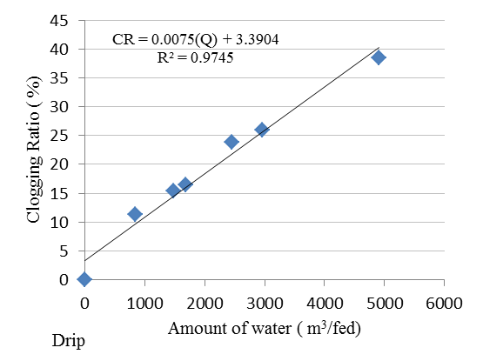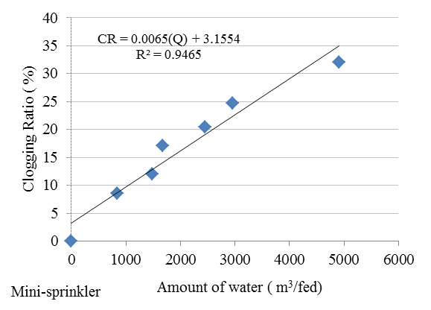

**Fig.3 Impacts of amounts of water on clogging ratio under different irrigation systems.**

Obviously, there are a liner inverse relationship between a Solar radiation (SR) and (EUa); for instance; that the values of (EUa) decrease when (SR) increasing. The reason of decreased (EUa) in drip irrigation more than mini-sprinkler may related to that the clogging in drip irrigation which is higher than clogging in mini-sprinkler. Moreover; the velocity of flow in drip is too lowcomparing with flow at Mini-sprinkler which led to increase a contamination accumulated inside the emitter’s flow path. (Boswell, 1990**)** the uniformity was improved related to removal the large amounts of organic and inorganic suspended solids which block emitter outlets.

On the other hand; there is an inverse relationship between water quantity and (EUa) whatever the type of irrigation system technique. Meaning; with increasing amounts of water the (EUa) decreased linearly. For instance; as shown at fig (5),After adding (2960.5 m3/fed) the (EUa) recorded 85% for drip and 88.3% for mini-sprinkler but the (EUa) reached to 78.6%, 84% for both drip and Mini-sprinkler respectively after applying (4915.7 m3/fed). Eventually; Next models illustrate the relation between different factors [water quantities and solar ration] and their influence on Absolute Emission Uniformity for different irrigation systems. Recapitulation; to decrease the (EUa) 1% needs to approximately 341.3(m3/fed) with drip and to 546.1(m3/fed) with mini-sprinkler.

**(EUa)D = -0.0016Q-0.001 (SR)+93.23 (R2= 0.79) (8)**

**(EUa)M = -0.001Q-0.00075 (SR)+93.2 (R2=0.9) (9)**

Where:-

(EUa)D = Absolute Emission Uniformity for drip

irrigation (%)

(EUa)M = Absolute Emission Uniformity for Mini

sprinkler irrigation (%)

Q = Total water applied (m3/fed).

SR = Solar Radiation (MJ/m2).

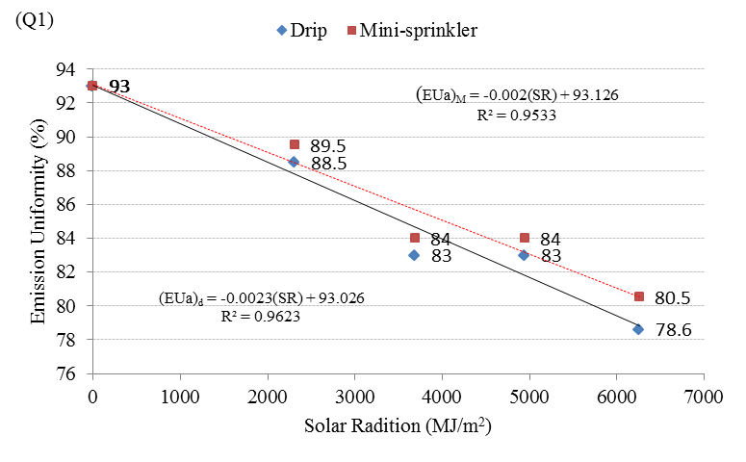

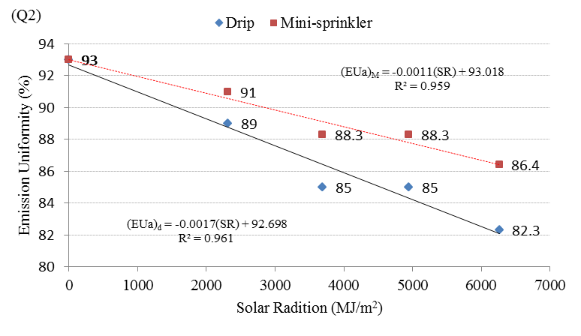

**Fig.4 Impacts of solar radiation on Emission Uniformity under different irrigation systems.**

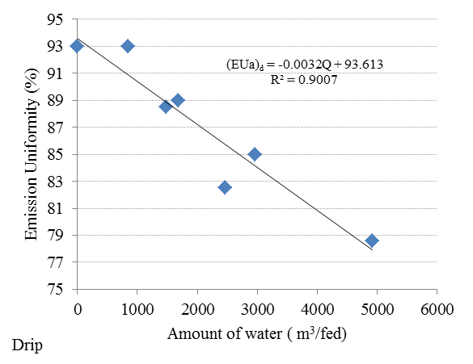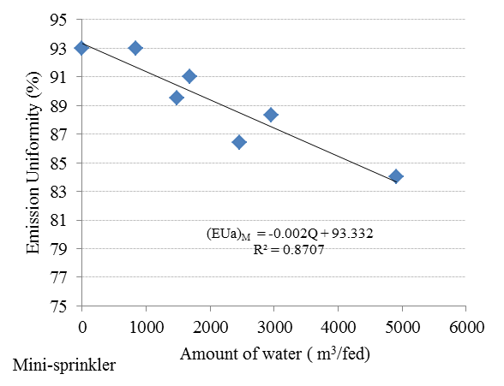

**Fig.5 Impacts of amounts of water on Emission Uniformity under different irrigation systems.**

**Yield**

As shown at fig (6). Data indicated that the drip irrigation system has a significant influence on yield production comparing with mini-sprinkler for both crops. Further; drip irrigation system recorded as a mean value 4.2 (ton/fed.) with Bottle Gourd and 7.93 (ton/fed) for broccoli. However; with mini-sprinkler yield obtained 1.96 (ton/fed) and 5.8 (ton/fed) for Bottle Gourd and broccoli respectively. May this relate to; that the drip irrigation system needs to a long time (significant time) to irrigate crops by net irrigation water requirement. In a contrast; mini-sprinkler needs to short time to ending irrigation requirement.

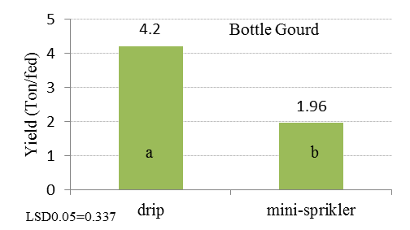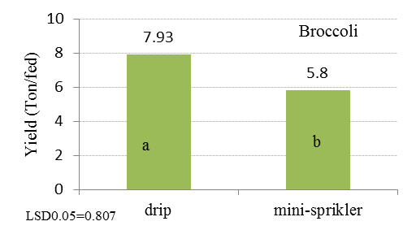

**Fig.6 Influence of localized irrigation system on yield production**

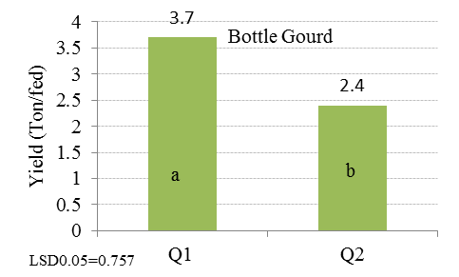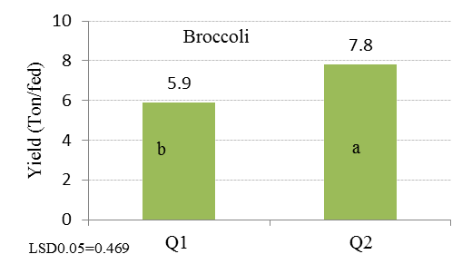

**Fig.7 Influence of different water quantities on yield production**

Finally; different amounts of water Q1 and Q2 have a high influence on yield production. For instance; Q1 had a significant influence on Bottle Gourd’s yield comparing with Q2; where, Q1 recoded 3.7 (ton/fed) as a mean value [Fig (7)]. In a contrast; Q2 obtained a high yield production 7.8 (ton/fed) as a mean value for broccoli. May this related to; that the bottle gourd needs to irrigate by low amount of water and does not need to a lot of water which led to waterlogged soils and effect on Physiological performance especially for Bottle Gourd. Thus; Bottle Gourd has a good response to irrigate by a low amount of water. Moreover; drip irrigation depends on wetting elongated line concept with using a significant time comparing with mini-sprinkler.Subsequently; Helping root’s plant to accomplish its Physiological action by giving an opportunity to use both water and air in soil.

**Conclusion**

Noticeable; the solar radiation has a significant impact on clogging ratio and emission uniformity. In fact, the influence of solar radiation is extrusive on Clogging Ration, hence; influence on emission uniformity. Thus; 1% of clogging ratio needs to 195.65 (MJ/m2) SR under Q1 and needs to 306.9 (MJ/m2) SR under Q2 with mini-sprinkler. Moreover; 1% of clogging ratio for drip irrigation system needs for 172 (MJ/m2) SR under Q1 and to 263(MJ/m2) SR under Q2. Doubtless; these give an allusion about different behavior response between solar radiation and water quantities on both clogging ratio and emission uniformity. On the other hand, mini-sprinkler has a good value for the clogging ratio and absolute emission uniformity comparing to drip irrigation systems. However; a highest means values for yield production were appeared with drip irrigation system for both crops Bottle Gourd and Broccoli.

**References**

1. APHA- AWWA- WPCF(1992), Washington D.C. PP 118-130.
2. Bar, I. (1995). Iron Control System for Drip Irrigation. Microirrig. for Changing the World {I. Microirrig. Cong.} Publ. ASAE. 239-243.
3. Boman, B.J. (1989). Emitter and Spaghetti Tubing Effects on Microsprinkler Flow Uniformity. Transaction of ASAE vol.32 (1): January–February. 168-172.
4. Boswell, M. J. (1990). Micro Irrig. Design Manual. 4/1-4/15. FAO AQUASTAT. FAO's Information System on Water and Agriculture: Climate Information tool. AQUASTAT Climate characteristics. <http://www.fao.org/nr/water/aquastat/main/> (August 2015).
5. FAO (1998). Richard G. Allen, Luis S. Pereira, Dirk Raes and Martin Smith Crop evapo-transpiration - Guidelines for computing crop water requirements: Irrigation and drainage paper No.56 : 103-135.
6. Hamdy, A. (2002). Sustainable use and management of non-conventional water resources in the arid regions. Proceedings of the International Symposium on Techniques to Control Salination for Horticultural Productivity, 7-10 November, 2000, Antalya-Turkey. Acta Horticulturae 573, ISHS, pp 159-174.
7. Kadir Bakirci, 2009. Models of solar radiation with hours of bright sunshine: A review. Renewable and Sustainable Energy Reviews: 13, 2580–2588.
8. Klute, A., (1986). Water retention: laboratory methods. In A. Klute (Ed.), Methods of soil analysis. Part 1. Physical and mineralogical methods (2nd ed.). USA: Am. Soc. Agron., Inc. Soil Sci. Soc. Am (Agronomy; No.9).
9. Keller J., karmeli D., 1974. Trickle irrigation design parameters. Trans. ASAE 17, 678-684.
10. Mahmoud A.K. and M.S.Kamel,2015. Interlaced Influence of Various Water Quantities and Mite Densities on Broccoli (*[Brassica Oleracea](https://en.wikipedia.org/wiki/Brassica_oleracea" \o "Brassica oleracea).*) Production. Journal of Natural Science Research, Vol 5, No.24:PP 31-39.
11. Numan, M. and E.G. Kruse, (1989). Emitter Discharge Evaluation of Subsurface Trickle Irrigation Systems. Transaction of ASAE vol. 32 (4): July – August. 1223-1228.
12. Phocaides., 2000. Technical Handbook on Pressurized Irrigation Techniques; Food and Agriculture Organization of the United Nations.
13. Rewaa. S.El shatoury and A.K.Mahmoud, 2014. Mathematical Relationship for Influencing Amount of Water and Plant Distance on Bottle Gourd Plant Production. *Journal of Agriculture and Veterinary Science, Volume 7, Issue 11 Ver. I, PP29-33.*

3/1/2016