Correlation between Prostate Specific Antigen and Total Bone Scan Findings of Prostate Cancer Patients

*Elumelu T.N., **Jatto J.B., *Abdus-salam A.A., *Adenipekun A.A

*Department of Radiation Oncology, College of Medicine, University of Ibadan, Ibadan
**Department of Radiation Oncology, University College Hospital, Ibadan.
telumelu@com.ui.edu.ng, tessynek@yahoo.com

Abstract: Introduction: Plasma levels of Prostate Specific Antigen (PSA) and total body bone scan findings play major role in diagnosis, treatment and monitoring of patients with cancer of the prostate. Although it has been suggested that total body bone scan (TBS) may not be necessary in prostate cancer patients with normal prostate specific antigen plasma level, controversy still exists. Aim: The study evaluates relationship between prostate specific antigen levels and Total Body Bone Scan findings in our prostate cancer patients and also to determine the PSA cut-off at which TBS is indicated. Methodology: This a retrospective review of the bone scan reports and the PSA levels of 101 prostate cancer patients at presentation in Radiotherapy Department of the University College Hospital, Ibadan, Nigeria. Results: Patients’ PSA level ranges from 1.12ng/ml – 837ng/ml. As the PSA increases, the rate of patients with positive TBS also increases at 3.3%, 6.6%, 8.8%, 15.4%, 41.8%, and 24.2% in patients with a PSA 0-4, 4.1-10, 10.1-20, 20.1-40, 40.1-100, and above 100ng/ml, respectively (p<0.002). In patients with PSA levels of ≤ 10ng/ml, 2 (18%) and 9 (82%) of them had negative and positive TBS respectively. Conclusion: There is a significant positive correlation between PSA levels and TBS findings in our study but failed to provide PSA cut-off at which a TBS is required. It is advised that TBS be performed in all diagnosed prostate cancer regardless of the PSA levels, with or without bony symptoms.
[Elumelu T.N., Jatto J.B., Abdus-salam A.A., Adenipekun A.A. Correlation between Prostate Specific Antigen and Total Bone Scan Findings of Prostate Cancer Patients. N Y Sci J 2016;9(3):46-52]. ISSN 1554-0200 (print); ISSN 2375-723X (online). http://www.sciencepub.net/newyork. 9. doi:10.7537/marsnys09031609.

Key Word: Prostate Specific Antigen, Total Bone Scan, Correlation

Introduction:
Prostate cancer is a leading cause of mortality in men and has gradually increased in incidence throughout the world resulting in more than 200,000 deaths annually¹. It is also the second most common cause of cancer-associated mortality in Western countries and is responsible for 9% of all cancer deaths among European men^{2,3,4}. In Nigeria according to GLOBOCAN report of 2008, prostate cancer is the top male cancer and the fourth commonest cancer⁵. Prostate cancer may be curable when it is identified at an early organ-confined stage, however a quarter of patients present with advanced or metastatic disease at the time of diagnosis⁶. The skeleton accounts for up to 80% of all prostate cancer metastases⁷. Despite various therapeutic strategies, nearly half of patients with metastatic disease die within 30 months, and 85-100% of those who die from prostate cancer have skeletal metastasis⁸.
When bone metastasis develops, the effect is not only on the prognosis of the disease but also on the quality of life of the patient. The clinical characteristics of skeletal metastasis in prostate cancer include bone pain, impaired mobility, pathological fracture, spinal cord or nerve root compression and paraparesis or paraplegia. To select appropriate treatment, detection of osseous metastasis is essential in patients with prostate cancer for both disease staging and the creation of a subsequent follow-up plan. One of the current modality in clinical practice for assessing skeletal metastasis of prostate cancer is total body bone scan, using technetium Tc-99m methylene diphosphonate (Tc-99m MDP)^{9,10}. It is a highly sensitive one-step procedure that utilizes whole body skeletal surveying.
A tumor marker, prostate specific antigen (PSA) is widely used as a biomarker to screen, monitor, and predict disease severity among prostate cancer patients and its introduction in clinical practice has led to an increased rate of organ-confined disease, associated with a reduction in the incidence of bone metastases at diagnosis^{11,12}. However, a rising prostate specific antigen level may occur several months before changes in bone scan can be seen.
Several studies have investigated the ability of baseline clinical parameters to predict the risk of bone metastasis at diagnosis^{13,14,15}. On the basis of the results of these studies, the European Association of Urology (EAU)², the American Urological Association (AUA)¹⁶, the National Comprehensive Cancer Network (NCCN)¹⁷, and the American Joint Committee on Cancer (AJCC)¹⁸ updated their guidelines to indicate the need for total bone scans only in patients with certain unfavorable prostate cancer characteristics. A likewise outcome will be beneficial in the case of total body bone scan and prostate cancer.
The purpose of this study is to determine the possible appropriate prostate specific antigen cut-off value and the correlation using total body bone scan for determining skeletal metastasis in patients with prostate cancer.

Materials and Methods
This was a retrospective and descriptive study involving one hundred and one (101) cases of histologically diagnosed prostate cancer seen in the Department of Radiotherapy, University College Hospital, Ibadan. Demographic data and records of patients’ prostate specific antigen (PSA) values and total body bone scan (TBS) reports at the time of presentation were obtained for analysis.

Results
Demography
Patients were between the ages of 47 and 88 years with mean age of 67.1(±1.8) years. Forty six (45.5%) were between the age range of 60 – 69 years while 3 (3%) were in the age range of 40 – 49 years (figure 1). Forty-three (42.6%) patients were retired, 3 (3%) were traditional rulers and clergy men (none of them catholic) respectively. Others were civil servants 9 (8.9%), traders 19 (18.8%) and those in self-employment 24 (23.8%).

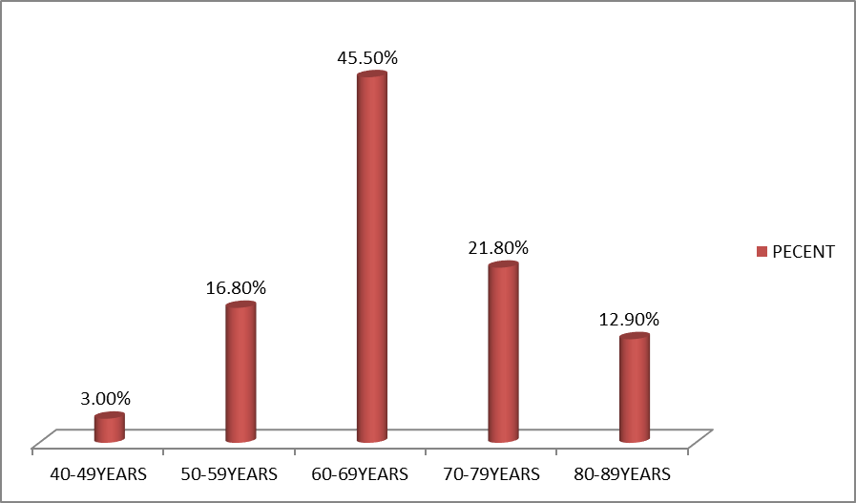
Figure 1: Age distribution

Fifty-two (51.5%) of the patients had tertiary education, while 34 (33.7%), 12 (11.9%), and 3 (3%) had secondary level, primary level, and no formal education respectively. Ninety-eight (97%) patients were married and 3 (3%) widowers. Eighty-two (81.2%) were Christians, 17 (16.8%) Muslims and 2 (2%) traditional religion worshippers. Fifty (49.5%) of the patients neither smoke nor consume alcohol, 37 (36.6%) of them smoke and consume alcohol while 11 (10.9%), and 3 (3%) consume alcohol only and smoke only respectively.

Symptoms and Disease Stages
Forty-five (44.6%) patients had back pain, while 21(20.8%) had paraparesis at the time of presentation. Average duration of illness prior to presentation at Radiotherapy was 22.3 months. All the patients had histologically confirmed adenocarcinoma.
There were 91(90.1%) stage IV, 9(8.9%) stage III and 1 (1%) stage 2 diseases. No patient presented with a stage 1 disease.
The PSA level ranges from 1.12ng/ml - 837ng/ml. Forty (39.6%) patients had a PSA range of 40.1 – 100ng/ml and 4 (4%) with PSA of 0 – 4ng/ml and another 4 (4%) had PSA levels above 500ng/ml. (Figure 2).

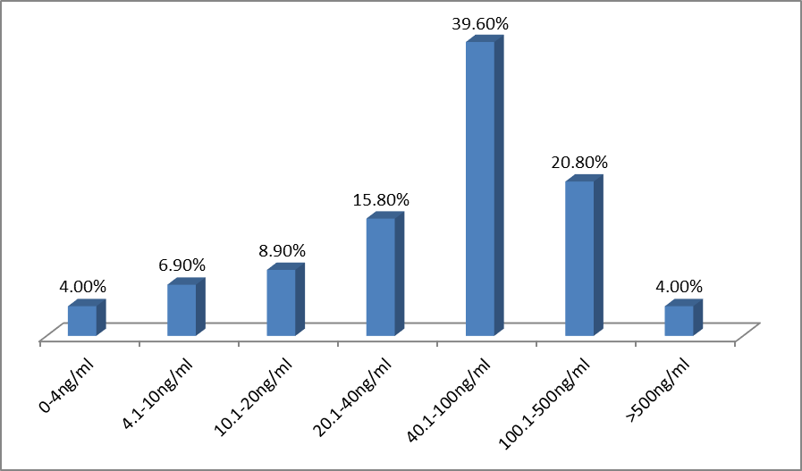
Figure 2: PSA Level at presentation.

Ninety-one (90.1%) patients had positive TBS at presentation, while 10 (9) were negative. Sixty (59.4%) TBS showed wide spread bony metastasis, 14 (13.9%) had only two sites of bone involvement and 17 (16.8%) had single site bone involvement (Table 1).

Table 1: Correlation between PSA and TBS at Presentation.
PSA at presentation | No site (n,%) | One site (n,%) | Two sites (n,%) | Wide spread (n,%) | Total (patients) | p-value
0-4ng/ml | 1(25.0%) | 3(75.0%) | - | - | 4(4.0%) | 0.002
4.1-10ng/ml | 1(14.3%) | 2(28.6%) | 2(28.6%) | 2(28.6%) | 7(6.93%)
10.1-20ng/ml | 1(11.1%) | 3(33.3%) | 1(11.1%) | 4(44.4%) | 9(8.91%)
20.1-40ng/mg | 2(12.5%) | 6(37.5%) | 4(25.0%) | 4(25.0%) | 16(15.8%
40.1-100ng/mg | 2(5.0%) | 2(5.0%) | 6(15.0%) | 30(75.0%) | 40(39.6%
100.1-500ng/mg | 3(14.3%) | 1(4.8%) | - | 17(81.0%) | 21(20.8%
>500ng/ml | - | - | 1(25.0%) | 3(75.0%) | 4(4.0%)
Total (sites) | 10(9.9%) | 17(16.8%) | 14(13.9%) | 60(59.4%) | 101(100%

There is significant positive correlation between the PSA and TBS at presentation. The prevalence of bony metastasis proven by TBS increases progressively with rising PSA level, rising from 3 (3.3%), 6 (6.6%), 8 (8.8%), 14 (15.4%), 38 (41.8%), 18 (19.8%), and 4 (4.4%) patients for PSA 0-4ng/ml, 4.1-10ng/ml, 10.1-20ng/ml, 20.1-40ng/ml, 40.1-100ng/ml, 100-500ng/ml, and >500ng/ml respectively (p-value 0.002).
Three (30%) of the 10 patients who initially had negative TBS at presentation, became positive at subsequent TBS at follow-up (2-6 years).
Using the risk stratification system proposed by D’Amico et al¹⁹, 94 (93%) patients were in high-risk group while 2 (2%) were in low-risk group (Fig 4). The patients at high-risk stratification have more positive TBS findings (92.6%) compare to other risk groups (Table 2).

Table 2: Relationship between Risk Stratification and Total Body Bone Scan findings
Risk Stratification | Total Body Bone Scan |  |  | p-value
 | Positive | Negative | Total
Low-risk | 1(50%) | 1 | 2 | 0.001
Intermediate-risk | 3(60%) | 2 | 5
High-risk | 87(92.6%) | 7 | 94

Discussion
Prostate cancer has become a major global health problem and African American men have among the highest reported prostate cancer rates in the world²⁰. However, it is unclear whether similar high rates occur among men in Africa²¹. The diagnosis of bony metastasis secondary to prostate cancer significantly alters the patient's treatment. Currently, total body bone scans are the gold standard for detecting osseous metastasis.
One hundred and one patients with histologically confirmed adenocarcinoma of the prostate were studied retrospectively. The results of this study gave a mean age of 67.1 years and age range of 47-88 years, similar to results of previous study on prostate cancer in Nigeria²² but lower than that of a previous study reported in developed countries²³. Over 40% (44.6%) of the patients in the study is within the ages of 60 – 69 years, which is lower than the highest incident rate of 70-74 in the United State of America reported by National Institute of Cancer²⁴. About 51.5% of these patients had tertiary education, which means better education and higher standard of life in this elite group with a possibility of a longer life span as compared to those with lower educational standard, hence more of them may reach prostate cancer age group, this is similar to findings in a previous study²². Almost all the patients 90.1% presented with a stage IV disease, which is far more than the 75% reported in most studies on prostate cancer in Nigeria.^{25,26} This may be due to the fact that most of the patients are only referred when metastatic symptoms arise. About 90.1% of the patients presented with skeletal metastasis which is in agreement with a previous study that reported that the skeleton is the most common site of metastatic spread, accounting for 80% of all prostate cancer metastases⁷. The results of this study show 65.5% of the patients presenting with pain as complaint compared with the 90.1% that eventually had radiological evidence of bony metastasis. It shows that even patients who did not present with pain as symptom may benefit from a TBS. The study also noted that 56.5% of the patients presented with complaints >1year duration, indication late hospital presentation.
In this study 24.8% of the patients had PSA values > 100ng/ml, which far exceed the PSA in a study of 703 American men with prostate cancer, where PSA values obtained in 99% of the patients were below 50ng/ml and only 1% had a PSA > 50ng/ml²⁷. Other studies from Nigeria also corroborate the differences in PSA values between African men on one hand and American and African-American men on the other²⁸. These studies suggest that higher PSA values in African men with prostate cancer are probably due to higher tumor stages at presentation in African than in American patients.
This study showed significant positive correlation between the PSA and TBS. The results show that as the PSA increases the probability of positive TBS is higher, which is evidenced by a PSA of 0-4ng/ml, 4.1-10ng/ml, 10.1-20ng/ml, 20.1-40ng/ml, 40.1-100ng/ml, and >100ng/ml resulting in positive TBS findings of 3.3%, 6.6%, 8.8%, 15.4%, 41.8%, and 24.2% respectively (p-value 0.002). This corresponds with findings of similar studies done in Sudan, Argentina, Spain, Japan, Taiwan, Germany, Netherlands, United State of American, and Bosnia and Herzegovina²⁹⁻³⁶.
Several studies advocate that TBS is not indicated when PSA levels are low, and when patients are in the low-risk stratification of prostate cancer^{13,23}. However, different studies established different cut-off levels for indication of TBS. Despite recent numerous studies and reviews citing between 10-20ng/ml as a threshold for omitting TBS, others still believe that the small but measurable risk is sufficient to warrant TBS^{37,38}. In this study 4 patients had a PSA of 0-4ng/ml, out of which 3 (75%) of them had positive TBS. This is very significant, meaning even with a low PSA, the patients are still at risk of developing positive TBS. Several studies have also reported that a significant proportion of patients with bone metastasis have normal PSA whose TBS findings may need further confirmation with the use of CT scan and MRI due to possibility of false positive results³⁹⁻⁴³.
Total body bone scan have also been an important investigation in monitoring disease progression after completion of treatment. This study showed 3 (30%) of the 10 patients that initially had a negative TBS, became positive during follow-up. However, the same controversy exist about the optimal post-treatment PSA at which to recommend TBS^{23,44}.

Conclusion
This study shows that there is a progressive rising incidence of bone metastasis as evidence on TBS in relation to the PSA levels in patients diagnosed of prostate cancer.
The study however, shows no PSA cut-off point for positive TBS in our patients. This may be attributed to higher tumor stages at presentation as compared with other studies. Total bone scan should be recommended at presentation regardless of the PSA level in patients with or without bony symptoms. Though the financial and psychological burden may be enormous bearing in mind the cost and availability of the facility in the country, its benefit we believe out-weighs the burden. This may reduce drastically the number of preventable complications and morbidity from skeletal-related events with improved quality of life of these patients.

Corresponding Author:
Elumelu T.N MBBS, FMCR, FWACS, DPC, MBA.
Department of Radiotherapy,
College of Medicine,
University of Ibadan,
Ibadan, Oyo State, Nigeria.
Email- telumelu@com.ui.edu.ng, tessynek@yahoo.com

References
- Ferlay J, Bray F, and Pisani P, et al. (2001). Globocan 2002: cancer incidence, mortality and prevalence worldwide: IARC Cancer Base num 5, version I.O. Lyon IARC Press.
- Heidenreich, G. Aus, M. Bolla et al.(2008). EAU guidelines on prostate cancer. Eur Urol; 53: 68–80.
- F. Bray, R. Sankila, J. Ferlay, D.M. Parkin. (2002). Estimates of cancer incidence and mortality in Europe in 1995. Eur J Cancer; 38: 99–166.
- R.J. Black, F. Bray, J. Ferlay, D.M. Parkin. (1997). Cancer incidence and mortality in the European Union: cancer registry data and estimates of national incidence for 1990. Eur J Cancer; 33: 1075–1107.
- Ferlay J, Shin HR, Bray F, Forman D, Mathers C, Parkin DM. (2010). IARC Cancer Base No. 10 [Internet] Lyon, France: International Agency for Research on Cancer. GLOBOCAN 2008, Cancer Incidence and Mortality Worldwide.
- National institute for clinical excellence (NICE). (September 2002). Guidance on cancer services: improving outcome in urological cancers, urological (CSGUC). The manual-NICE.
- Rigaud J, Tiguert R, Le Normand L, et al.( 2002). Prognostic value of bone scan in patients with metastatic prostate cancer treated initially with androgen deprivation therapy. J Urol; 168: 1423-6.
- Carlin BL, Andriole GL. (2000). The natural history, skeletal complications, and management of bone metastases in patients with prostate carcinoma. Cancer; 88: 2989-94.
- D.L. Schaffer, H.P. Pendergrass. (1976). Comparison of enzyme, clinical, radiographic, and radionuclide methods of detecting bone metastases from carcinoma of the prostate. Radiology; 121: 431–434.
- Thurairaja, J. McFarlane, Z. Traill, R. Persad. (2004). State-of-the-art approaches to detecting early bone metastasis in prostate cancer. BJU Int; 94: 268–271.
- Gallina, F.K. Chun, N. Suardi et al. (2008). Comparison of stage migration patterns between Europe and the USA: an analysis of 11 350 men treated with radical prostatectomy for prostate cancer. BJU Int; 101: 1513–1518.
- C.J. Ryan, E.P. Elkin, E.J. Small, J. Duchane, P. Carroll. (2006). Reduced incidence of bony metastasis at initial prostate cancer diagnosis: data from CaPSURE. Urol Oncol; 24: 396–402.
- N. Lee, R. Fawaaz, C.A. Olsson et al. (2000). Which patients with newly diagnosed prostate cancer need a radionuclide bone scan? An analysis based on 631 patients. Int J Radiat Oncol Biol Phys; 48: 1443–1446.
- Ataus, A. Citçi, B. Alici et al. (1999). The value of serum prostate specific antigen and other parameters in detecting bone metastases in prostate cancer. Int Urol Nephrol; 31: 481–489.
- M.E. Gleave, D. Coupland, D. Drachenberg et al. (1996). Ability of serum prostate-specific antigen levels to predict normal bone scans in patients with newly diagnosed prostate cancer. Urology; 47: 708–712.
- Thompson, J.B. Thrasher, G. Aus et al. (2007). Guideline for the management of clinically localized prostate cancer. J Urol; 177: 2106–2131.
- Clinical recommendations. National Comprehensive Cancer Network Web site. http://www.nccn.org/professionals/physician_gls/f_guidelines.asp.
- F.L. Greene, D.L. Page, I.D. Fleming, et al (Eds.). (2002). American Joint Committee on Cancer staging manual (6th ed.), Springer-Verlag, New-York. P 91.
- D’Amico AV, Whittington R, Malkowicz SB, et al. Biochemical outcome after radical prostatectomy, external beam radiation therapy, or interstitial radiation therapy for clinically localized prostate cancer. JAMA. 1998;280:969–74.
- Hsing AW, Devesa SS. (2001). Trends and patterns of prostate cancer: what do they suggest? Epidemiologic Reviews; 23(1): 3–13.
- Parkin DM, Ferlay J, Hamdi-Cherif M, et al. (2003). Cancer in Africa: Epidemiology and Prevention. Lyon, France: IARC Scientific Publications.
- Osegbe D N et al. (1997). Prostate cancer in Nigerians: facts and nonfacts. The Journal of Urology; 157(4): 1340-1343.
- Kosuda, S., Yoshimura, I., Aizawa, T., Koizumi, K., Akakura, K., Kuyama, J., Ichihara, K., Yonese, J., Koizumi, M., Nakashima, J. and Fujii, H. (15 February 2002). Can initial prostate specific antigen determinations eliminate the need for bone scans in patients with newly diagnosed prostate carcinoma? Cancer; 94(4): 964–972.
- Surveillance, Epidemiology, and End Results Program (SEER) of the National Cancer Institute. [Accessed November 11, 2011]. Fast Stats: An interactive tool for access to SEER cancer statistics. Bethesda, MD: SEER, National Cancer Institute; nd. Available from: www.seer.cancer.gov/faststats.
- Dawam D, Rafindadi AH, Kalayi GD. (2000). Benign prostatic hyperplasia and prostate carcinoma in native Africans. BJU Int; 85(9): 1074–7.
- Ekwere PD, Egbe SN. (2002). The changing pattern of prostate cancer in Nigerians: current status in the southeastern states. J Natl Med Assoc; 94(7): 619–27.
- Thompson I M, Chi C, Ankerst D P, Goodman P J, Tangen C M, Lippman S M, et al. (2006). Effect of finasteride on the sensitivity of PSA for detecting prostate cancer. J Natl Cancer Inst; 98(16): 1128-33.
- Amayo A, Obara W. (2004). Serum prostate specific antigen levels in men with benign prostate hyperplasia and cancer of prostate. East Afr Med J; 81(1): 22-6.
- Khalid KE, Brair AI, Elhaj AM, Ali KE. (2011). Prostate-specific antigen level and risk of bone metastasis in Sudanese patients with prostate cancer. Saudi J Kidney Dis Transpl; 22(5): 1041-3.
- López M, Montes De Oca L, Bernardo N, Scorticati C Jr, Suárez P, Bencardino F, De Lasa T, Sotero Falco E, Coimbra F, Scorticati C. (1996 Nov). Correlation between specific prostatic antigen and findings with total body bone scintigraphy. Arch Esp Urol; 49(9): 953-5.
- Wymenga, L., Boomsma, J., Groenier, K., Piers, D. and Mensink, H. (2001). Routine bone scans in patients with prostate cancer related to serum prostate-specific antigen and alkaline phosphatase. BJU International; 88(3): 226–230.
- Ortega A, Alonso JC, Suárez M, Domínguez P, Almoguera I, Bittini A, Gómez A, Martínez L, Herranz F, Pérez-Vázquez JM. (2000 Oct). Bone scintigraphy findings in patients with recently diagnosed adenocarcinoma of the prostate: relationship with prostate specific antigen levels. Rev Esp Med Nucl; 19(6): 409-15.
- Begic A, Kucukalic-Selimovic E, Obralic N, Duric O, Lacevic N, Begovic-Hadzimuratovic S, Skopljak A, Dzubur-Aganovic M. (2006). The relationship between the serum prostate specific antigen and whole body scintigraphy in prostate cancer patients after prostatectomy. Med Arh; 60(1): 54-5.
- J.M. Wolff, M. Zimny, H. Borchers, J. Wildberger, U. Buell, G. Jakse. (1998). Is Prostate-Specific Antigen a Reliable Marker of Bone Metastasis in Patients with Newly Diagnosed Cancer of the Prostate? Eur Urol; 33(4): 376-381.
- Michael L. Cher, Fernando J. Bianco Jr., John S. Lam, Lawrence P. Davis, David Jgrignon, Waela. Sakr, Mousumi Banerjee, J. Edson Pontes, David P. Wood JR. (October 1998). Limited role of radionuclide bone scintigraphy in patients with prostate specific antigen elevations after radical prostatectomy. The Journal of Urology; 160(4): 1387–1391.
- Ling-Huei Wei, Jainn-Shinn Chin, Shion-Ying Chang, Yuh-Feng Wang. (Dec 2008). Predicting bone metastasis in prostate cancer patients: Value of prostate specific antigen. Tzuchi med J; 20(4): 291-295.
- Warren KS, Chodak JW, See WA, Iverson P, McLeod D, Wirth M, et-al. (2006). Are bone scans necessary in men with low APE levels following localized therapy? J Urol; 176: 70-4.
- Oesterling IE, Martin SK, Bergstralh EJ, Lowe FC. (1993). The use of prostate-specific antigen in staging patients with newly diagnosed prostate cancer. JAMA; 269: 57-60.
- Lecovet FE, Geukens D, Stainier A et al. (2007). Magnetic resonance imaging of the axial skeleton for detecting bone metastasis in patients with high-risk prostate cancer: Diagnosis and cost-effectiveness and comparison with current detection strategies. J Clin Oncol; 25(22): 3281-3287.
- Traill ZC, Talbot D, Golding S, Gleeson FV. (1999). Magnetic resonance imaging vs radionuclide scintigraphy in screening for bone metastasis. Clin Radiol; 54(7): 448-451.
- Hricak H, Choye PL, Eberhardt SA, Leibel A, Scardino PT. (2007). Imaging prostate cancer: A multidisciplinary perspective. Radiology; 243(1): 28-53.
- Wymenga, L., Boomsma, J., Groenier, K., Piers, D. and Mensink, H. (2001). Routine bone scans in patients with prostate cancer related to serum prostate-specific antigen and alkaline phosphatase. BJU International; 88(3): 226–230.
- Ortega A, Alonso JC, Suárez M, Domínguez P, Almoguera I, Bittini A, Gómez A, Martínez L, Herranz F, Pérez-Vázquez JM. (2000 Oct). Bone scintigraphy findings in patients with recently diagnosed adenocarcinoma of the prostate: relationship with prostate specific antigen levels. Rev Esp Med Nucl; 19(6): 409-15.
- Hoffman RM, Stone SN, Espey D, Potosky AL. (2005). Differences between men with screening detected versus clinica1ly diagnosed prostate cancers in the USA. BMC Cancer; 5: 27-37.

3/1/2016

