Occurrence of Diabetes with Hypertension during Pregnancy

Amber Mahmood¹, Irum Samreen Siddiqui1², Saira Dars² and Zainab Aslam Saeed Memon³

^{1.} Molecular biology (Genetics) Laboratory, Liaquat University of Health & Medical Sciences, Jamshoro
^{2.} Department of Obstetrics & Gynaecology, Liaquat University Hospital, Sindh, Pakistan
^{3.} Liaquat University of Health & Medical Sciences, Jamshoro Pakistan
ambermahmood47@outlook.com

Abstract: Objective: To study the occurrence of diabetes and hypertension in pregnancy. Material & methods: It was observational study and conducted at Gynecology & Obstetrics Department. Process of collection of data was proforma was got in which there, parity, gestational age and gestational age when gestation converted hypertension diagnosis, concerning diabetes, age, BMI and history of pregnancy induced hypertension were noted. Results: In this study 120 pregnant ladies were involved in age range was 25-42 years, 20% were obese, and 60% of induced hypertension and 40% were diabetes. Conclusion: It is concluded that the high rate of morbidity and mortality among mothers and newborns may, in part, as of increased occurrence of diabetes with hypertension.
[AM, ISS, SD, AND ZASM. Occurrence of Diabetes with Hypertension during Pregnancy. N Y Sci J 2016;9(3):43-45]. ISSN 1554-0200 (print); ISSN 2375-723X (online). http://www.sciencepub.net/newyork. 8. doi:10.7537/marsnys09031608.

Keywords: Pregnancy, hypertension, diabetes

- Introduction
Placenta is an important organ for development of fetus [1, 2]. Fetal membranes chorion and amnion cover the placenta [3]. Common pathologies of pregnancy like intrauterine growth retardation, preeclampsia (pregnancy induced hypertension), are associated with incomplete vascular remodeling in the placenta [4-6]. It is a medical problem, when pregnancy is complicated by diabetes and or hypertension which affect maternal health, architecture and functions of the placenta may even jeopardize the fetal normalcy. The placenta, connected amongst maternal fetal movements, reflected as a frame by which maternal disorders and their effects on fetal well-being can be understood [6]. Placental examination is of severe assessment not only in collecting information regarding etiologies, consequences and managing of the pathological systems disturbing pregnancy, then similarly in improving the management in subsequent gestations [7, 8]. The morphology of placenta is necessary for transferring oxygen and nutrients to fetus and excluding carbon dioxide and waste products. Gestational diabetes and hypertension cause devastation to structure placental and alter its functions being the major contributors to insufficiency of placenta [9, 10].
Hypertension and diabetes are communal in smaller socioeconomic clusters. [11, 12].
This case report was done to detect the variations in the placenta of a mother (a primigravida) with PIH and gestational diabetes. The objective of study was to study the occurrence of diabetes with hypertension during pregnancy.

- Materials And Methods
It was an observational study and conducted at Gynecology & Obstetrics Department from 10th January 2013 – 10th January 2014. Process of collection of data was proforma and the printed informed consent was got in which there, parity, gestational age and gestational age when gestation converted hypertension diagnosis, concerning diabetes, age, BMI and history of pregnancy induced hypertension were noted.
All the pregnant women with hypertension and diabetes during pregnancy were included. The data was analyzed using SPSS version 16.0.

- Results & Discussion

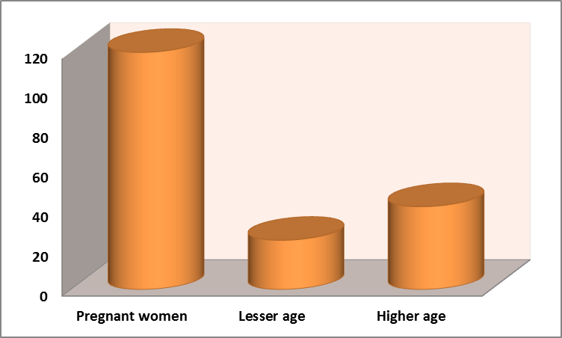

Fig:1 shows the demographic profile of pregnant women

In the present study, 120 pregnant women were involved in age range by 25-42 years, 20% were obese, and 60% of induced hypertension and 40% were diabetes. (Fig: 1-2).

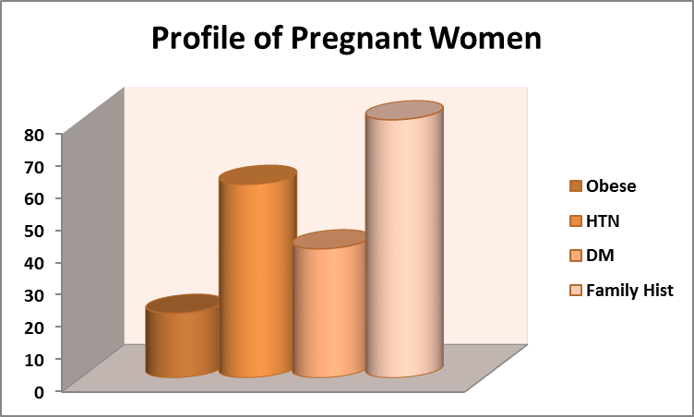
Fig:2 shows the BMI, Obese, Diabetes, Hypertension and History of pregnant women

The Complications of pregnancy such as hypertension and diabetes are replicated in the placenta in a substantial mode [13]. Complications of diabetes of pregnancies are communal than prevailing diabetes. Pregnancy-induced hypertension is a type of high blood pressure occurring in pregnancy.
There is the correlation of pregnancy-induced hypertension with fetal growth obstruction [14] with increasing age, BMI and parity [15].
It was described that higher age of the women [16] had noticed a contrary correlation among the GDM of the pregnant woman and it was also noticed in alternative study that increased rate of lesser age women had observed towards interrelated with reduced risks of GDM [17].
In another study, there was a description the associations between youngsters with diabetes and contrary consequences in pregnant women. [18]. High parity also connected peril aspect for diabetes with hypertension. [19]
In our study, it was not noticed that history of diabetes with hypertension to correlate with higher chances of progression GDM [20].
In our study, occurrence of diabetes with hypertension during pregnancy was found towards correlated with age, BMI and history of diabetes with hypertension.

Conclusion
It is concluded that the high level of morbidity and mortality among mothers and newborns may, in part, be of increased occurrence of diabetes with hypertension. Consequently it’s endorsed that proper managing strategy may articulate to endorse enhanced implications during pregnancy.

Corresponding Author:
Dr. Amber Mahmood
Molecular biology (Genetics) Laboratory,
Liaquat University of Health & Medical Sciences, Jamshoro Pakistan
E-mail: ambermahmood47@outlook.com

References
- Sayeed MA, Mahtab H, Khanam PA, Begum R, Banu A, Azad Khan AK. Diabetes and hypertension in pregnancy in a rural community of Bangladesh: a population-based study. Diabet Med. 2005 Sep; 22(9):1267-71.
- Carpenter MW. Gestational diabetes, pregnancy hypertension, and late vascular disease. Diabetes Care. 2007 Jul;30.
- Emery SP, Levine RJ, Qian C, Ewell MG, England LJ, Yu KF, Catalano PM, CPEP Study Group: Twenty-four-hour urine insulin as a measure of hyperinsulinaemia/insulin resistance before onset of pre-eclampsia and gestational hypertension. Br J Obstet Gynaecol 112:1479–1485, 2005.
- Barden A, Singh R, Walters BN, Ritchie J, Roberman B, Beilin LJ: Factors predisposing to pre-eclampsia in women with gestational diabetes. J Hypertens22:2371–2378, 2004.
- Temelkova-Kurktschiev T, Siegert G, Bergmann S, Henkel E, Koehler C, Jarob W, Hanefeld M: Subclinical inflammation is strongly related to insulin resistance but not to impaired insulin secretion in a high risk population for diabetes. Metab 51:743–749, 2002.
- Retnakaran R, Hanley AJG, Raif N, Connelly PW, Sermer M, Zinman B: C-reactive protein and gestational diabetes: the central role of maternal obesity. J Clin Endocrinol Metab 88:3507–3512, 2003.
- Heitritter SM, Solomon CG, Mitchell GF, Skali-Ounis N, Seely EW: Subclinical inflammation and vascular dysfunction in women with previous gestational diabetes mellitus. J Clin Endocrinol Metab 90:3983–3988, 2005.

Montoro MN, Kjos SL, Chandler M, Peters RK, Xiang AH, Buchanan TA: Insulin resistance and preeclampsia in gestational diabetes mellitus. Diabetes Care 28:1995–2000, 2005.
- Go RC, Desmond R, Roseman JM, Bell DS, Vanichanan C, Acton RT: Prevalence and risk factors of microalbuminuria in a cohort of African-American women with gestational diabetes. Diabetes Care 24:1764–1769, 2001.
- Paradisi G, Biaggi A, Ferrazzani S, De Carolis S, Caruso A: Abnormal carbohydrate metabolism during pregnancy: association with endothelial dysfunction. Diabetes Care 25:560–564, 2002.
- Mokdad AH, Bowman BA, Ford ES, Vinicor F, Marks JS, Koplan JP: The continuing epidemics of obesity and diabetes in the United States. JAMA286:1195–1200, 2001.
- Buchanan TA: Pancreatic B-cell defects in gestational diabetes: implications for the pathogenesis and prevention of type 2 diabetes. J Clin Endocrinol Metab86:989–993, 2001.
- Bryson CL, Ioannou GN, Rulyak SJ, Critchlow C: Association between gestational diabetes and pregnancy-induced hypertension. Am J Epidemiol 158:1148–1153, 2003.
- Yasuhi I, Hogan JW, Canick J, Sosa MEB, Carpenter, MW: Midpregnancy serum C-peptide concentration and subsequent pregnancy-induced hypertension. Diabetes Care 24:743–747, 2001.
- Emery SP, Levine RJ, Qian C, Ewell MG, England LJ, Yu KF, Catalano PM, CPEP Study Group: Twenty-four-hour urine insulin as a measure of hyperinsulinaemia/insulin resistance before onset of pre-eclampsia and gestational hypertension. Br J Obstet Gynaecol 112:1479–1485, 2005.
- Barden A, Singh R, Walters BN, Ritchie J, Roberman B, Beilin LJ: Factors predisposing to pre-eclampsia in women with gestational diabetes. J Hypertens22:2371–2378, 2004.
- Temelkova-Kurktschiev T, Siegert G, Bergmann S, Henkel E, Koehler C, Jarob W, Hanefeld M: Subclinical inflammation is strongly related to insulin resistance but not to impaired insulin secretion in a high risk population for diabetes. Metab51:743–749, 2002.
- Retnakaran R, Hanley AJG, Raif N, Connelly PW, Sermer M, Zinman B: C-reactive protein and gestational diabetes: the central role of maternal obesity. J Clin Endocrinol Metab 88:3507–3512, 2003.
- Heitritter SM, Solomon CG, Mitchell GF, Skali-Ounis N, Seely EW: Subclinical inflammation and vascular dysfunction in women with previous gestational diabetes mellitus. J Clin Endocrinol Metab 90:3983–3988, 2005.
- Wilson BJ, Watson MS, Prescott GJ, Sunderland S, Campbell DM, Hannaford P, Smith WCS: Hypertensive diseases of pregnancy and risk of hypertension and stroke in later life: results from cohort study. Br Med J 326:845–856, 2003.

2/28/2016

