Bioaccumulation of heavy metals in the organs and tissues of Xenopus laevis and sediment concentrations from Alaro Stream in Ibadan.

Emmanuel Teryila Tyokumbur

Department of Zoology, University of Ibadan, Ibadan, Nigeria.
Email: e.tyokumbur@mail.ui.edu.ng

Abstract: A study was carried out on the bioaccumulation of heavy metals (Lead, Cadmuim, Arsenic and Nickel) in the organs of Xenopus laevis and concentration in the sediments of Alaro Stream, Ibadan. Edible frogs are an affordable source of protein that is abundant and widely consumed even though studies on heavy metal bioaccumulation in their organs is relatively scarce in Nigeria. Twenty three (23) frogs were collected from disused crab holes, water surface and along the shore of the stream. Collected frogs were washed and dissected to remove the bones, gut, heart, liver and muscle for oven drying at 120⁰C for 8 hours. Dried organ samples were pulverized and acid digested for heavy metal analyses. All the mean As and Ni concentration in the organs of Xenopus laevis was higher than the World Health Organization’s (WHO) permissible limit guideline standard of 0.01ppm and 0.07ppm respectively. With of the exception of the gut (1.56ppm), all the mean Pb in the organs were below the WHO’s permissible limit guideline standard of 1ppm. With the exception of the gut (0.069ppm) and the bones (0.063ppm), all the other organs had mean Cd level below the WHO’s permissible limit of 0.05ppm. All detectable heavy metals (Ni and Pb) in the sediment were above regulatory standards. The study shows that most of the heavy metals bioaccumulated in the organs of Xenopus laevis higher than the recommended World Health Organization’s permissible limit thereby making the edible frogs caught in Alaro Stream unfit for human consumption.
[Emmanuel Teryila Tyokumbur. Bioaccumulation of heavy metals in the organs and tissues of Xenopus laevis and sediment concentrations from Alaro Stream in Ibadan. N Y Sci J 2016;9(3):38-42]. ISSN 1554-0200 (print); ISSN 2375-723X (online). http://www.sciencepub.net/newyork. 7. doi:10.7537/marsnys09031607.

Keywords: Bioaccumulation, heavy metals, Xenopus laevis, Edible frog, Ibadan.

Introduction
The ardour of the edible frogs like Xenopus laevis makes them widely consumed in many cultures hence the need to assess the heavy metal accumulation in order to safeguard public health (Tyokumbur, 2011) .Although edible frogs are an affordable source of protein that is abundant and widely consumed, studies on heavy metal bioaccumulation in the organs is relatively scarce in Nigeria. Hence, there is the need for continuous biomonitoring studies of heavy metal bioaccumulation in edible frogs at regular intervals in order to sustain the good health of the consumers. For the main purpose of safeguarding human health, the Food and Agricultural Organization in collaboration with the World Health Organization has recommended the provisional tolerable weekly intake of contaminants that includes heavy metals that should not exceed and updated from time to time (FAO/WHO, 1989). Furr et al (1979) established the existence of heavy metals in adult amphibians in a study that that showed adult newts (Notophthalmus viridescens) inhabiting a contaminated site had elevated levels of selenium was higher than the control site. Guthrie and Cherry (1979) found elevated levels of heavy metals in ranid tadpoles inhabiting a coal ash basin, although the study did not match its findings with set guidelines and standards given that they occupy the lower trophic level. Rowe et al, (1996) found that bullfrog tadpoles inhabiting a coal ash basin accumulated significant levels of As, Ba, Cd, Cr and Se in comparison with tadpoles from control sites. Ilona, et al. [8] investigated the effect of high concentrations of molybdenum, chromium and cadmium ions on the metamorphosis of Eurasian marsh frog Pelopyhax ridibundus under laboratory conditions. The effects of these heavy metals at concentration exceeding maximum permissible concentration on the growth, survival and erythrocytes morphology of tadpole and young frogs have been studied. As a result of increasing anthropogenic activities, heavy metals pollution of soil, water, and the atmosphere represents a growing environmental problem affecting food quality and human health (Shaapera et al, 2013). The aim of this study is to assess the bioaccumulation of heavy metals (Lead, Pb; Cadmuim, Cd; Arsenic, As and Nickel, Ni) in the organs of Xenopus laevis and sediment concentrations in Alaro Stream and to compare it with World Health Organization’s permissible limit guideline standards.
Materials and methods
Study area
The study area from where Xaenopus laevis and sediments were collected is the Alaro Stream flowing through Oluyole Industrial Estate in a West to South East direction from its source at Agaloke near Apata in Ibadan. It joins forms a confluence with River Ona at the South East tip of an animal farm. These stream and river flow through Oluyole Industrial Estate in Ibadan. The Alaro Stream receives most of its industrial effluents from the industries found here. The study area is located Latitude 7⁰ 21’N – 7⁰22’ and Longitude 3⁰ 50’ E -30⁰ 52’E in Ibadan, Nigeria.
Sample collection and preparation
Twenty three (23) frogs were collected by field assistants from disused crab holes, water surface and along the shore of the stream. Collected frogs were sacrificed by hitting the back of their heads on the blade of a cutlass. Collected frogs were washed and dissected to remove the bones, gut, heart, liver and muscle into separate aluminium foils for oven drying. The organs were oven-dried at 120⁰C for 8 hours to a constant weight. Dried organ samples were pulverized in a porcelain mortar using a pestle after which they were stored in Ziploc bags and labelled prior to acid digestion. Pulverized organ digestion was carried out by adding 2mL of trace metal grade HNO₃ to 0.5g of each sample in Teflon digestion tubes which was heated at 105⁰C for 1 hour in a heat block. The resulting clear solution was then allowed to cool down, followed by addition of 1mL H₂O₂. After the simmering reaction, it was boiled and left overnight to cool. The digested sample was diluted to the 10mL mark using MilliQ water and transferred into test tubes rinsed with deionized water for Inductively Coupled Plasma Mass Spectrometer (ICP-MS) analyses.
Collection and preparation of sediments.
Sediment samples from the sites of collection of the edible crabs were collected using a hand trowel. Six samples were collected from the six study sites and air-dried on white polythene sheets and ground into fine powder in a mortar. The ground fine sediment powder was sealed in labelled Ziploc bags .0.5g of each of the sediment digested using 2mL technical grade HNO₃ in a beaker at 95⁰C for 1hour after which 2mL.
H₂O₂ was added. After cooling, the samples were decanted and diluted with milliQ water to the 10Ml and transferred into test tubes rinsed with deionized water for ICP-MS analyses.
Standard reference materials (SRMs)
Quality assurance of results was determined with National Institute of Standards and Technology’s (NIST) Standard Reference Material (SRM) number 1577 (Bovine liver) for reproducibility and recovery of the heavy metals in the organs of Xaenopus laevis by the ICP-MS. Percentage recoveries of quality determination were all above 70%. Similarly, NIST SRM number 2709 (San Joaquin soil) was used for quality assurance in the sediments and the recoveries were also above 70%.
Results and Discussion
The highest mean Ni concentration in the organs of Xenopus laevis were in the bones (1.75ppm) while least value was in the muscle (0.12ppm) in the order: bone>gut>liver>heart>muscle. All the mean Ni concentration in the organs of Xenopus laevis was higher than the World Health Organization’s permissible limit guideline standard of 0.07ppm (WHO/FAO (1989); WHO, 2008).

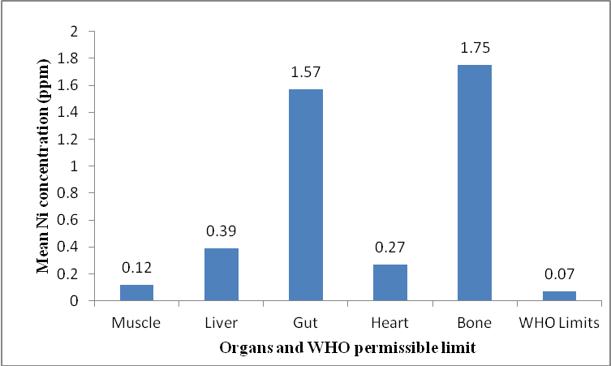
Figure 1: Mean Ni concentration (ppm) in the organs of Xenopus laevis.

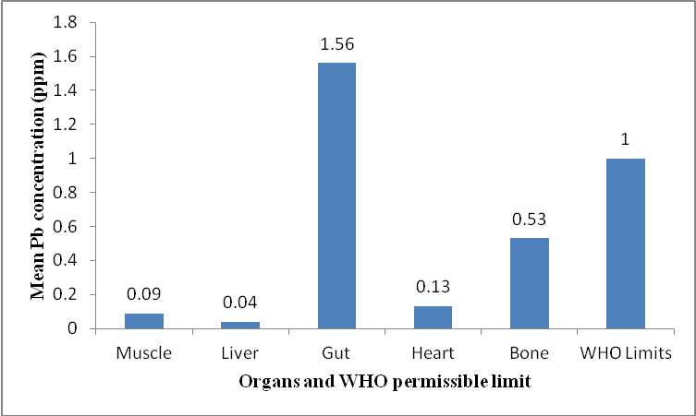
Figure 2: Mean Pb concentration (ppm) in the organs of Xenopus laevis.

The highest mean Pb concentration in the organs of Xenopus laevis was 1.56ppm (gut) while the least was in the liver (0.04ppm) in the order: gut>bone>heart>muscle>liver. With of the exception of the gut (1.56ppm), all the other organs were below the World Health Organization’s permissible limit guideline standard of 1ppm, however some scholars have asserted that there is no safe limit for Pb and as such any concentration is hazardous to human health.

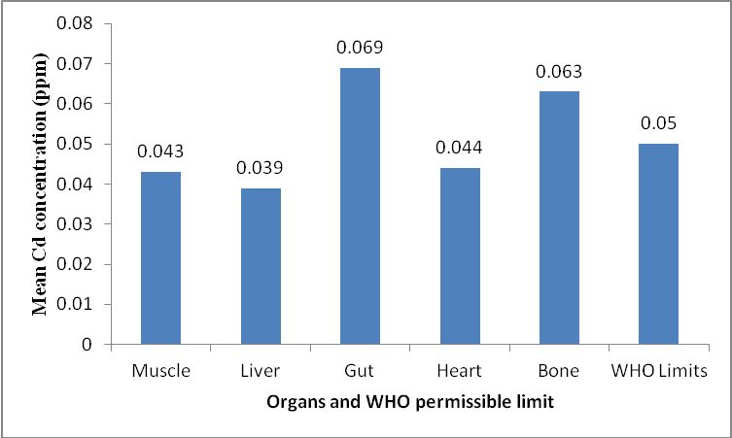
Figure 3: Mean Cd concentration (ppm) in the organs of Xenopus laevis.

The highest mean Cd level in the organs of Xenopus laevis was 0.069ppm (gut) while the lowest was 0.039ppm (liver) in the order: gut>bone>heart>muscle>liver. With the exception of the gut (0.069ppm) and the bones (0.063ppm), all the other organs had mean Cd level below the World Health Organization’s permissible limit of 0.05ppm.

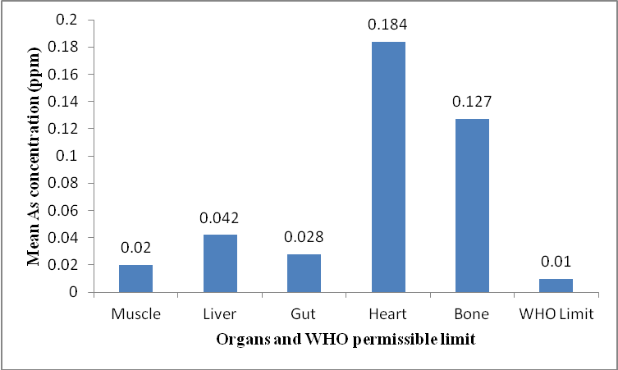
Figure 4: Mean As concentration (ppm) in the organs of Xenopus laevis.

All the mean As concentration in the organs of Xenopus laevis were above the WHO permissible limit of 0.01ppm. The highest mean As concentration was in the heart (0.184ppm) while the least was in the muscle (0.02ppm) in the order: heart>bone>liver>gut>muscle.

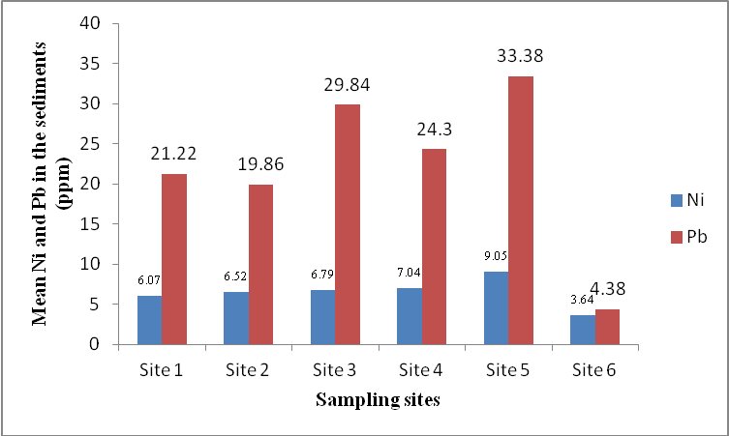
Figure 5: Mean Ni and Pb (ppm) in the sediments.

The highest mean Ni concentration in the sediments was at Site 5 (9.05ppm) while the least was at Site 6 (3.64ppm) in the decreasing order: Site 5>Site 4>Site 3>Site 2>Site 1>Site 6. The highest mean Pb concentration in the sediments was at Site 5 (33.38ppm) while the least was at Site 6 (4.38ppm) in the increasing order: Site 6<Site 2<Site 1<Site 4<Site 3<Site 5.Cd and As were not detected in the sediment samples while all the detected heavy metals were all above standards set by the Federal Environmental Protection Agency (FEPA, 1992). The study shows that most of the heavy metals bioaccumulated in the organs of Xenopus laevis higher than the recommended World Health Organization’s permissible limit thereby making the edible frogs caught in Alaro Stream unfit for human consumption. This corroborates previous findings by Tyokumbur and Okorie (2011) that showed similar trends in which selenium and silver were higher in the bone, gut, heart and muscle while silver was the only heavy metal with the lowest concentration in the bones of the edible frog in contrast to calcium which ranked highest in the study. In the study, significant correlation was recorded between the bioaccumulated heavy metals crabs and edible frogs. Similarly, Shaapera et al, (2013) in which the liver contained the highest concentration (43.6%) of the frog (Rana esculentus) organs, Fe had the highest concentration in the liver, followed by skin and lowest in the intestine. According to Shaapera et al (2013), the trend of the heavy metals concentration in the organs was: Fe > Mn > Pb > Zn > Cu > Cr > Cd while the concentrations of all the metals in the liver, skin and intestine of the frog were found to be statistically significant with Pb, Fe, Cr and Mn above the tolerance limits by the WHO with exception of Cd, Cu and Zn that were below the permissible limits in the samples. There was heavy metal variation in the organs of Xenopus laevis because bioccumulation of metals in various organs and tissues depends on the route of exposure such as t diet or their elevated level in surrounding environment (Nussey, 1996; Alam et al, 2002; Akan et al, 2012). The results also show that the sediments are contaminated and have the potential of releasing heavy metals into the water body since the detected Ni and Pb were above regulatory standards. It can be concluded that Alaro Stream is polluted and edibles frogs caught there are not safe for human consumption.

References
1 Alam, M. G. M., Tanaka, A., Allinson, G., Lauren- son, L.J.B., Stagnitti, F. and Snow, E.T. (2002). A Comparison of Trace Element Concentrations in Cultured and Wild Carp (Cyprinus carpio) of Lake Kasumigaura, Japan. Ecotoxicology and Environmental Safety. 53(3): 348-354.
2 Akan, J.C., Mohmoud, S., Yikala, B.S and Ogugbuaja, V.O.(2012). Bioaccumulation of Some Heavy Metals in Fish Samples from River Benue in Vinikilang, Adamawa State, Nigeria. American Journal of Analytical Chemistry. 3: 727-736.
3 FEPA .1992.Guidelines for Environmental Pollution Control in Nigeria. Federal Environmental Protection Agency.
4 Furr, A.K, Parkinson, T.F, Young, W.D, Berg, D.O, Gutenmann, W.H, Pakkala, I.S, Lisk, D.J.(1979): Elemental content of aquatic organisms inhabiting a pond contaminated with coal fly ash. NY Fish Game J 26(2):154-161.
5 Guthrie, R.K, Cherry, D.S. (1979): Trophic level accumulation of heavy metals in a coal ash basin drainage system. Water Res Bull 15(1): 244-248
6 Ilona, E.S., Anush, S.T. and Yurv, P.P. (2011). Effect of molybdenium, chromium and cadmium ions on metamorphosis and erythrocytes morphology of the Marsh Frog Pelophylax ridibundus (Amphibia: Anura),” Journal of Environmental Science and Technology, Vol. 4, No. 2, 2011, pp. 172-181.
7 Nussey, G. (1996). Bioaccumulation of Chromium, Manganese, Nickel and Lead in the Tissues of the Moggel, Labeo umbratus (Cyprinidae), from Witbank Dam, Mpumalanga. Water SA. Vol. 26, No. 2, 2000, pp. 269-284.
8 Rowe, C.L, Kinney, O.M, Fiori, A.P. and Congdon, J.D. (1996): Oral deformities in tadpoles (Rana catesbeiana) associated with coal ash deposition: effects on grazing ability and growth. Freshwater Biol 36:723-730.
9 Shaapera, U., Nnamonu, L.A. and Eneji, I.S. (2013). Assessment of heavy metals in Rana esculenta Organs from River Guma, Benue State Nigeria. American Journal of Analytical Chemistry. 4, 496-500
10 Tyokumbur, E.T. and Okorie, T.G. (2011): Macro and trace element accumulation in edible crabs and frogs in Alaro stream ecosystem, Ibadan. Journal of Research in National Development (JORIND). Vol.9.No.2, 439-446.
11 WHO/FAO (1989): Evaluation of certain food additives and contaminants. Thirty third Report of the joint FAO/WHO Expert Committee on Food Additives. WHO Technical Report Series (Geneva). World Health Organization/Food and Agricultural Organization.
12 World Health Organisation (WHO). (2008). Guidelines for Drinking Water Quality. 3rd Edn., Health Criteria and Supporting Information. WHO, Geneva, pp: 668.Retrieved from: http://www.who.int/water_sanitation_ health / dwq/fulltext.pdf.

2/28/2016

