Hematological and Biochemical Changes In Pyrexic Subjects Attending Olabisi Onabanjo University
Health Centre, Ago Iwoye, Ogun State, Nigeria

J.B. Folorunso¹, E.S. James², D.S.K. Olanrewaju-Kehinde³, A. Davies⁴, R.M. Kolawole⁵ and B.T. Thomas⁵

¹Department of Medical Laboratory, Health Services Directorate, Olabisi Onabanjo University, Ago Iwoye,
Ogun State, Nigeria
²Department of Clinical Pharmacy, Olabisi Onabanjo University, Sagamu, Ogun State, Nigeria
³Department of Environment Science (Microbiology option), Olabisi Onabanjo University, Ago Iwoye, Ogun State, Nigeria
⁴Department of Medical Microbiology and Parasitology, Babcock University, Ilisan-Remo, Ogun State, Nigeria
⁵Department of Cell Biology and Genetics, University of Lagos, Akoka, Nigeria
benthoa2013@gmail.com

Abstract: This study evaluated the hematological and biochemical indices of pyrexic subjects using standard techniques. Results obtained revealed no significant variation between the packed cell volume and the random blood sugar of both the pyrexic subjects and the control group (P>0.05). However, an apparent statistical disparity was observed in the white blood cell counts of both the pyrexic and the control group with the pyrexic subjects having an approximately 20% percentage white blood cell reduction relative to the control group (P<0.05). It can therefore be concluded based on our research findings that pyrexia of bacterial origin have a statistical significant relationship with the white blood cell count and not any other examined hematological and/biochemical parameters.
[J.B. Folorunso, E.S. James, D.S.K. Olanrewaju-Kehinde, A. Davies and B.T. Thomas. Hematological and Biochemical Changes In Pyrexic Subjects Attending Olabisi Onabanjo University Health Centre, Ago Iwoye, Ogun State, Nigeria. N Y Sci J 2016;9(2):9-11]. ISSN 1554-0200 (print); ISSN 2375-723X (online). http://www.sciencepub.net/newyork. 2. doi:10.7537/marsnys09021602.

Keywords: Hematological, biochemical, pyrexic subjects.

1. Introduction
Pyrexia of undetermined origin otherwise known as hyperthermia according to Axelrod and Diringer [1], is characterized by an elevation of temperature above normal range of 36.5⁰-37.5⁰C due to an increase in body temperature regulatory set point [2]. This medical problem remain the leading cause of morbidity and mortality among the populace, especially in sub-saharan Africa [3].
The spectrum of diseases causing pyrexia of unknown origin not only seems to be determined by geography factors, but also to change with time [4]. The condition is a diagnostic challenge and as such constitutes a significant number of referrals to tertiary care centers. Previous studies have described the spectrum of the disease to be mainly secondary to infectious, neoplastic and inflammatory diseases [5]. The diagnostic work up for pyrexia of undetermined origin is well described [6]. But there is no ‘gold standard’ and it may be done differently depending on the clinical situation. In most cases, it begins by confirming the presence of fever in hospital. A minimal work up includes a complete history and physical examination including drug history, complete blood count with differential, blood film, routine blood chemistry, urinalysis and microscopy, blood and urine cultures, anti nuclear antibodies rheumatoid factor, HIV antibodies, chest X-ray and hepatitis serology.
It is a prominent symptom of many diseases in human and animals with different microbial aetiologies including bacteria, viruses and protozoans. It is considered a medical emergency as it may indicate a serious underlying condition or lead to significant side effects [7]. Recent studies even suggest possible dysfunction in hematological and biochemical parameters of pyrexic subjects. This study was therefore undertaken to determine the frequency and severity of hematological and biochemical changes in pyrexic subjects attending Olabisi Onabanjo University Health Centre, Ago Iwoye, Ogun State, Nigeria.

2. Material and Methods
2.1 Ethical Issues and Study Subjects
Three hundred Subjects (138 male and 162 female), 16 years of age with clinical illness compatible with febrile (auxiliary temperature (38.3⁰C) or history of fever in the previous 3 weeks and with no history of antibiotics or anti-malarial administration in the previous week were recruited into this study based on satisfactory inclusion criteria and after due consent of the subject has been obtained. Subjects with history of treatment with antibiotics/anti malarial drugs in the past one week were excluded from the study. All these were done after obtaining ethical approval from the Institutional Research Committee. The control group consisted of one hundred apparently healthy persons (50 males and 50 females) with no history of fever in the previous 3 weeks. The age range of test and control groups was 16 years and above.
2.2 Hematological and biochemical indices of pyrexic subjects
5mls of blood was collected from the test and control groups. A portion (2mls) was anticoagulated with EDTA and used for the haematological profiles while the remaining was allowed to clot and serum used for biochemical profiles. Haematological profiles were determined by the method of Bain (1997). The glucose was determined by glucose oxidase method of Trinder 1969.

2.3 Statistical Analysis
The mean results of tests and controls were analysed using students “t” test. The level of significance was set at p<0.05

3.0 Results
The table below shows the hematological and biochemical indices of pyrexic subjects attending Olabisi Onabanjo University Health Centre, Ago Iwoye, Ogun State, Nigeria. The results revealed no significant variation between the packed cell volume and the random blood sugar of both the pyrexic subjects and the control group (P>0.05). However, an apparent statistical disparity was observed in the white blood cell counts of both control groups and the pyrexic subjects. This is because the white blood cell of the pyrexic subjects reduced by approximately 20% relative to the control group group.

Table 1: Hematological and biochemical indices of pyrexic subjects
Parameters PCV WBC RBS
Pyrexic subjects 37.80±0.48 5557.25±1148±88 94.57±7.40
Control group 38.71±0.00 6671.00±0.00 96.64±0.00
P value >0.05 <0.05 >0.05

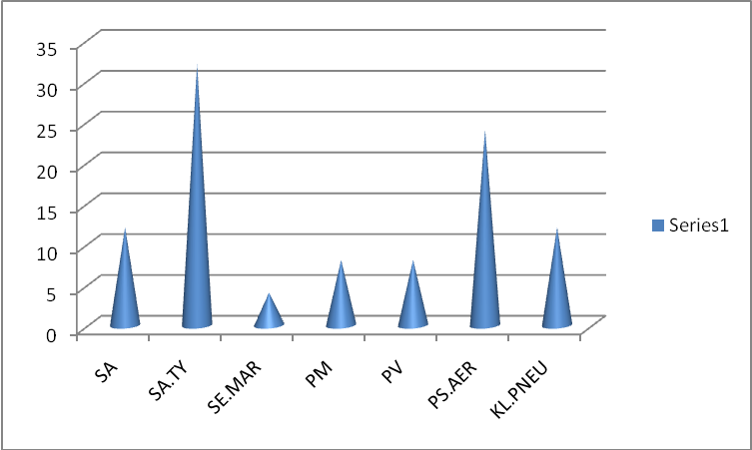
Figure 1: Prevalence of Bacteria in the examined pyrexic subjects

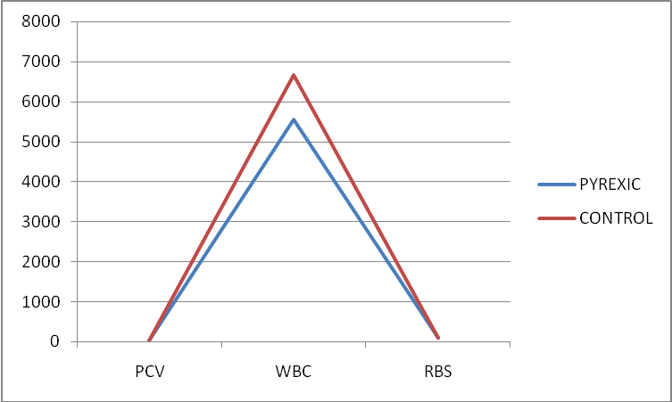
Figure 2: Relative measurement of hematological and biochemical parameters of pyrexic and control groups

4.0. Discussion and Conclusion
Pyrexia of undetermined origin remain the leading cause of morbidity and mortality among the populace, especially in sub-saharan Africa [3] while the spectrum of diseases causing this infection not only seems to be determined by geography factors, but also to change with time [4]. In this study, no correlation was found between change in PCV level and onset of pyrexia. This observation is an indication that pyrexia does not cause anaemia, thus vindicating the pyrexic subjects as being free of polycychaemic vera [11]. Significant difference occur in the mean total WBC of the control and the pyrexic subjects as apparent reduction in white blood cell of the infected subjects (leucopenia) was observed. This findings may be due largely to ineffective or depressed granulopoiesis in the bone marrow [12]. The lack of apparent difference observed between the control group and the infected group in terms of the RBS level means that the pyrexia may not affect blood sugar level for Our findings however suggest a possible relationship between white blood cell and pyrexia of undetermined origin. However, in order to delineate the pathogenesis of pyrexia of undetermined origin, further studies are necessary to completely elucidate the involvement of this infection in the alteration of hematological and biochemical system of subjects using larger sample size. It can therefore be concluded based on our research findings that no significant relationship exist between PCV and FBS rather strong correlation exist between pyrexia and white blood cell.

Corresponding Author:
B.T. Thomas
Department of Cell Biology and Genetics,
University of Lagos, Akoka, Nigeria
Telephone: +234 806 4011412
E-mail: benthoa2013@gmail.com

References
- Axelrod, Y.K., M.N. Diringer, 2008. Temperature management in acute neurologic disorders”. Neuron clin. 26(2): 585-603.
- Karakitosis, D., A. Karabinis, 2008. Hypothermia therapy after traumatic brain injury in children. N. Engl. J. Med. 359(11): 1179-80.
- Bryce, J., C. Boschi-Pinto, K. Shibaya, R.E. Black, 2005. WHO Child health Epidemiology Reference Group Lancit, 365(65): 1147-52.
- De Kleijn, E.M., J.P. Vandenbroucke, J.W. Van der Meer, 1997. Fever of unknown origin (FUO); A prospective multicenter study of 167 patients with FUO, using fixed epidemiologic entry criteria. The Netherlands FUO Study Group. Medicine, 76:392-400.
- Baicus, C., H.D. Bolosiu, C. Tanasecu, A. Baicus,2003. Fever of unknown origin in Romania II: Diagnostic procedure: prospective multicenter study of 164 patients. Rev. Med. Chir Soc Med Lasi., 107: 772-80.
- Mourad, O., V. Palda, A.S. Detsky, 2003. A comprehensive evidence based approach to fever of unknown origin. Arch Intern Med., 163:545-551.
- McGugan, E.A., 2001. Hyperpyrexia in the emergency Department. Emerg. Meg., 13(1). 116-20.
- Jain, N.C (1986). Schalms veterinary Parasitology, 4th edition. (Ed N.C. Jain); Philadelphia: Lea and Febiger.
- Takeet, M.I and Fagbemi, B.O. (2009). Haematological, Pathological and Plasma biochemical changes in rabbits experimentally infected with Trypanosoma congolense. Science World Journal 4(2): 29-36.
- Harold, V. (1969). Practical clinical biochemistry 4th Edn. CB5 Publication, India.
- Cheesborough, L.M. (2005). Identification of bacteria. In medical laboratory manual for tropical countries. Vol II. Butter Worth and Co. Publishers. London, Uk.
12. Anosa, V.O, Logan-Henfrey, L.L and Wells C.W. (1997a). The hematology of T. congolense infection in cattle Macrophages structure and function in adult Boran cattle. Comparative Hematology international 7:23-29.

1/27/2016

