**Liver function status in hepatitis C virus patients with chronic Renal Failure on hemodialysis**

Fawzy Megahed Khalil1, Mohamed Ahmed El Assal1, Ahmed Mohamed Hussein Dabour1, Ahmed Hassan El.Thakaby2 and Ibrahim Hamdy Ibrahim2.

1. Internal Medicine department, Faculty of Medicine, Benha University, Qalyubia, Egypt.

2.Nephrology and Internal Medicine department, National Institute of Nephrology and Urology, Cairo, Egypt.

[Swallow_special_boss@yahoo.com](mailto:Swallow_special_boss@yahoo.com)

**Abstract: Background:** The aims of this study is to clarify hemodialysis related changes in liver function status in hepatitis C virus patients versus negative patients with chronic kidney disease on hemodialysis. **Subjects and Methods:** The study included 70 patients with history of chronic kidney disease on hemodialysis for more than 1 year ago: 40 Patients with hepatitis C virus are patient group, and 30 Patients without hepatitis C virus are control group. The study was performed at national institute of nephrology and urology, in Cairo. Patients were subjected to full history taking, clinical examination including blood pressure measurement, and laboratory studies including: complete blood count, Serum levels of alanine aminotransferase, Aspartate aminotransferase, international ratio, total proteins, albumin, urea, creatinine, sodium, potassium, cholesterol, triglycerides, virology markers using Enzyme Linked-Immunoassay technique over 1 year with 3 months between each one, and polymerase chain reaction for hepatitis C virus Ribo Nucleic Acid once allover the study. **Results:** The study showed no significant difference between patients and control as regard serum liver aminotransferases, albumin and international ratio allover the study, and all are within normal ranges, also 72.5%, 22.5% and 5% of patients group are in low, intermediate, and high viremia respectively, and with Comparative study between low, intermediate and high viremia as regard duration of starting dialysis (years) there is: highly significant difference between them, indicating that: There is inverse association with increase duration of starting dialysis there is decrease in hepatitis C viral load. **Conclusion:** Our data confirm that patients with chronic kidney disease on hemodialysis with hepatitis C virus have normal level of liver aminotransferases, and low viremia in hepatitis C virus patients on hemodialysis is an important factor in maintaining them with in normal ranges, and this low viral load may be related to duration since starting of hemodialysis.

[Fawzy Megahed Khalil, Mohamed Ahmed El Assal, Ahmed Mohamed Hussein Dabour, Ahmed Hassan El.Thakaby, Ibrahim Hamdy Ibrahim. **Liver function status in hepatitis C virus patients with chronic Renal Failure on hemodialysis.** *N Y Sci J* 2016;9(2):1-8]. ISSN 1554-0200 (print); ISSN 2375-723X (online). <http://www.sciencepub.net/newyork>. 1. doi:[10.7537/marsnys09021601](http://www.dx.doi.org/10.7537/marsnys09021601).

**Keywords:** Hepatitis C virus, Chronic kidney disease, Hemodialysis.

**1. Introduction:**

Chronic kidney disease (CKD), also known as chronic renal disease (CRD), is a progressive loss in renal function over a period of months or years. The symptoms of worsening kidney function are non-specific, and might include feeling generally unwell and experiencing a reduced appetite. Often, CKD is diagnosed as a result of screening of people known to be at risk of kidney problems, such as those with high blood pressure or diabetes and those with a blood relative with CKD. CKD may also be identified when it leads to one of its recognized complications, such as cardiovascular disease, anemia or pericarditis ***(1)***. Recent professional guidelines classify the severity of CKD in five stages, with stage 1 being the mildest and usually causing few symptoms and stage 5 being a severe illness with poor life expectancy if untreated. Stage 5 CKD is often called end-stage renal disease (ESRD), end stage renal failure (ESRF), or end-stage kidney disease (ESKD) and is synonymous with the now outdated terms chronic kidney failure (CKF) or chronic renal failure (CRF). There is no specific treatment un equivocally show to slow the worsening of chronic kidney disease. If there is an underlying cause to CKD, such as vasculitis, this may be treated directly to slow the damage. In more advanced stages, treatments may be required for anemia and bone disease. Severe CKD requires renal replacement therapy, which may involve a form of dialysis, but ideally constitutes a kidney transplant ***(1)***. The serum levels of the liver enzymes alanine aminotransferase (ALT), and Aspartate aminotransferase (AST) are markers of aggression against hepatocytes ***(2)***. Thus, they are elevated in several diseases, such as chronic viral hepatitis ***(3)***, non-alcoholic fatty liver disease ***(4)***, autoimmune hepatitis **(*5)***, hemochromatosis ***(6)***, and alcoholic liver disease ***(7)***. These enzymes assist in diagnosis and patient follow-up and response to treatment because they reflect inflammatory activity in the parenchyma of the liver ***(8)***. The prevalence of hepatitis C virus (HCV) infection varies greatly among patients on hemodialysis (HD) from different geographic regions. In a review of data published in 1999, ***Wreghitt*** described a range from 4% in the United Kingdom (UK) to 71% in Kuwait for HCV prevalence among the HD population ***(9)***.In Egypt, the prevalence of HCV antibodies in HD patients was found to be ranging from 52.3% to 82.3% ***(10)***. Several studies have reported nosocomial patient-to patient transmission of HCV infection among HD patients ***(11, 12)***. The patients with CKD on HD had reduced serum levels of aminotransferases due to hemodilution, lower pyridoxine levels, or elevated homocysteine levels. The CKD patients on HD infected with the HCV also had lower aminotransferase levels compared with the infected patients without CKD. This reduction is in part due to decreased viremia caused by the dialysis method, the production of a hepatocyte growth factor (HGF) and endogenous interferon-alpha (INF-α), and lymphocyte activation, which decrease viral action on hepatocytes ***(13)***.

**2. Material and Methods:**

This retrospective study was conducted in HD Unit of National Institute Of Nephrology and Urology in Cairo.

**Exclusion criteria:**

Hepatitis B virus surface antigen (HBsAg) positive patients, Human immunodeficiency virus antibody (HIVAb) positive patients.

**Inclusion criteria:**

All patients are above 18 years old, All patients have CKD and on regular HD more than 1 year ago.

This study included 70 patients with history of CKD on HD for more than 1 year ago: 40 Patients with HCV are patient group, 30 Patients without HCV are control group.

**Study design:**

All Patients were subjected to full history taking, Clinical examination including blood pressure measurement, Laboratory studies including: complete blood count (CBC), Serum levels of alanine aminotransferase (ALT), Aspartate aminotransferase (AST), international ratio (INR), total proteins, albumin, urea, creatinine, sodium, potassium, cholesterol, triglycerides, virology markers using Enzyme Linked-Immunoassay (ELISA) technique over 1 year with 3 months between each one, and polymerase chain reaction (PCR) for HCV Ribo Nucleic Acid (RNA) once allover the study.

**Statistical Analysis:**

Data were analyzed using Statistical Program for Social Science (SPSS) version 18.0. Quantitative data were expressed as mean ± standard deviation (SD). Qualitative data were expressed as frequency and percentage.

**The following tests were done:**

Independent-samples t-test of significance was used when comparing between two means. Paired sample t-test of significance was used when comparing between related sample. A one-way analysis of variance (ANOVA) when comparing between more than two means. Chi-square (X2) test of significance was used in order to compare proportions between two qualitative parameters. Pearson's correlation coefficient (r) test was used for correlating data. Probability (*P*-value), *P*-value <0.05 was considered significant. *P*-value <0.001 was considered as highly significant. *P*-value >0.05 was considered insignificant.

**3. Results:**

The present study included 70 patients with history of CKD on HD for more than 1 year ago, 40 Patients HCV virus are patient group, and 30 Patients without HCV are control group. Patient group gender in our study are 22 patients male (55%) and 18 patients female (45%), Of average age (mean±SD = 46.98±15.62 years), Most of them were on long term HD (mean±SD = 7.83±3.49 years), 35, 7 and 13 patients of them (87.5%, 17.5% and 33.5%) are hypertensive, diabetic and ischemic respectively, The remaining 5, 33 and 27 patients (12.5%, 82.5% and 67.5%) are not hypertensive, diabetic or ischemic respectively, Access of HD is Arteriovenous fistula in 39 patients (97.5%) and Permicath in 1 patient (2.5%), 30 patients (75%) had taken blood transfusion, With average number of transfusion (mean±SD = 1.48±1.40), With average duration between each blood transfusion (mean±SD = 27.18±24.21 months), While the remaining 10 patients (25%) hadn't taken blood transfusion.

Control group gender in our study are 10 patients male (33.3%) and 20 patients female (66.7%), Of average age (mean±SD = 47.90±15.18 years), Most of them were on long term HD (mean±SD = 7.37±3.44 years), 24,4 and 8 patients of them (80%, 13.3% and 26.7%) are hypertensive, diabetic and ischemic respectively, The remaining 6, 26 and 22 patients (20%, 86.7% and 73.3%) are not hypertensive, diabetic or ischemic respectively, Access of HD is Arteriovenous fistula in 28 patients (93.3%) and Permicath in 2 patient (6.7%), 18 patients (60%) had taken blood transfusion, With average number of transfusion (mean ± SD = 1.07±1.17), With average duration between each blood transfusion (mean ± SD = 11.90±13.65 months), While the remaining 12 patients (40%) hadn't taken blood transfusion.

**Table (1):** Demographic dataof the studied patients.

|  |  |  |  |
| --- | --- | --- | --- |
| Parameter | ESRD Patients without HCV (Control group)  (n=30) | ESRD Patients with HCV (Patient group)  (n=40) | *p*-value |
| 1. Gender:   Male: Number (%)  Female: Number (%) | 10 (33.3%)  20 (66.7%) | 22 (55%)  18 (45%) | 0.072 |
| Statistical test: Chi square test (*x2*), *p*-value >0.05: non-significant. | | | |
| 1. Age (years):   Mean±SD | 47.90±15.18 | 46.98±15.62 | 0.805 |
| Statistical test: Independent-samples t-test, *p*-value >0.05: non  significant. | | | |
| 1. Comorbidities A) HTN:   Yes: Number (%)  No: Number (%) | 24 (80%)  6 (20%) | 35 (87.5%)  5 (12.5%) | 0.394 |
| B) DM:  Yes: Number (%)  No: Number (%) | 4 (13.3%)  26 (86.7%) | 7 (17.5%)  33 (82.5%) | 0.635 |
| C) IHD:  Yes: Number (%)  No: Number (%) | 8 (26.7%)  22 (73.3%) | 13 (32.5%)  27 (67.5%) | 0.598 |
| Statistical test: Chi square test (*x2*), *p*-value >0.05: non-significant. | | | |
| 4) HD duration (years):  Mean±SD | 7.37±3.44 | 7.83±3.49 | 0.673 |
| Statistical test: Independent-samples t-test, *p*-value >0.05: non-significant. | | | |
| 1. Acess of HD:   AVF: Number (%)  Permicath: Number (%) | 28 (93.3%)  2 (6.7%) | 39 (97.5%)  1 (2.5%) | 0.394 |
| Statistical test: Chi square test (*x2*), *p*-value >0.05: non-significant. | | | |
| 1. Blood Transfusion:   Yes: Number (%)  No: Number (%) | 18 (60%)  12 (40%) | 30 (75%)  10 (25%) | 0.181 |
| Statistical test: Chi square test (*x2*), *p*-value >0.05: non-significant. | | | |
| 7) Number of blood Transfusion:  Mean±SD  8) Duration between transfusion (months): Mean±SD | 1.07±1.17  11.90±13.65 | 1.48±1.40  27.18±24.21 | 0.200 |
| Statistical test: Independent-samples t-test, *p*-value >0.05: non-significant. | | | |

**Table (2):** Laboratory data of patients groupallover the study.

|  |  |  |
| --- | --- | --- |
| **Parameter** | **Mean** | ±**SD** |
| Creatinine (mg/dL) | 7.97 | ±1.79 |
| Urea (mg/dL) | 109.05 | ±20.05 |
| Na (mEq/L) | 136.44 | ±1.58 |
| K (mEq/L) | 3.89 | ±0.26 |
| Hb (g/dL) | 11.49 | ±0.86 |
| Cholesterol (mg/dL) | 168.54 | ±45.91 |
| Triglycerides (mg/dL) | 120.13 | ±49.27 |
| Total protein (g/dL) | 7.85 | ±0.33 |
| Albumin (g/dL) | 3.88 | ±0.24 |
| INR | 1.02 | ±0.05 |
| ALT (U/L) | 38.54 | ±13.01 |
| AST (U/L) | 28.15 | ±9.99 |

As shown in the table, patients have elevated serum creatinine, urea, also they were generally anaemic despite the regular use of erythropoietin but it is our target to avoid arteriovenous thrombosis.

Also all patients are HCV positive, none are HBV or HIV positive.

**Table (3):** Laboratory data of control group allover the study.

|  |  |  |
| --- | --- | --- |
| **Parameter** | **Mean** | ±**SD** |
| Creatinine (mg/dL) | 9.65 | ±2.28 |
| Urea (mg/dL) | 116.13 | ±26.80 |
| Na (mEq/L) | 135.38 | ±1.56 |
| K (mEq/L) | 3.91 | ±0.25 |
| Hb (g/dL) | 10.67 | ±0.76 |
| Cholesterol (mg/dL) | 184.76 | ±44.57 |
| Triglycerides (mg/dL) | 140.67 | ±73.41 |
| Total protein (g/dL) | 7.87 | ±0.39 |
| Albumin (g/dL) | 3.93 | ±0.24 |
| INR | 1.01 | ±0.02 |
| ALT (U/L) | 34.40 | ±9.73 |
| AST (U/L) | 19.16 | ±7.75 |

As shown in the table, patients have elevated serum creatinine, urea, also they were generally anaemic despite the regular use of erythropoietin but it is our target to avoid arteriovenous thrombosis.

Also all patients are none HCV, HBV or HIV positive.

**Table (4):** Comparison between patients and control as regardALT at the beginning, middle"3 and 6 months later" and at the end of the study.

|  |  |  |  |  |  |  |
| --- | --- | --- | --- | --- | --- | --- |
| **ALT** | **Patients** | | **Control** | | **t-test** | |
| **Mean** | ±**SD** | **Mean** | ±**SD** | **T** | **p-value** |
| ALT0 | 39.15 | 14.15 | 35.00 | 9.62 | 1.016 | 0.129 |
| ALT1 | 35.00 | 12.42 | 31.70 | 8.29 | 2.612 | 0.081 |
| ALT2 | 41.13 | 12.82 | 36.87 | 10.02 | 1.573 | 0.098 |
| ALT3 | 38.90 | 12.68 | 34.03 | 11.02 | 1.085 | 0.144 |

Comparative study between patients and control as regard ALT at the beginning, middle"3 and 6 months later" and at the end of the study using Independent-samples t-test revealed non-significance, *p*-value( >0.05).

**Table (5):** Comparison between patients and control as regard AST at the beginning, middle"3 and 6 months later" and at the end of the study.

|  |  |  |  |  |  |  |  |  |  |  |  |  |  |  |  |  |  |  |  |  |  |  |  |  |  |  |  |  |  |  |  |  |  |  |  |  |  |  |  |  |  |
| --- | --- | --- | --- | --- | --- | --- | --- | --- | --- | --- | --- | --- | --- | --- | --- | --- | --- | --- | --- | --- | --- | --- | --- | --- | --- | --- | --- | --- | --- | --- | --- | --- | --- | --- | --- | --- | --- | --- | --- | --- | --- |
| |  |  |  |  |  |  |  | | --- | --- | --- | --- | --- | --- | --- | | **AST** | **Patients** | | **Control** | | **t-test** | | | **Mean** | ±**SD** | **Mean** | ±**SD** | **T** | ***p*-value** | | AST0 | 26.58 | 10.83 | 20.07 | 9.92 | 1.421 | 0.077 | | AST1 | 29.78 | 8.76 | 19.23 | 8.07 | 0.153 | 0.155 | | AST2 | 29.68 | 11.16 | 19.87 | 7.12 | 0.790 | 0.126 | | AST3 | 26.58 | 9.23 | 17.50 | 5.92 | 0.296 | 0.141 | |

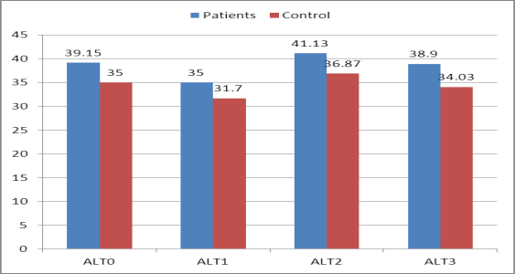

**Figure (1):** Comparison between patients and control as regard ALT at the beginning, middle"3 and 6 months later" and at the end of the study.

Comparative study between patients and control as regard AST at the beginning, middle"3 and 6 months later" and at the end of the study using Independent-samples t-test revealed non-significance,*p*-value( >0.05).

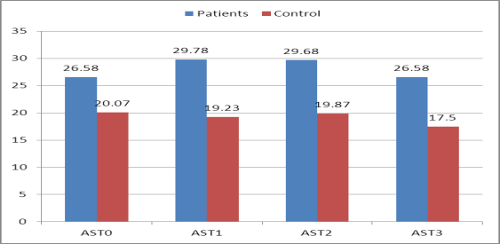

**Figure (2):** Comparison between patients and control as regard AST at the beginning, middle"3 and 6 months later" and at the end of the study.

**Table (6):** Comparison between patients and control as regard ALB at the beginning, middle"3 and 6 months later" and at the end of the study.

|  |  |  |  |  |  |  |
| --- | --- | --- | --- | --- | --- | --- |
| **Alb.** | **Patients** | | **Control** | | **t-test** | |
| **Mean** | ±**SD** | **Mean** | ±**SD** | **T** | ***p*-value** |
| ALB0 | 3.77 | 0.30 | 3.88 | 0.28 | -1.621 | 0.110 |
| ALB1 | 3.83 | 0.23 | 3.96 | 0.24 | -1.249 | 0.098 |
| ALB2 | 3.89 | 0.17 | 3.88 | 0.19 | 0.157 | 0.876 |
| ALB3 | 4.06 | 0.26 | 4.02 | 0.27 | 0.662 | 0.510 |

Comparative study between patients and control as regard serum ALB at the beginning, middle"3 and 6 months later" and at the end of the study using Independent-samples t-test revealed non-significance, *p*-value (>0.05).

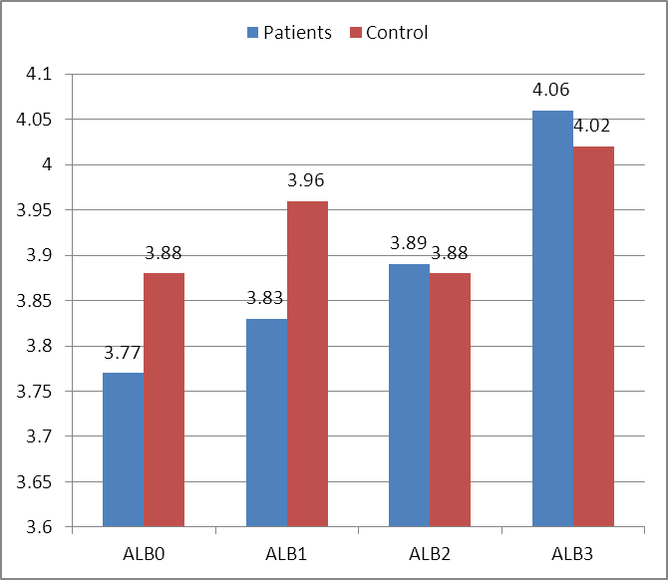

**Figure (3):** Comparison between patients and control as regard ALB at the beginning, middle"3 and 6 months later" and at the end of the study.

**Table (7):** Comparison between patients and control as regard INR at the beginning, middle"3 and 6 months later" and at the end of the study.

|  |  |  |  |  |  |  |
| --- | --- | --- | --- | --- | --- | --- |
| **INR** | **Patients** | | **Control** | | **t-test** | |
| **Mean** | ±**SD** | **Mean** | ±**SD** | **T** | ***p*-value** |
| INR0 | 1.02 | 0.06 | 1.02 | 0.05 | 0.451 | 0.654 |
| INR1 | 1.04 | 0.06 | 1.01 | 0.02 | 1.020 | 0.114 |
| INR2 | 1.02 | 0.04 | 1.00 | 0.01 | 1.044 | 0.101 |
| INR3 | 1.02 | 0.04 | 1.01 | 0.02 | 1.783 | 0.079 |

Comparative study between patients and control as regard INR at the beginning, middle "3 and 6 months later" and at the end of the study using Independent-samples t-test revealed non-significance, *p*-value (>0.05).

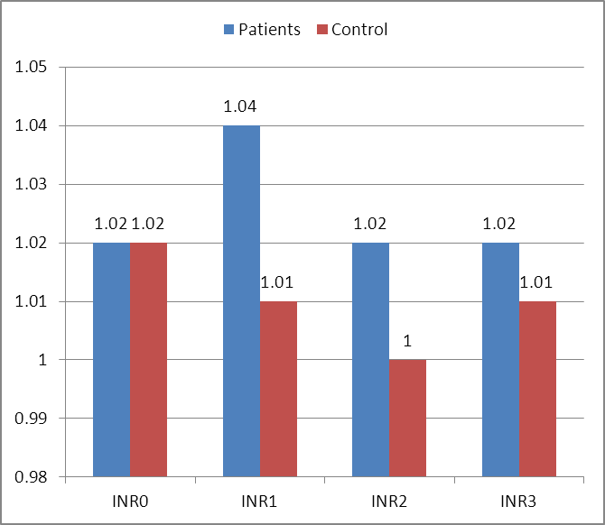

**Figure (4):** Comparison between patients and control as regard INR at the beginning, middle"3 and 6 months later" and at the end of the study.

**Table (8):** patients HCV PCR classification.

|  |  |  |
| --- | --- | --- |
| **PCR** | **No.** | **%** |
| Low viremia | 29 | 72.5 |
| Intermediate viremia | 9 | 22.5 |
| High viremia | 2 | 5 |
| Total | 40 | 100 |

Statistical analysis of patients HCV PCR revealed the following: 29 patients are in low viremia (72.5**%**), 9 patients are in intermediate viremia (22.5**%**), 2 patients are in high viremia (5**%)**.

**Figure (5):** patients HCV PCR classification.

Comparative study between low, intermediate and high viremia as regard duration of dialysis (years) using A one-way analysis of variance (ANOVA) test revealed highly significance p-value (**<**0.001), There is inverse association with increase duration of dialysis there is decrease in hepatitis C virus PCR viremia.

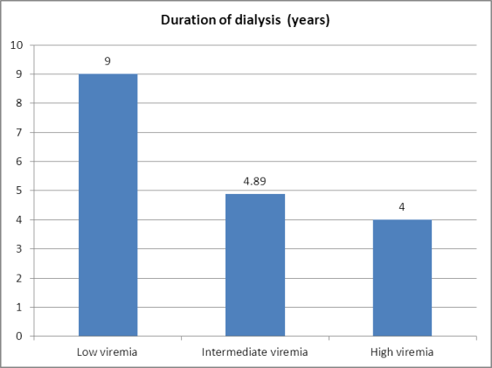

**Figure (6):** Comparsion between low, intermediate and high viremia as regard duration of dialysis (years).

**Table (9):** Comparison between low, intermediate and high viremia as regard duration of dialysis (years).

|  |  |  |  |  |
| --- | --- | --- | --- | --- |
| **PCR** | **Duration of dialysis (years)** | | **ANOVA** | |
| **Mean** | ±**SD** | **F** | ***p*-value** |
| Low viremia | 9.00 | 3.32 | 8.26 | **<0.001** |
| Intermediate viremia | 4.89 | 1.54 |
| High viremia | 4.00 | 1.41 |

**4. Discussion:**

Serum levels of the liver enzymes ALT, and AST are markers of aggression against hepatocytes ***(2)***. Thus, they are elevated in several diseases, such as chronic viral hepatitis ***(3)***, non-alcoholic fatty liver disease ***(4)***, autoimmune hepatitis ***(5)***, hemochromatosis ***(6)***, and alcoholic liver disease ***(7)***. These enzymes assist in diagnosis and patient follow-up and response to treatment because they reflect inflammatory activity in the parenchyma of the liver ***(8, 14, 15)***.HCV infection still remains a major problem among patients on maintenance HD. The immune suppression seen in this patient population, resulting in an absence of clinical and biochemical evidence of liver disease, is believed to accelerate further dissemination of the virus ***(16)***.The importance of prevention of HCV infection and control is due to its well-documented progression to hepatic cirrhosis, liver malignancies, and liver failure ***(17)***.The prevalence of HCV infection varies greatly among patients on HD from different geographic regions. In a review of data published in 1999, ***Wreghitt*** described a range from 4% in the United Kingdom (UK) to 71% in Kuwait for HCV prevalence among the HD population***(9)***. In Egypt, the prevalence of HCV antibodies in HD patients was found to be ranging from 52.3 to 82.3% ***(10)***. Several studies have reported nosocomial patient-to patient transmission of HCV infection among HD patients ***(11, 12)***. As a result, in 2001 the Center for Disease Control and prevention (CDC) recommends that special precautions should be observed in dialysis units, including wearing and changing of gloves and waterproof gowns between patients, systematic decontamination of the equipment circuit and surfaces after each patient treatment, and no sharing of instruments (e.g., tourniquets, stethoscope, blood pressure cuff) or medications (e.g., multiuse vials of heparin) among patients. Although some studies found that nosocomial spread of HCV declined when HCV-infected patients were treated in dedicated HD units ***(18, 19)***, other investigators could control nosocomial spread of HCV by strict application of hygienic precautions without isolation of HCV-infected subjects or machine segregation ***(20, 21)***.

The aim of this study is to clarify HD related changes in liver function status in HCV antibody positive patients versus negative patients.

The present study included 70 patients with history of CKD on HD for more than 1 year, 40 Patients with HCV are patient group, and 30 Patients HCV virus are control group.

Patient group gender in our study are 22 patients male (55%) and 18 patients female (45%), Of average age (46.98±15.62 years), Most of them were on long term HD (7.83±3.49 years). 35 ,7 and 13 patients of them (87.5%, 17.5% and 33.5%) are hypertensive, diabetic and ischemic respectively, The remaining 5, 33 and 27 patients (12.5%, 82.5% and 67.5%) are not hypertensive, diabetic or ischemic respectively, Access of HD is Arteriovenous fistula in 39 patients (97.5%) and Permicath in 1 patient (2.5%), 30 patients (75%) had taken blood transfusion, With average number of transfusion (1.48±1.40), With average duration between each blood transfusion (27.18±24.21 months), While the remaining 10 patients (about 25%) hadn't taken blood transfusion.

Control group gender in our study are 10 patients male (33.3%) and 20 patients female (66.7%), Of average age (47.90±15.18 years), Most of them were on long term HD (7.37±3.44 years). 24 ,4 and 8 patients of them (80%, 13.3% and 26.7%) are hypertensive, diabetic and ischemic respectively, The remaining 6, 26 and 22 patients (20%, 86.7% and 73.3%) are not hypertensive, diabetic or ischemic respectively, Access of HD is Arteriovenous fistula in 28 patients (93.3%) and Permicath in 2 patient (6.7%), 18 patients (60%) had taken blood transfusion, With average number of transfusion (1.07±1.17), With average duration between each blood transfusion (11.90±13.65 months), While the remaining 12 patients (about 40%) hadn't taken blood transfusion.

As in the study by *Fabrizi* *et al*, our study showed that serum level of liver transaminases (ALT and AST) allover the study are within normal as mean of ALT of HCV patients on HD is 39.15, 35, 41.13 and 38.90 versus 35, 31.70, 36.87 and 34.03 of non HCV patients on HD at the beginning, middle "3 and 6 months later" and at the end of the study respectively, Also mean of AST of HCV patients on HD is 26.58, 29.78, 29.68 and 26.58 versus 20.07, 19.23, 19.87 and 17.50 of non HCV patients on HD at the beginning, middle "3 and 6 months later" and at the end of the study respectively ***(22)***. Our study showed non-significant differences between patients and control as regard ALT(T = 1.016, *P* value = 0.129, T = 2.612, *P* value = 0.081, T = 1.573, P value = 0.098 and T = 1.085, *P* value = 0.144) and AST (T = 1.421, *P* value = 0.077, T = 0.153 *P* value = 0.155, T = 0.790, *P* value = 0.126 and T = 0.296, *P* value = 0.141) at the beginning, middle "3 and 6 months later" and at the end of the study respectively, in contrary to Fabrizi *et al.* who found serum ALT and AST levels were significantly higher (P value = 0.008 and 0.009 respectively) in viraemic patients than in individuals with no detectable HCV RNA in serum ***(22)***. This may be explained by:-Patients in our study are 70 patients, while they are 394 patients by the study of Fabrizi *et al.,* Serum ALT and AST in our study are measured 4 times with 3 months between each one, while in the study of Febrizi *et al.,* they are measured once, Mean of duration of starting dialysis in our study in patients and control is 7.37 and 7.83 years respectively, with no significant differences in between, while in the study of Febrizi *et al.,* it is not clear. The serum aminotransferase levels are within normal in CKD patients on HD (with or without viral hepatitis) this is related to factors such as hemodilution, pyridoxine deficiency and hyperhomocysteinemia and, in patients with viral hepatitis, is associated with low viral load. As in the study by ***Kaiser*** *et al.,* evaluated the viremia and serology of HCV-infected patients during 20 HD sessions and demonstrated both anti-HCV and HCV-RNA decline during the dialysis procedure. They also observed that there was a linear 77% reduction in anti-HCV titers during the HD session and a 73% reduction of HCV-RNA at the end of the HD session ***(23)***. Our study showed that:-29 patients are in low viremia (72.5**%**), 9 patients are in intermediate viremia (22.5**%**), 2 patients are in high viremia (5**%)**. And with Comparative study between low, intermediate and high viremia as regard duration of starting dialysis (years) using A one-way analysis of variance (ANOVA) test revealed highly significance *p*-value (**<**0.001), indicating that: There is inverse association with increase duration of starting dialysis there is decrease in hepatitis C viral load. Our data confirm that patients with CKD on HD with HCV have normal level of liver aminotransferases, and low viremia in HCV patients on HD is an important factor in maintaining them within normal ranges, and this low viral load may be related to duration since starting of HD. Comparative study between patients and control as regard serum albumin showed that mean of patients is (3.77, 3.83, 3.89 and 4.06) versus (3.88, 3.96, 3.88 and 4.02) of control all are within normal with no significance between them as *P* value (0.011, 0.098, 0.876 and 0.510) at the beginning, middle"3 and 6 months later" and at the end of the study respectively. Also Comparative study between patients and control as regard INR showed that mean of patients is (1.02, 1.04, 1.02 and 1.02) versus (1.02, 1.01, 1.00 and 1.01) of control all are within normal with no significance between them as *P* value (0.654, 0.114, 0.101 and 0.079) at the beginning, middle"3 and 6 months later" and at the end of the study respectively. Both serum albumin and INR are synthetic functions of liver, Although they are within normal, they are affected by many factors such as nutritional status of patients and also their heparinization during HD session. Finally, it was confirmed that, with or without HCV infection, serum aminotransferases are within normal in patients with CKD on HD. Hemodilution is involved in this reduction; other factors, such as pyridoxine deficiency or increased homocysteine, may also be involved. In HCV-infected patients, the serum levels of these enzymes are potentially within normal due to the reduction of the viral load. Further studies are required to investigate the reduction of HCV viremia and the involvement of pyridoxine and homocysteine in patients with CKD on HD.

**Conclusion:**

Patients with CKD on HD have reduced serum aminotransferase levels. The reasons for this reduction remain unclear; however, they likely begin before dialysis and are due in part to hemodilution in patients before dialysis, lower pyridoxine serum levels, and higher homocysteine levels.CKD patients who are on HD and infected with HCV also present reduced aminotransferase levels compared with patients with these infections who do not have CKD. This reduction is due to factors related to CKD and the reduced viremia during dialysis, the production of HGF and INF-α, and the lymphocyte activation induced by HD, which together could decrease viral action in the liver tissue.

**References:**

1. National Kidney Foundation (2002). "K/DOQI clinical practice guidelines for chronic kidney disease". 2008-06-29.
2. Pratt DS, Kaplan MM. Evaluation of abnormal liver-enzyme results in asymptomatic patients. N Engl J Med. 2000;342(17):1266-71.
3. Katkov WN. Elevated Serum Alanine Aminotransferase Levels in Blood Donors: The Contribution of Hepatitis C Virus. Ann Intern Med. 1991;115(11):882, <http://dx.doi.org/10.7326/0003-4819-115-11-882>.
4. Schindhelm RK, Diamant M, Dekker JM, Tushuizen ME, Teerlink T, Heine RJ. Alanine aminotransferase as a marker of non-alcoholic fatty liver disease in relation to type 2 diabetes mellitus and cardiovascular disease. Diabetes Metab Res Rev. 2006; 22(6):437-43.
5. Alvarez F, Berg PA, Bianchi FB, Bianchi L, Burroughs AK, Cancado EL, *et al.* International Autoimmune Hepatitis Group Report: review of criteria for diagnosis of autoimmune hepatitis. J Hepatol. 1999; 31(5):929-38.
6. Allen KJ, Gurrin LC, Constantine CC, Osborne NJ, Delatycki MB, Nicoll AJ, *et al.* Iron-overload-related disease in HFE hereditary hemochromatosis. N Engl J Med. 2008; 358(3): 221-30.
7. Sorbi D, Boynton J, Lindor KD. The ratio of aspartate aminotransferase to alanine aminotransferase: potential value in differentiating nonalcoholic steatohepatitis from alcoholic liver disease. Am J Gastroenterol. 1999;94(4):1018-22.
8. Kim YJ, Jang BK, Kim ES, Park KS, Cho KB, Chung WJ, *et al.* Rapid normalization of alanine aminotransferase predicts viral response during combined peginterferon and ribavirin treatment in chronic hepatitis C patients. Korean J Hepatol. 2012;18(1):41-7.
9. Wreghitt TG. Blood-borne virus infections in dialysis units. Reviews in Medical Virology. 1999; 9:101–109.
10. Hassan A, Khalil R. Hepatitis C in dialysis patients in Egypt: relationship to dialysis duration, blood transfusion, and liver disease. Saudi Journal of Kidney Diseases and Transplantation. 2000; 11:72–73.
11. Iwasaki Y, Esumi M, Hosokawa N, Yanai M, Kawano K. Occasional infection of hepatitis C virus occurring in haemodialysis units identified by serial monitoring of the virus infection. Journal of Hospital Infection. 2000;45(1):54–61.
12. Schneeberger PM, Keur I, Van Loon AM, *et al.* The prevalence and incidence of hepatitis C virus infections among dialysis patients in The Netherlands: a nationwide prospective study. Journal of Infectious Diseases. 2000;182(5):1291–1299.
13. Liberato I, Lopes E, Cavalcante M, Pinto T, Moura I, Loureiro-Jr L. Liver enzymes in patients with chronic kidney disease undergoing peritoneal dialysis and hemodialysis. Clinics. 2012;67(2):131-4, [http://dx.doi.org/10.6061/clinics/2012(02)07](http://dx.doi.org/10.6061/clinics/2012%2802%2907).
14. Whitfield JB. Gamma glutamyltransferase. Crit Rev Clin Lab Sci. 2001;38(4):263-355, <http://dx.doi.org/10.1080/20014091084227>.
15. Villela-Nogueira CA, Perez RM, de Segadas Soares JA, Coelho HSM. Gamma-glutamyltransferase (GGT) as an independent predictive factor of sustained virologic response in patients with hepatitis C treated with interferon-alpha and ribavirin. J Clin Gastroenterol. 2005;39(8):728-30, <http://dx.doi.org/10.1097/01.mcg.0000174025.19214.32>.
16. Carneiro MA, Teles SA, Dias MA, *et al.* Decline of hepatitis C infection in hemodialysis patients in Central Brazil: a ten years of sur­veillance. Memórias do Instituto Oswaldo Cruz. 2005; 100(4):345–349.
17. Bukh J, Wantzin P, Krogsgaard K, Knudsen F, Purcell RH, Miller RH. High prevalence of hepatitis C virus (HCV) RNA in dialysis patients: failure of commercially available antibody tests to identify a significant number of patients with HCV infection. Journal of Infectious Diseases. 1993;168(6):1343–1348.
18. Gallego E, Lopez A, Perez J, *et al.* Effect of isolation measures on the incidence and pre­valence of hepatitis C virus infection in hemo­dialysis. Nephron Clinical Practice. 2006; 104:c1–c6.
19. Yang CS, Chang HH, Chou CC, Peng SJ. ­lation effectively prevents the transmission of hepatitis C virus in the hemodialysis unit. Journal of the Formosan Medical Association. 2003;102:79–85.
20. Gilli P, Soffritti S, De Paoli Vitali E, Bedani PL. Prevention of hepatitis C virus in dialysis units. Nephron. 1995;70(3):301–306.
21. Shaheen FA, Huraib SO, Al-Rashed R, *et al.* Prevalence of hepatitis C antibodies among he­modialysis patients in Jeddah area, Saudi Arabia. Saudi Medical Journals. 2003; 2:S125–S126.
22. F. Fabrizi, P. Martin, V. Dixit *et al.* “Quantitative assessment of HCV load in chronic hemodialysis patients: a cross-sectional survey,” Nephron, vol. 80, no. 4, pp. 428–433, 1998.
23. Kaiser T, Damerow HC, Tenckhoff S, Finger A, Böttcher I, Hafer C, *et al.* Kinetics of hepatitis C viral RNA and HCV-antigen during dialysis sessions: evidence for differential viral load reduction on dialysis. J Med Virol. 2008;80(7):1195-201, <http://dx.doi.org/10.1002/jmv.21190>.

2/21/2016